1-Please name 10 advantages of an IDE compared to a simple text editor.

1. Helps you write code faster with suggestions.
2. Shows mistakes while you are coding.
3. Helps you find and fix problems easily.
4. Organizes all your files and folders.
5. You can run programs without leaving the IDE.
6. Makes your code look clean automatically.
7. Helps you track and manage changes (like Git).
8. Offers ready-to-use code examples.
9. Allows coding in many languages.
10. You can add extra tools easily.

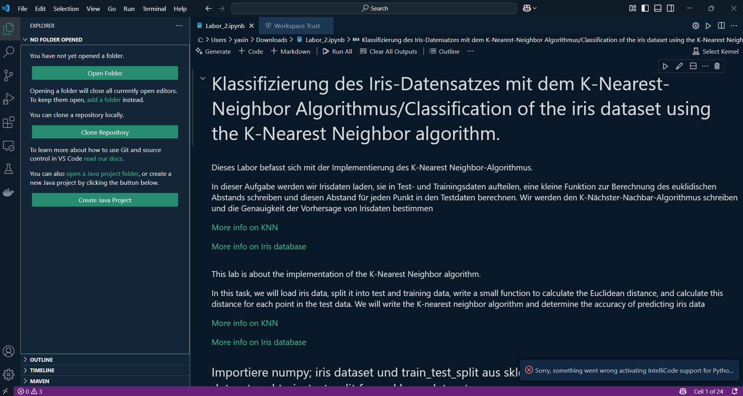

2

As I researched, I found out that it is non solvable question. It’s called the **Collatz Conjecture**.

3

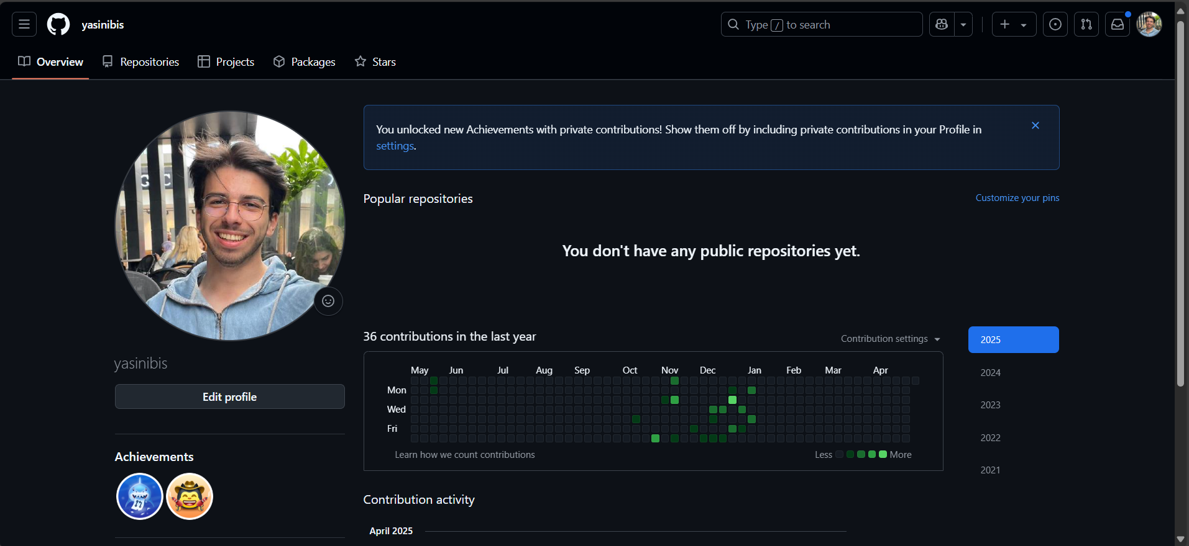

4

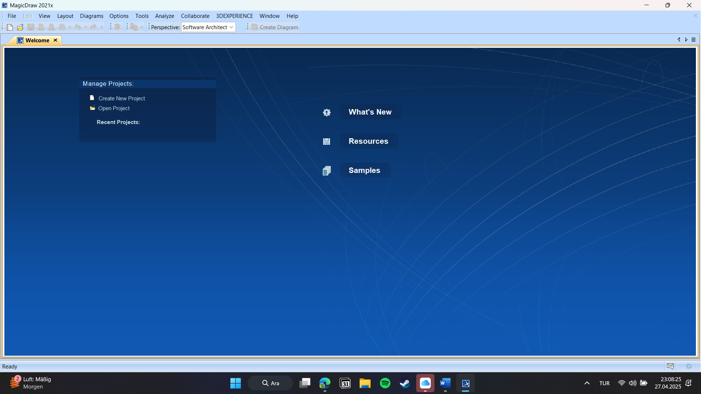

5

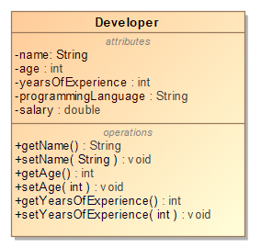

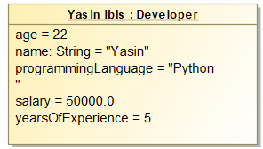

6

Define the term software design. Explain how this differs from software analysis

Software design is the process of planning how a software will work. It decides the structure of the program and how different parts work together. Software analysis is different because it focuses on understanding what the software must do. In analysis, we find the needs of the users and the problems. The main difference is that analysis tells us what the software must do, while design shows us how the software will do it.

7

I think software design is really necessary for any software project. It helps everyone know what to do and how things should fit together before starting to code. Without a design, everything would get really confusing.

8

I think the design activities like architecture, database, user interface, and components are all connected. They have to work together. Like in a big app such as Instagram, the database saves all the photos and messages, the architecture makes sure everything runs fast, the components handle different features like stories, and the user interface shows it all to the user. If one part is bad, the whole app could have problems. So, they really depend on each other.