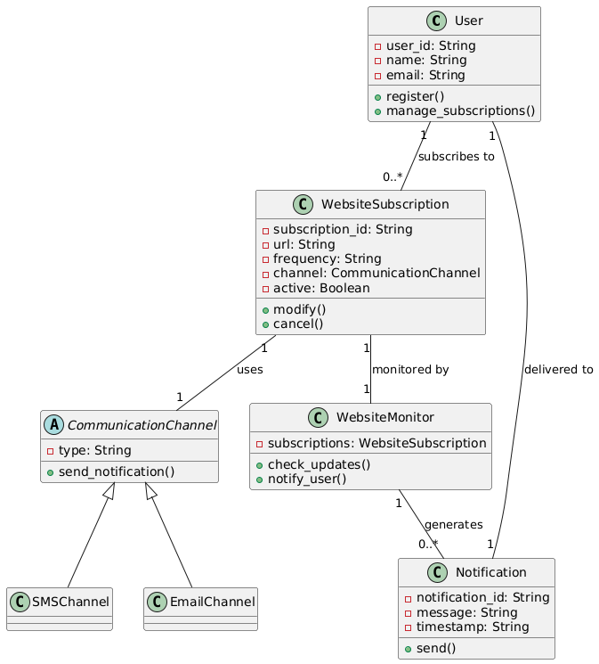

Q2: How to choose the right class for a method or object?

1. Choosing the Class for a Method

GRASP Principle: Information Expert

Give the job to the class that has the needed data.

How to do it:

Think about what the method does.

Find which class has the needed information.

Put the method in that class.

Example:

If you want to get the total price of an order, the Order class should have this method (because it knows the items and prices).

Other helpful GRASP rules:

Controller: For system actions (like a user clicking a button), use a controller class.

Low Coupling: Choose a class that doesn’t depend too much on others.

High Cohesion: Put methods in classes where they feel like a natural part.

2. Choosing the Class to Create an Object

GRASP Principle: Creator

Let the class create another object if it uses, contains, or knows the data for it.

How to do it:

Choose the class that holds or uses the new object.

Or the one with the data needed to build it.

Example:

If an Order has OrderLine items, then Order should create OrderLine objects.

Summary Table

What You’re Doing GRASP Rule How to Choose the Class

Writing a method Information Expert Give it to the class that has the needed information

Creating a new object Creator Give it to the class that holds, uses, or builds the data

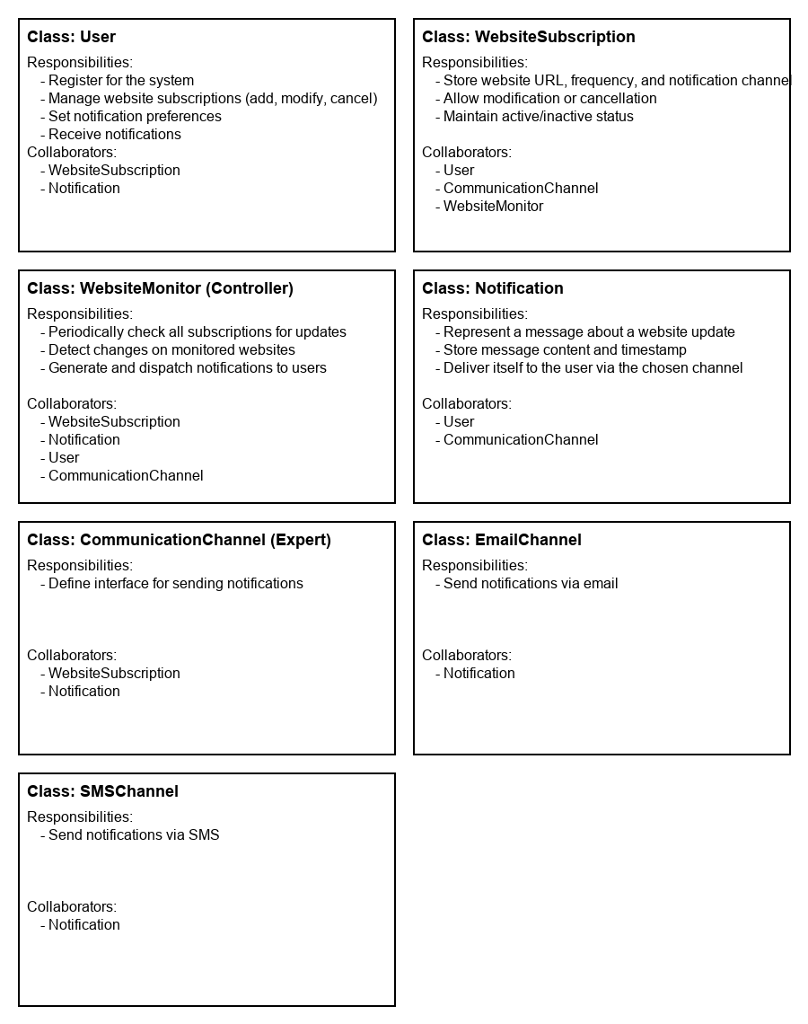

Did I change the responsibility of any method?

Answer:

No. The responsibilities of all methods are still the same as before.

Each method is in the right class based on its role and data. This follows the GRASP principles: Information Expert and Controller.

Examples:

register() and manage_subscriptions() → stay in User

modify() and cancel() → stay in WebsiteSubscription

check_updates() and notify_user() → stay in WebsiteMonitor (Controller)

send() → stays in Notification

send_notification() → stays in CommunicationChannel and its subclasses