Term Project Assignment Report - Hotel Safe

< Yasin Okuş S006978 >

Hotel Safe is an electronics system with a CPU, a numpad, a 2-row LCD, 2 motors and an Emergency LED. It has 2 sections with individual passwords, a master password to open any section and a bait password that when entered will alert the police. It is a simplified application of an actual safe system.

Purpose : The objective in building this system is to apply what we have learned in this course for a real-life situation and get a better understanding of what we have learned.

İn this project , I used KEYPAD-PHONE,L293D,LED-RED,LM016L,MOTOR-BISTEPPER and RESİSTANCE components with this details :

* İ used Arduino Uno ATmega328 for a microcontroller.
* İ used LCD library( <LiquidCrystal.h>) and used stepper library for my motor ( <Stepper.h>).
* İ used Arduino IDE and Proteus 8 Pro for programming and simulation.
* AND HERE İS THE MY PROTEUS DESİGN :

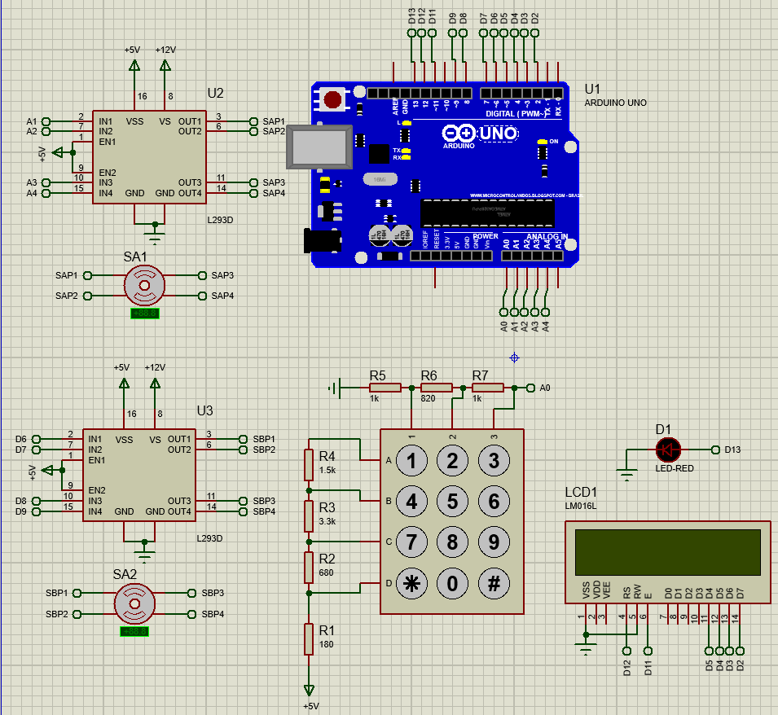

* İ did’nt use connection cables in my design because it seems more complex , so I tagged them in my arduino code and upper motor represent A section, other one represent B section.
* İ preffered to use Arduino Uno because we used in class and our purpose was appliying what I learned in this course.

Let’s talk about details as how to I design my project :

* Firstly, I should say that I added many commits in my code part , so someone can track easily my code.
* Beginning of the coding , I added libraries which will I use and I defined all pins names . Then, determined the dafault passwords like in the picture :

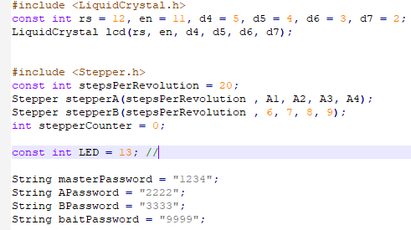

* İn the above picture, you can see that I setted stepsPerRevolution number as 20. Because, my motors which I used in proteus have a 18 degree . So 360/18 = 20 . İt means that, our motor should step 20 times for 1 time turning ( 360 degree).
* After I crate all outputs modes of pins, I designed to my lcd main screen ( oppening) like this:

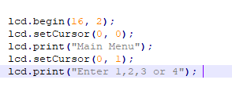

* I setted the motors for 2 times running as said in project pdf :



* In the main part, we had 4 options to choose one of them. So , I created returning functions for main screen and masterLock screen like in pdf. And defined them with speceliaties which were in our project pdf file. Here are the pictures of them as arduino code :

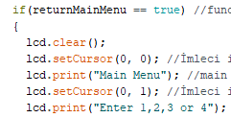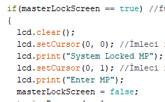

* For the entering bait password, I created a if conditon and created a 2 action like if the password equal to bait pass and if we are in inside A or B section… So, when we enter bait password in section A or B, our Led ligting High and lcd screen showing it. (in every return step I am clearing lcd screen with lcd.clear() method)

So, I follow all steps for logic part like exactly in our pdf.

* I controlled succesfull and unseccesfull attemps with integers and lcd can show all attemps when we choose 4th option. Here are the some important logics how to I consider attemps :

1. When bait pass entered, it considered as succesfull attemp.
2. When we are in master lock state , if we enter succesfull password , it consired also succesfull attemp.
3. Also, when I change the passwords , it s also succesfull atemps for my system.

* I setted some delays , so my system running better to follow steps.

! So, please wait when run the proteus 2 second and wait 1 sec for every lcd screen changing to click keypad buttons. So , we can get better result for running my system.

* For the numberkey part, I had some problems. First of all my arduino pin numbers are not enough for numberkeypad with using other components ; so I used resistances and created a voltage divider circuits like this :

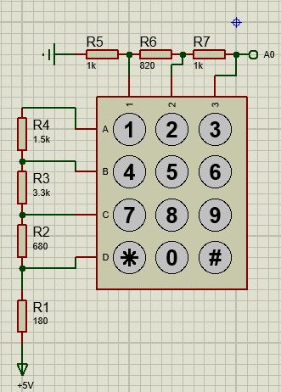

When we click the butons on numberpad, current is flowing 5V to GND. So there is being voltage diffrence between two resistance. This is why we called this like “ voltage divider circuit”. And arduino using 10 bit ADC, it means that system can’t read the keypad like “3v or 4v”. İt returns us as a number. İt coding logic like this picture :

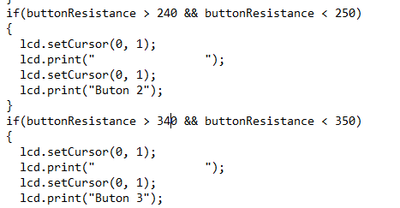

İ got this idea from <http://electronicbeans.com/>

+++ So when we click the button, we are reading the value with A0 pin.