USER MANUAL

!!! Please wait 2 second when you run system ( Section gates will fix themselves). And please wait 1 second for every LCD changing screen and every attemp to enter password.

İn the my system and it’s code, there are many delay parts for better working. So, you should wait 2 seccond when you run the system begin. After wait 2 second , LCD screen will be like that :

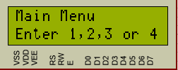

İt means that, you will have 4 option to choose. You should use numberkey pad to enter your options.

When you click “1 “ , LCD screen will enter SectionA like this :

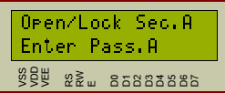

İt means that, you should enter default password SectionA which is “2222” to open A gate. İf you enter the right password , A gate will return 2 times and Main Menu Screen will come again.

Also, İf you enter bait password , A gate will open and return 2 times but this time emergency led will be active like this :

🡪 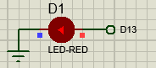

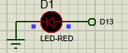

However, İf you enter wrong password, lcd will say “wrong password” and system will want to again entering password from you, if you enter 3 times wrong, Lcd will go MasterLock Part like this :

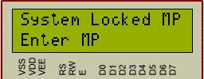

İf you enter your MasterPassword ( default MP is “1234”) , you will go again Main Menu Screen ; however if you enter wrong Master Password, System will count 20 second like this( 20..19..18..17..16.15…) :

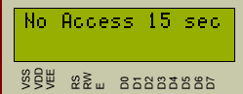 After 20 sec, you will go again MasterLockScreen.

So , Option “1” and “2” have same operations.

Option “3” is the password change part. When you choose “3”, LCD will want MasterPassword from you:

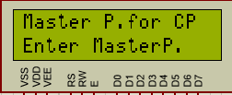

İf you enter right MasterPassword, LCD will have 4 new options again like this :

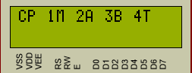 Option “1” is changing MasterPasswod, Option “2” is changing SectionA password, Option “3” is changing SectionB password and Option “4” is changing BaitPassword.

And the last part is , viewing our total Succesfull and UnSeccusfull attemps. İf you choose option “4” when you are in Main screen , LCD will show your total attemps like this :

