**1. What is Jenkins?**

Jenkins is a open-source automation server that can be used to automate all sorts of tasks related to building, testing, and delivering or deploying software.

**2. Explain what is continuous integration?**

 A software development process where the changes made to software are integrated into the main code as and when a patch is ready so that the software will be always ready to be - built, tested, deployed, monitored - continuously.

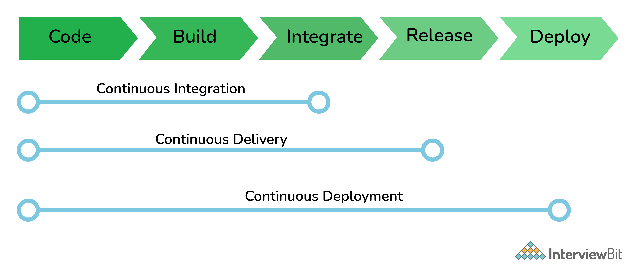**3. What is a Jenkins job?**

A Job/Project is the fundamental unit of a logical work (like a software build, an automation task, test execution, etc) using the Jenkins automation server and other required plugins, configurations & infrastructures.

Jobs can be of different types like - a freestyle project, a multi-configuration project, a pipeline project, a multi-branch project, etc.

**4. What is Jenkins Pipeline? What is a CI CD pipeline?**

The pipeline can be defined as the suite of plugins supporting the implementation and integration of continuous delivery pipelines in Jenkins.

Continuous integration or continuous delivery pipeline consists of build, deploy, test, release pipeline. The pipeline feature saves a lot of time and error in maintaining the builds. Basically, a pipeline is a group of build jobs that are chained and integrated in sequence.

**5.** **How do you store credentials in Jenkins securely?**

Credentials can be stored securely in Jenkins using the Credentials plugin, which stores different types of credentials like - Username with a password, SSH username with the private key, AWS Credentials, Jenkins Build Token, Secret File/Text, X509 & other certificates, Vault related credentials securely with proper encryption & decryption as and when required.