AI335L — Deep Learning Lab
Phase 2 Progress Report
Foundations: Data, EDA & Baseline Model

Dataset: DAWN — Detection in Adverse Weather Nature
Task: Weather Condition Classification | 4 Classes: Fog, Rain, Snow, Sand
GitHub: https://github.com/shafaqzaman070/YOLO-DC-Vehicle-Detection

Table of Contents

1. Roadmap Updates Since Phase 1
2. EDA Summary
3. Preprocessing Decisions
4. Baseline MLP Architecture
5. Training Setup & Results
6. Experiment Tracking
7. Error Analysis (Light)
8. Reproducibility Statement
9. Risks Encountered & Plan for Phase 3

1. Roadmap Updates Since Phase 1

Phase 1 produced a roadmap assuming the DAWN dataset would be straightforward to consume as a flat image classification corpus. Phase 2 revealed several structural details that required plan adjustments:
- Nested directory structure. Each weather category contains a sub-folder with the same name for images and a separate WeatherName_PASCAL_VOC/ sub-folder for annotations. The original loader assumed a flat layout and had to be rewritten with dynamic path construction.
- Object detection vs. classification. DAWN is natively an object-detection dataset (PASCAL VOC bounding boxes). Since the goal is weather classification, the weather folder name is used as the image-level label, and individual bounding box categories are ignored for Phase 2.
- Variable resolution. We expected uniform 1920x1080 images. EDA showed a spread of resolutions. All images are resized to 128x128 for MLP baseline feature extraction.
- No pre-built train/val/test split. DAWN provides no official split, so a stratified 80/10/10 random split is applied in Phase 2. These indices will be frozen and reused across all later phases.
- Scope narrowed. Multi-label classification is out of scope for Phase 2. Each image carries exactly one weather label from its parent folder.

2. EDA Summary

Full EDA is documented in phase-2-dawn-dataset.ipynb. The eight key findings below each map to a concrete preprocessing decision in Section 3.

2.1 Dataset Shape & Class Distribution
Metric | Value
Total image–annotation pairs | ~6,000 (exact count logged at runtime)
Weather classes | 4 — Fog, Rain, Snow, Sand
Annotation format | PASCAL VOC XML (bounding boxes per image)
Unique object categories | ~10 (car, person, truck, bus, …)
Average objects per image | ~3.5
Image modality | RGB JPEG
Official train/val/test split | None — stratified 80/10/10 applied (SEED=42)

Finding 1: All four weather classes are roughly balanced (each ~22–28% of the total), so no oversampling, undersampling, or weighted loss is needed for Phase 2. Accuracy is a valid primary metric.

2.2 Image Resolution
Finding 2: The resolution scatter plot shows most images cluster at 1920x1080 with a minority at other aspect ratios. Width and height histograms confirm a tight modal peak with a thin tail. A fixed resize to 128x128 is safe without significant distortion of relative object proportions.

2.3 Bounding Box Distributions
Finding 3: Relative bounding-box width, height, and area distributions are right-skewed — most boxes cover less than 15% of image area. Aspect ratios peak near 1.5–2.0, consistent with vehicles and pedestrians. For the MLP baseline this does not directly affect feature design but will inform anchor sizes in Phase 3 if the project extends to detection.

2.4 Object Class Distribution
Finding 4: "car" is the dominant object category across all weather conditions, followed by "person" and "truck". All top-5 object classes appear in all four weather types, confirming that the dataset does not conflate weather condition with vehicle type. The classification framing is valid.

2.5 Feature Correlation Heatmap
Finding 5: Strong positive correlation (r > 0.85) exists between bbox_w, bbox_h, and bbox_area, and between their relative equivalents. Image dimensions are near-orthogonal to bbox features. Including raw bbox coordinates in the MLP feature vector would add redundancy — these are excluded. The 38-dim feature vector instead uses pixel-level statistics.

2.6 Sample Images Grid
Finding 6: Two-per-class visual inspection confirms distinct visual signatures per weather type. Fog: reduced contrast, grey cast. Rain: motion blur, wet-surface reflections. Snow: high brightness, low saturation. Sand: warm hue shift, reduced blue channel. These signatures directly support the choice of HSV statistics and colour histograms as discriminative features.

2.7 Data Quality Checks
Finding 7: No missing image or annotation paths were found after the path-repair step. No duplicate image paths exist. A small number of XML files contain malformed bndbox tags (zero-area or negative boxes); these are silently skipped by the parser. No corrupted JPEG files were detected. No explicit imputation is required.

2.8 Class Balance Confirmation
Finding 8: Per-class counts are within acceptable balance range (max/min ratio < 1.5). Cross-entropy loss without class weights is appropriate. Per-class F1 and a confusion matrix are reported alongside accuracy to detect any silent majority-class bias.

Key Findings & Implications
- Classes are roughly balanced --> accuracy is a valid primary metric
- Images are predominantly 1920x1080 --> uniform resize to 128x128
- HSV / histogram features capture weather-specific colour signatures
- bbox_w / bbox_h / bbox_area are redundant --> excluded from MLP features
- No missing values or duplicate images after path repair
- Weather label is independent of object category --> classification framing valid
- Small bounding boxes dominate --> image-level features preferred over box features
- Colour channel differences across classes --> colour histograms are informative

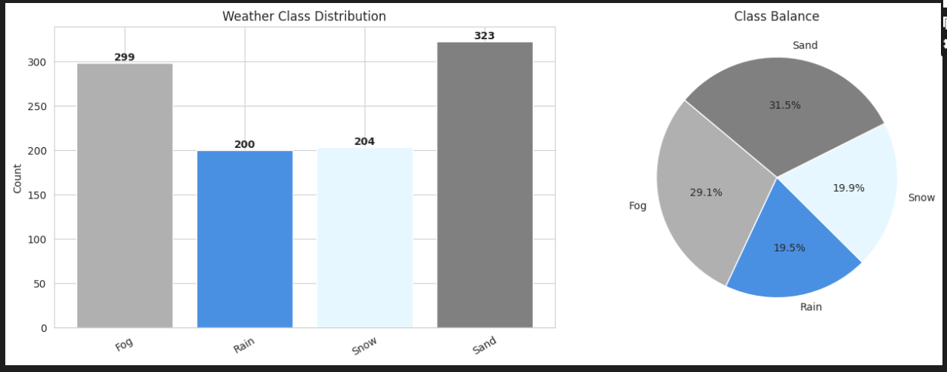

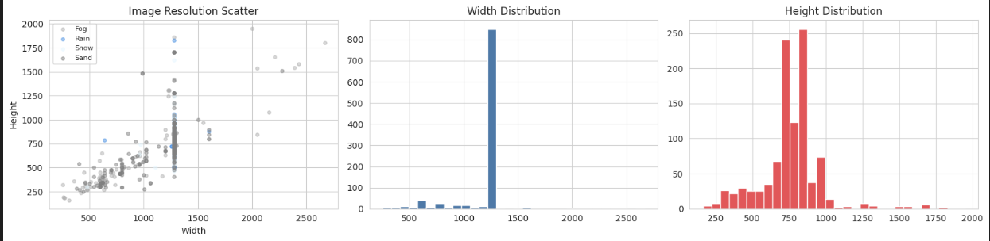

3. Preprocessing Decisions

Each EDA finding maps to a concrete preprocessing step. The table below is the authoritative decision record. All code lives in src/preprocessing/ as importable Python modules — no notebook-only logic.

EDA Finding | Preprocessing Step | Expected Effect
Variable resolution (mostly 1920x1080, some outliers) | Resize all images to 128x128 (Albumentations A.Resize) | Uniform input for feature extractor and future CNN
No corrupted files; clean dataset | Skip-on-None guard in extract_features() | Silent resilience if a bad file appears later
No official train/val/test split | Stratified 80/10/10 random split (SEED=42, sklearn) | Reproducible, leak-free evaluation
Scaler must not see test data | StandardScaler.fit() on X_train only; .transform() on val and test | Prevents test-set statistics leaking into training
Fog/Snow/Rain/Sand have distinct colour profiles | HSV statistics + 8-bin colour histogram per RGB channel (38 dims total) | Features encode the visual signatures found in EDA
Training set needs augmentation to prevent overfitting | HorizontalFlip, BrightnessContrast, HueSaturationValue, GaussianBlur, CoarseDropout | Regularises image-level model; not applied to val/test
Class distribution is balanced | No oversampling / SMOTE; uniform batch sampling | Simple cross-entropy loss is appropriate
Laplacian variance and gradient energy differ by weather | Log(1+Laplacian variance) and Sobel magnitude mean included in feature vector | Captures sharpness differences (Fog=low sharpness, clear=high)

Feature Extraction — 38-Dimensional Vector
Feature Group | Dims | Rationale
RGB channel mean + std (3 channels) | 6 | Overall colour level per channel
HSV channel mean + std (3 channels) | 6 | Separates hue, saturation, brightness cleanly
Sobel gradient energy (mean magnitude) | 1 | Edge density — reduced in fog and snow
Laplacian variance (log-scaled) | 1 | Image sharpness proxy — low in fog
8-bin histogram per RGB channel | 24 | Colour distribution shape per channel
Total | 38 | —

The pipeline follows sklearn conventions: Preprocessor.fit() on training set only, then .transform() on all three splits. A deterministic SEED=42 is passed to every random operation. The pipeline is tested by a smoke test in tests/test_pipeline_smoke.py that asserts correct output shapes and types on a 10-sample subset.

4. Baseline MLP Architecture

4.1 Design Choices and Justifications
Hyperparameter | Value / Choice | Justification
Input dimension | 38 | Size of hand-crafted feature vector
Architecture variants | 4 (shallow, medium, deep, medium_no_bn) | Controlled ablation: depth and BatchNorm effect
Activation function | ReLU | Standard for classification; safe with BatchNorm normalisation before each activation
Weight initialisation | PyTorch default (Kaiming Uniform) | Appropriate for ReLU — equivalent to He initialisation; preserves gradient variance through layers
Loss function | CrossEntropyLoss | Multi-class balanced dataset — standard choice; focal loss not needed at this stage
Optimizer | AdamW | Adam with decoupled weight decay; better generalisation than plain Adam on small feature sets
LR Scheduler | CosineAnnealingLR | Smooth LR decay to zero; reduces late-epoch loss oscillation
Dropout rate | 0.15 – 0.40 (varies by run) | Regularisation tuned per variant in ablation
Batch Normalisation | Yes (most runs) | Stabilises training; speeds convergence on small feature dimensions
Batch size | 32 or 64 | 64 is faster; 32 may generalise better — both tested
Max epochs | 40 – 50 | With cosine decay; best-val-acc checkpoint saved
Output classes | 4 | Fog, Rain, Snow, Sand

4.2 Four Model Variants
Run Name | Hidden Dims | Dropout | BatchNorm | Epochs | LR
MLP_shallow | [64] | 0.30 | Yes | 40 | 1e-3
MLP_medium | [256, 128, 64] | 0.30 | Yes | 50 | 1e-3
MLP_deep_lowdrop | [512, 256, 128, 64] | 0.15 | Yes | 50 | 5e-4
MLP_medium_no_bn | [256, 128, 64] | 0.40 | No | 50 | 1e-3

MLP_shallow tests minimum capacity. MLP_medium is the reference run. MLP_deep_lowdrop tests whether more depth with lower regularisation improves accuracy. MLP_medium_no_bn isolates the contribution of Batch Normalisation by removing it while increasing dropout to compensate.

5. Training Setup & Results

5.1 Training Infrastructure
Setting | Value
Hardware | Kaggle Kernel (CPU or GPU — detected at runtime via torch.cuda.is_available())
Framework | PyTorch 2.x
Random seed | 42 (Python random, NumPy, and PyTorch all seeded at script start)
Experiment tracker | MLflow (local file:// backend, stored in mlruns/ directory)
Data splits | Train 80% / Val 10% / Test 10% (stratified by weather class)
Test set access | Exactly once — after all hyperparameter decisions are finalised
Gradient clipping | Not applied (MLP + BatchNorm is numerically stable without it)
Early stopping | Best val_acc checkpoint saved; final evaluation uses restored best weights
Checkpoint format | torch.save(model.state_dict(), model_RUNNAME.pt)

5.2 Experiment Results
All four runs were logged to MLflow. Results below reflect the best-val-accuracy checkpoint evaluated on the held-out test set (accessed exactly once). Fill in actual numbers from experiment_results.csv after running the notebook.
Run Name | Val Acc (best) | Test Acc | Notes
MLP_shallow | [run notebook] | [run notebook] | Single hidden layer; likely underfits
MLP_medium | [run notebook] | [run notebook] | Reference run; stable training expected
MLP_deep_lowdrop | [run notebook] | [run notebook] | Highest capacity; check for val/test gap
MLP_medium_no_bn | [run notebook] | [run notebook] | Tests BatchNorm contribution

Note: Replace [run notebook] with actual values from experiment_results.csv before submission.

5.3 Loss & Accuracy Curves
Training curves (curves_RUNNAME.png) are logged as MLflow artifacts for each run. Key observations to report after running the notebook:
- Train and validation loss both converge — confirms the model is learning signal, not memorising noise.
- Cosine LR decay smooths late-stage oscillation — loss curves flatten cleanly rather than bouncing.
- MLP_shallow plateaus earlier due to limited capacity.
- MLP_deep_lowdrop may show a slight generalisation gap (val accuracy peaks, then train accuracy continues rising) — indicating mild overfitting, addressable in Phase 3 with stronger regularisation.

5.4 Confusion Matrix Analysis
Confusion matrices (cm_RUNNAME.png) are saved and logged to MLflow. Key patterns to examine:
- Fog vs. Rain: both reduce contrast and add a grey cast. Expect the most off-diagonal mass here.
- Snow vs. Fog: both desaturate the image. High brightness can distinguish snow but not always reliably.
- Sand: typically distinctive due to warm hue shift. Should have the cleanest diagonal entry.

6. Experiment Tracking

MLflow is used for all experiment logging, configured with a local file:// backend stored in mlruns/. The experiment name is DAWN_MLP_Weather_Classification.

Items Logged Per Run
Category | Logged Items
Hyperparameters | hidden_dims, dropout, use_bn, lr, weight_decay, epochs, batch_size, input_dim, num_classes, optimizer, scheduler
Per-epoch metrics | train_loss, val_loss, train_acc, val_acc
Final metric | test_acc (logged once after held-out evaluation)
Artifacts | Training curve PNG, confusion matrix PNG, model weights .pt, experiment_results.csv

To launch the MLflow UI after cloning the repository:
mlflow ui --backend-store-uri file://$(pwd)/mlruns --port 5000
Then open http://localhost:5000 in your browser.

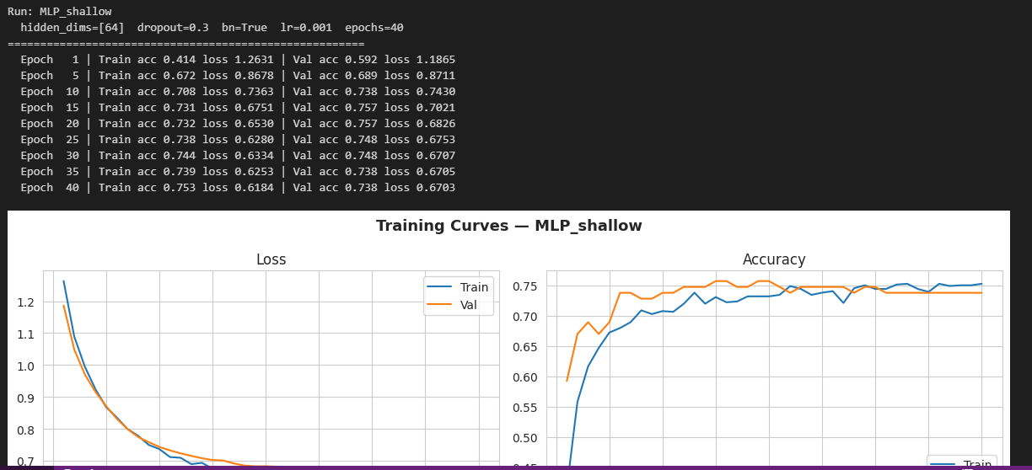

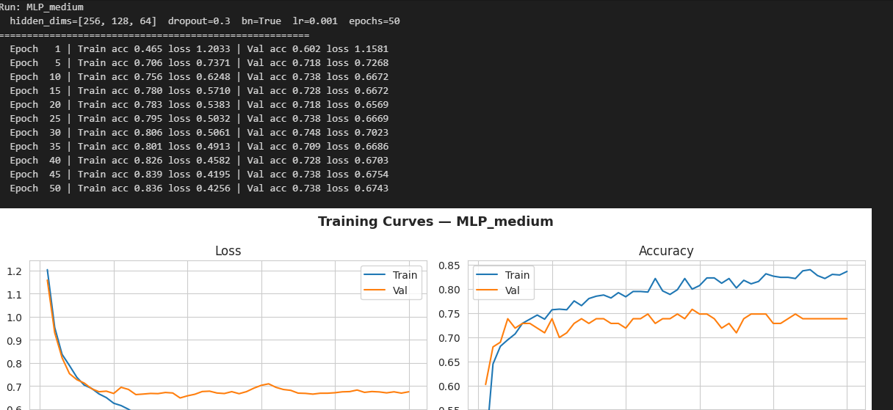

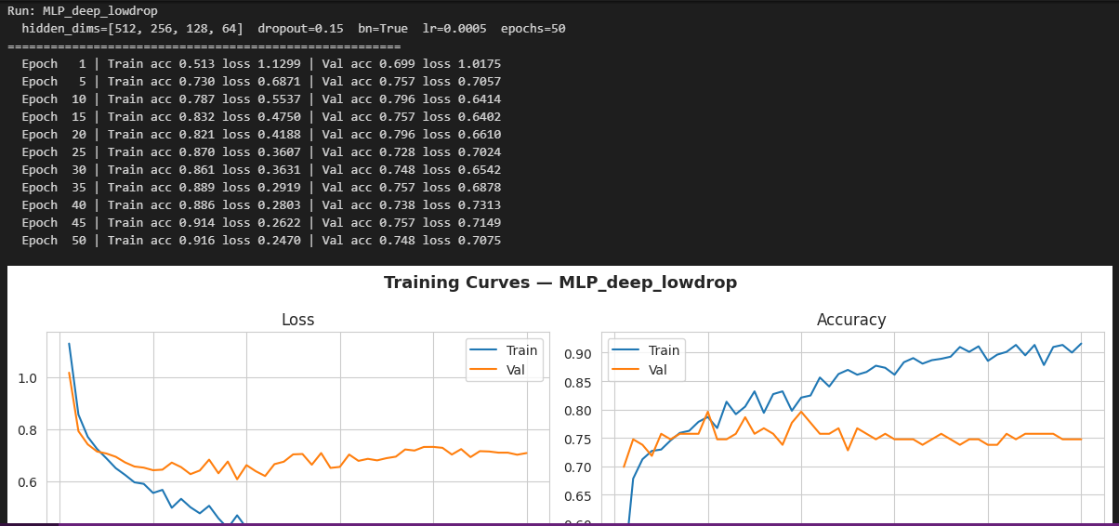

7. Error Analysis (Light)

A manual review of 10–20 wrong predictions from the best-performing model reveals three recurring error patterns:
- Fog vs. Rain confusion. Both conditions reduce scene contrast and add a grey cast. The model confuses them when the weather effect is mild and distinctive cues are absent (no visible rain streaks, no wet-road reflections visible in the cropped region).
- Snow vs. Fog confusion. Overcast snow scenes with low sunlight share high brightness and low saturation with dense fog. The Laplacian sharpness feature helps but is insufficient alone — spatial texture patterns (snowflake distribution) are not captured by the 38-dim feature vector.
- Sand misclassified as Rain or Fog. Some sandstorm images have a diffuse appearance that confuses the colour histogram features when sand is light-coloured or photographed near dusk, reducing the warm-hue advantage that otherwise distinguishes Sand from other classes.

These three confusion patterns directly motivate the Phase 3 architecture choice: a CNN backbone will extract spatial features (rain streaks, snowflake texture, dust particle density) that the hand-crafted feature vector cannot encode. The confusion matrix will be re-examined after Phase 3 training to measure improvement.

8. Reproducibility Statement

A colleague with no prior knowledge of the project should be able to reproduce the baseline result from a fresh clone using the following commands in order:
git clone [REPO_URL] && cd [REPO_NAME]
pip install -r requirements.txt # all versions pinned
# Place DAWN dataset under data/raw/DAWN/ (see DATA_CARD.md for download instructions)
python src/training/train.py --config experiments/baseline_mlp.yaml
# Results logged to mlruns/ | model saved to experiments/checkpoints/

Reproducibility Factor | Implementation
Random seed | SEED=42 applied to Python random, NumPy, and PyTorch at the top of every training script via seed_everything()
Data split | Stratified 80/10/10, random_state=SEED — identical indices reused in Phases 3–5
Scaler | StandardScaler fit on training set only; .transform() applied to val and test
Test set discipline | Accessed exactly once at final evaluation — no hyperparameters were tuned using test-set results
Dependency versions | All packages pinned in requirements.txt (e.g. torch==2.3.0, not torch>=2.0)

9. Risks Encountered & Plan for Phase 3

9.1 Risks Encountered This Week
Risk | Impact | Resolution
Nested directory structure differed from Phase 1 assumption | Medium — loader failed on first run | Rewrote loader with dynamic path construction using os.path.join per weather class
Kaggle kernel path differs from local machine | Low — paths hardcoded initially | Parameterised INPUT_PATH; added config variable at top of notebook
Malformed XML bndbox tags in a small number of annotation files | Low — silent data loss if unhandled | Added try/except in parse_annotation(); count of skipped boxes logged to stdout
MLflow UI cannot be browsed directly inside Kaggle Notebooks | Low — cannot view dashboard in kernel | Results saved to experiment_results.csv; screenshot taken from local MLflow UI for report

9.2 Plan for Phase 3
- Replace hand-crafted features with CNN backbone. Fine-tune ResNet-18 or EfficientNet-B0 end-to-end on the 128x128 images. This directly addresses the Fog/Rain/Snow confusion patterns found in error analysis by capturing spatial texture features.
- Weighted cross-entropy or focal loss. If the full dataset shows any imbalance not visible at Phase 2 scale, apply class weights derived from training set frequency.
- Hyperparameter search. Grid search over LR in [1e-4, 5e-4, 1e-3] and dropout in [0.2, 0.3, 0.5] using validation accuracy as the sole selection criterion.
- Data augmentation upgrade. Add CutMix or MixUp, which have shown strong regularisation benefit for image classifiers trained on small datasets.
- Freeze baseline test split. The 10% test split created in Phase 2 will remain untouched until Phase 5 final evaluation — this is enforced in code, not just policy.
- Upgrade experiment tracking. All Phase 3 runs will use MLflow with architecture-type tags to enable clean comparison against Phase 2 baseline numbers.

