ENGAGE
Admin Panel Documentation
Features • Application Flows • Data Flow Diagrams
Product: Aster ENGAGE | Package: daftarkhwan_vms_admin
Version 1.0 | July 2026

Table of Contents
1. Introduction & Overview
2. Technology Stack
3. System Architecture
4. Navigation & Module Map
5. Authentication & Authorization
6. Feature Modules (Detailed)
7. Application Flow Diagrams
8. Data Flow Diagrams
9. Data Models & Entity Relationships
10. API Inventory
11. Role-Based Access Matrix
12. Integrations
13. Known Limitations

1. Introduction & Overview
ENGAGE Admin is a web-based operations console for managing coworking spaces, meeting rooms, tenant companies, users, bookings, and wallet credits. Although the repository package name is daftarkhwan_vms_admin, the product is not a classic visitor check-in VMS — it is a space and meeting-room administration panel for Aster ENGAGE.
Primary goals of the admin panel:
- Configure and maintain physical locations (spaces) and meeting rooms.
- Manage tenant companies and their users.
- Create, monitor, and cancel meeting room bookings.
- View real-time room slot availability for a selected date.
- Maintain wallet credits (meeting room / printing) and export transaction reports.
Backend API base URL: https://engage-app.astererp.com/api/v1/
Default post-login landing page: /home/locations (Space module).

2. Technology Stack
Layer | Technology
UI Framework | React 19
Build Tool | Vite 7
Routing | react-router v7 (BrowserRouter)
Styling | Tailwind CSS v4 + feature CSS
HTTP Client | Axios (Bearer token interceptor)
Auth Persistence | localStorage (token, user)
State Management | React Context (UserContext) — no Redux
Image Storage | Firebase Storage
Exports | xlsx + file-saver (Excel / CSV)
Select Controls | react-select

3. System Architecture
The admin panel is a single-page application (SPA). Feature pages live under a shared Home layout that renders a persistent sidebar and an Outlet for nested routes. API communication is centralized through Axios modules under src/api/. Image uploads for locations and rooms go to Firebase Storage; all other business data flows through the ENGAGE REST API.
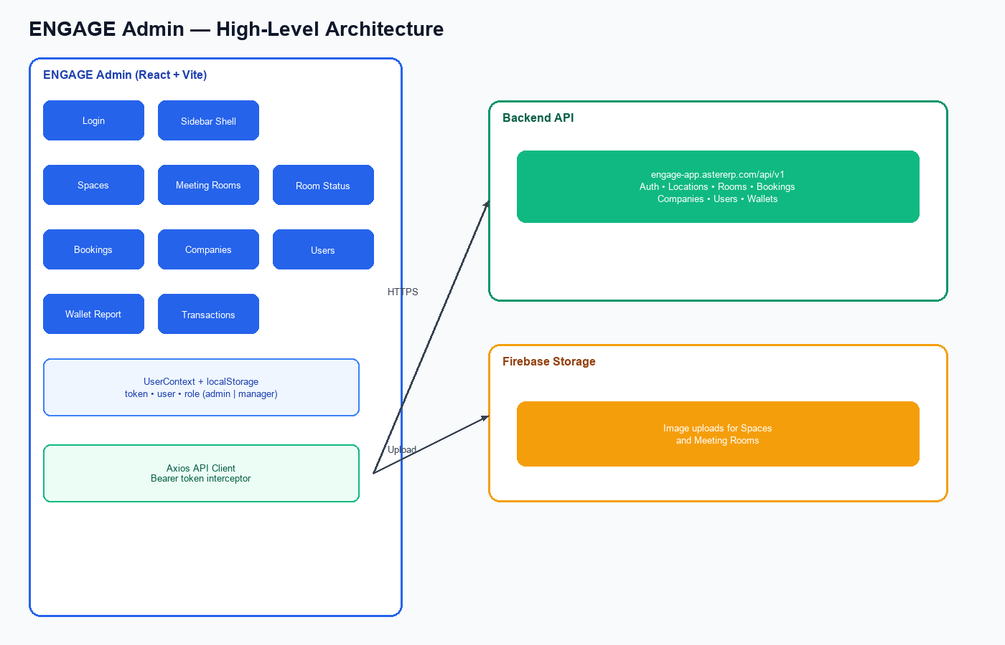

3.1 Project Structure
src/
api/ — Axios client and domain API modules
components/ — Shared UI (sidebar, dialogs, popups, loader)
context/ — UserContext (auth user / role)
features/ — Feature modules (auth, locations, rooms, bookings, users, wallet, …)
firebase/ — Firebase app initialization (Storage)
router/ — Route definitions
App.jsx — BrowserRouter + UserProvider + routes

4. Navigation & Module Map
The left sidebar branded “ENGAGE” provides primary navigation. Transaction history opens in a separate route (/transactions/:id) without the sidebar shell.
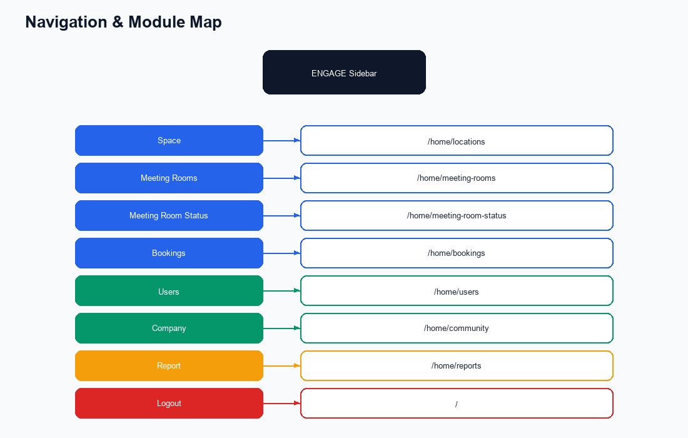

Menu Label | Route | Feature Module
Space | /home/locations | Locations management
Meeting Rooms | /home/meeting-rooms | Room configuration
Meeting Room Status | /home/meeting-room-status | Slot grid & booking
Bookings | /home/bookings | Booking list & CRUD
Users | /home/users | User & wallet management
Company | /home/community | Tenant companies
Report | /home/reports | Wallet transaction report
Logout | / | Clears storage and redirects
(Transactions) | /transactions/:id | Per-wallet history (new tab)

5. Authentication & Authorization

5.1 Login Flow
Users authenticate with email and password. Only roles admin and manager are allowed into the console. On success, the API authorization token and user object are stored in localStorage. Every subsequent Axios request attaches Authorization: Bearer <token>.
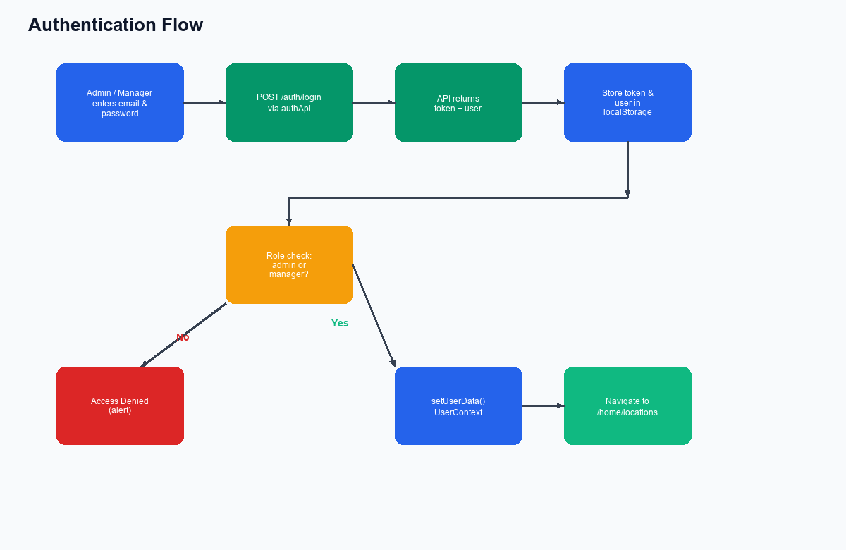

5.2 Logout
Logout clears localStorage, sessionStorage, and cookies for the current domain, then redirects to the login page (/).

5.3 Route Protection Note
There is no dedicated client-side ProtectedRoute guard on /home/* routes. Access is enforced at login (role gate) and via per-action UI checks for admin-only mutations. API calls without a valid token fail at the backend.

6. Feature Modules (Detailed)

6.1 Space (Locations)
Manage physical coworking sites. Admins can create, edit, and delete locations; managers can view and search. Images are uploaded to Firebase Storage.
Capabilities:
- List locations with client-side search (name, city, contact, email) and pagination (10/page).
- Add / Edit / Delete location (admin only).
- Fields: name, contactNumber, email, legalBusinessName, address, city, lat, lng, status, image.

6.2 Meeting Rooms
Configure bookable rooms under locations, including pricing in credits, capacity, operating hours, available weekdays, and amenities.
- List rooms with search and filters (location, floor).
- Add / Edit / Delete room (admin only); Firebase image upload.
- Fields: name, locationId, floor, creditsPerSlot, pricePerCredit, seatingCapacity, opening/closing time, status, amenities (multi-select), availableDays, image.
- Amenities loaded from GET /amenities.

6.3 Meeting Room Status
Operational day view showing 30-minute slots for a selected room and date. Free slots can be booked; booked slots show details and allow cancellation. Past slots for the current day are non-bookable. Hours follow the room’s opening/closing times (default 09:00–21:30).
- Select location → room → date → Check Status.
- Click free slot or “Make a Booking” to open booking form (preset fields).
- Click booked slot to view title, description, company, user, time — then cancel if needed.

6.4 Bookings
Paginated booking management with server-side paging (page_size=10). Supports create and cancel. Dependent dropdowns load rooms by location and users by company.
- List, search (client filter on current page), location filter, sort by date.
- Create booking payload: title, description, date, startTime/endTime, location_id, room_id, company_id, user_id, status=confirmed.
- Cancel via POST /bookings/cancel/:id.
- Handled errors: 403 insufficient wallet credits; 409 room conflict.

6.5 Company
Manage tenant companies associated with locations. Admins can add and edit companies. A delete icon exists in the list UI but the parent page does not currently wire onDelete.
- List, search, filter by location/status.
- Fields: name, email, contactNumber, businessType, websiteUrl, LocationId, locationName, reference, billingEmail, gstn, status.

6.6 Users
Manage platform users and their credit wallets. Roles assignable at create: admin, manager, member.
- List and search users.
- Add / Edit user (admin only).
- Update Wallet — adjust meeting room credits and printing credits.
- Open transaction history in a new tab (/transactions/:walletId).
- Delete confirmation currently removes from local UI state only (no delete API call).
- Fields: name, role, email, company_id, phoneNumber, password (create), credit_types (prepaid/postpaid), auto_renew, status.

6.7 Report (Wallet Transactions)
Generate a filtered wallet transaction report by selecting a user and date range, then export results to Excel or CSV.
- POST /company/wallet/report with user and date filters.
- Table display of transactions (amount, type, reason, timestamps, metadata).
- Export via xlsx / file-saver.

7. Application Flow Diagrams

7.1 Booking Creation & Cancellation
Bookings can be started from the Bookings page or from Meeting Room Status. The form submits to POST /bookings. The backend validates wallet balance and room availability.
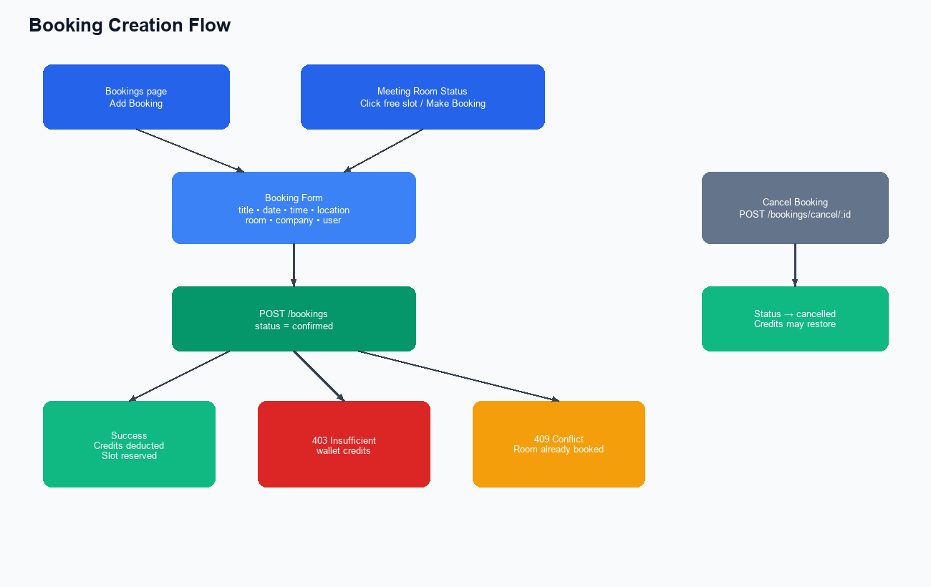

7.2 Wallet & Credits Flow
Credits are topped up from the Users page, consumed when bookings are created, and audited via transaction history and the Report module.
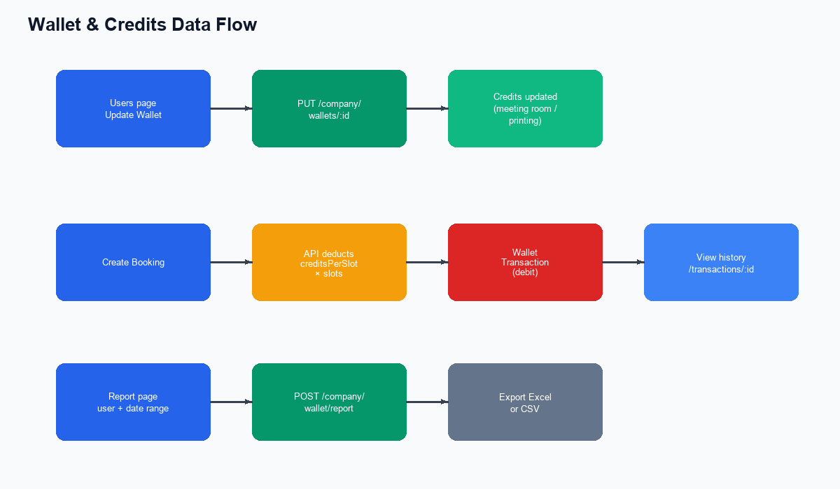

7.3 Typical Operator Journey
End-to-end path for day-to-day operations:
1. Sign in as admin or manager.
2. Ensure Space (location) and Meeting Rooms are configured (admin).
3. Ensure Company and Users exist with sufficient wallet credits.
4. Open Meeting Room Status — pick location, room, date — review free/booked slots.
5. Create a booking from a free slot or from the Bookings page.
6. If needed, cancel a booking from the list or status detail modal.
7. Review wallet activity under Report or per-user Transactions.

8. Data Flow Diagrams
Data moves from UI presentation through feature/application modules into the integration layer (REST API and Firebase), and persists as domain entities on the backend.
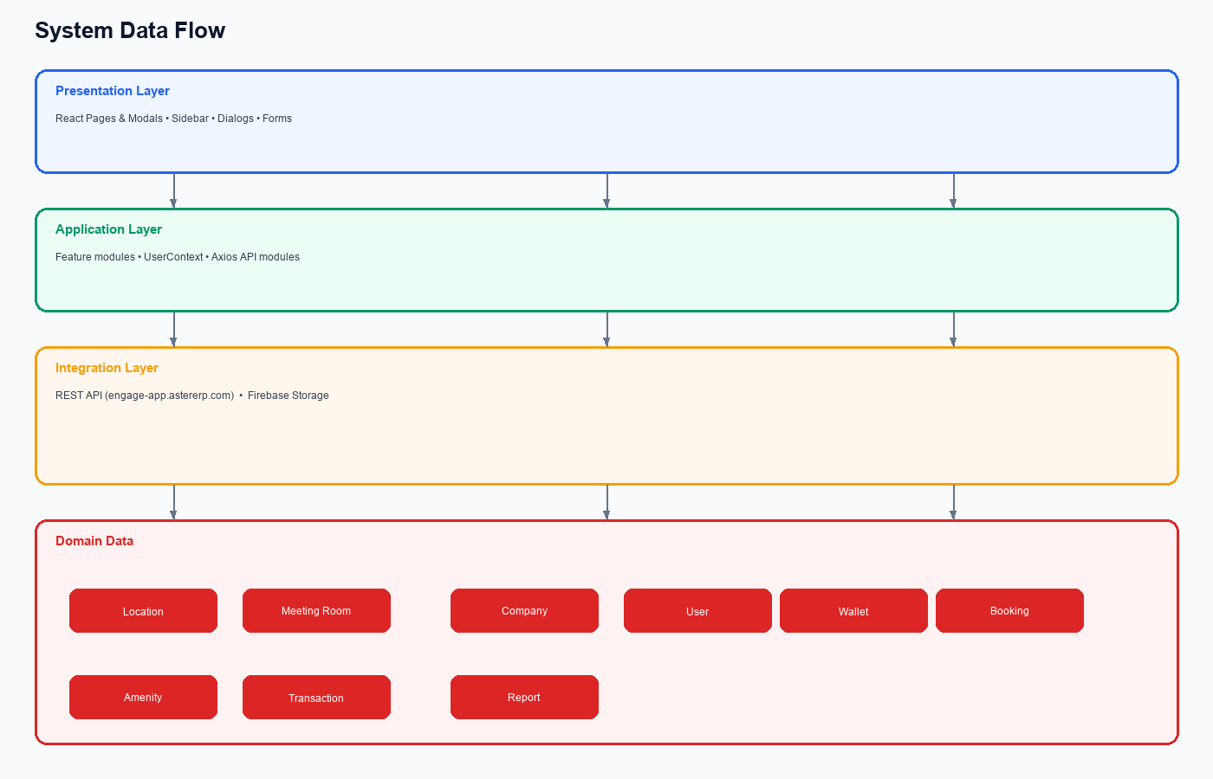

8.1 Request Lifecycle
- User action in a React page/modal updates local component state.
- Handler calls a domain API function (e.g., addNewBooking).
- Axios interceptor attaches Bearer token from localStorage.
- Request sent to https://engage-app.astererp.com/api/v1/<resource>.
- Response JSON is mapped into component state (lists, modals, toasts).
- For images: file uploaded to Firebase Storage; returned URL included in create/update payload.

8.2 Cross-Entity Data Dependencies
UI Action | Dependent Loads | Write Target
Create room | Locations, Amenities | POST /meeting-rooms (+ Firebase image)
Create company | Locations | POST /company
Create user | Companies | POST /auth/register/
Create booking | Locations → Rooms; Companies → Users | POST /bookings
Room status check | Locations → Rooms; Bookings by room+date | GET bookings/by-room-and-date
Update wallet | User wallet id | PUT /company/wallets/:id
Wallet report | Users list | POST /company/wallet/report

9. Data Models & Entity Relationships
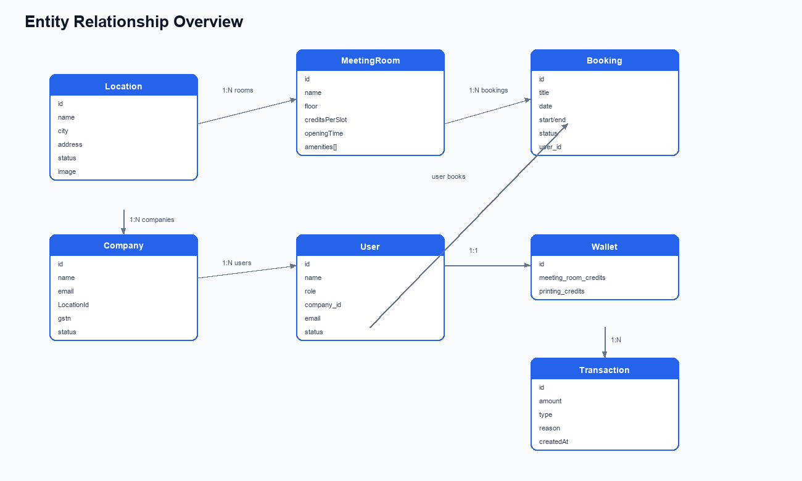

9.1 Entity Field Reference
Location
id, name, contactNumber, email, legalBusinessName, address, city, lat, lng, status, image/imageUrl
Meeting Room
id, name, LocationId/location_id, location (nested), floor, creditsPerSlot, pricePerCredit, seatingCapacity, openingTime, closingTime, status, availableDays[], amenities[], image, availableSlotsCount
Company
id, name, email, contactNumber, businessType, websiteUrl, LocationId, locationName, location, reference, billingEmail, gstn, status
User
id, name, email, role (admin|manager|member), company_id, Company {name, locationName}, phoneNumber, password, credit_types, auto_renew, status, Wallet {id, meeting_room_credits, printing_credits}
Booking
id, title, description, date, startTime, endTime, location_id, room_id, company_id, user_id, status (confirmed|cancelled), nested Room, User, User.Company
Wallet Transaction
id, amount, type (credit|debit), reason, createdAt, metadata (JSON: company, date, startTime, roomName, location, slots, totalCredits), performedByUser, user

10. API Inventory
All endpoints are relative to https://engage-app.astererp.com/api/v1/
Module | Method | Endpoint | Purpose
Auth | POST | /auth/login | Sign in
Auth | GET | /auth/users/company/:id | Users by company
Users | GET | /auth/users | List users
Users | POST | /auth/register/ | Create user
Users | PUT | /auth/users/edit/:id | Edit user
Locations | GET | /locations | List locations
Locations | POST | /locations | Create location
Locations | PUT | /locations/:id | Update location
Locations | DELETE | /locations/delete/ | Delete location
Rooms | GET | /meeting-rooms | List rooms
Rooms | GET | /meeting-rooms/location/:id | Rooms by location
Rooms | POST | /meeting-rooms | Create room
Rooms | PUT | /meeting-rooms/:id | Update room
Rooms | DELETE | meeting-rooms/delete/:id | Delete room
Rooms | GET | /amenities | List amenities
Bookings | GET | /bookings?page&page_size | Paginated bookings
Bookings | POST | /bookings | Create booking
Bookings | POST | /bookings/cancel/:id | Cancel booking
Bookings | GET | /bookings/by-room-and-date | Slots for room/date
Bookings | GET | /bookings/:id | Booking detail
Company | GET | /company | List companies
Company | POST | /company | Create company
Company | PUT | /company/:id | Update company
Company | GET | /company/location-id/:id | Companies by location
Wallet | PUT | /company/wallets/:id | Update wallet credits
Wallet | GET | /company/wallet/transactions/:id | Transaction history
Wallet | POST | /company/wallet/report | Filtered wallet report

11. Role-Based Access Matrix
Capability | Admin | Manager | Member
Login to admin panel | Yes | Yes | No
View spaces / rooms / bookings / companies / users / reports | Yes | Yes | —
Add / Edit / Delete locations | Yes | No (UI blocked) | —
Add / Edit / Delete meeting rooms | Yes | No (UI blocked) | —
Add / Edit companies | Yes | No (UI blocked) | —
Add / Edit / Delete users | Yes | No (UI blocked) | —
Create / Cancel bookings | Yes | Yes | —
Meeting room status book/cancel | Yes | Yes | —
Update wallet / run reports | Yes | Yes | —

Note: Role checks for mutations are primarily enforced in the UI. Backend authorization may apply additional rules.

12. Integrations
Integration | Usage
Aster ENGAGE REST API | Primary backend for all business operations
Firebase Storage | Image uploads for locations and meeting rooms (path: images/<filename>)
xlsx + file-saver | Export wallet reports to Excel/CSV
react-select | Multi-select amenities on meeting rooms

Payments, email, and SMS providers are not integrated in this frontend. Classic visitor management (check-in/check-out) is not present in this codebase.

13. Known Limitations
- No client-side route guard on /home/* — deep links load the shell without re-checking auth.
- User delete confirms in UI but does not call a delete API.
- Company delete control is present in the list but not wired from the parent page.
- src/features/community/community.jsx is an unused legacy companies UI; the router uses companies.jsx.
- Manager vs admin restrictions are UI-gated; document backend enforcement separately if needed.
- Package naming (daftarkhwan_vms_admin) reflects historical naming; product branding is ENGAGE.

Document Control
Field | Value
Document title | ENGAGE Admin Panel Documentation
Audience | Product, engineering, operations
Source codebase | daftarkhwan_vms_admin
Generated | July 2026
Format | Microsoft Word (.docx)

