# Azure Policy

## **Tutorial**

### **New Resource Group**

The first thing is to create a new resource group

**$ az group create -n policyRG -l eastus2**

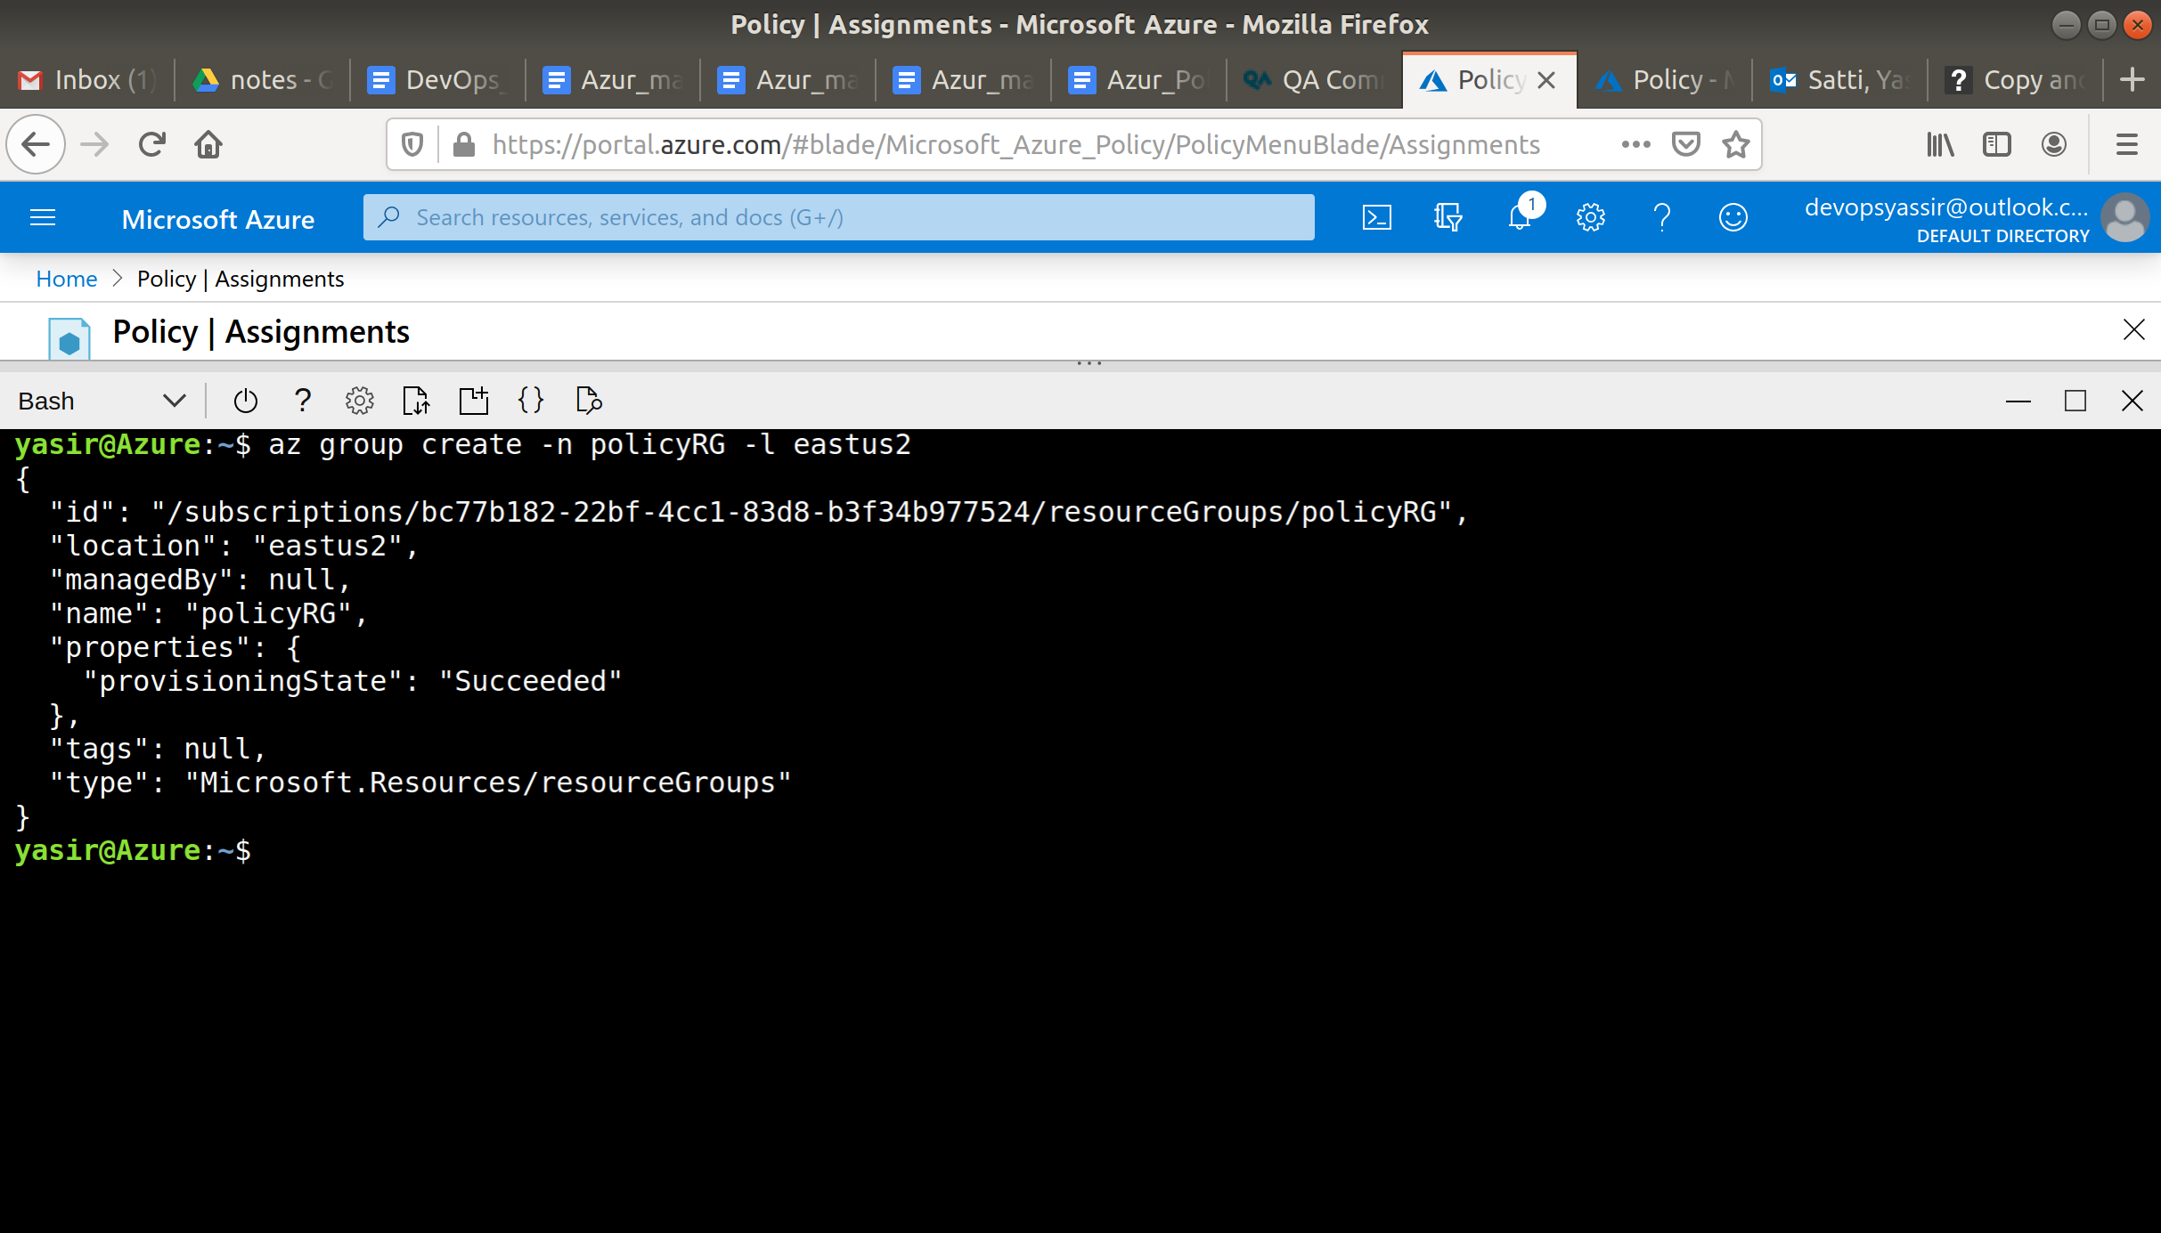

### **Assigning a Policy**

From the new resource group you created, navigate to **Policies**.

In the compliance blade, click Assign Policy at the top.

Under the heading **Scope** click the ellipsis.



This should open a new blade, in which we will select the resource group we just created.

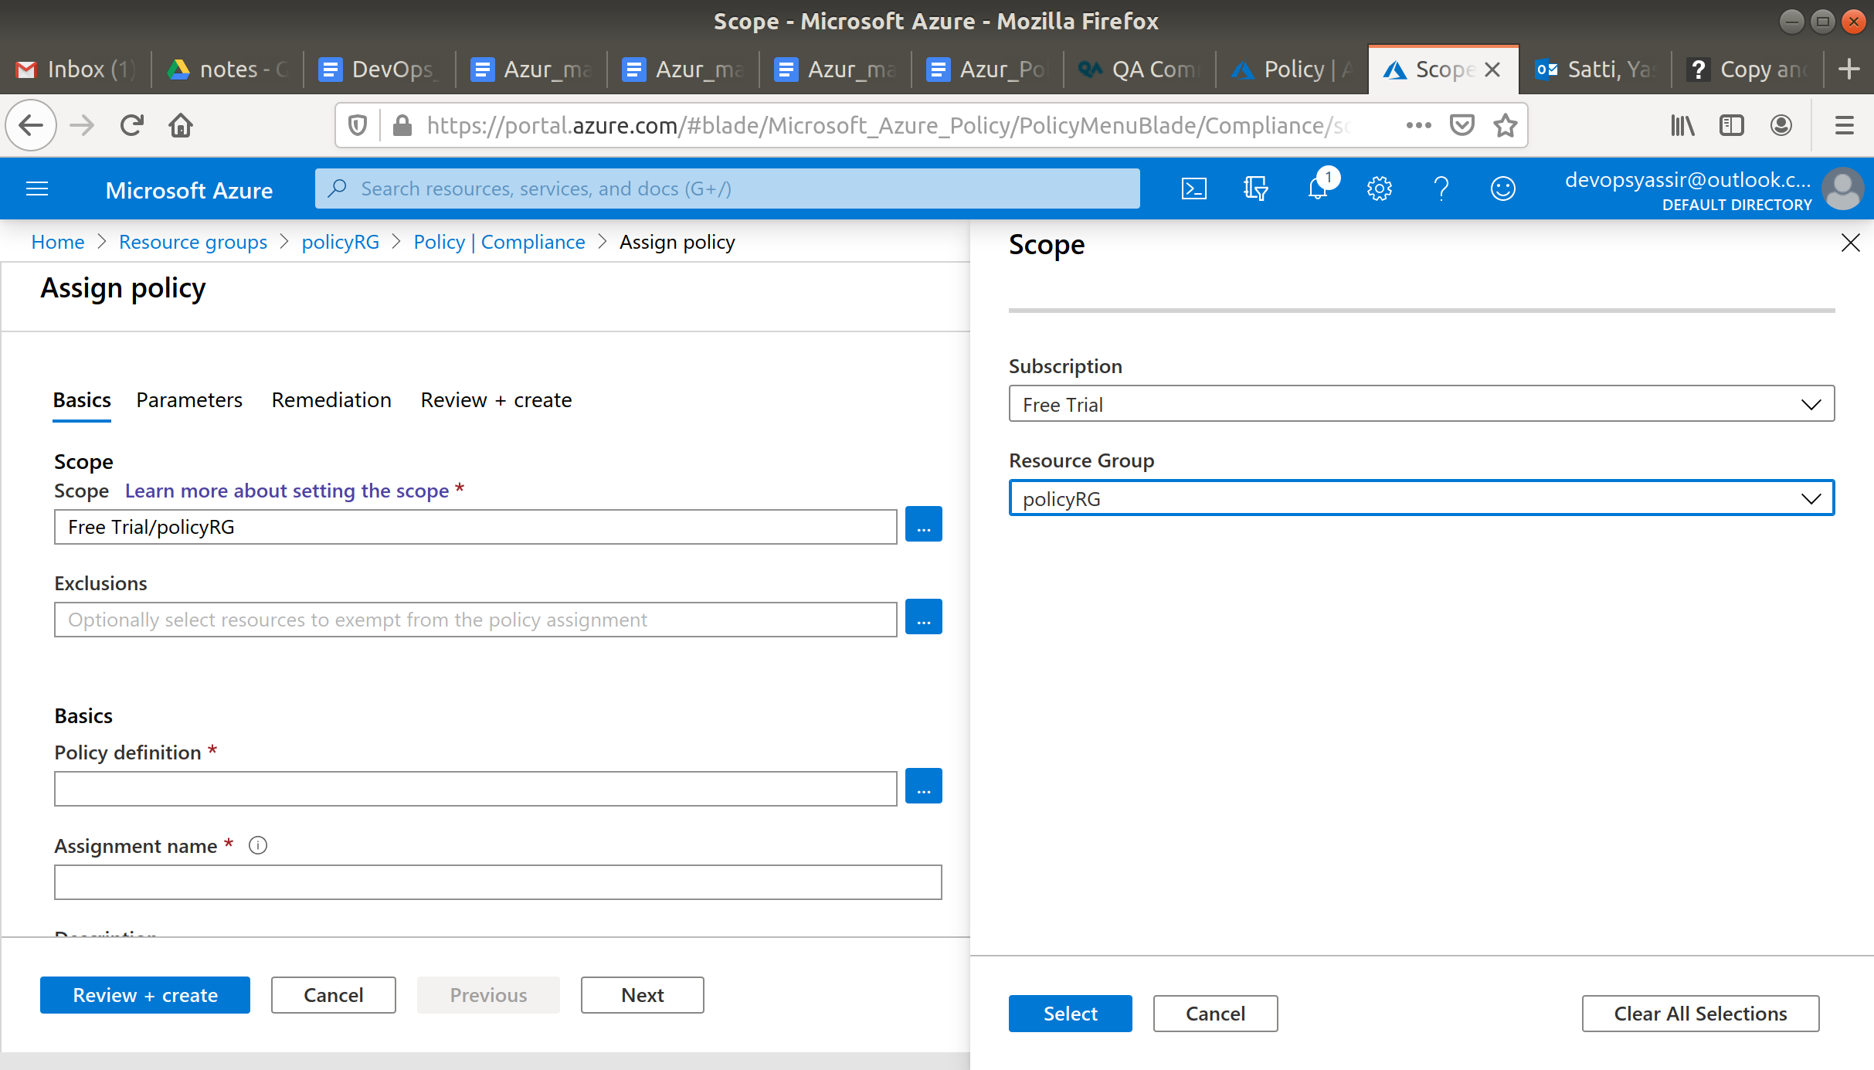

Under **Policy definition** click the ellipsis.

We will then search for SKU and select Allowed virtual machine SKUs.

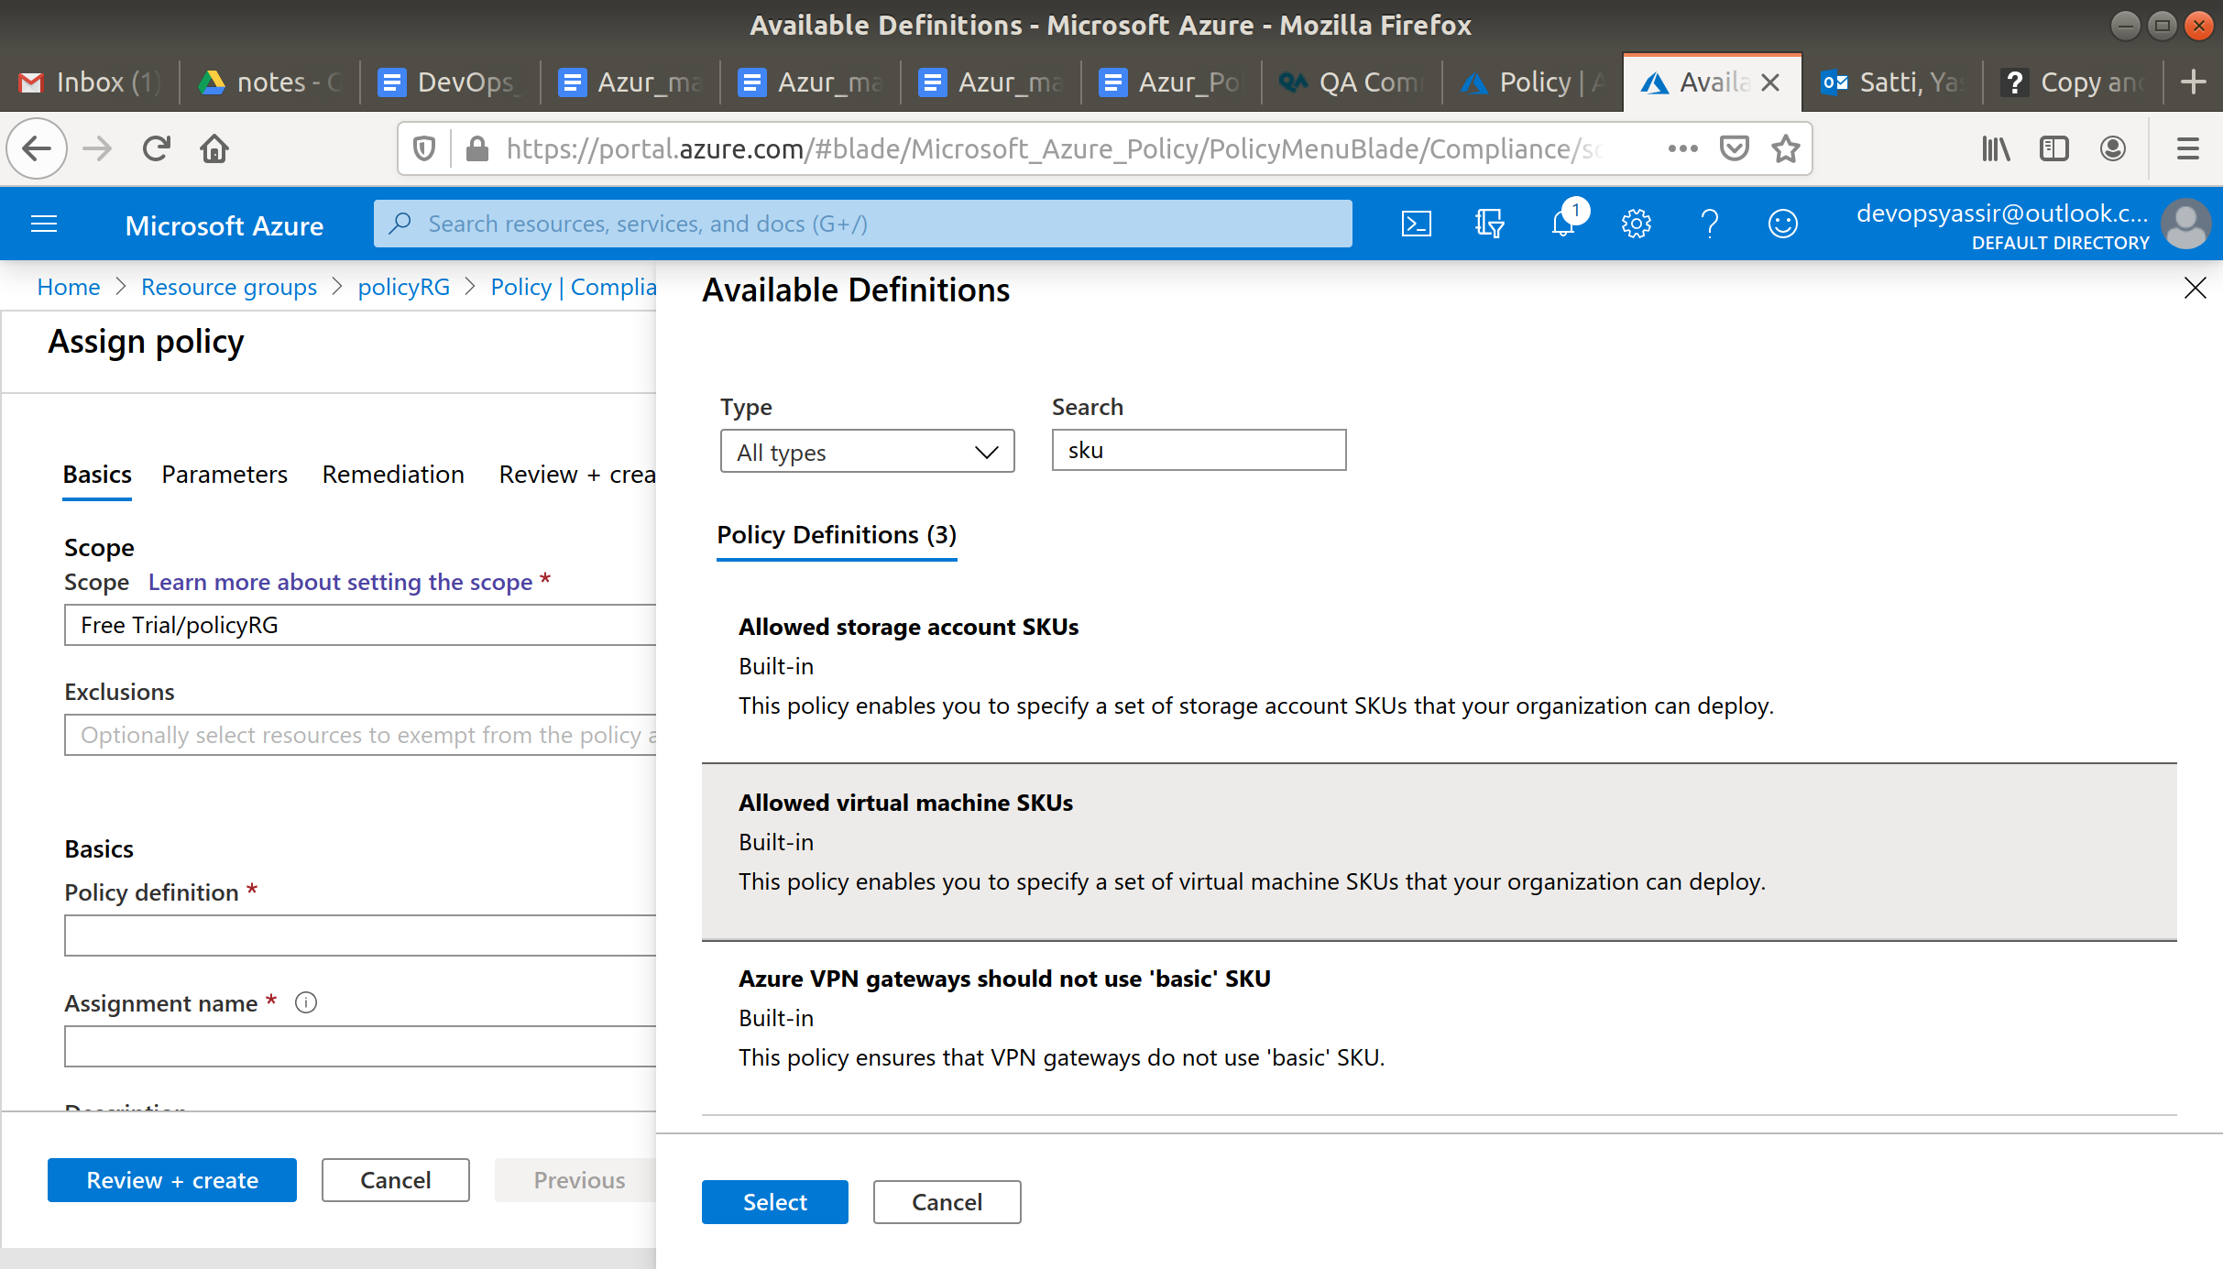

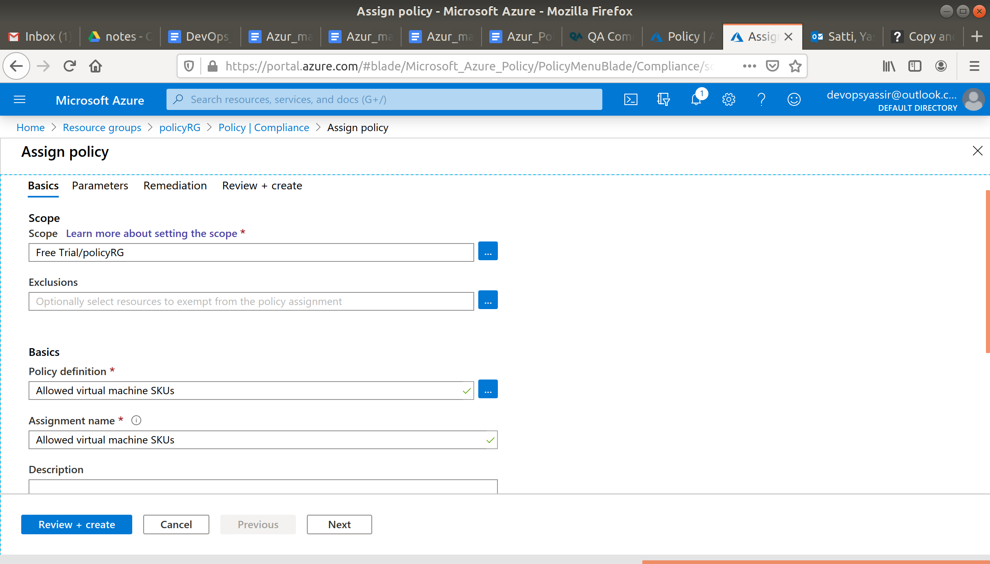

Navigate to parameters and choose Standard_D2s_v3.

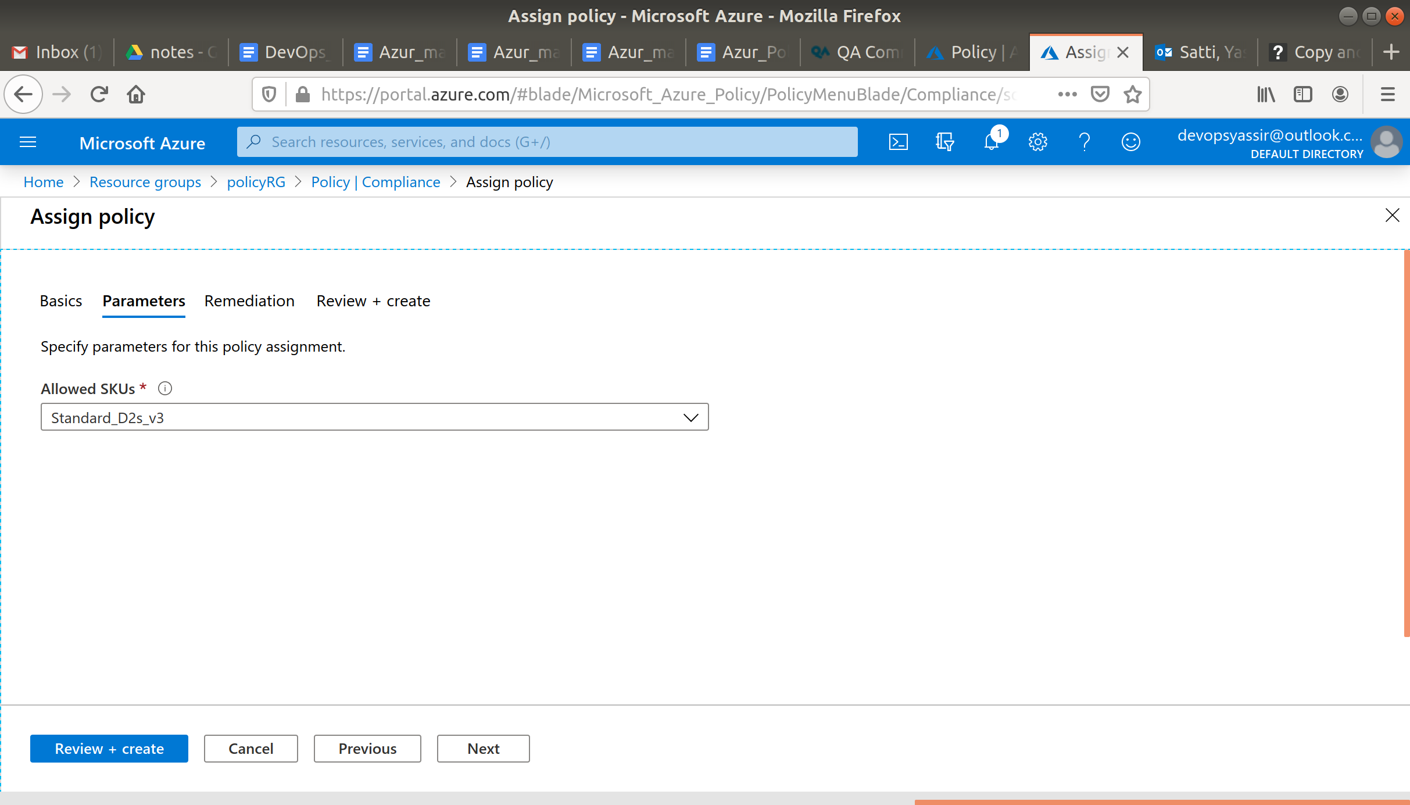

Click Review + create and click Create.

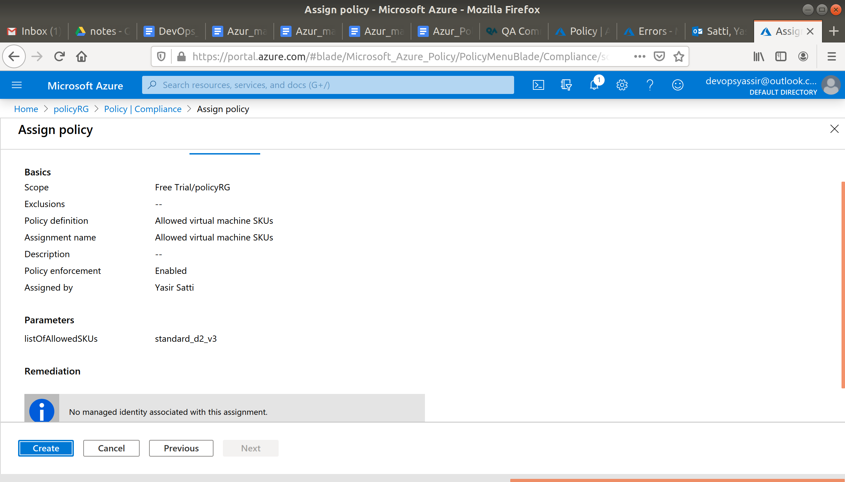

### **Create a New VM**

Return to the blade for the new resource group you created earlier, and click the + Add.

Choose Ubuntu Server 18.04 LTS.

The configuration can be whatever you want, except it **must** be in the **resource group** you created earlier and the size **must not** be **Standard_D2s_v3**!

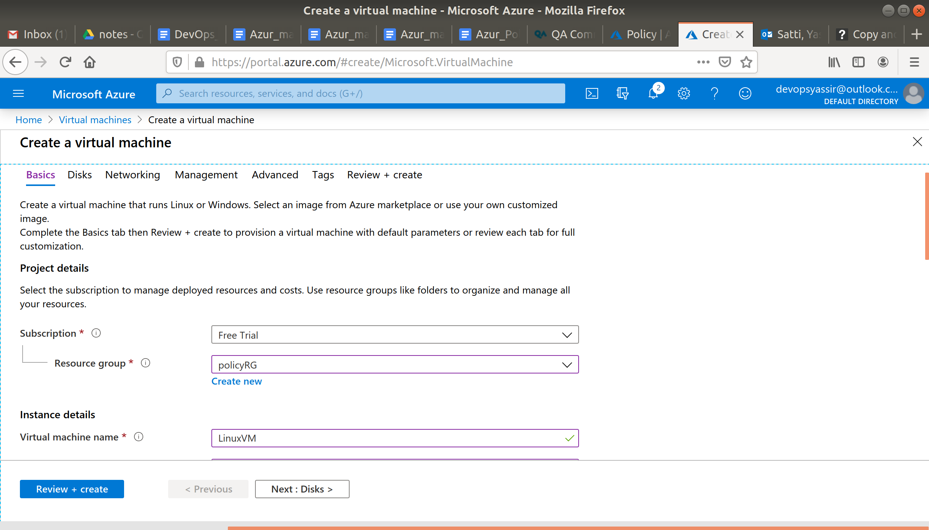

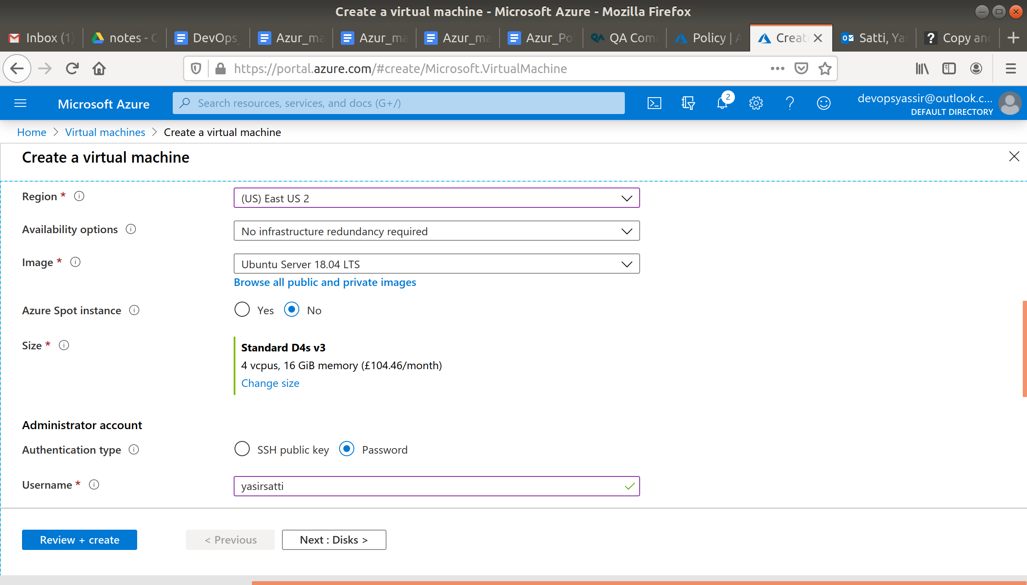

If this is the first VM you have created after assigning the policy, you will have to click Review + create and then create.

Azure will attempt to create the VM but will find that it can't due to a policy.

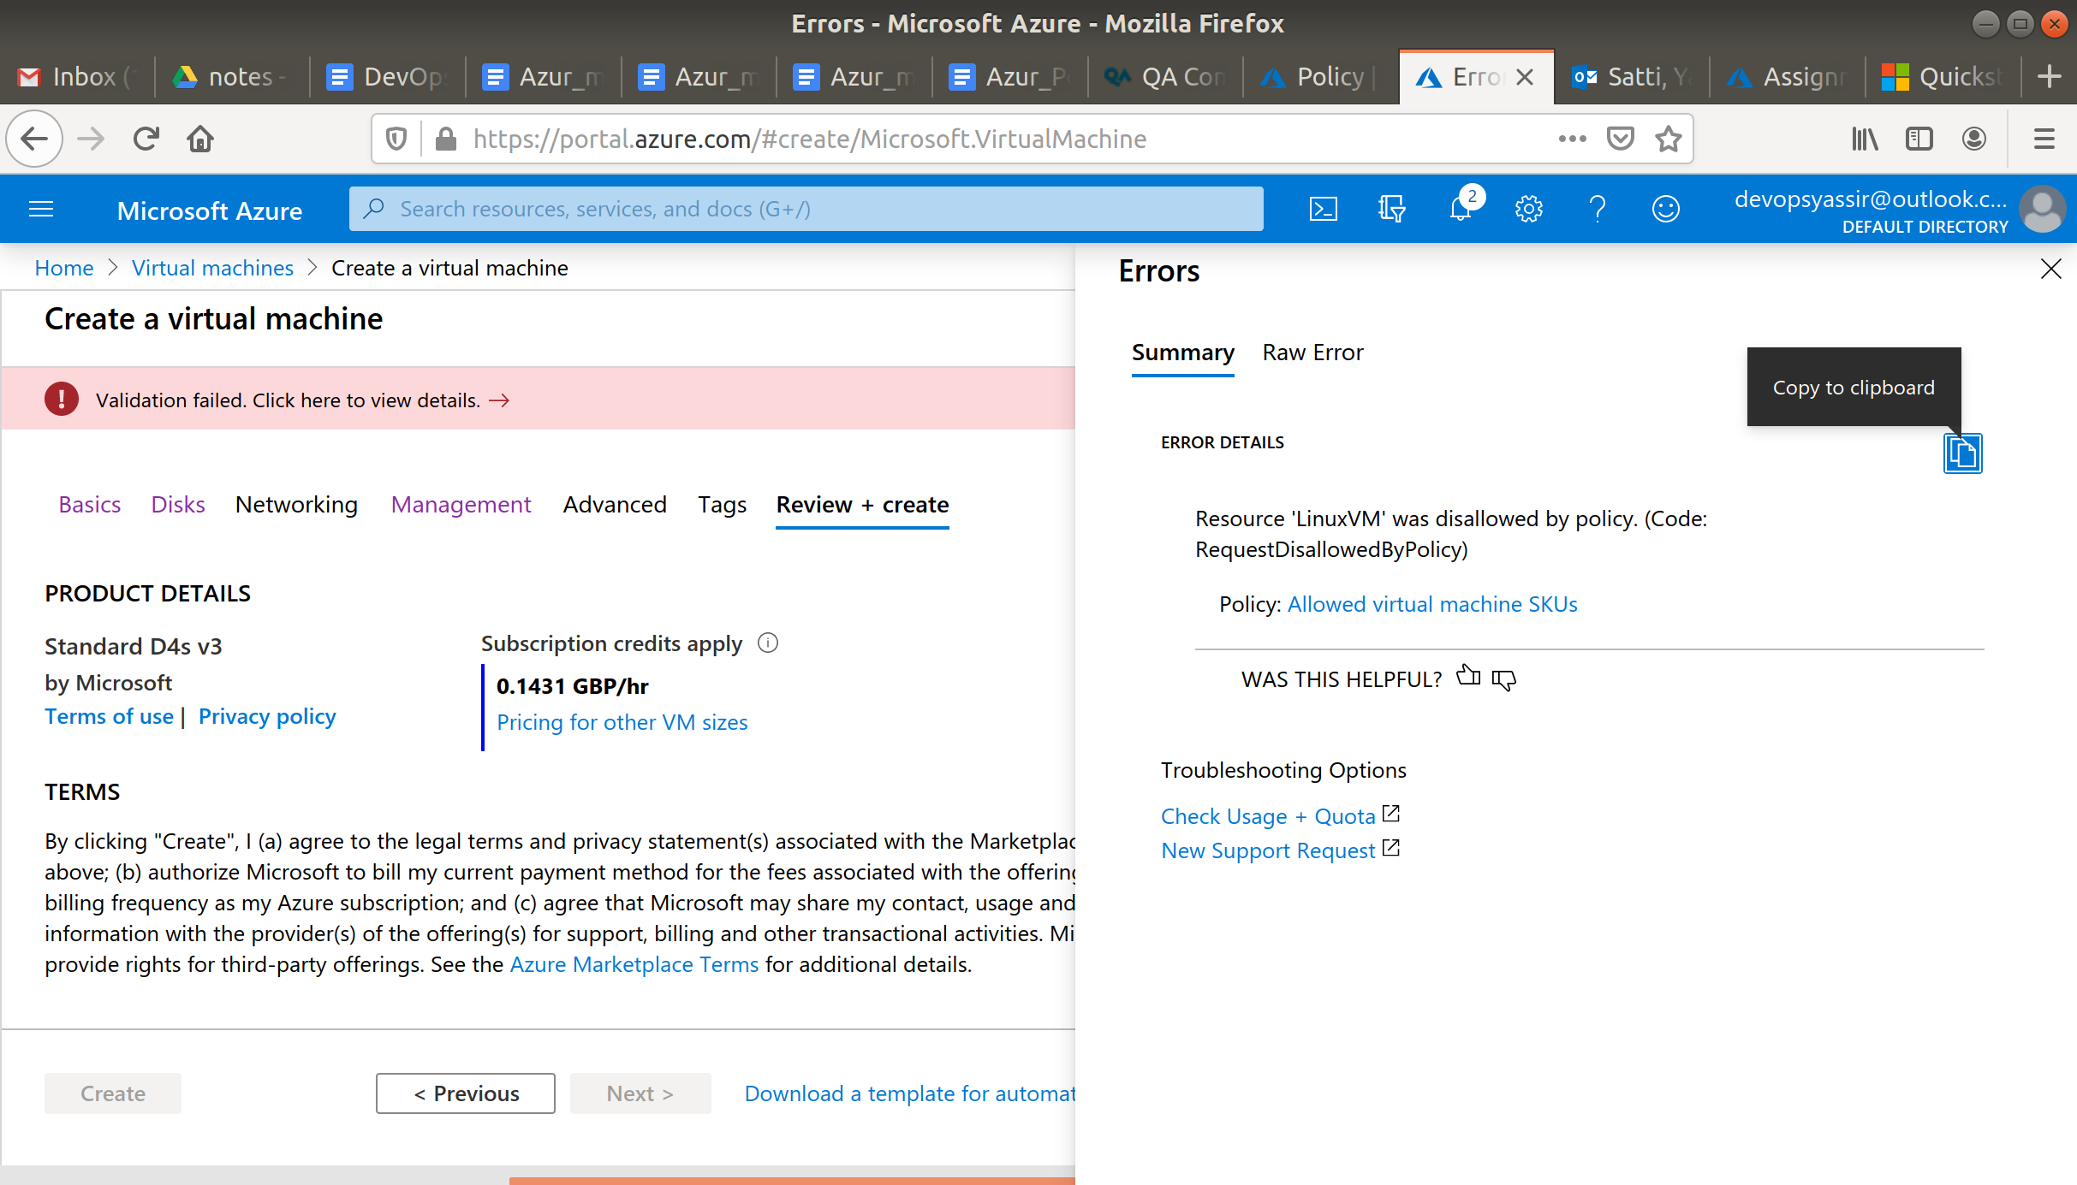

So we can see that the policy we created worked.

### **Clean Up**

To clean up, go back to the Resource Group page, click your resource group you used for this module, and then choose Delete.