# Azure Locks

# 

## **Tutorial**

In this tutorial we are going to apply a lock to a VM and a lock to a resource group.

### **New Resource Group**

The first thing is to create a new resource group, which we can do by clicking the burger bar in the top left corner and choosing Resource groups:

Then, we can click +Add:

Here, we can name the resource group and pick a location to have it in:

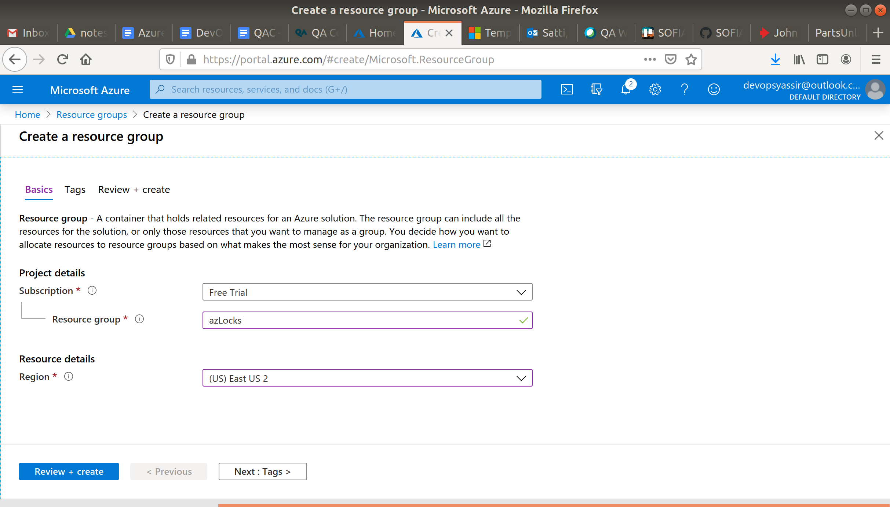

Lastly, we will click Review & Create and then Create to create the resource group:

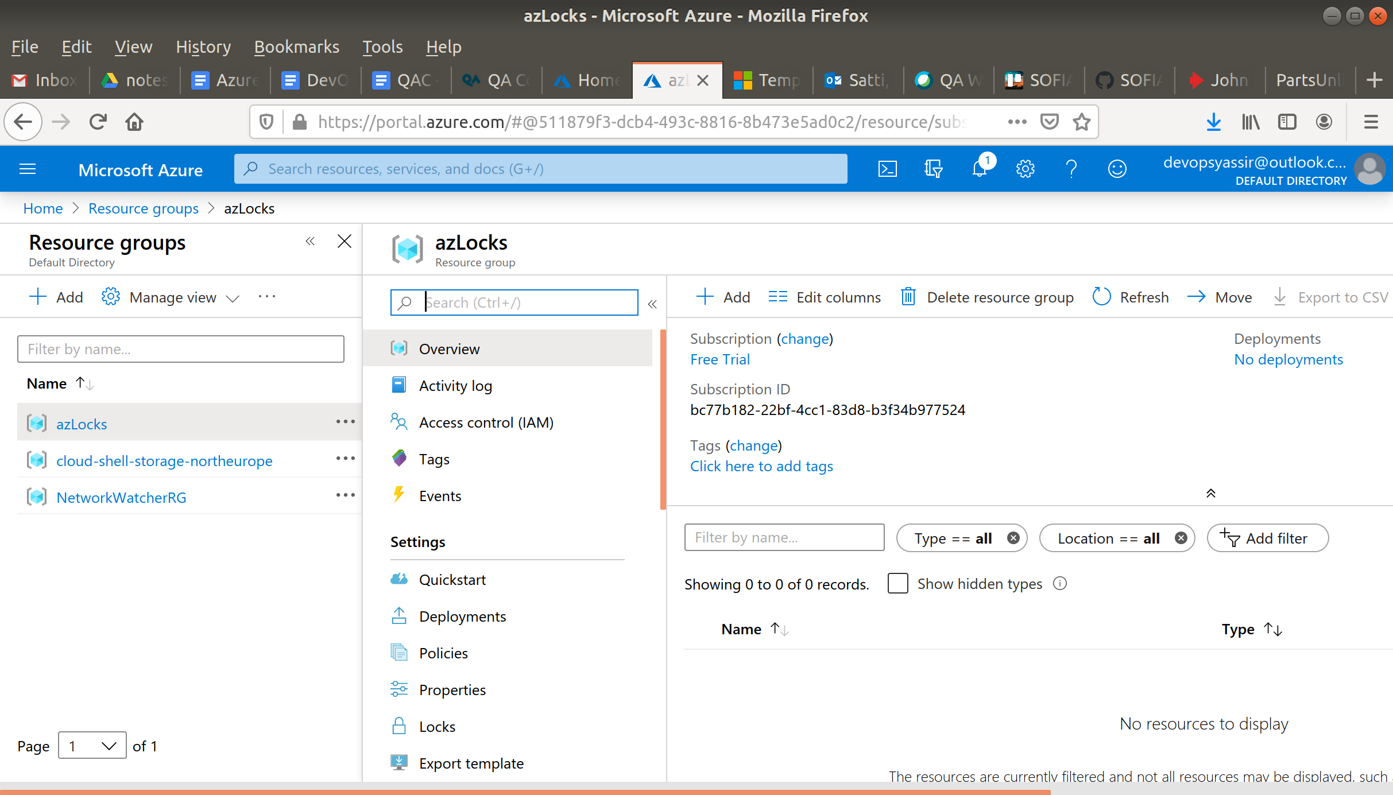

### **New Virtual Machine**

For this, we need to first go to the hamburger menu again, but this time click Virtual machines:

Then, we click + Add:

We will need to choose our new resource group from the drop down menu, give the machine a name and pick a region for it to be deployed into.

The image can be Ubuntu Server 18.04 LTS, and the Size can be Standard D2s v3:

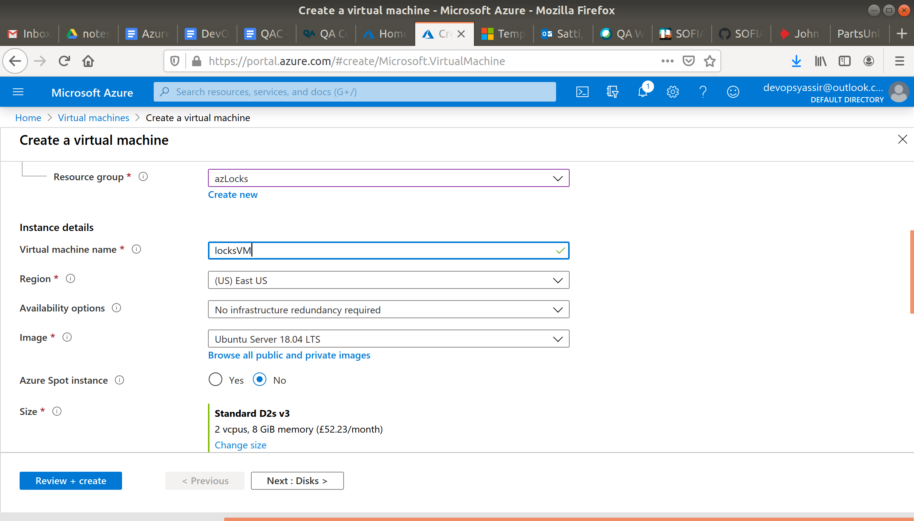

We need to choose password for authentication type, and create a username and password.

We also need to ensure that Port 22 is open, so we can SSH into the machine later (this should be checked by default):

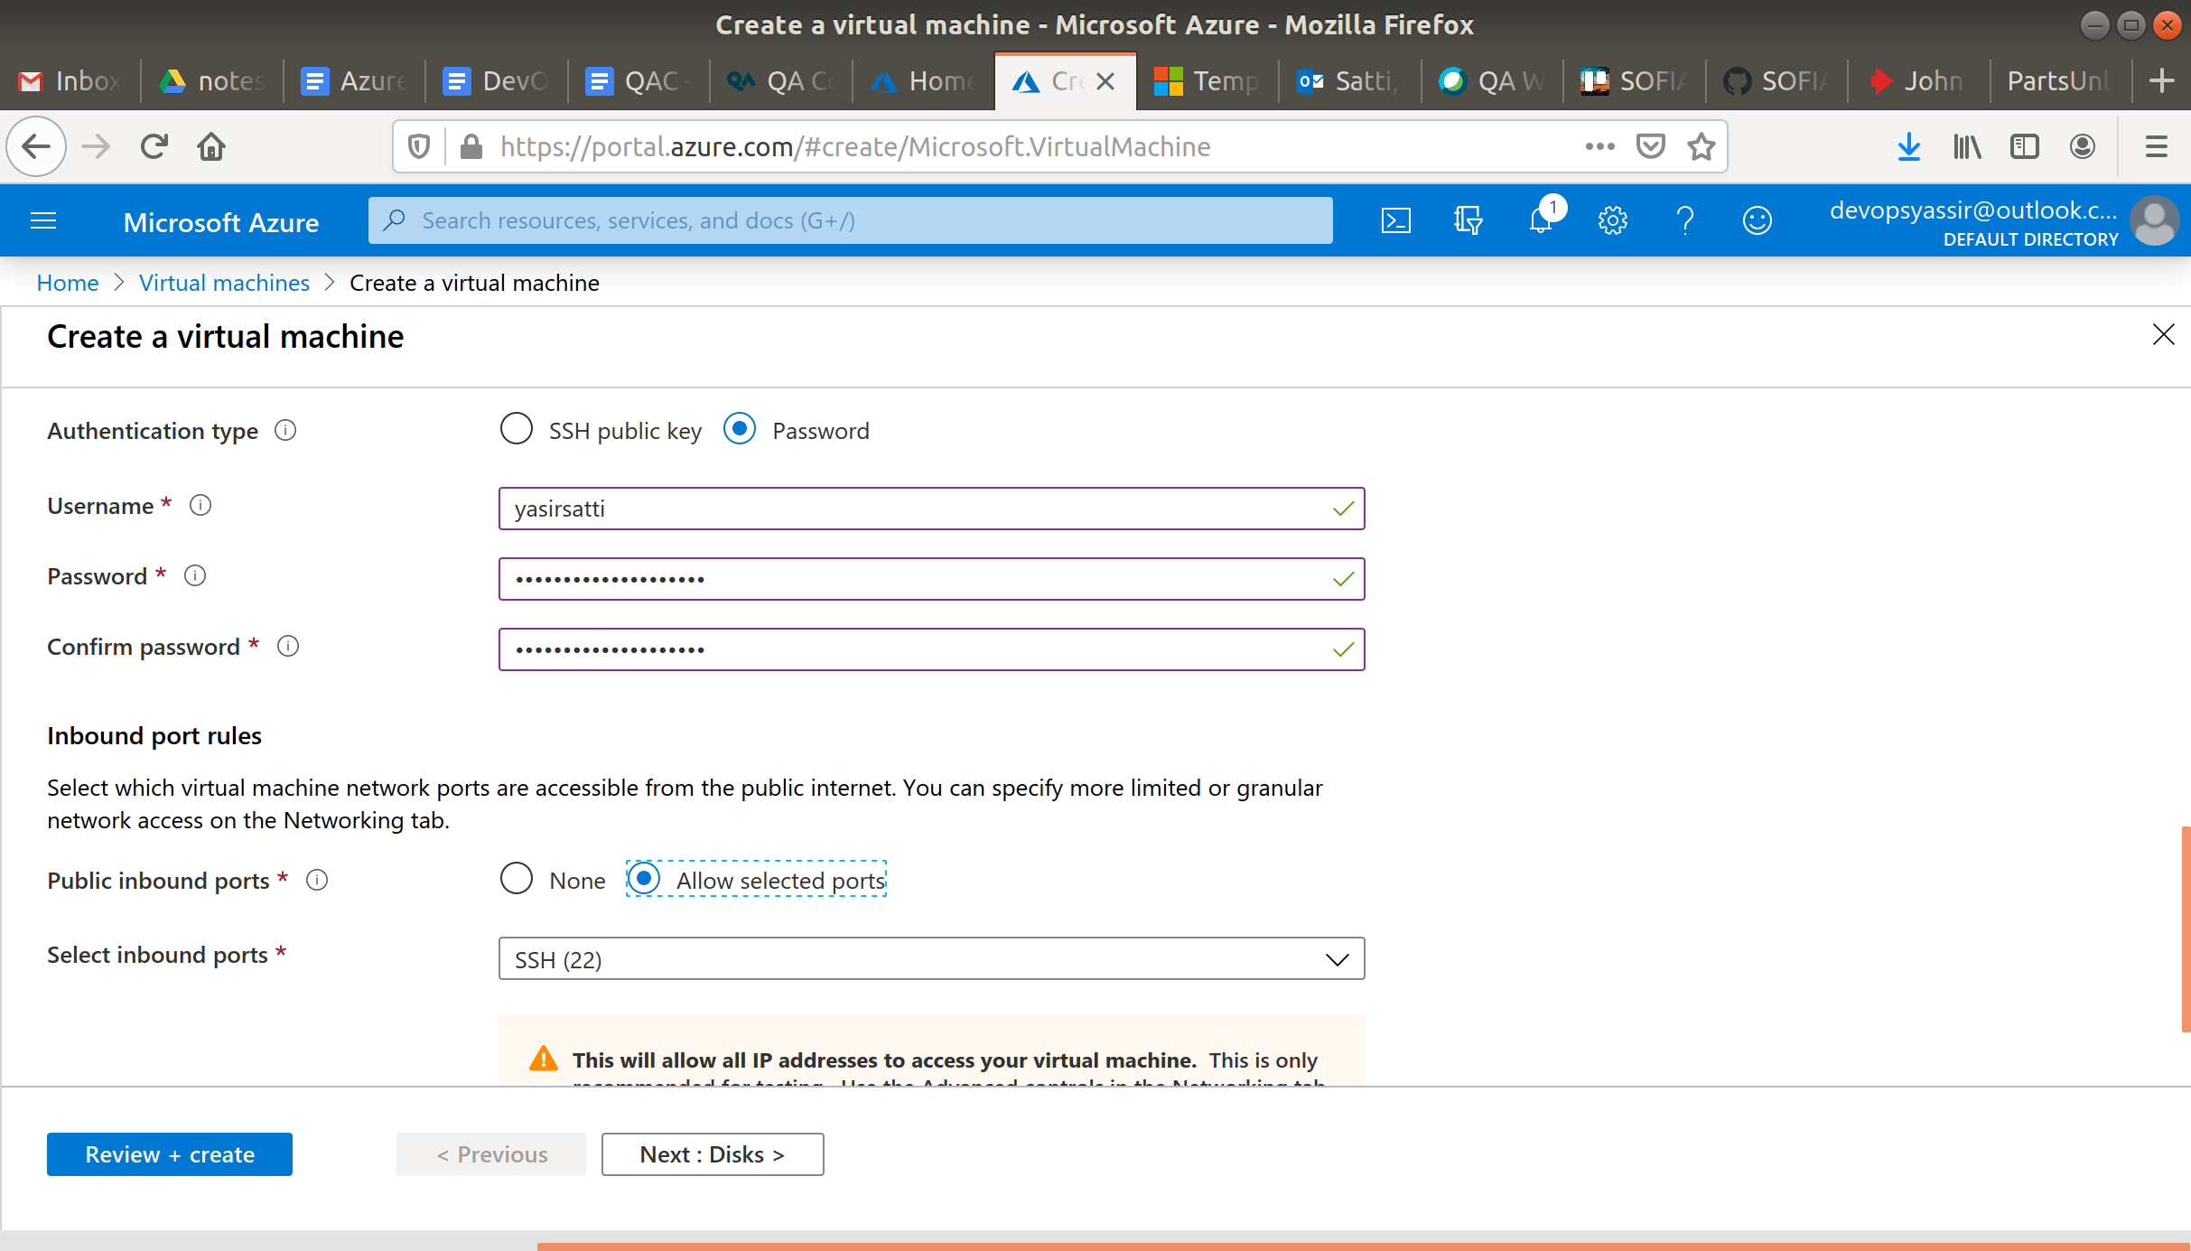

After clicking Create, our Linux VM is created!

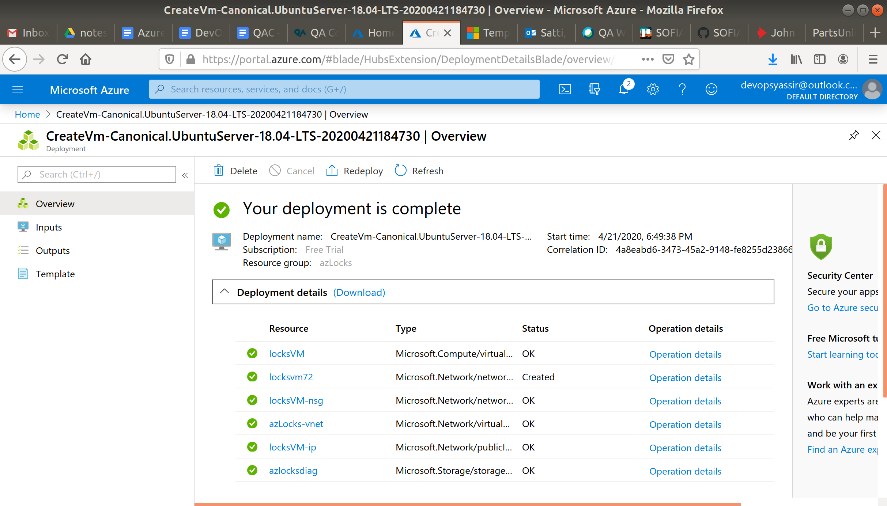

### **New Locks**

Go to your VM and select Locks in the left blade.

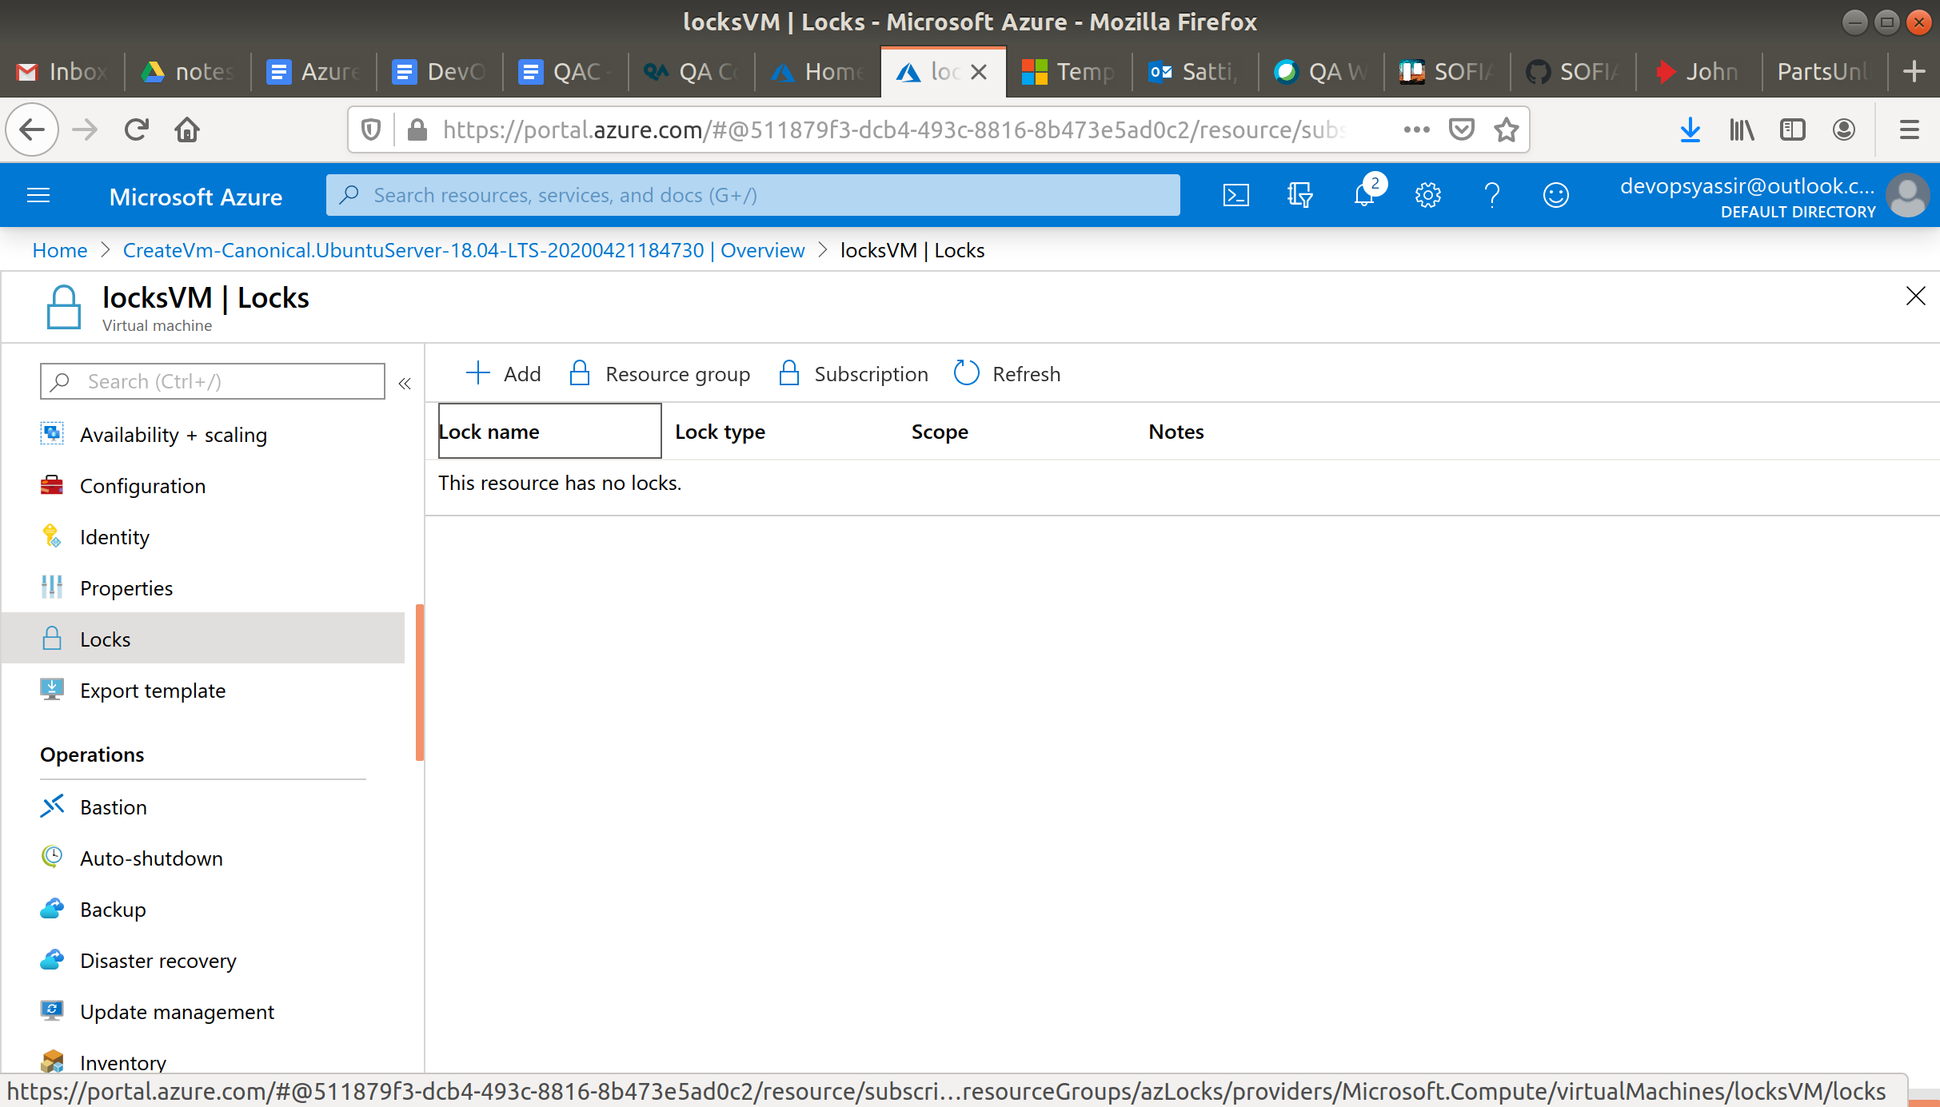

Click +Add and enter the following:

* Lock name - Lock1
* Lock type - Delete

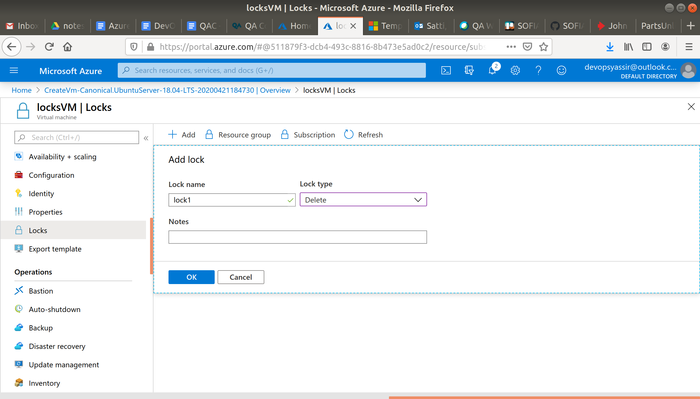

Click OK, you should see your new lock.

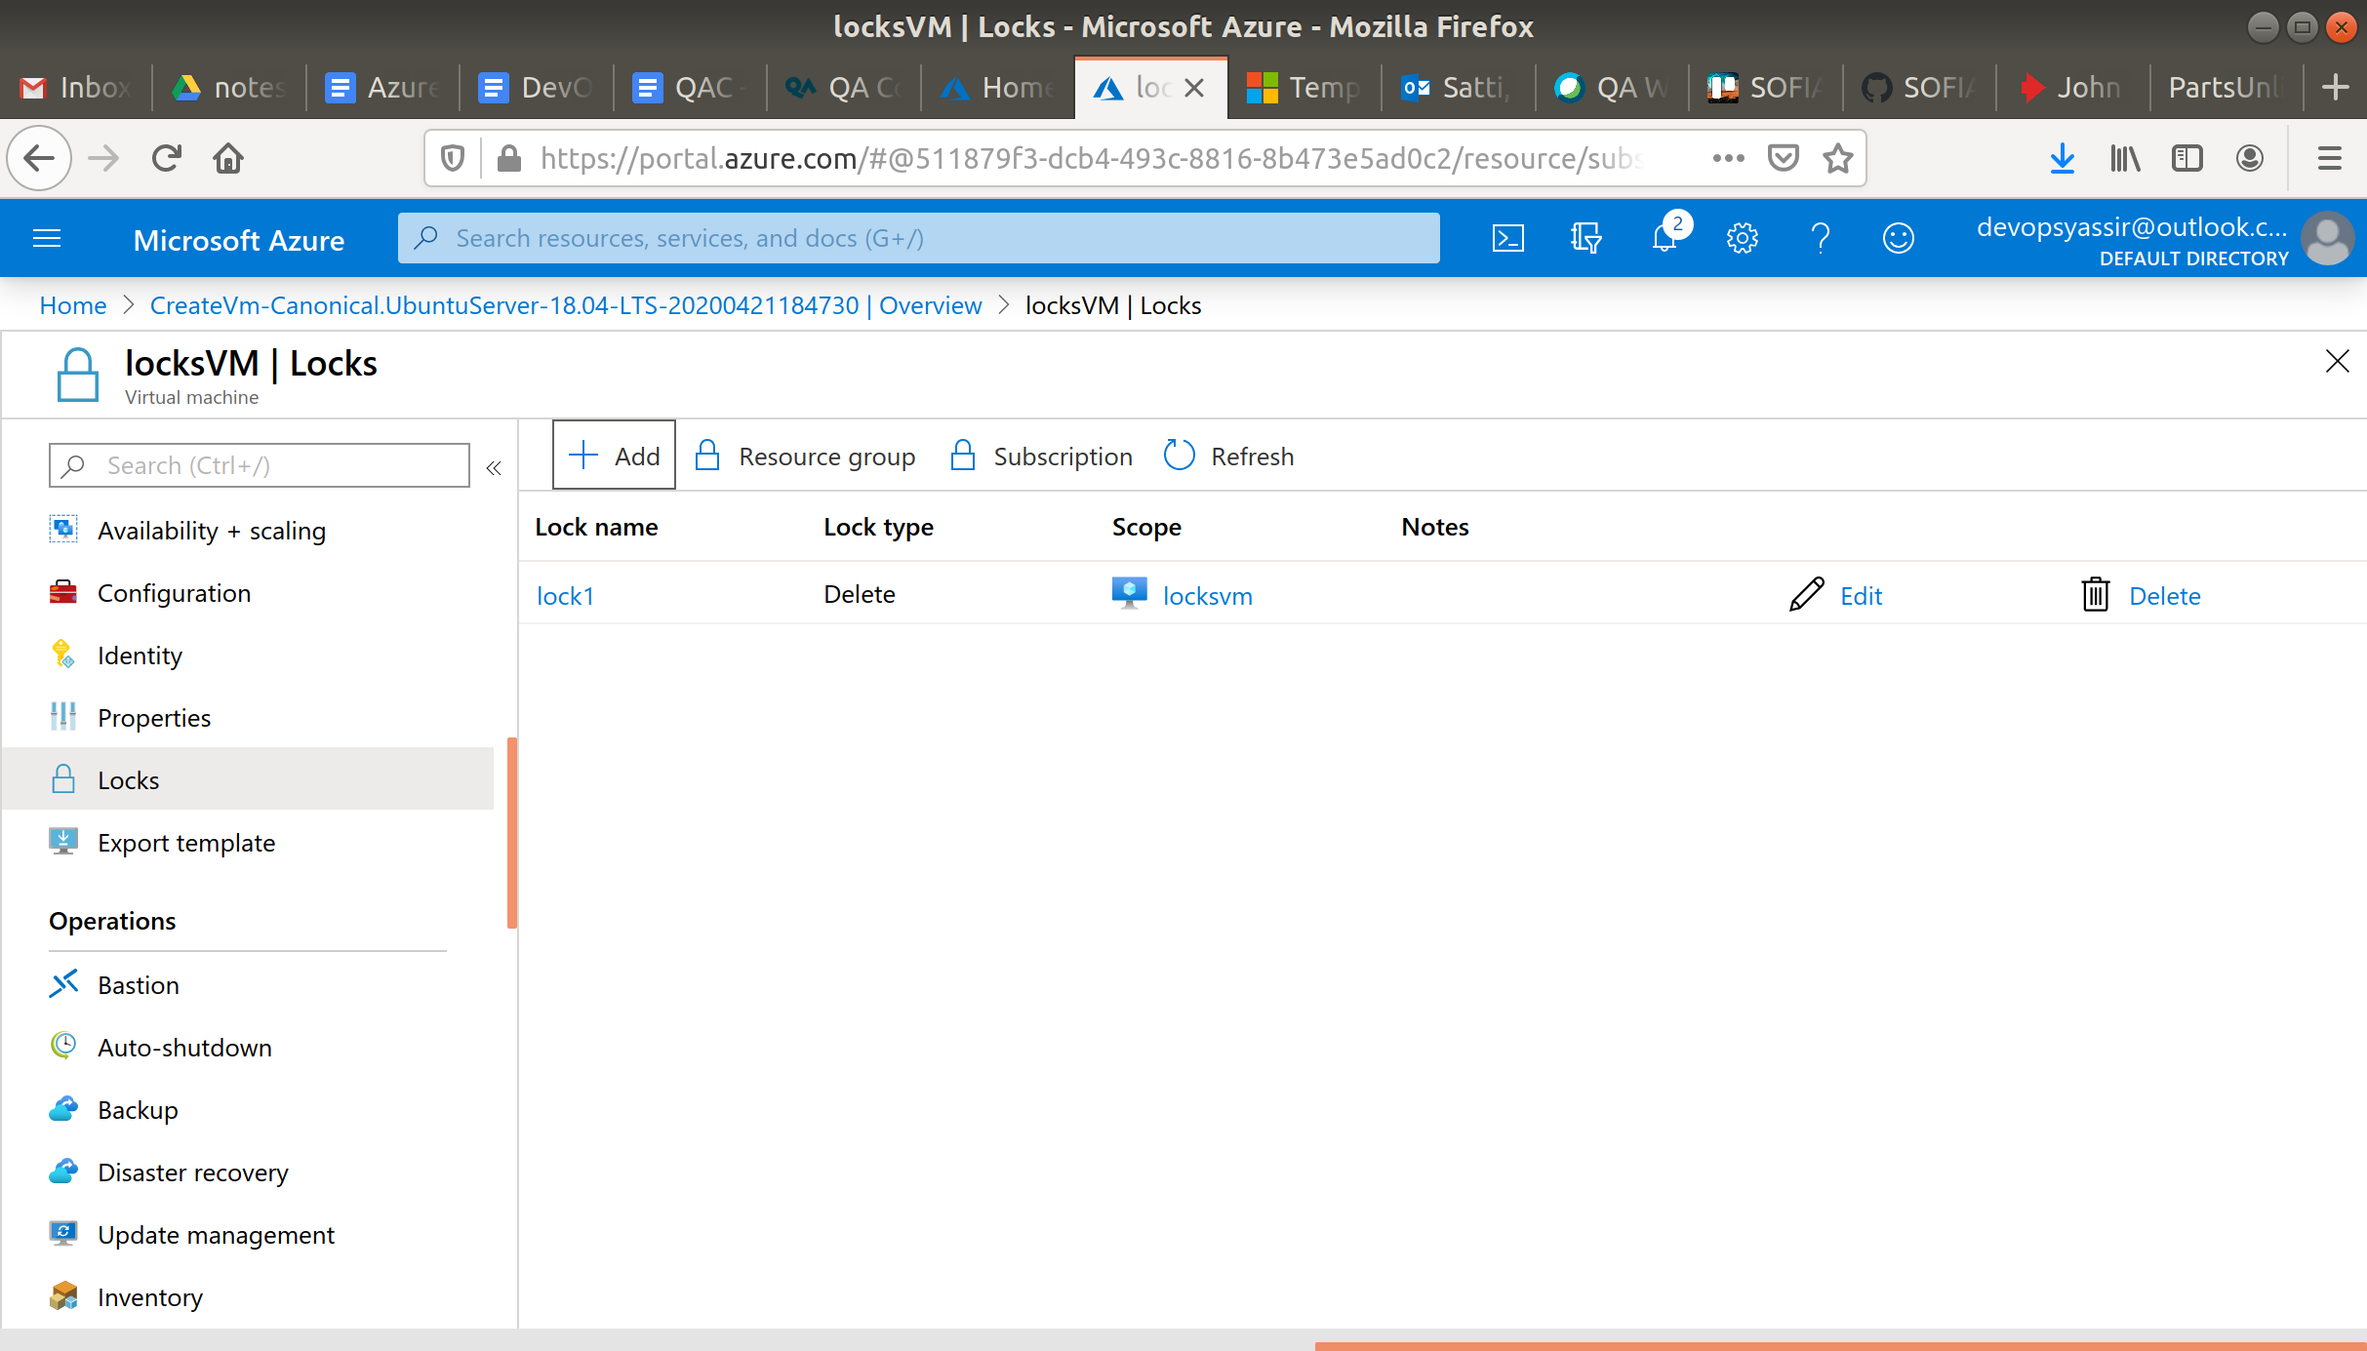

Now click Resource Group

locks-rg

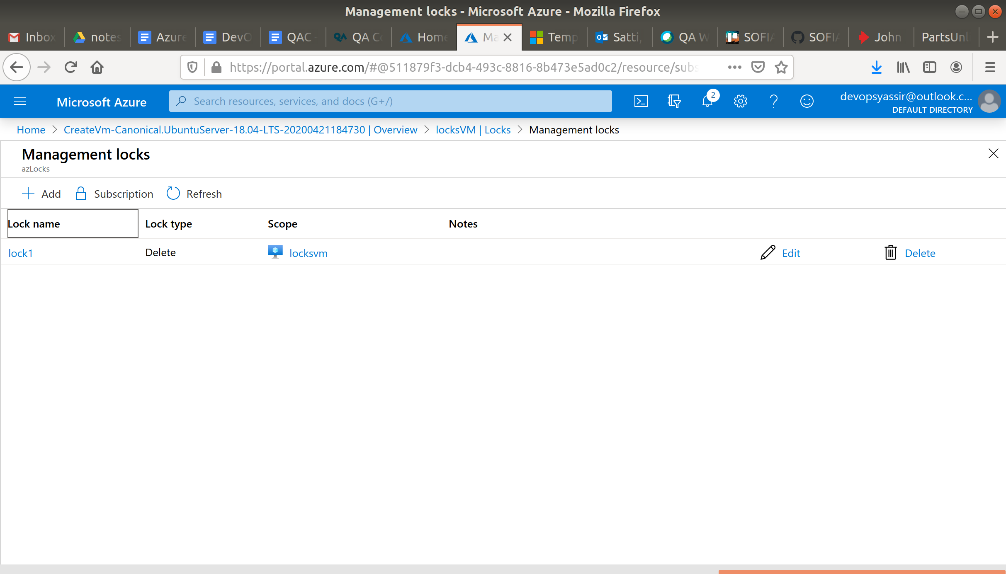

Select +Add again and create another lock but this time make the lock type Read Only.

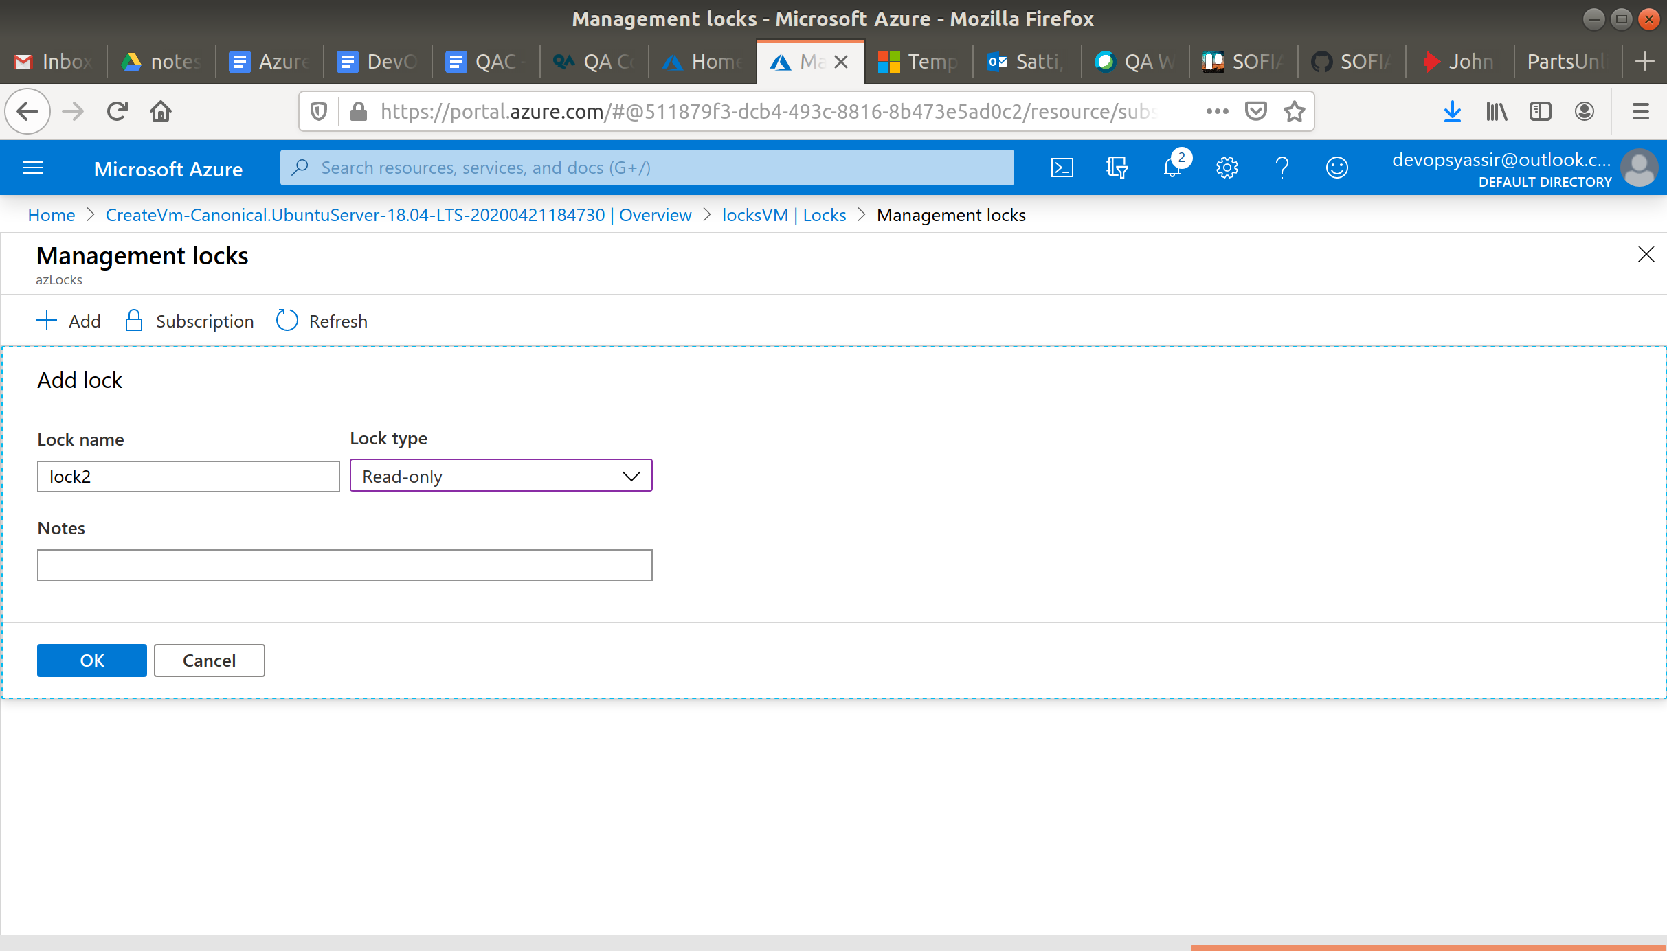

Now go to your VM and try to delete it and create a vm and try and add it to your resource group.

You shouldn't be able to do either, because of your locks.

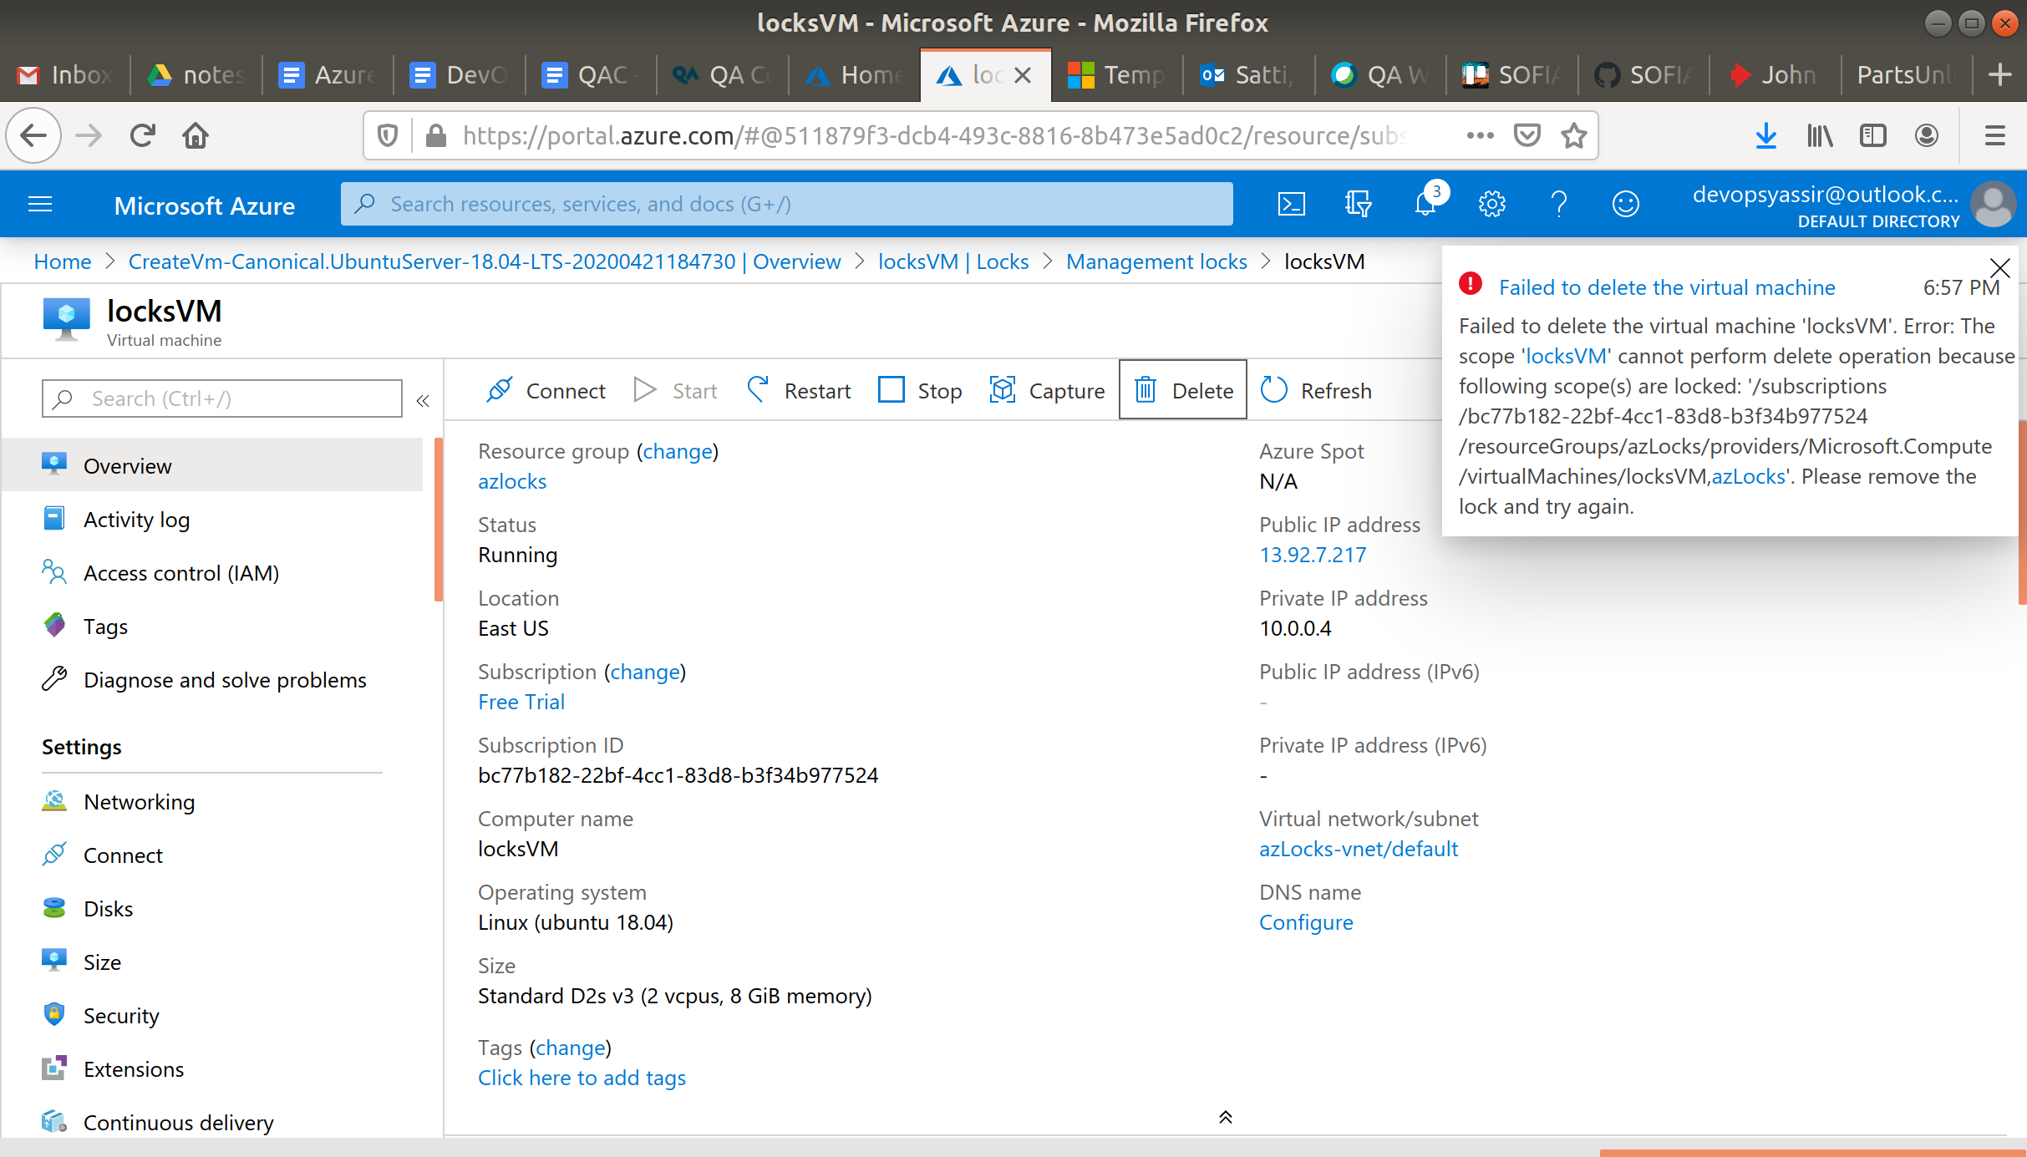

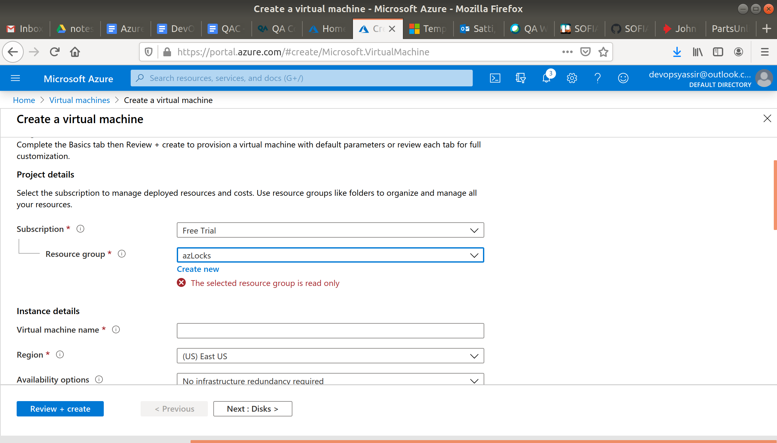

### **Clean Up**

To clean up, go back to the Resource Group page and delete your locks then, click your resource group you used for this module, and then choose Delete.

Once you type the name of the resource group to confirm deletion, this will be deleted along with everything inside of it.

