# Azure Managing Resource Groups

# 

## **Tutorial**

In this tutorial, we will work with a resource group and some of the management capabilities on offer in Azure.

1. Create a resource group:

**az group create -n manageRG -l uksouth**

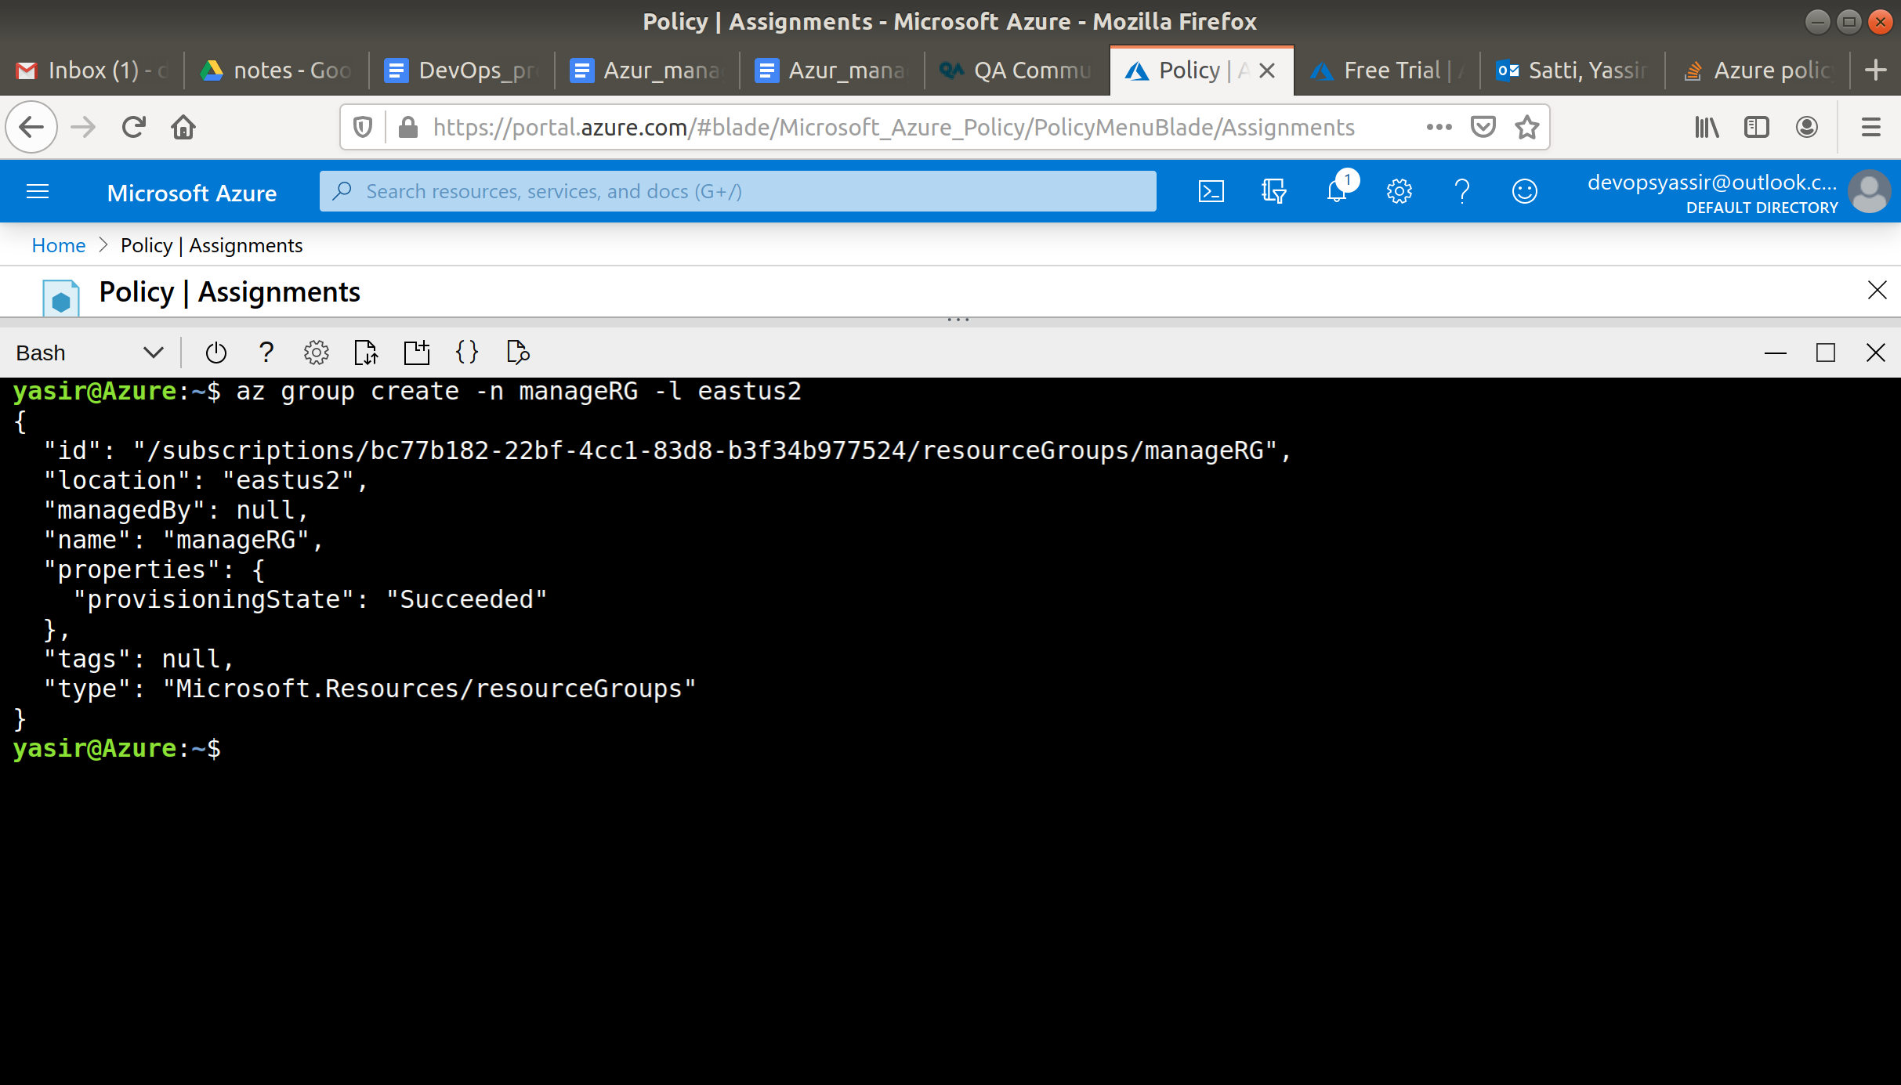

1. Add a tag to the resource group:

**az group update -n manageRG --tags 'Environment=Production'**

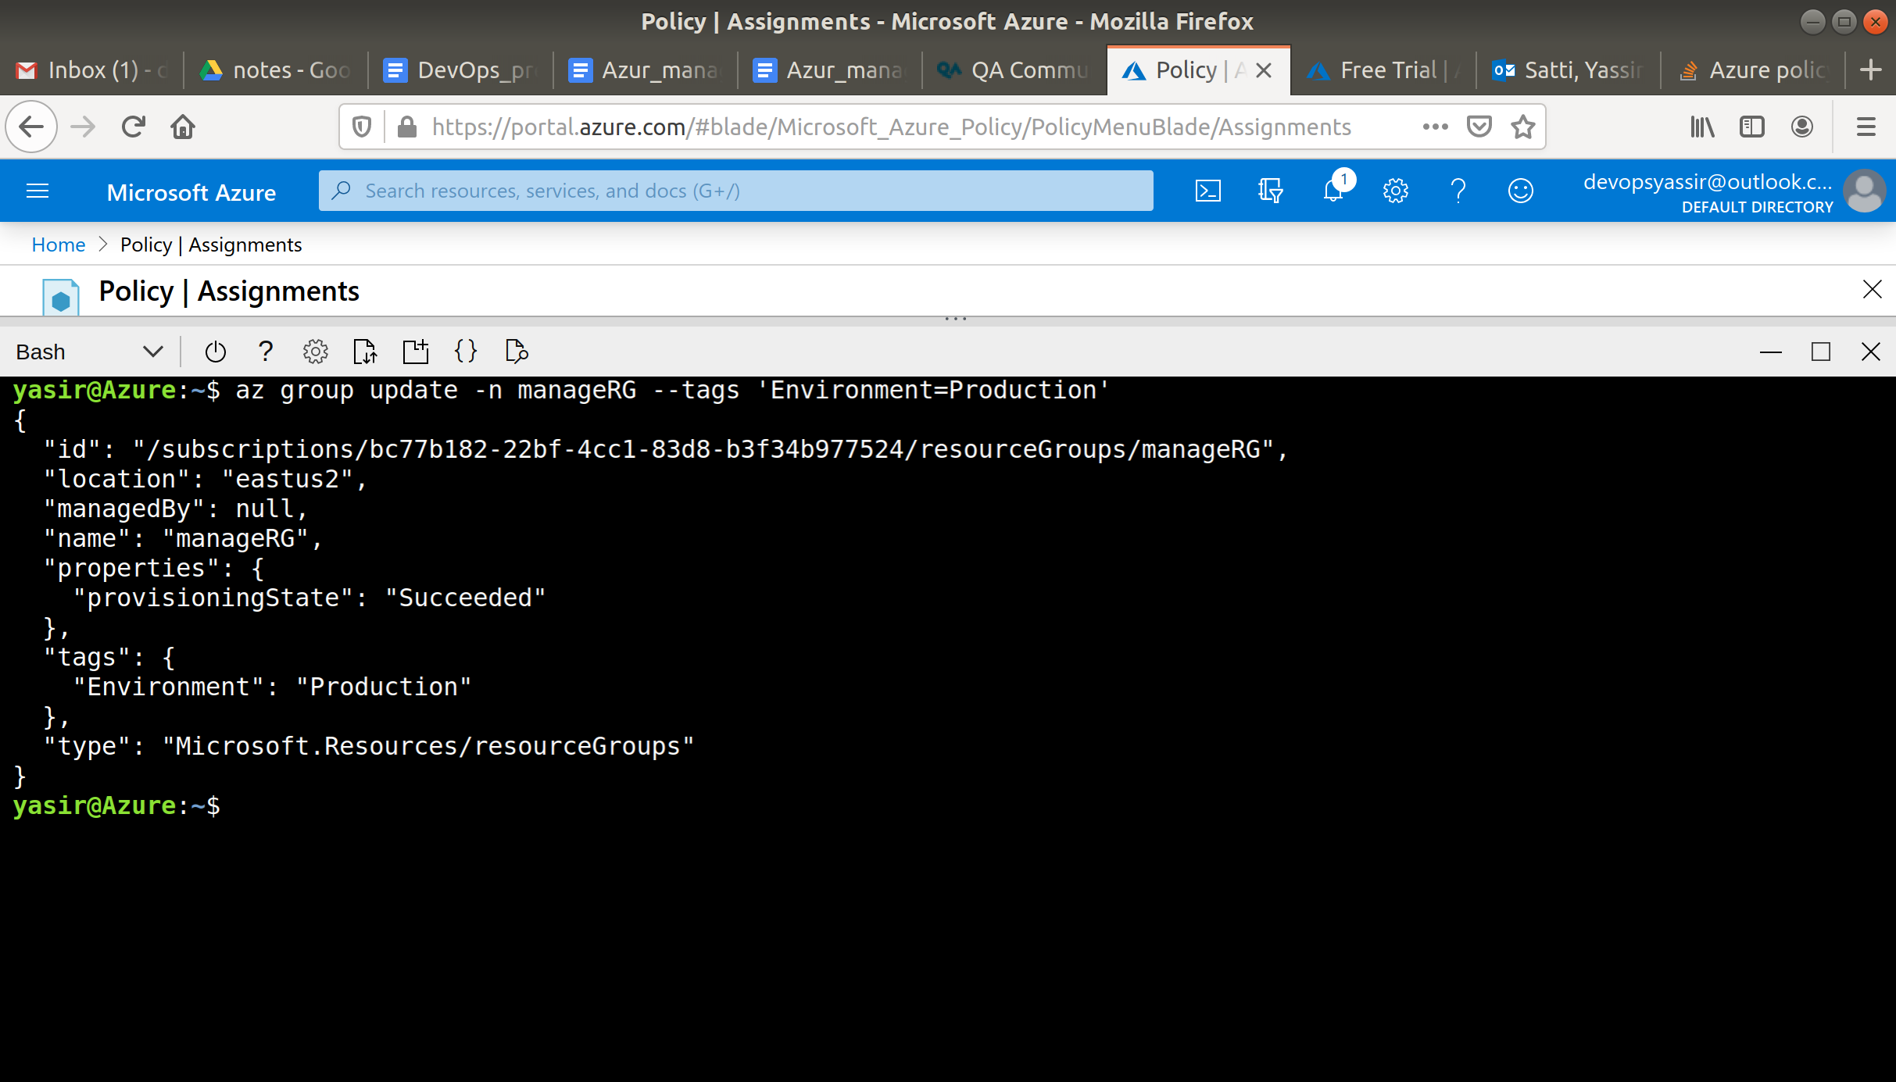

1. We can check the tag has been applied using:

**az group show -n manageRG --query tags**

or

**az group list --tag Environment=Production**

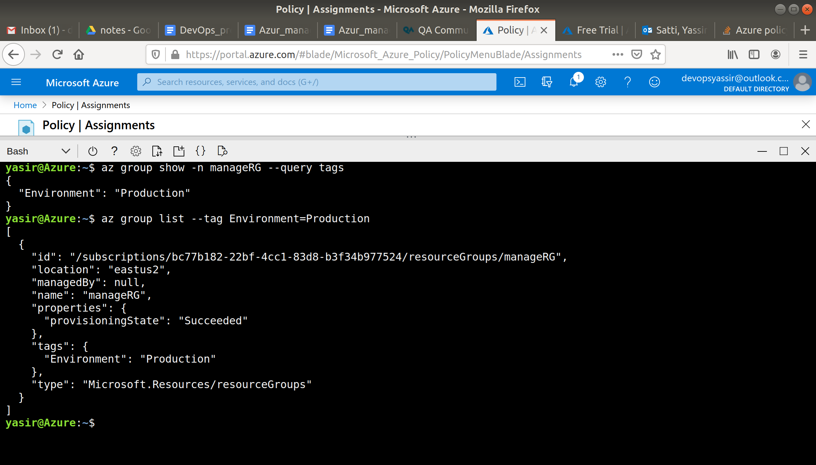

1. **Add a lock to prevent deletion of the resource group:  
     
    az lock create -n noDelete -g manageRG --lock-type CanNotDelete**

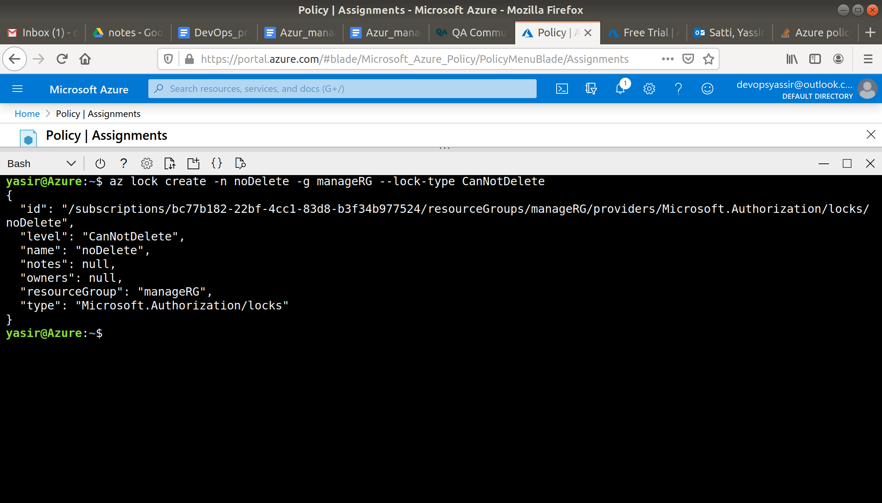

1. Let's see what happens if we try to delete the resource group:

**az group delete -n manageRG -y**

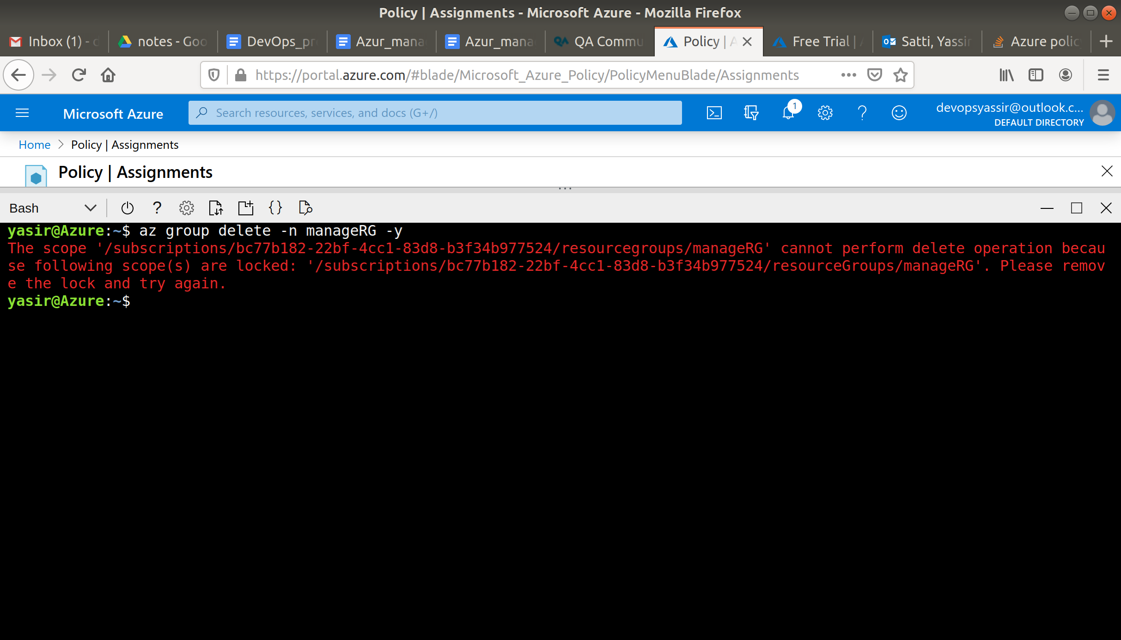

1. Now we can take the lock off and see that the group can be deleted:

**az lock delete -n noDelete -g manageRG**

**az group delete -n manageRG -y**

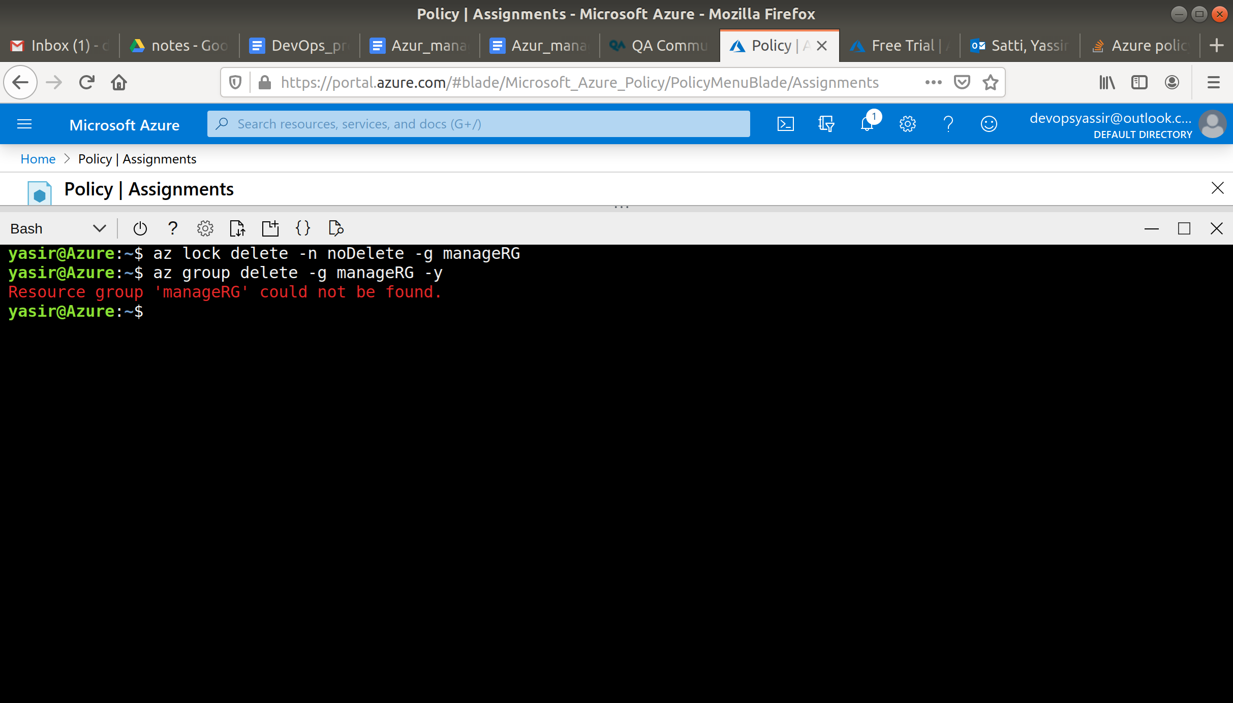

session timedout before taking a screenshot, so it was already deleted...