# Azure Active Directory

# 

## **Tutorial**

In this tutorial we will add a new user via Azure AD.

### **Creating a new user**

Navigate to Azure AD by clicking the burger bar in the top left corner and choosing Azure Active Directory, or by using the search bar at the top.

Then in the navigation blade, click Users.

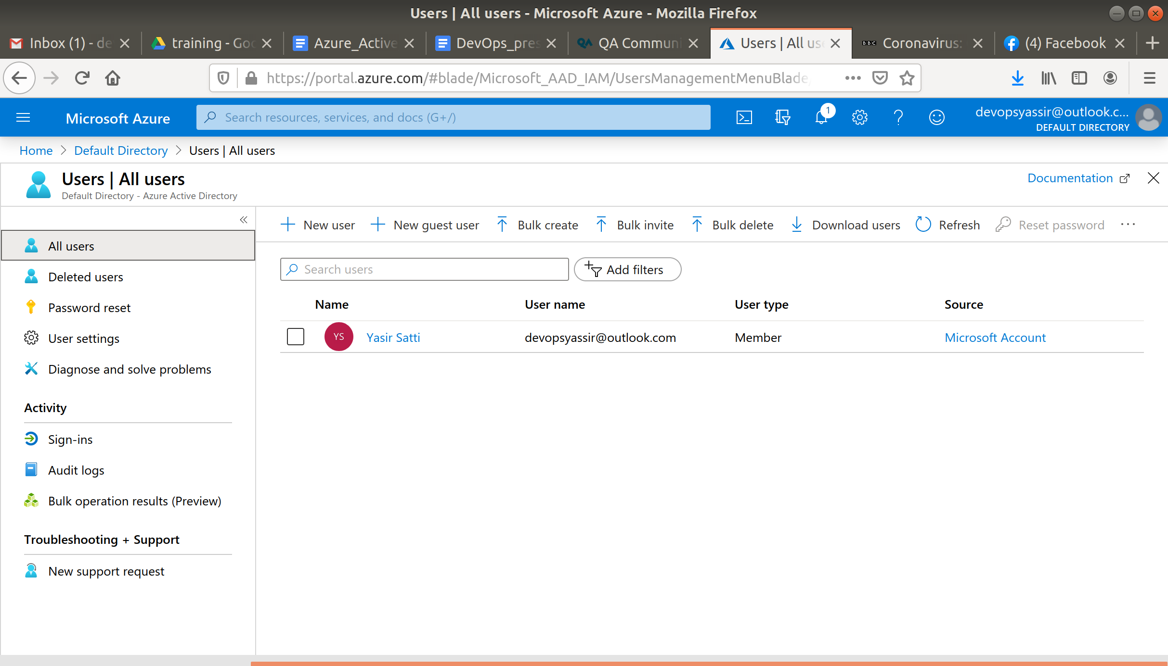

You should then see a list of the current users with access to your Azure account.

There will probably just be your own user.

Click the + New User button, to be taken to the user creation page.

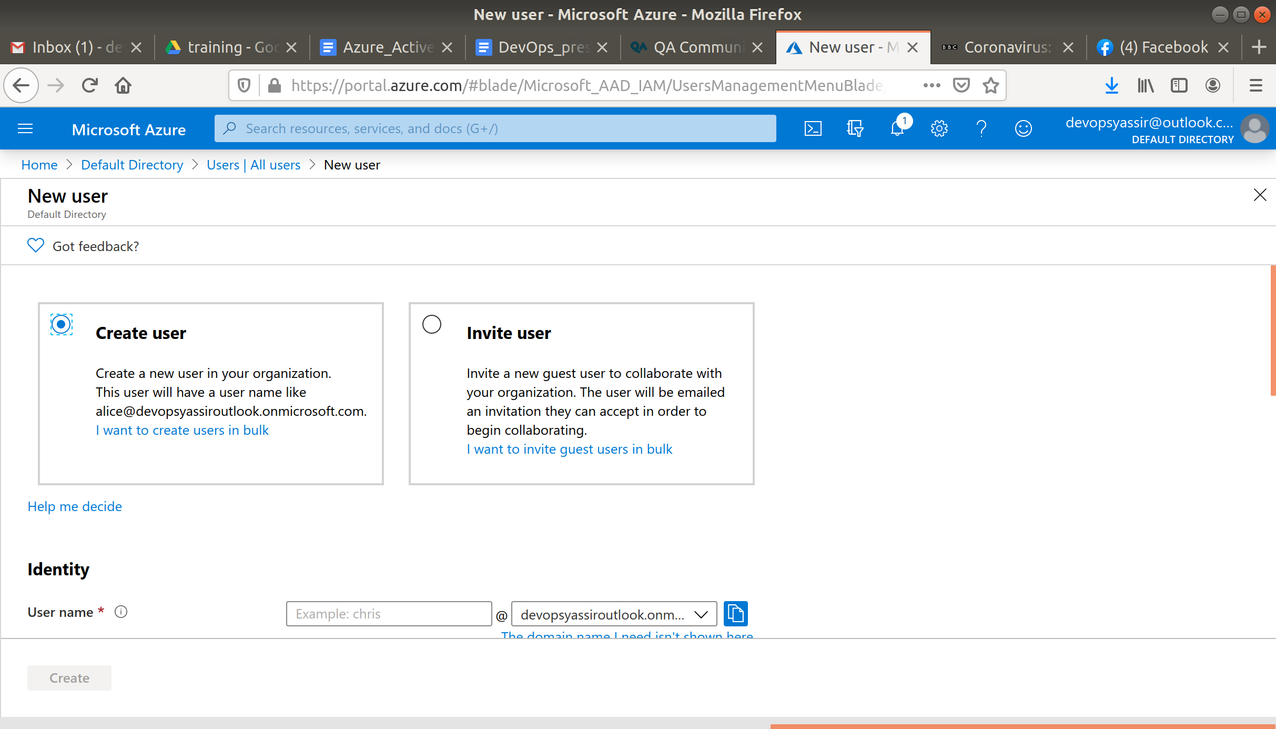

Here you will create a new user with access to your Azure account.

You need to set their *User name* and their *Name*.

Make a note of the user name, you will need this to sign in.

You can also set a *password*. Leave this as auto-generate, but make sure to show the password, and make a note of it.

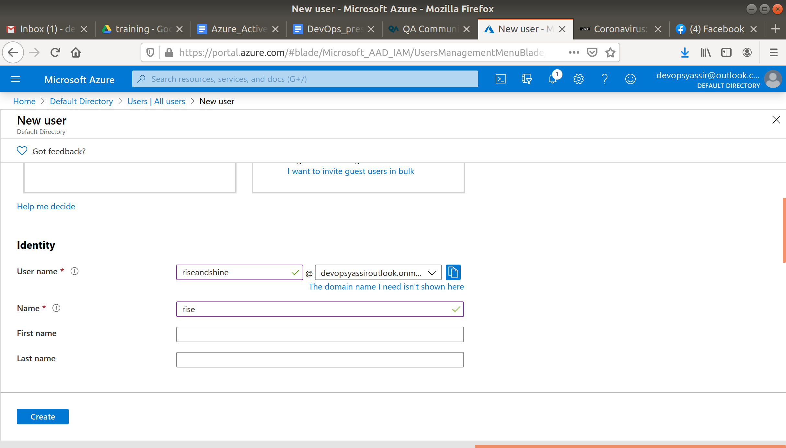

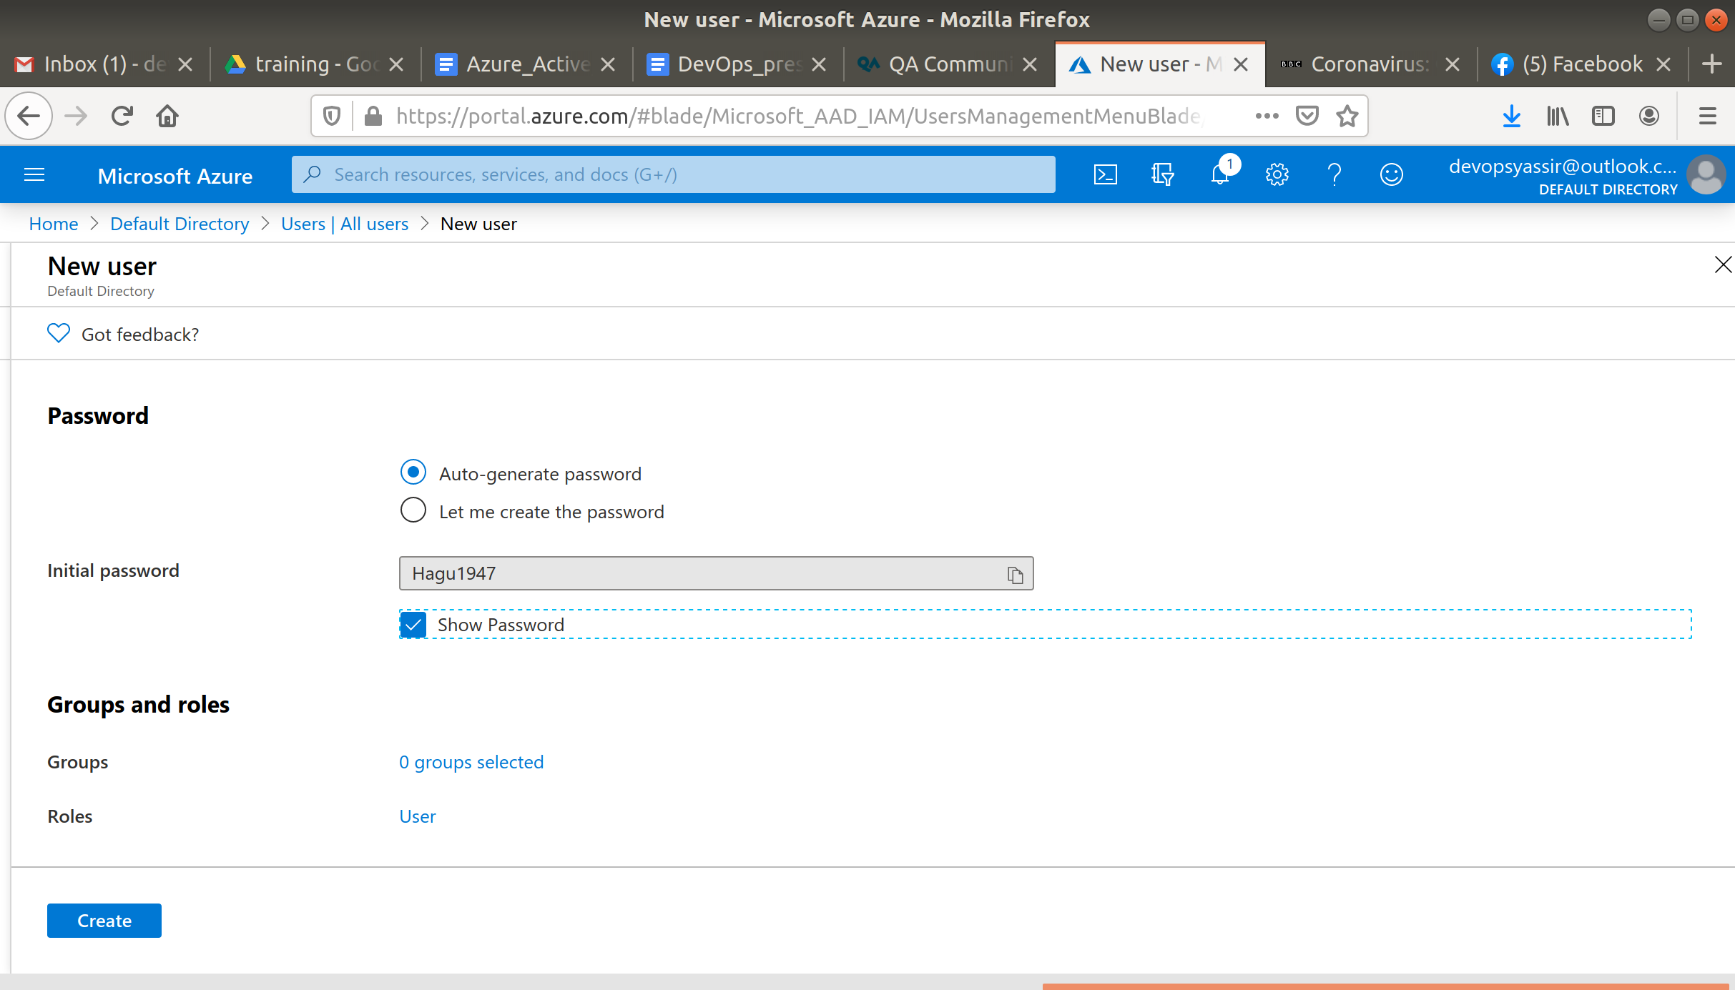

Then click Create to create your new user.

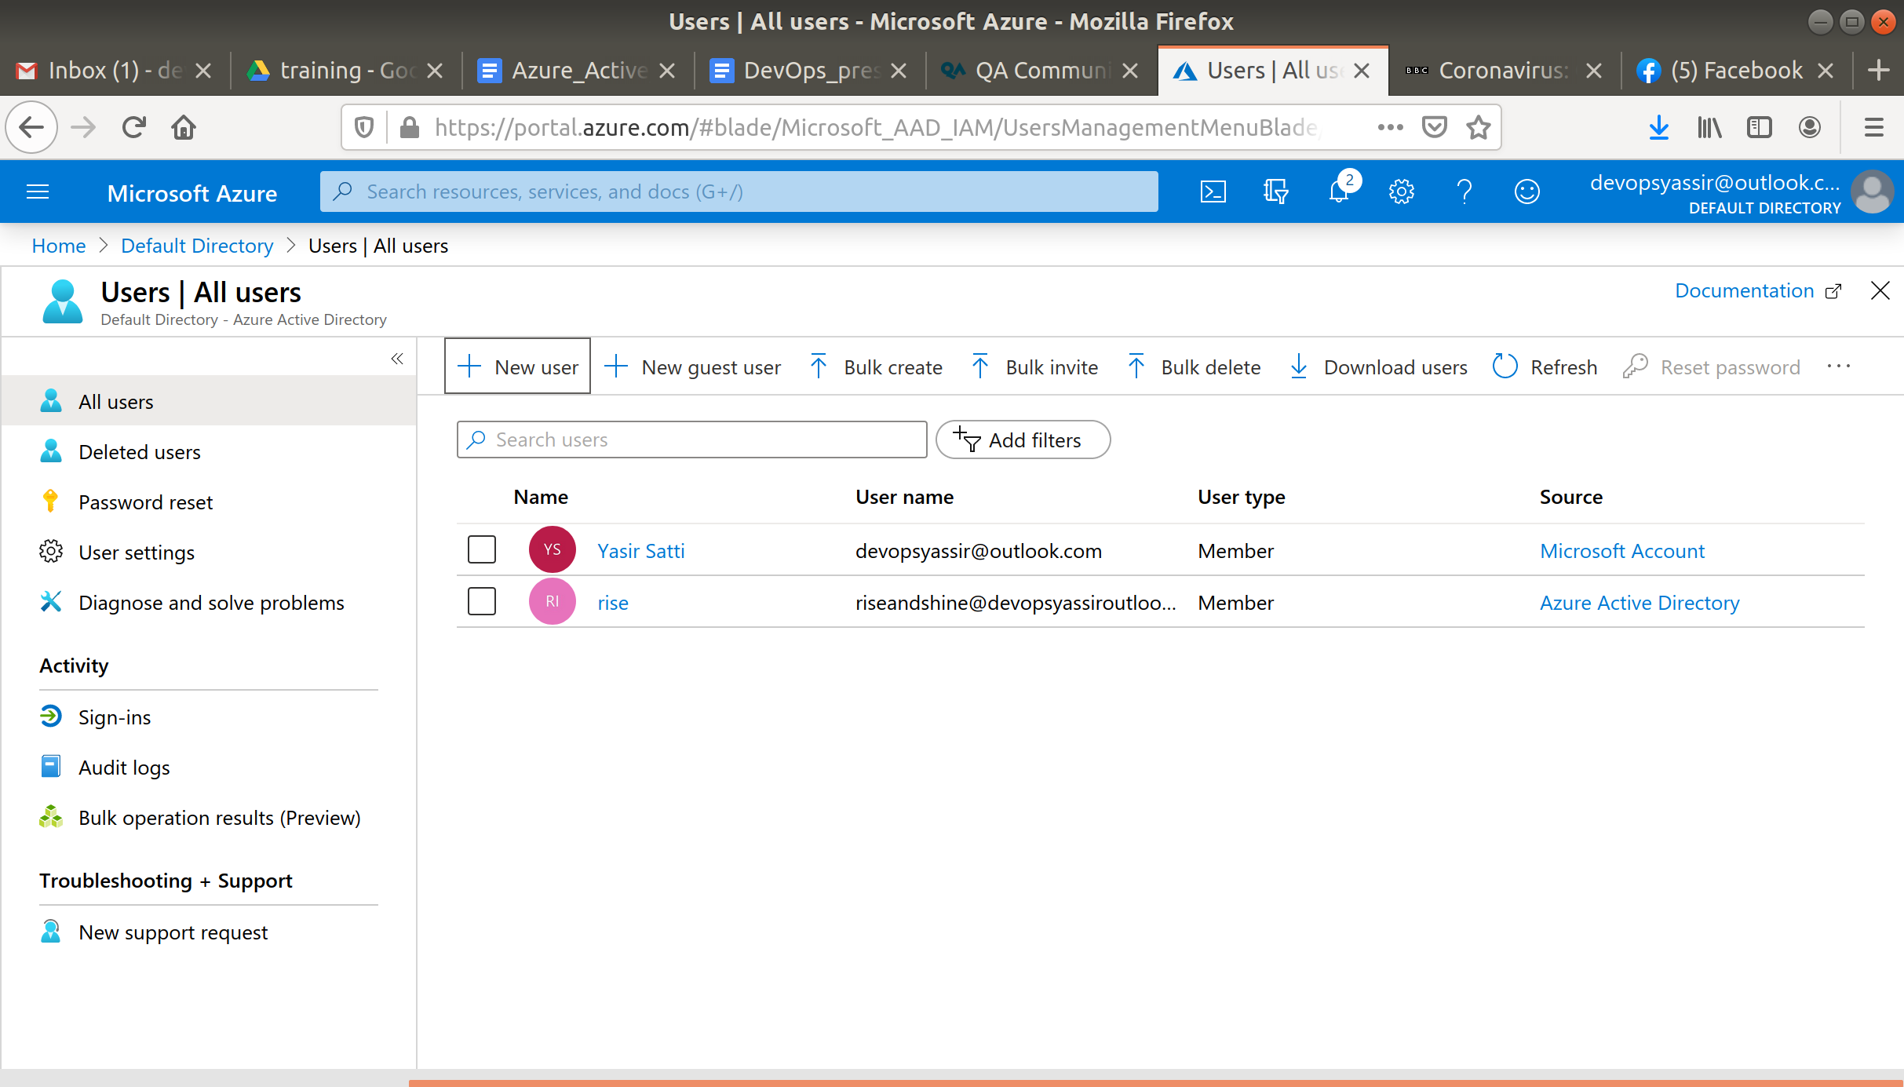

### **Logging in to the new user**

Now we will check that the new user has been created, click on your user in the top right of the portal and select sign in with a different account.

You will be redirected to the sign in page, chose the option to User another account.

Log in with the user name and password you saved earlier.

You will probably be prompted to change the password, just as a new user would when they logged in for the first time.

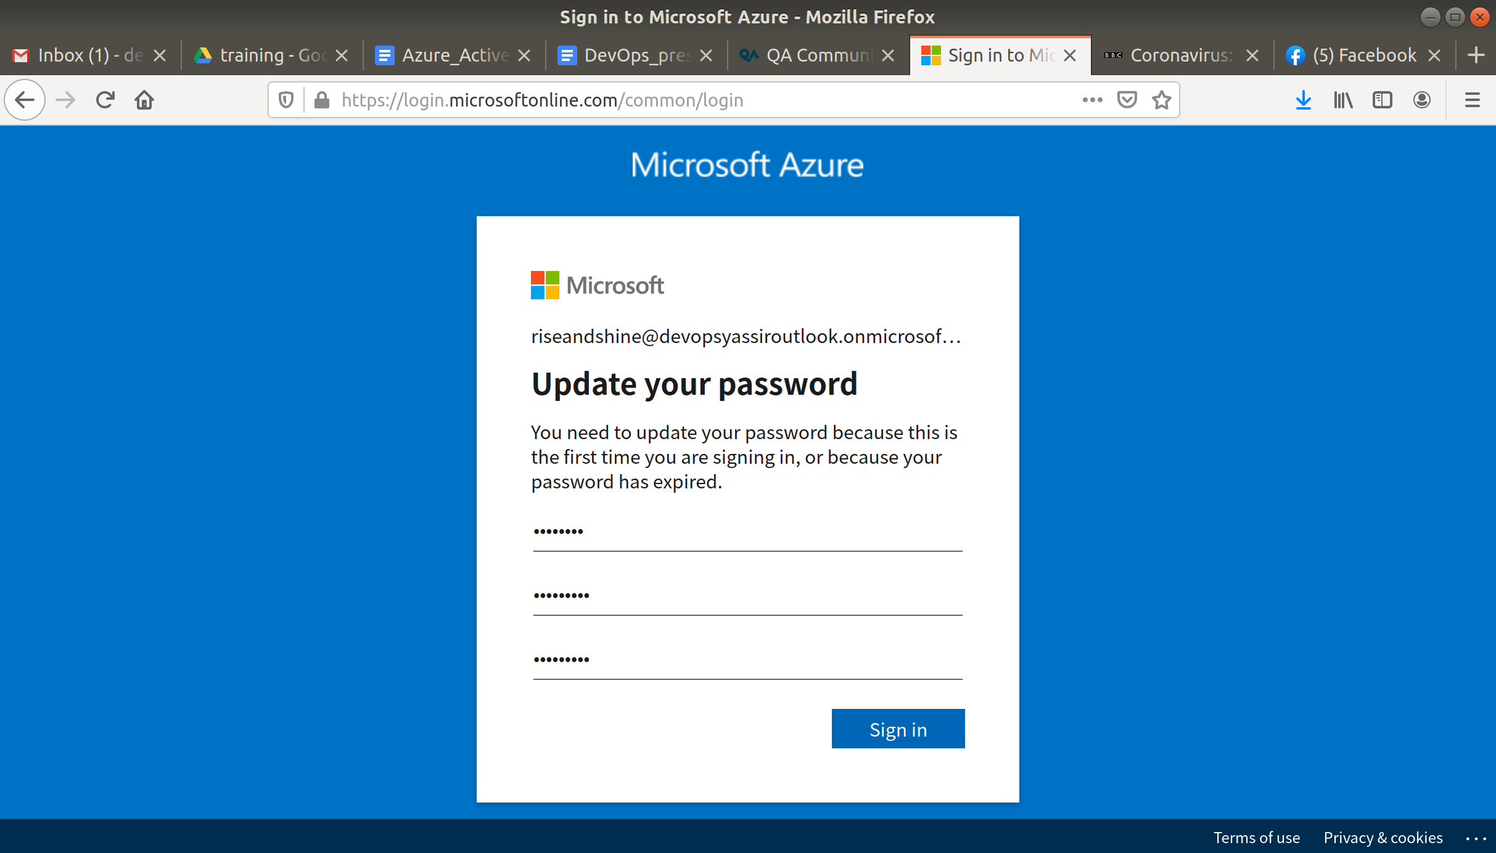

This means that the Administrator won't have access to the new user's password after they log in.

Once you are logged in, you can check that this is the user you created by checking the user name in the top right.

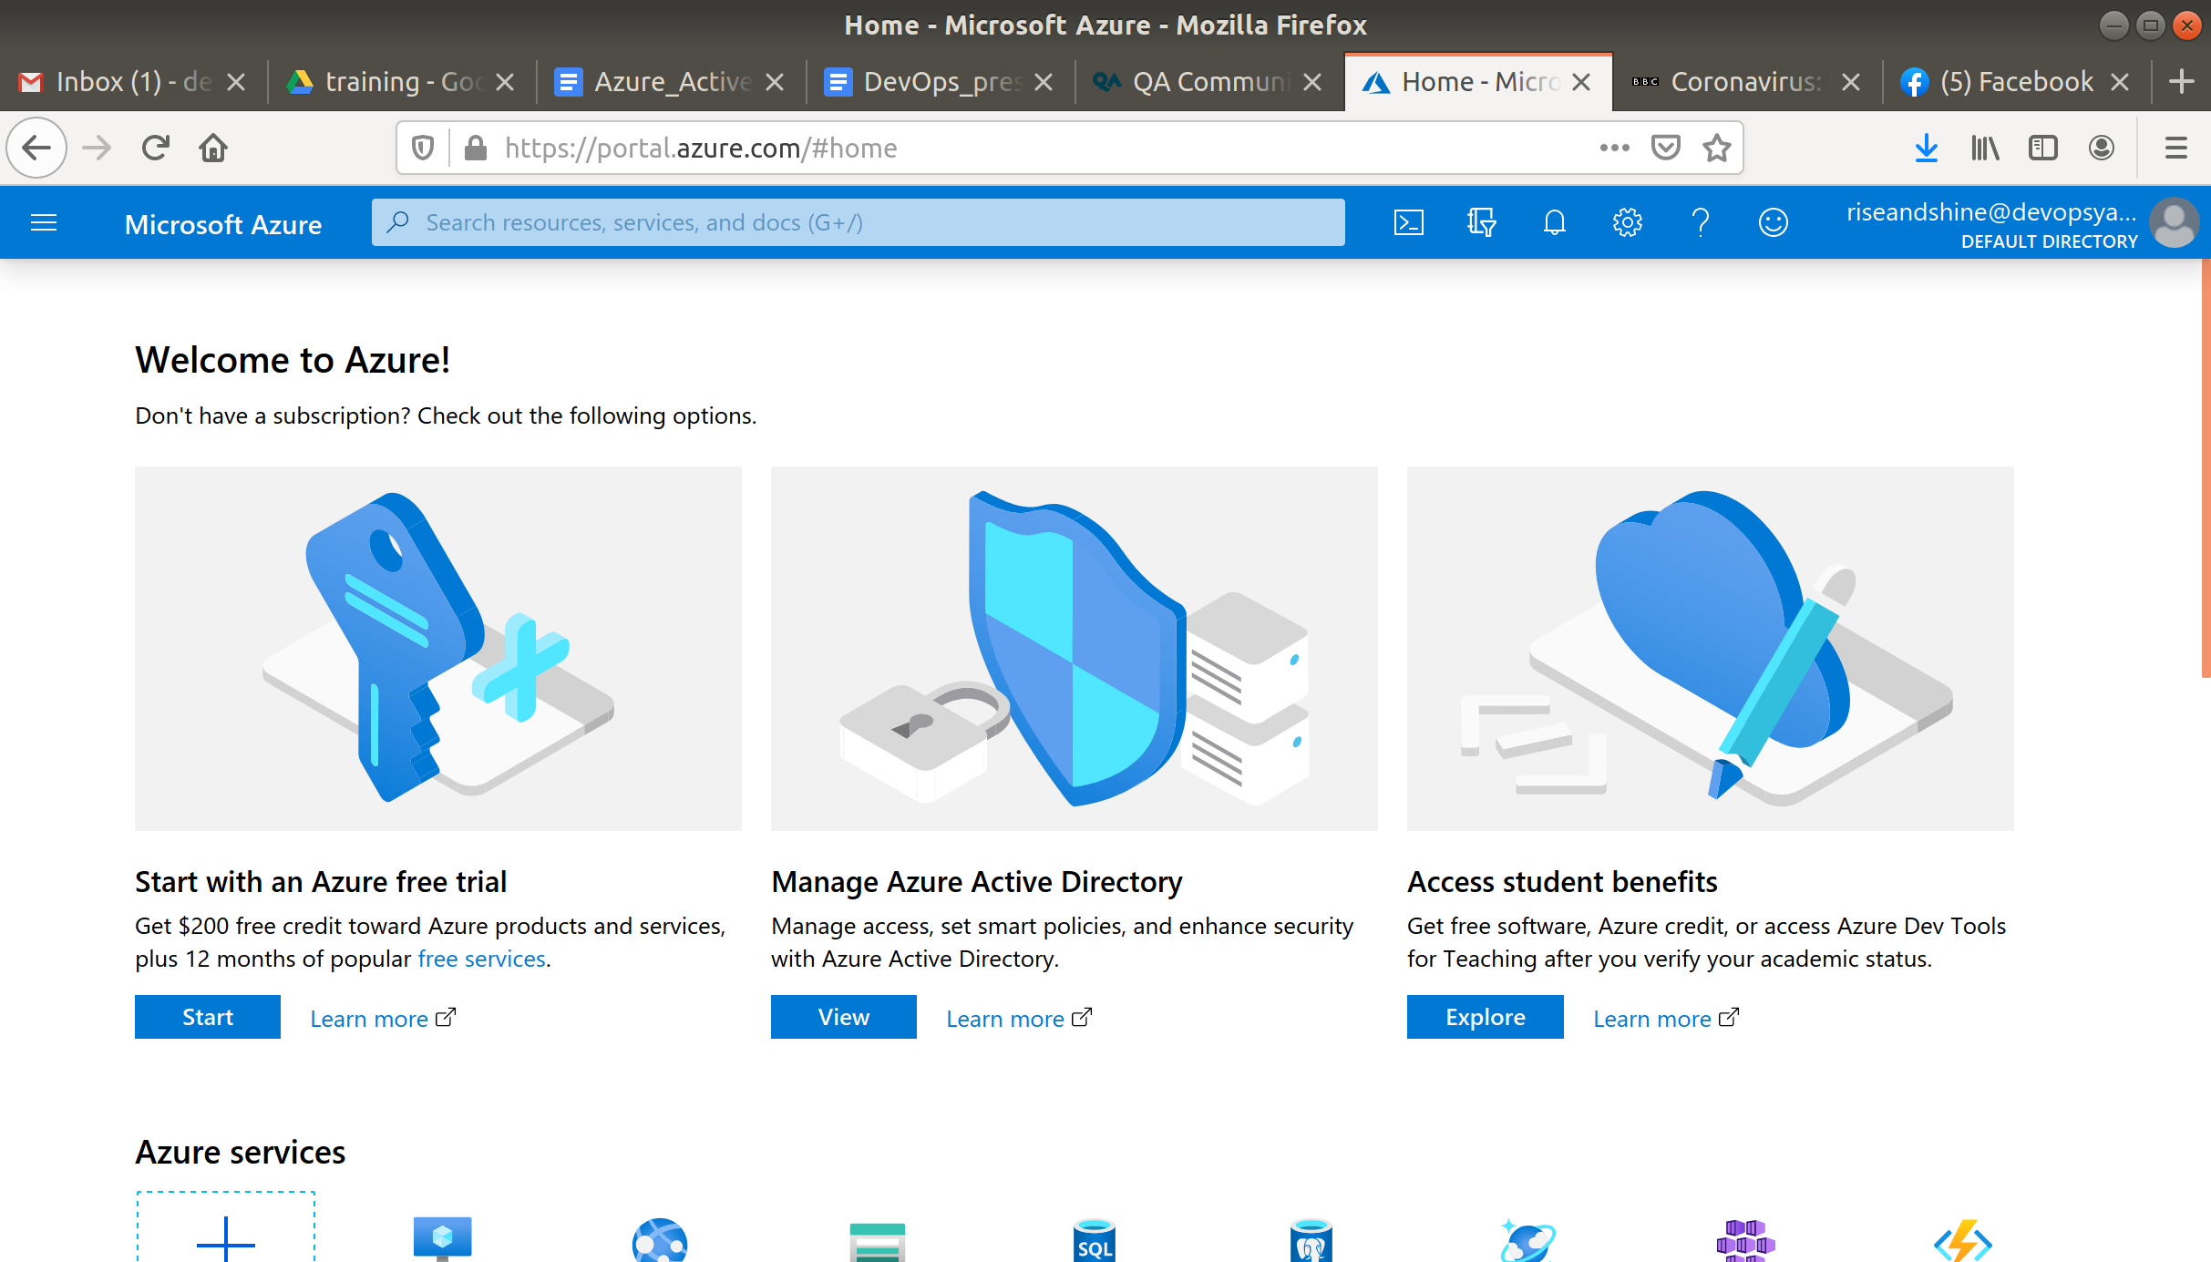

### **Clean up**

To log out of your new user, click on the user name in the top right then select sign in with a different account.

Then click the three vertical dots next to this user, and select sign out and forget

Log back into your own user.

Navigate back to Azure AD and then the Users blade.

Hopefully it will be on the dashboard, if not navigate to it as we did before.

You should now see the user which we created and logged in to, as well as your own user.

Select the new user and click delete user and then confirm you want to delete it when prompted.

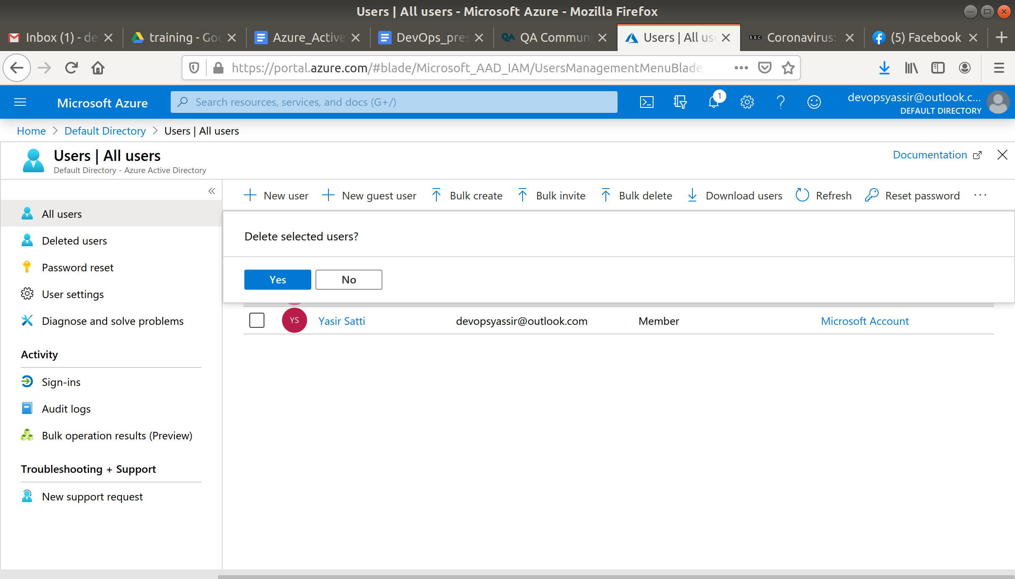

Azure should once again only display your own user.

