# Azure Content Delivery Network

# 

## **Tutorial**

In this tutorial we are going to connect a CDN endpoint to a vm.

### **Registering CDNs**

CDNs are not enabled by default.

You need to register the service to use it.

Type in Subscriptions in the search bar and select it.

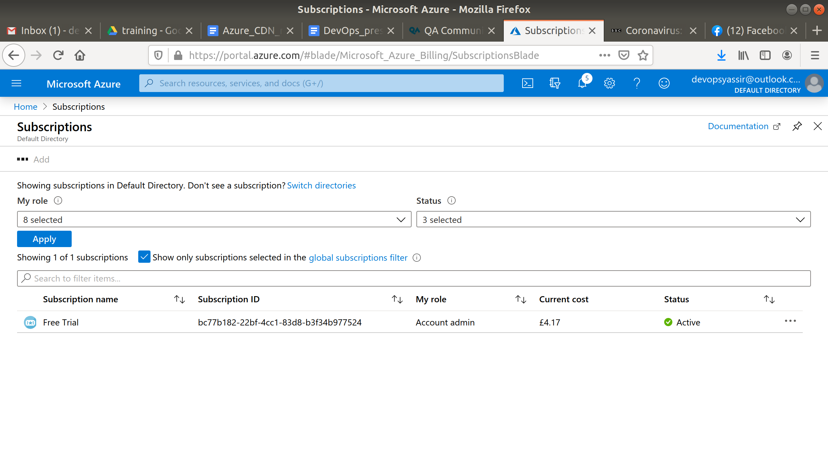

Select your subscription.

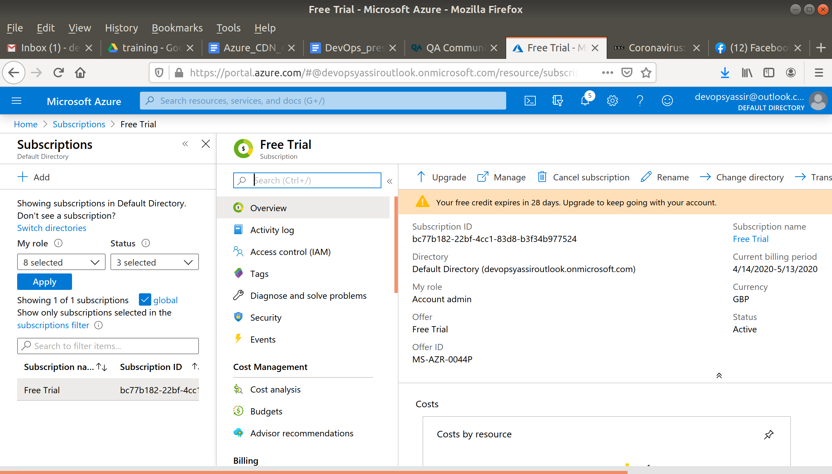

In the left blade select Resource Providers.

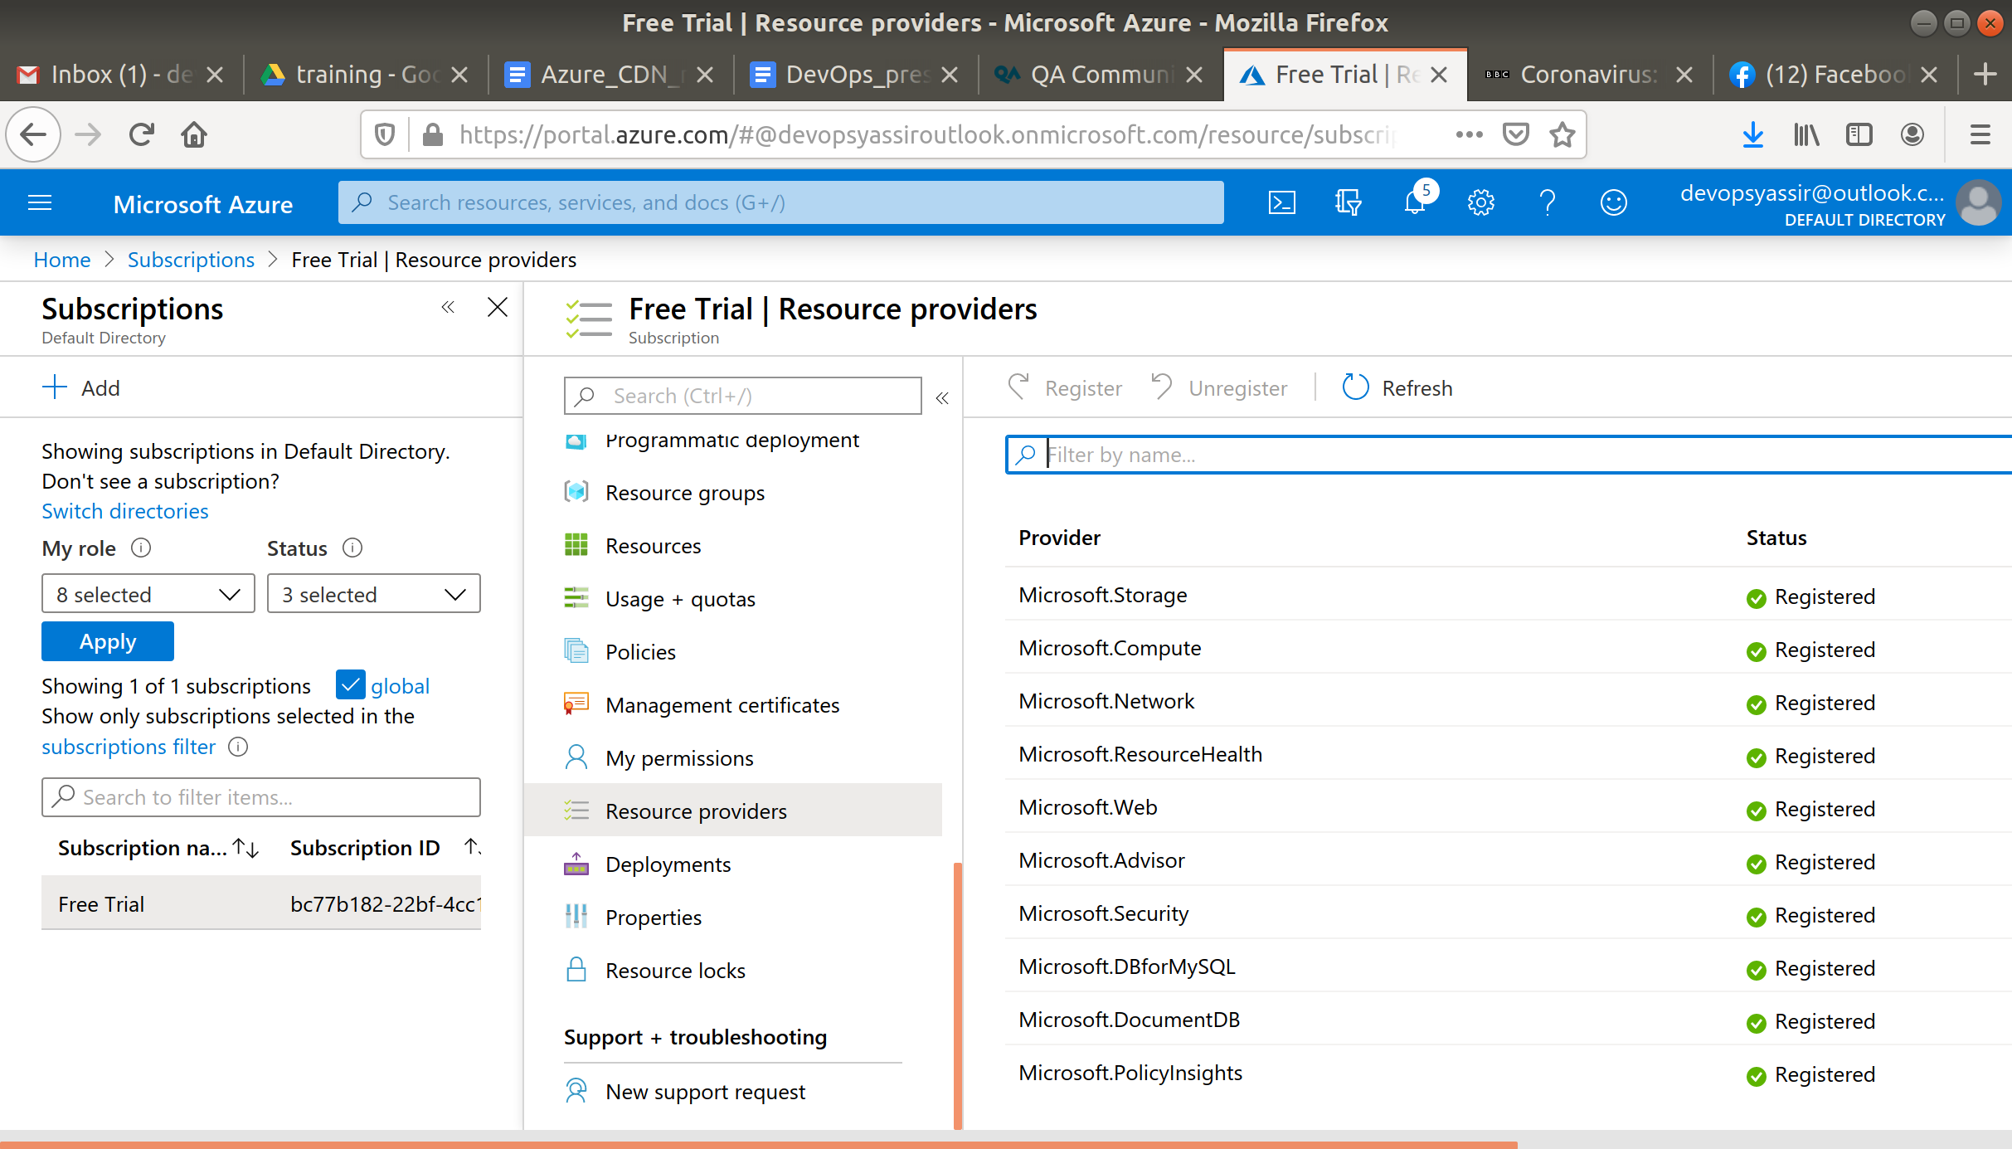

Type cdn in the search bar below the command bar and select Microsoft.Cdn.

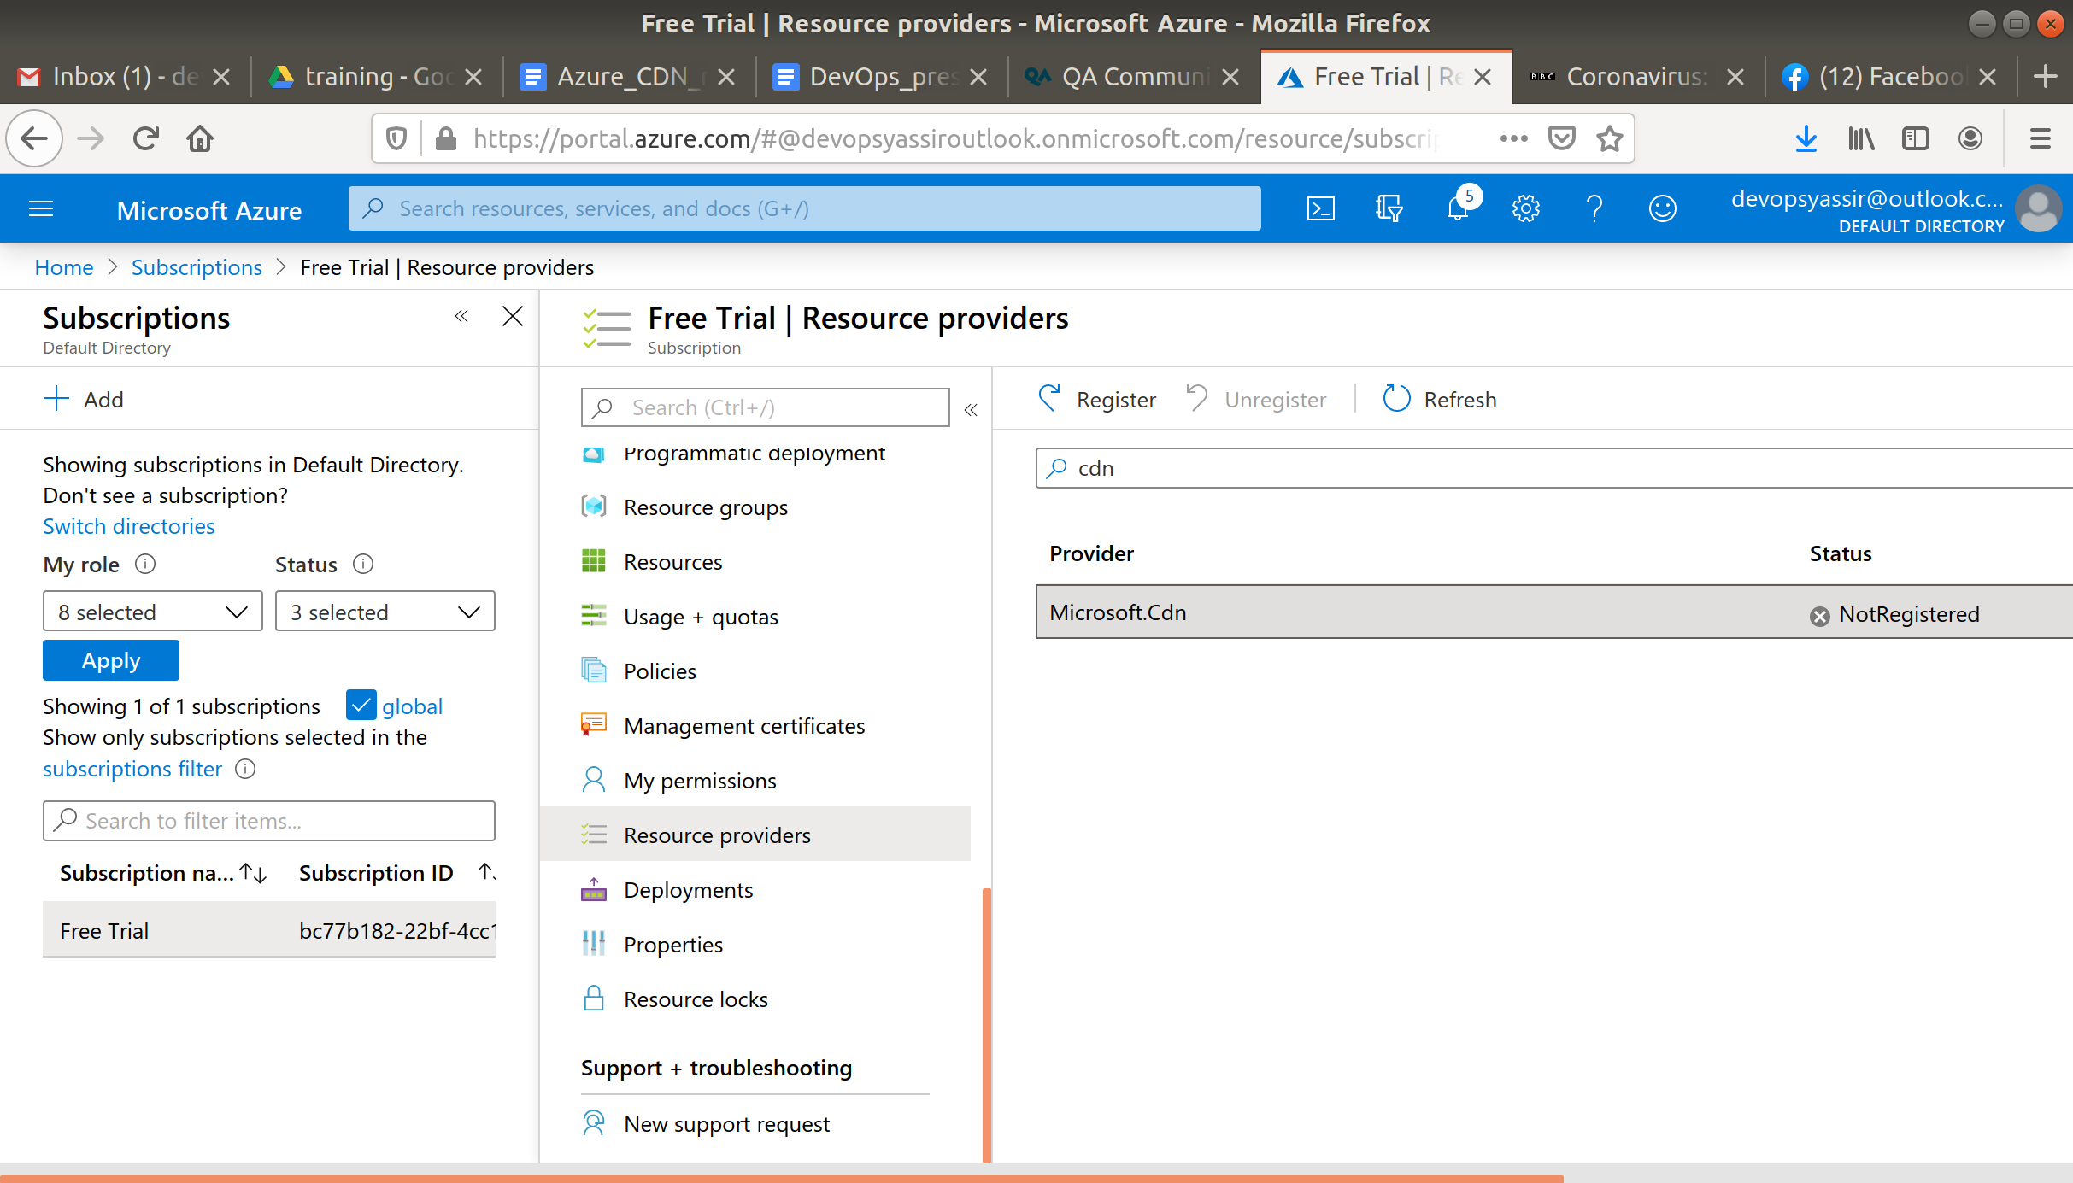

Finally click Register.

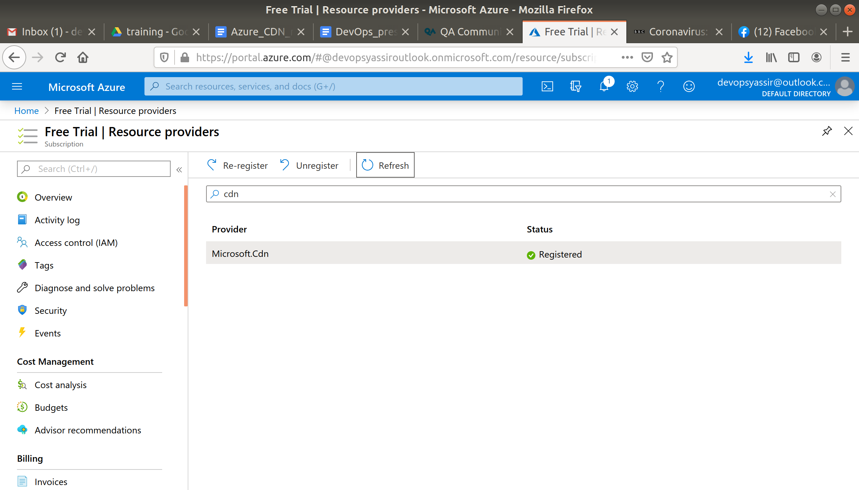

### **New Resource Group**

The first thing is to create a new resource group, which we can do by clicking the burger bar in the top left corner and choosing Resource groups:

Then, we can click +Add:

Here, we can name the resource group and pick a location to have it in:

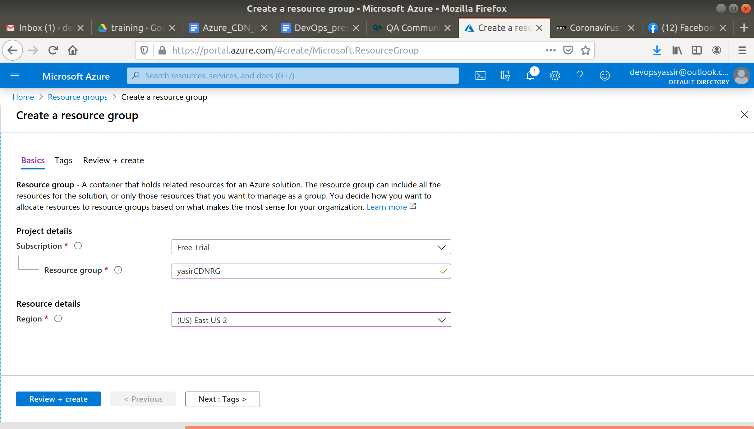

Lastly, we will click Review & Create and then Create to create the resource group:

### **New Virtual Machine**

For this, we need to first go to the hamburger menu again, but this time click Virtual machines:

Then, we click + Add:

We will need to choose our new resource group from the drop down menu, give the machine a name and pick a region for it to be deployed into.

The image can be Ubuntu Server 18.04 LTS, and the Size can be Standard D2s v3:

We need to choose password for authentication type, and create a username and password.

We also need to ensure that Port 22 is open, so we can SSH into the machine later (this should be checked by default):

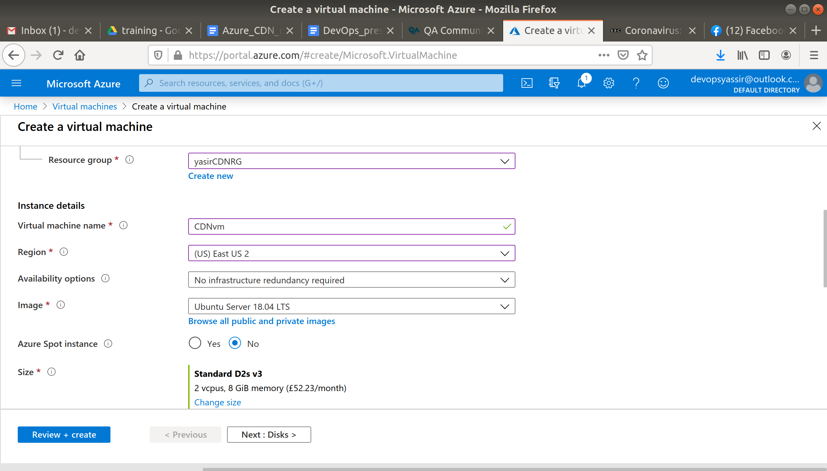

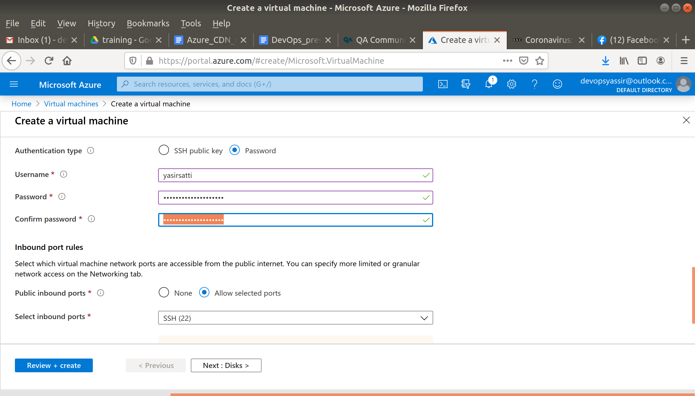

After clicking Create, our Linux VM is created!

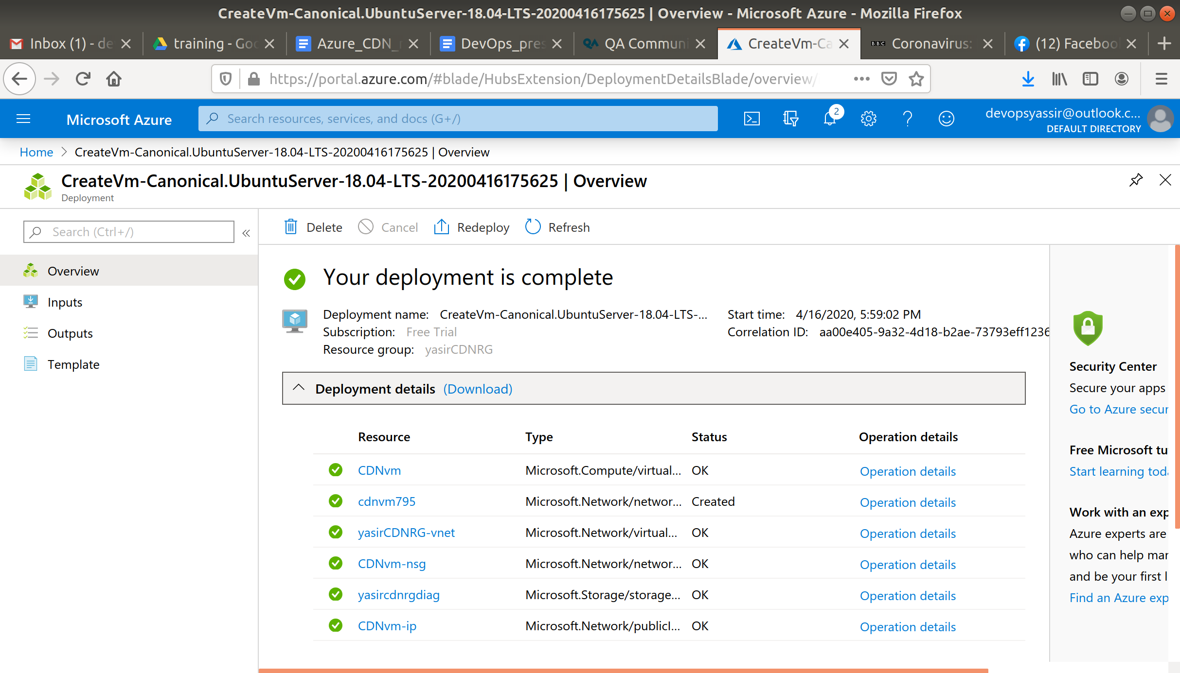

### **New CDN Profile**

Type in CDN Profiles in the search bar and select it.

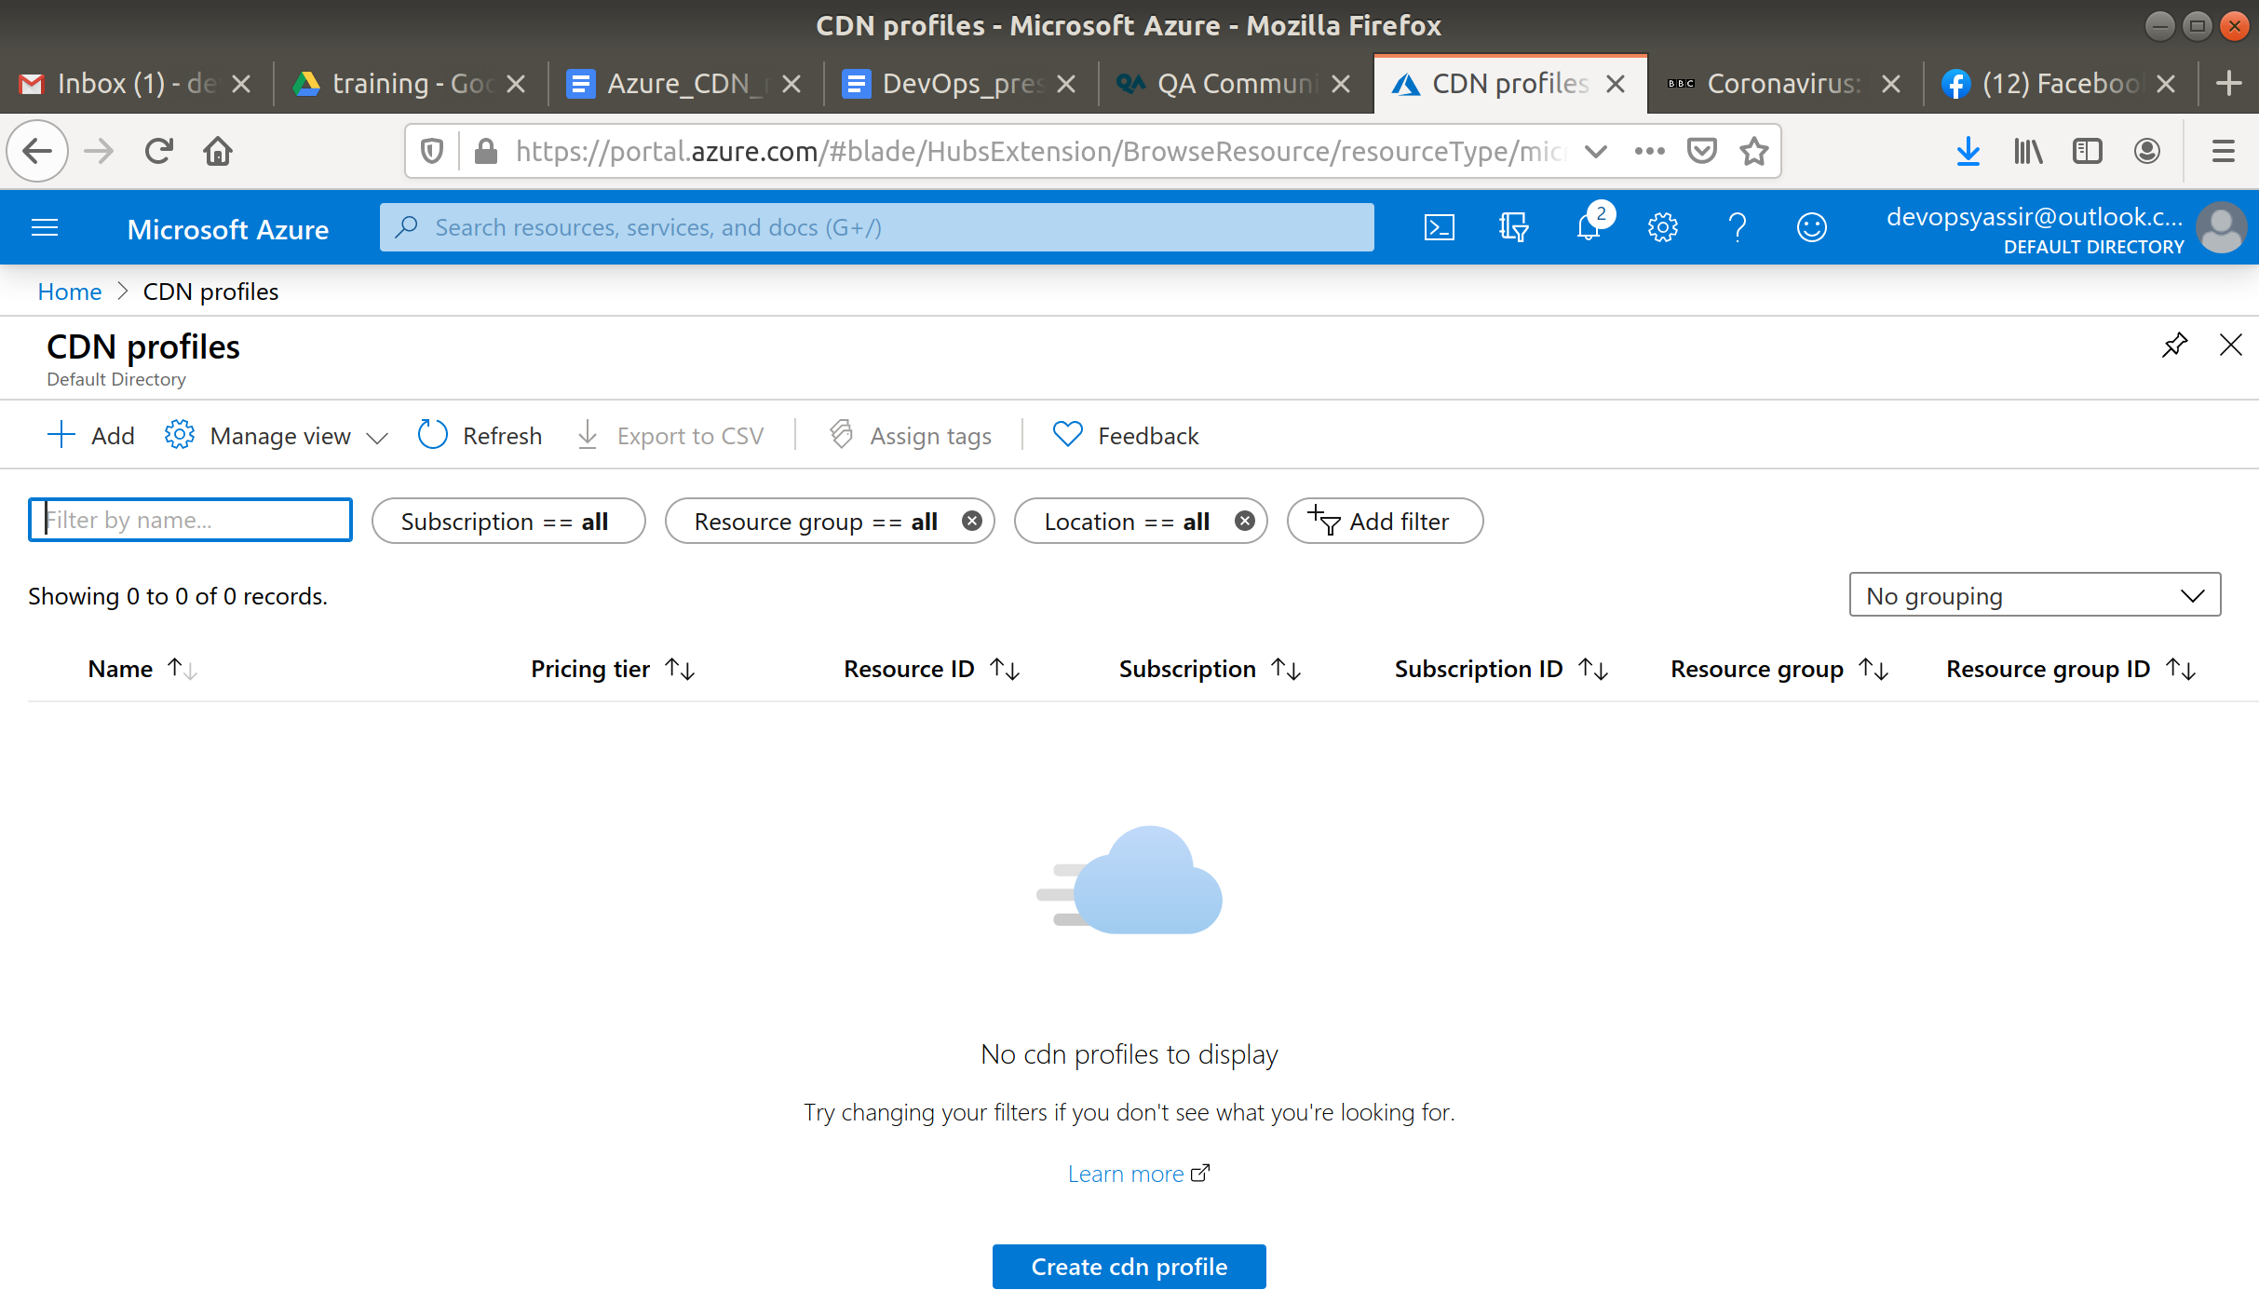

Click +Add.

Now enter the following:

* Name - Any name you like
* Subscription - Your Azure subscription
* Resource Group - The RG we created eariler
* Location - West Europe
* Pricing Tier - Standard Microsoft

select create an endpoint

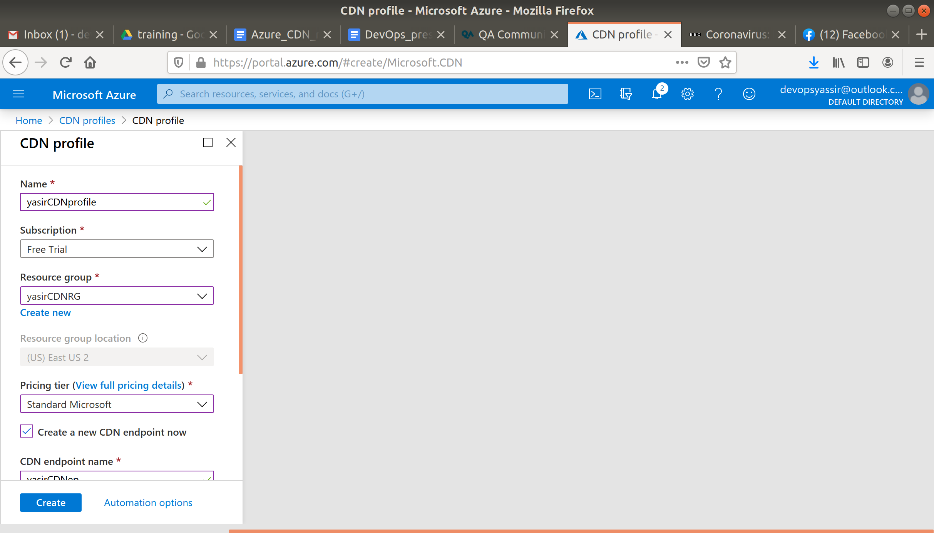

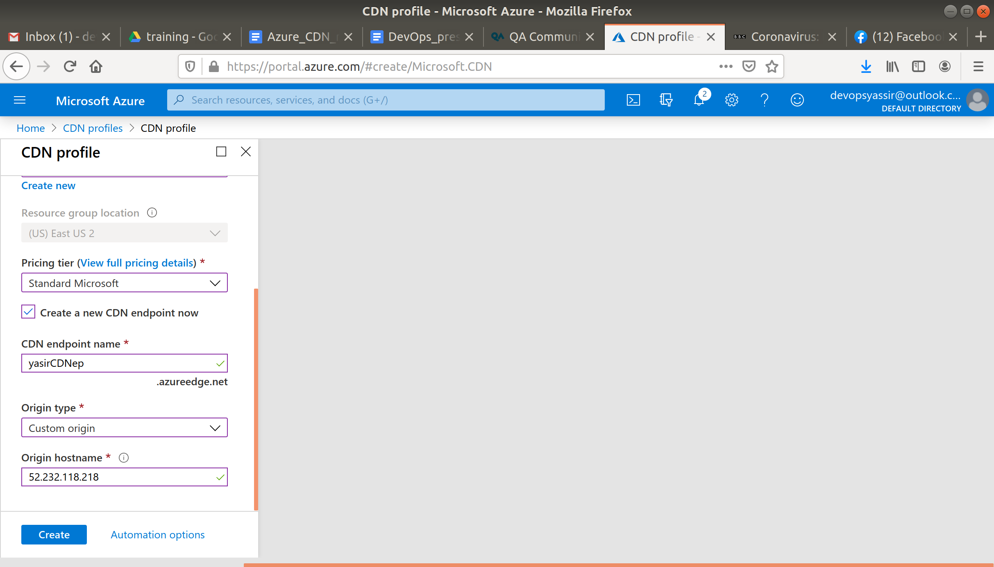

Then click Create.

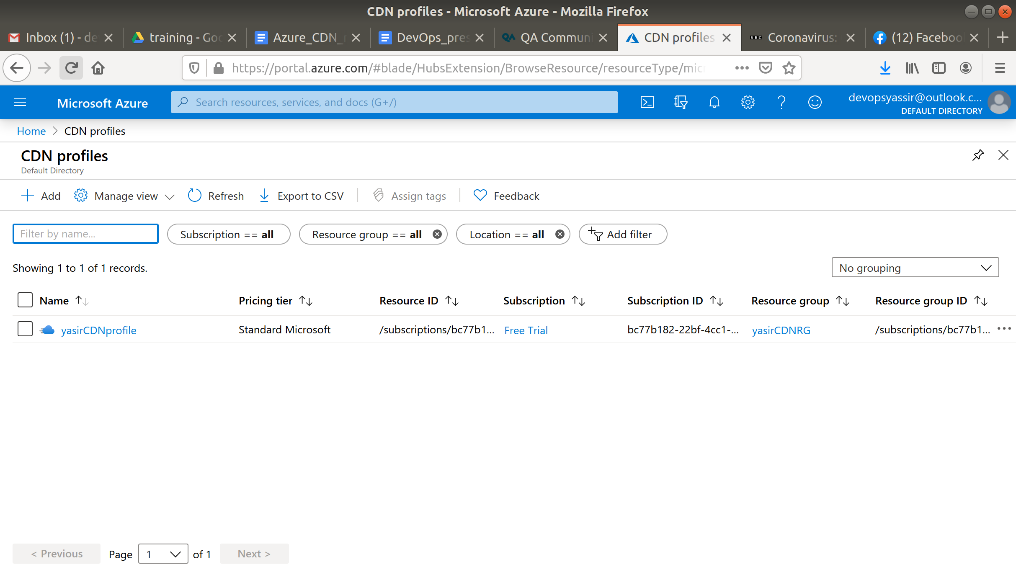

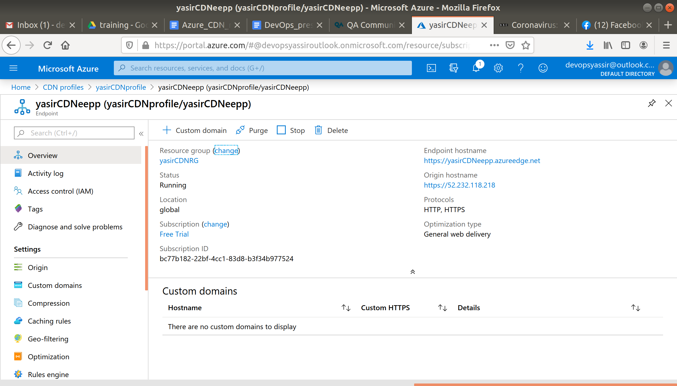

Once it has deployed, select your new CDN profile.

Click +Endpoint and enter the following.

* Name - Any name, it must be unique
* Origin Type - Custom Origin
* Origin Hostname - The public IP address of your vm

Leave the rest as default and click Add.

Now enter your hostname in your browser and you should get an Azure 404 message, this is expected as your vm isn't hosting an application of any kind.

### **Clean Up**

To clean up, go back to the Resource Group page, click your resource group you used for this module, and then choose Delete.

Once you type the name of the resource group to confirm deletion, this will be deleted along with everything inside of it.