# Azure CLI

## **Exercises**

1. Install the CLI on your chosen platform.

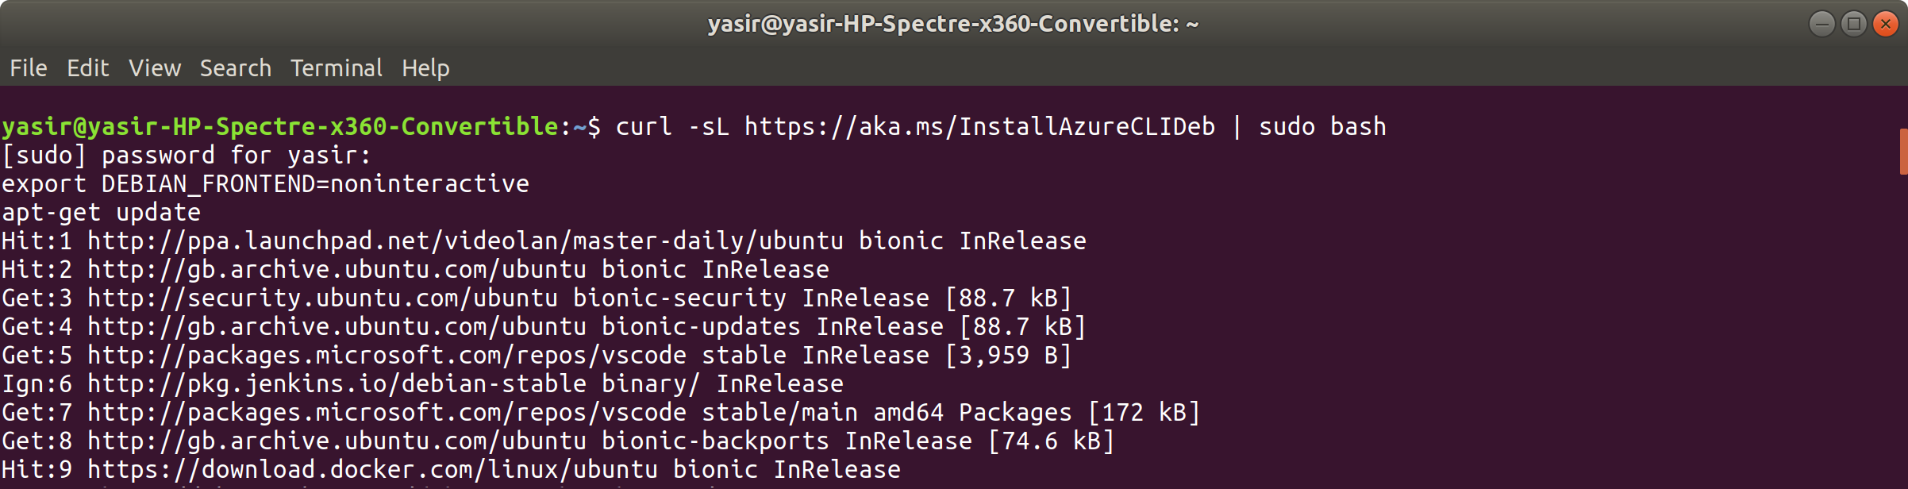

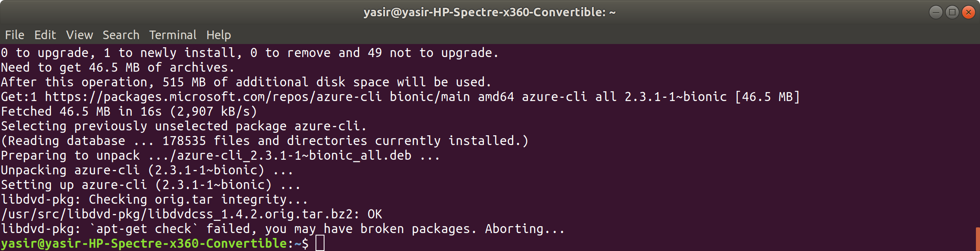

1. Authenticate with your Microsoft Azure account.

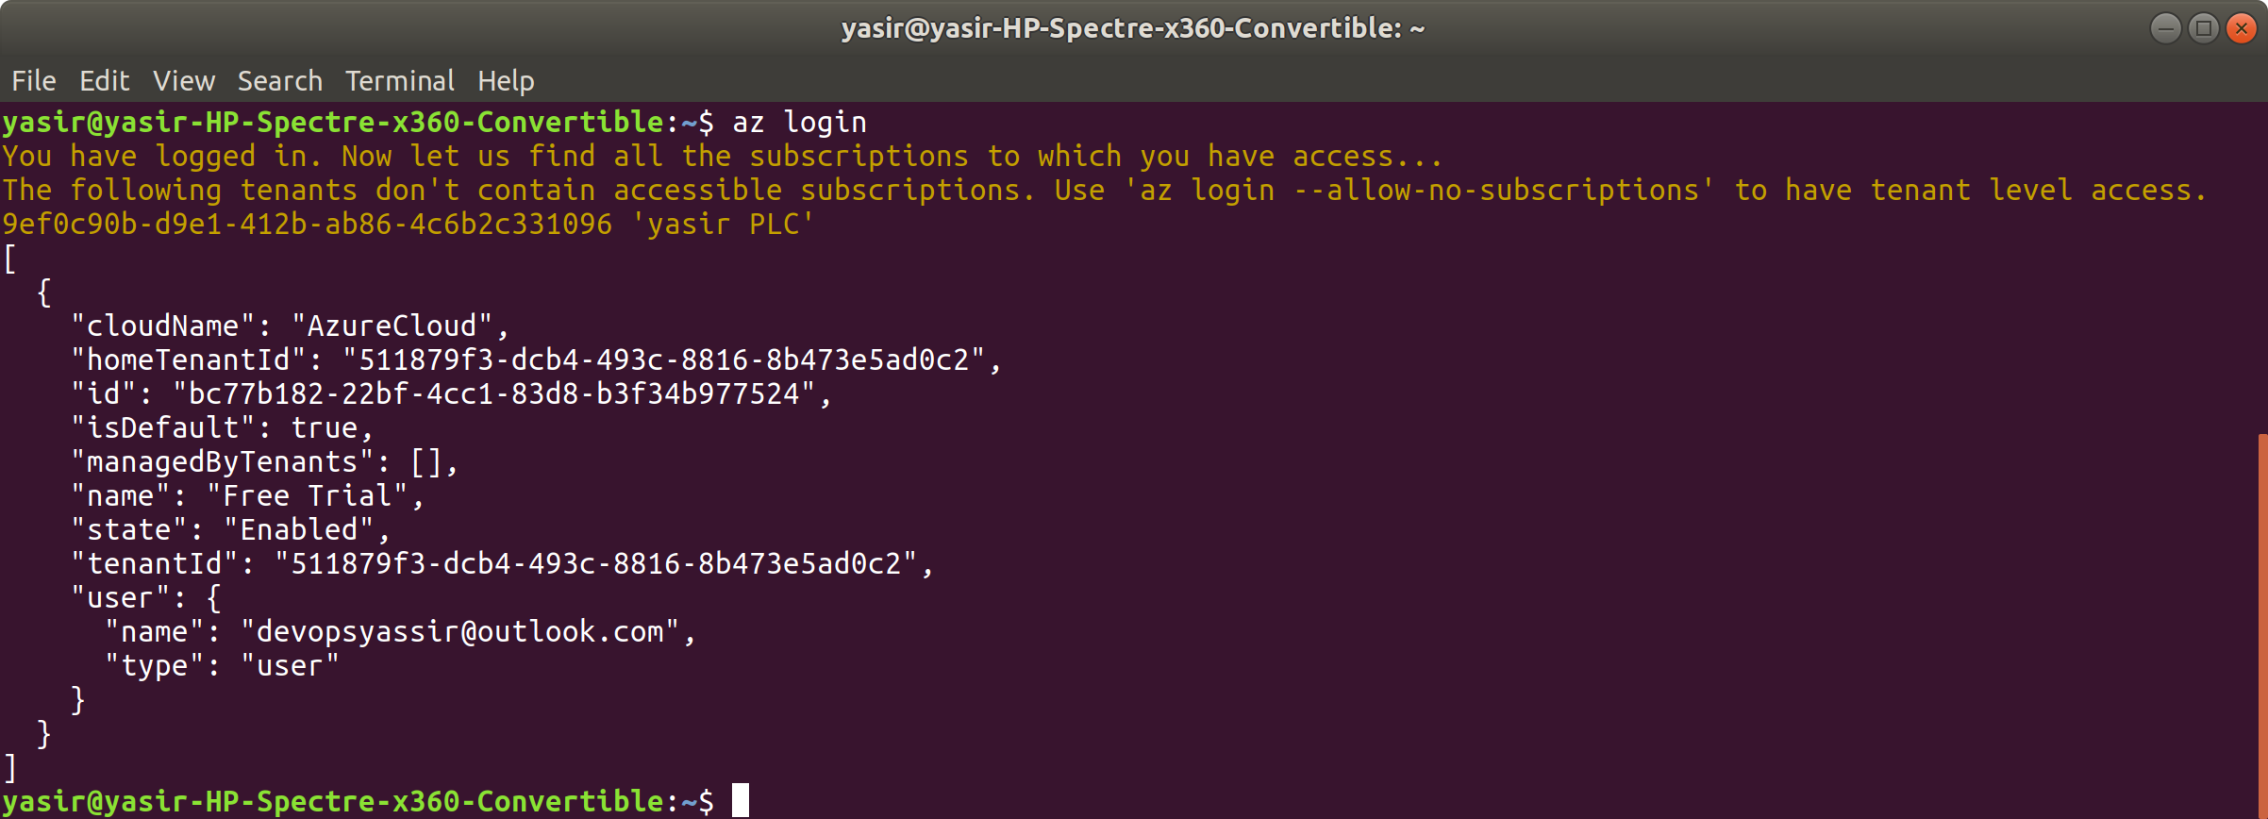

1. Create a new resource group.

**$ az group delete --name MyResourceGroup --yes**

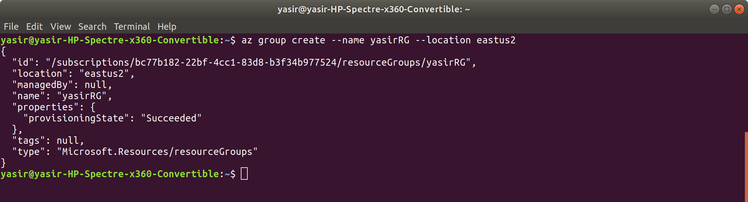

1. Create a VM from the CLI and place it in the resource group.
2. Delete the resource group, and all the resources inside it, **without waiting** for the terminal to become available again.