# Azure CLI

## **Tutorial**

In this tutorial, we are going to create, and then delete, a new resource group using the CLI:

**$ az group create --name MyResourceGroup --location uksouth**

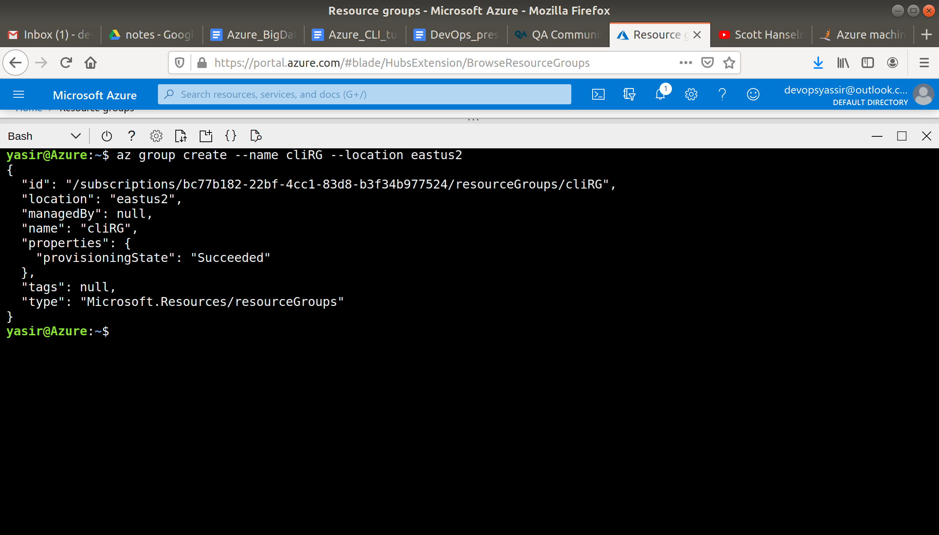

We can make it even easier for ourselves by configuring our default location to be "UK South":

**$ az configure --defaults location=uksouth**

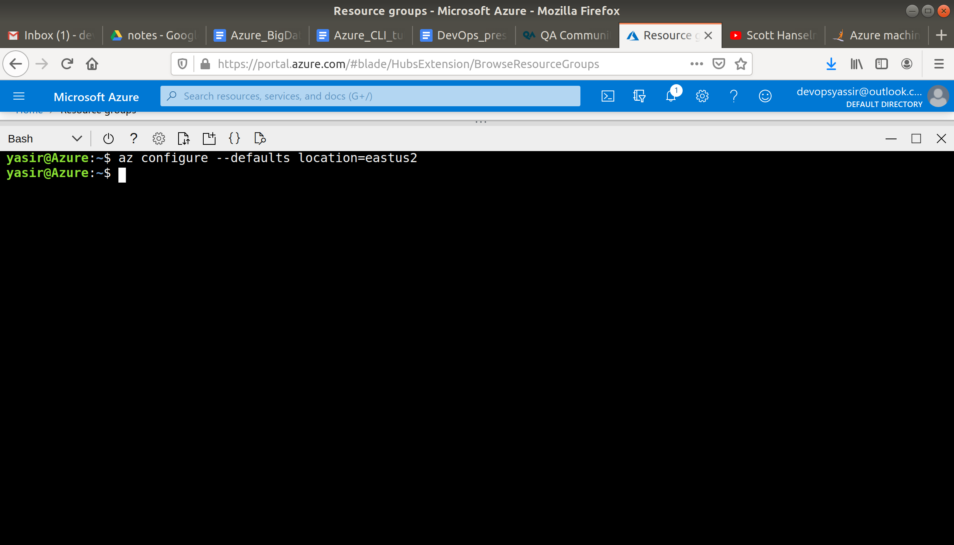

To view our resource group, we can use:

**$ az group list -o table**

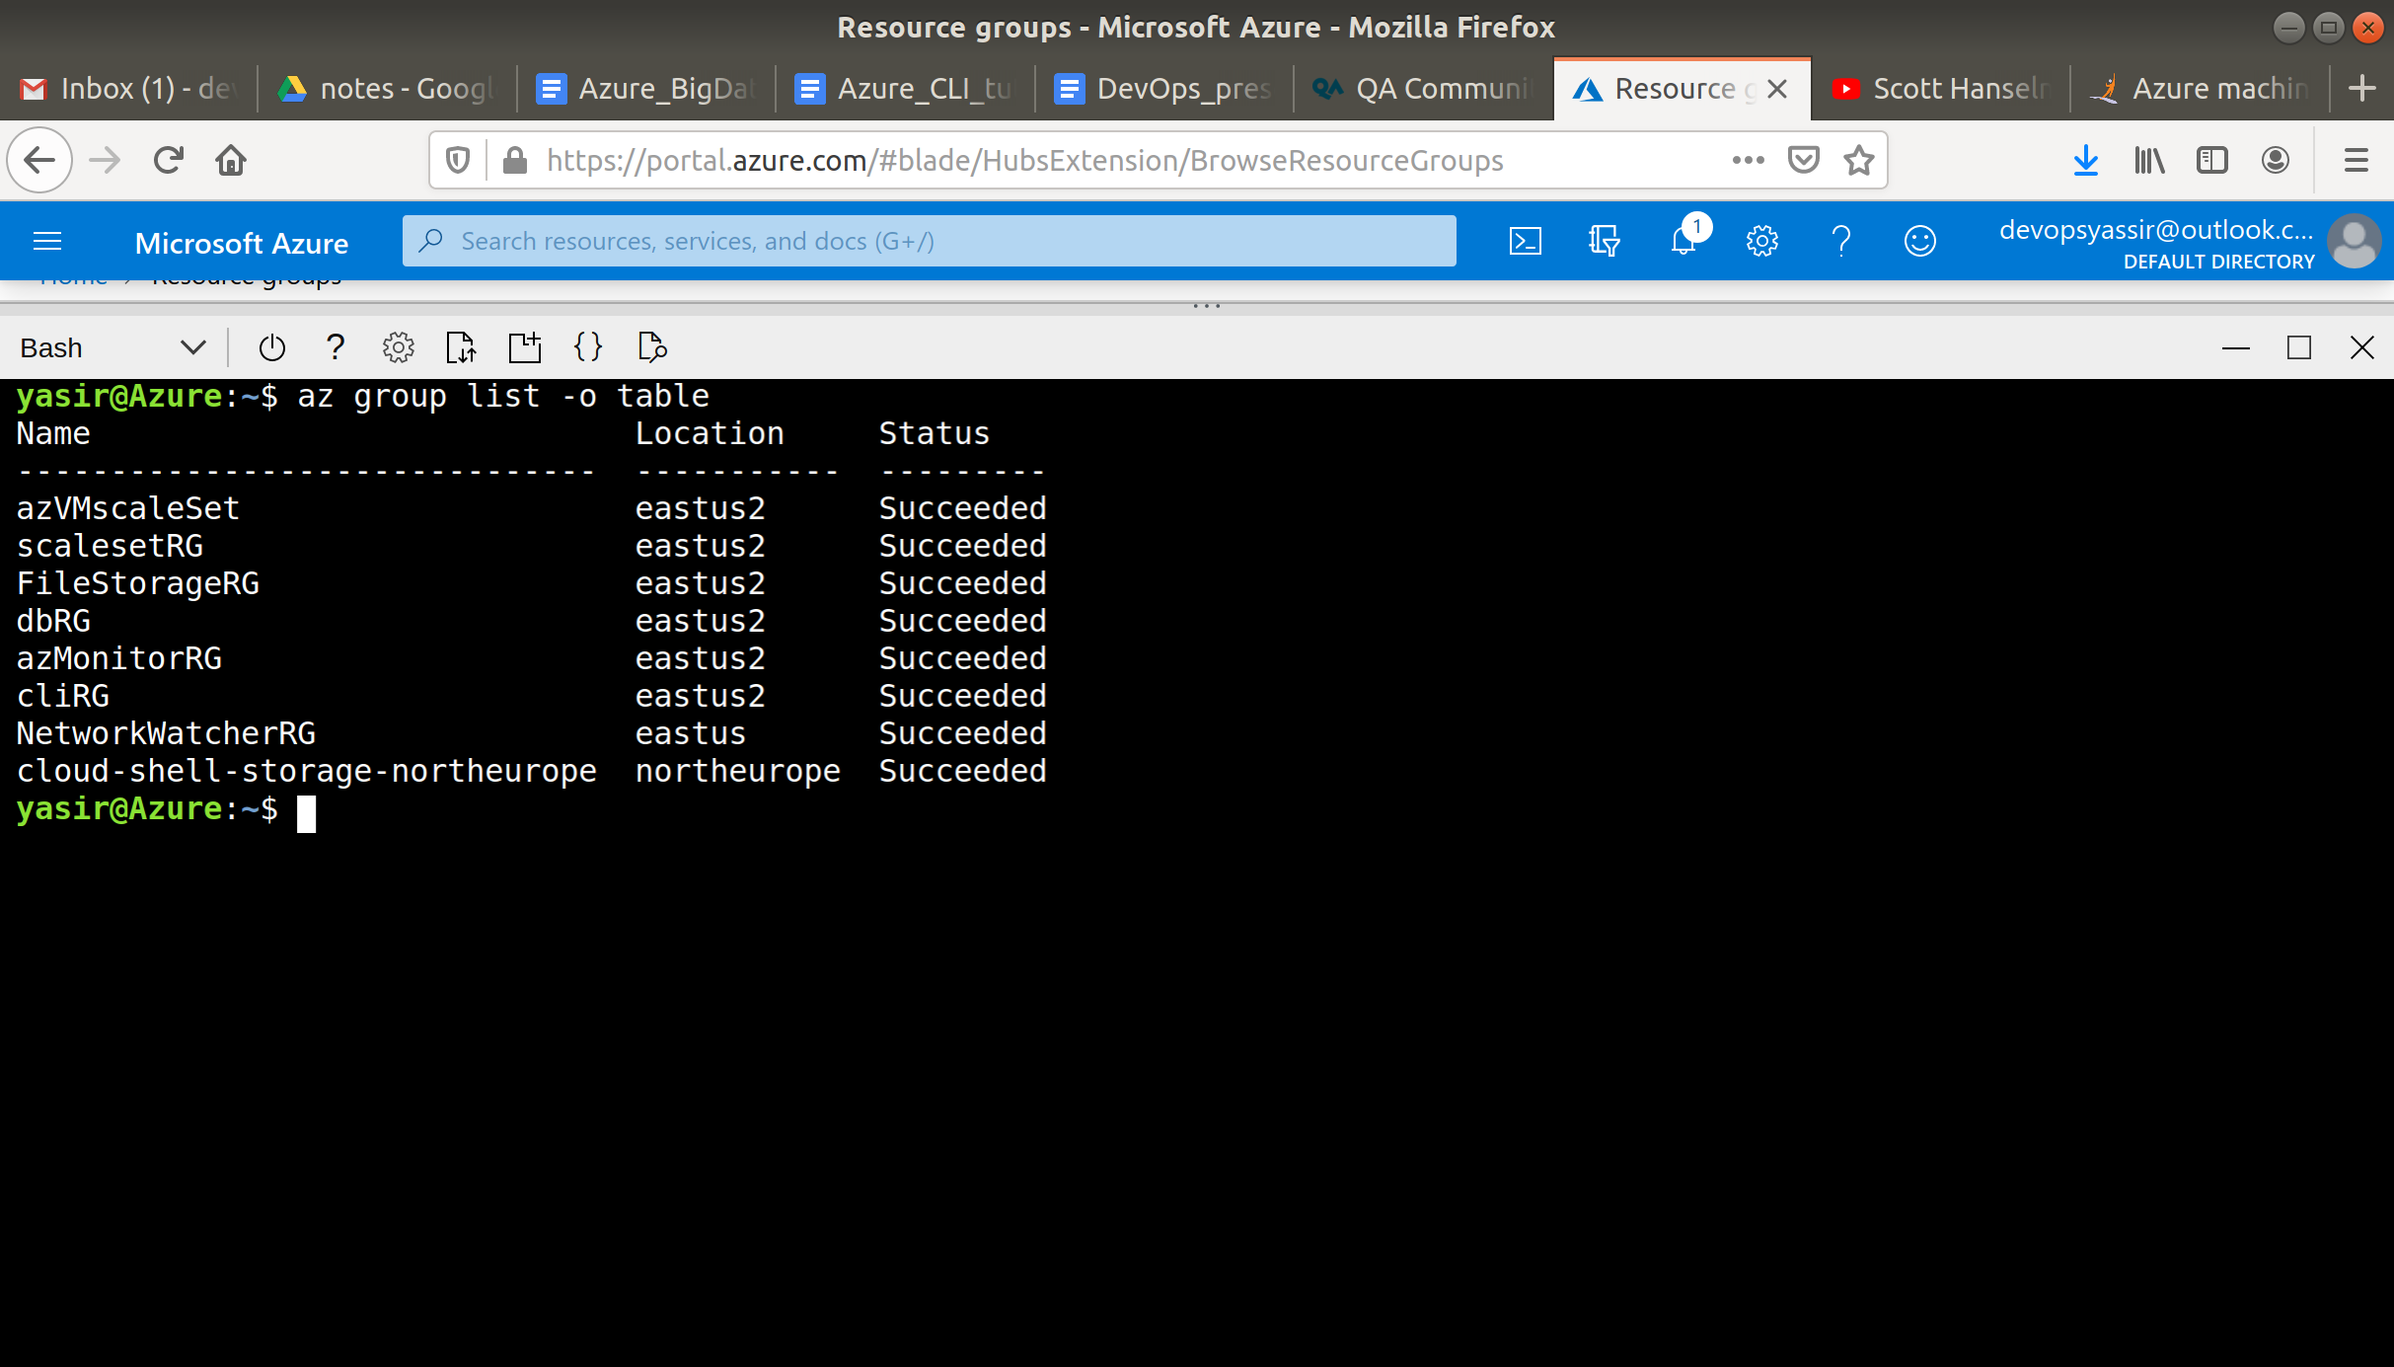

To delete the resource group, we use:

**$ az group delete --name MyResourceGroup --yes**

