# Azure MySQL Database

# 

## **Tutorial**

In this tutorial we are going to create a CosmosDB account.

In the Azure Portal, type CosmosDB in the search bar and select it.

Click the +Add button.

In the following fields enter:

* Subscription - Any subscription you like
* Resource Group - Create New, name it CosmosTutorial
* Account Name - Any name you like
* API - Core (SQL)
* Location - UK South

Leave any other field as their default.

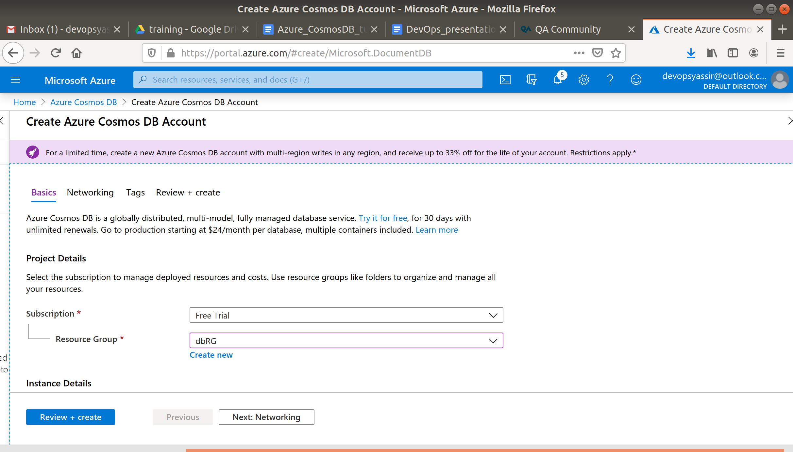

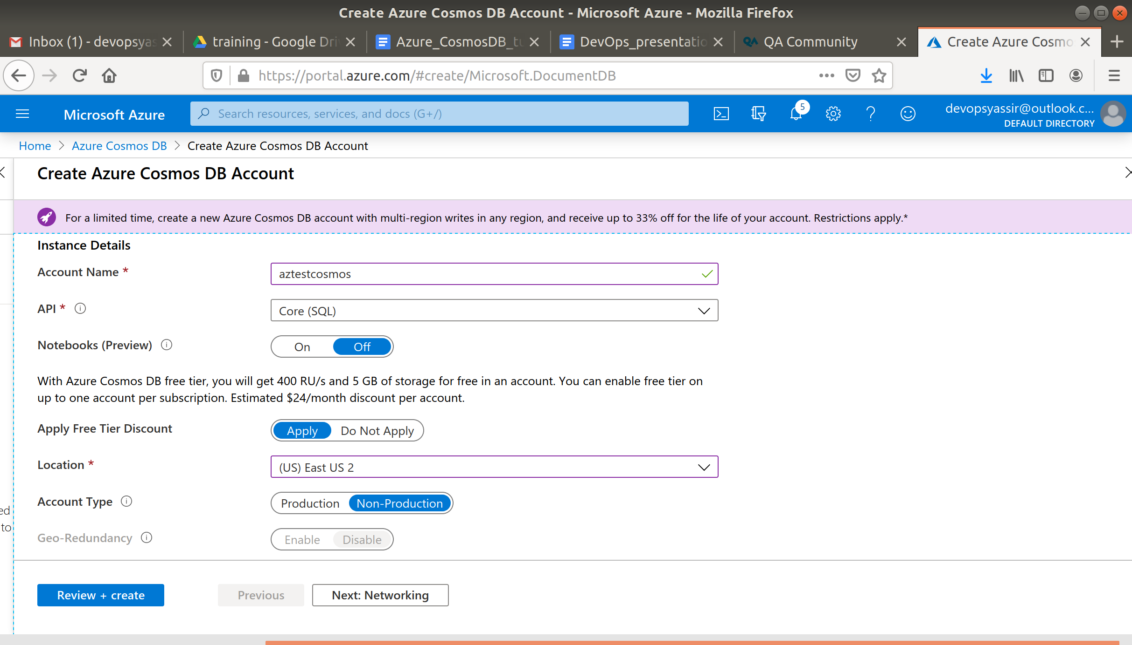

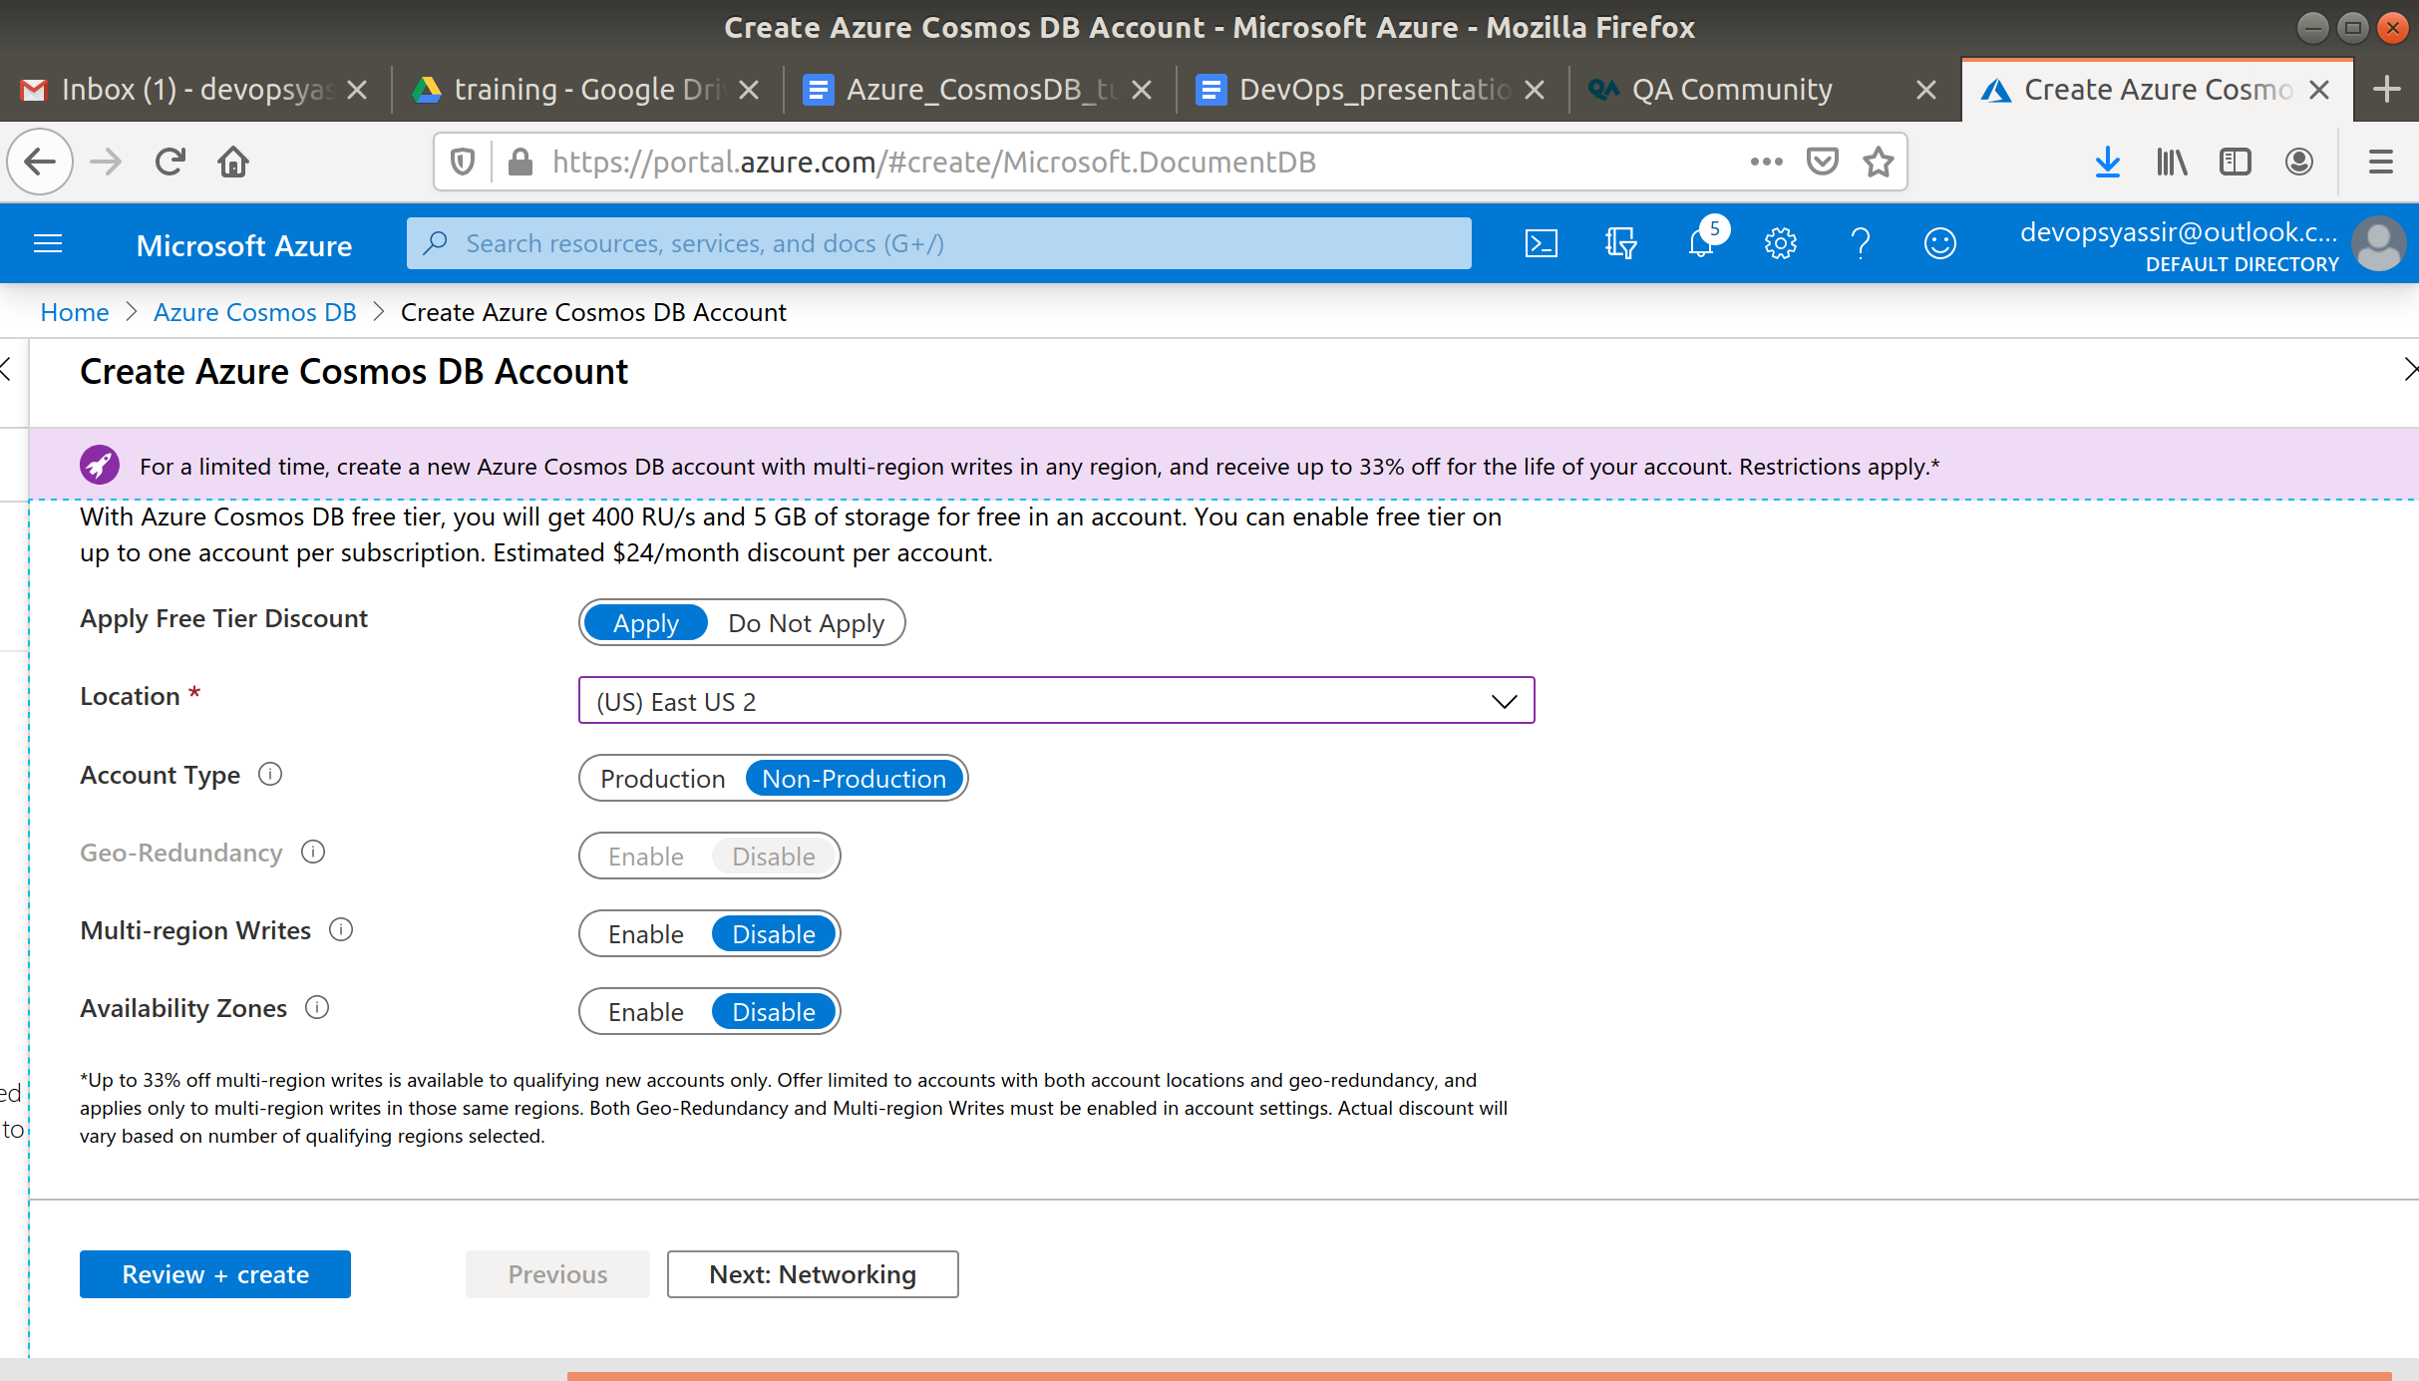

Click Review and Create and then Create when the validations pass.

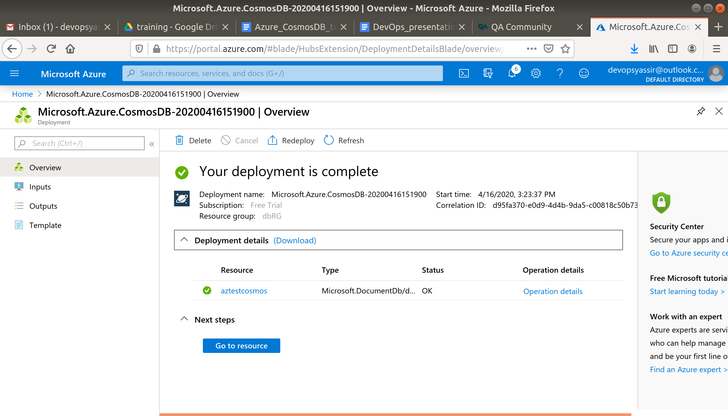

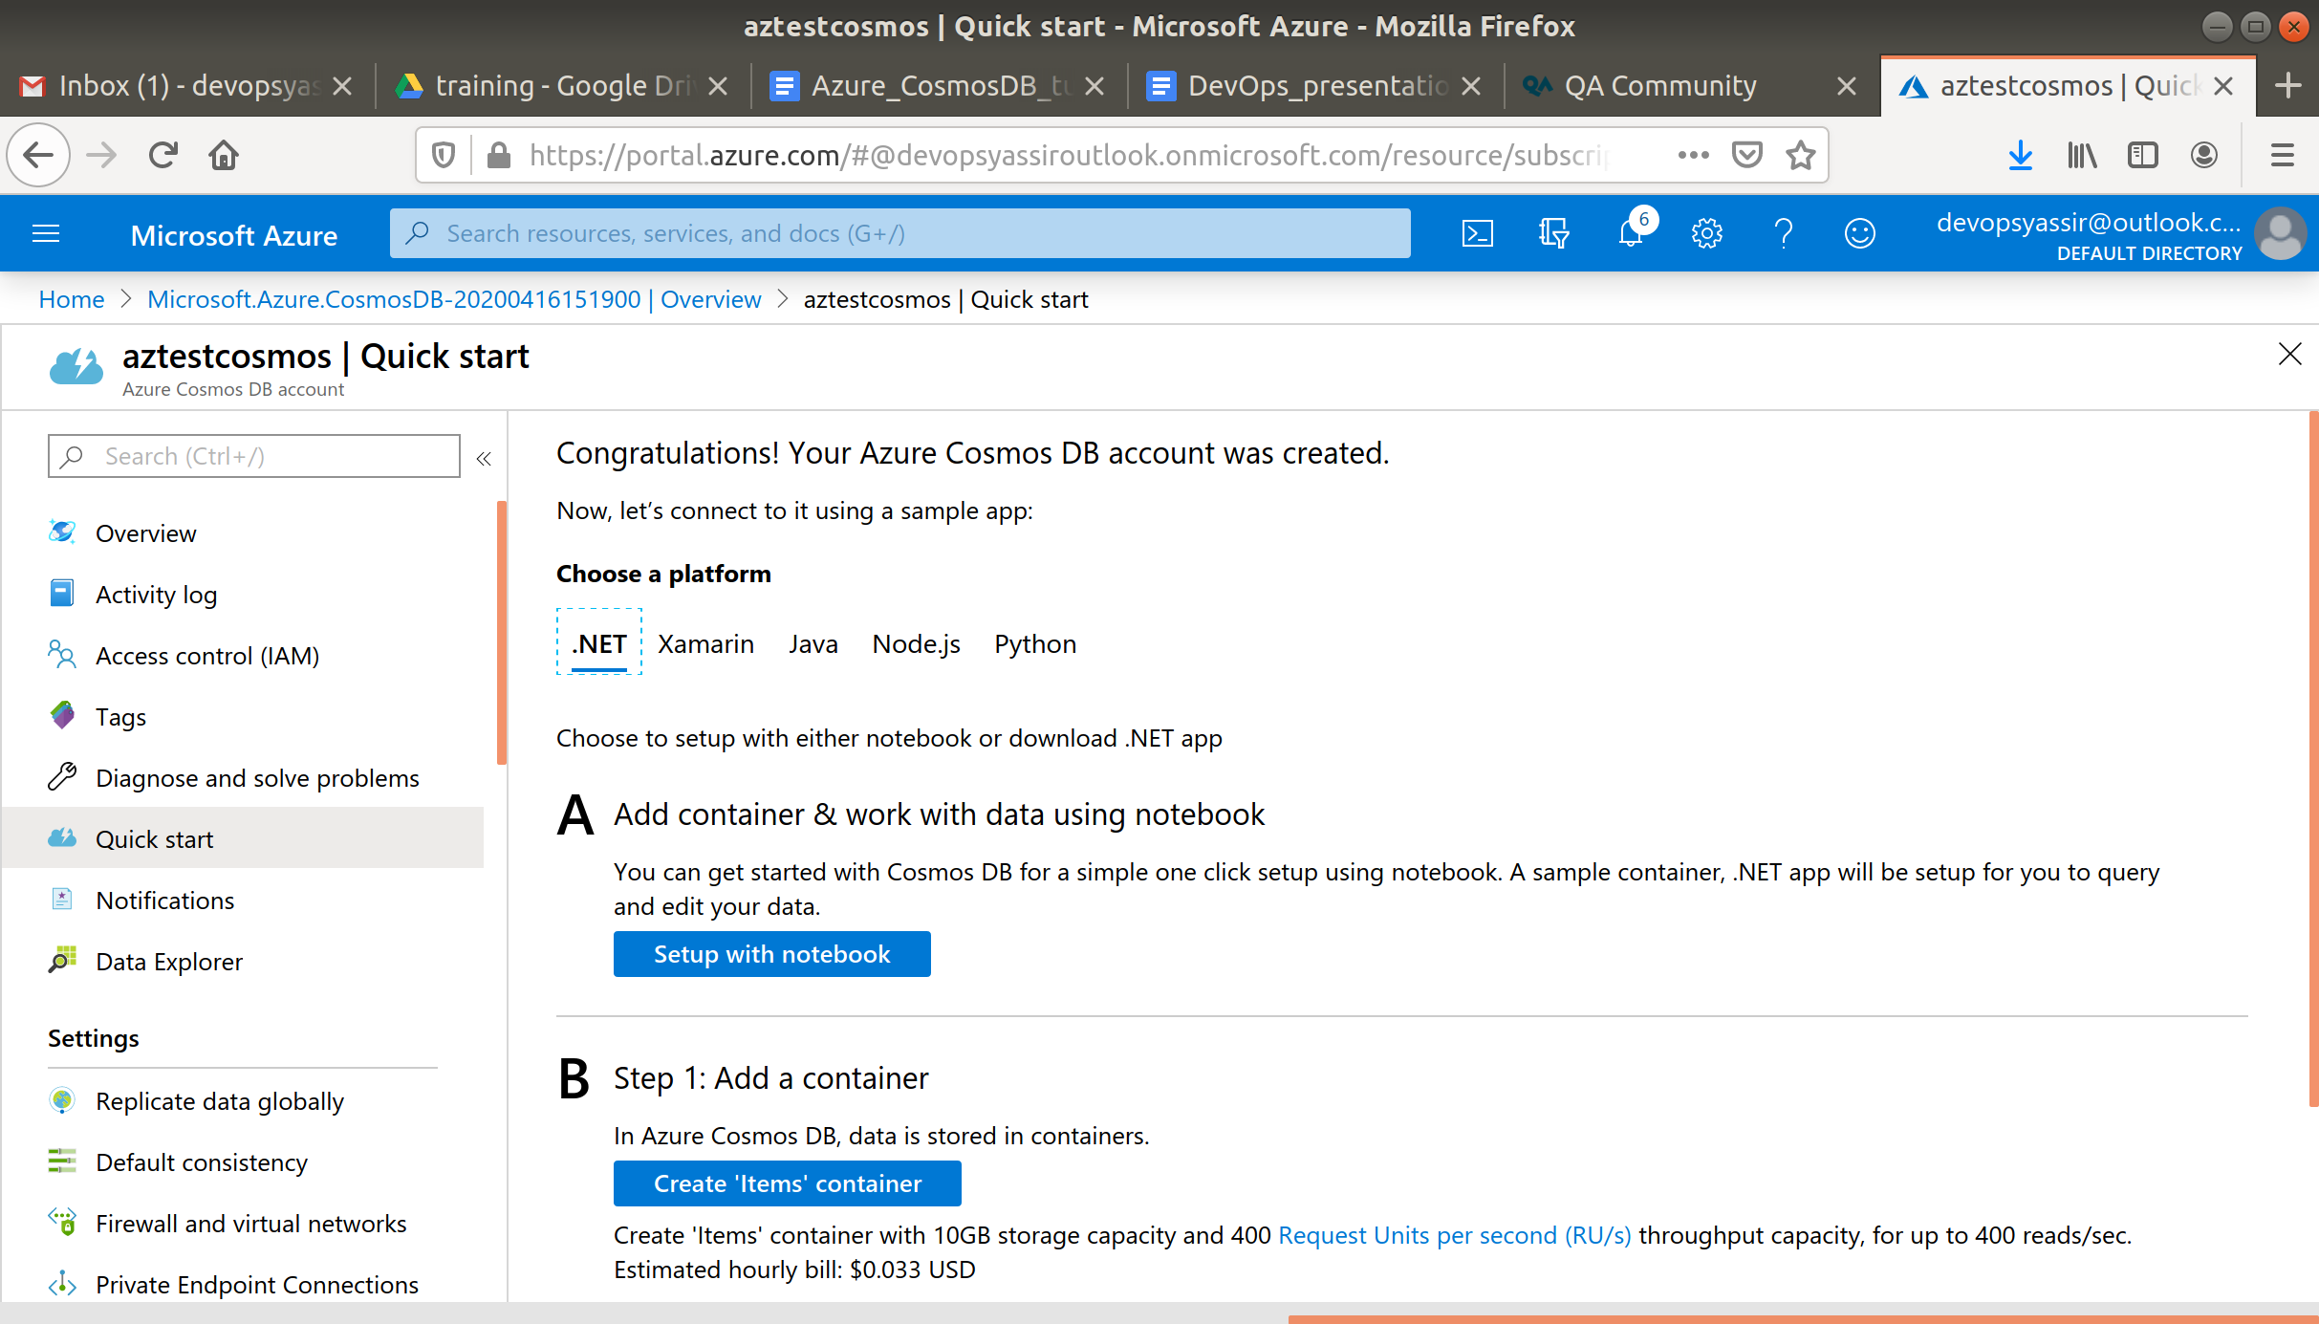

You now have a CosmosDB account!

Now we are going to add some data.

Click on your CosmosDB account and select Data Explorer in the left blade.

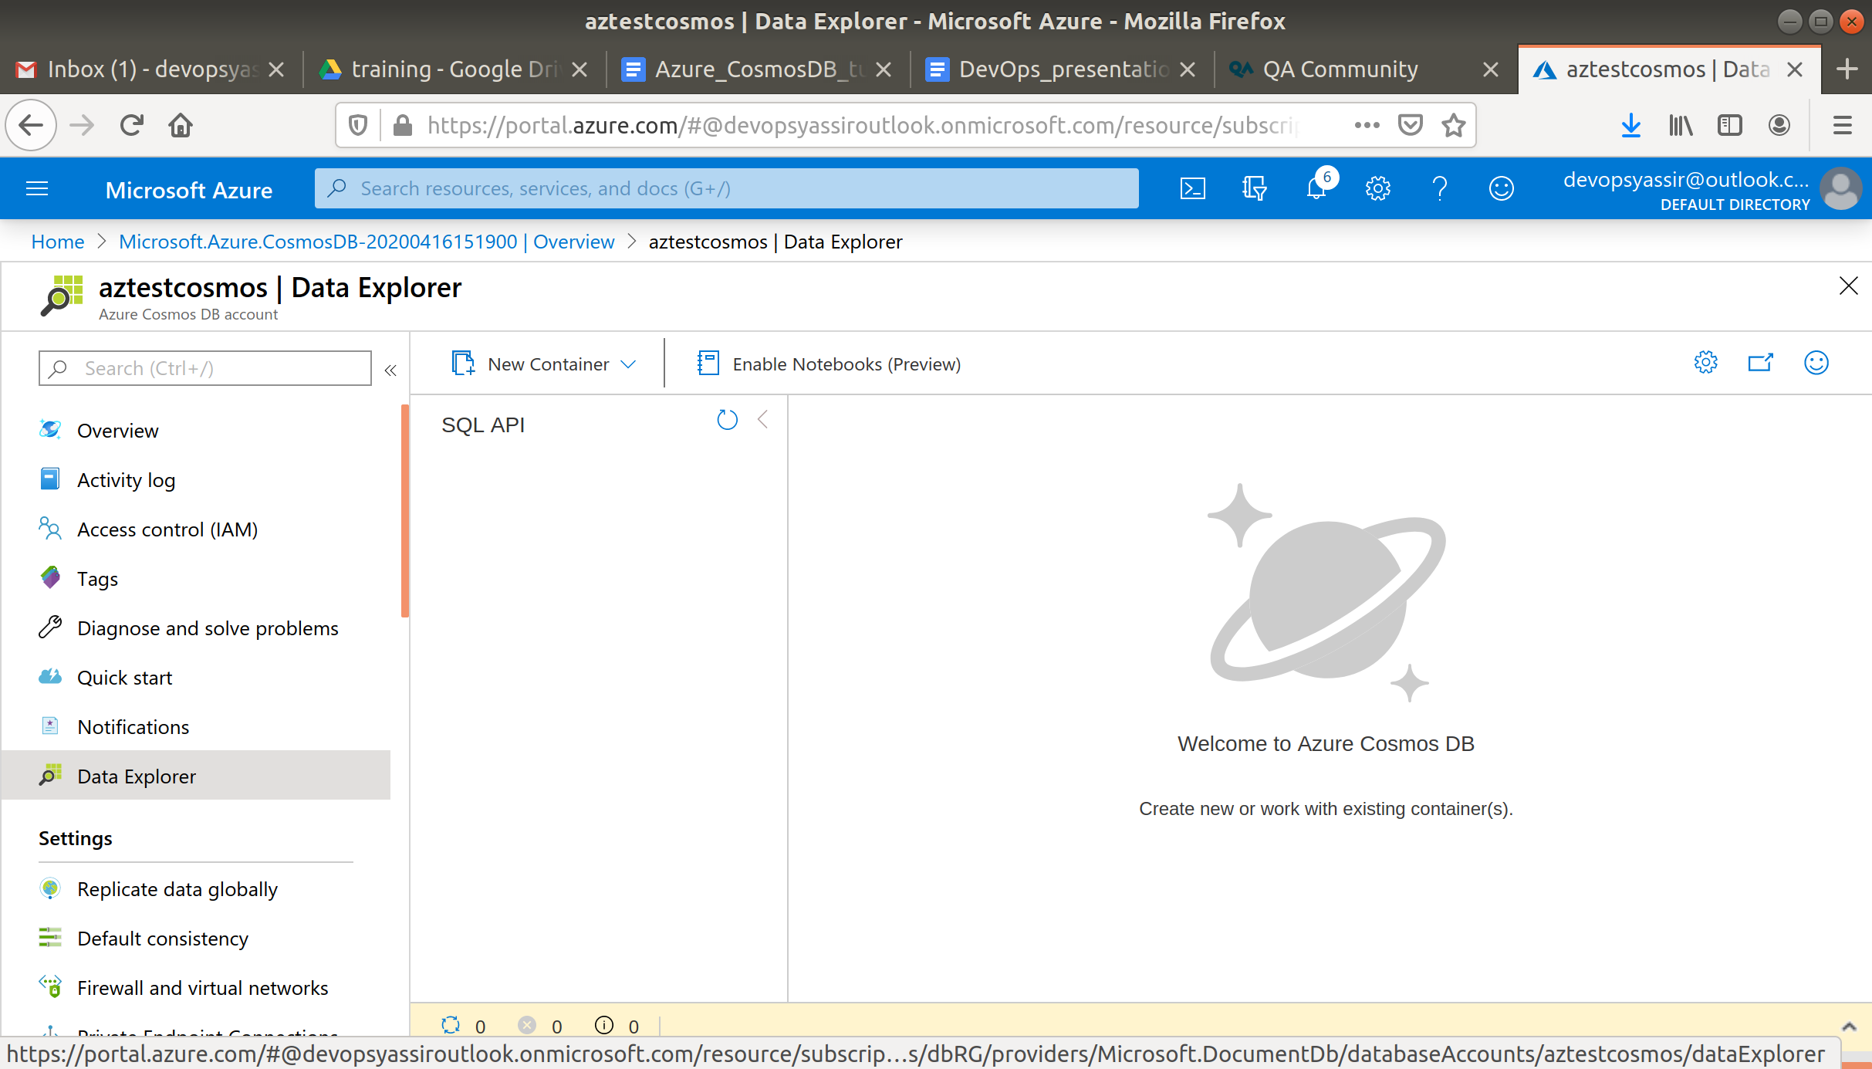

Select New container in the command bar.

new-container

When the new container form appears, enter the following:

* Database ID - Items
* Container ID - Container1
* Partition Key - /userid

Leave the other fields as their default.

Click OK.

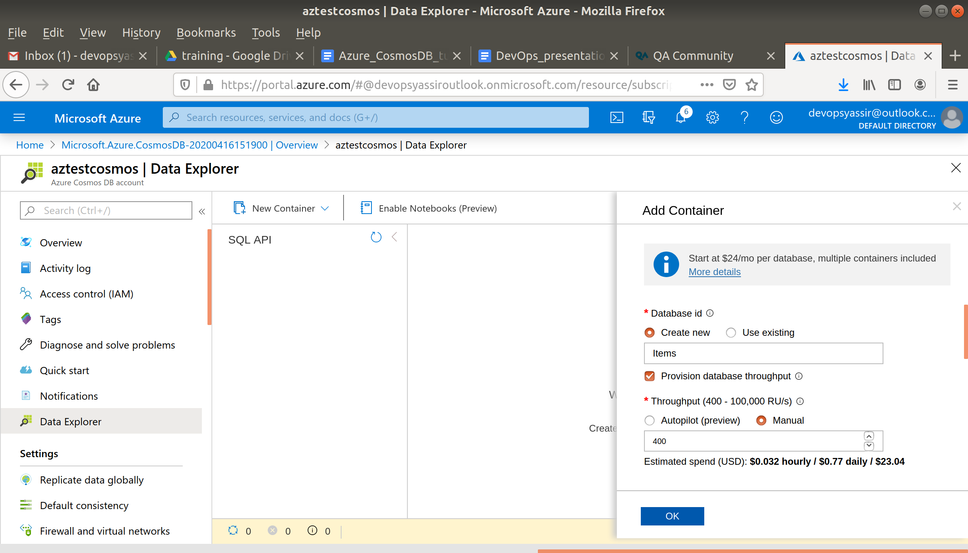

Now select Items under your SQL API and select the Items section under container1.

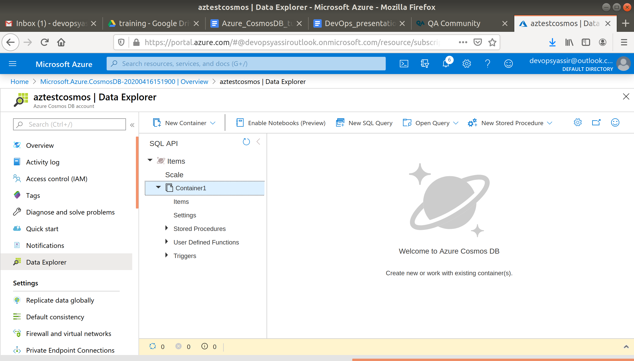

In the command bar, select New Item.

new-item

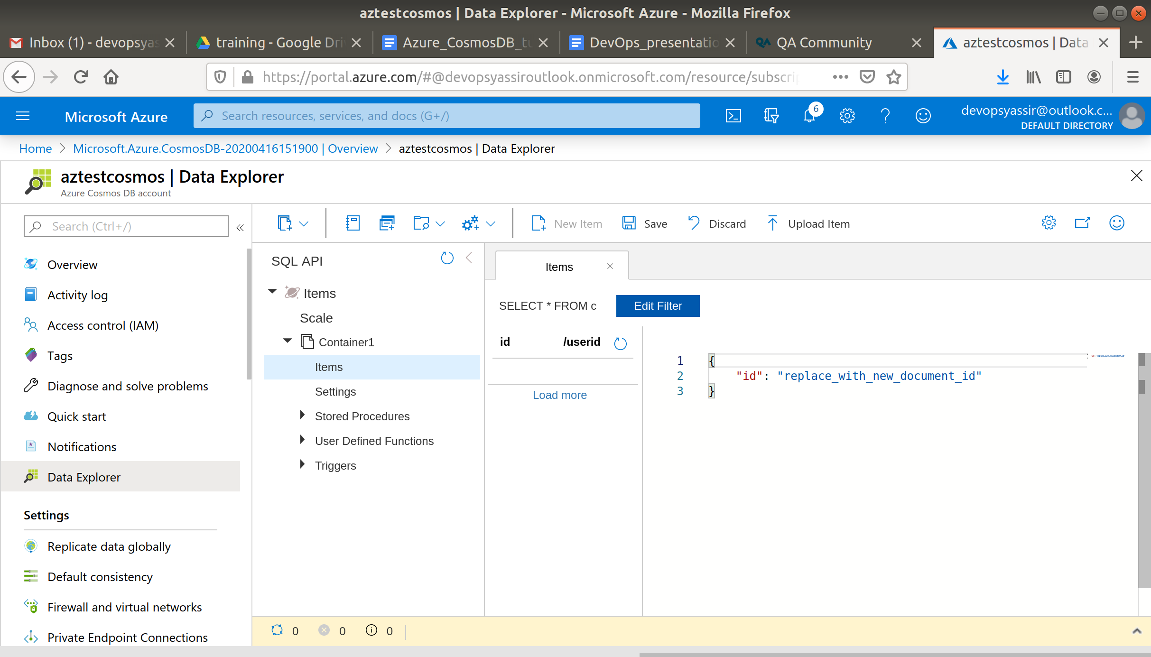

Now enter the following:

{

"id":"1",

"name":"Ben",

"favourite_sport":"Football",

"verified":false

}

And click Save.

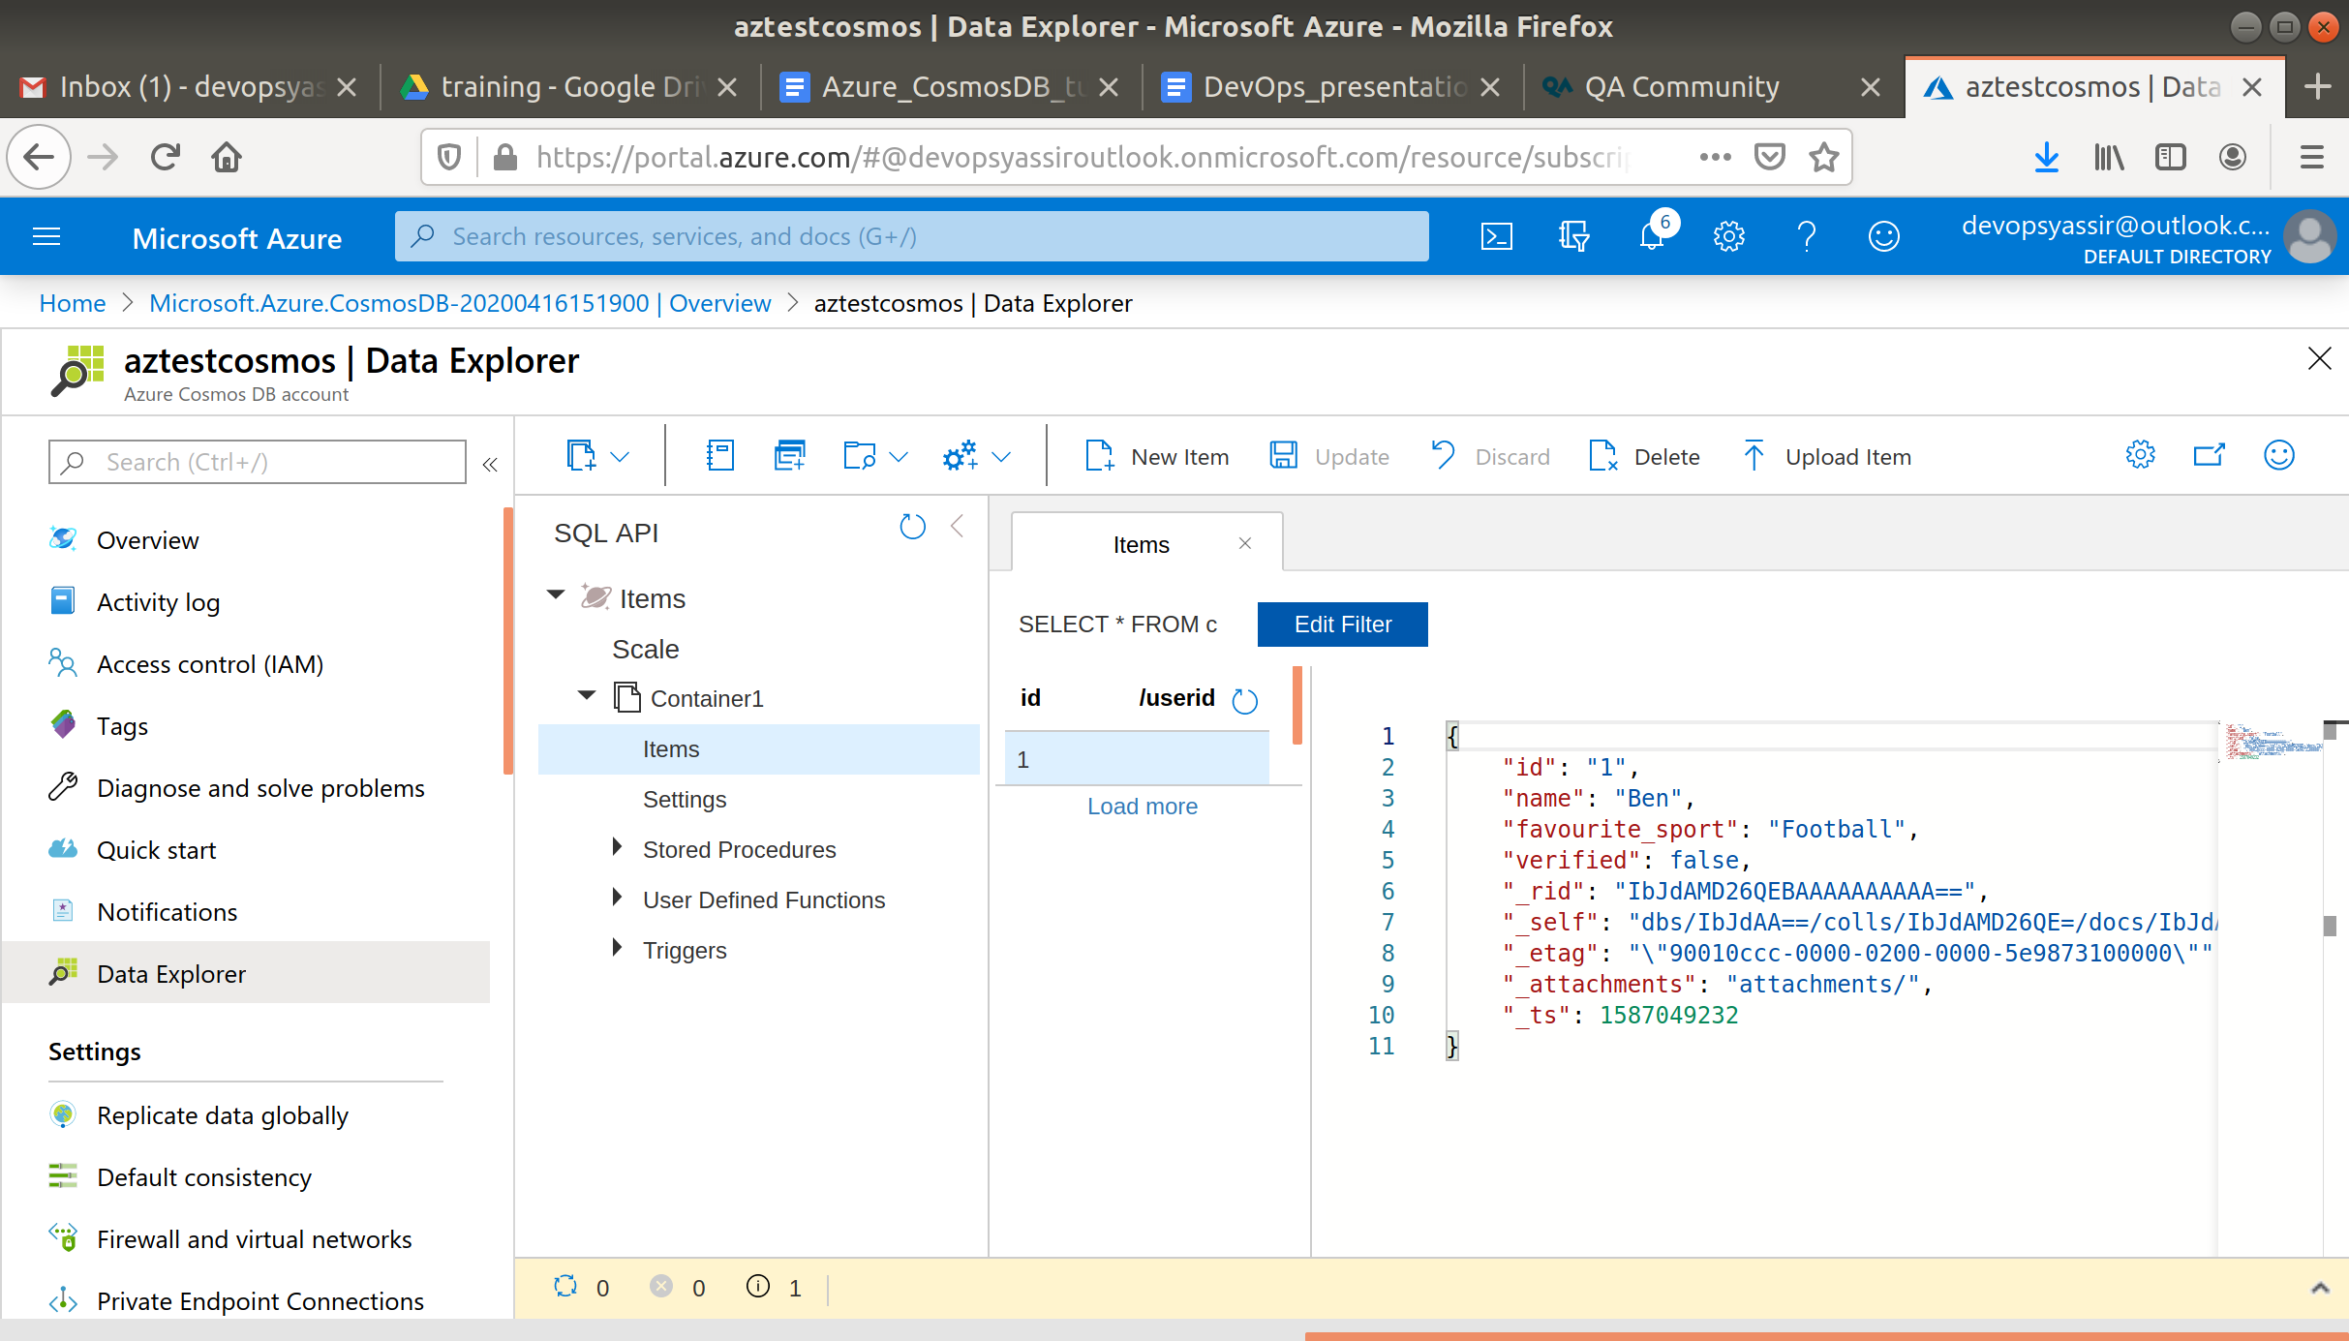

Some extra data will be automatically added.

Now enter a new item as above with some of your own data.

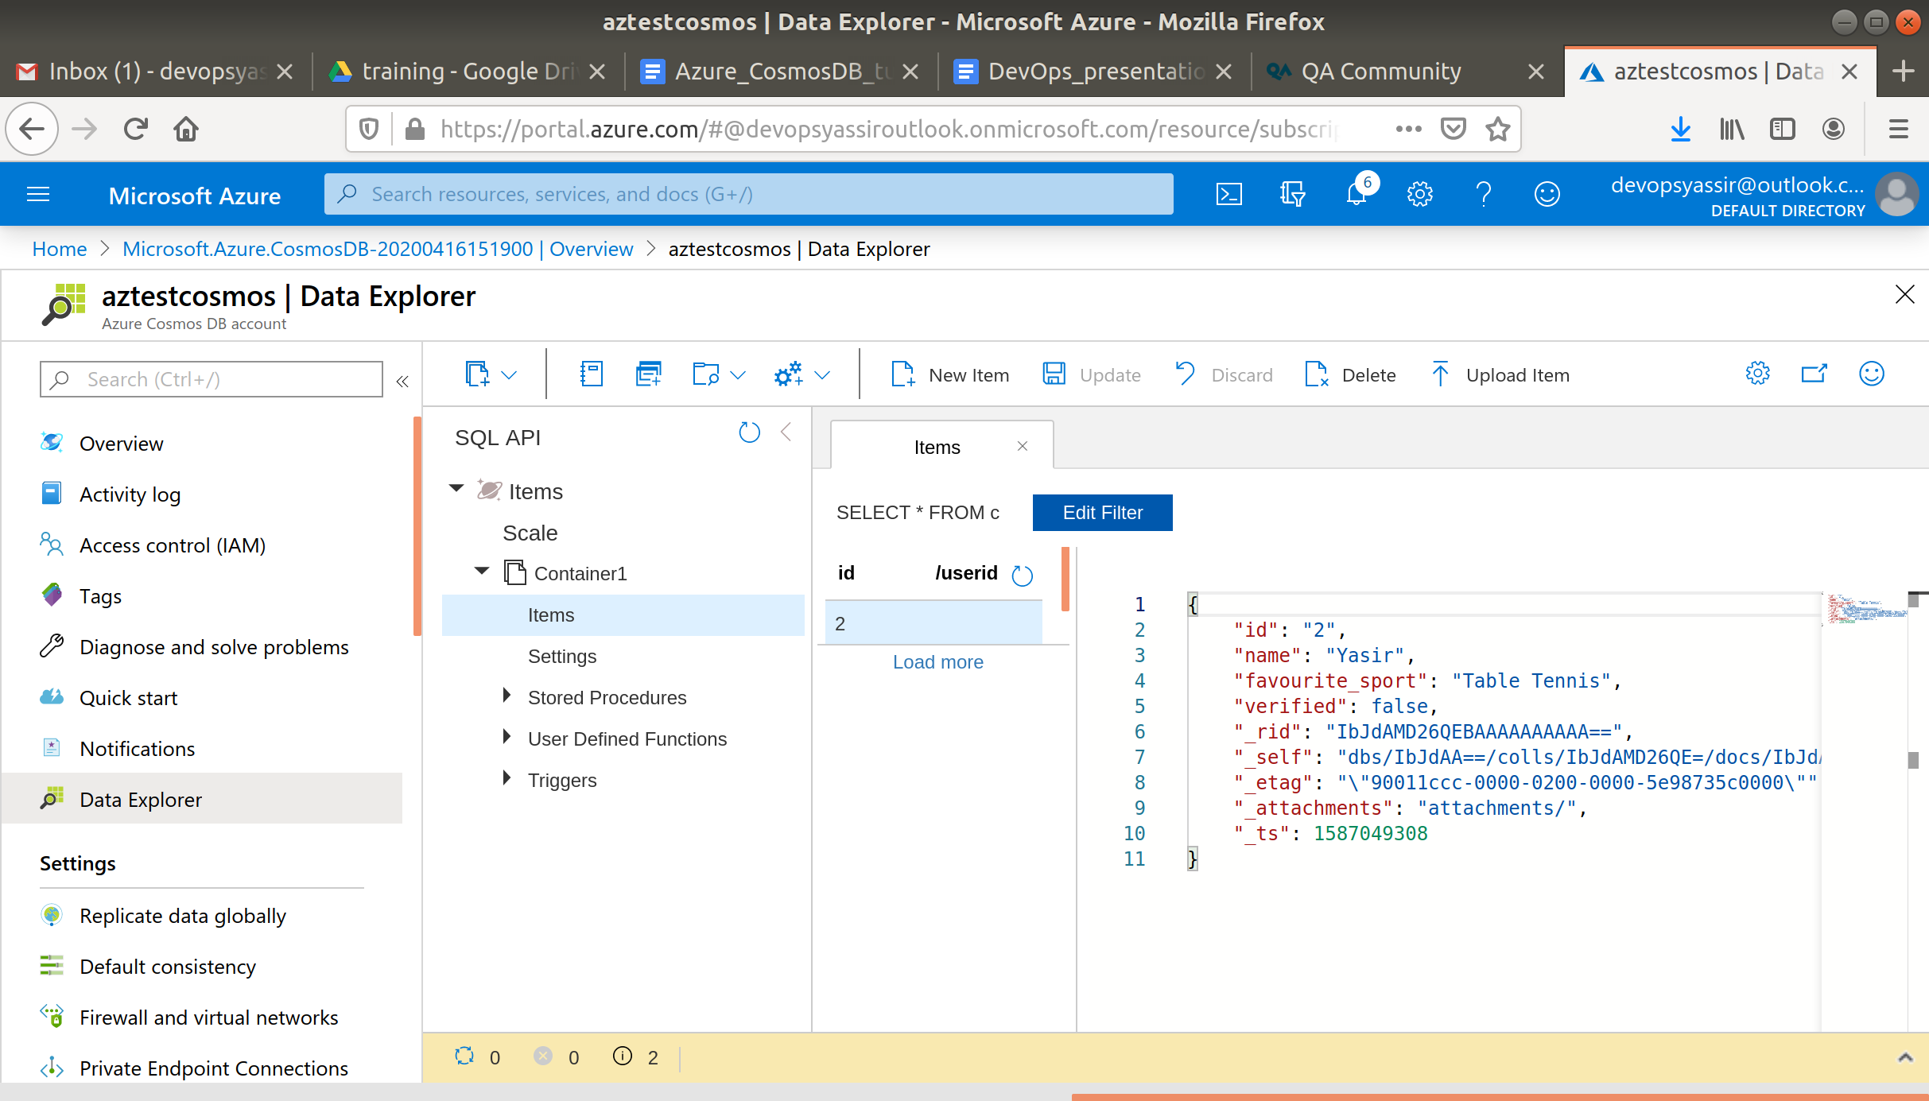

You should have 2 entries now.

Now select the Edit Filter button and enter the following:

ORDER BY c._ts DESC.

So that the whole command says:

SELECT * FROM c ORDER BY c._ts DESC

filter

Click Apply Filter.

Now your queries should be in reverse order.