# Azure IoT Fundamentals

# 

## **Exercises**

Research one example of an IoT solution you think might be used in your day-to-day life.

<https://www.uk.insight.com/en-gb/content-and-resources/articles/cloud-hub/2018-02-21-3-use-cases-for-azure-iot>

# **3 Use Cases for Azure IoT - An Architects Thoughts**

21 Feb 2018

In July 2017 Gartner included IoT platform and 5G in its top trends report called “Hype Cycle for Emerging Technologies 2017” reflecting the massive interest in this innovation triggers from big companies like Intel, HPE, Dell-EMC, IBM, and GE Digital and mostly from the big cloud providers like Microsoft Azure and Amazon AWS offerings.

IoT is an ecosystem play with a massive number of companies providing technology at the device, network, and software layer. No one vendor can do it all, nor do they have the roadmap to do it. There are industry-specific platforms, horizontally focused enterprise platforms as well as consumer-focused platforms, because of the many use cases these platforms will serve and the pivotal role they play in enabling the IoT, there are many providers of such products not just providing the sensors, gateways and hardware components but the tools, libraries, frameworks, storage, analytics and full platform solutions in the ecosystem.

5G networks will be one of the enablers for [IoT success](https://www.uk.insight.com/learn/articles/2017-11-13-is-your-business-ready-for-iot), which are projected to switch on around 2020. A current preview is happening right now by Korea Telecom (KT) deploying a 5G mobile trial platform for the 5G network at the 2018 Pyeongchang Olympic Winter Games.



*Image: 2018 Winter Olympics Open Ceremony with more than 1,200 air drones*

5G planning aims at higher capacity than current 4G, allowing a higher density of mobile broadband users, and supporting device-to-device, more reliable, and massive machine communications. Winter Olympics attendees get access to gigabit-speed wireless broadband, low-latency video, and live-streamed content at the Winter Olympic Park.

In addition to providing faster speeds, it’s predicted that 5G networks will also need to meet use cases, such as the Internet of Things (internet connected devices), as well as broadcast-like services. The IoT market is expected to grow to an installed base of 30.7bn devices in 2020 and 75.4bn in 2025 according to Forbes.

Big Data and advanced analytics skills are a highly valuable commodity in the IoT ecosystem today. IoT-enabled objects are fitted with sensors, software, electronics and connectivity and as such, vast amounts of data can be exchanged between manufacturers, operators and other internet-connected devices, but the value is providing productivity and analytics outcomes to gain operational efficiencies, advanced monitoring and predictability to businesses.

This post explores just three of many possible scenarios of how industries are using the Internet of Things for specific industries. It’s important to bear in mind that this is affecting companies in all industries, from process manufacturers, utilities and infrastructure contractors to upstream and midstream oil and gas organisations, asset management, transportation, healthcare, sports, and retail among others.

### **Scenario #1: Cyber Physical Systems**

The fourth industrial revolution discussed by world leaders at the World Economic Forum highlighted a cyber-physical systems revolution. Cyber-physical systems (CPS) are physical and engineered systems whose operations are monitored, coordinated, controlled and integrated by a computing and communication core. The [Internet of Things (IoT)](https://www.uk.insight.com/learn/articles/2017-07-06-4-ways-organisations-can-maximise-commercial-returns-from-iot) forms the foundation for this cyber-physical systems revolution. It is driving the biggest shift in business and technology since World War II.

Machines, robots, appliances and devices now interact and interface with each other as well as human beings in new ways. The combination of [artificial intelligence (AI), machine learning](https://www.uk.insight.com/learn/articles/2018-02-20-what-does-machine-learning-mean-for-the-enterprise), the cloud, and IoT means that systems of machines will be able to interact with human beings, learn about them and adapt to their habits and needs.

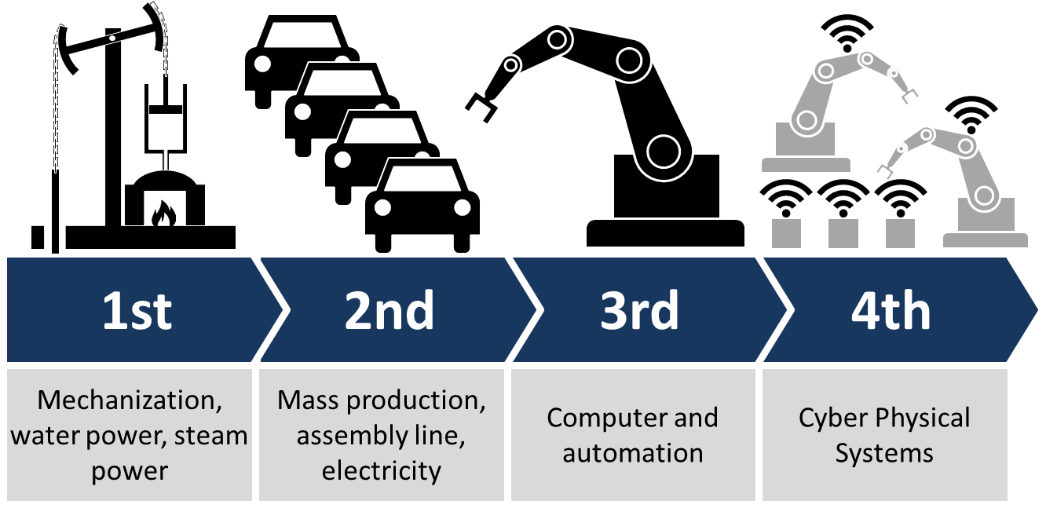

*Figure 1. CPS and the 4th Industrial Revolution*

"Just as the internet transformed how humans interact with one another, cyber-physical systems will transform how we interact with the physical world around us." (IEEE.org)

Cyber-physical systems will bring advances in personalized health care, emergency response, traffic flow management, and electric power generation and delivery, as well as in many other areas now just being envisioned. Other phrases that you might hear when discussing these and related CPS technologies include: Industrial Internet, Smart Cities, Smart Grid, "Smart" Anything (e.g., Cars, Buildings, Homes, Manufacturing, Hospitals, Appliances). Some specific cases:

* CPS’s are used in research in the neuroscience field to better understand human functions with the support of brain-machine interfaces and therapeutic robotics.
* CPS’s can improve processes among the industrial machines, manufacturing supply chain, suppliers, business systems, and customers processes by sharing real-time information, self-monitoring and controlling the entire production processes and then adapting production to satisfy customers' preferences.
* CPS’s in the renewable energy environment, smart grids are CPS’s where sensors and other devices monitor the grid to control it and provide better reliability and improve the energy efficiency.

### **Scenario #2: Smart Stadiums**

A smart stadium integrates a massive number of sensors, cameras, devices, kiosks, VR/augmented/mixed reality headsets, and digital signs that connect to wireless networks, and servers.

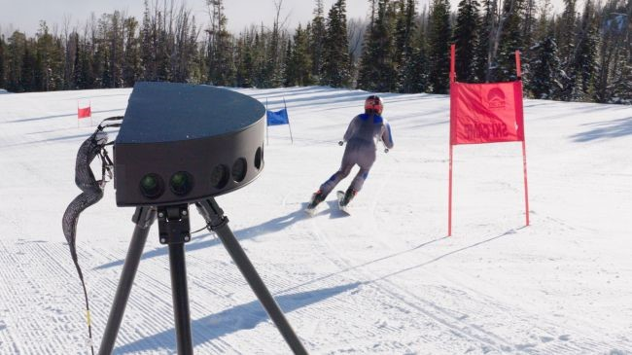

*Image: VR broadcasting at 2018 Pyeongchang Winter Olympic Games*

Personalization is a key component of VR broadcasts and adoption, because users can pick and choose their experience, two different people in the same place might be watching the same event at the same time, but one could be in one part of the arena, and the other could be in another part of the arena. To add to this another person could be in the VR Cast… and they're all experiencing it in a completely different way. Even in a specific camera angle, one may be interested in one team and the second person may be interested in the other team. People were able to jump around to different cameras placed around the outdoor courses and arenas.

Leading tech companies are reshaping the sports and entertainment industries for both sponsors and fans with new tools, apps and mobile platforms to enhance the overall experience. Stadium Wi-Fi, apps and LTE networks enable marketers to connect with fans on a whole new level, interacting with them individually, in a far smarter way. The event and/or stadium app can direct fans to the best place to park as they approach the stadium, it can lead them to their seats, offer upgrades, food, merchandising products or even guide them to the shortest line for the bathroom.

Generally speaking smart stadiums solutions could increase operational efficiency with improved building management, ensure a more fun fan experience and at the same time improve stadium security and risk management.

A smart stadium architecture diagram (Figure 2) requires a sophisticated mix of [hardware, software and wireless connectivity](https://www.uk.insight.com/solve/) to establish communication links between stadium operators, fans, broadcasting services and social networks. In short, they collect and analyse real-time streaming data using a cloud infrastructure, allowing stadium operators to make data-driven decisions that impact many aspects of the business.

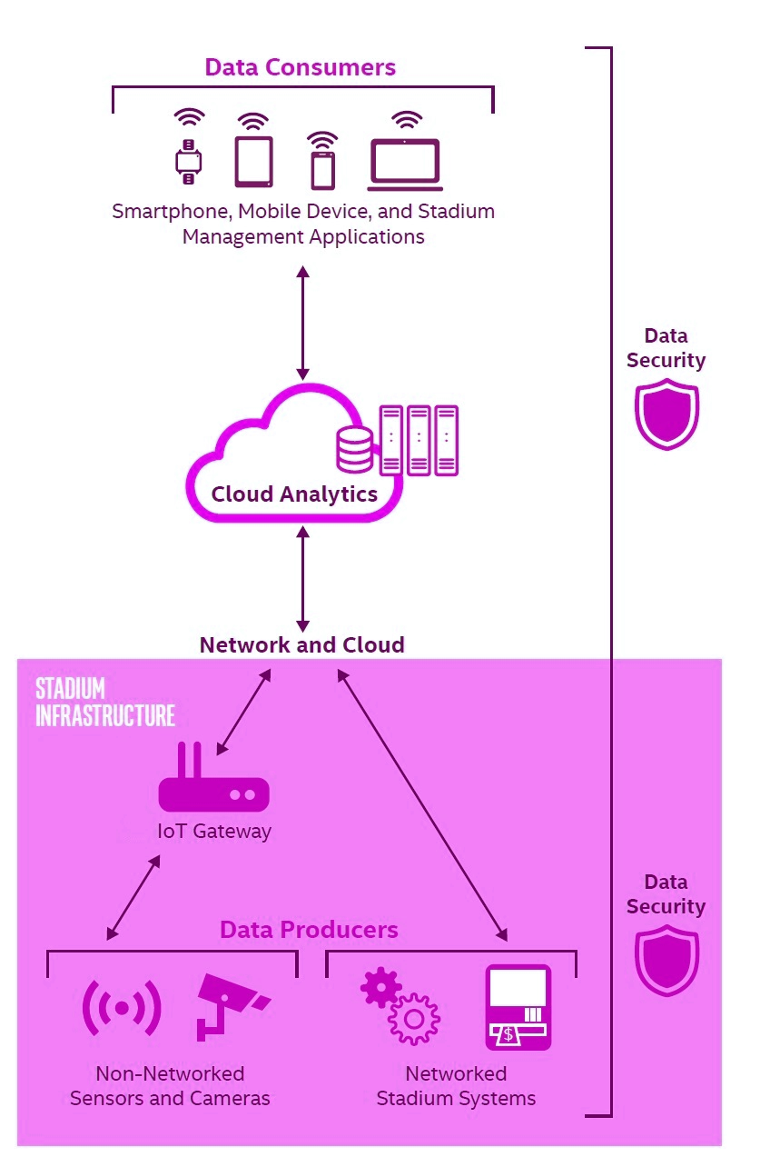

*Figure 2. Smart Stadium Architecture*

### **Scenario #3: Connected Vehicles**

Digital transformation is fundamentally reshaping the transportation and automotive industry thanks to changing customer expectations and the hyper-scale power of the cloud, advanced analytics, the Internet of Things (IoT). It’s predicted that more than 200million connected cars will be on the roads by 2020.

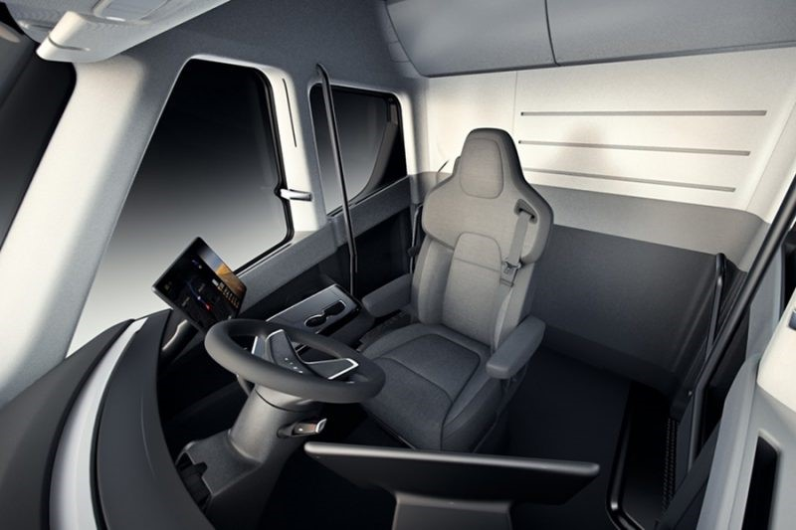

*Image: Tesla Semi lorry cab interior design with a centre seat flanked by two touch screens.*

The recent launch of the fully electric lorry Tesla Semi in November 2017, shows that many pioneering companies in Silicon Valley are focusing on driverless, smart and connected vehicles, through projects that explore electric cars, solar roofs and power storage.

Vehicles are increasingly becoming connected, creating new opportunities for automotive manufacturers (OEMs), tier one suppliers and ecosystem partners. A connected vehicle solution is the starting point for seizing these opportunities.

A Connected Vehicle Solution consists of a comprehensive set of services and products that span across the physical (car) and digital (cloud) world, with a focus on addressing commonly required use cases. These include telematics and predictive maintenance services, productivity and digital life, connected advanced driver assistance systems (ADAS), advanced navigation, and customer insights and engagement. Within these use cases, the number of applicable scenarios is nearly limitless.

### **Microsoft Connected Vehicle Platform Elements**

The Microsoft Connected Vehicle Platform foundations is built on a set of core cloud services and productivity products. These include Microsoft Azure IoT Hub and related IoT services, Cortana Intelligence Suite and related analytics services, CRM integration, and a host of supporting capabilities for API management, location-based services, time series capabilities and graph services.

The platform is also architected to integrate with productivity tools like Microsoft Office 365, Cortana (an intelligent digital personal assistant) and Skype for Business.

At the communications layer, Azure IoT Hub is used to communicate to send and receive messages from the car to the cloud. Additional core components process commands, store data, and create schedules and notifications, while extensions are used to create specific business case scenarios. These scenarios are powered by analytics capabilities in Azure: Stream Analytics, Data Lake Store and Data Lake Analytics for big data ingestion and analysis, and Machine Learning for predictive insights.

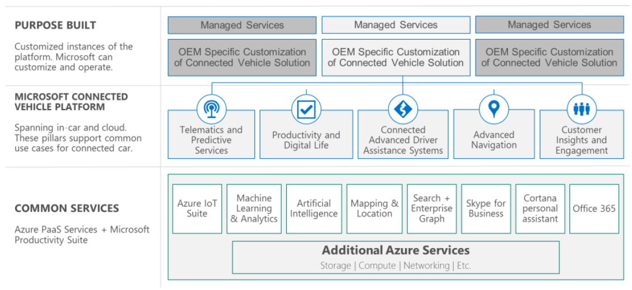

*Figure 3. Microsoft Connected Vehicle Platform at a glance*

The Microsoft Connected Vehicle Platform pulls the required capabilities for manufacturers (OEMs), suppliers and ecosystem partners together, including big data, information management, data modeling, data visualization, predictive analytics, machine learning and deep learning. Two of the key workloads included in this platform are:

* **Artificial Intelligence (AI) capabilities**. Microsoft offers a range of [AI capabilities](https://azure.microsoft.com/en-gb/overview/ai-platform/) that OEMs and tier one suppliers can build and customise into their solutions. These include cognitive services, a collection of intelligent APIs that can interpret speech, recognize faces and emotions, understand natural language, and more. Using these capabilities, connected car solutions can interact with drivers to promote better experiences—for example, a car could recognise driver emotion and fatigue, and react accordingly. When combined with analytics like machine learning, connected car solutions can use human-computer interactions to support intuitive, predictive, and personalized recommendations.
* **Internet of Things (IoT) expertise**. Microsoft’s approach to connected cars is supported by decades of experience in the connected things space, from machine to machine (M2M) technologies, to Windows Embedded, and now [Microsoft Azure IoT services](https://www.microsoft.com/en-gb/internet-of-things/azure-iot-suite). Platform capabilities include device management, preconfigured solutions for common scenarios, real-time, streaming data processing, and other services necessary for working with connected devices at scale.

### **Key Takeaways**

There are many ways to adopt and accelerate IoT solutions at the enterprise level to do a successful digital transformation and innovation roadmap.

Some of the uses cases discussed in this blog post are relevant to specific industries, but the same technologies, solutions and platforms could be applied to any company regardless of the industry, size or location.

A good starting point could be using one of the IoT preconfigured solutions available in Azure. You can used it to learn about common patterns in IoT solution design and development. A preconfigured solution is open source implementation of a common IoT solution patterns that you can deploy to Azure using your current subscription. Each preconfigured solution is a complete, end-to-end implementation that can use simulated or physical devices to generate telemetry, combining custom code and Azure services to implement a specific IoT scenario. You can customise any of the scenarios to meet your specific requirements. These scenarios include:

* Visualise data on a rich dashboard for deep insights and solution status.
* Configure rules and alarms over live IoT device telemetry.
* Schedule device management jobs, such as updates to software and configuration.
* Provision your own custom physical or simulated devices.
* Troubleshoot and remediate issues within your IoT device groups.

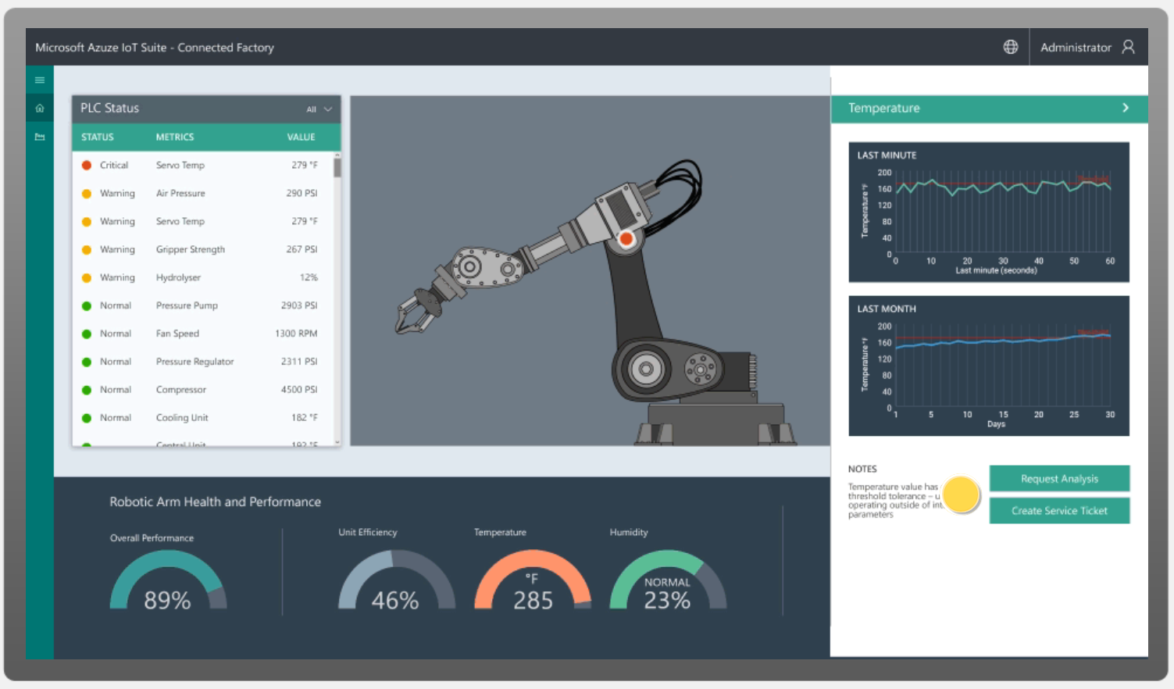

*Figure 4. Azure IoT Suite - Connected Factory dashboard*

Three [preconfigured solutions](https://docs.microsoft.com/en-us/azure/iot-suite/iot-suite-what-are-preconfigured-solutions) are available today:

* Remote monitoring
* Predictive maintenance
* Connected factory