# Azure IoT Central

## Tutorial

In this tutorial we will create an IoT application and look around the UI.

### **New Resource Group**

The first thing is to create a new resource group, which we can do by clicking the burger bar in the top left corner and choosing Resource groups:

Then, we can click +Add:

Here, we can name the resource group and pick a location to have it in:

Lastly, we will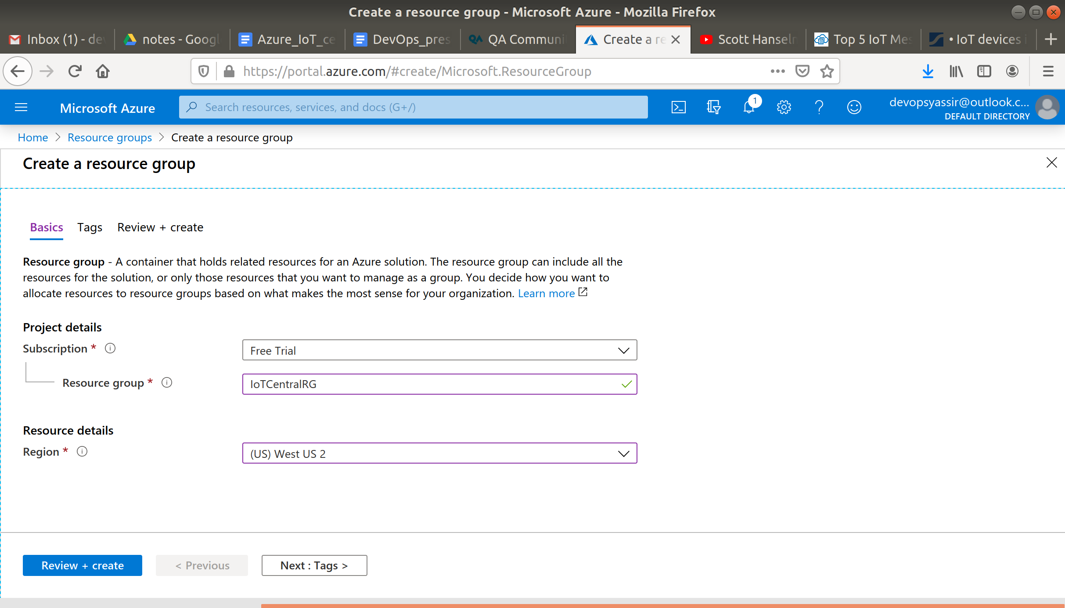 click Review & Create and then Create to create the resource group:

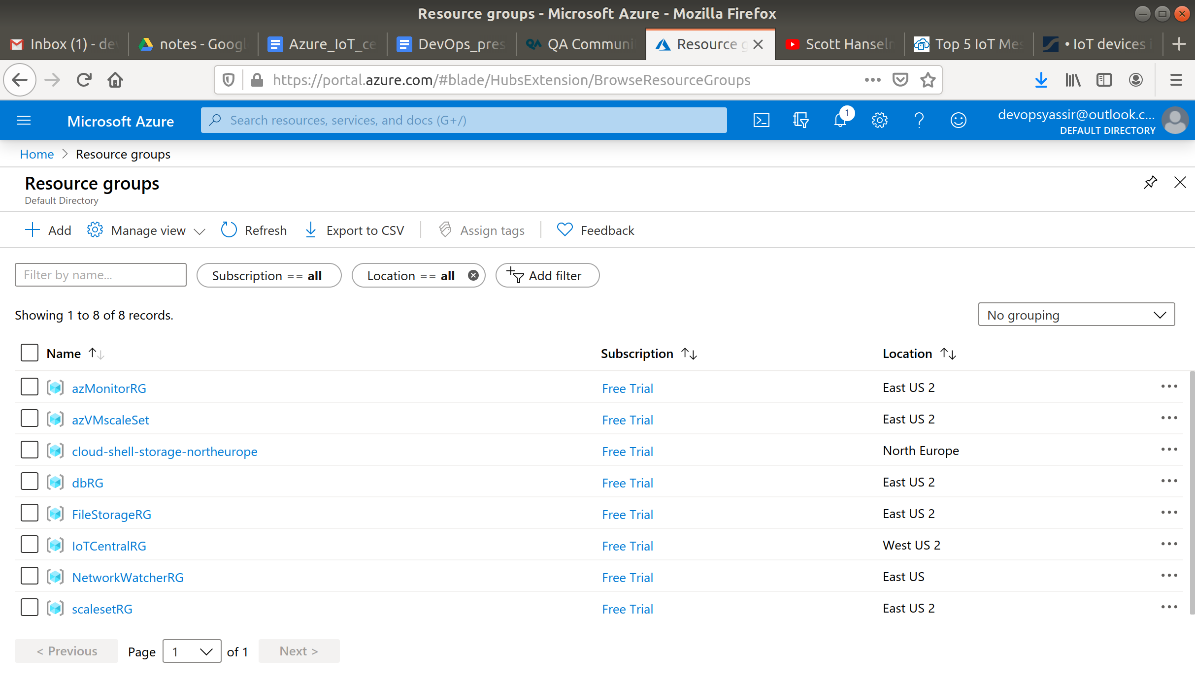

### **New IoT Application**

Type in IoT Central Applications in the search bar and select it.

Click +Add.

Now enter the following:

* Resource Name - Enter a name, it must be unique
* Resource URL - This will be filled in for you
* Resource Group - The group we just created
* Template - Preview Application
* Location - Europe

Leave the rest as their default.

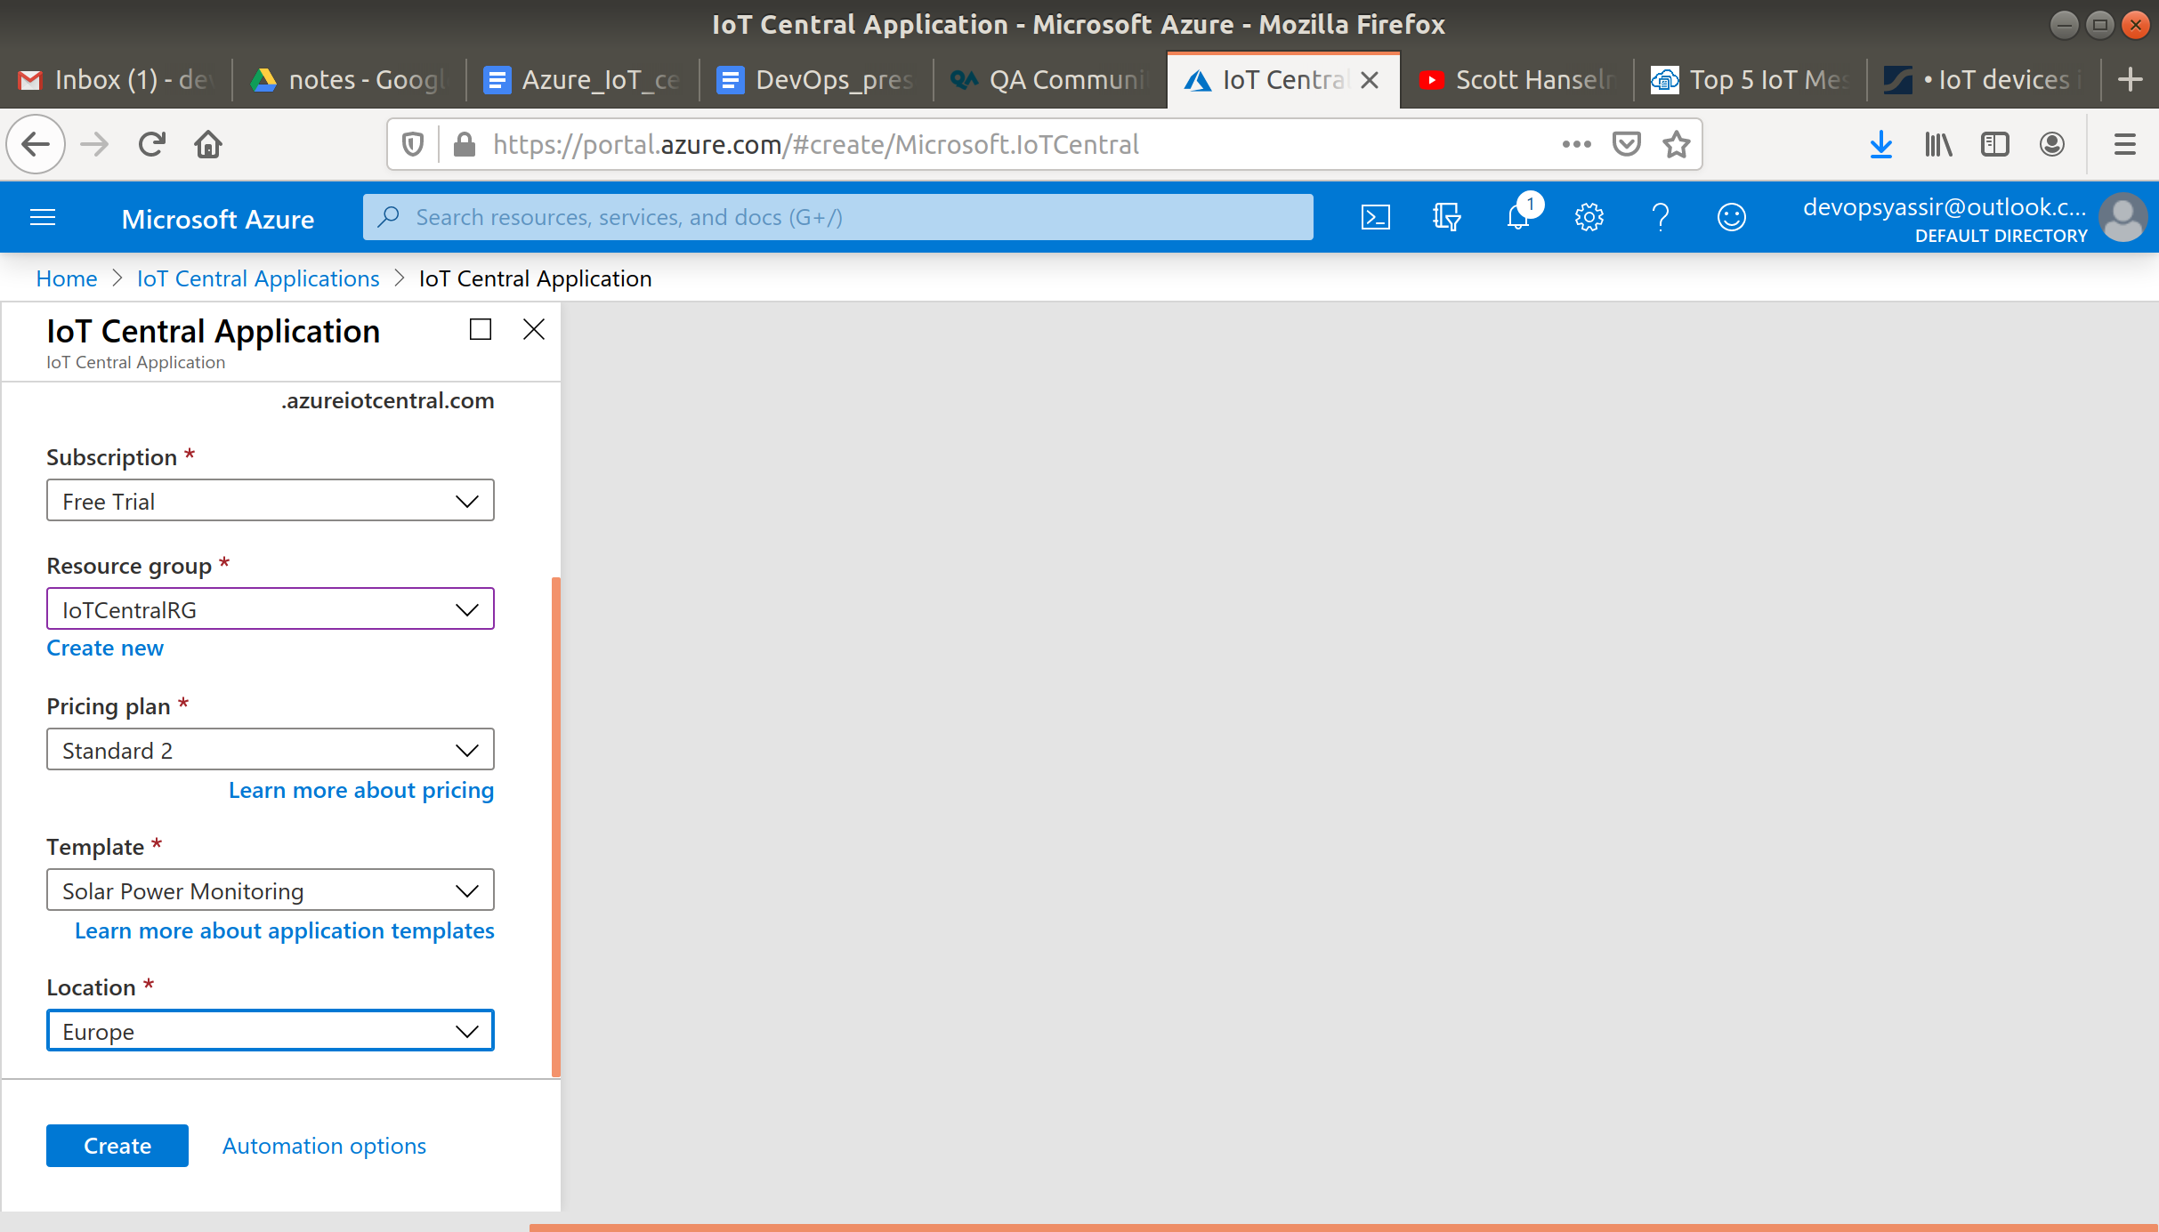

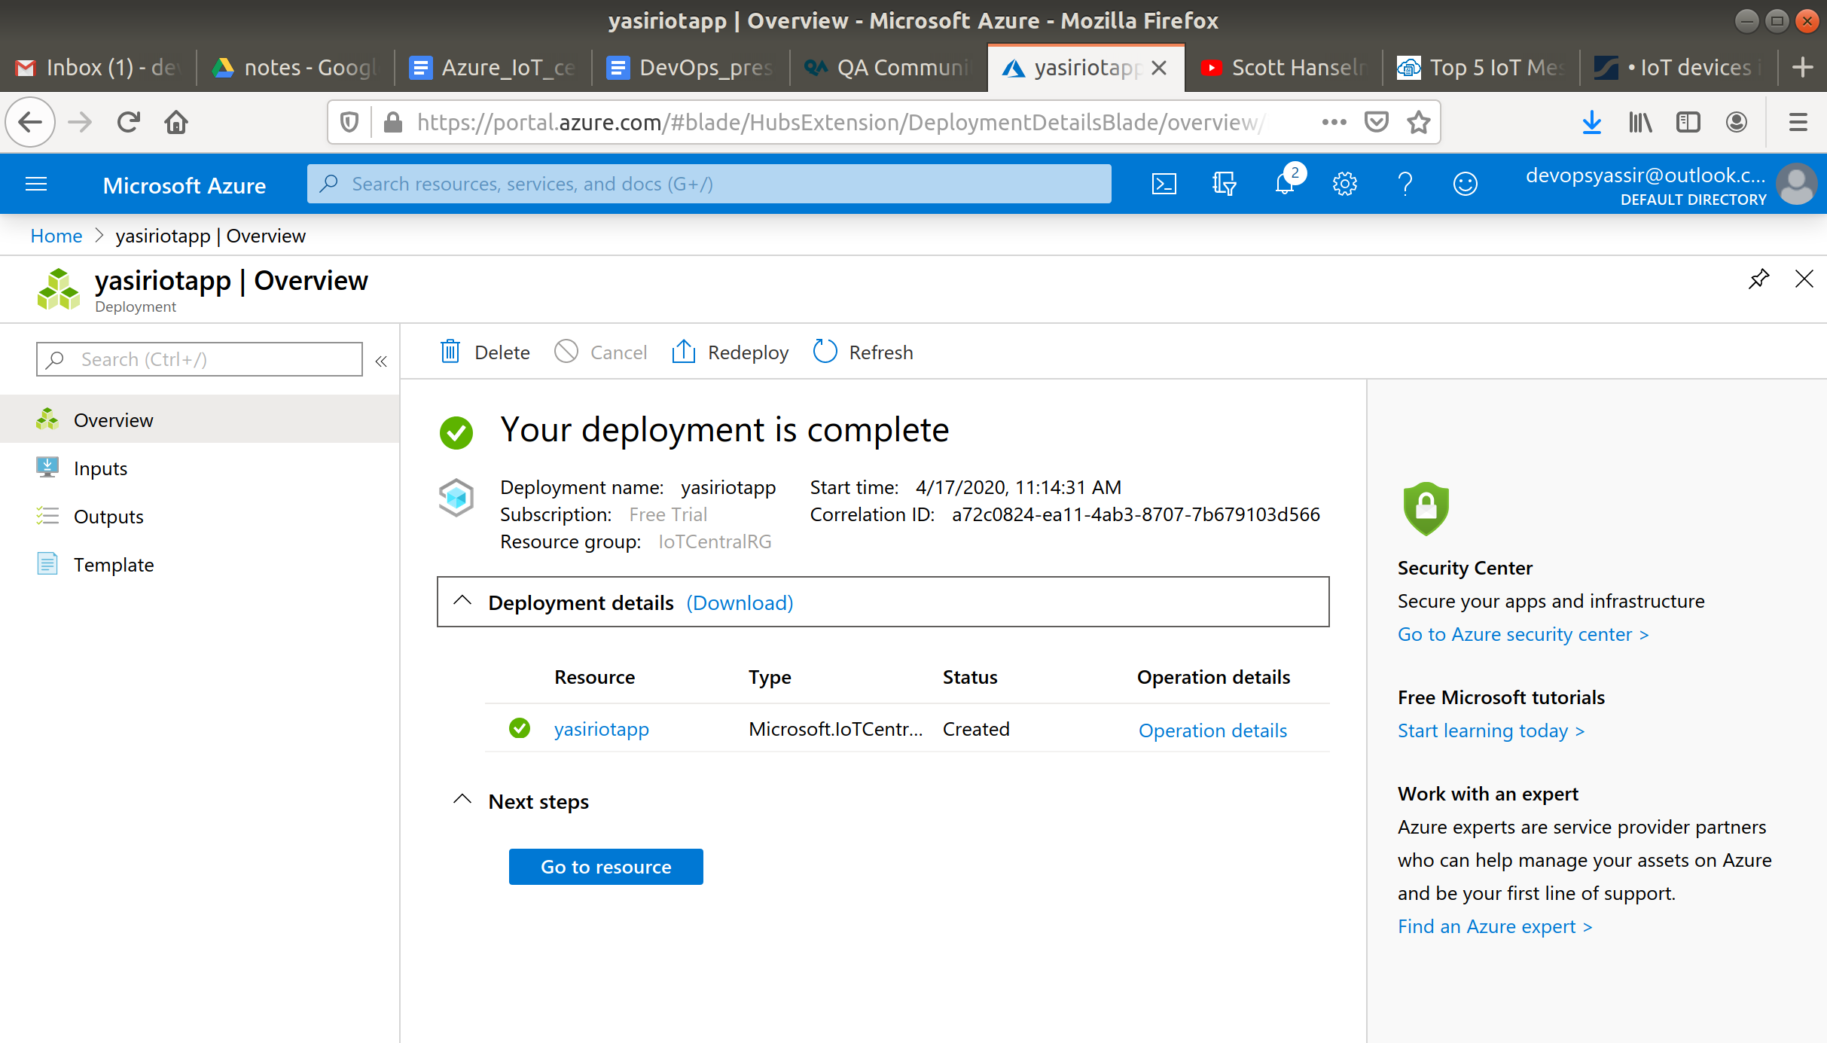

When it has finished deploying, go to the resource.

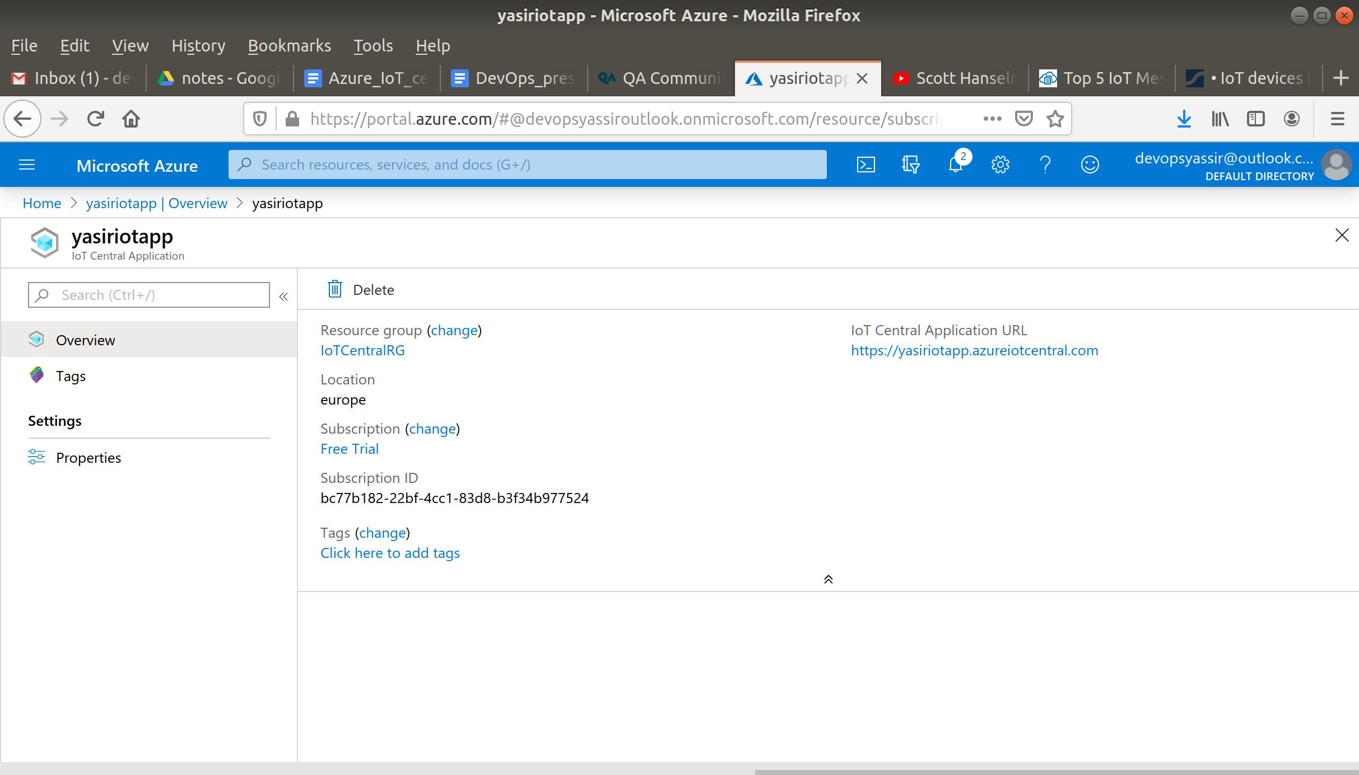

Copy the URL of the application and enter it into the browser.

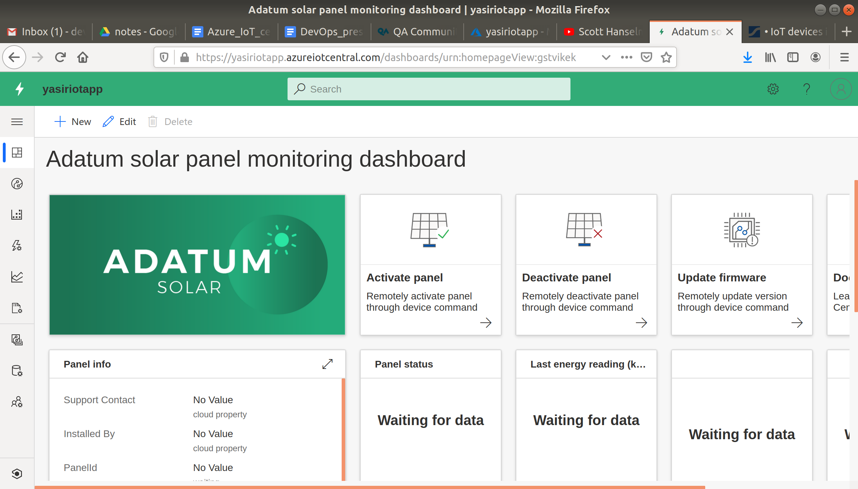

In the left blade you can see every tool you need, devices, rules, analytics, device templates etc.

Go to Device Templates and click +New.

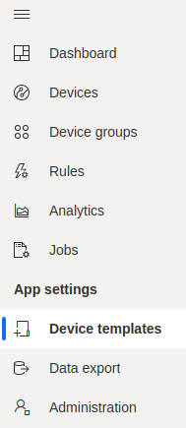

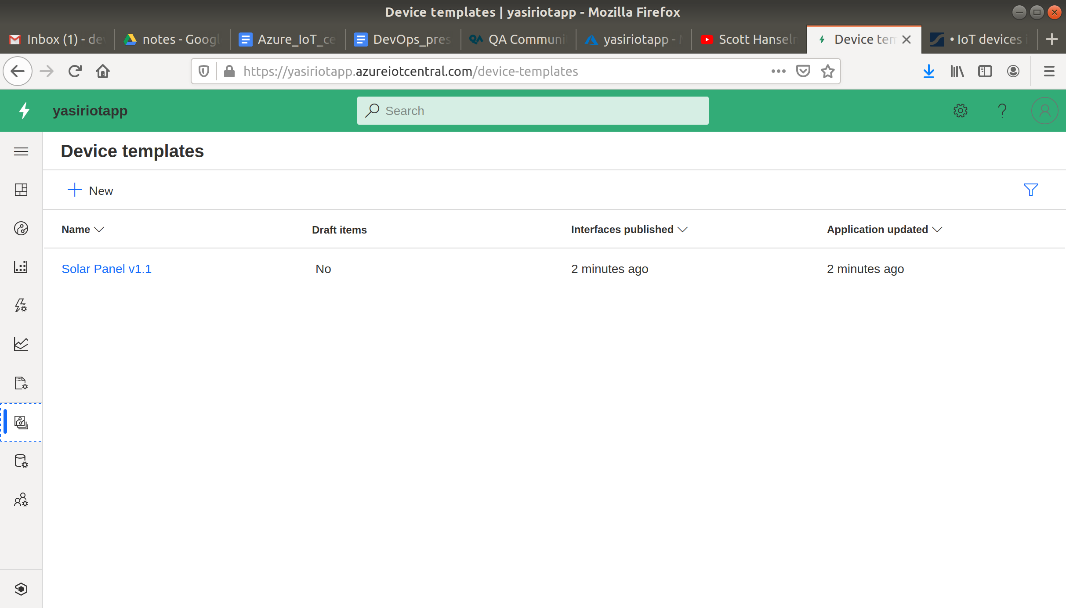

Here you can see many different IoT device templates and examples.

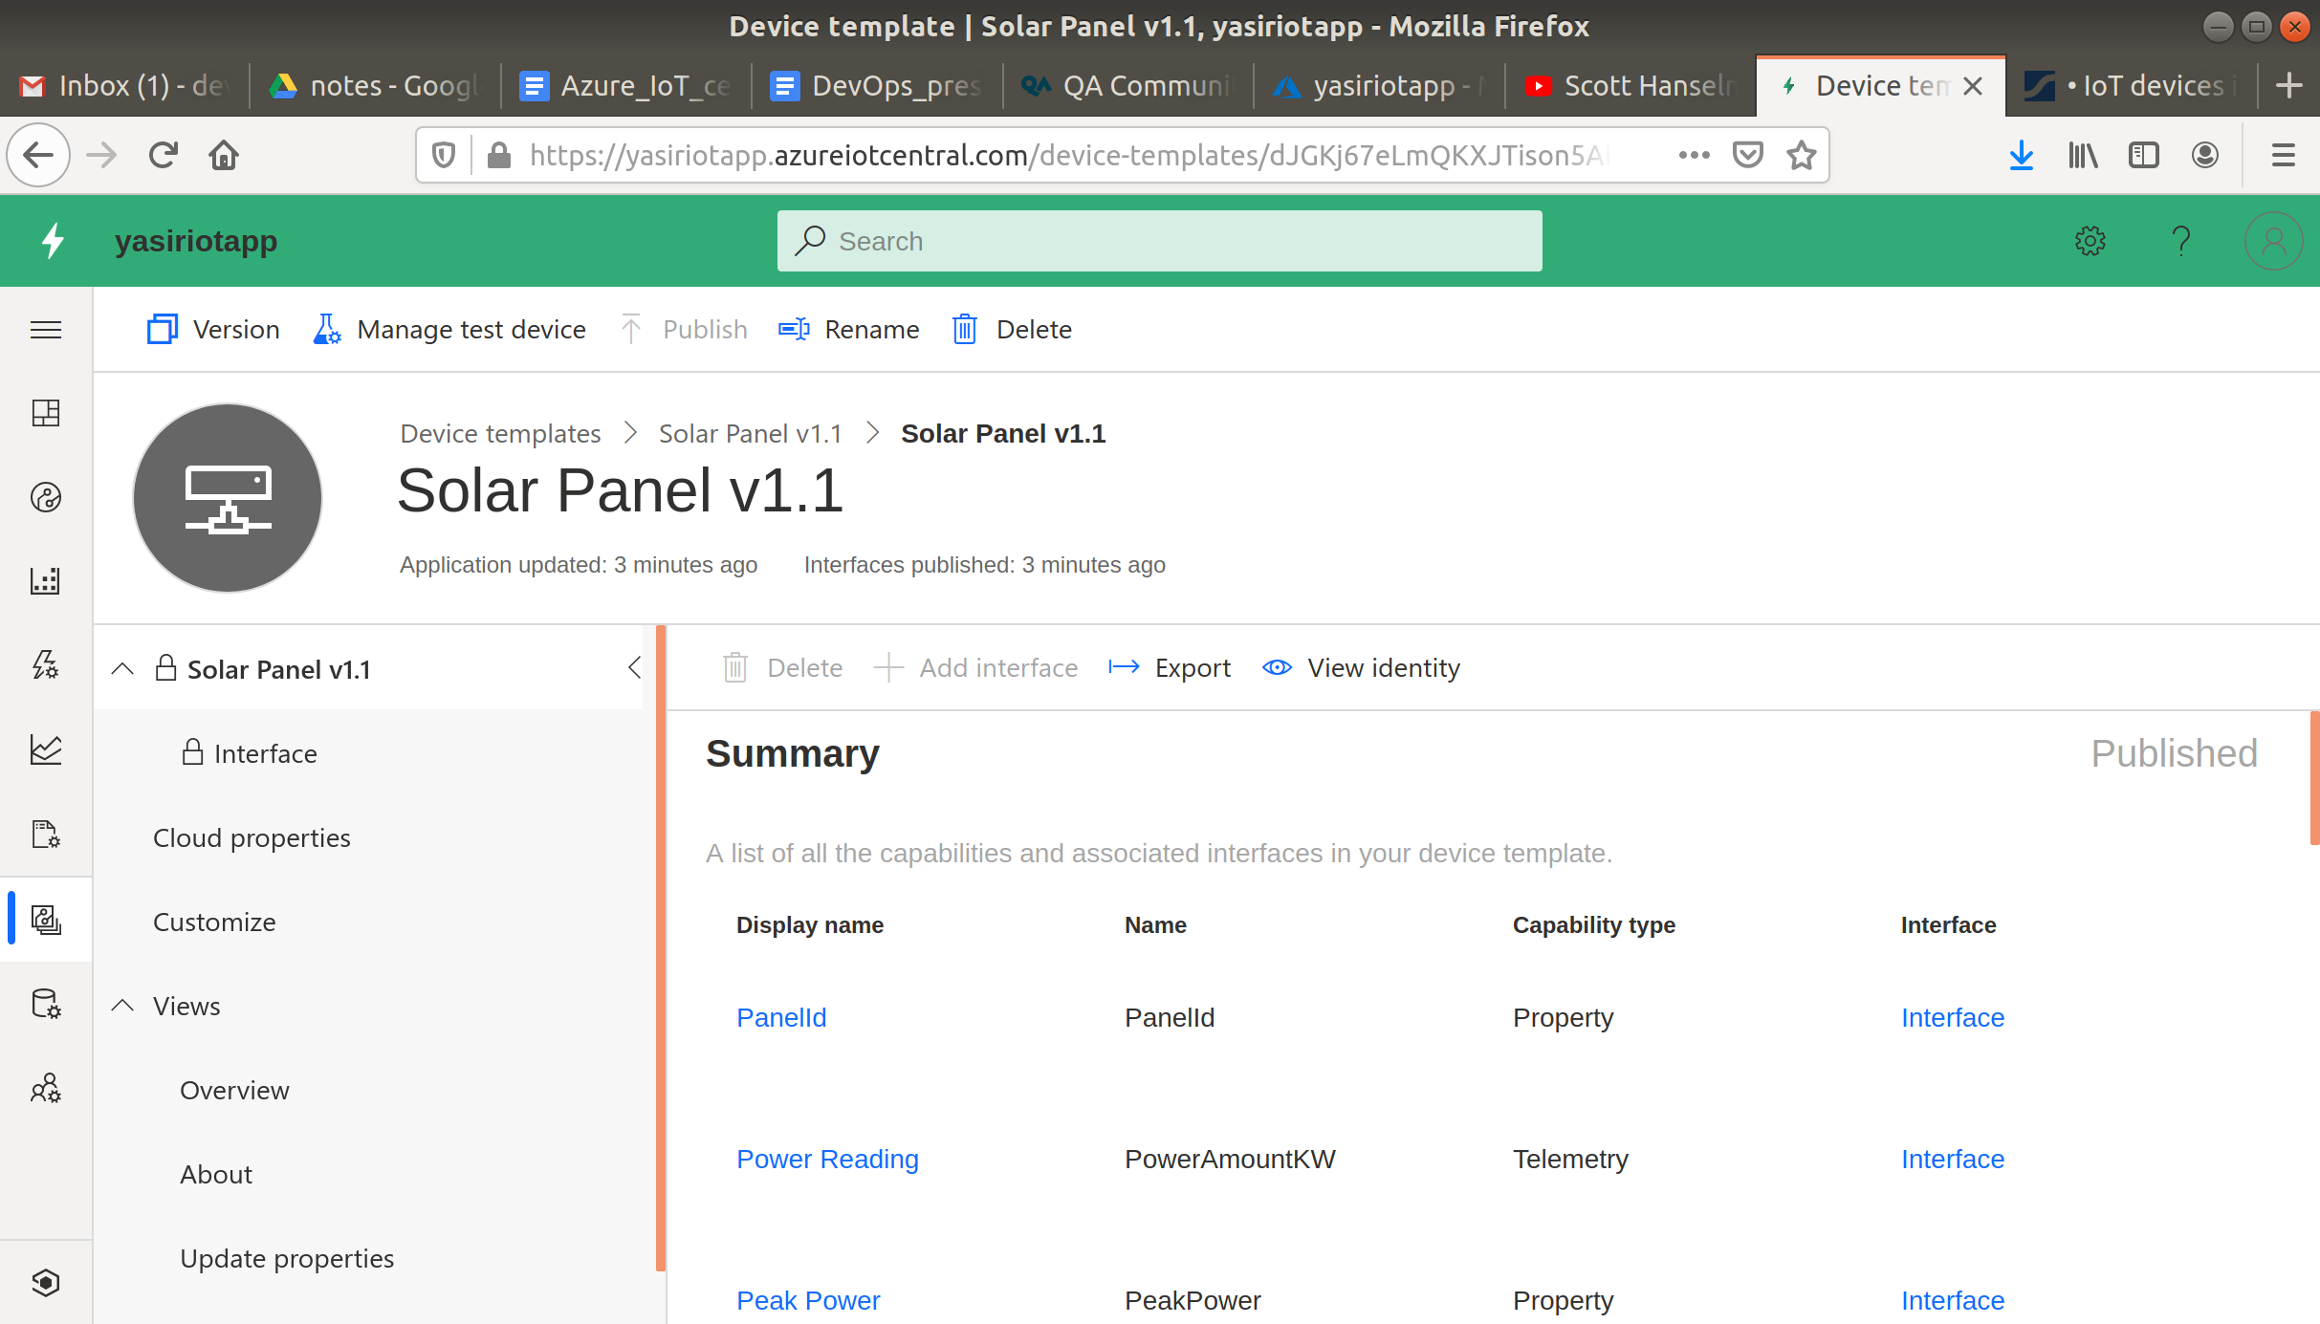

Now go back to the Azure portal.

### **Clean Up**

To clean up, go back to the Resource Group page, click your resource group you used for this module, and then choose Delete.

Once you type the name of the resource group to confirm deletion, this will be deleted along with everything inside of it.