# Azure Key Vault

# 

## **Tutorial**

In this tutorial we are going to create a key vault, a secret and create a new version of that secret.

### **New Resource Group**

The first thing is to create a new resource group, which we can do by clicking the burger bar in the top left corner and choosing Resource groups:

Then, we can click +Add:

Here, we can name the resource group and pick a location to have it in:

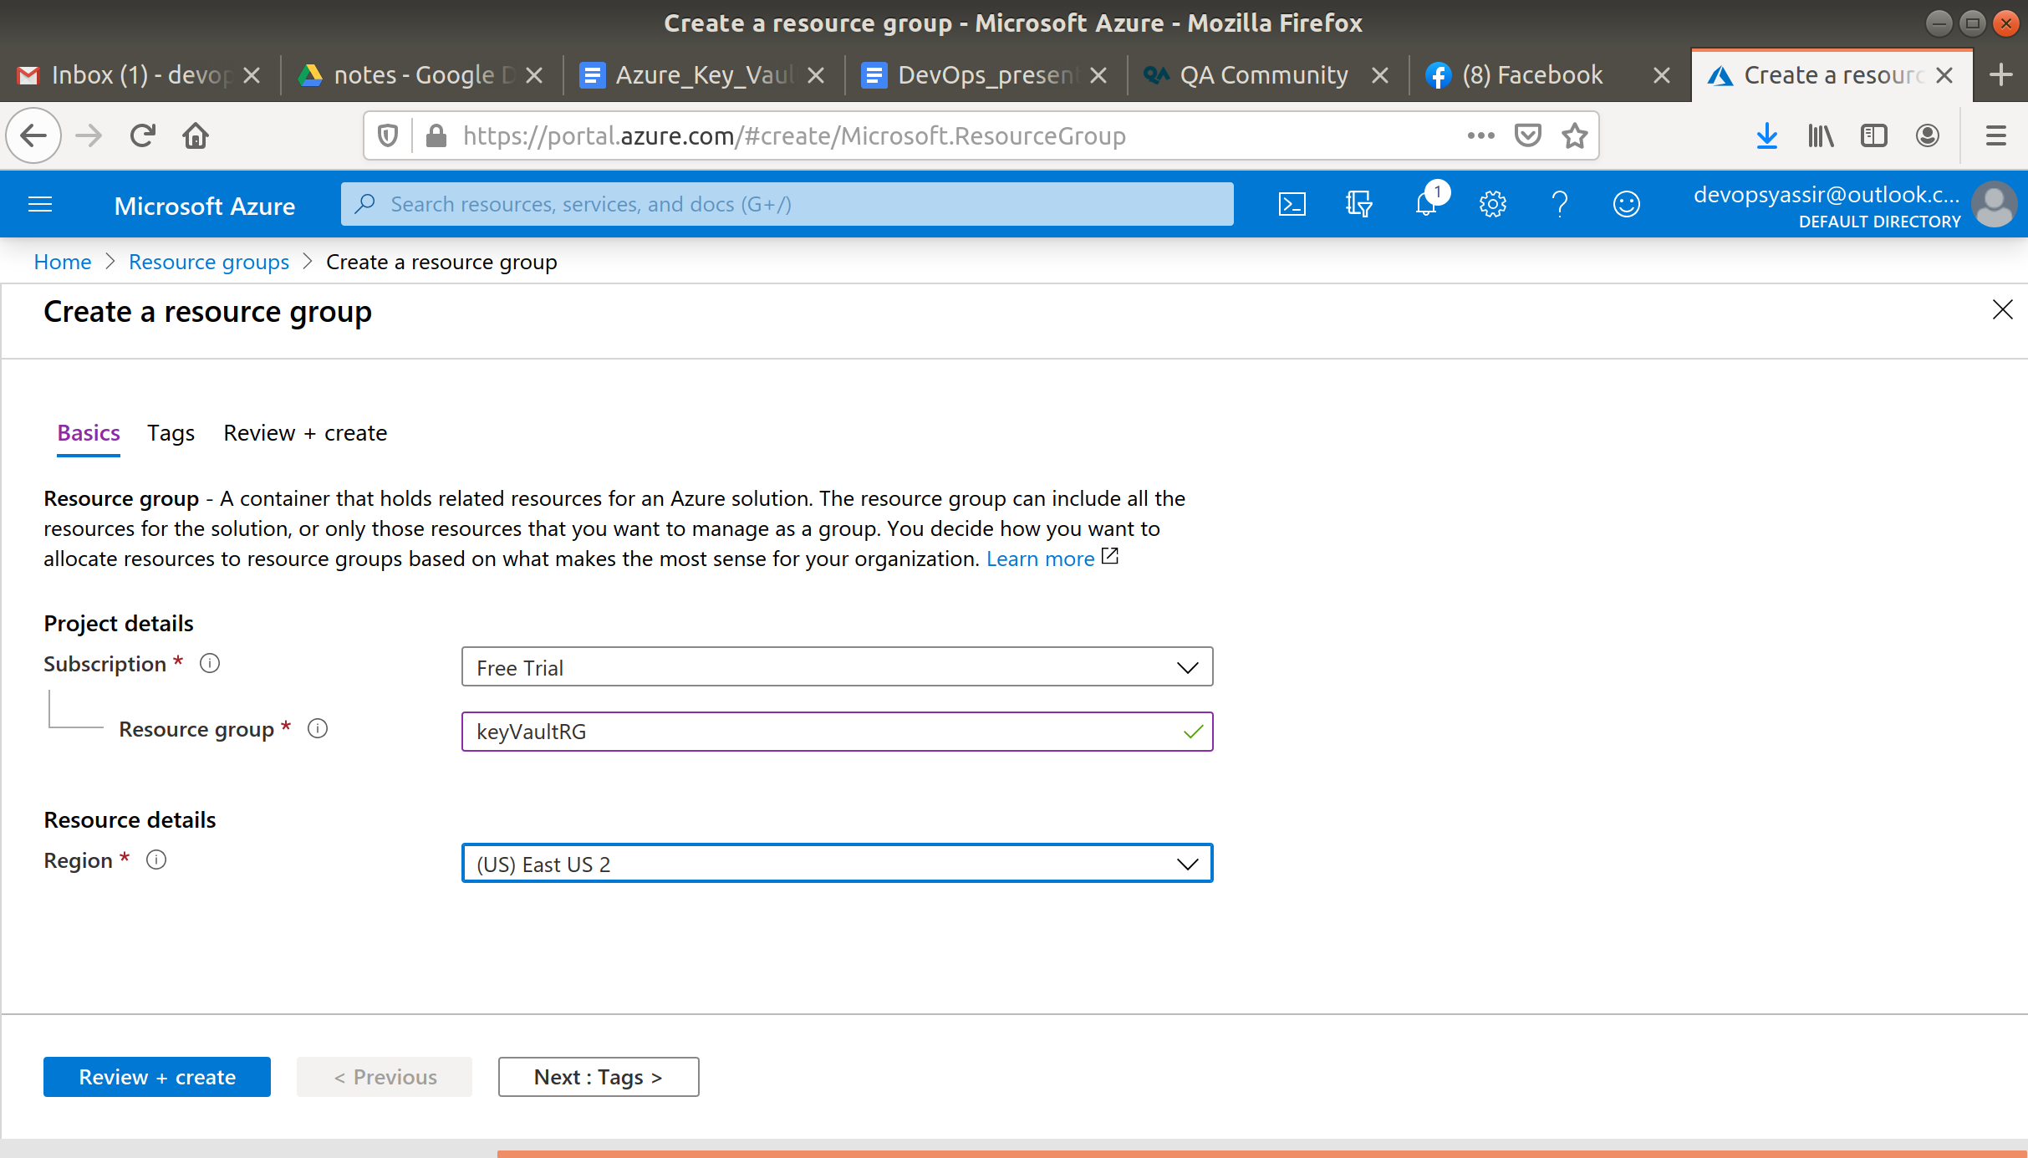

Lastly, we will click Review & Create and then Create to create the resource group:

### **New Key Vault**

Now type Key Vaults in the search bar and select it.

Click +Add and enter the following:

* Resource Group - The resource group you just created
* Key Vault Name - Tutorial
* Region - UK South
* Pricing Tier - Standard

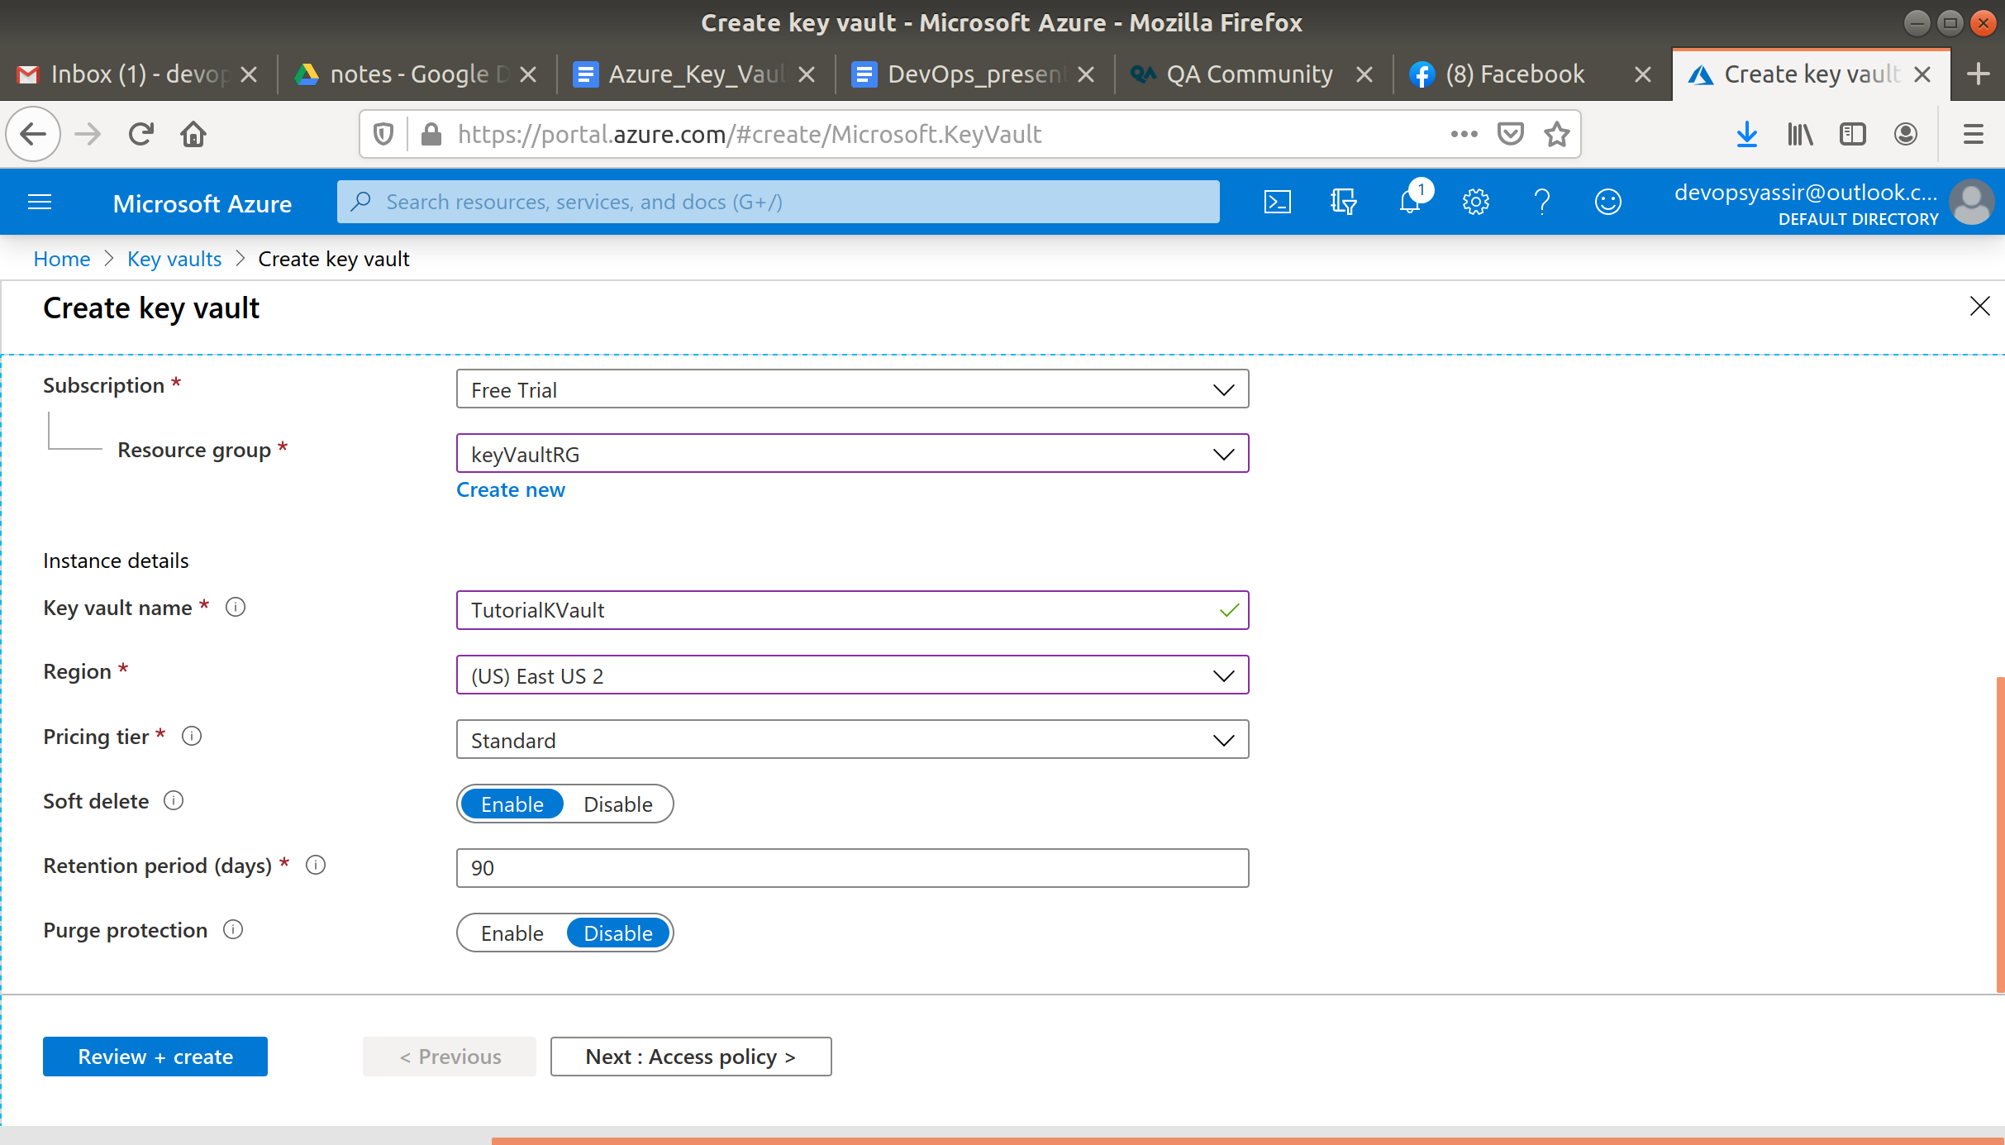

Click Review and Create and then Create.

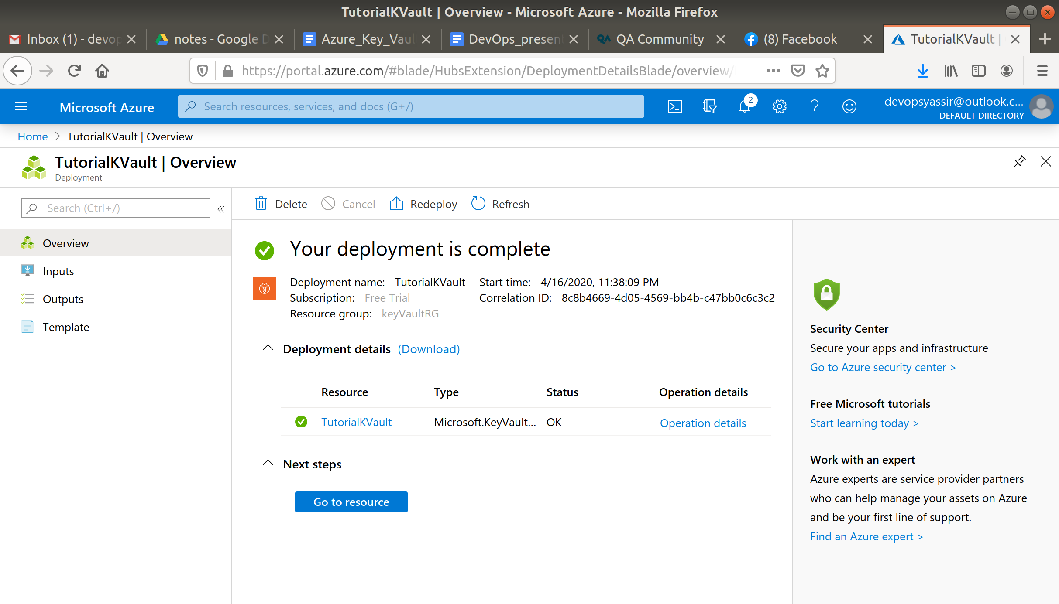

### **New Secret**

Once your key vault is deployed navigate to it.

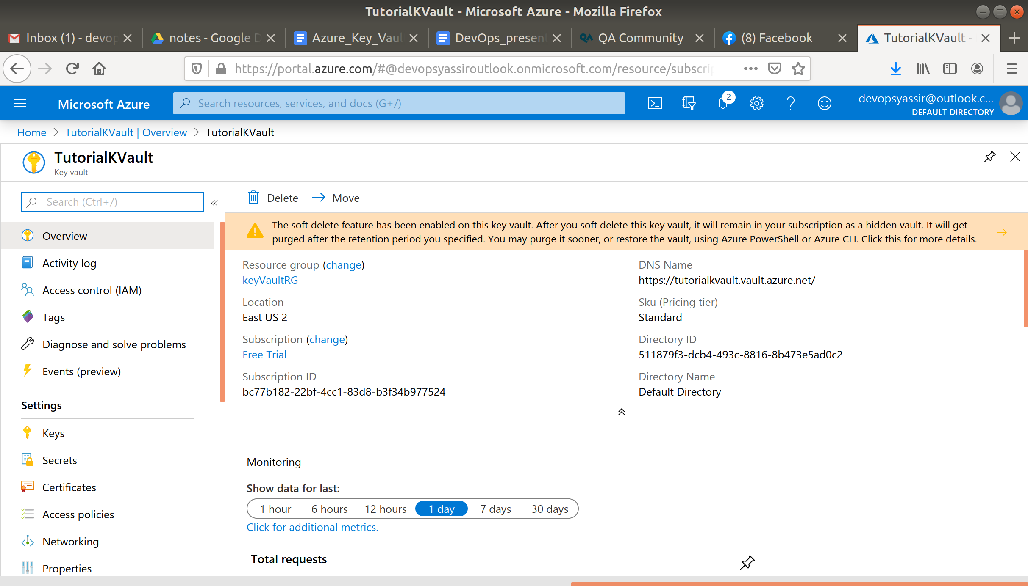

In the left blade select Access policies, here you will see that only you have access to this vault. You can also see all the permissions you have.

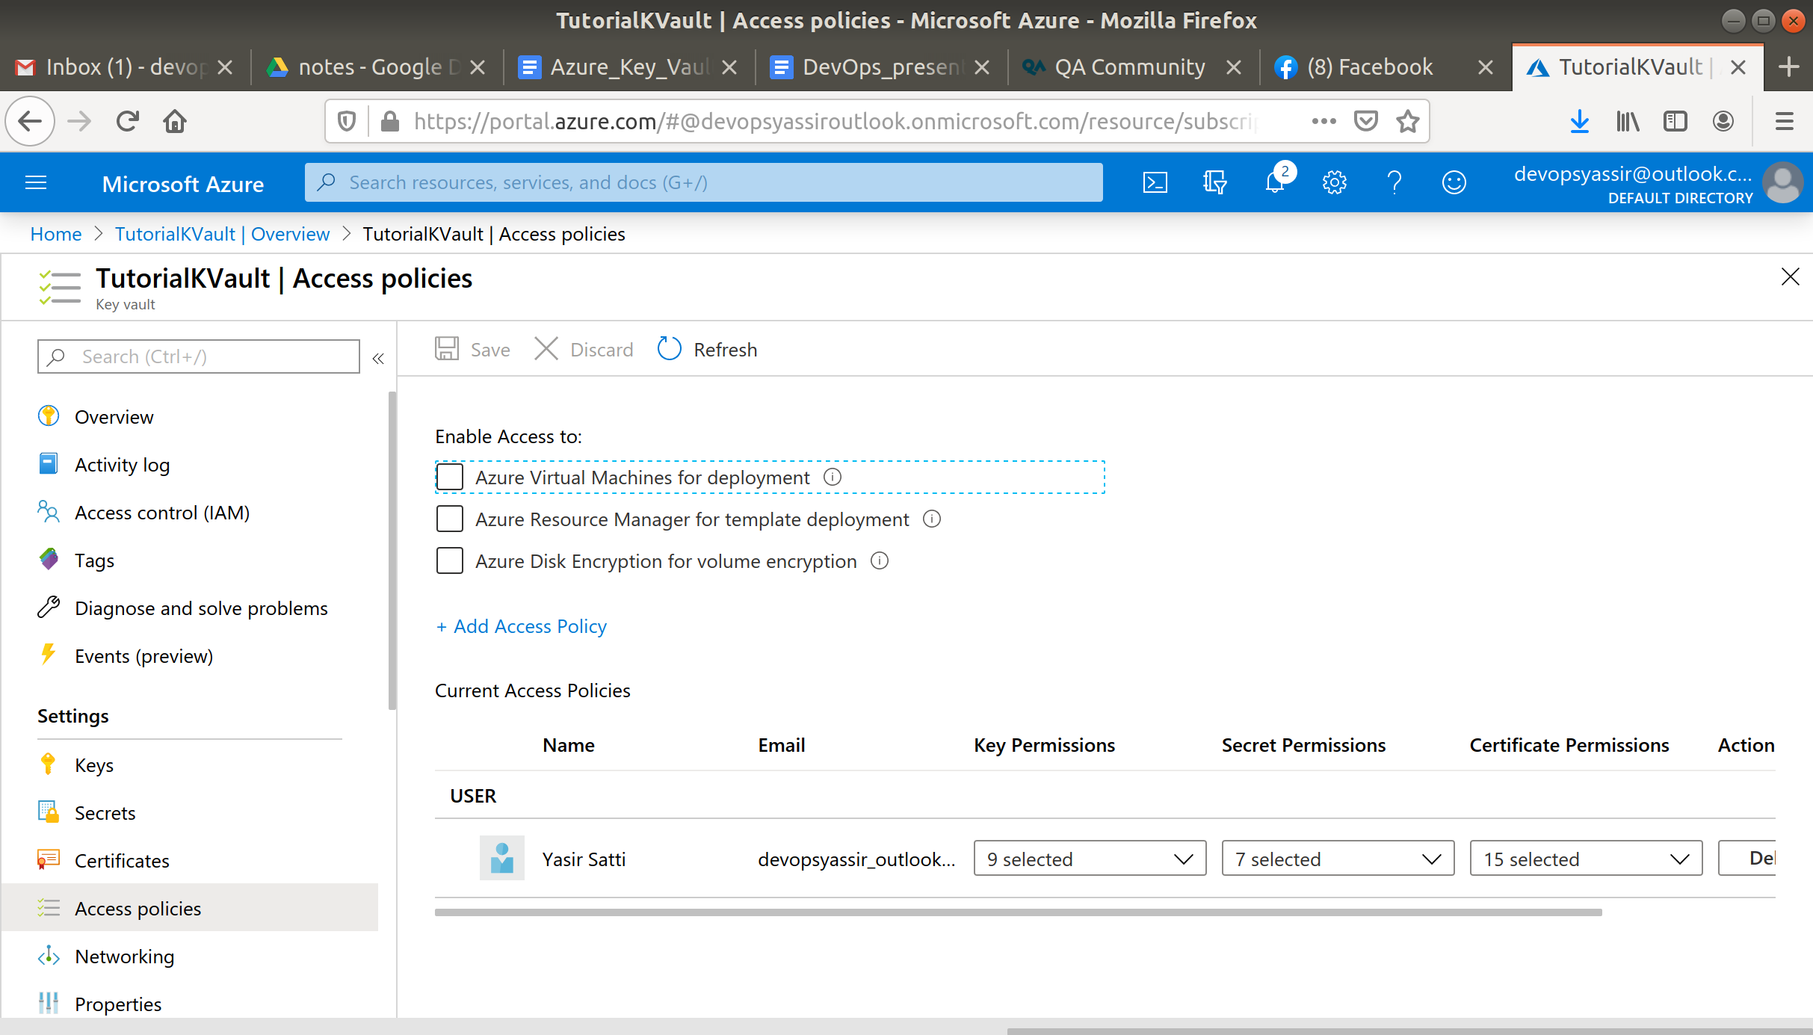

Now select Secrets in the left blade.

Click +Generate/Import and enter the following:

* Upload options - Manual
* Name - Anything you like
* Value - Your secret key

Leave the rest as their default and click Create.

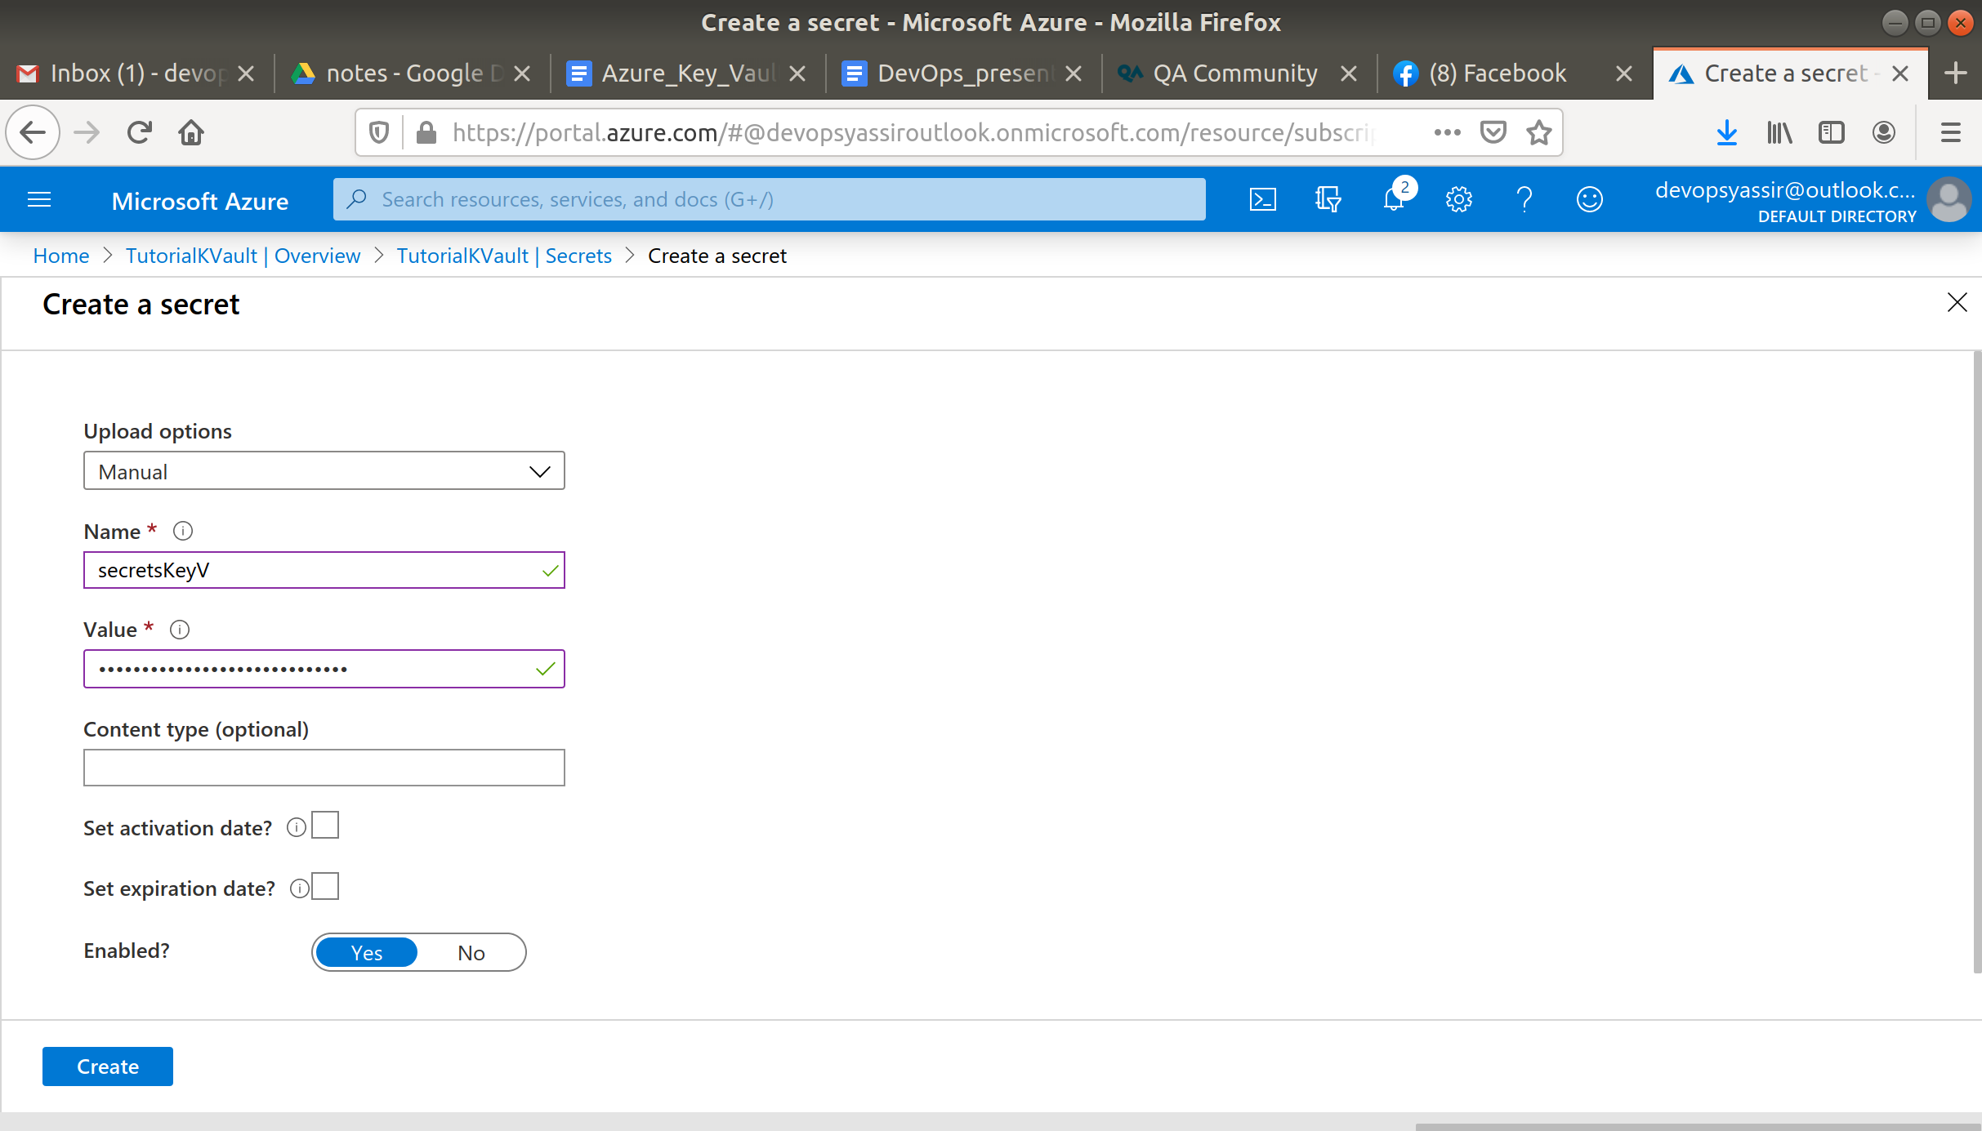

Now navigate to your new secret and click on the current version.

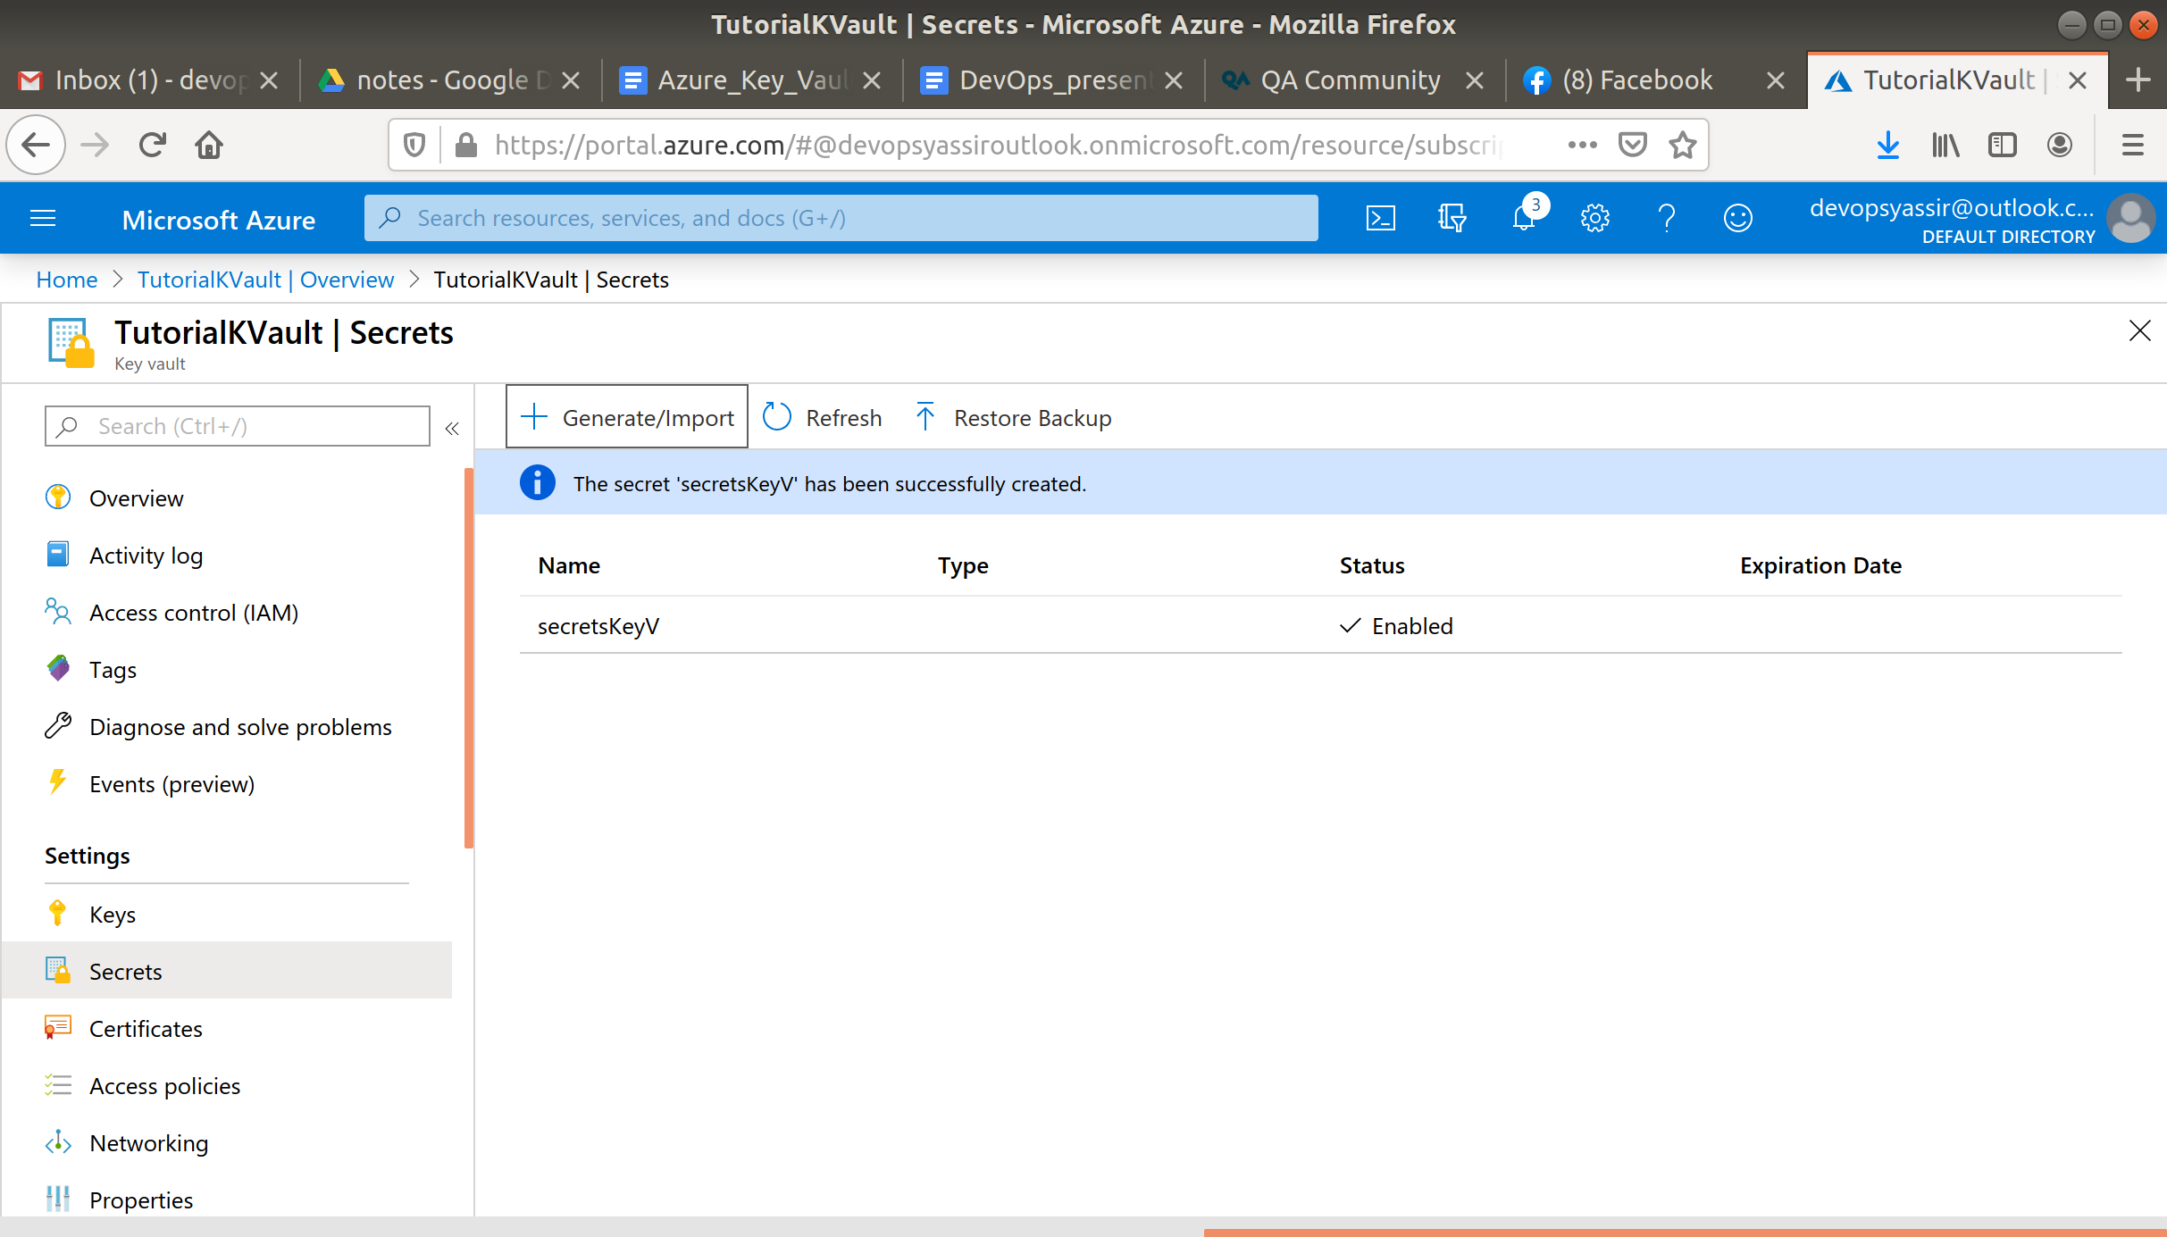

You will be able to click Show Secret Value and it will show you the secret.

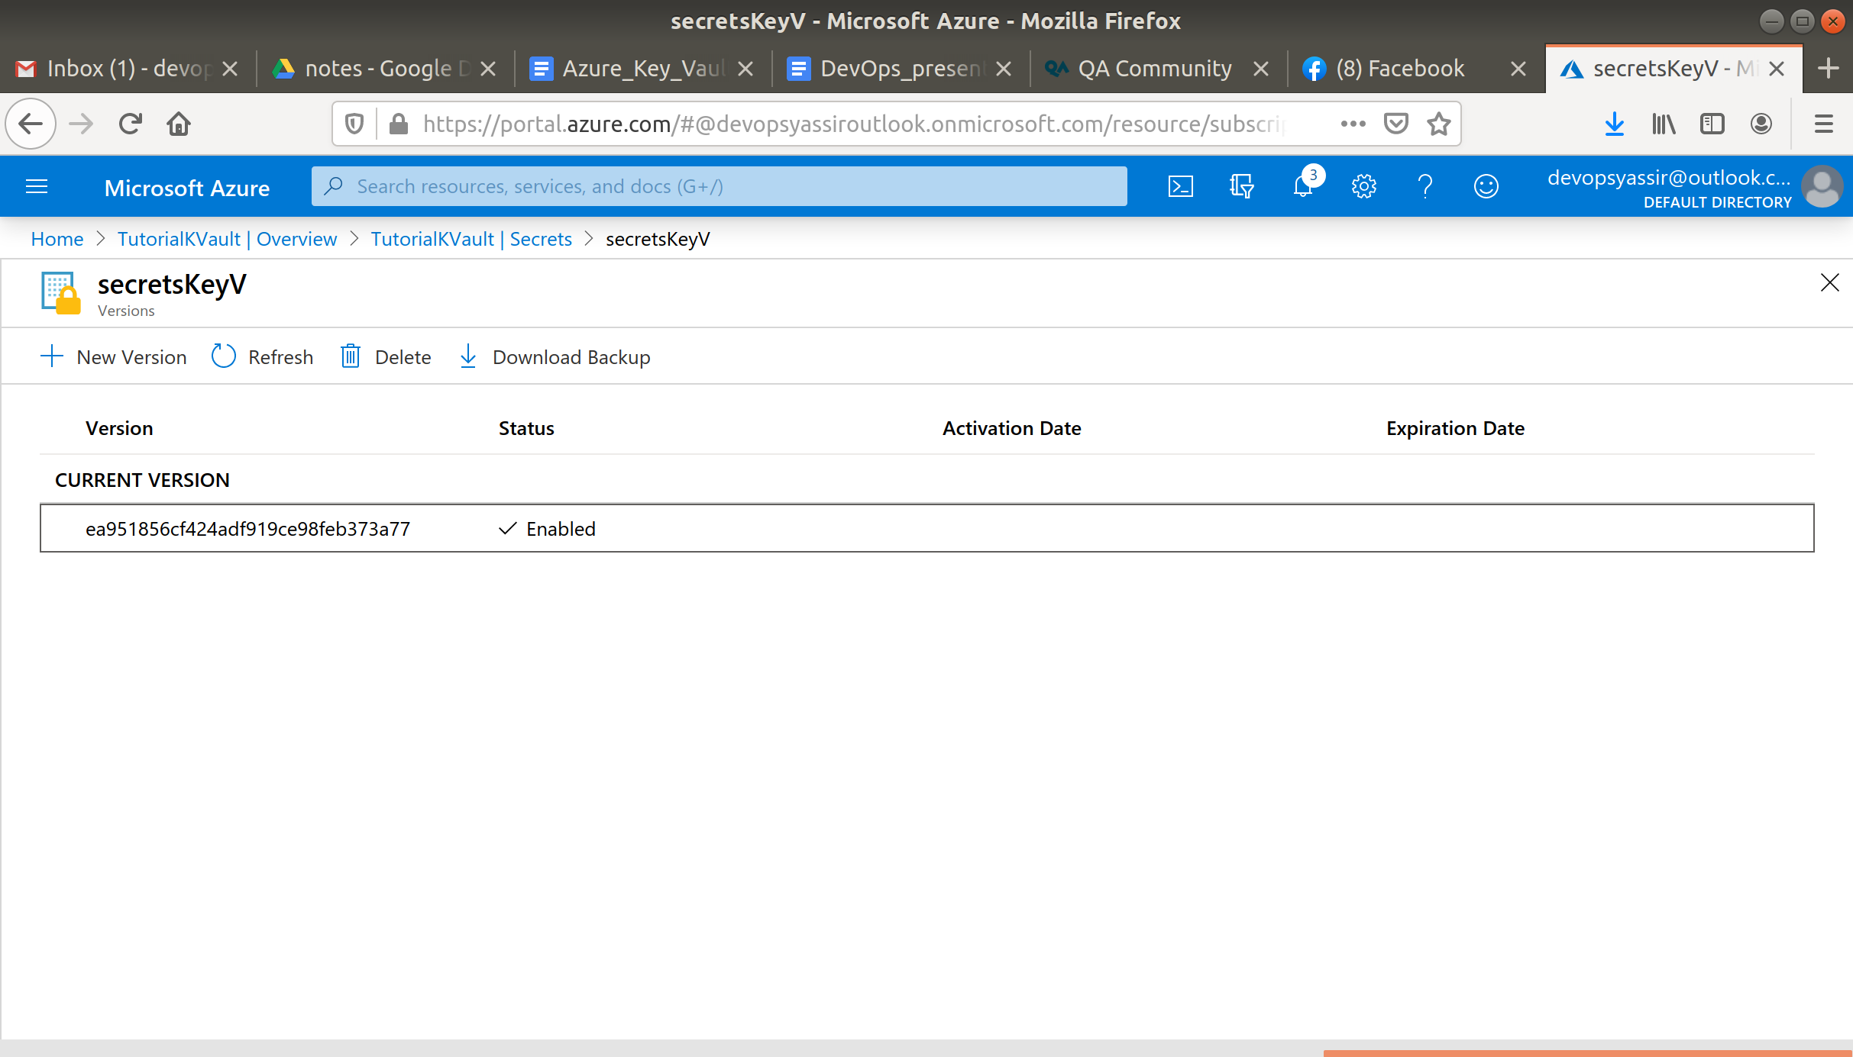

Now go back to your secret and click +New Version.

Now enter a new secret and click Create.

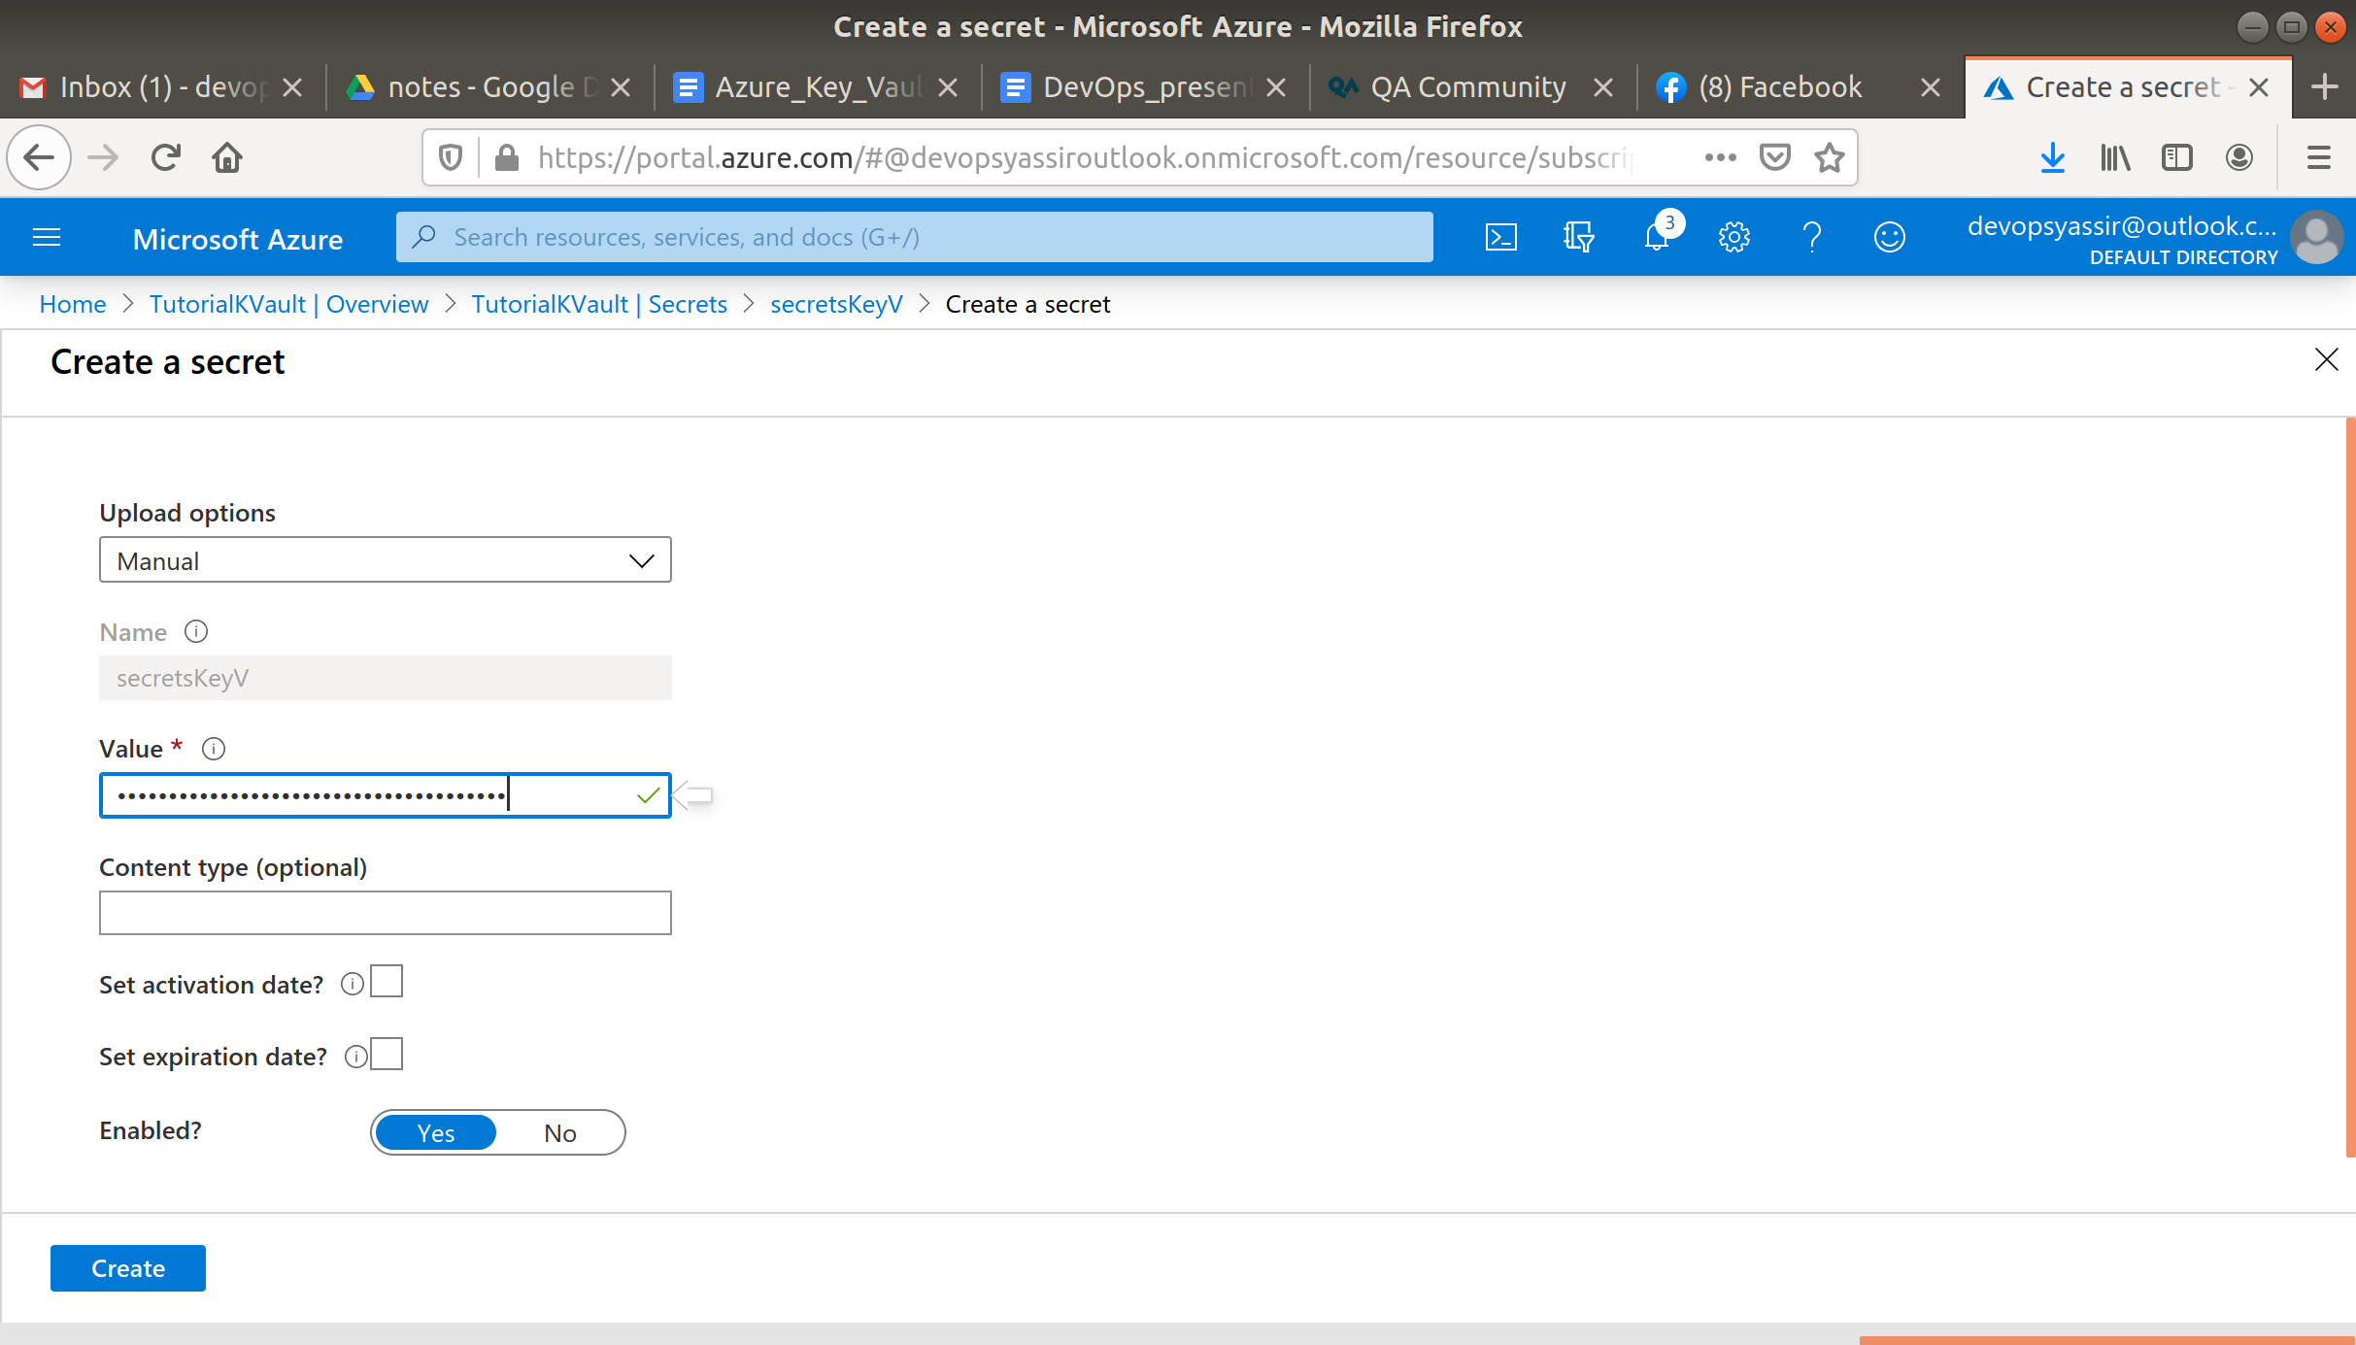

You will now see both your versions of the secret.

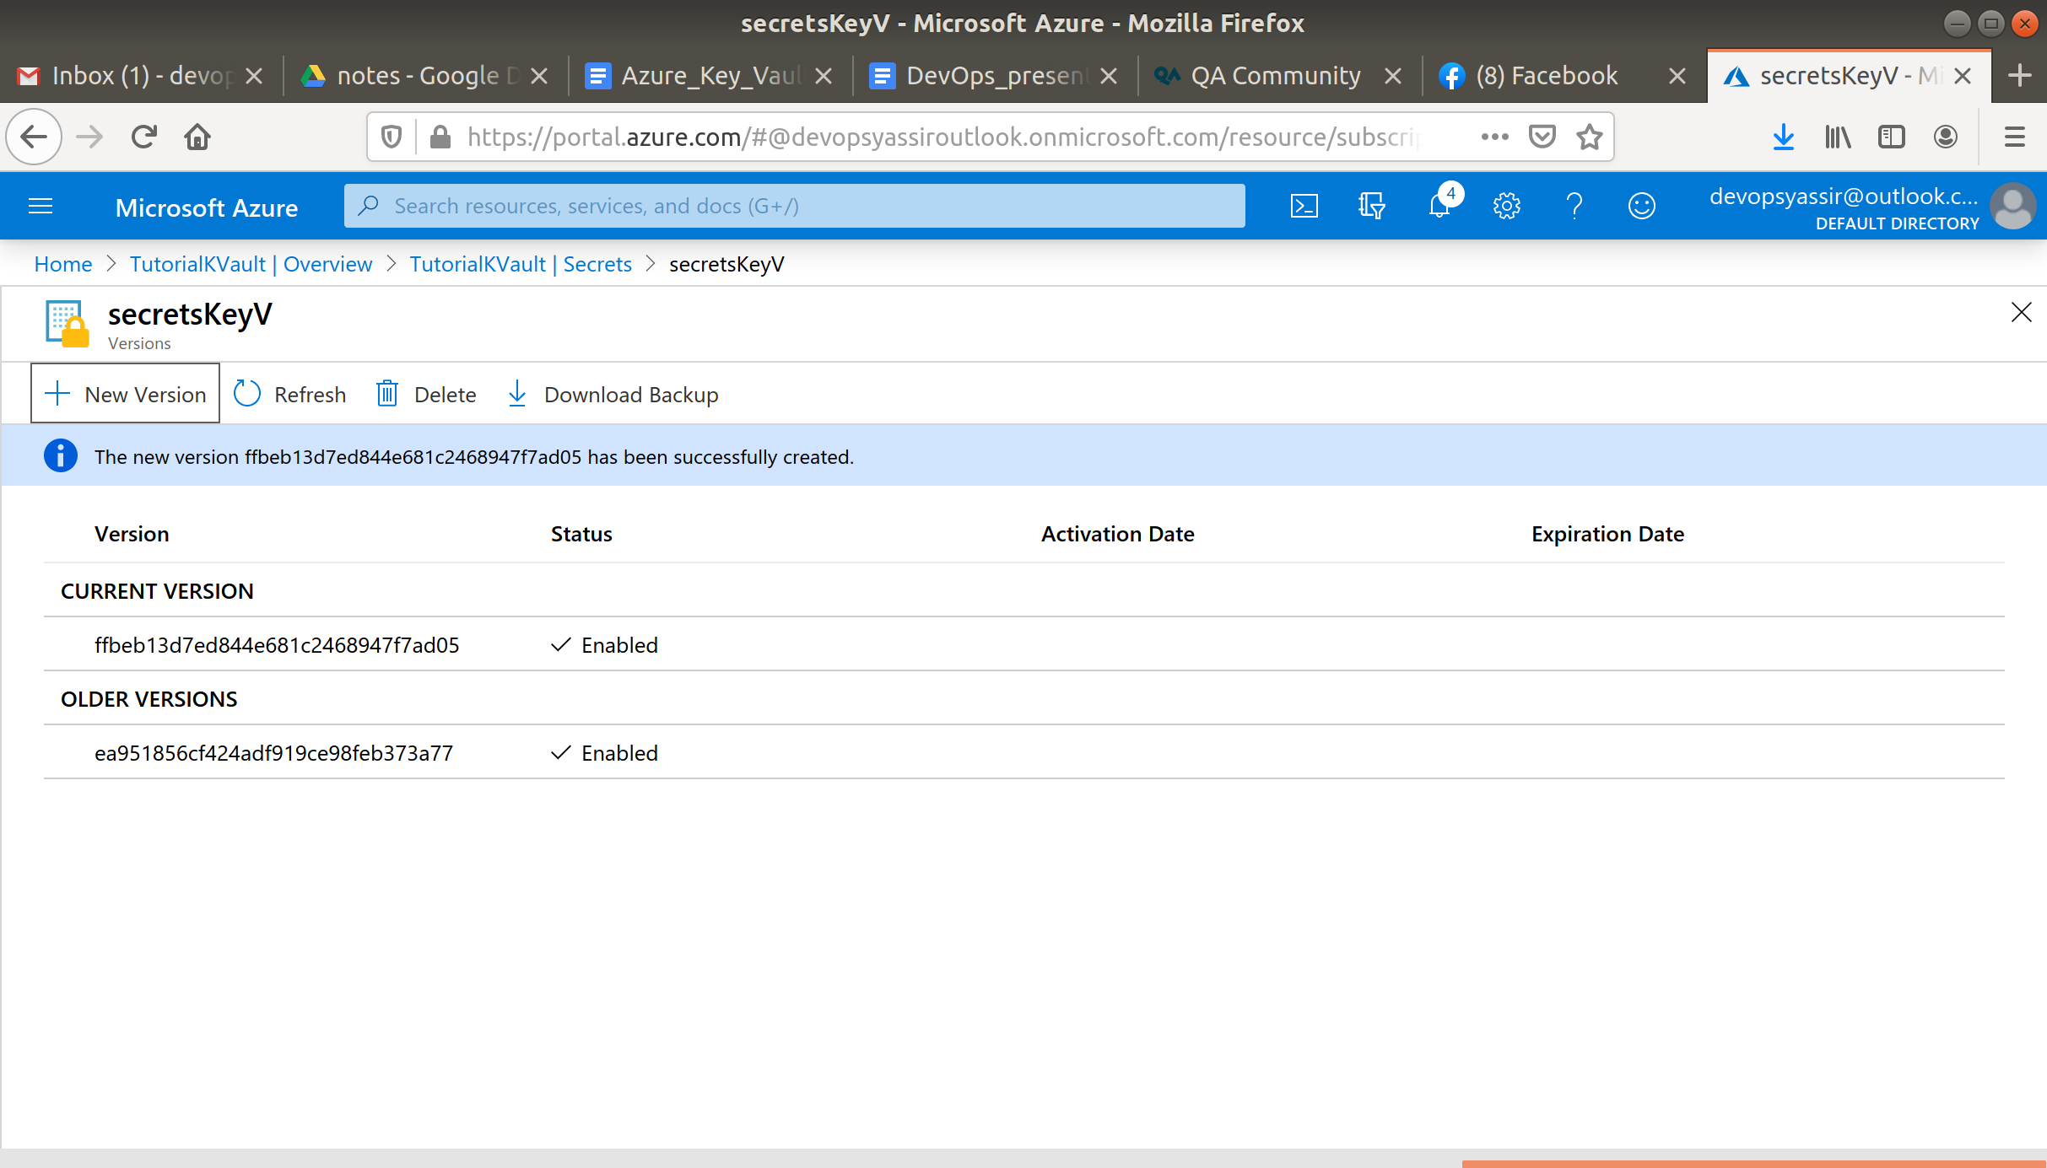

### **Clean Up**

To clean up, go back to the Resource Group page, click your resource group you used for this module, and then choose Delete.

Once you type the name of the resource group to confirm deletion, this will be deleted along with everything inside of it.