# Azure Monitor

# 

## **Tutorial**

In this tutorial we will take a quick look at some of the tools Azure Monitor provides.

### **New Resource Group**

The first thing is to create a new resource group, which we can do by clicking the burger bar in the top left corner and choosing Resource groups:

Then, we can click +Add:

Here, we can name the resource group and pick a location to have it in:

Lastly, we will click Review & Create and then Create to create the resource group:

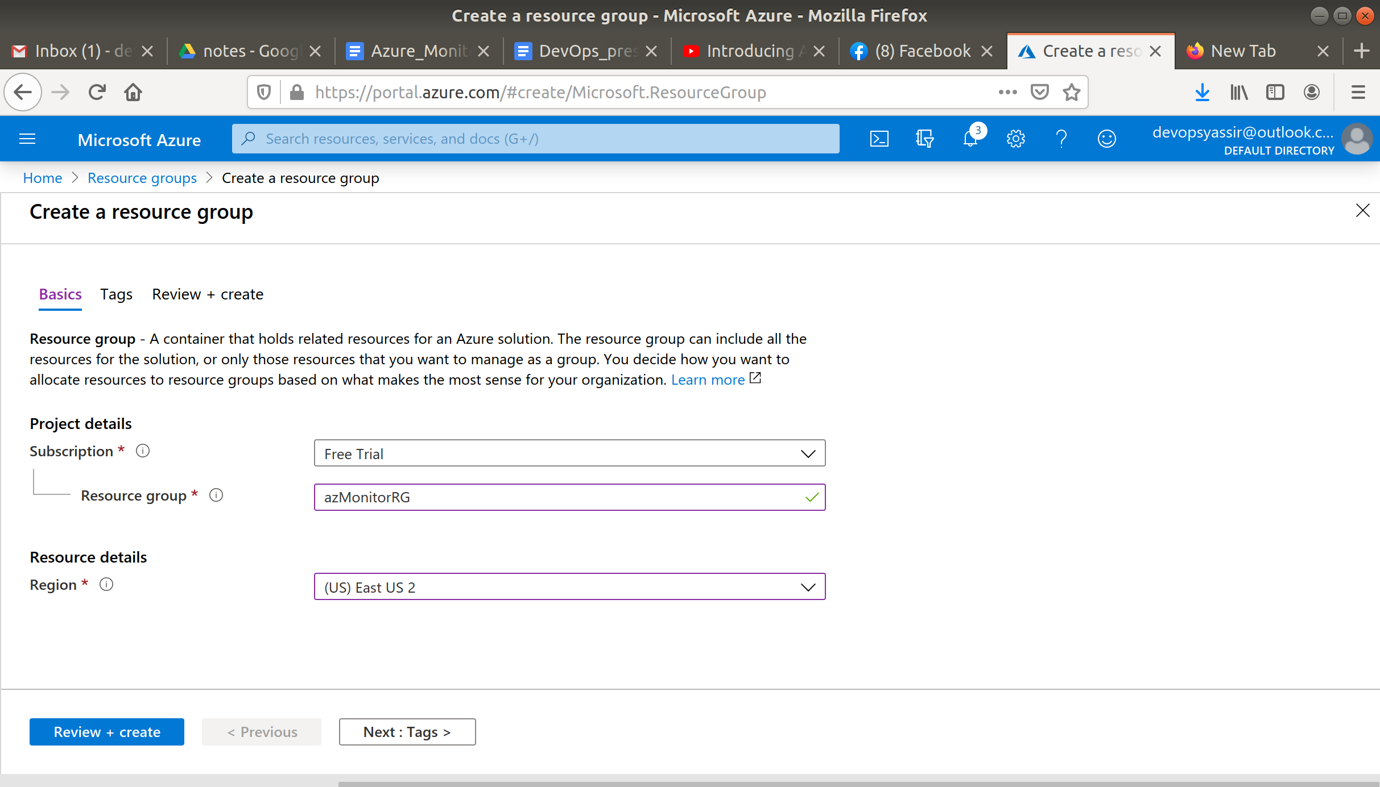

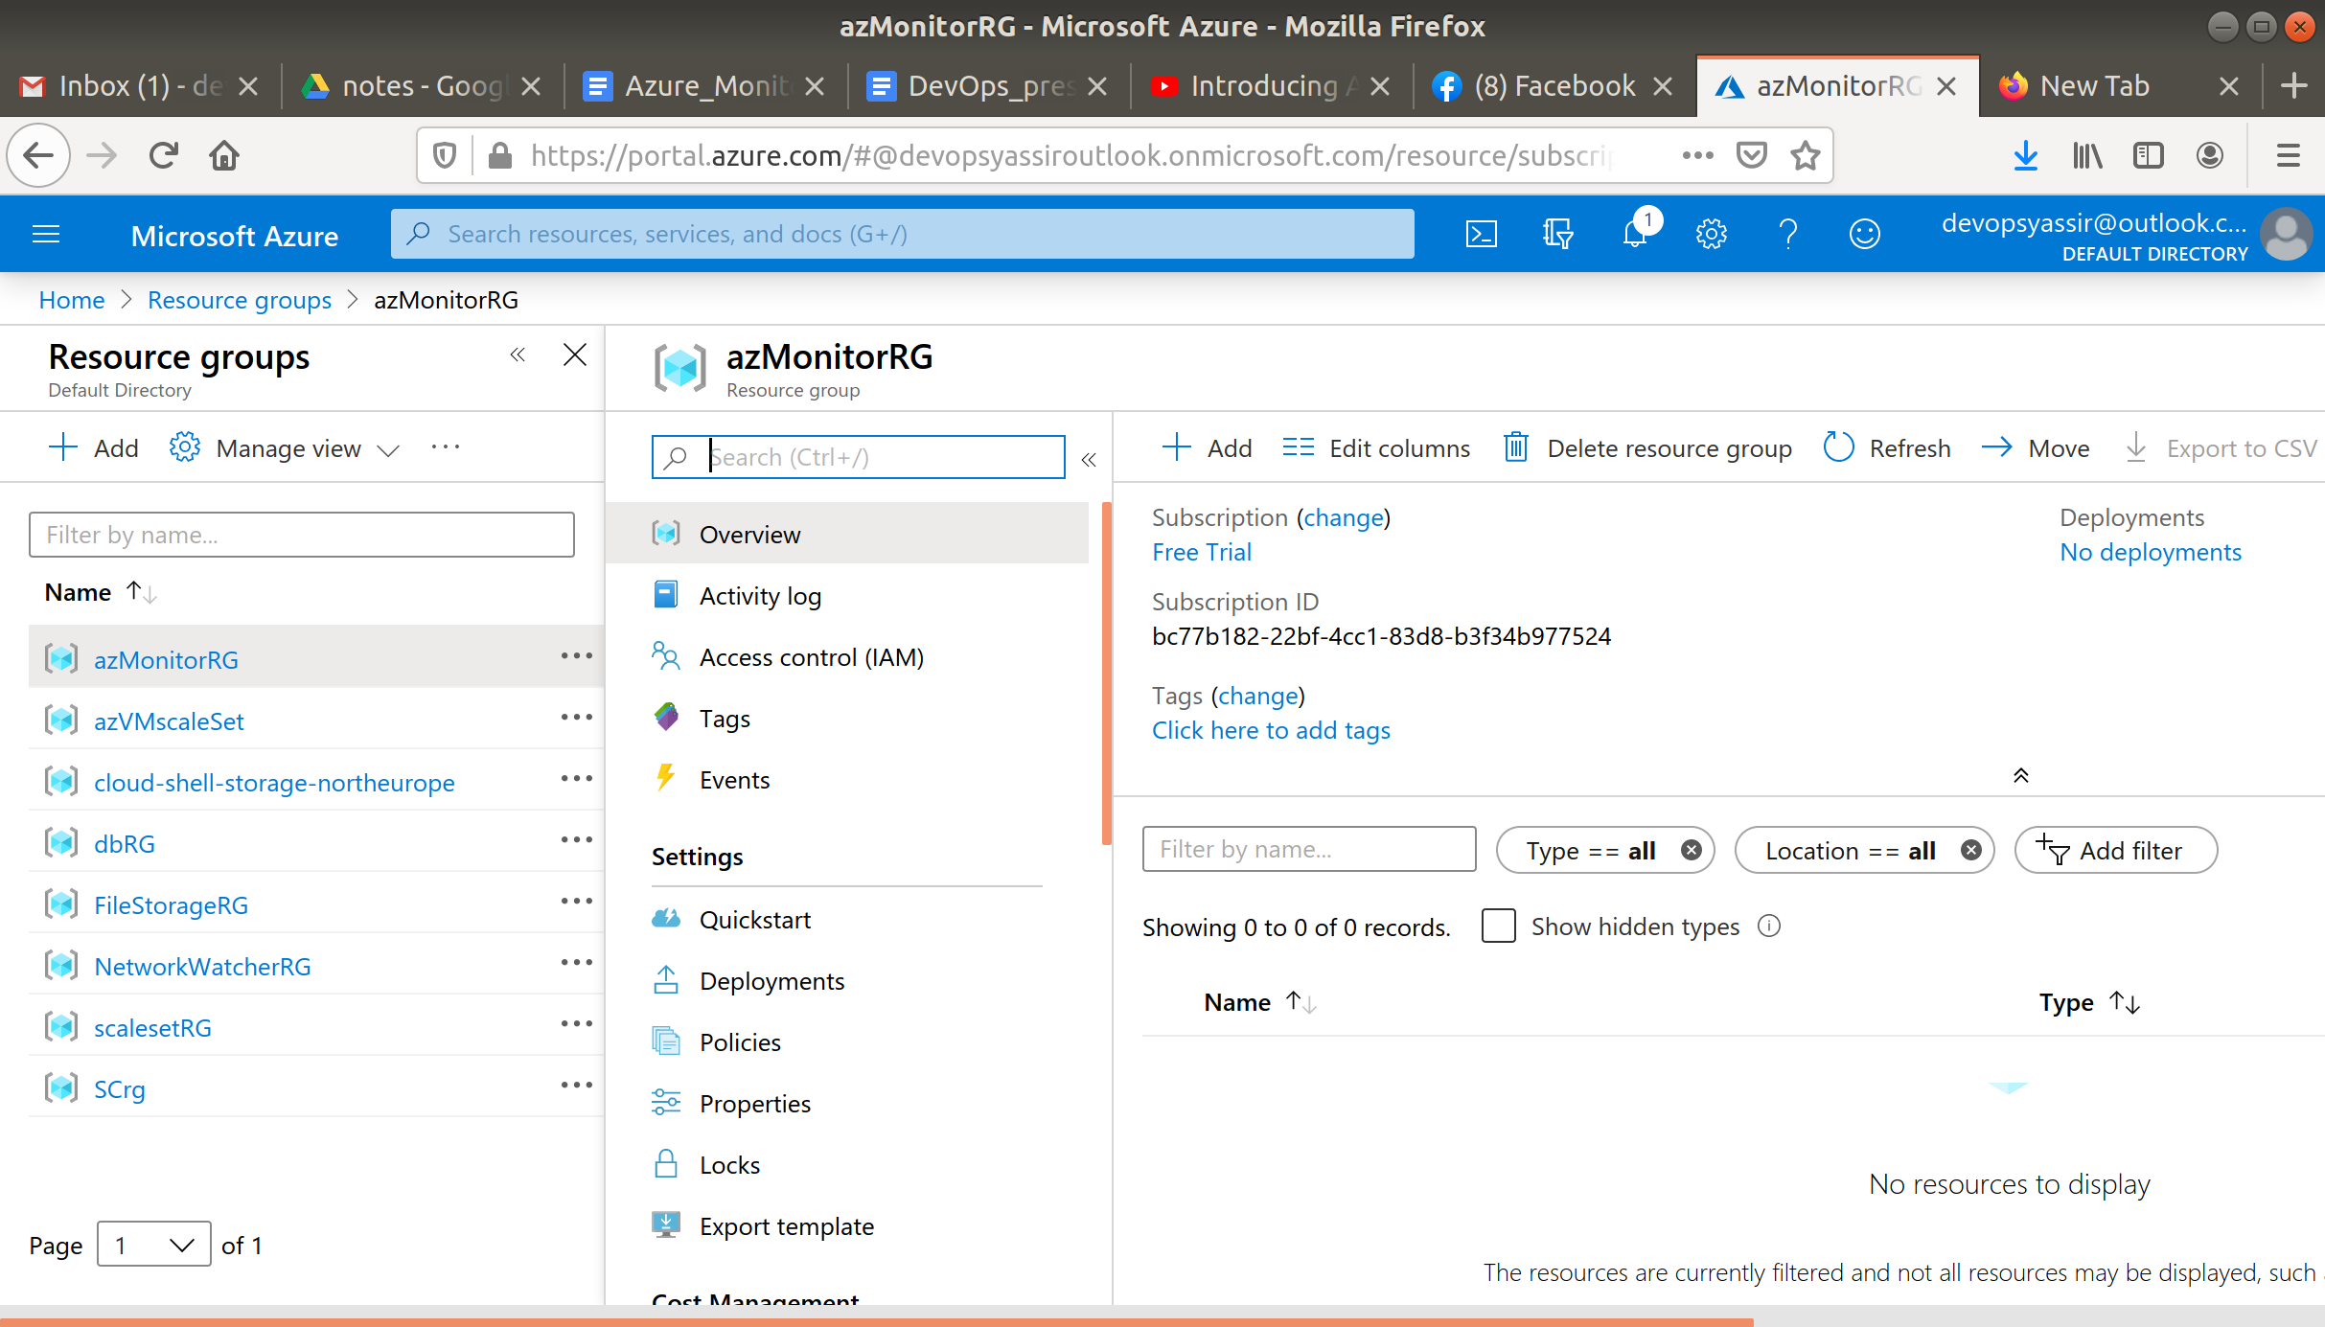

### **New Virtual Machine**

For this, we need to first go to the hamburger menu again, but this time click Virtual machines:

Then, we click + Add:

We will need to choose our new resource group from the drop down menu, give the machine a name and pick a region for it to be deployed into.

The image can be Ubuntu Server 18.04 LTS, and the Size can be Standard D2s v3:

We need to choose a password for authentication type, and create a username and password.

We also need to ensure that Port 22 is open, so we can SSH into the machine later (this should be checked by default):

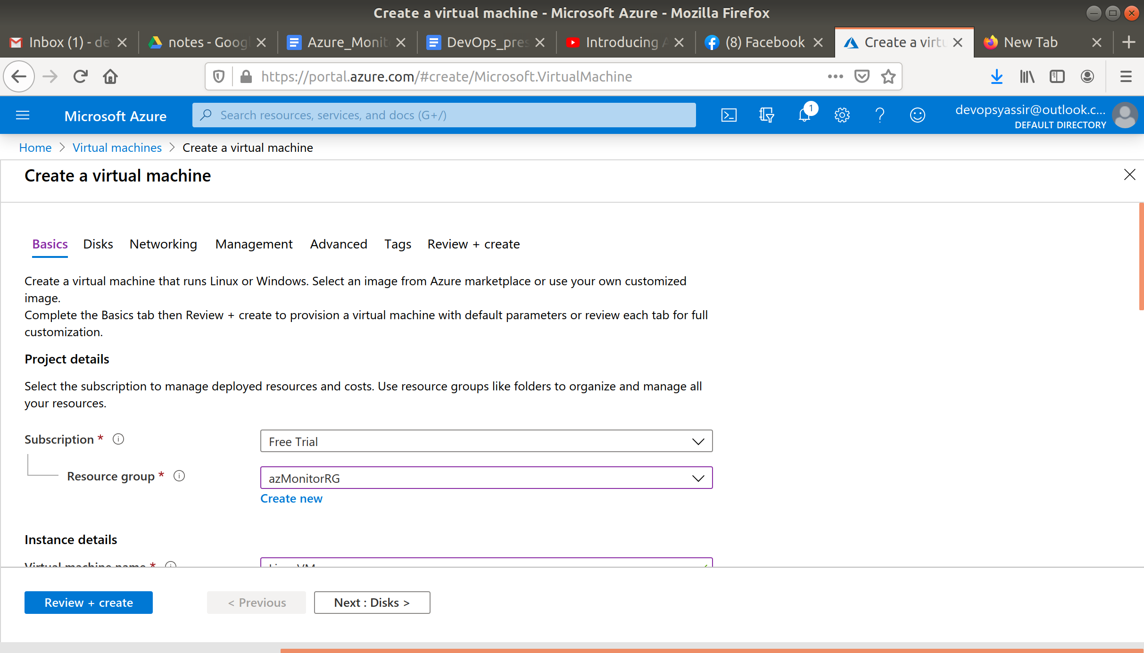

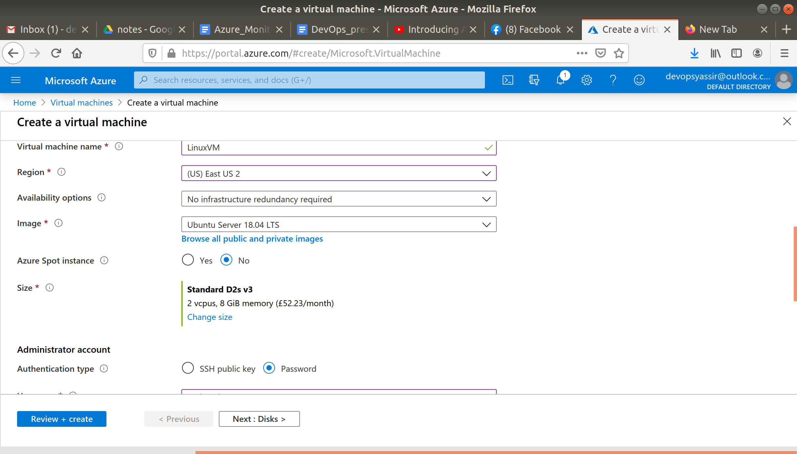

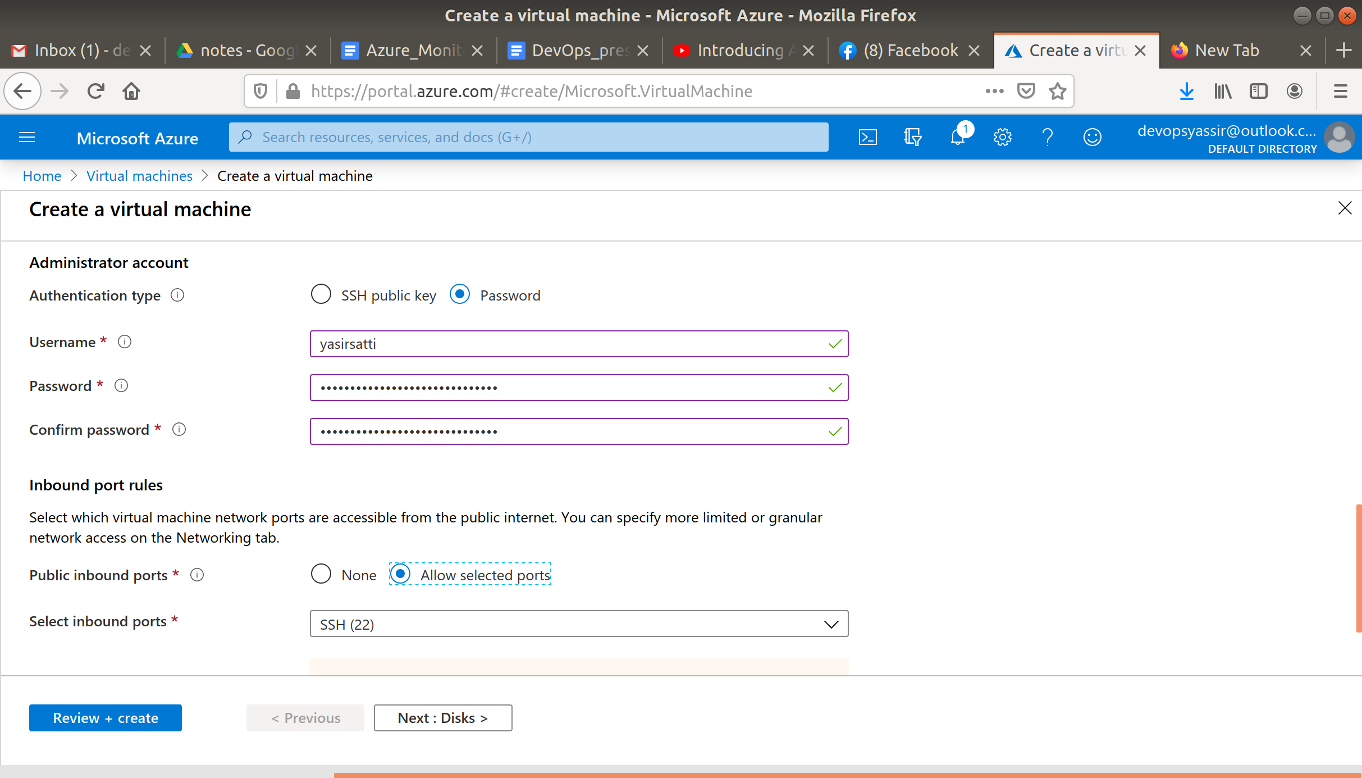

After clicking Create, our Linux VM is created!

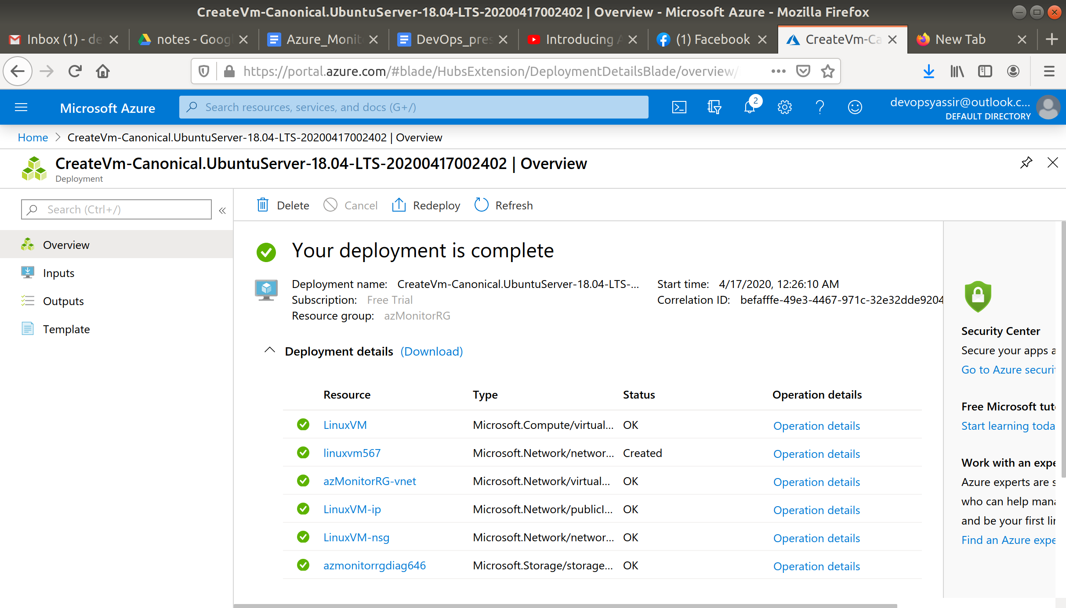

### **Monitor**

Navigate to Azure Monitor by typing **monitor** into the search bar at the top and selecting Monitor.

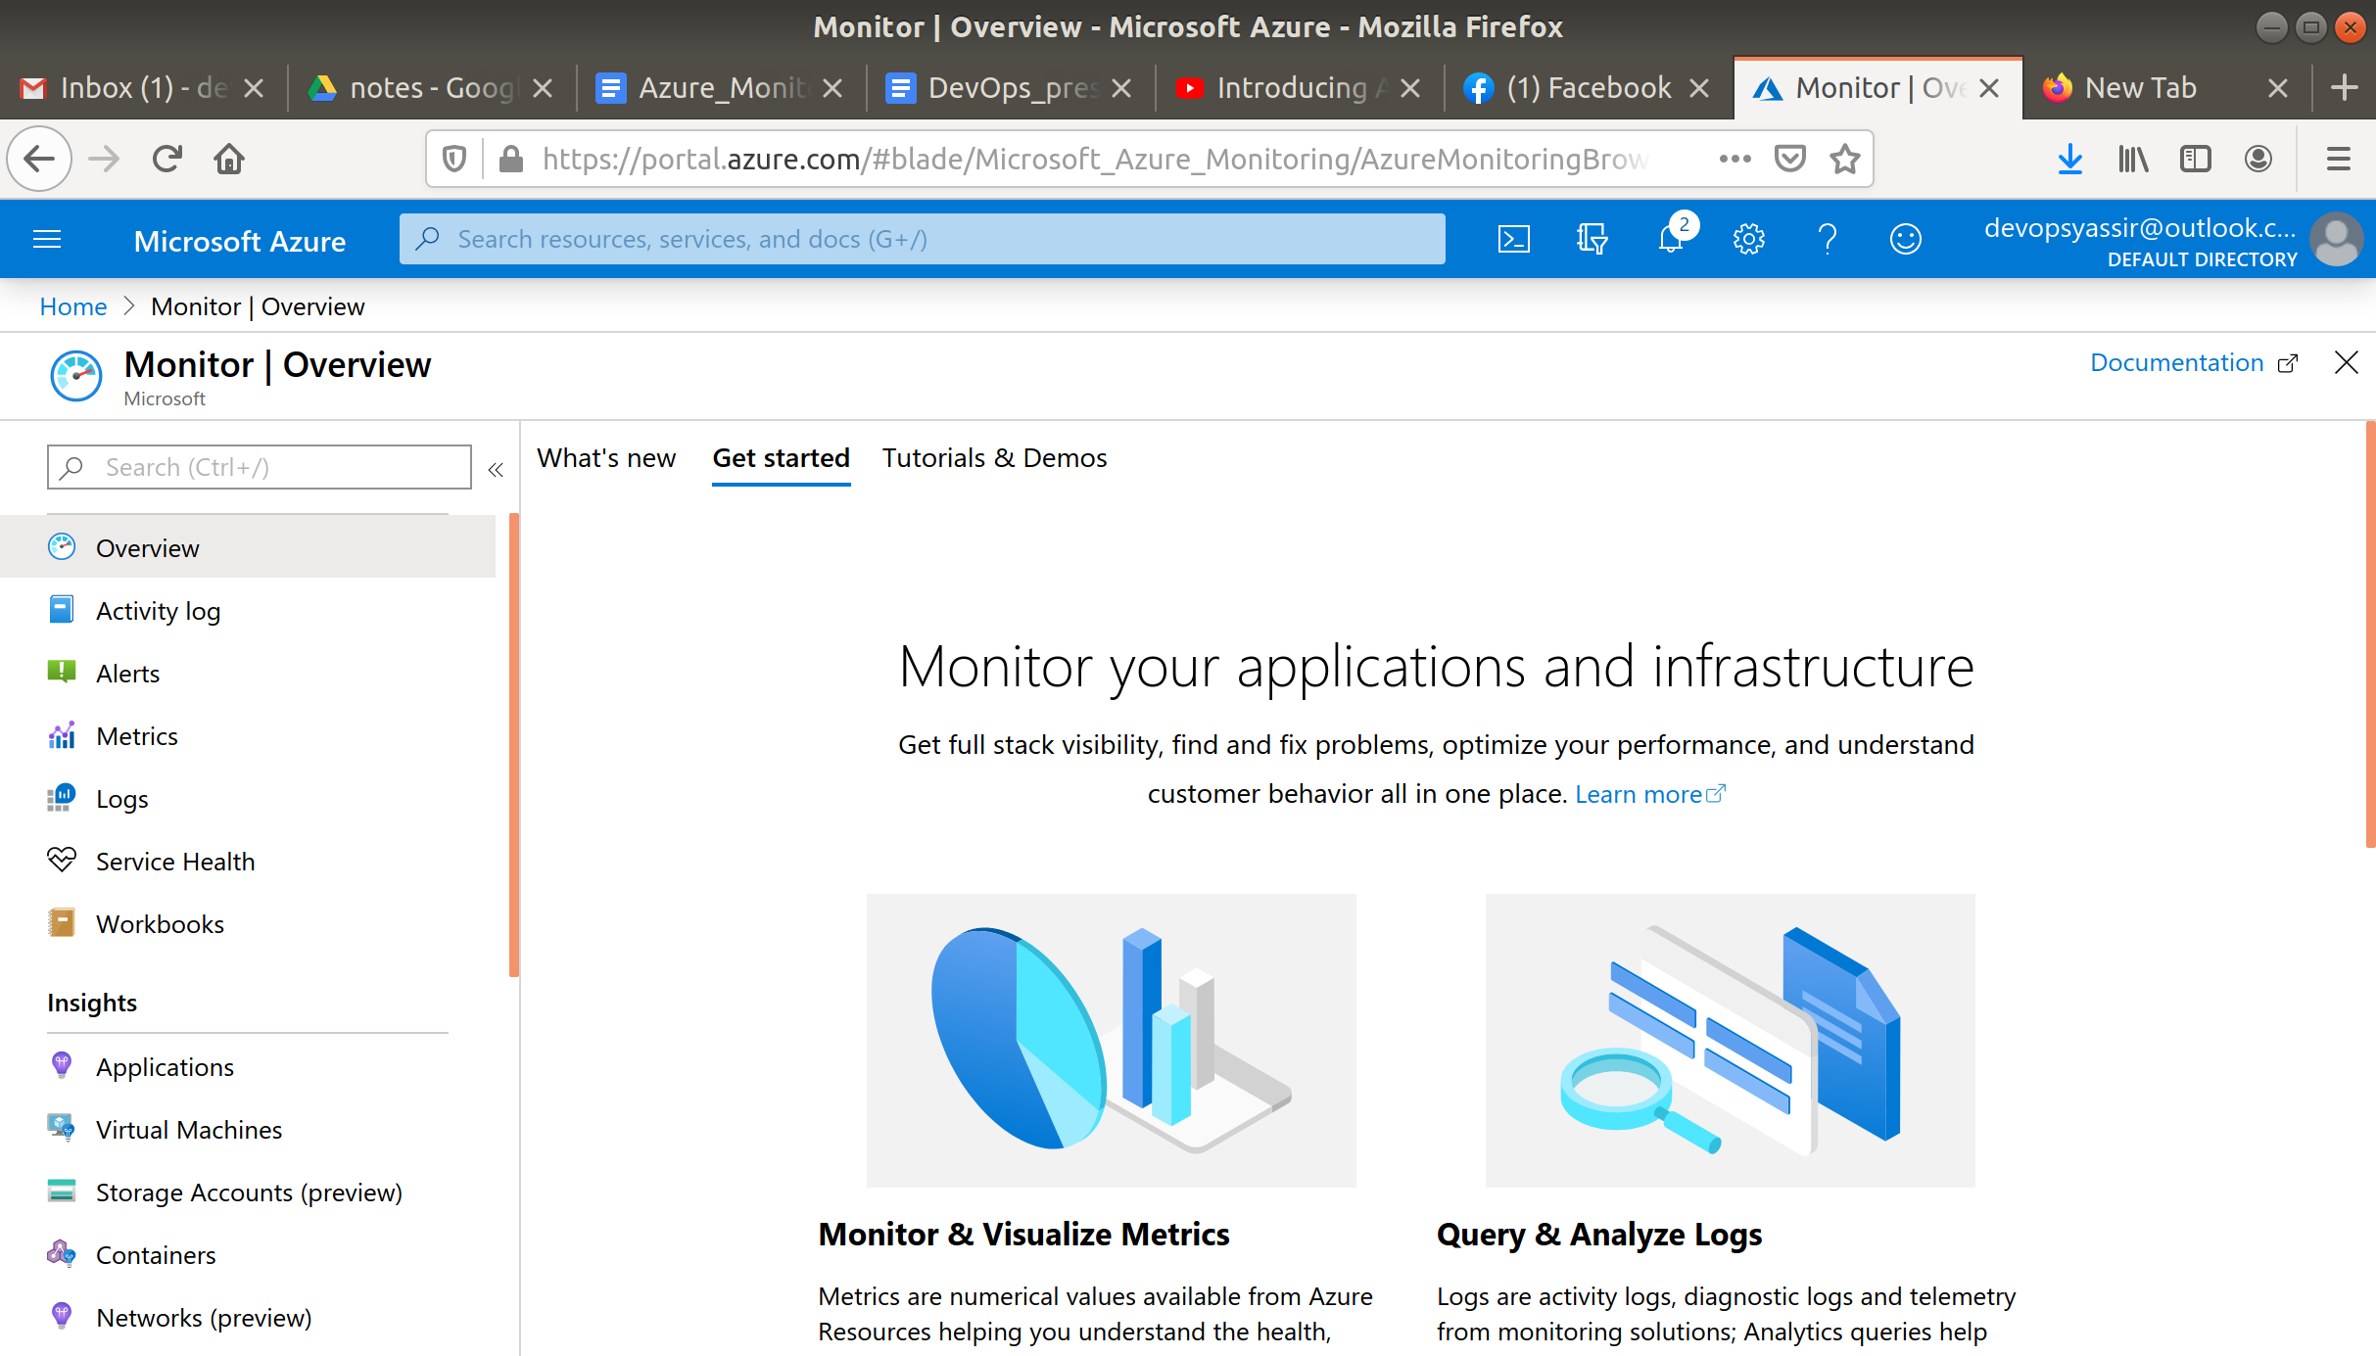

First click on Metrics in the blade on the left.

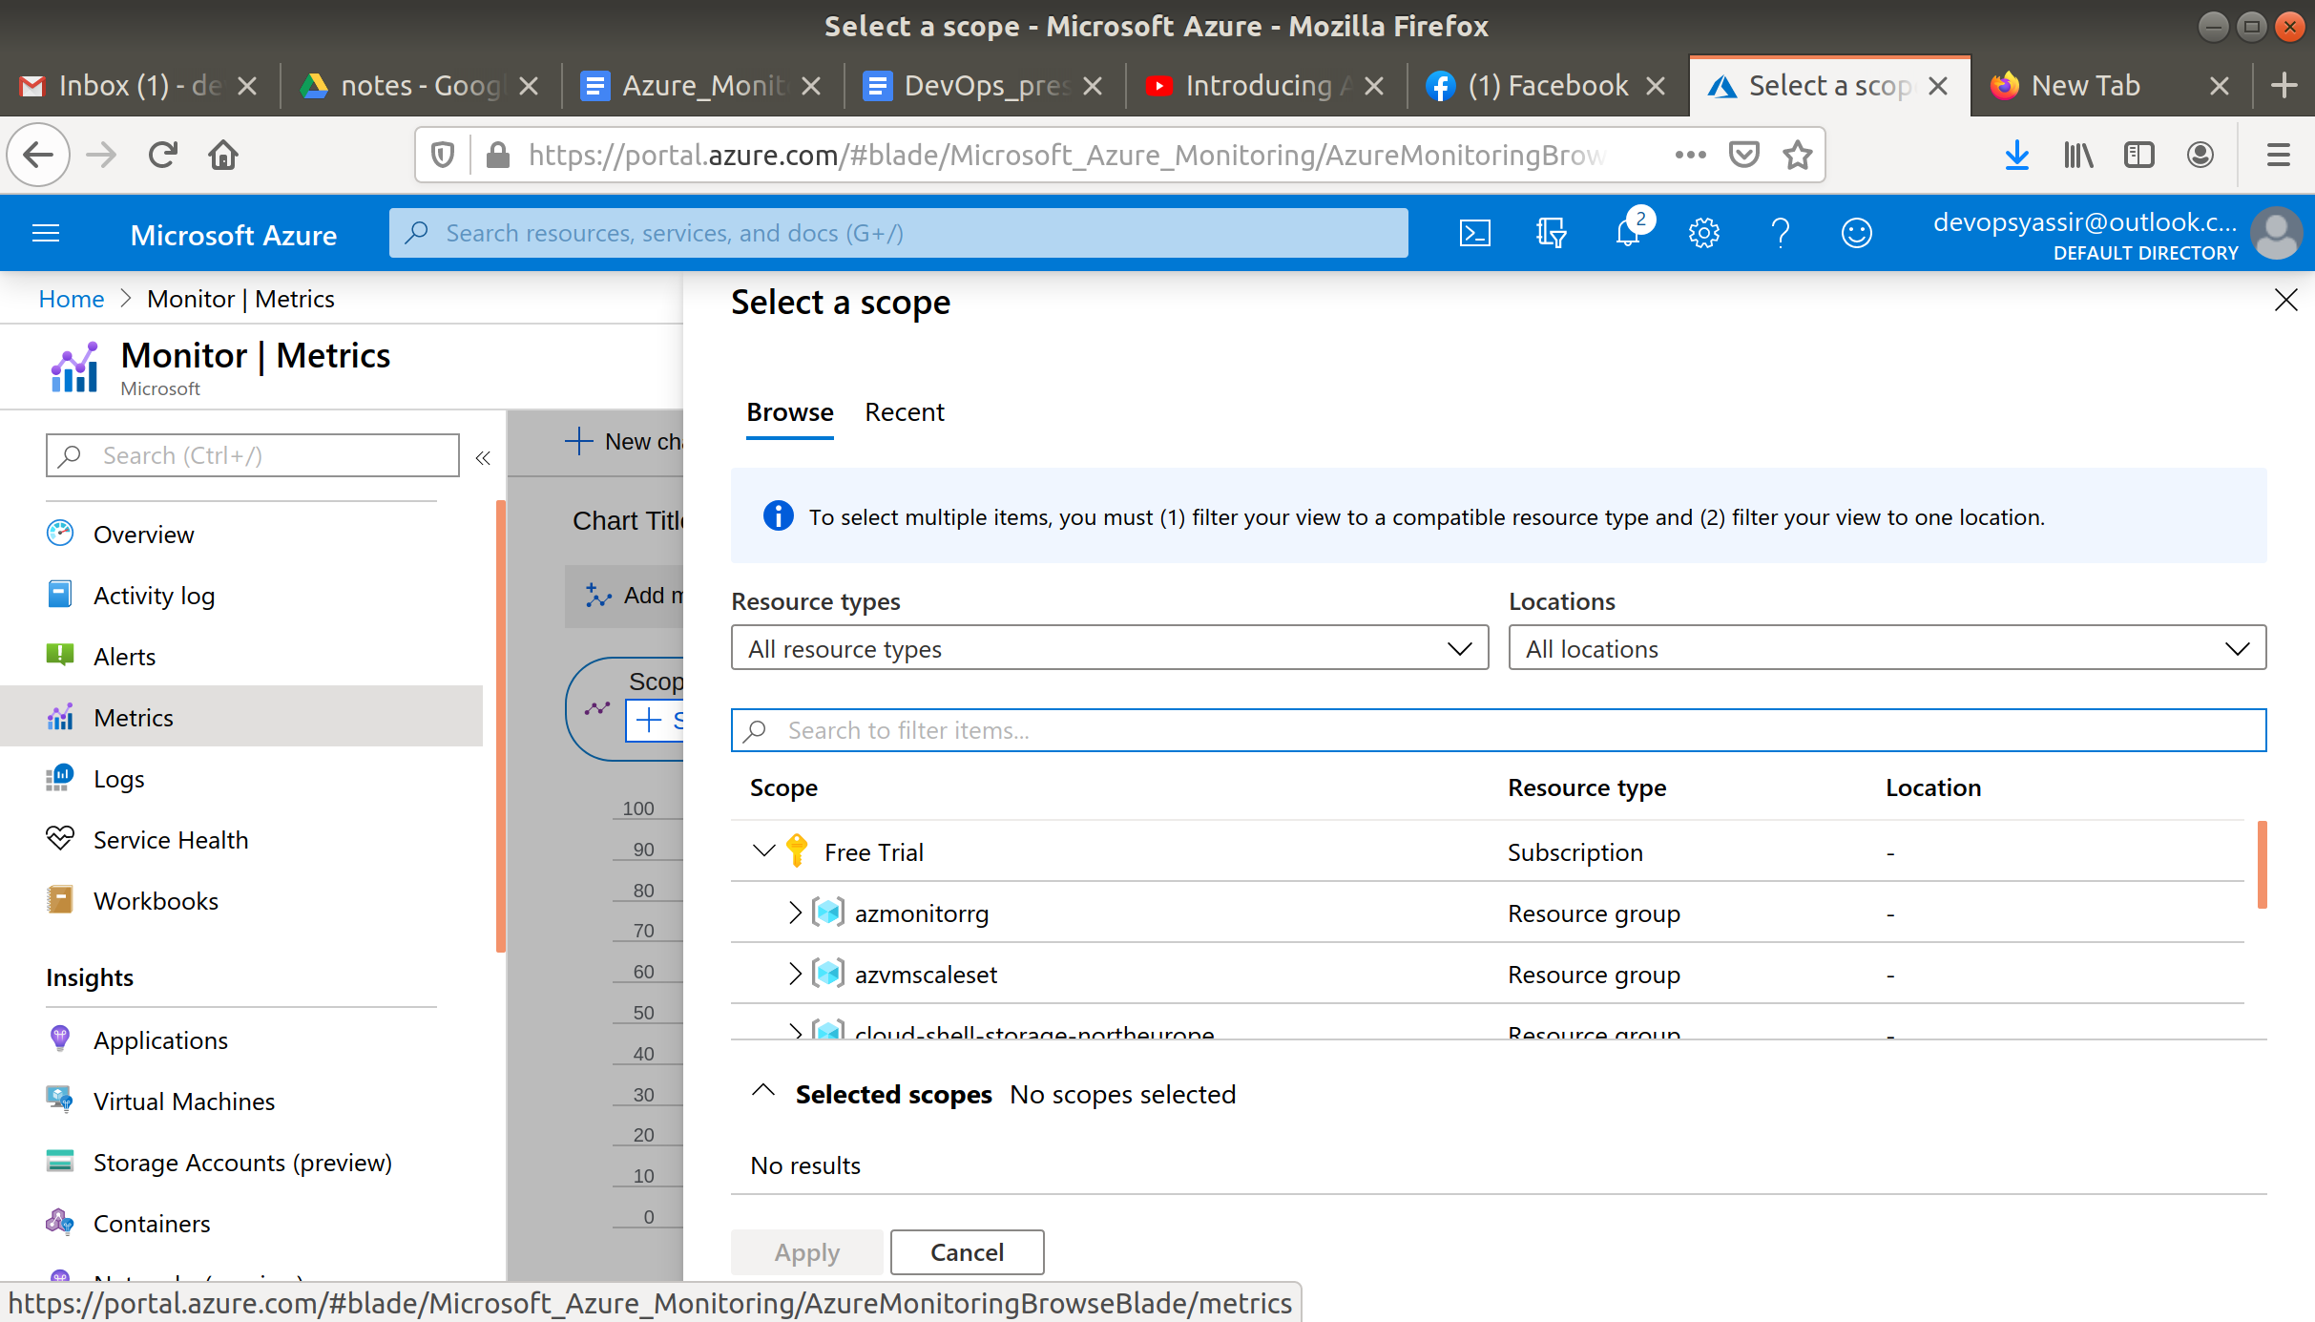

The click select a scope and choose the VM which you just created.

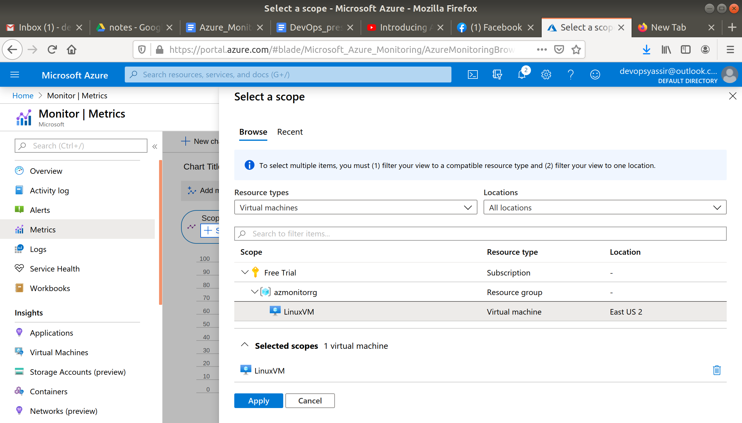

You can change the metric and see different information, I chose to look at **Disk Read**.

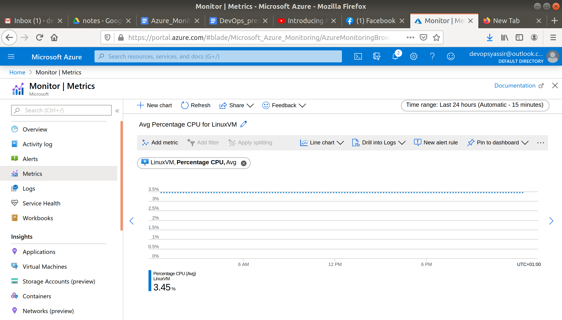

Navigate to Activity log in the left blade.

You should see some logs

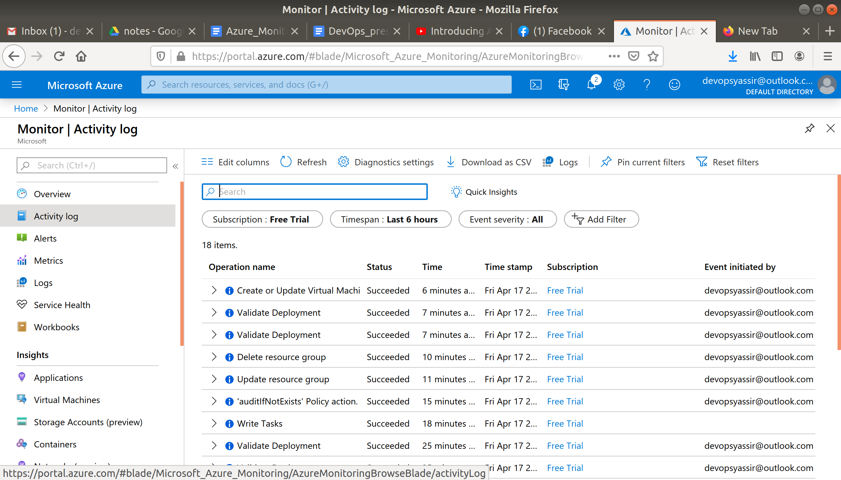

### **Clean Up**

To clean up, go back to the Resource Group page, click your resource group you used for this module, and then choose Delete.

Once you type the name of the resource group to confirm deletion, this will be deleted along with everything inside of it.