# Azure MySQL Database

# 

## **Tutorial**

In this tutorial, we are going to create an Azure Database for MySQL server.

1. Search "mysql" in the search bar at the top of the Portal
2. Click on "Azure Database for MySQL servers"

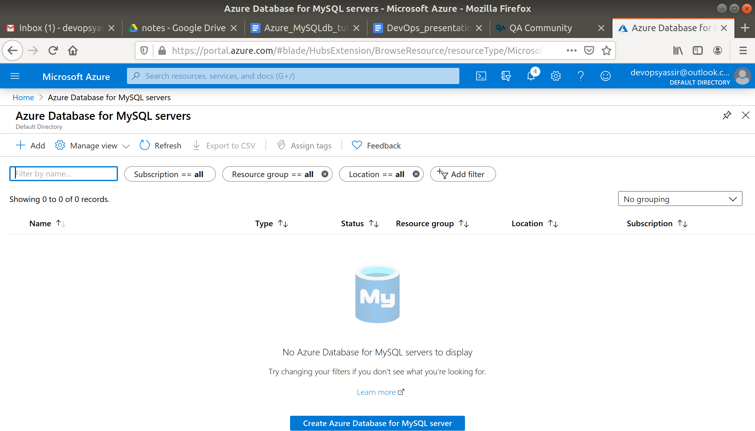

1. Click "+Add" in the top left
2. On this page, configure the following:  
   * Subscription: the subscription you wish to use
   * Resource group: click "create new", enter "dbrg" and click "ok"
   * Server name: Enter "aztest" followed by some numbers (this has to be unique)
   * Data Source: None
   * Admin username: Enter a username of your choice
   * Password: Enter a password of your choice
   * Location: Choose "UK South"
   * Version: Choose "5.7"
   * Compute + storage: leave as Default for now

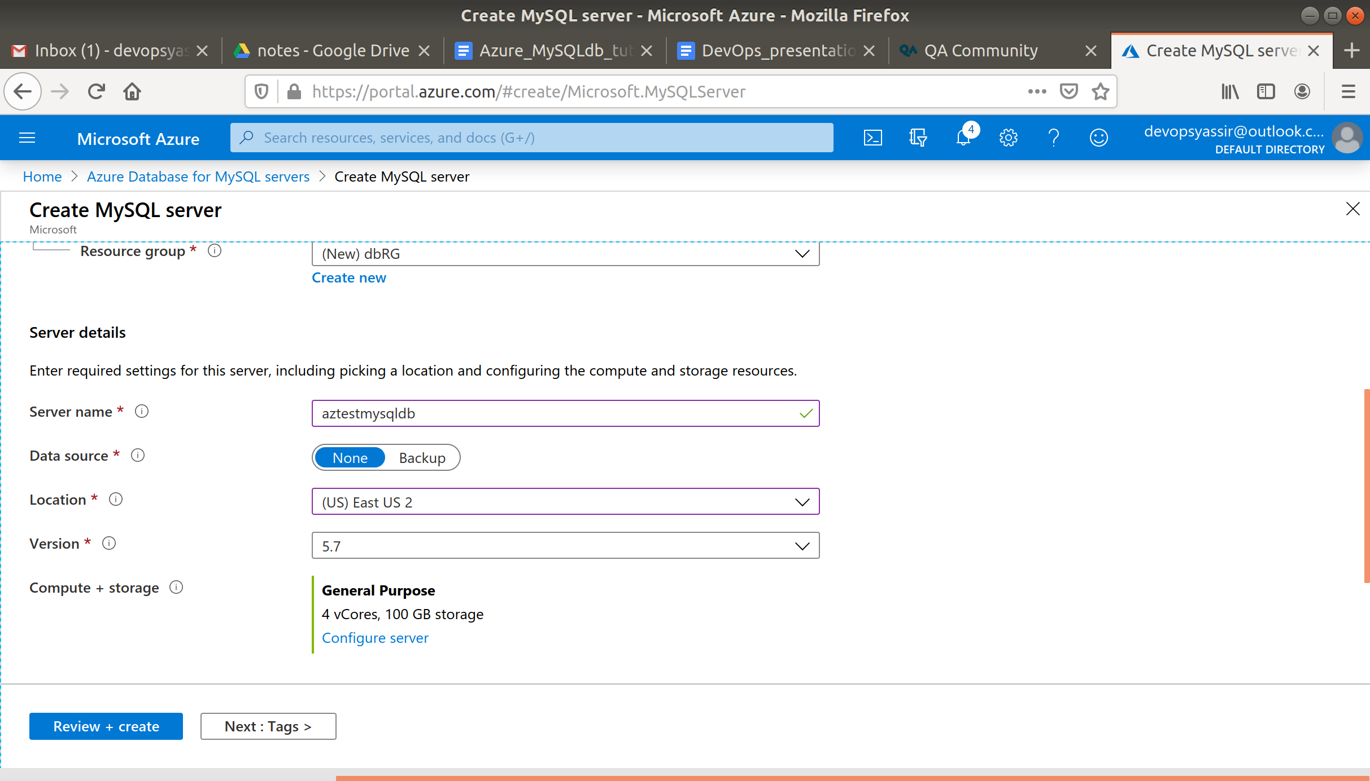

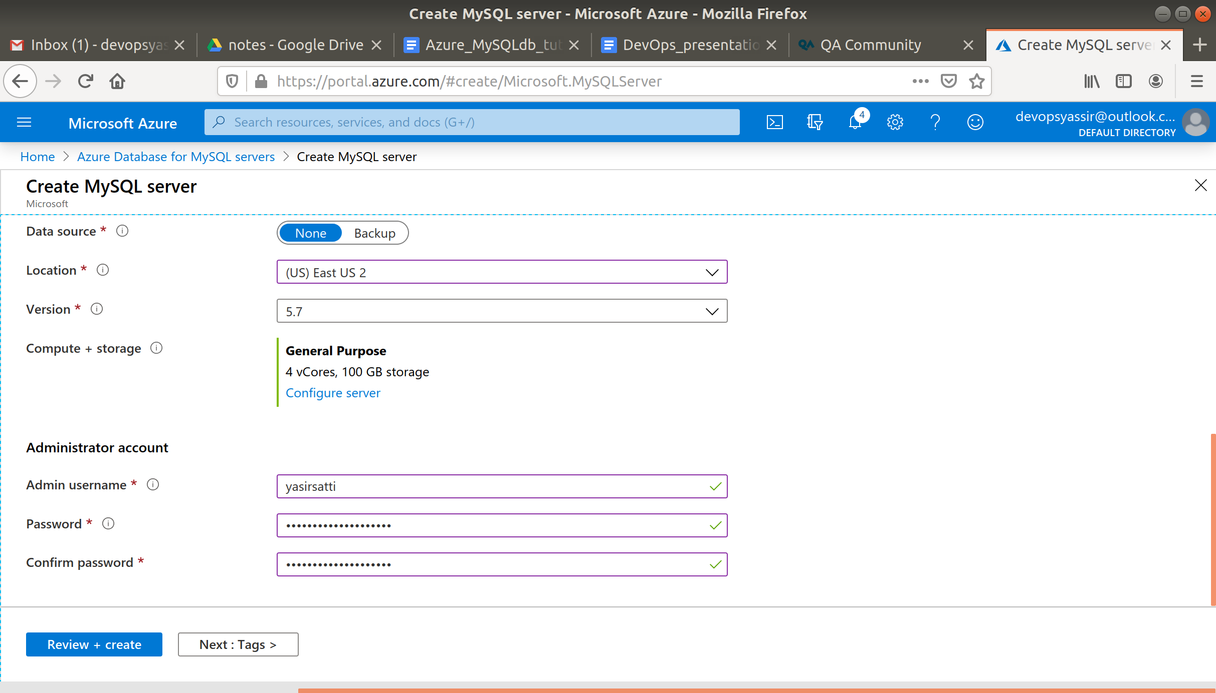

1. Click "Review + create"
2. Once validation has passed, click "Create"

