# Azure Role-Based Access Control

# 

## **Tutorial**

In this tutorial we will look at some more of the Azure built in roles.

Navigate to Azure Active Directory and select Roles and administrators in the left blade.

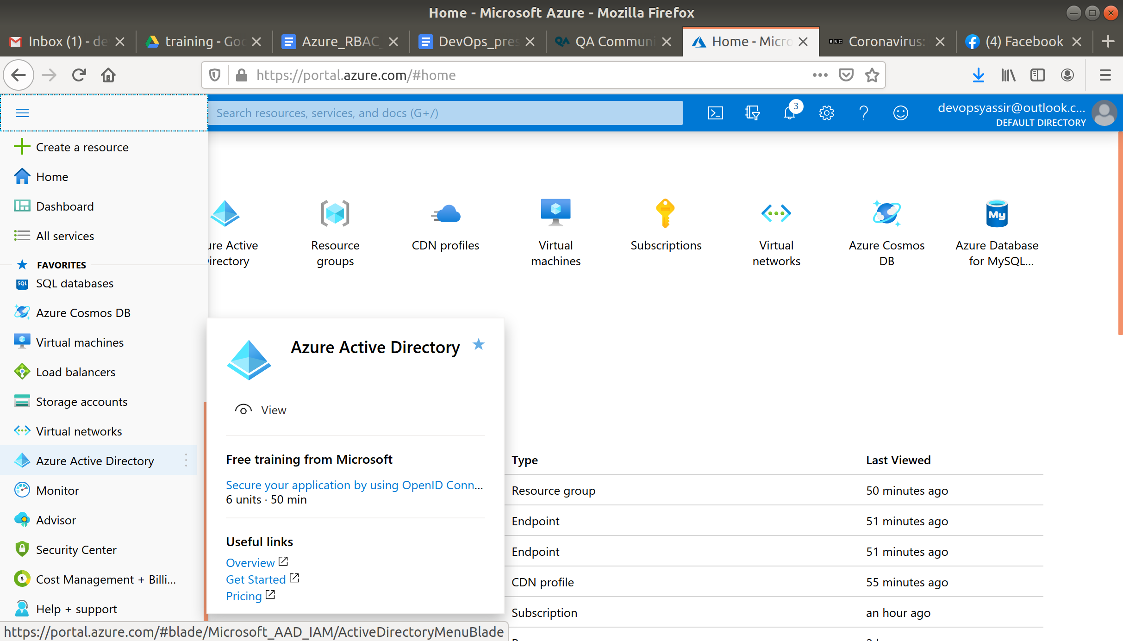

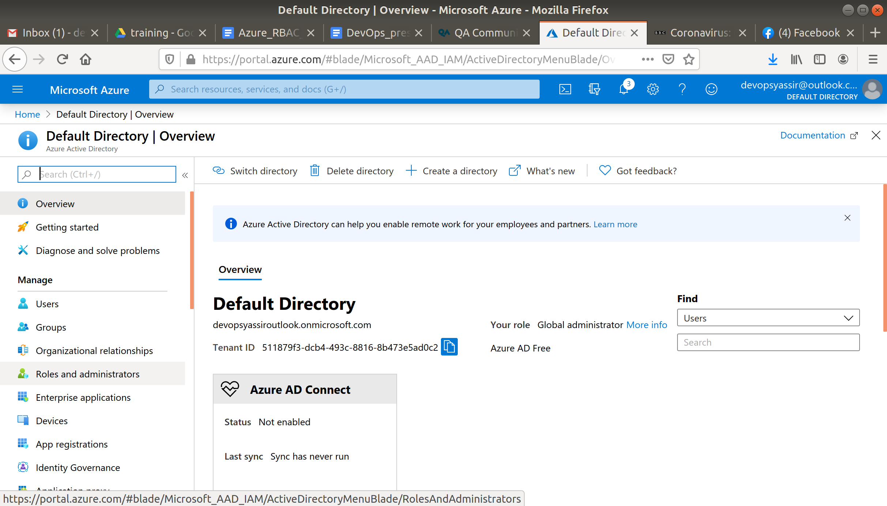

Now in the type box select built-in.

Here you can see all the roles Azure has ready to be used.

