# Azure Security Centre

# 

## **Tutorial**

### **New Resource Group**

The first thing is to create a new resource group, which we can do by clicking the burger bar in the top left corner and choosing Resource groups:

Then, we can click +Add:

Here, we can name the resource group and pick a location to have it in:

Lastly, we will click Review & Create and then Create to create the resource group:

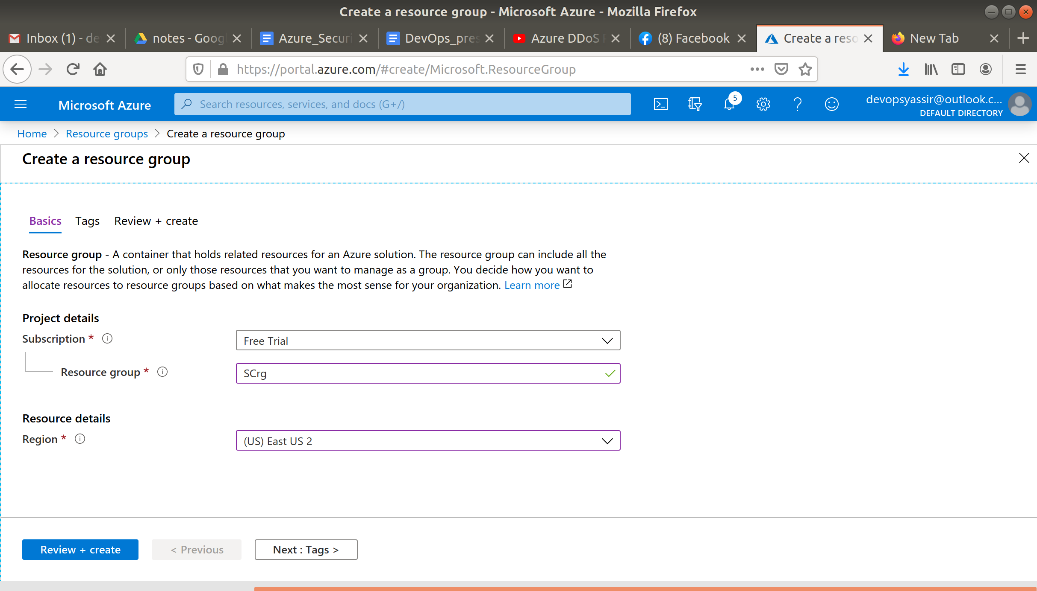

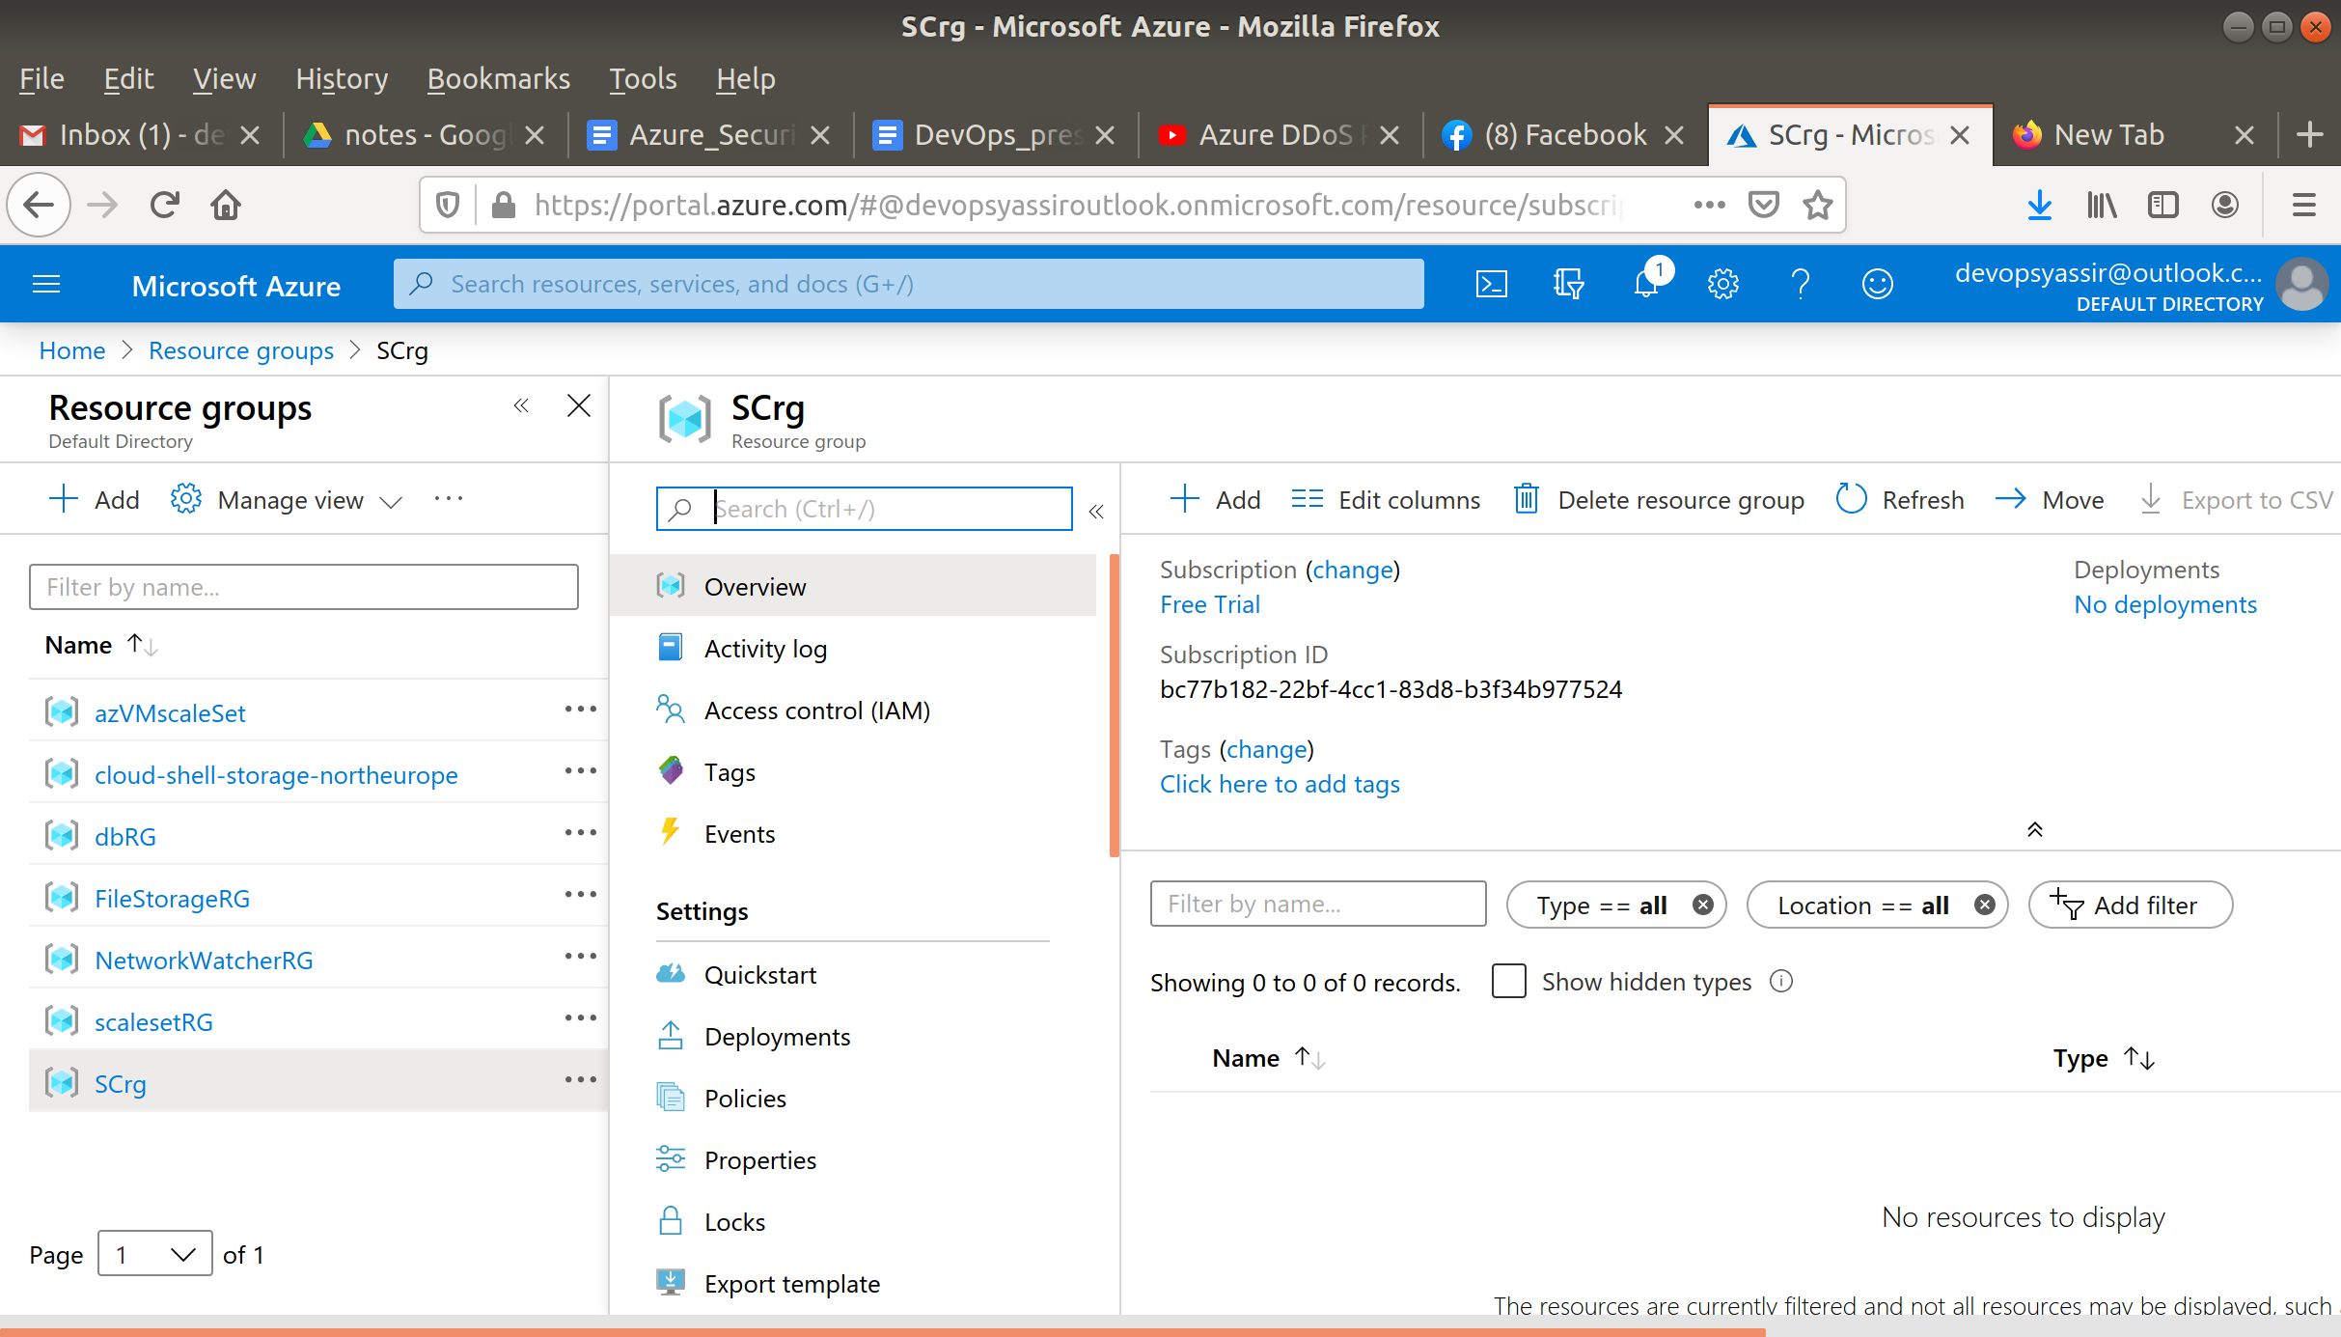

### **New Virtual Machine**

For this, we need to first go to the hamburger menu again, but this time click Virtual machines:

Then, we click + Add:

We will need to choose our new resource group from the drop down menu, give the machine a name and pick a region for it to be deployed into.

The image can be Ubuntu Server 18.04 LTS, and the Size can be Standard D2s v3:

We need to choose a password for authentication type, and create a username and password.

We also need to ensure that Port 22 is open, so we can SSH into the machine later (this should be checked by default):

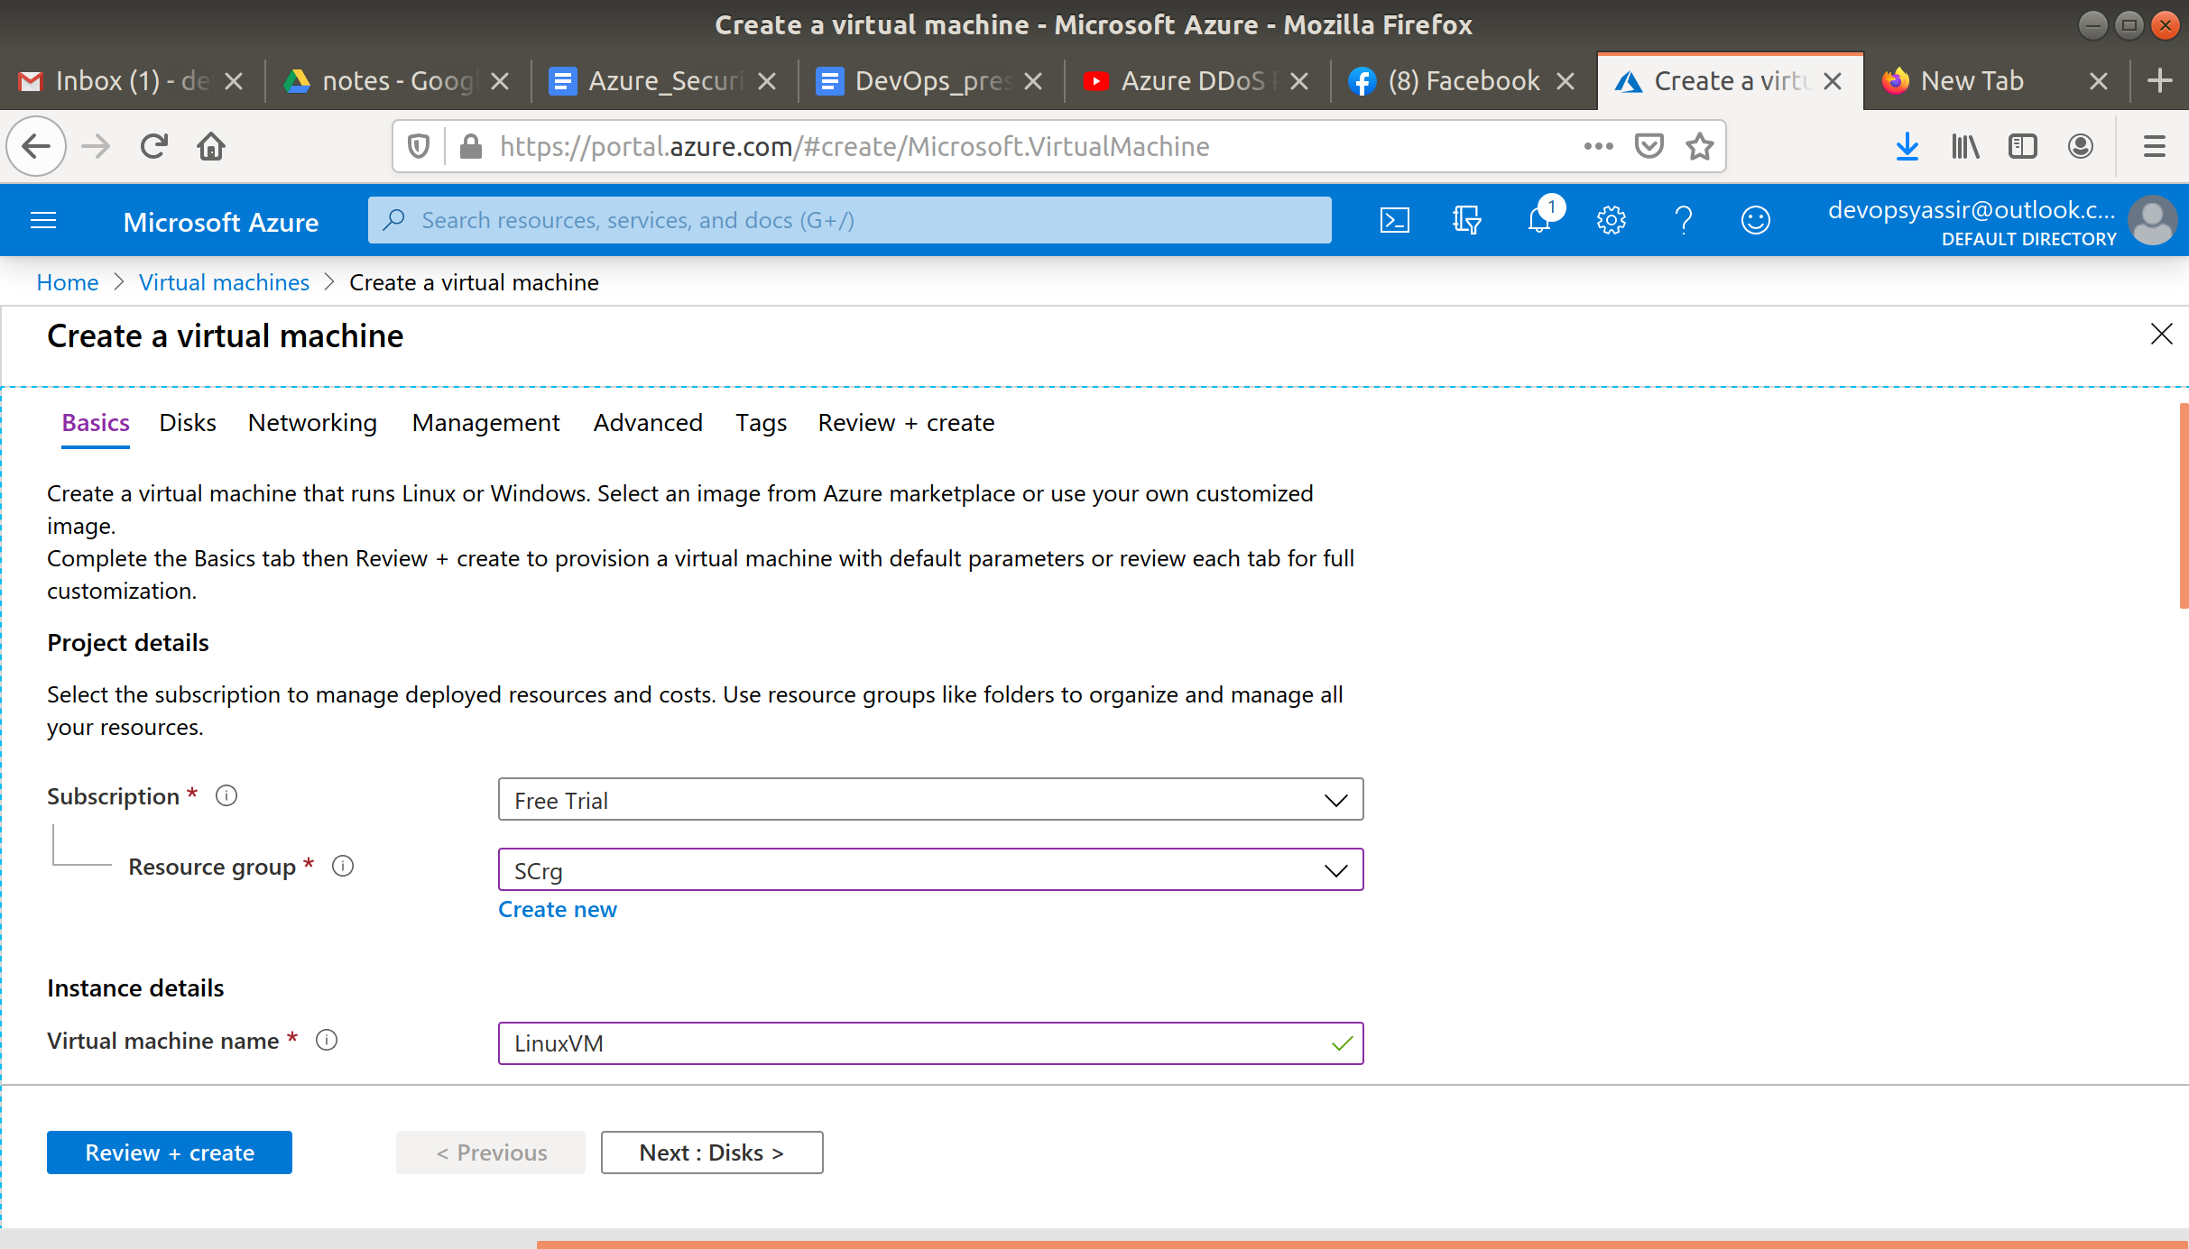

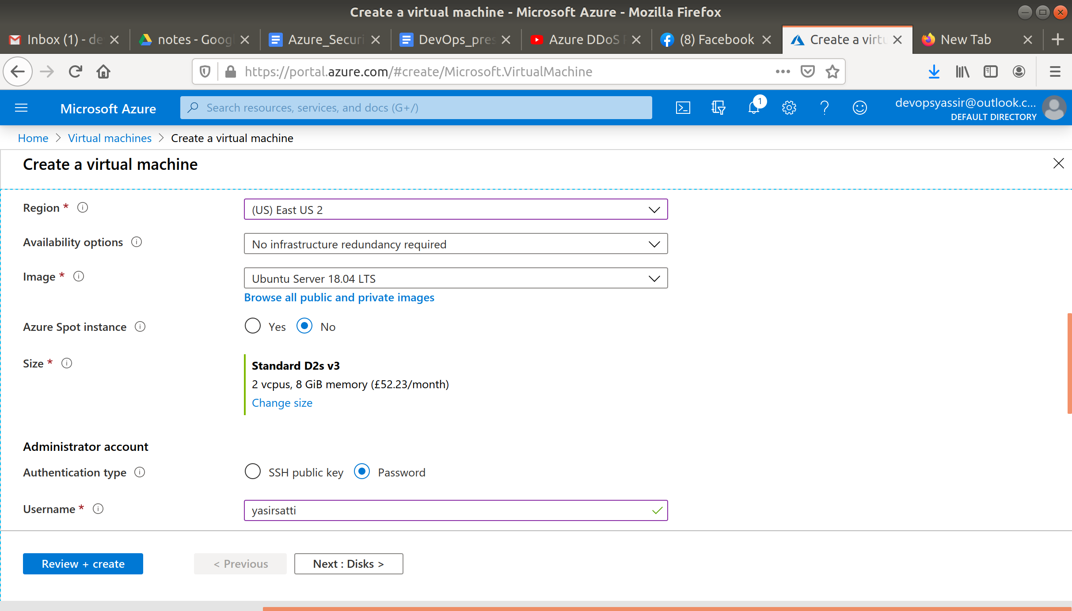

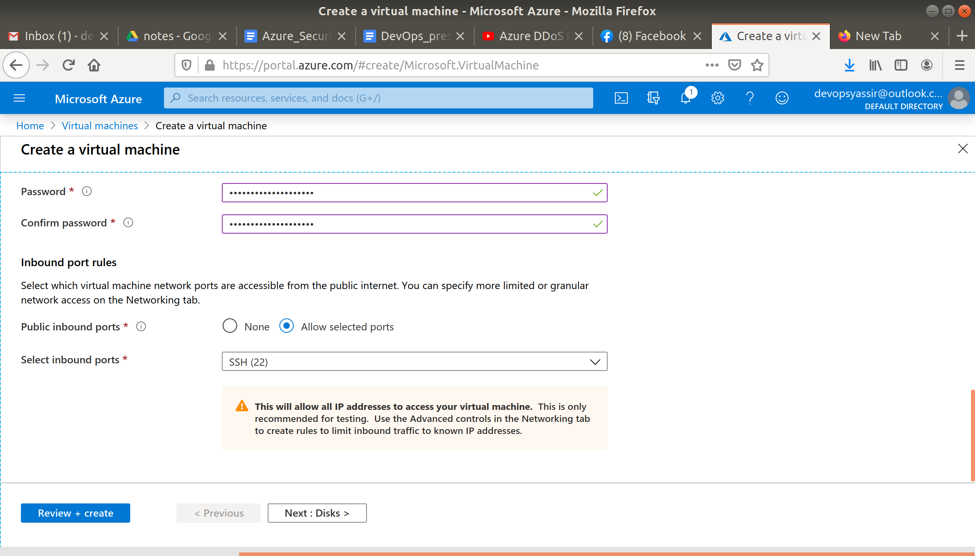

After clicking Create, our Linux VM is created!

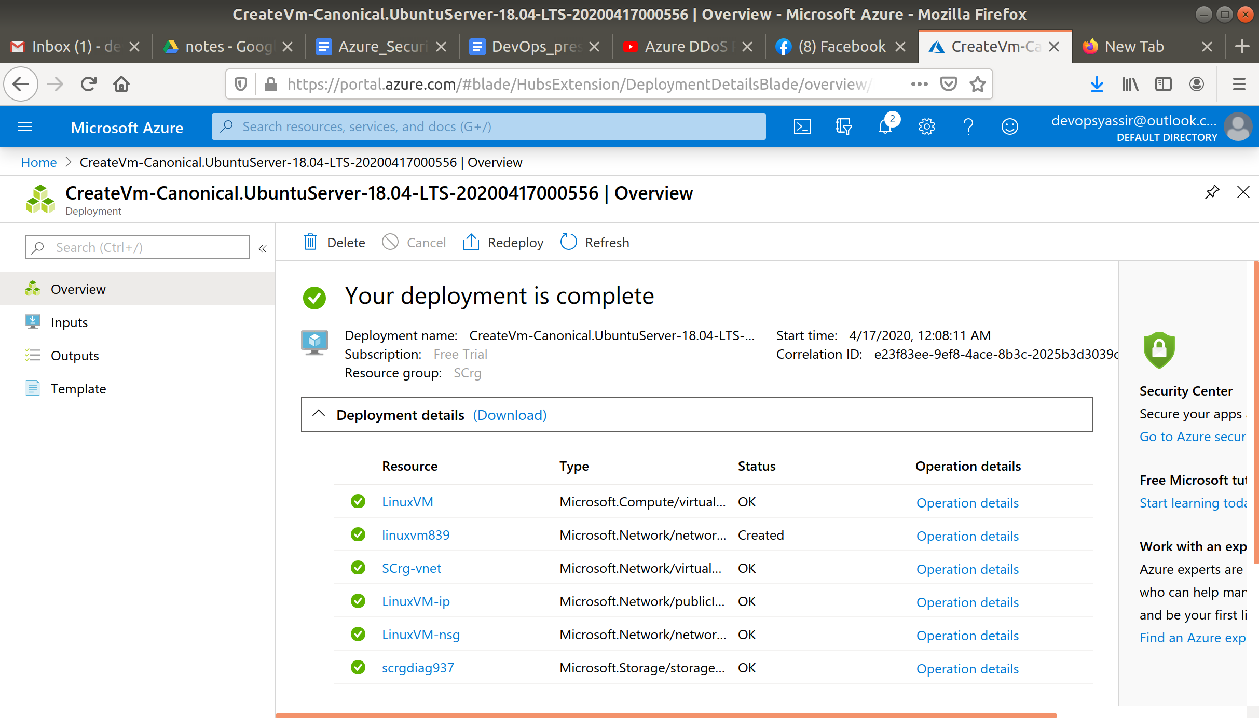

### **Security Centre**

Now go to the Security Centre in the left blade.

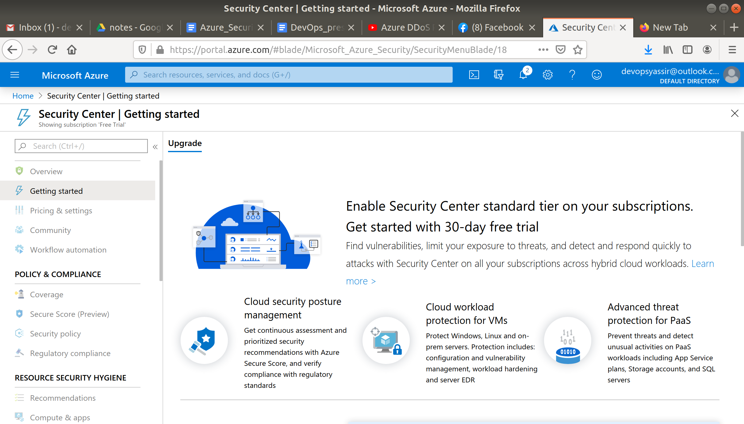

Now this may take a while to update but eventually you will be able to see an overview page

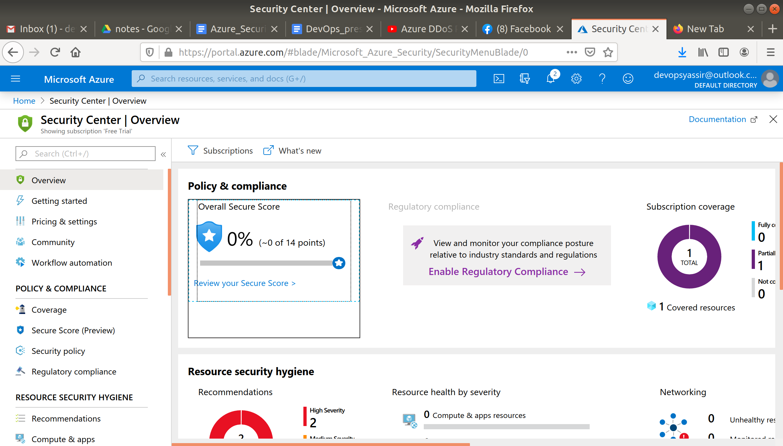

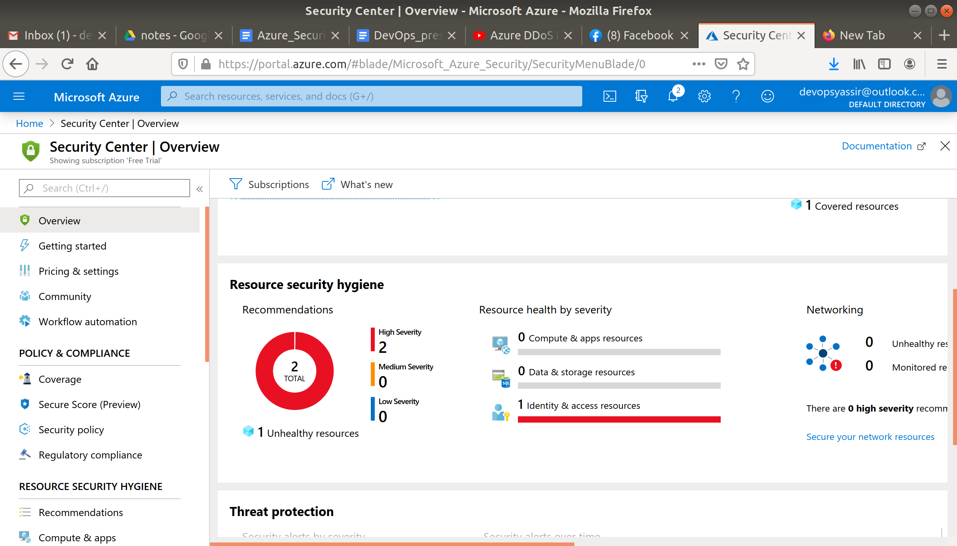

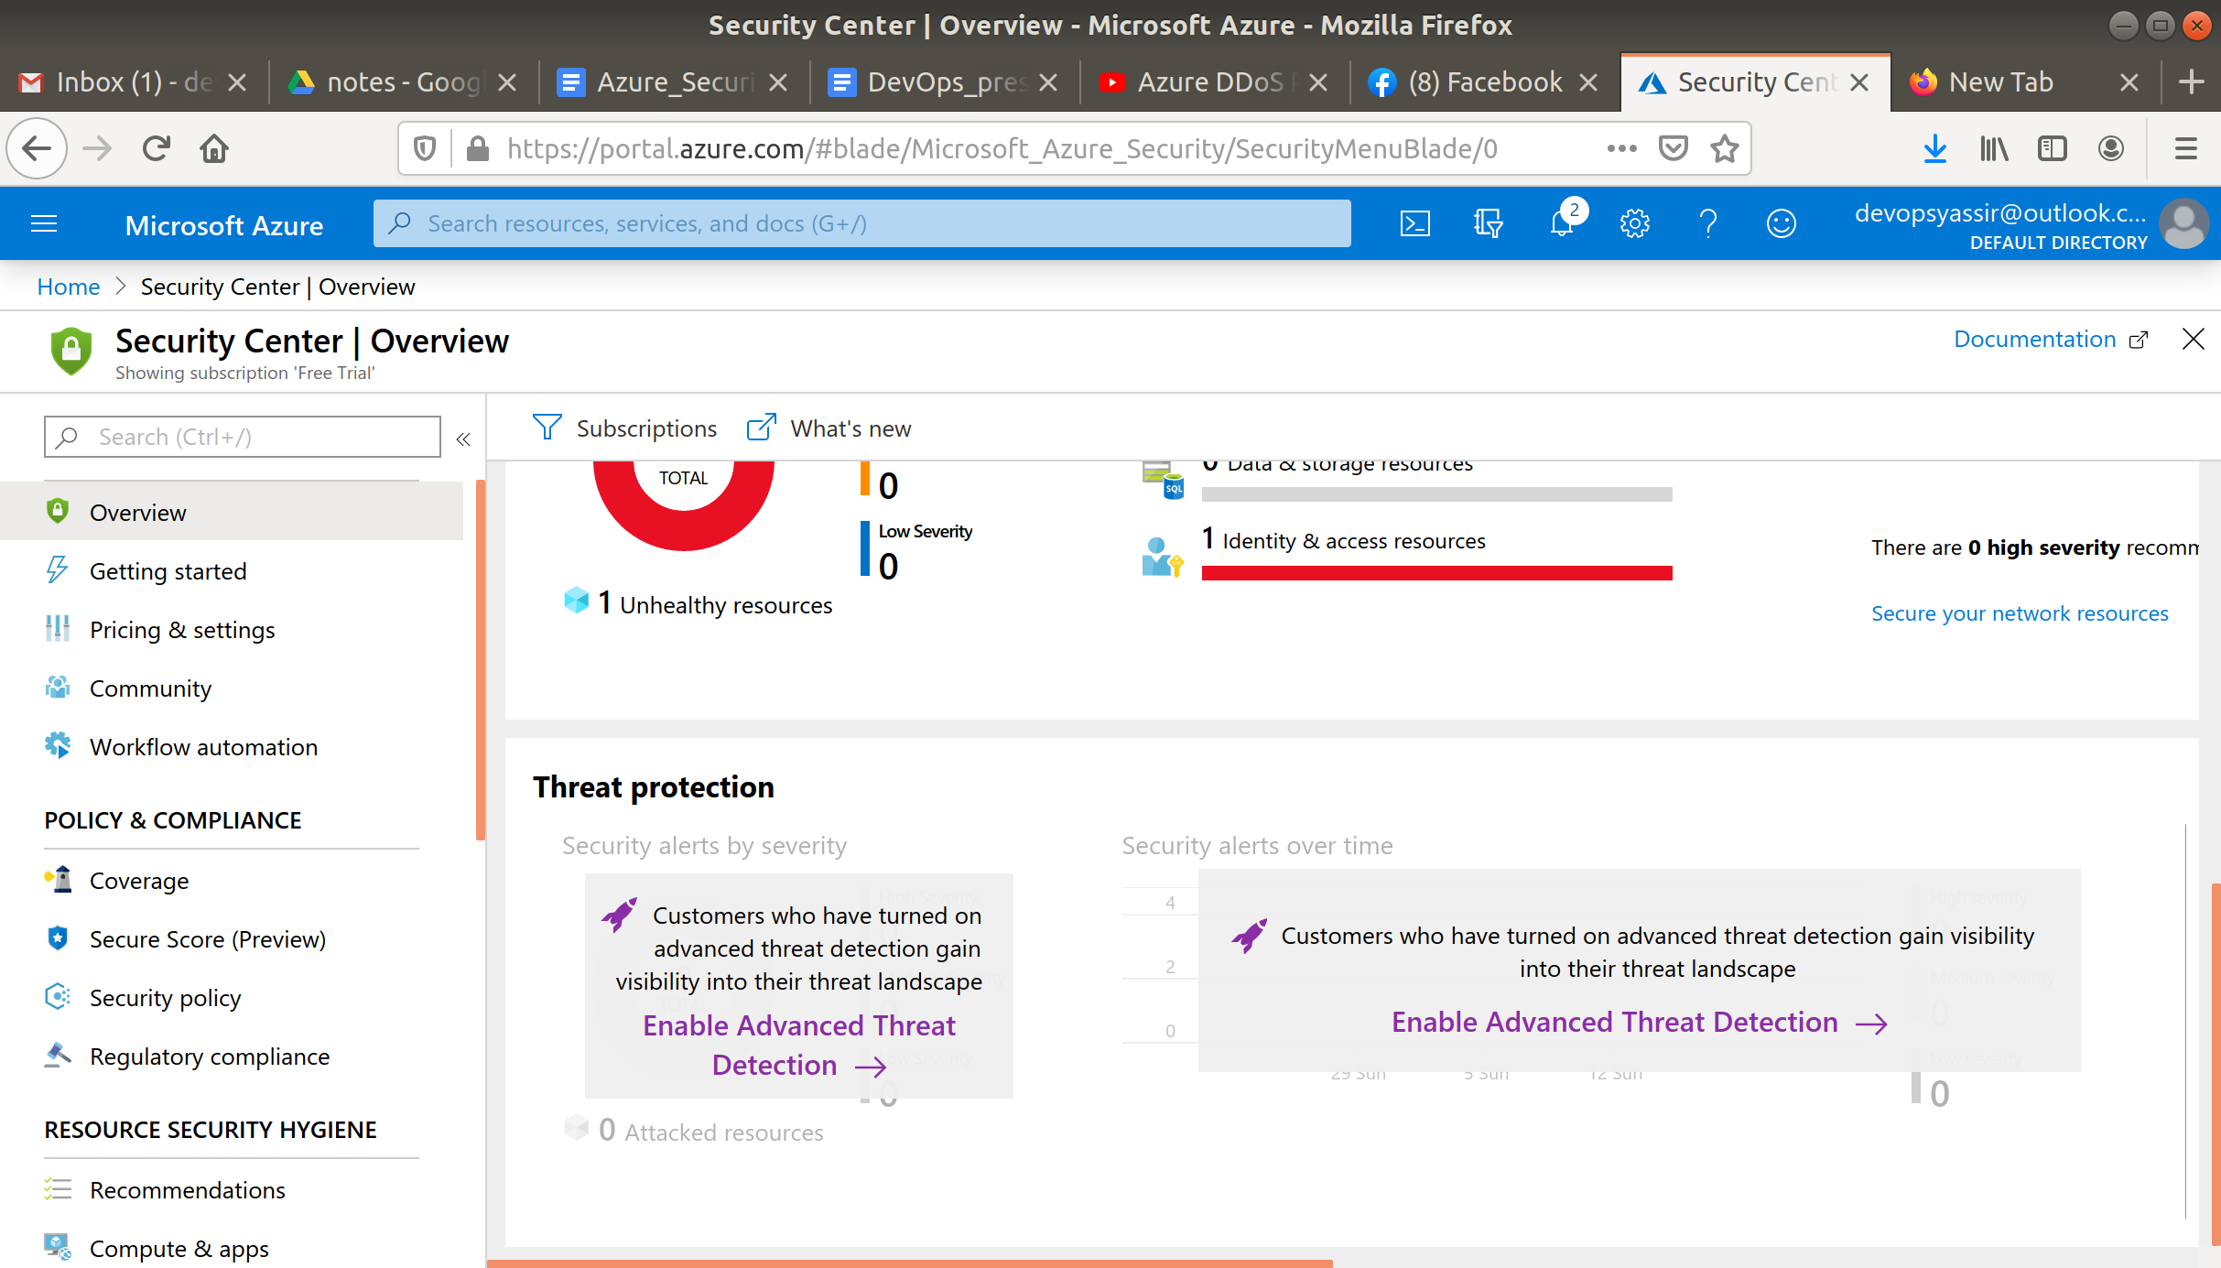

Now in the left blade click Compute & apps and you should be able to see the recommendations Azure is giving you in regards to the vm you just created.