# Azure Virtual Machine Scale Sets

## **Tutorial**

For this demo, we will be using the **Azure Portal**.

### **Load Balancer**

The first thing we need to do is create a **Load Balancer**:

1. In the search box at the top of the home page, we can search "Load Balancer" and click on it when it pops up
2. We'll click **+Add** in the top left
3. In the **Basics** tab of the **Create a load balancer** page, we can enter or select the following:

* Subscription - our subscription
* Resource Group - we will create a new one called "**scalesetRG**" for this demo
* Name - we'll type "**myLoadBalancer**"
* Region - we can select **uk south**
* Type - we will select **Public**
* SKU - we'll select **Standard**
* Public IP Address - we'll select **Create new**Public IP address name - we can type "**myPip**" for this
* Assignment - we'll choose **Static**
* Availability Zone - we will select **Zone-redundant**

1. We will then select **Review + create**
2. After it passes validation, we can click **Create**

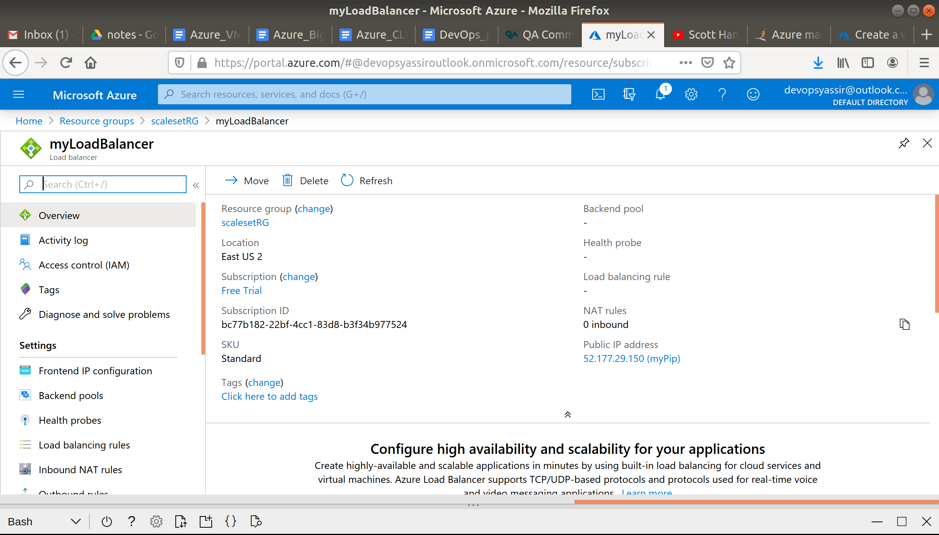

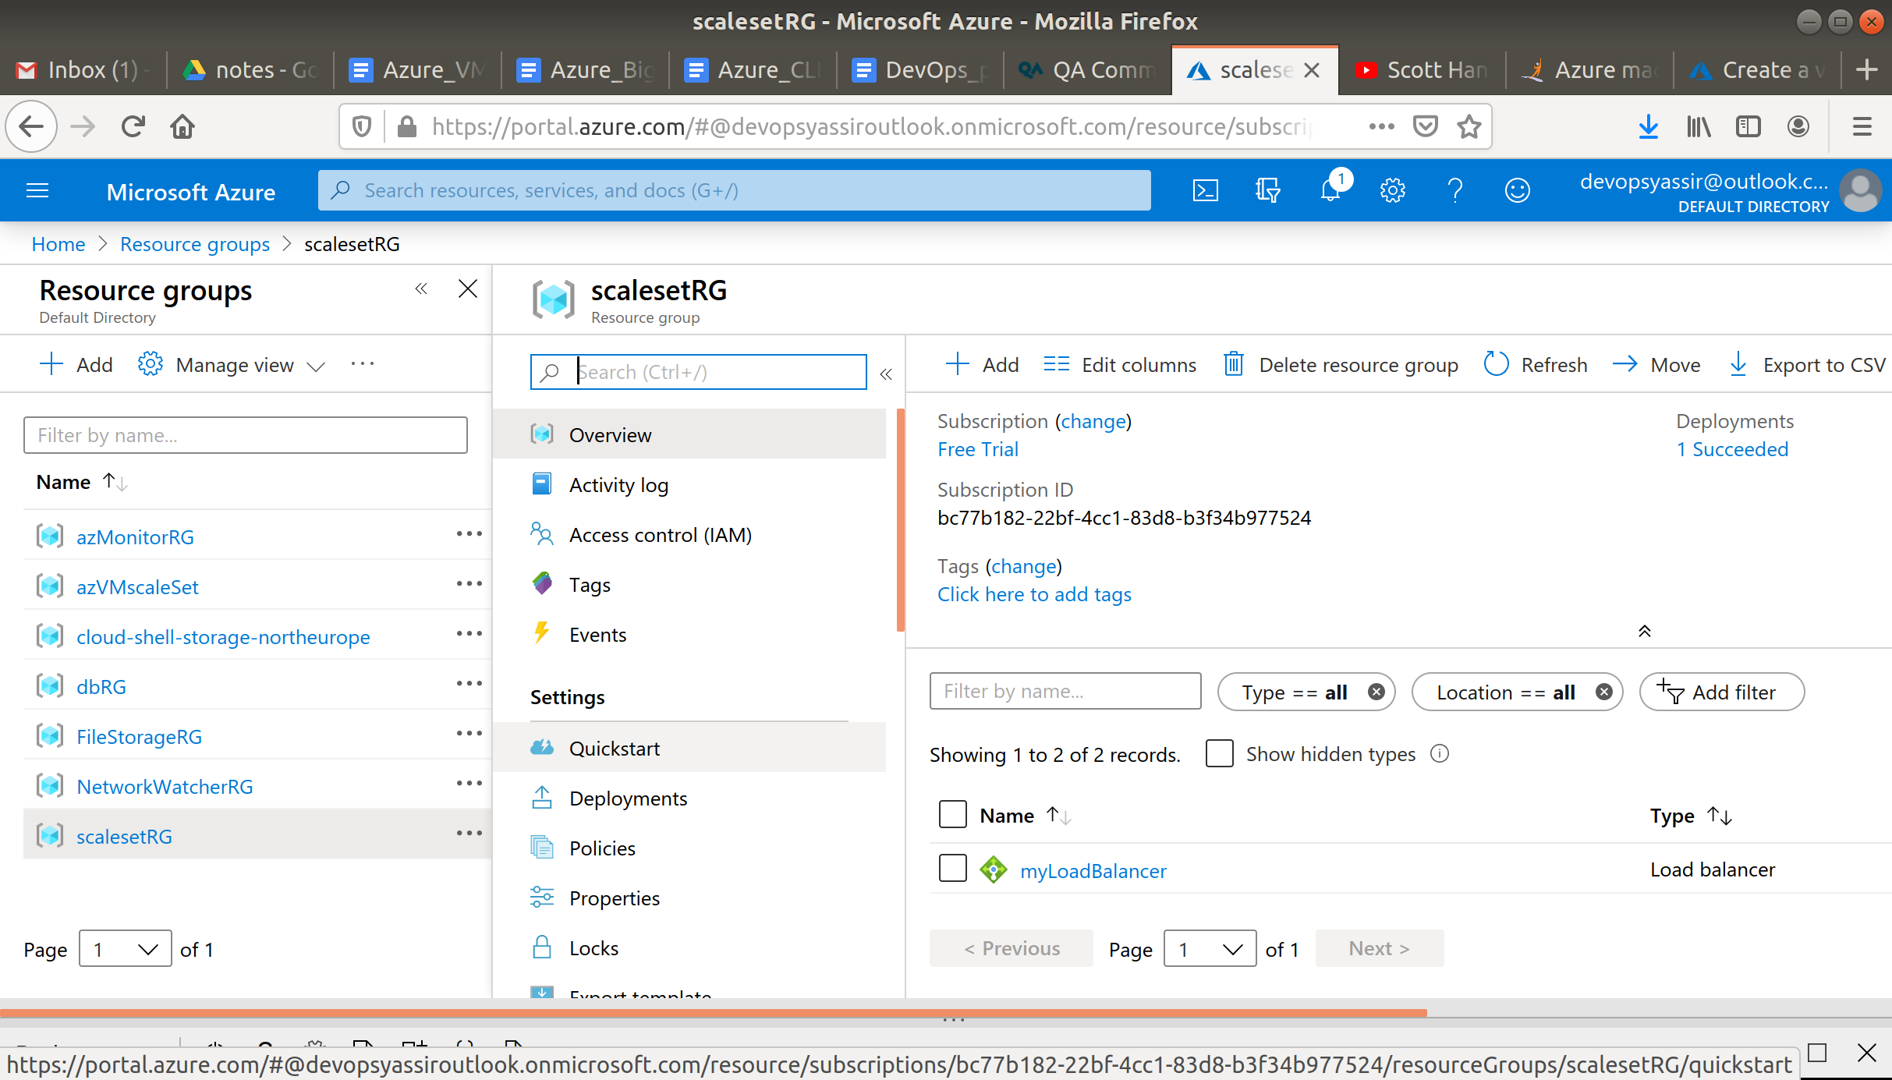

### **VM Scale Set**

Now, we can look at creating a Virtual machine scale set:

1. First, we type "Scale set" in the search bar and select "Virtual machine scale sets"
2. We click **+Add** in the top left
3. If this appears at the top of your screen, click it. Otherwise continue.
4. In the **Basics** tab, we will choose the correct subscription
5. We'll create a new resource group named "**vmScaleSetRG**"
6. The name of our scale set can be "**myScaleSet**", and for the location, we can choose **UK South**.
7. For **Orchestrator**, we can leave the default value of **ScaleSet VMs**
8. We will choose **Ubuntu Server 18.04 LTS** as the image
9. Then we can choose **Password**, and go ahead and create a username and password we want to use
10. We then select **Next**:

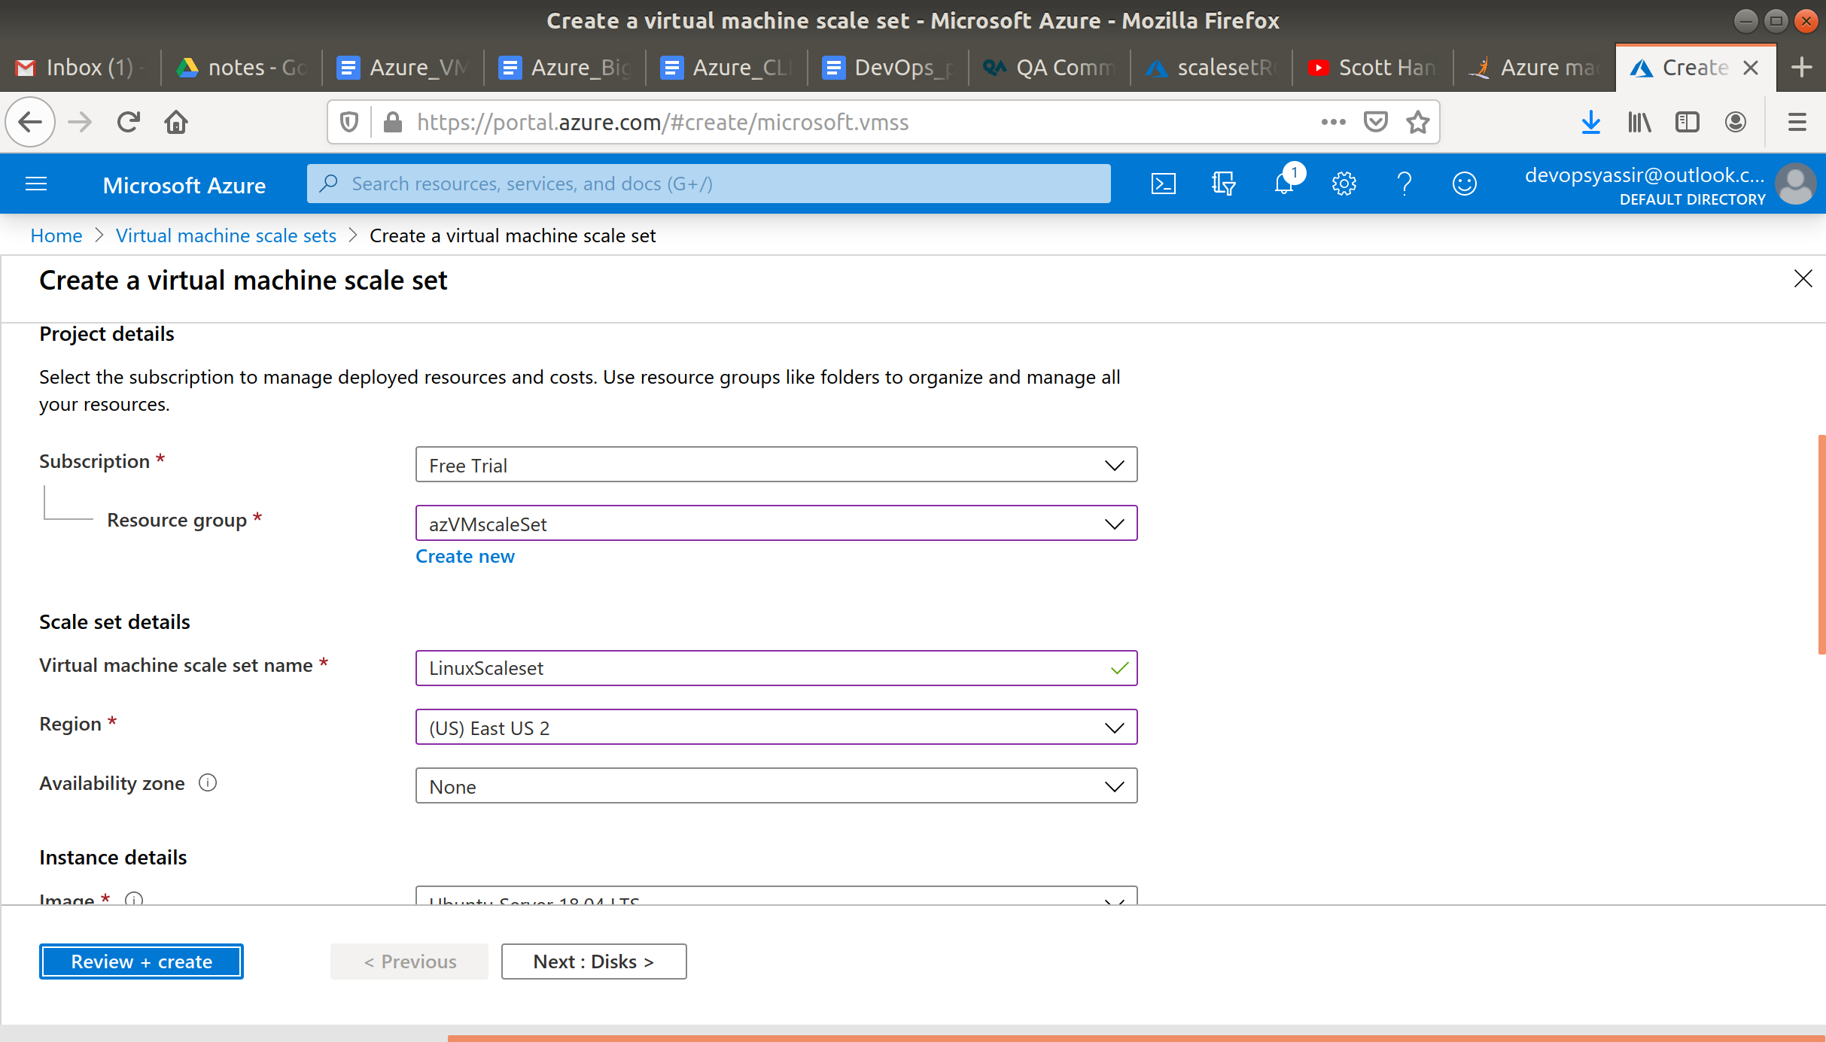

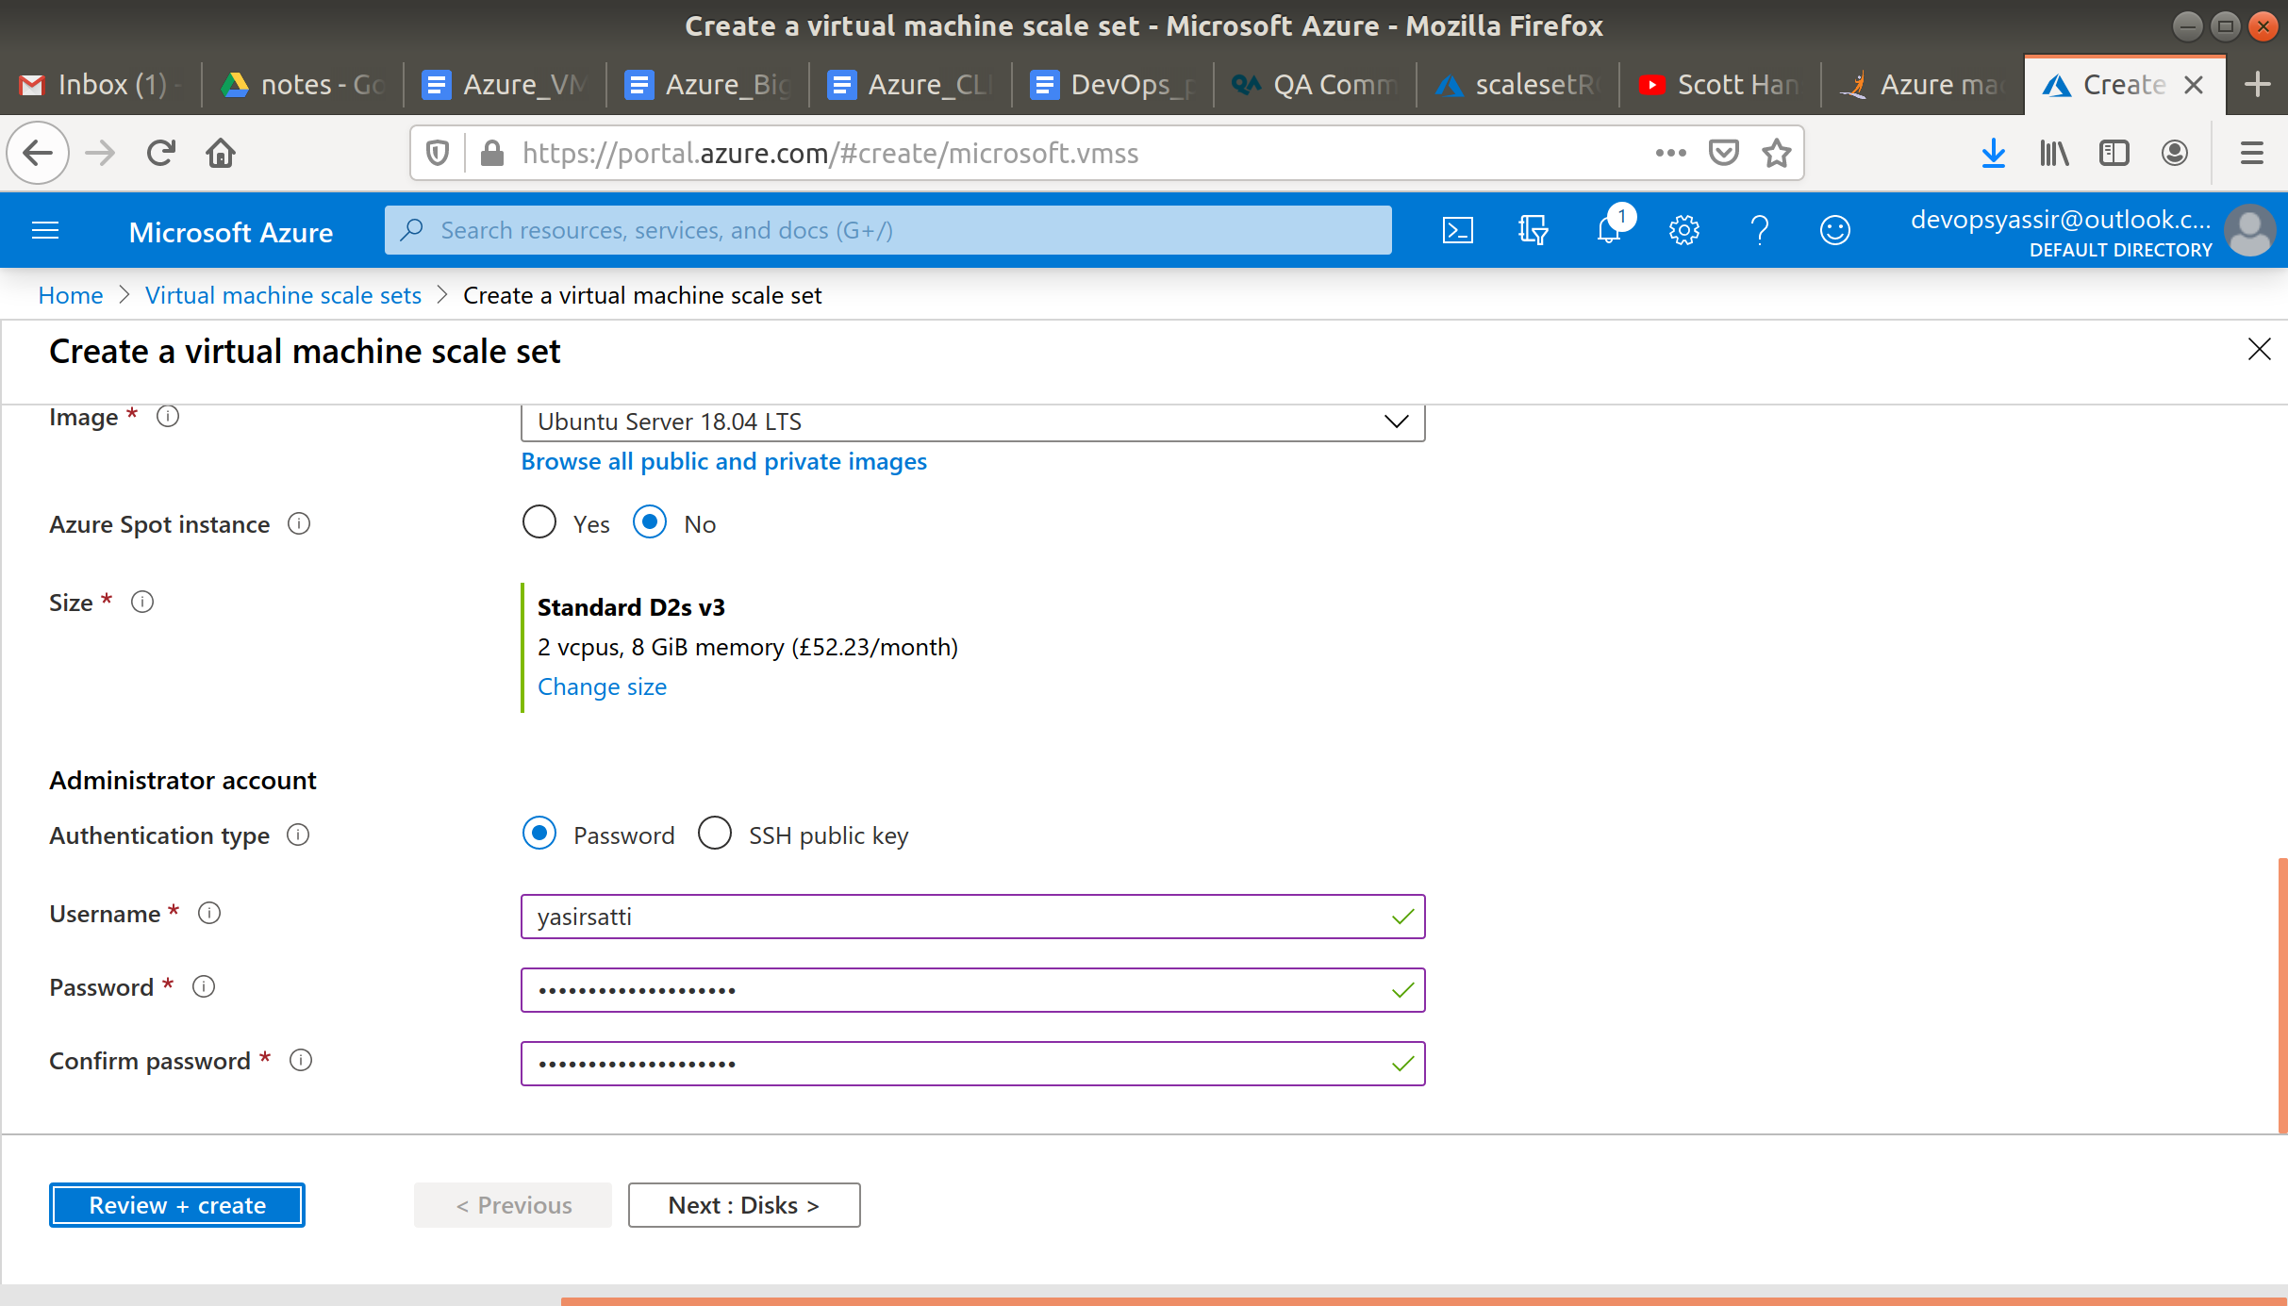

1. The we can select **Next** until we get to the **Networking** page
2. Here, under **Load balancing**, we'll select **Yes**
3. In **Load balancing options**, we can select **Azure Load balancer**
4. In **Select a load balancer**, we'll choose the load balancer that we created earlier
5. For **Select backend pool**, we'll choose **Create new**, type "myBackendPool" and then click **Create**

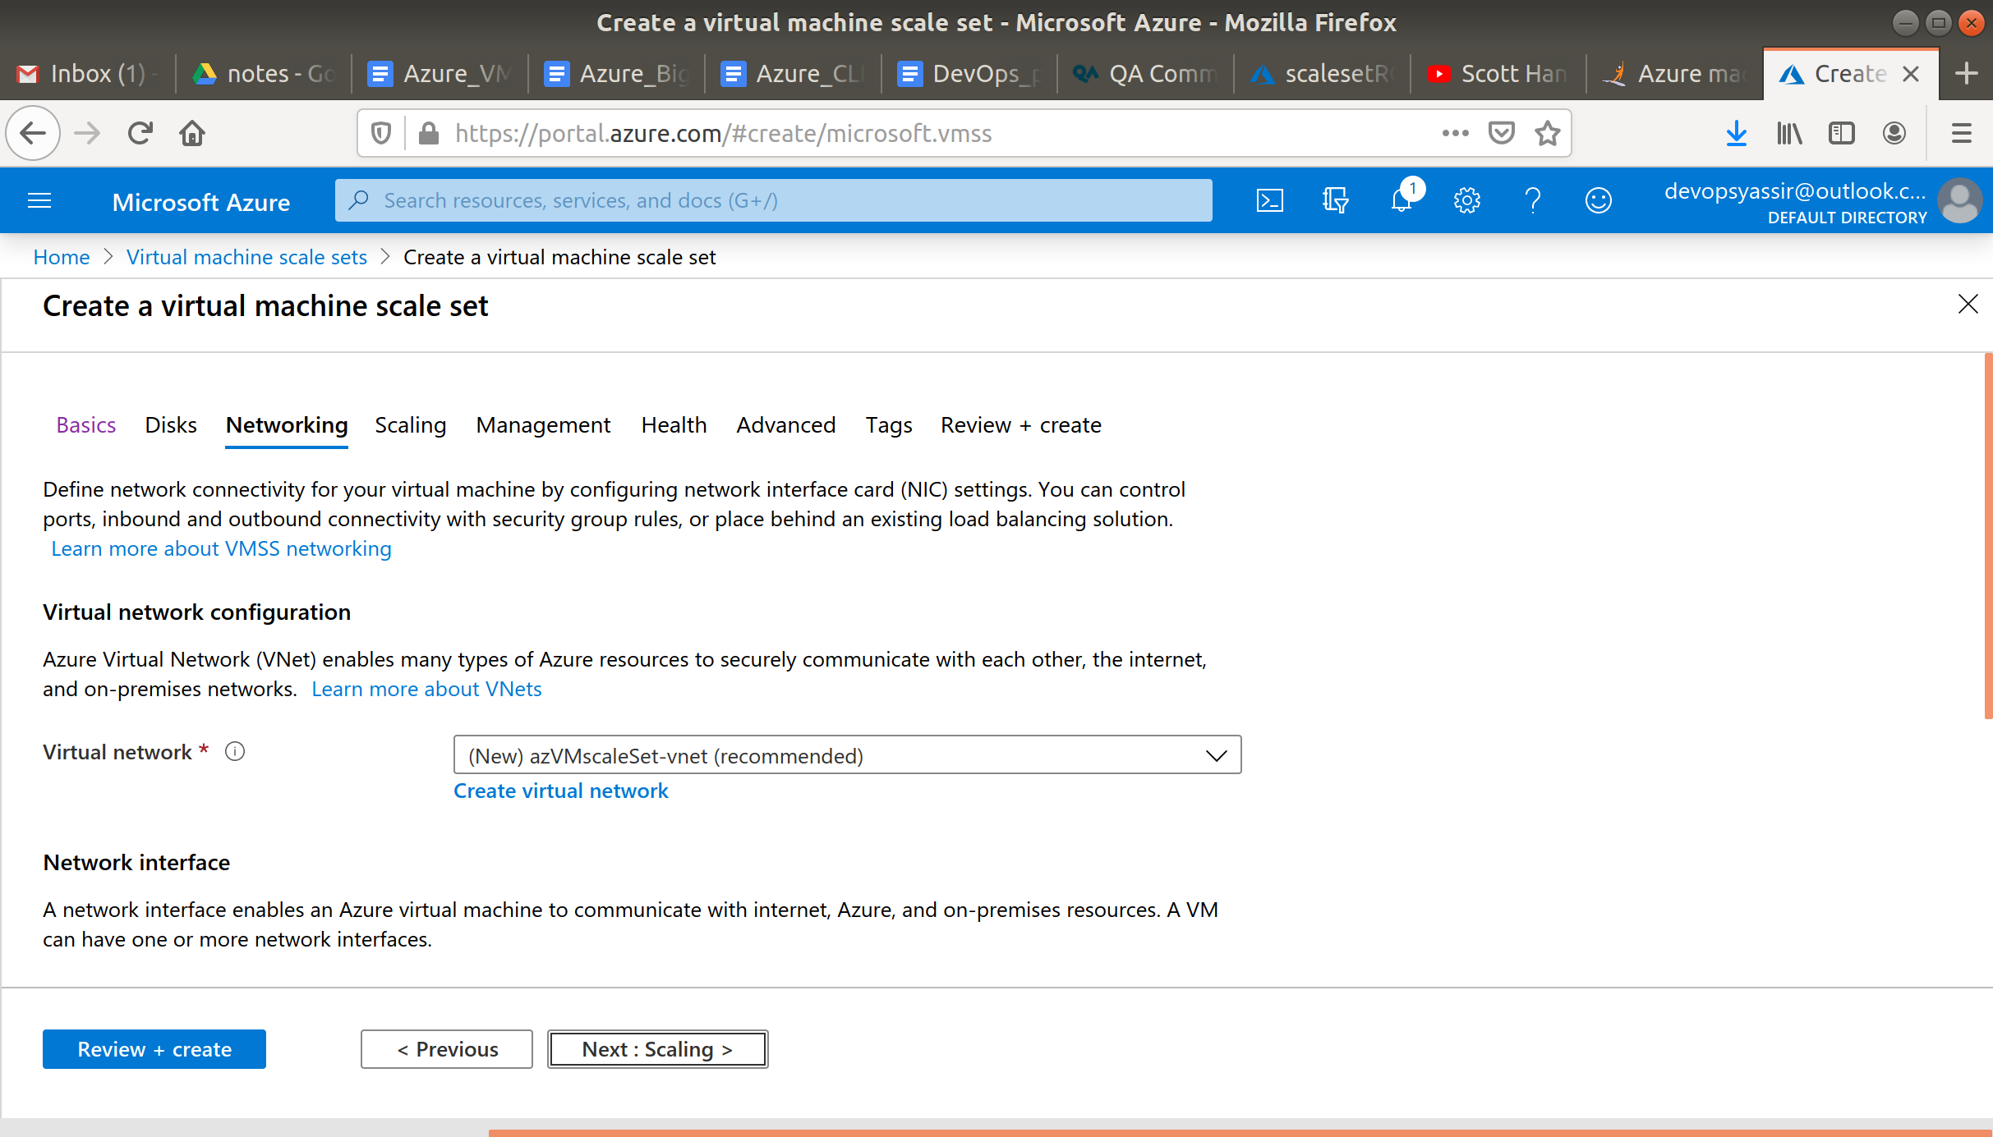

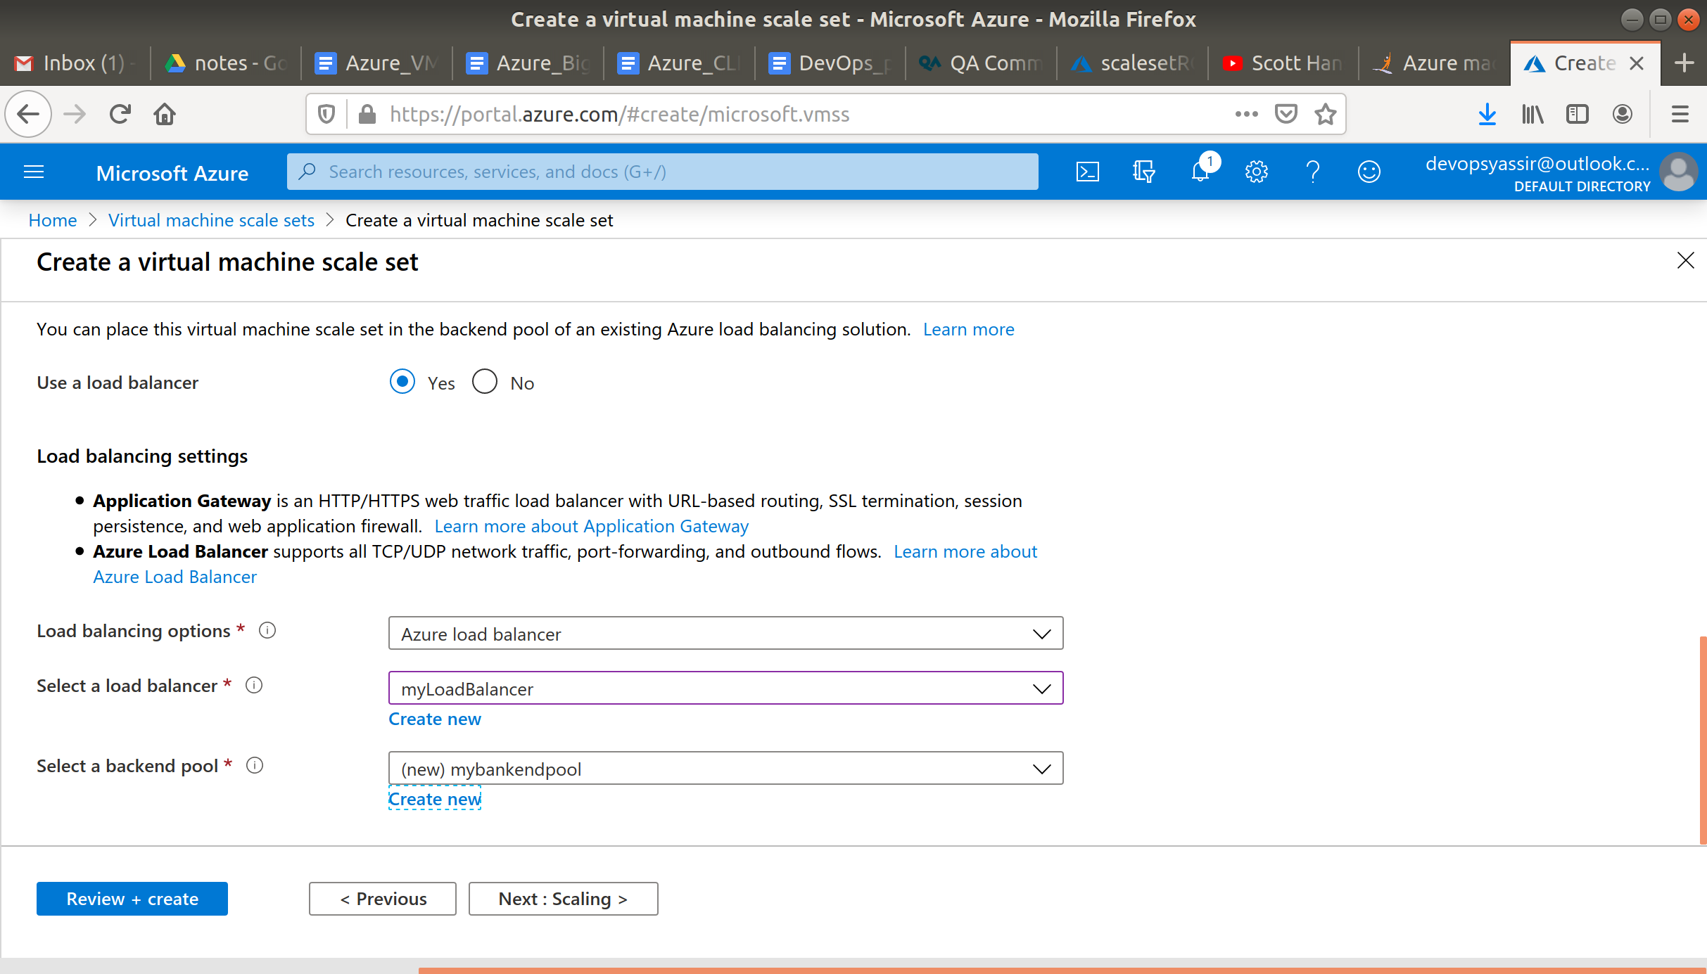

1. We'll select **Review + create**
2. Once validation is passed, we can select **Create**

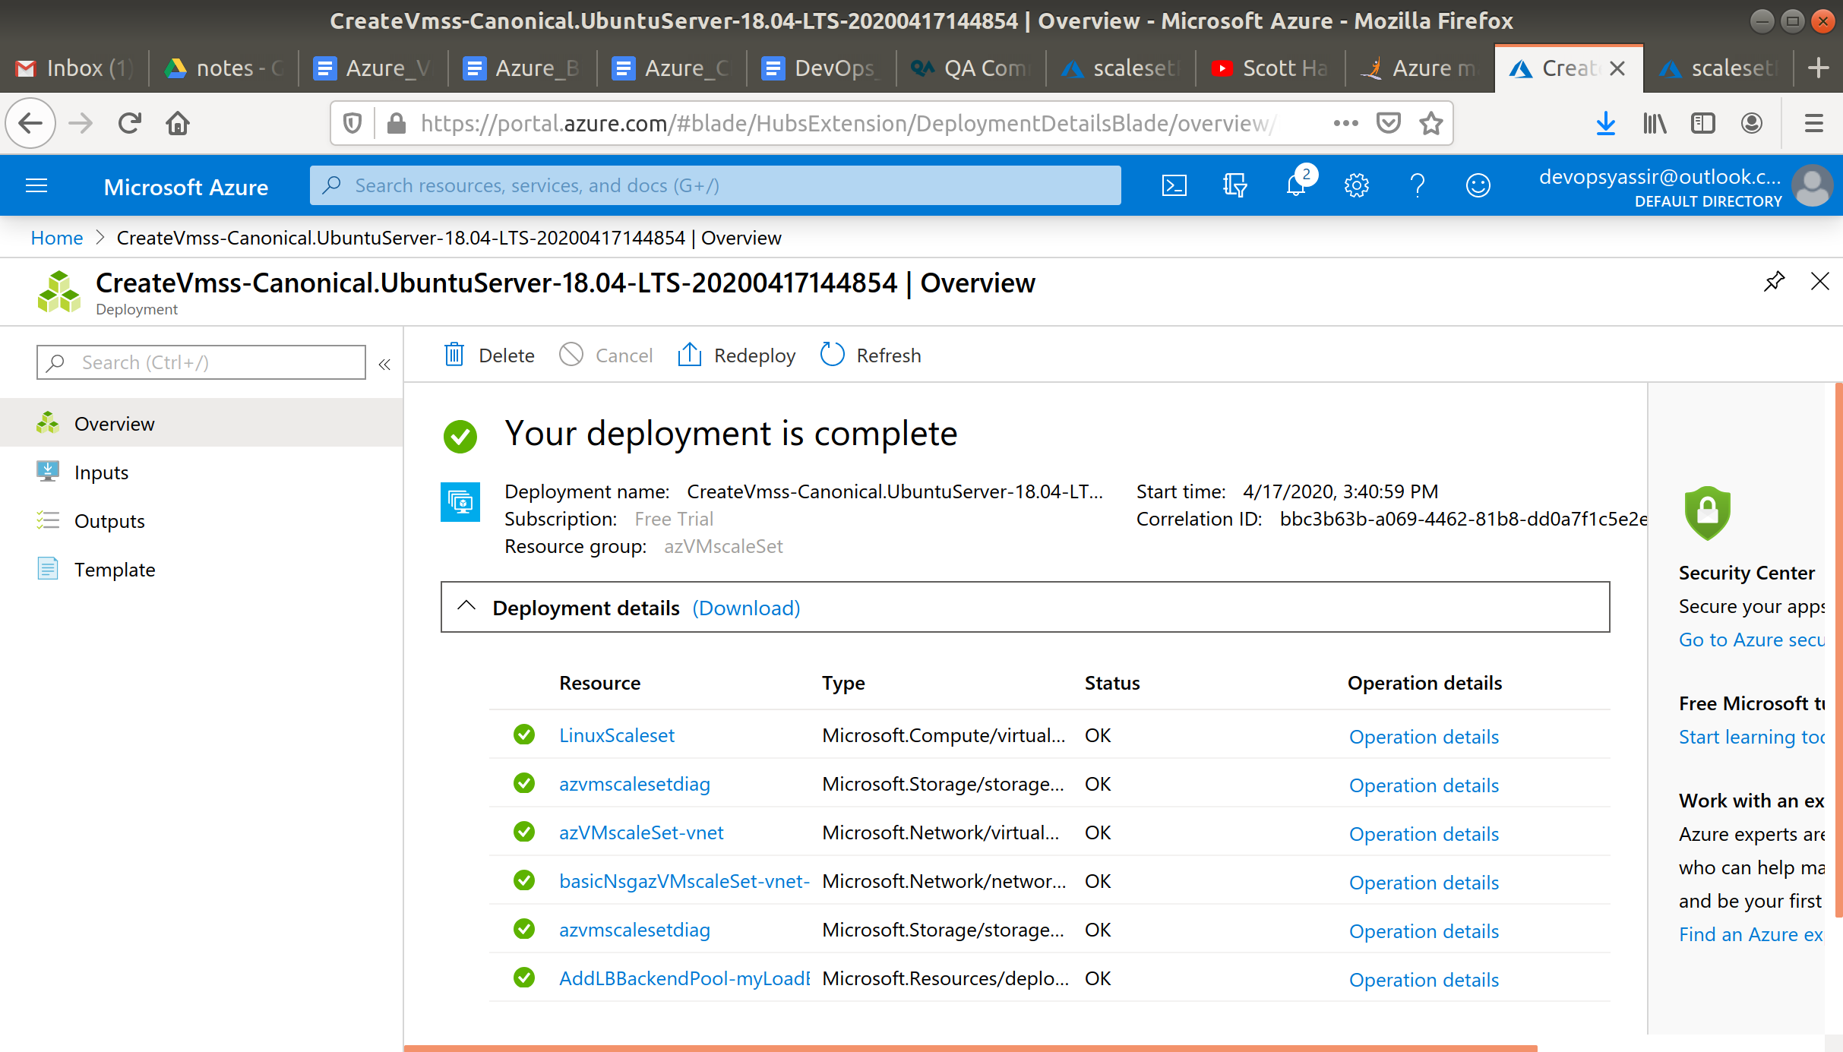

We've just deployed a load balanced Azure Virtual Machine Scale Set!

### **Cleaning up**

To clean up, use the hamburger menu at the top left of the Portal, and choose **Resource groups**.