# Azure Virtual Networks

## **Tutorial**

In this tutorial we see how to create a VNet.

### **New Resource Group**

The first thing is to create a new resource group, which we can do by clicking the burger bar in the top left corner and choosing Resource groups:

Then, we can click +Add:

Here, we can name the resource group and pick a location to have it in:

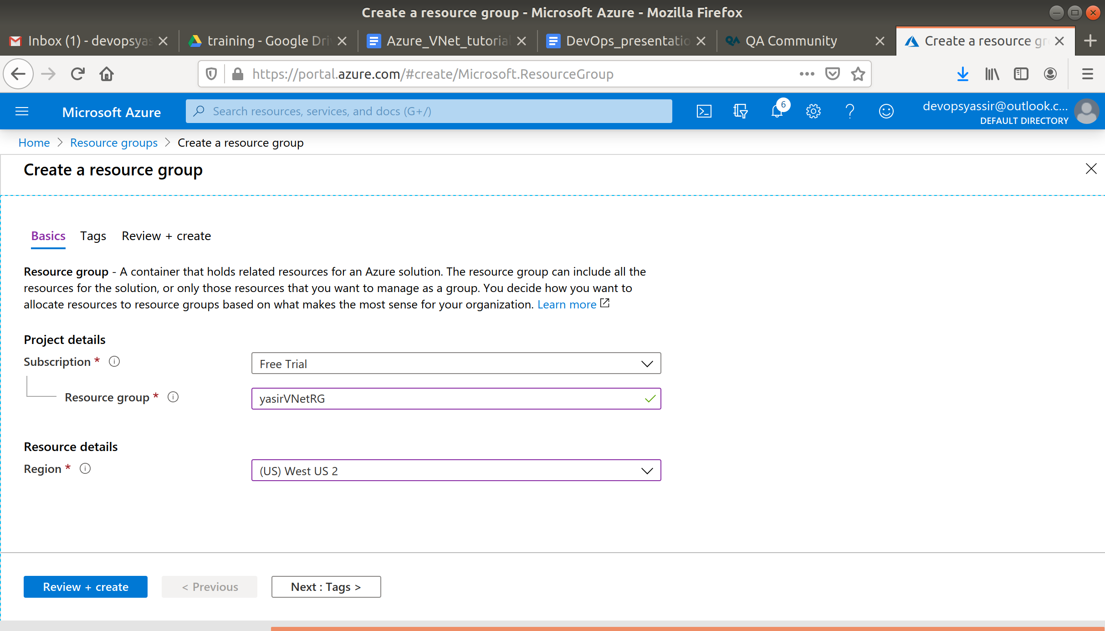

Lastly, we will click Review & Create and then Create to create the resource group:

### **Creating a Virtual Network**

From anywhere on the Azure Portal, click the burger bar in the top left corner, and then select Virtual networks from the menu. If you can't find it you can search for it in the search bar.

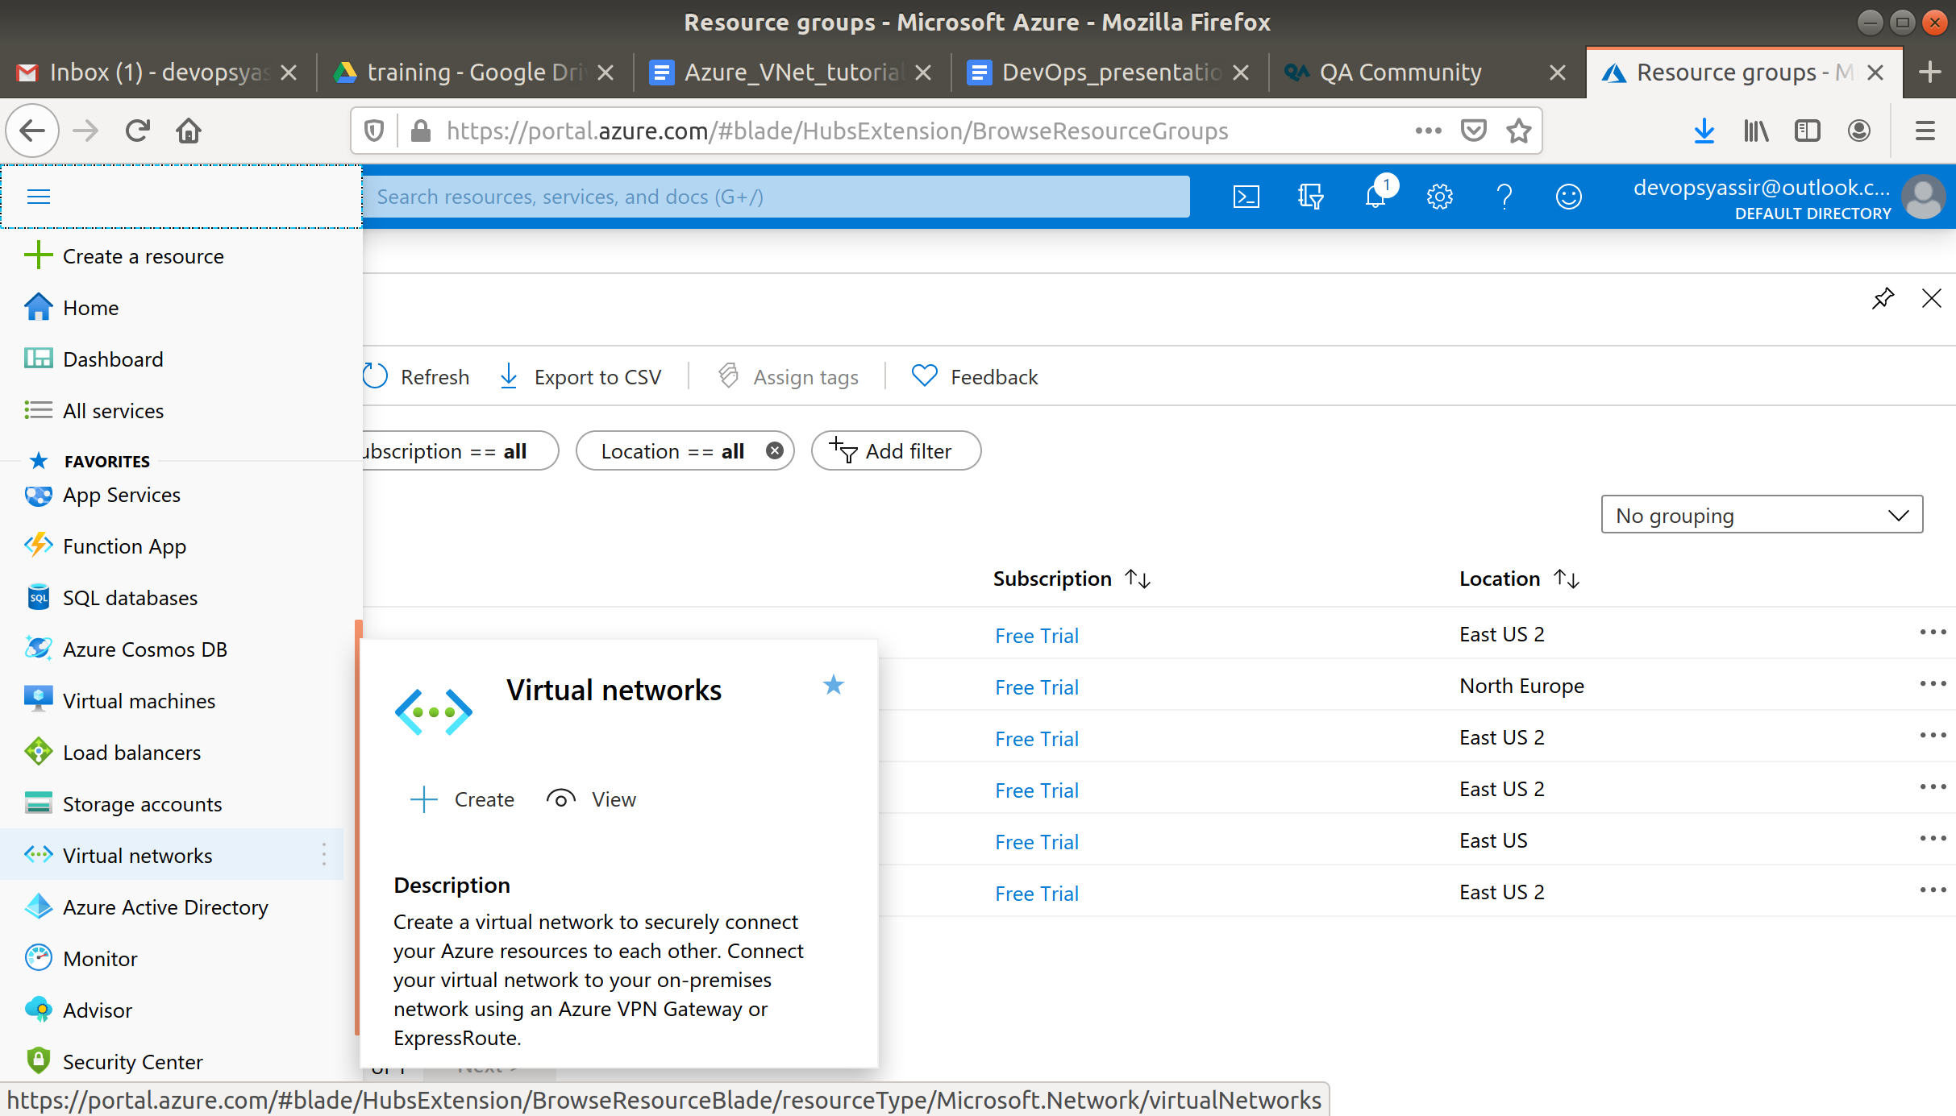

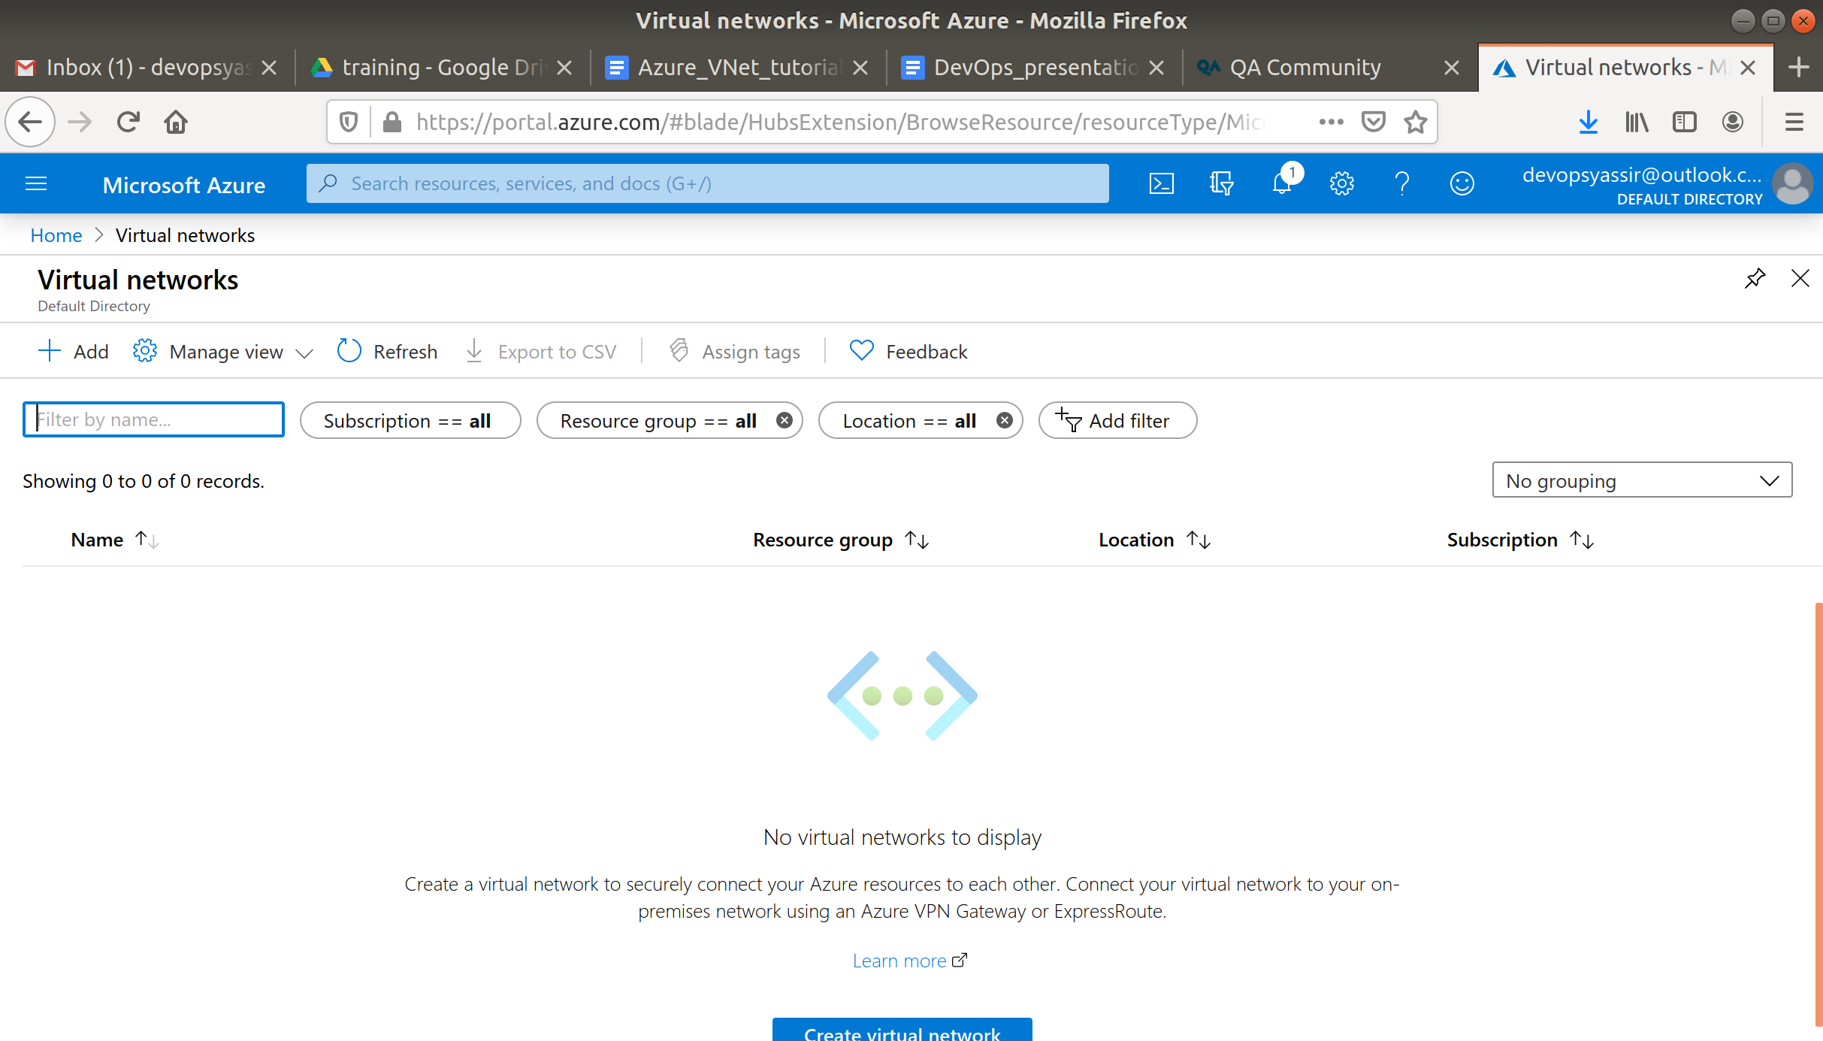

A list of all the Virtual networks currently on your account should be listed. We are going to add a new one.

Click the + Add button

As you can see, I have changed the name, address space, resource group, as well as creating a single subnet within my VNet.

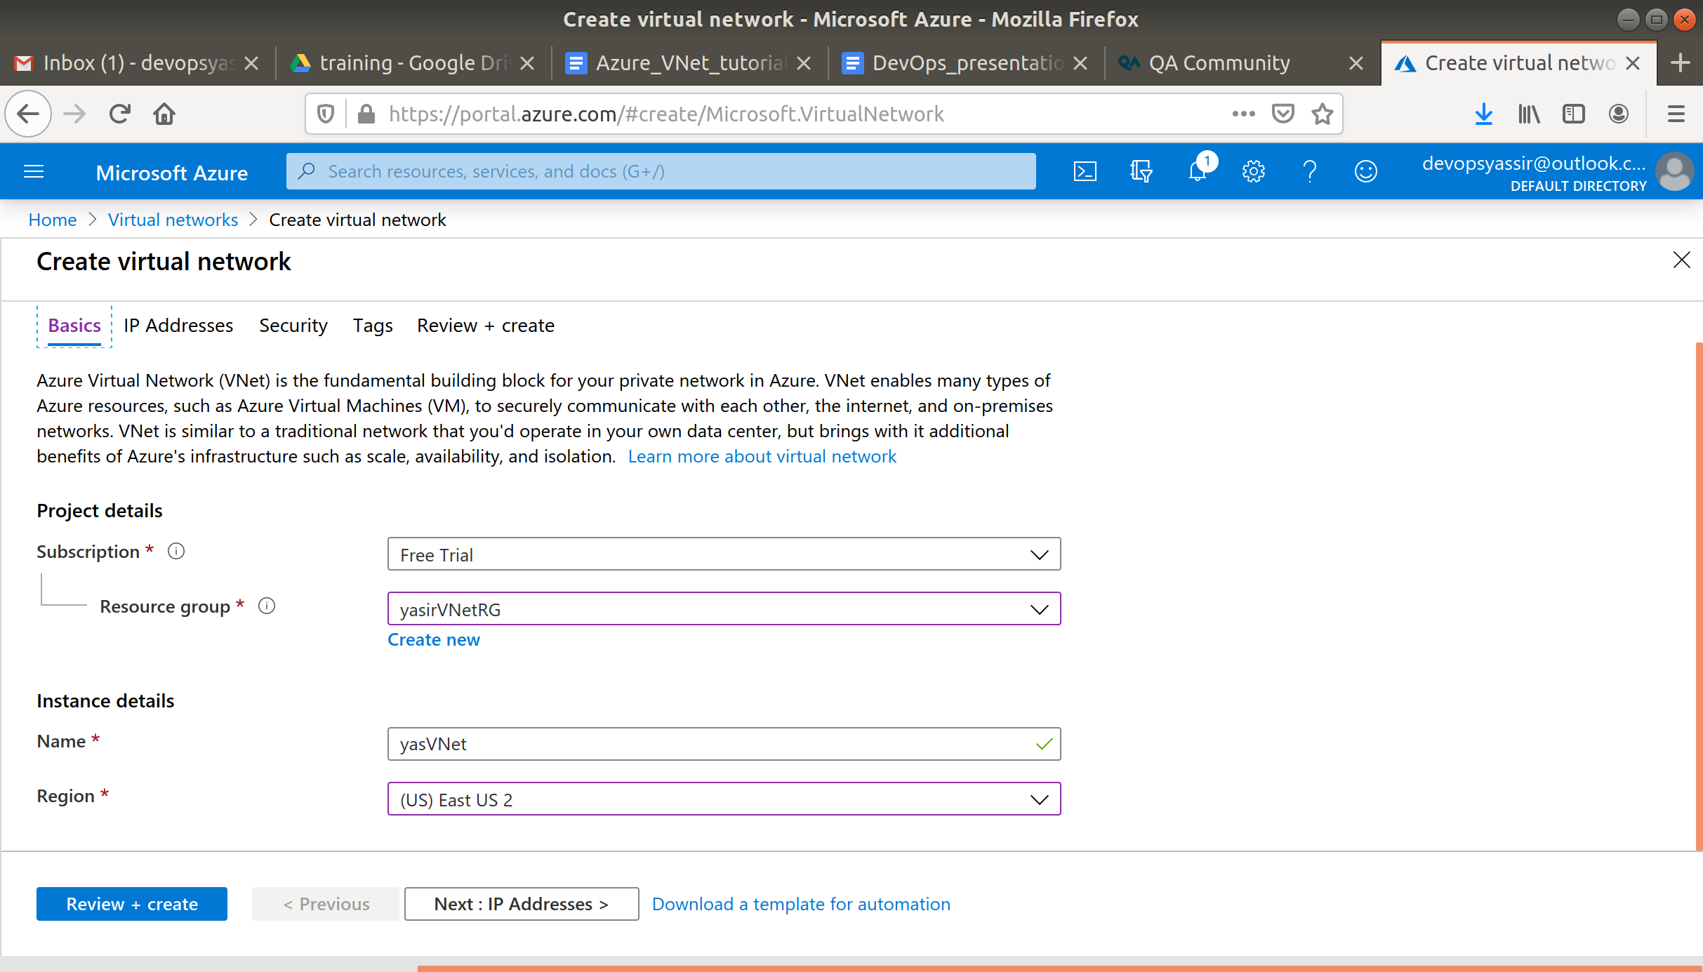

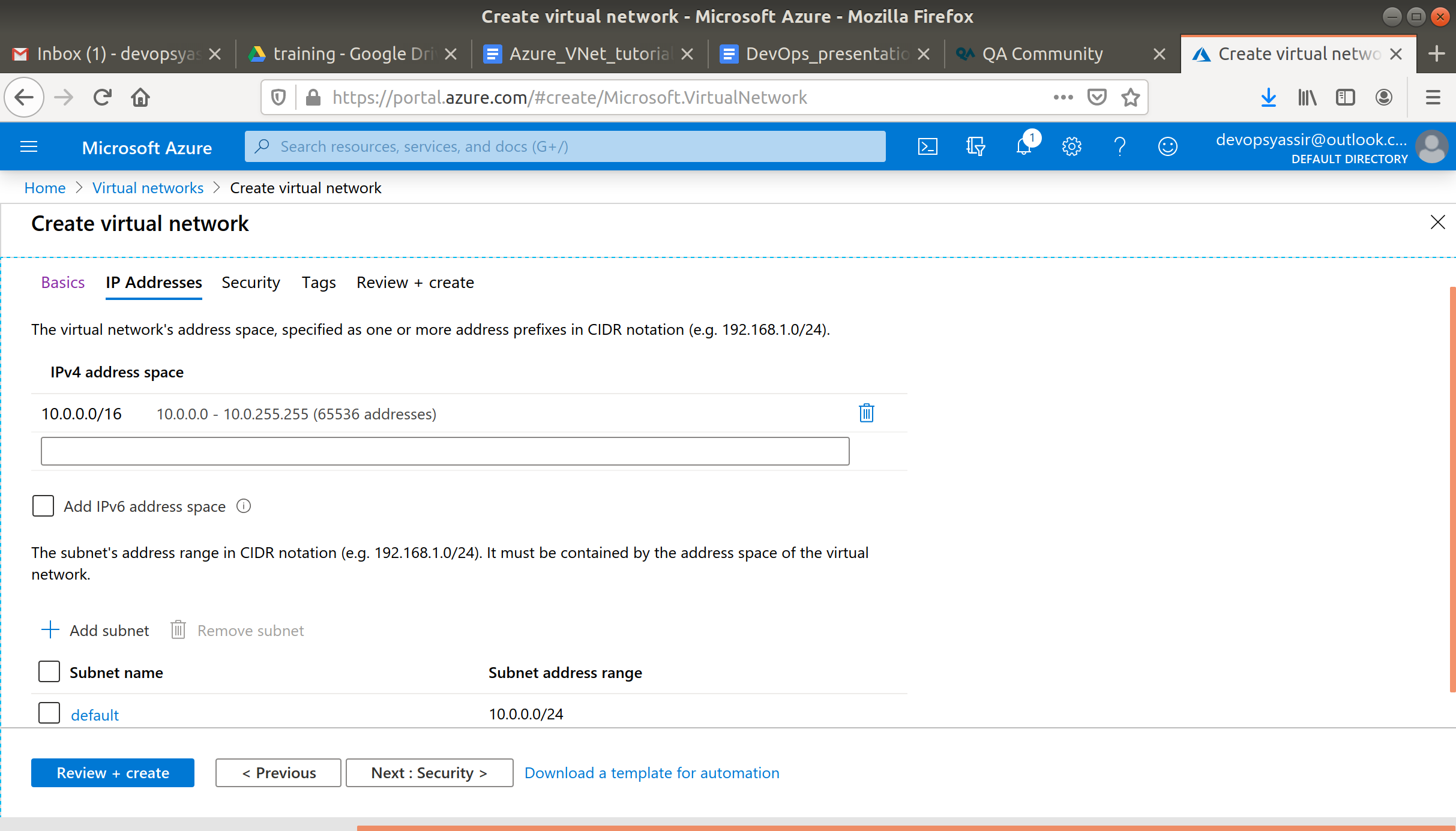

Click Create to create your Virtual Network.

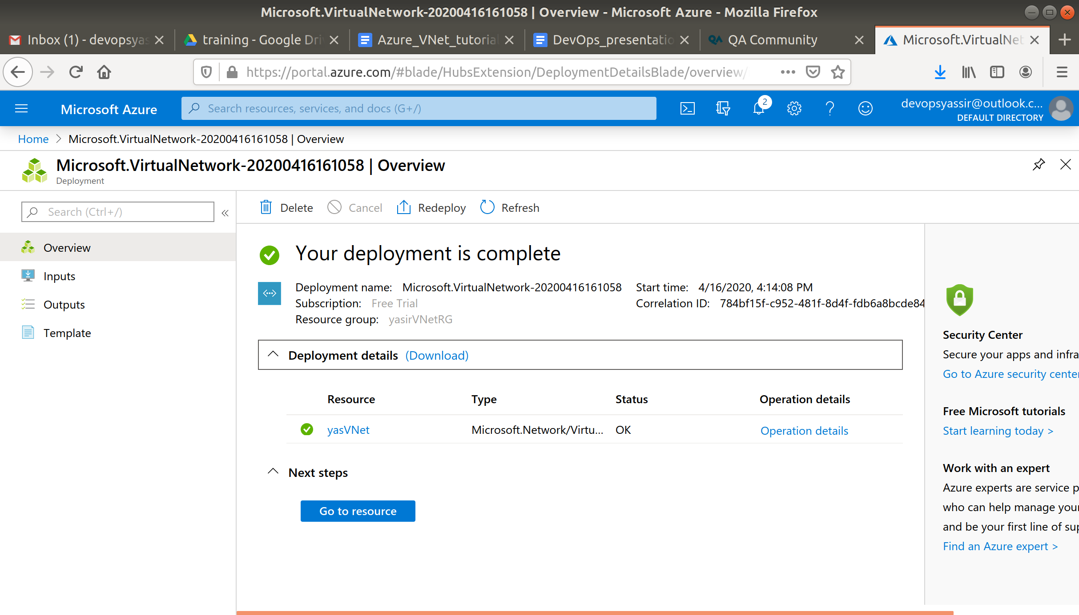

Navigate back to the virtual network page and you should see your new virtual network has appeared in the list, if not periodically refresh the page until it has.

Click on the name of your new VNet to navigate to the Overview blade for it. Here you can see an overview of the VNet you just created, as well as all the different settings available for this.

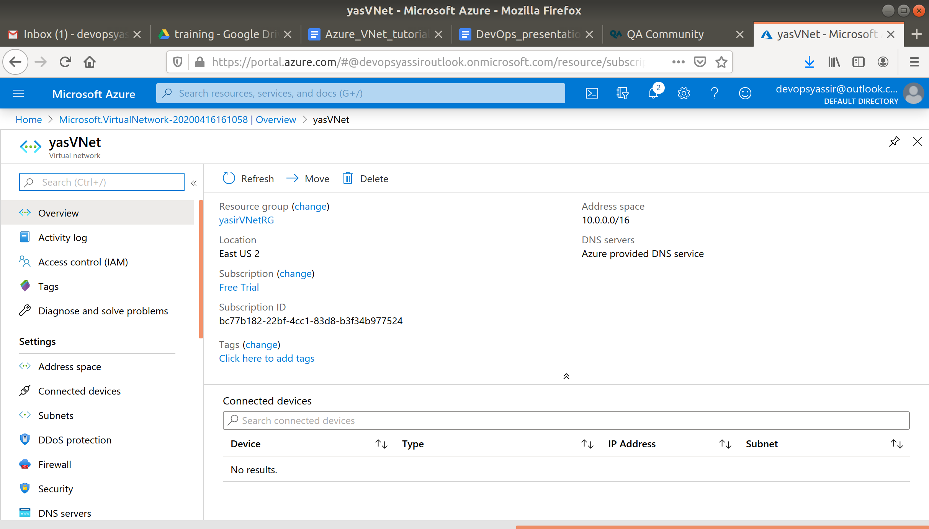

Have a look at the names of some of the settings, do you recognise any from this module, or any previous modules?

### **Clean Up**

To clean up, go back to the Resource Group page, click your resource group you used for this module, and then choose Delete.

Once you type the name of the resource group to confirm deletion, this will be deleted along with everything inside of it.