# Azure Configuring VMs

# 

## **Tutorial**

In this tutorial, we are going to create an availability set and add a VM to it.

1. **Create a resource group**:

**$ az group create -n avtutorial -l uksouth**

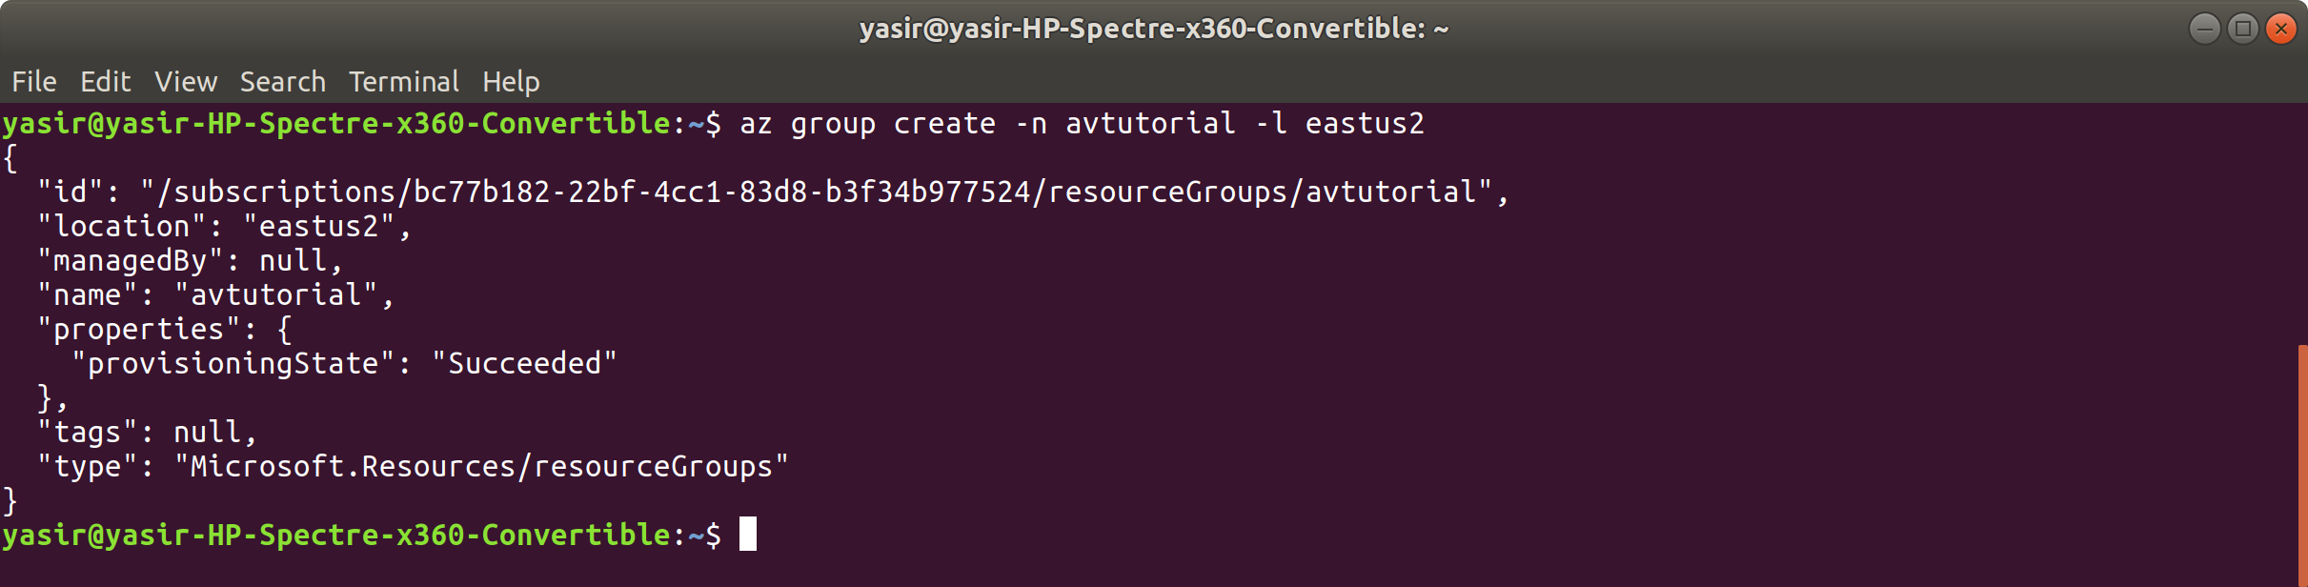

1. **Create an availability set**:

**$ az vm availability-set create -g avtutorial -n avset -l uksouth --platform-fault-domain-count 2 --platform-update-domain-count 5**

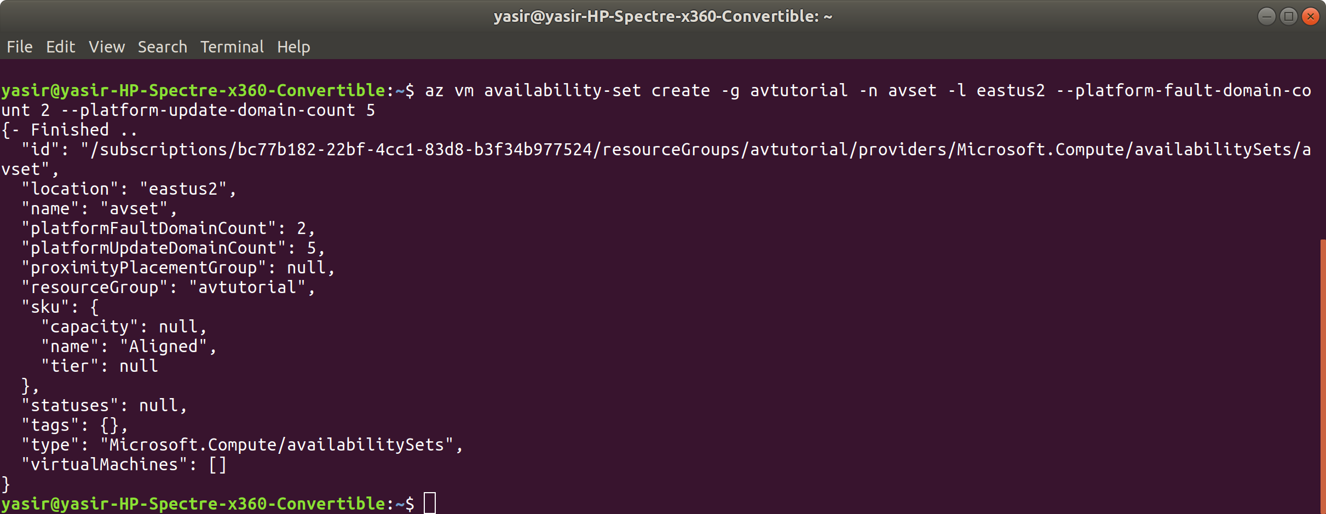

Here, we have specified that we want to configure 2 fault domains and 5 update domains for our Availability Set.

1. **Create a VM and add it to the availability set**:

**$ az vm create -g avtutorial -n av-vm -l uksouth --image UbuntuLTS --availability-set avset --generate-ssh-keys**

error (az CLI)

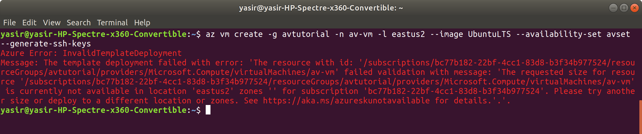

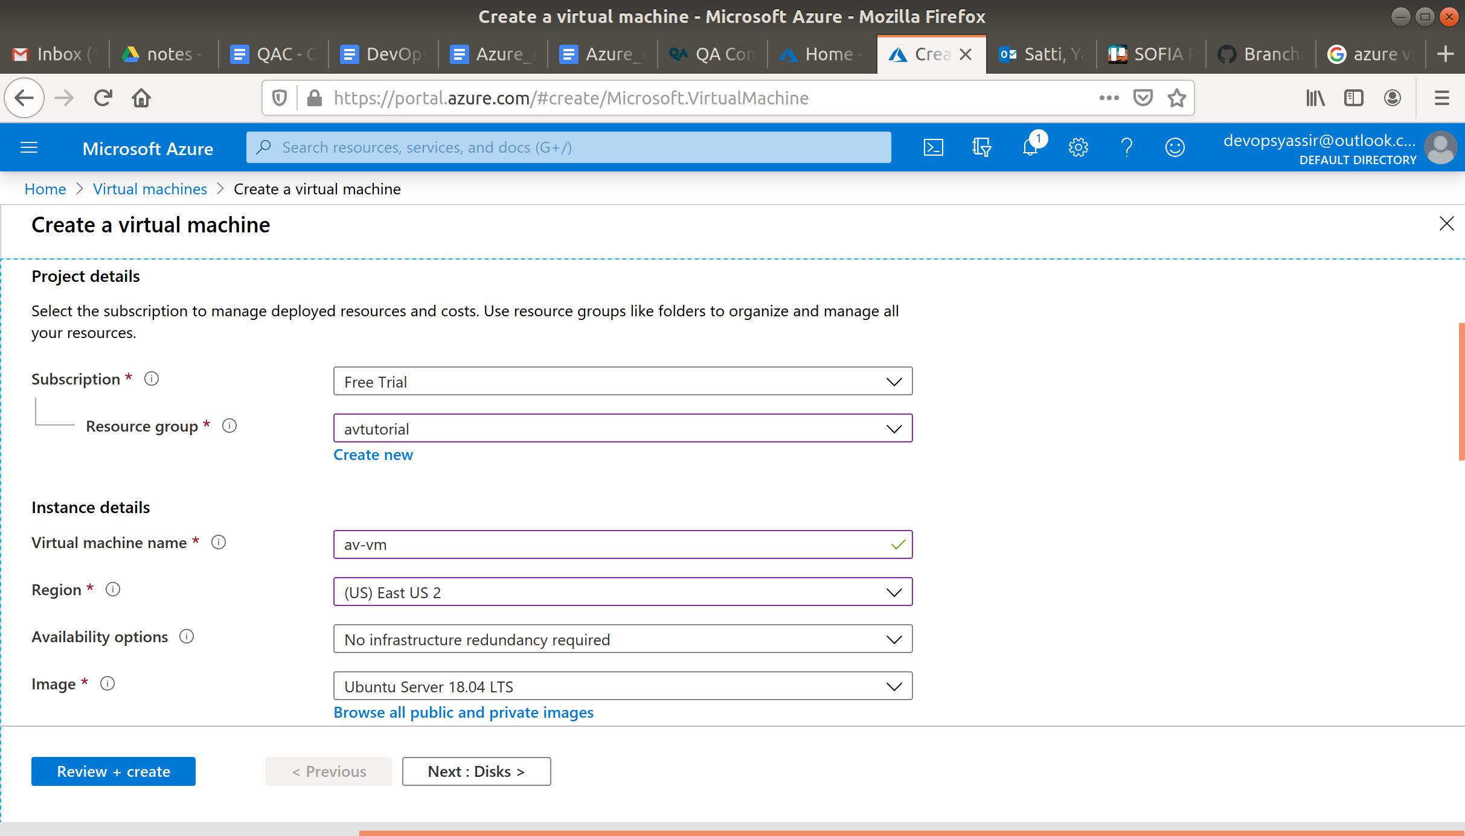

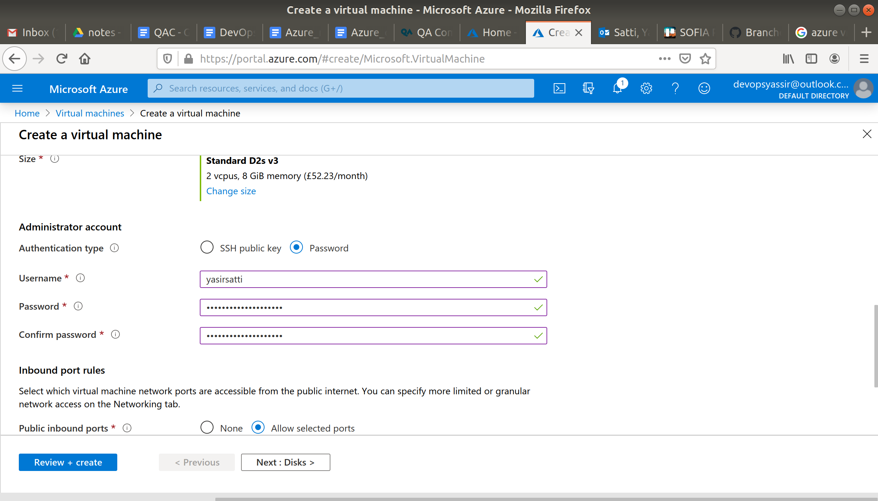

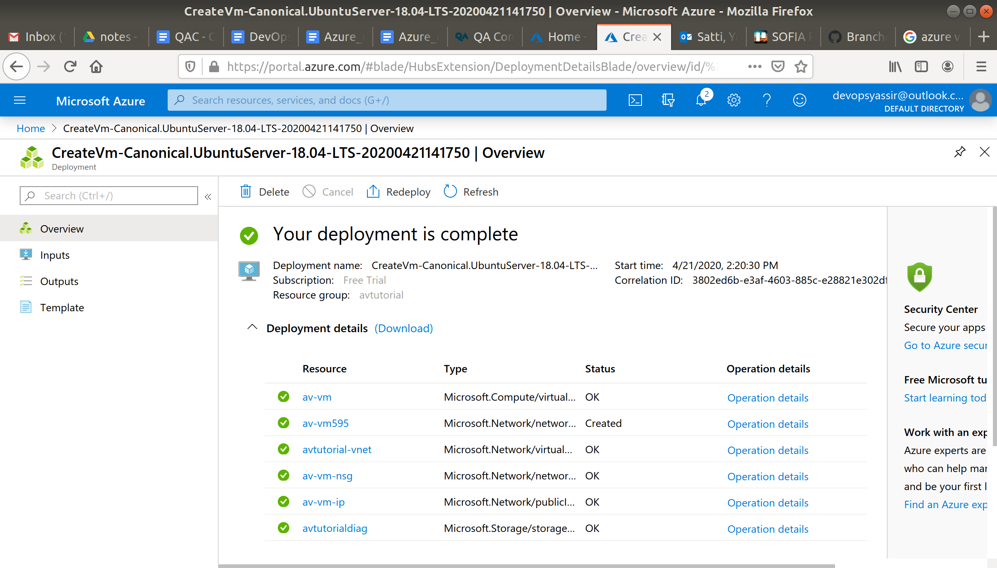



1. **Clean up**:

**$ az group delete -n avtutorial -y --no-wait**

