# Azure Configuring Files

# 

## **Tutorial**

In this tutorial, we will be using an Azure file share with the **File REST protocol**, a **Linux** machine and the **Azure CLI**.

1. Create a new resource group:

**$ az group create -n fileshare -l uksouth**

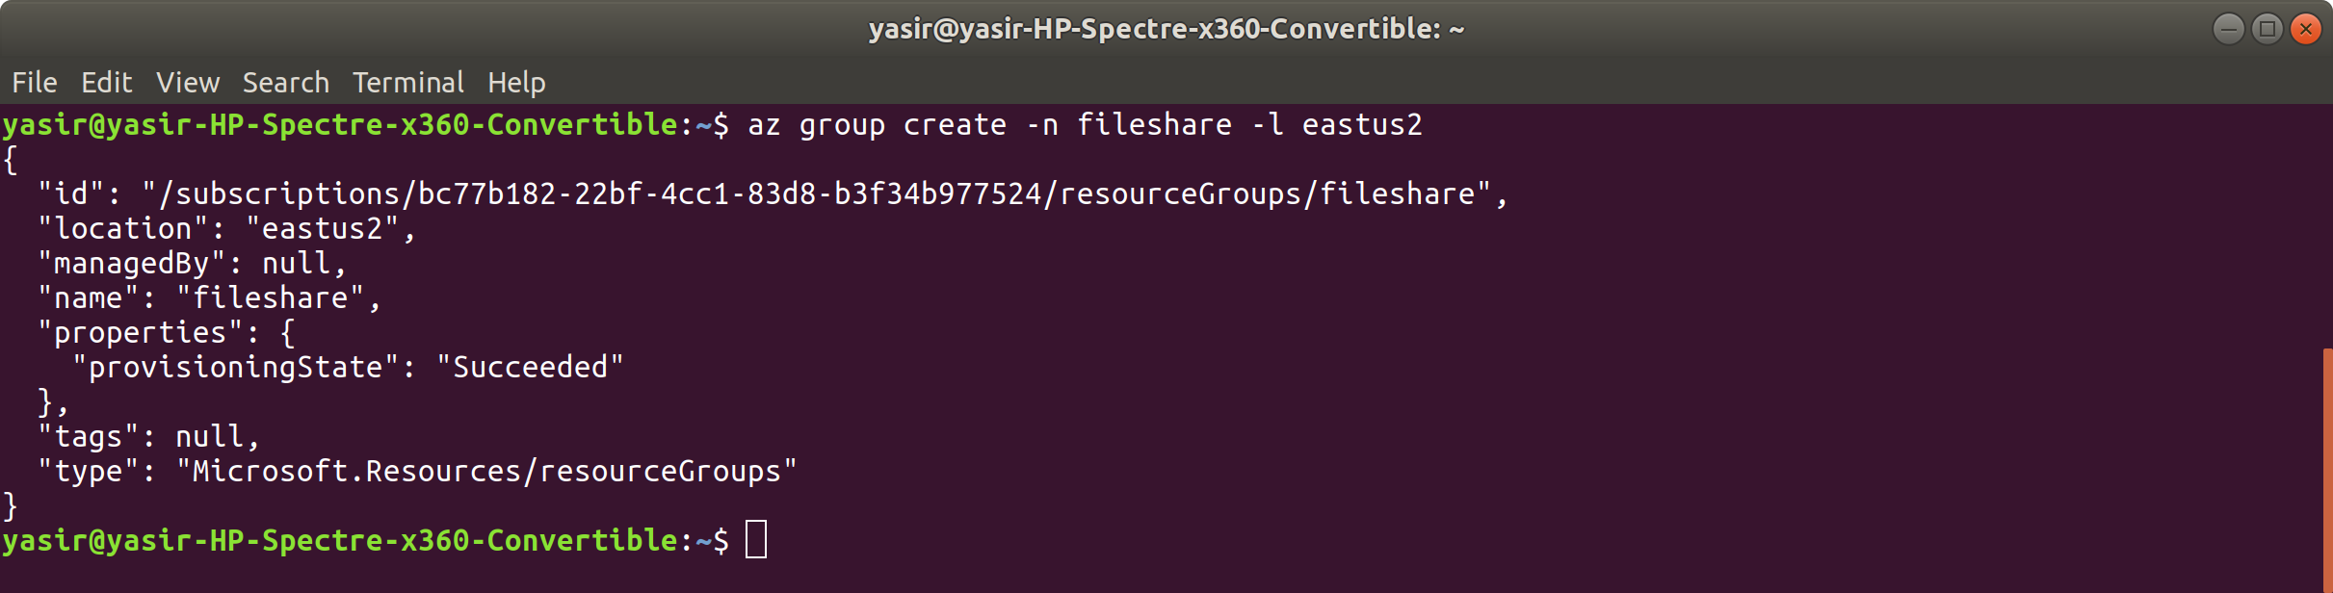

1. Create a Storage Account:

create a variable

STORAGEACCT=$(az storage account create -g fileshare -n <account-name> -l uksouth --query "name" | tr -d '""')

You will need to replace <account-name> with a unique name.

Here, we have created a storage account and placed the name of this account in a variable called STORAGEACCT, so it can be used later.

This command will output a json to the terminal. The --query flag allows us to scan this json for the property name, remove any quotation marks around its value(tr -d '""') and store the result in a variable.

**$ STORAGEACCT=$(az storage account create -g fileshare -n yasfile -l uksouth --query "name" | tr -d '""')**

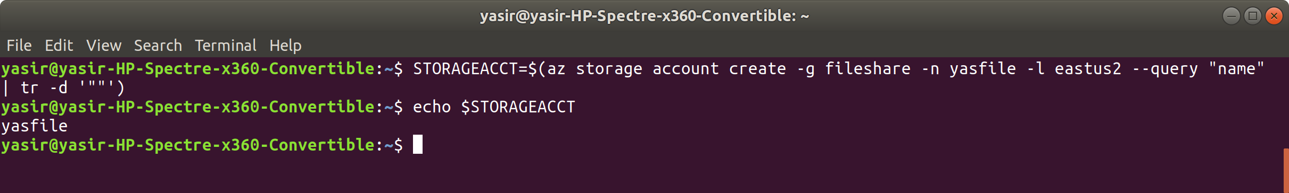

1. Get the Storage Account key, which, along with the Storage Account name, will be needed to authenticate with the Azure CLI from now on:

**$ STORAGEKEY=$(az storage account keys list -g fileshare --account-name $STORAGEACCT --query "[0].value" | tr -d '""')**

Here, the query obtains the first value from the list that is returned, removes any quotation marks and stores the result in a variable named STORAGEKEY.

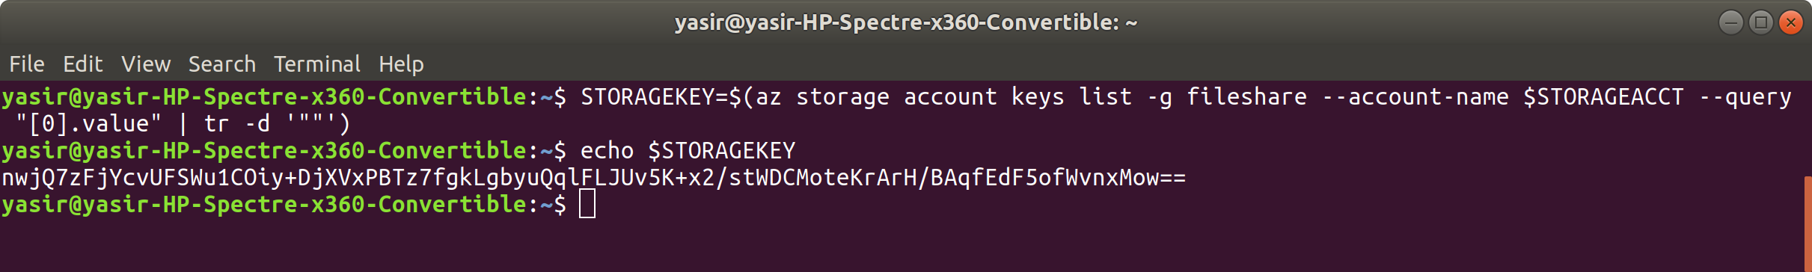

1. Create an Azure File Share:

**$ az storage share create --account-name $STORAGEACCT --account-key $STORAGEKEY -n tutorial-share**

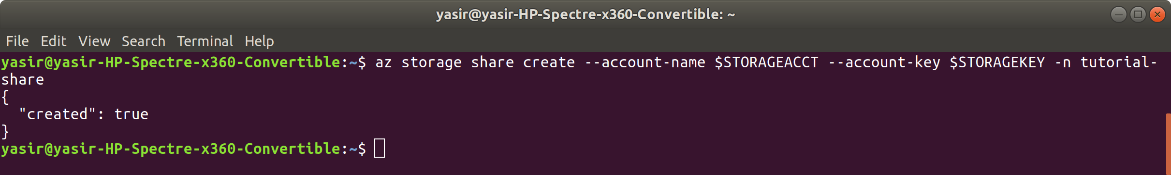

1. Create a Directory at the root of the File Share:

**$ az storage directory create --account-name $STORAGEACCT --account-key $STORAGEKEY --share-name tutorial-share -n tutdir**

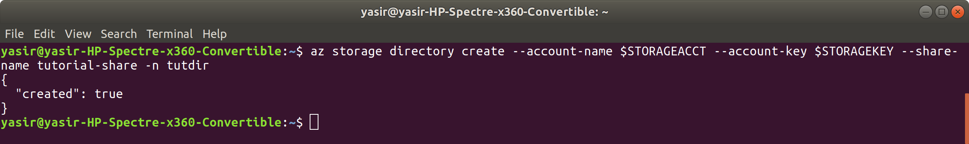

1. Create a file to upload:

**$ cd**

**$ mkdir az-dir**

**$ touch az-dir/hello.txt**

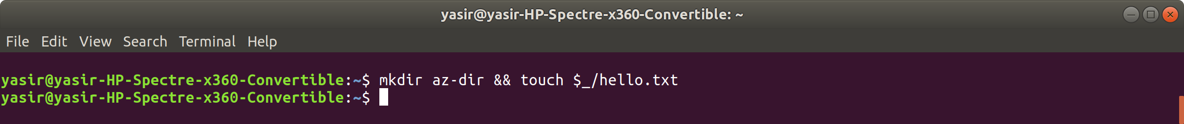

1. Upload the file:

**$ az storage file upload --account-name $STORAGEACCT --account-key $STORAGEKEY --share-name tutorial-share --source "az-dir/hello.txt" --path "tutdir/hello.txt"**

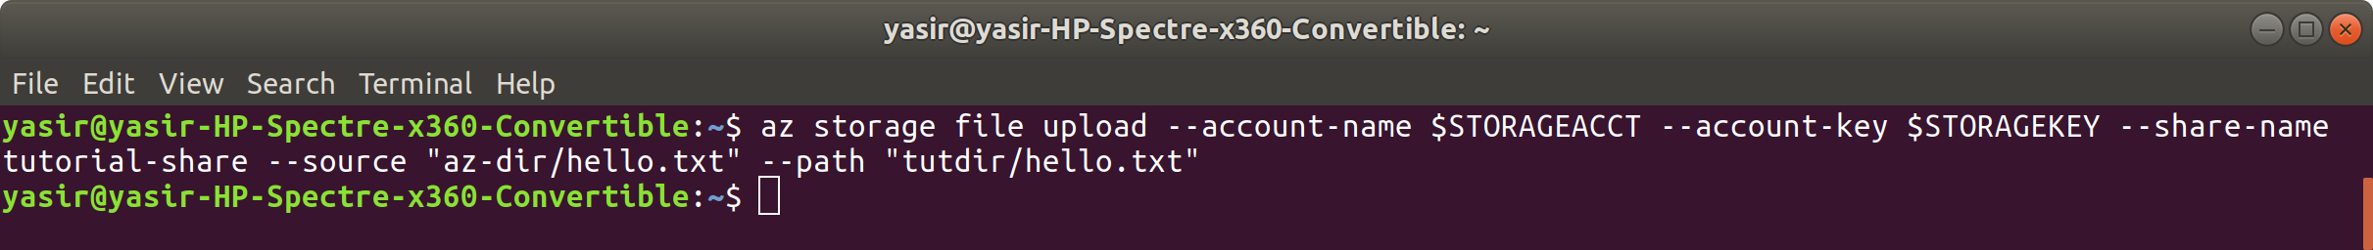

1. Check the file has uploaded to the Azure File Share:

$ **az storage file list --account-name $STORAGEACCT --account-key $STORAGEKEY --share-name tutorial-share --path "tutdir" -o table**

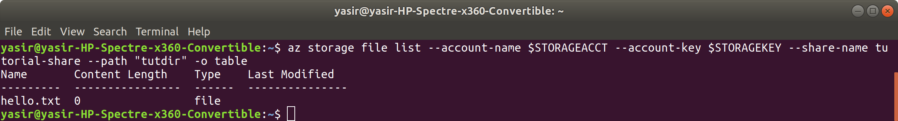

1. Delete the file locally:

**$ rm az-dir/hello.txt**



1. Download the file from your Azure File Share:

**$ az storage file download --account-name $STORAGEACCT --account-key $STORAGEKEY --share-name tutorial-share --path "tutdir/hello.txt" --dest "az-dir/hello.txt"**

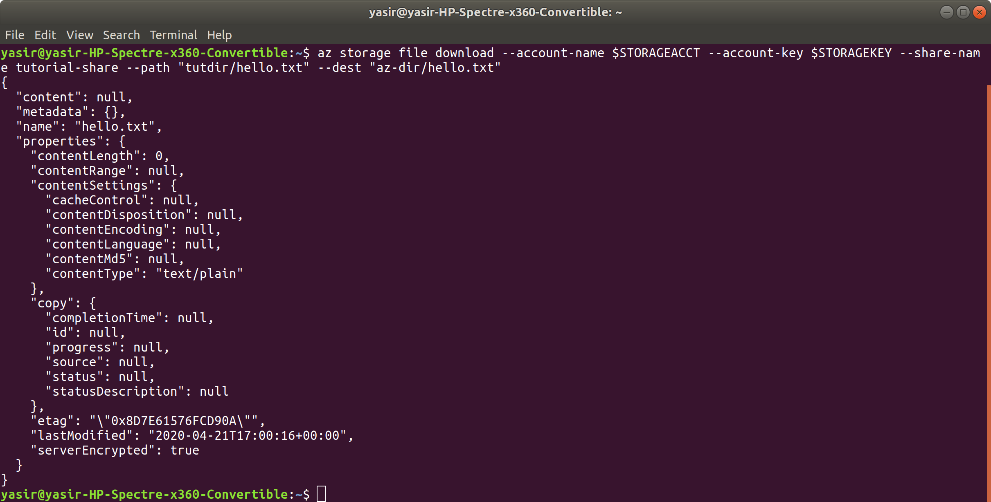

1. Ensure that the file is back on your local machine:

**$ ls az-dir**

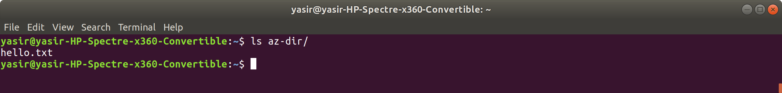

1. Clean up:

**$ az group delete -n fileshare -y --no-wait**

**$ cd**

**$ rm -rf az-dir**

