# Azure Cost Management

## **Tutorial**

In this tutorial we are going to create a budget.

Type Cost Management + Billing in the search bar and select it.

Then click Cost Management in the left blade.

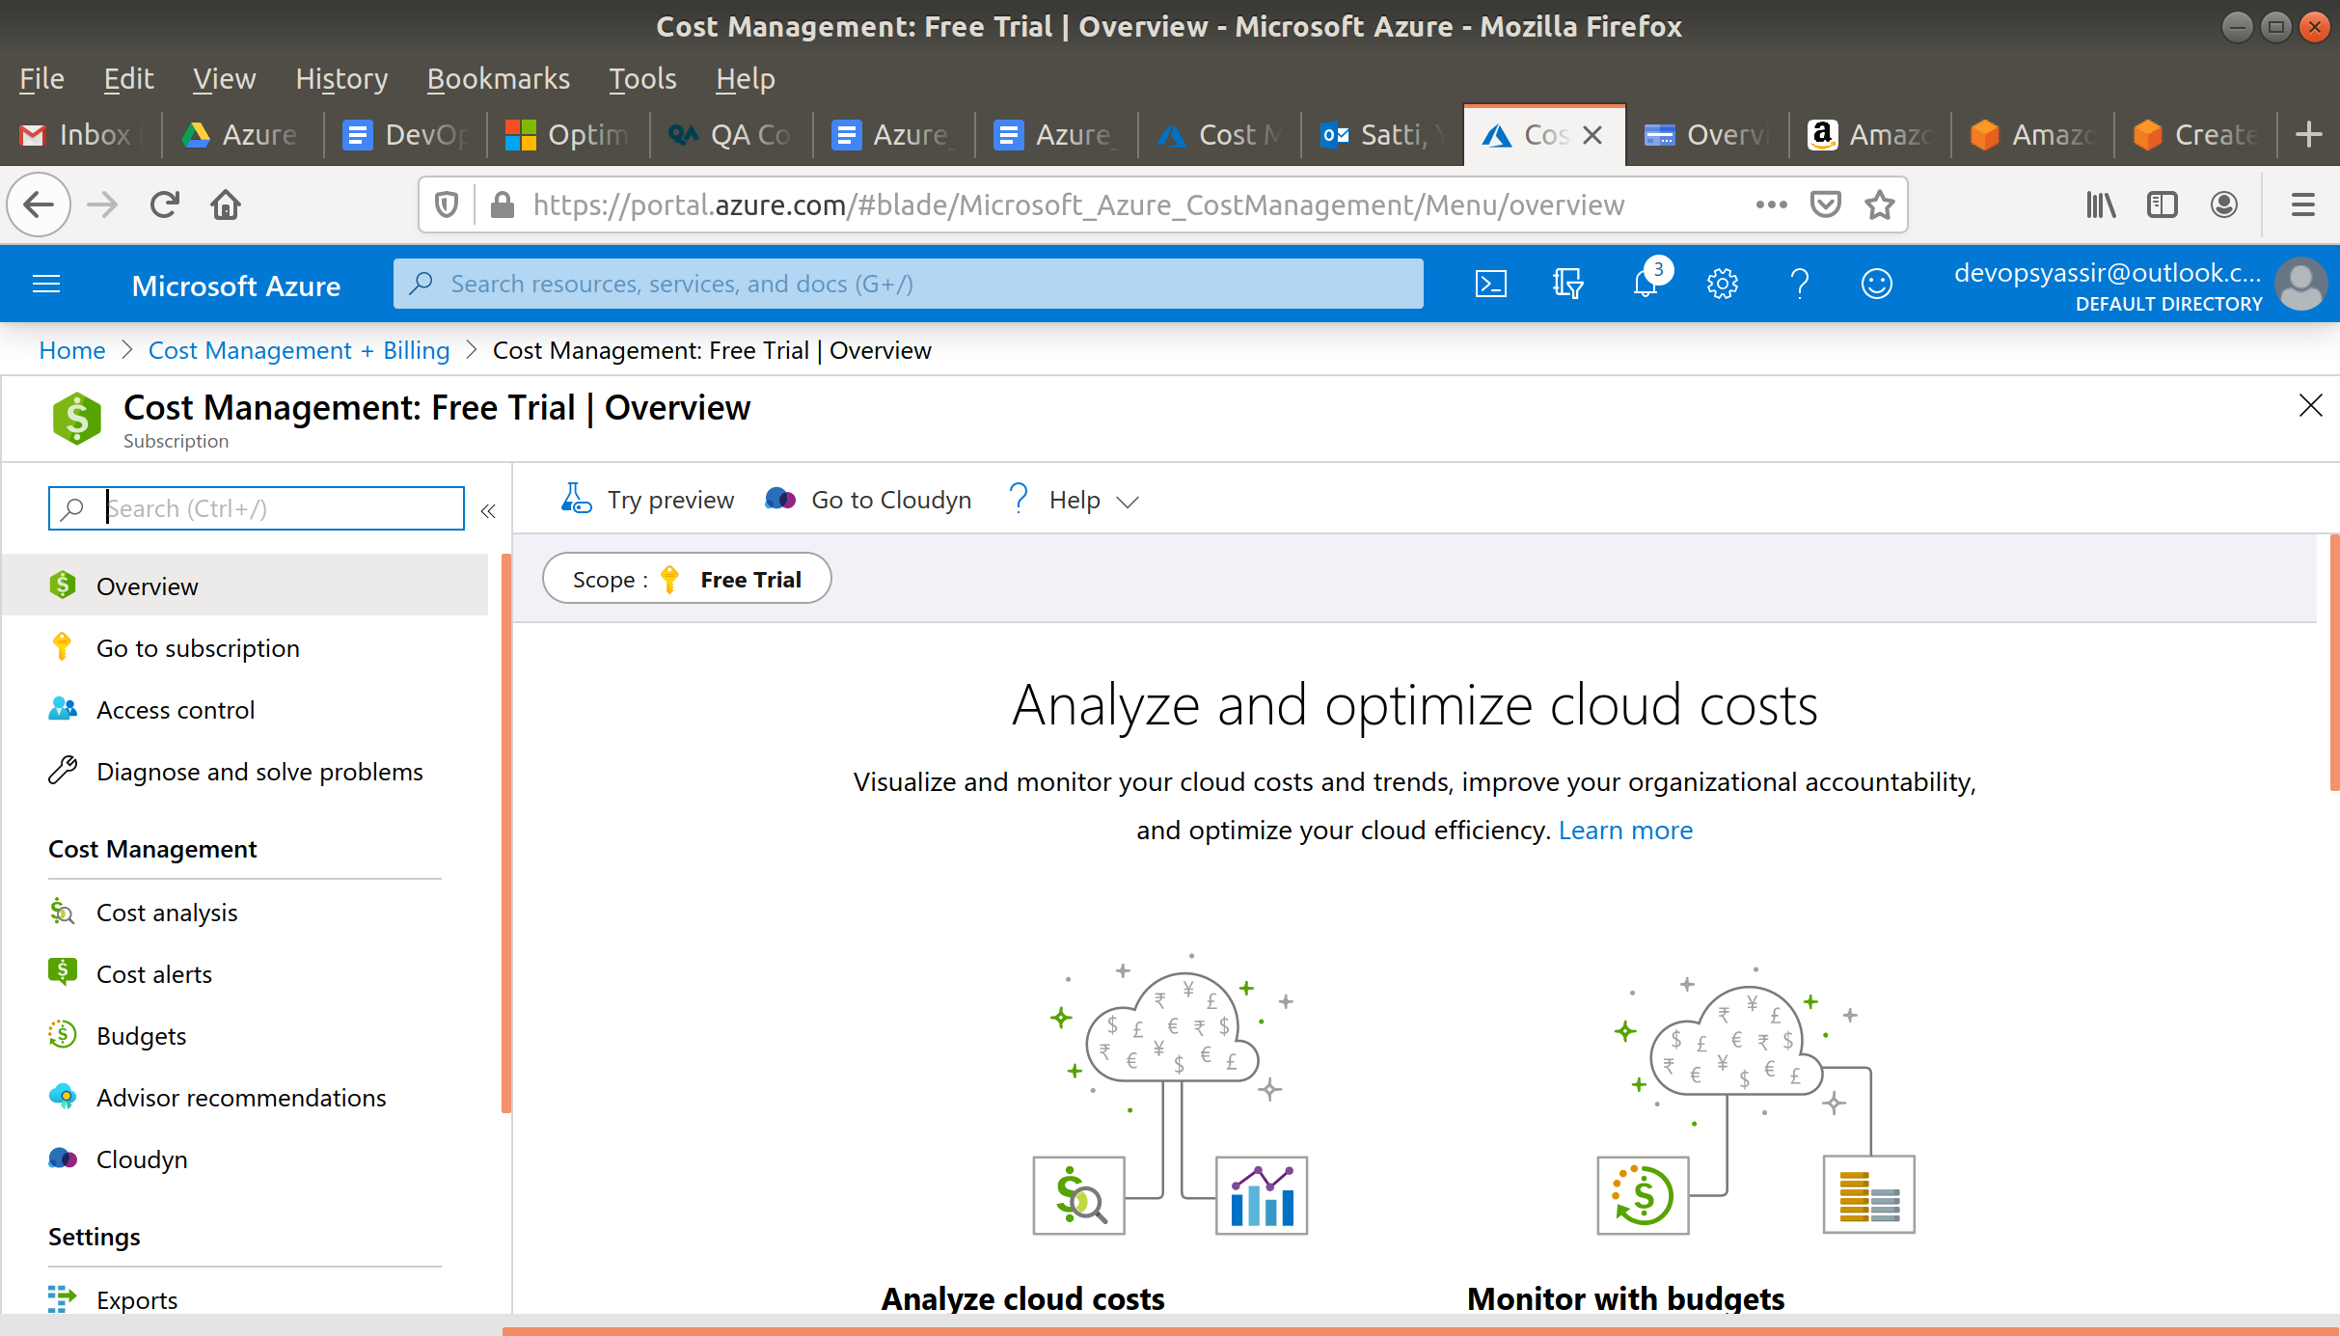

Select Budgets in the left blade.

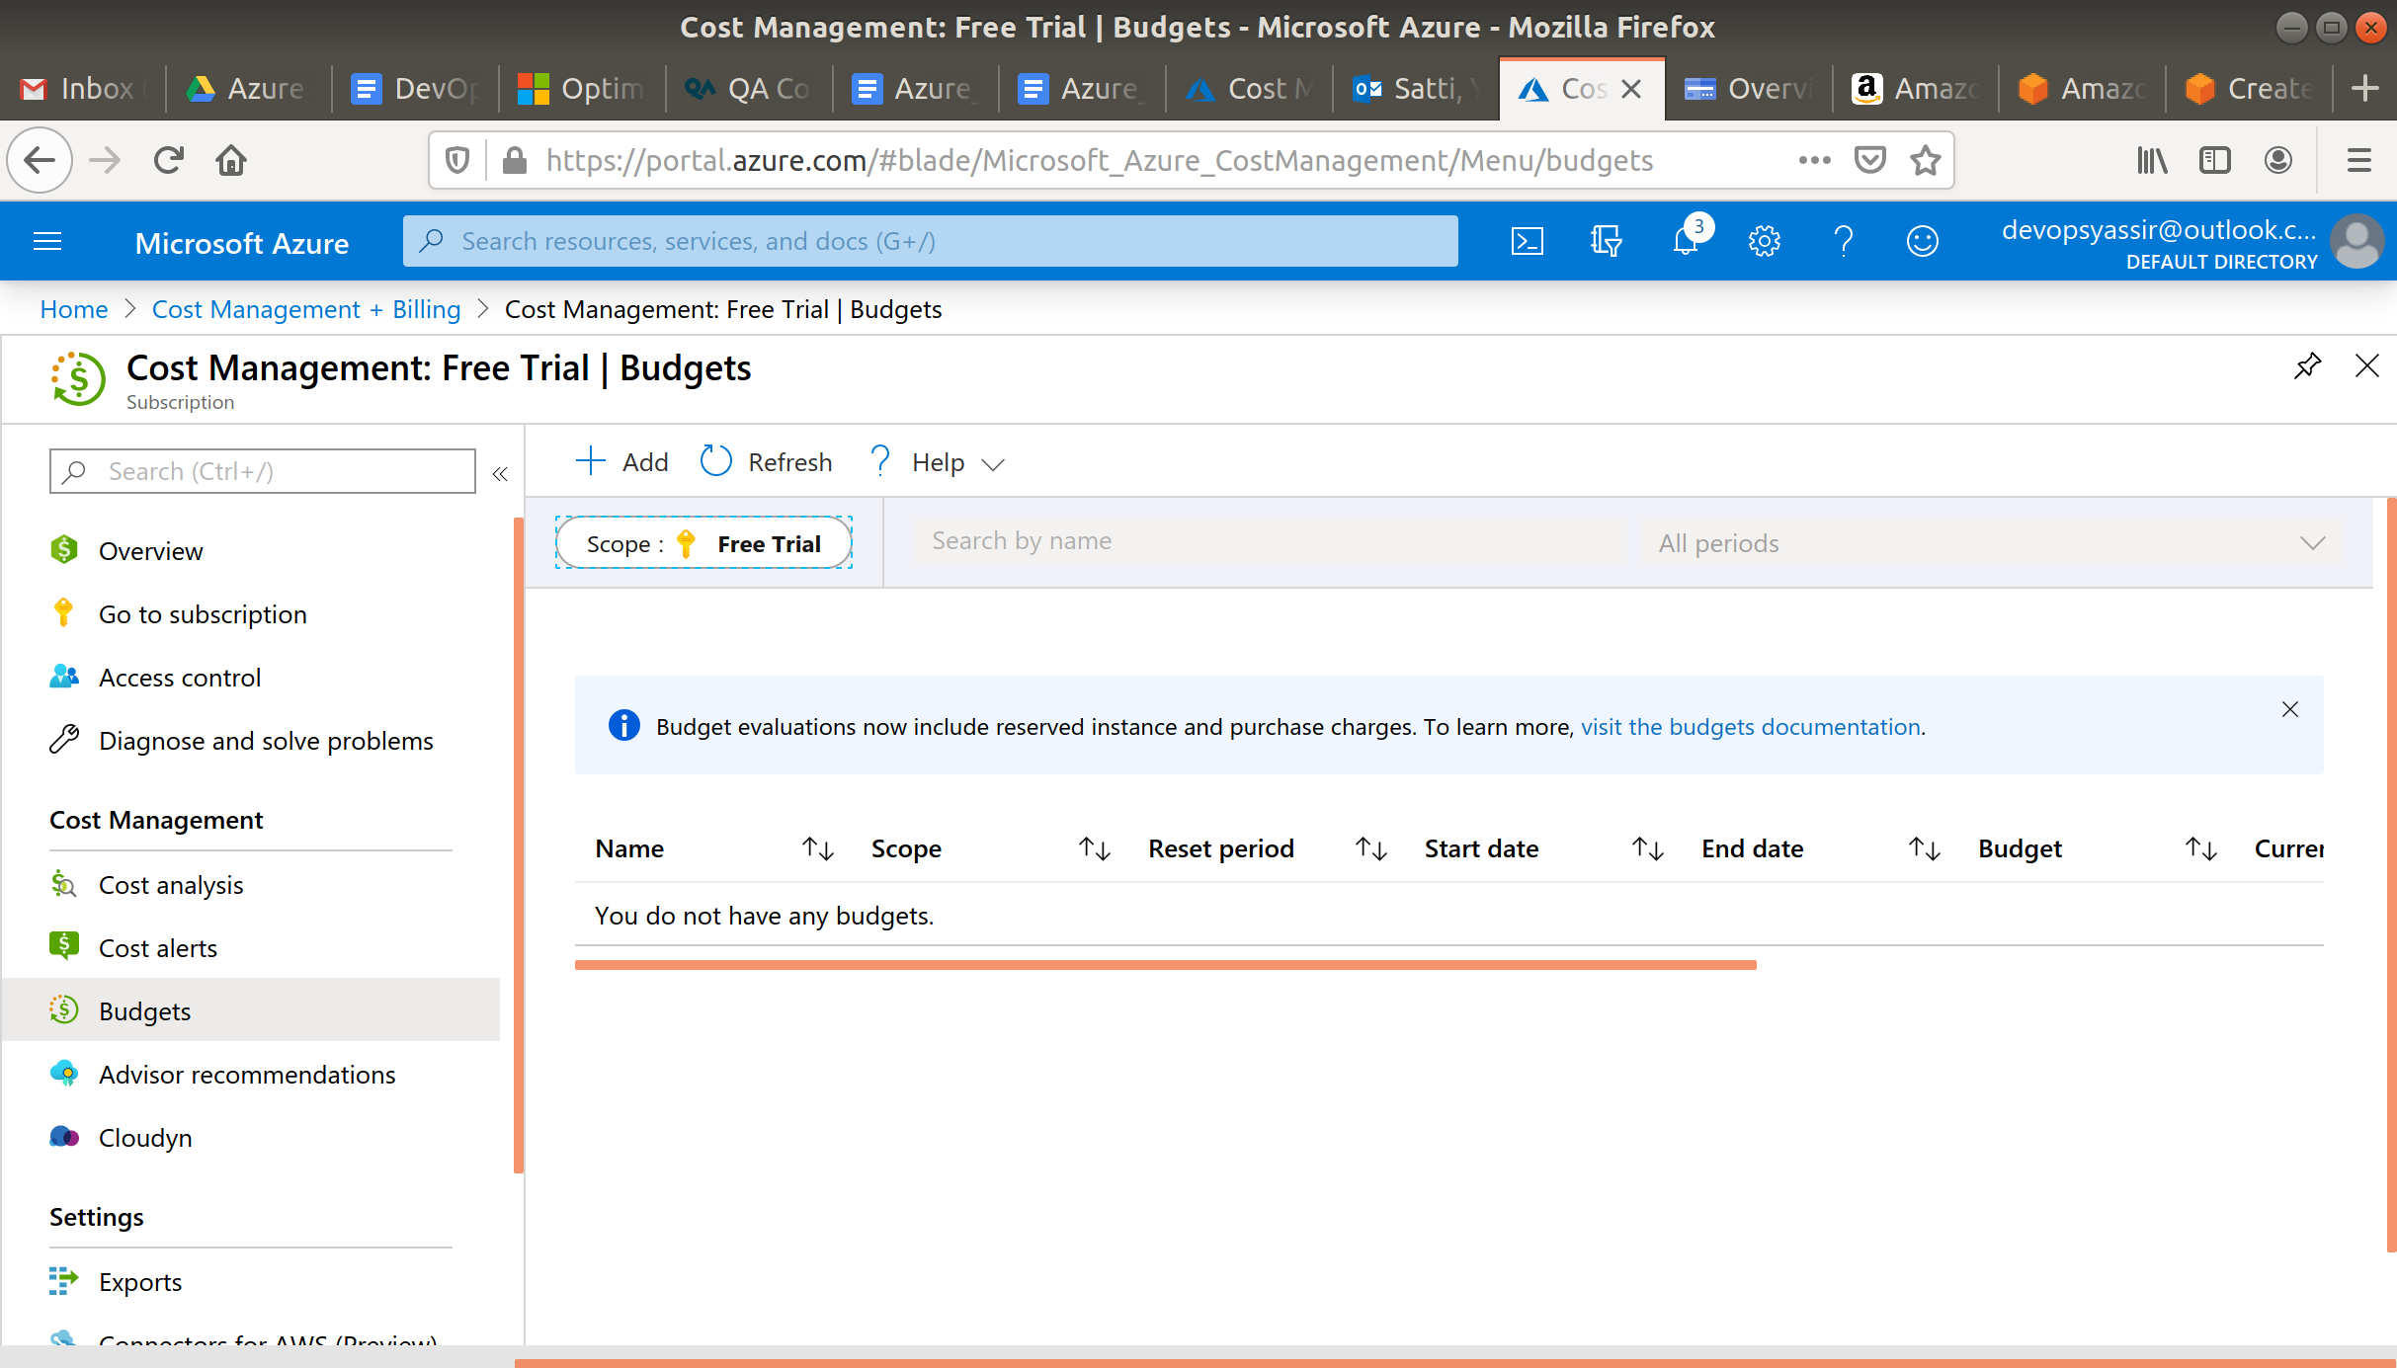

Now click +Add.

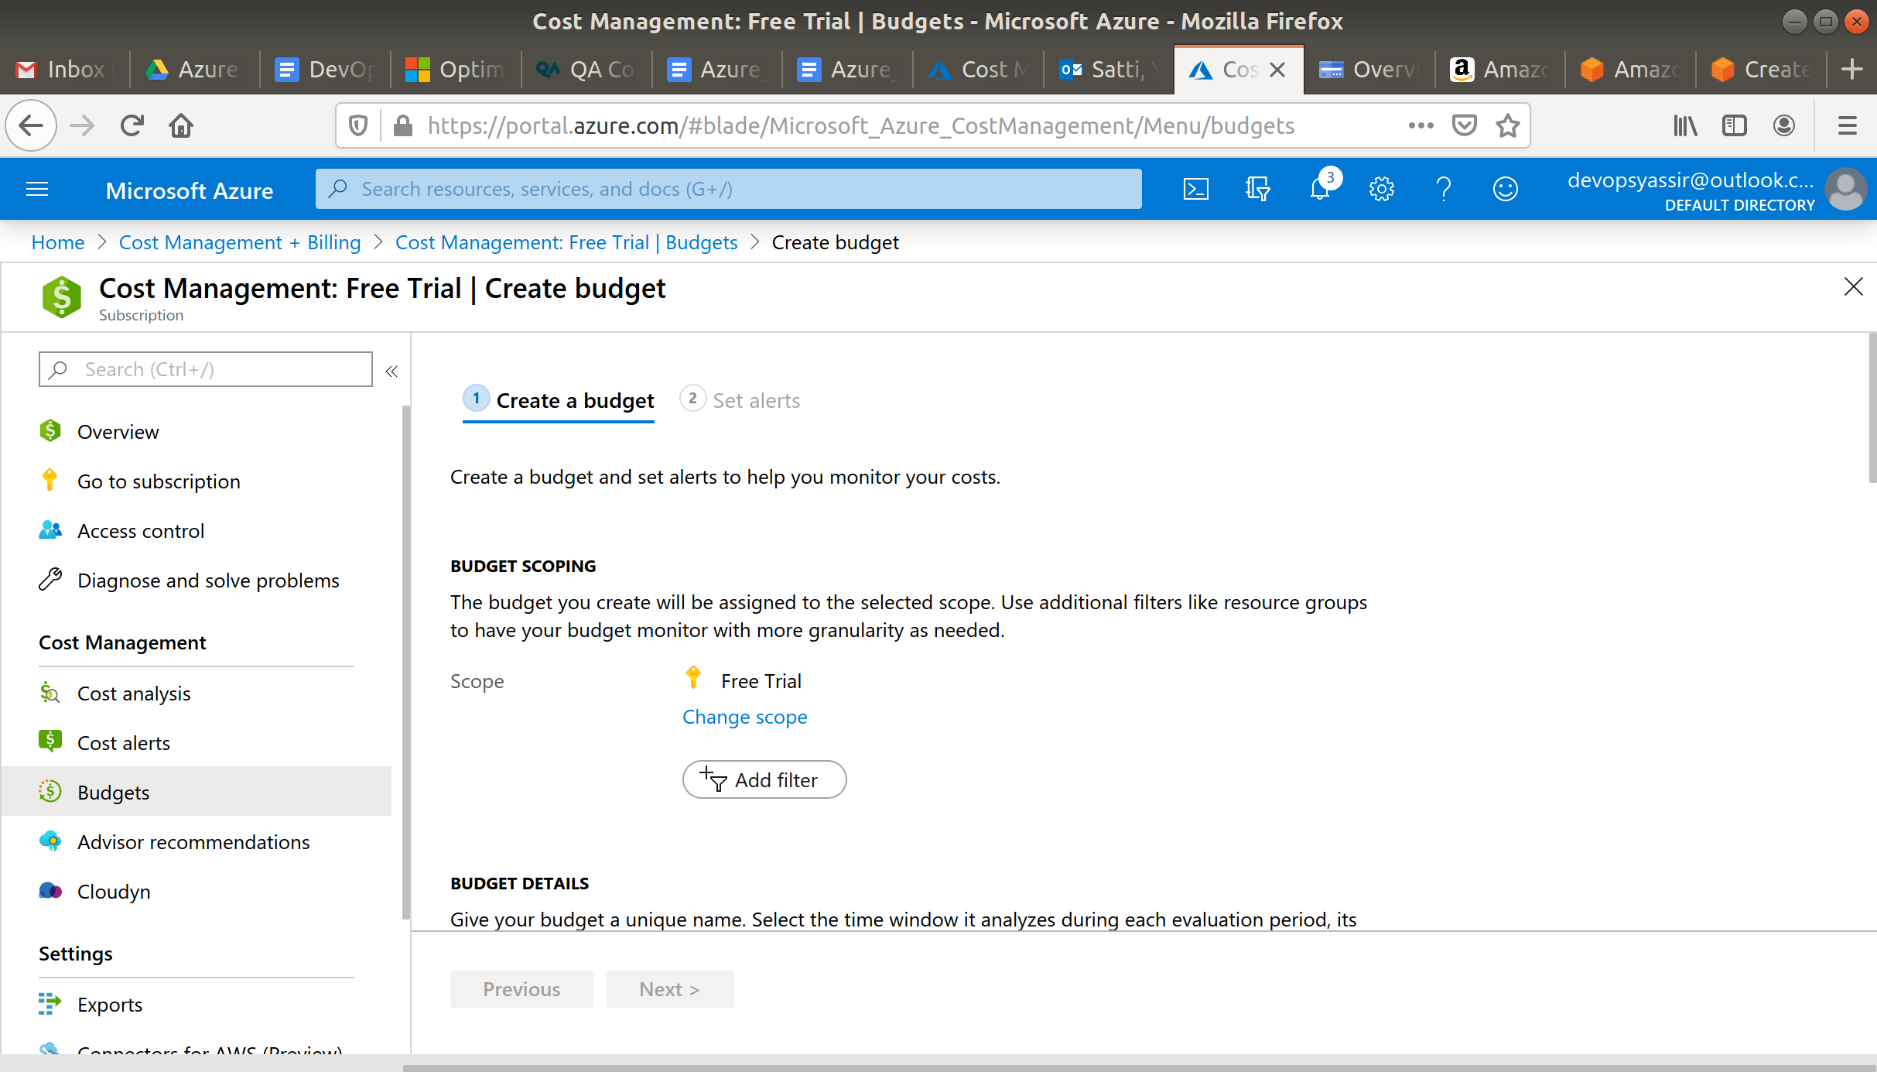

Now enter the following:

* Name - ImPoor
* Reset Period - Billing Month
* Amount - 2

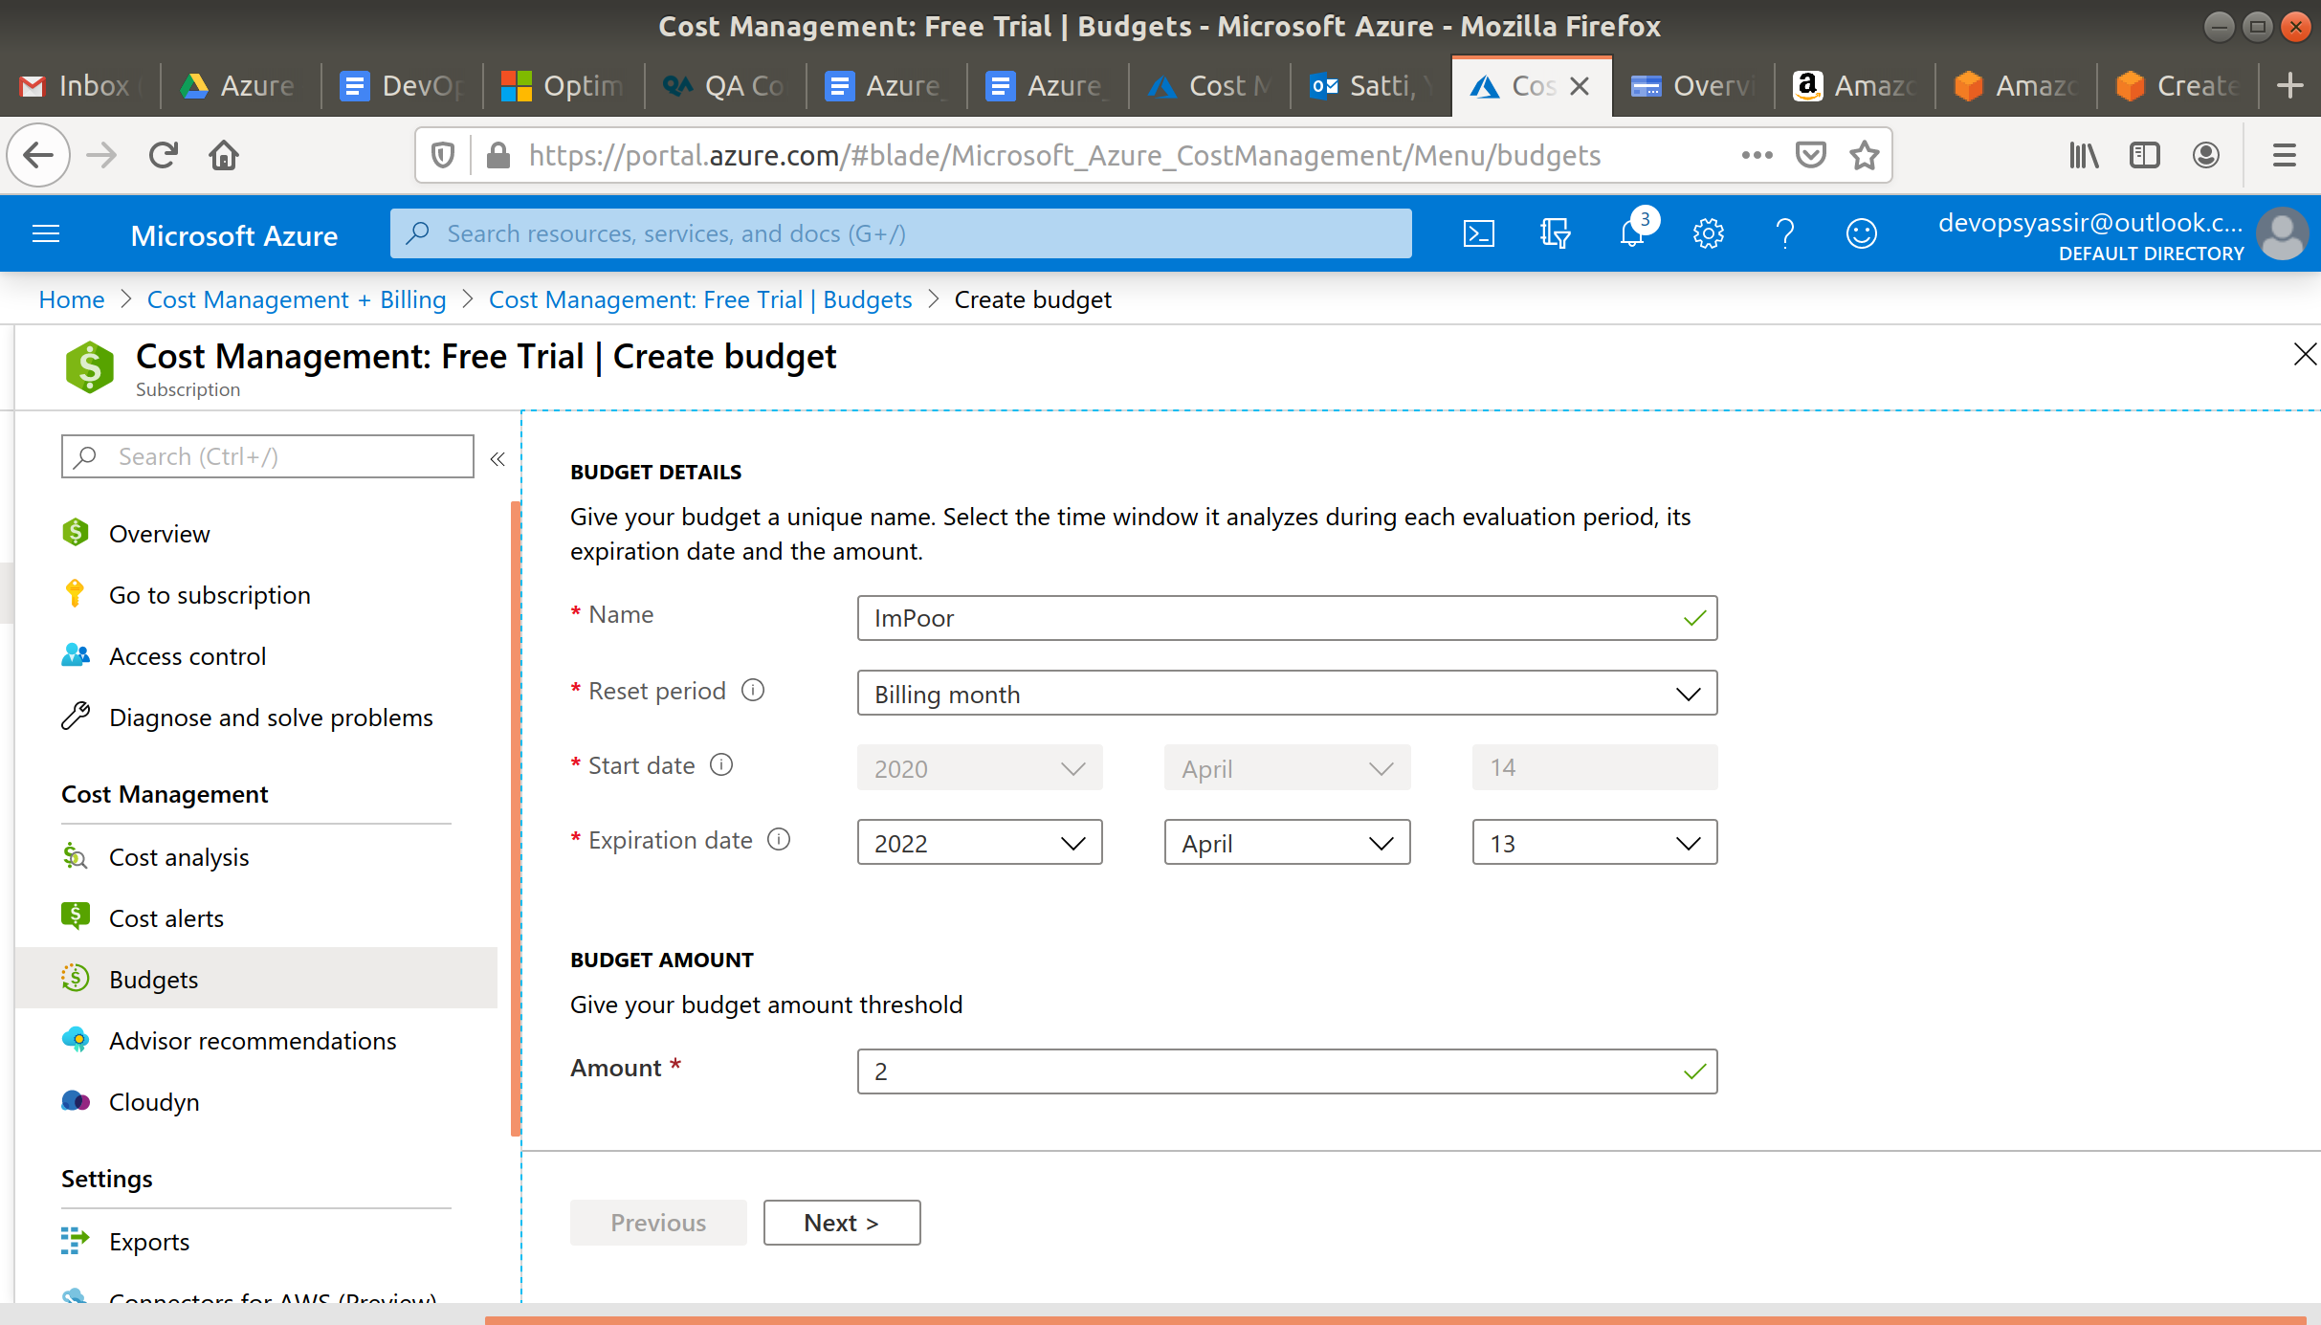

Now click Next.

Now enter 80 at the top of the page as the % of your budget that you would like to get an alert.

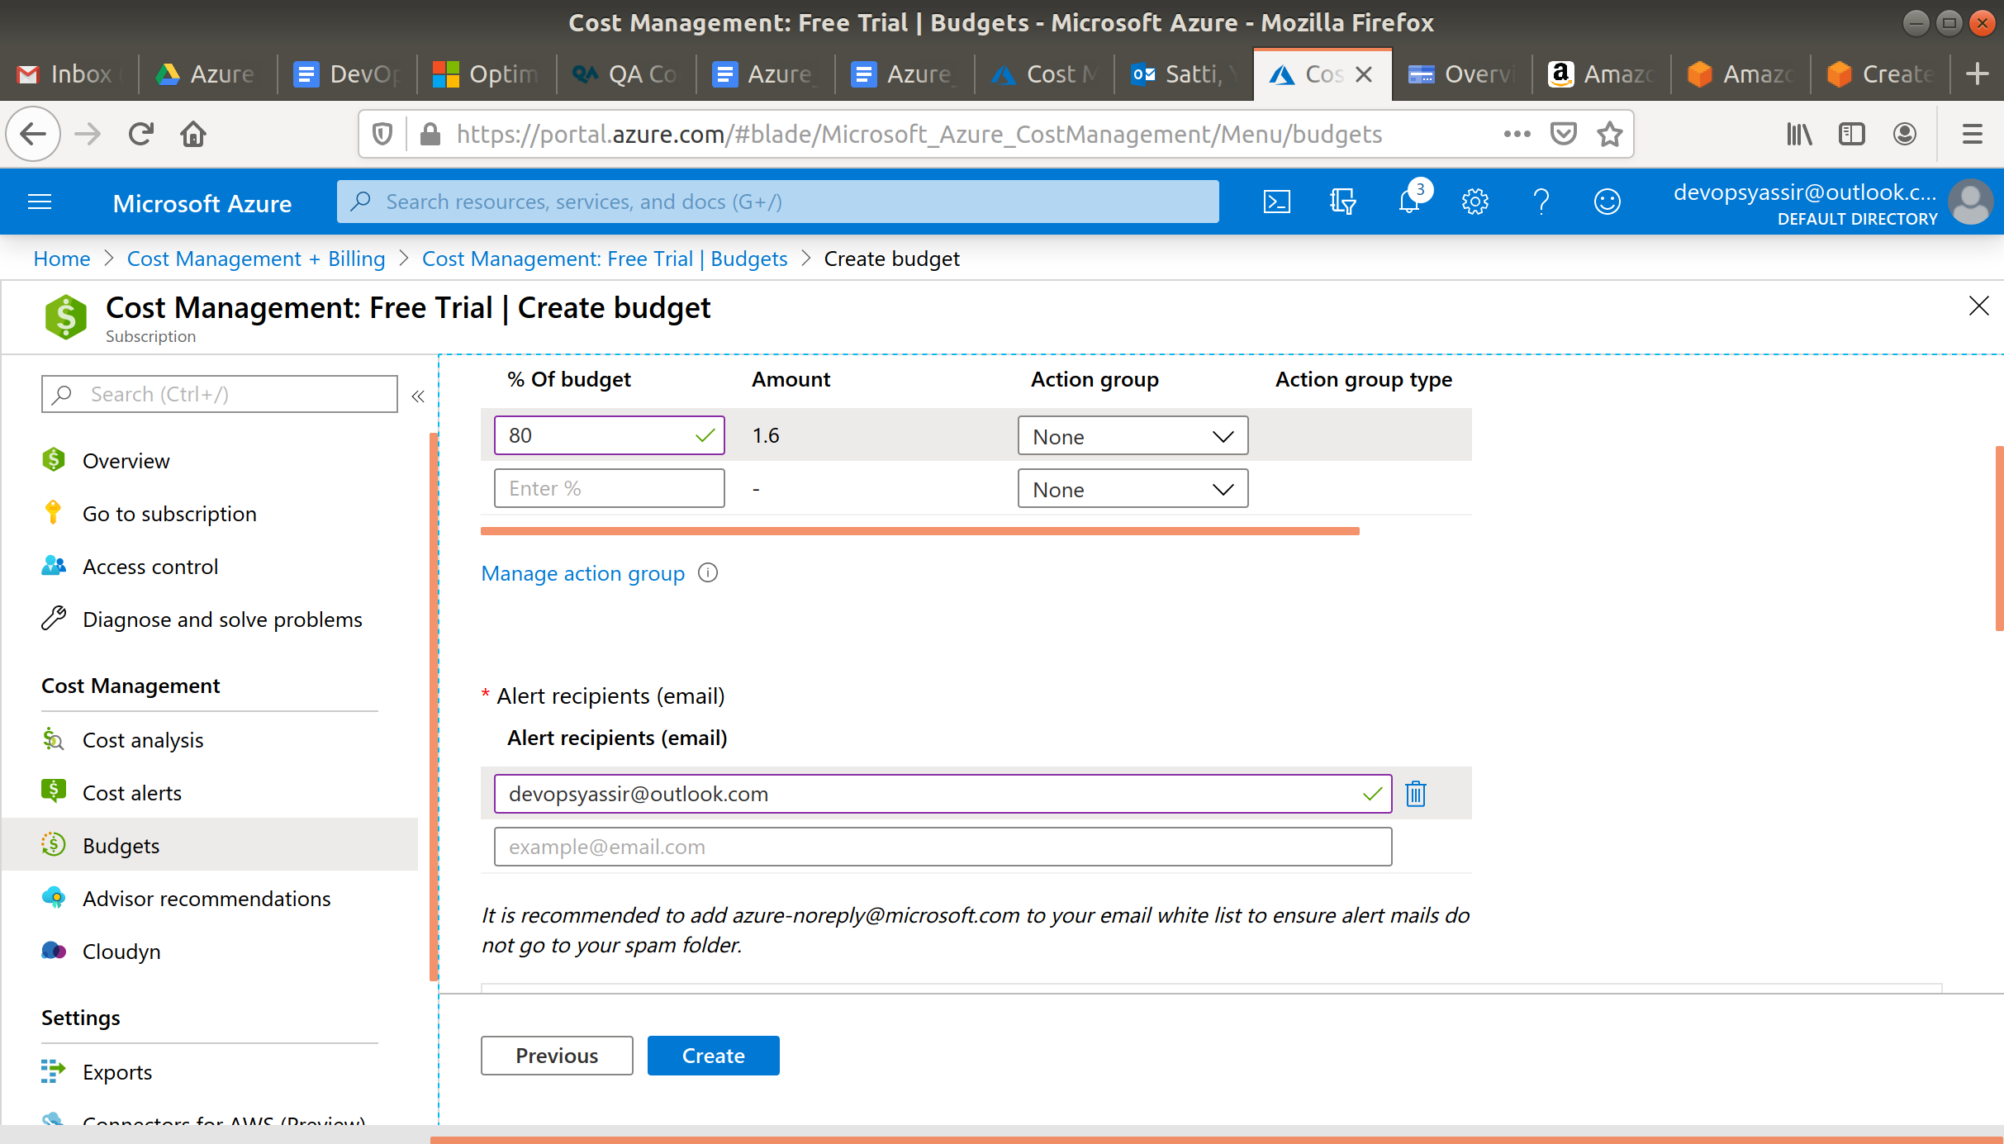

And finally enter your email and click Create.

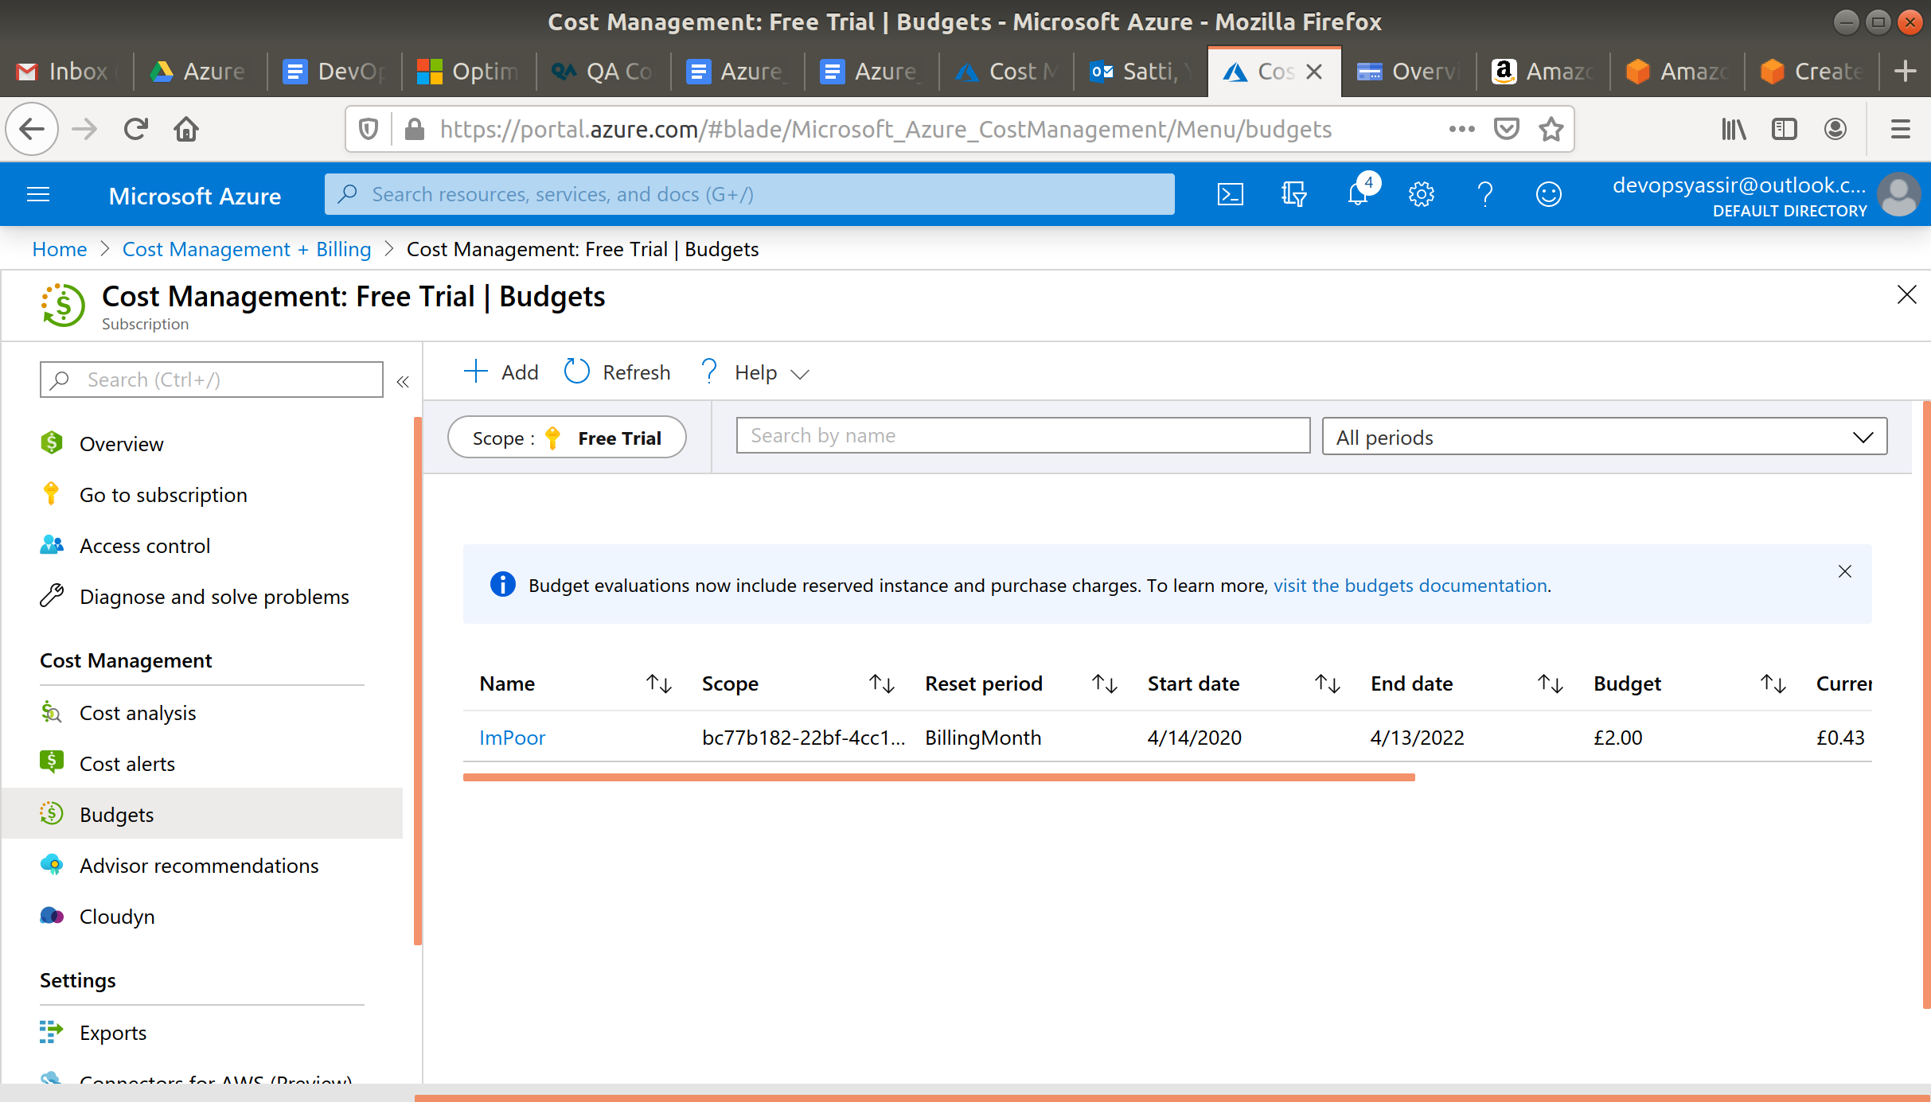

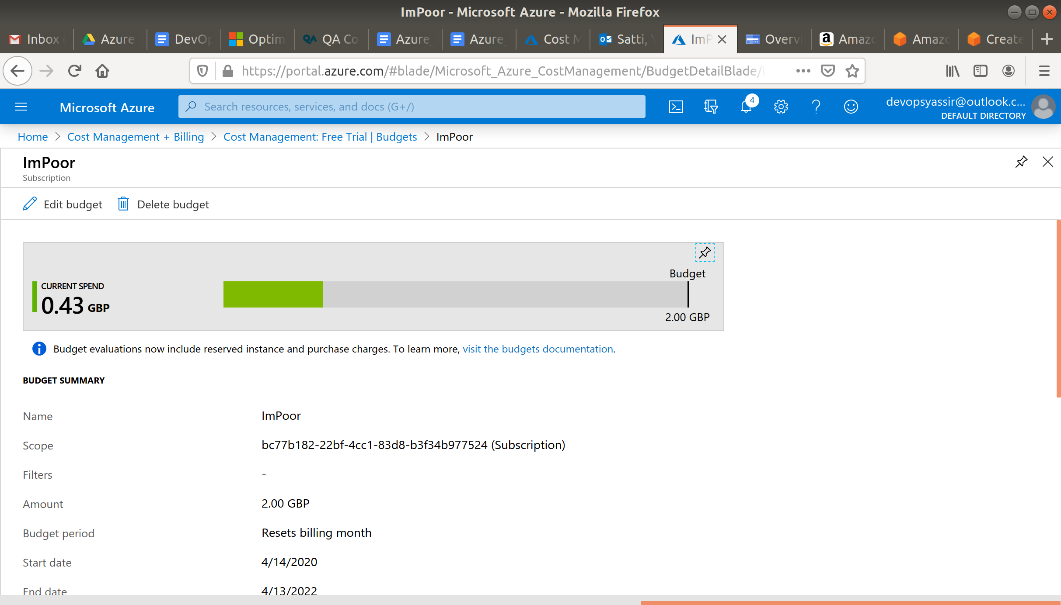

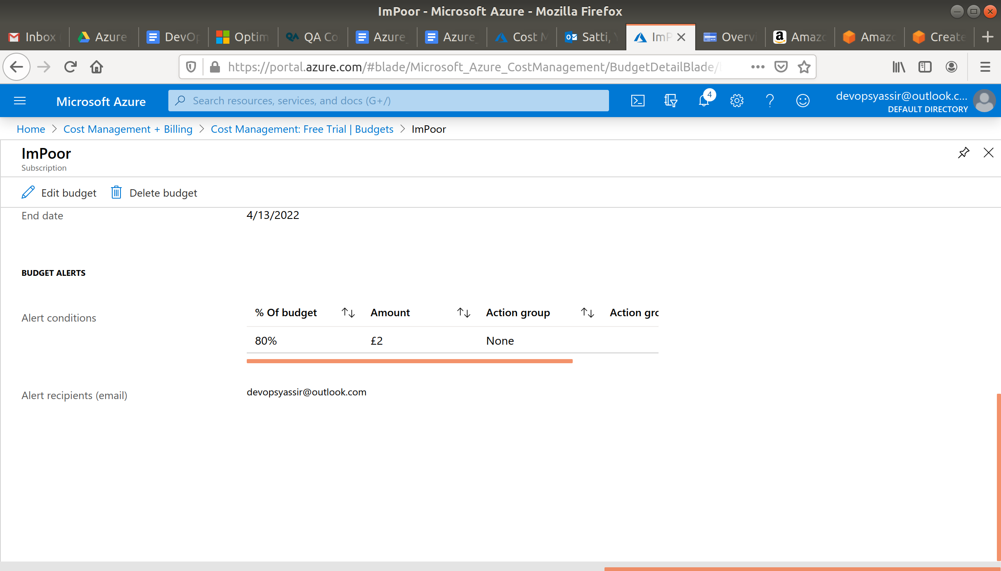

Now you have created a budget of £2!

## **Exercises**

Have a look around the cost management dashboard, look at your cost analysis and find out which resource you have spent the most money on.