# Azure Big Data

In this tutorial we are going to add some data to a Data Lake storage account through a very simple script that defines a data set and then outputs it to a Data Lake Storage Gen1 account.

### **New Resource Group**

The first thing is to create a new resource group, which we can do by clicking the burger bar in the top left corner and choosing Resource groups:

Then, we can click +Add:

Here, we can name the resource group and pick a location to have it in:

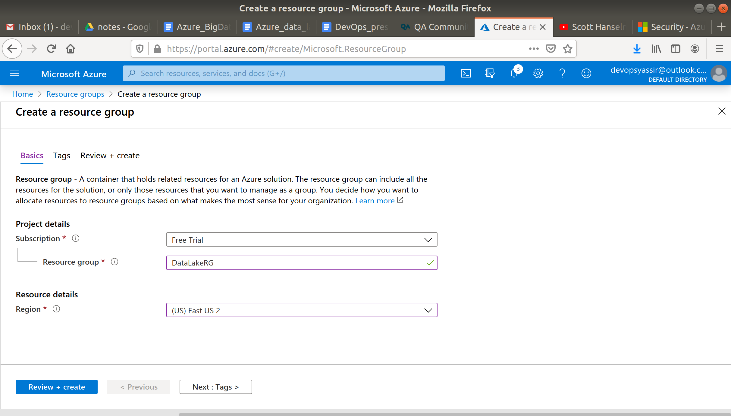

Lastly, we will click Review & Create and then Create to create the resource group:

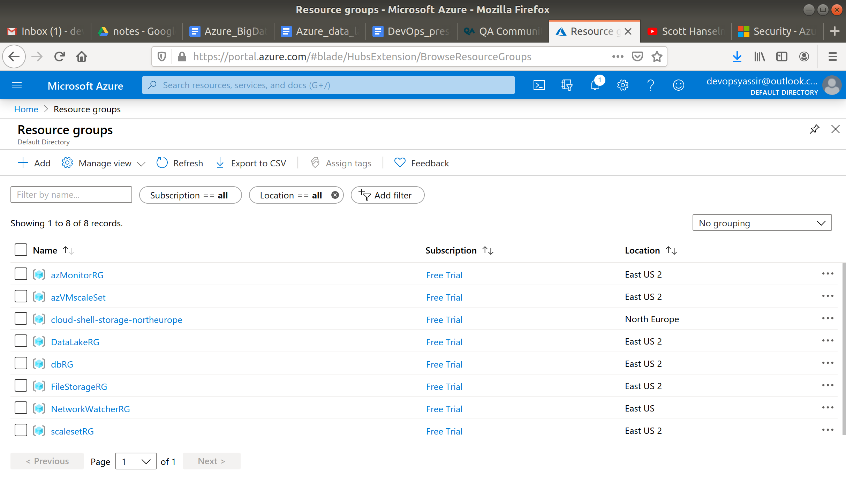

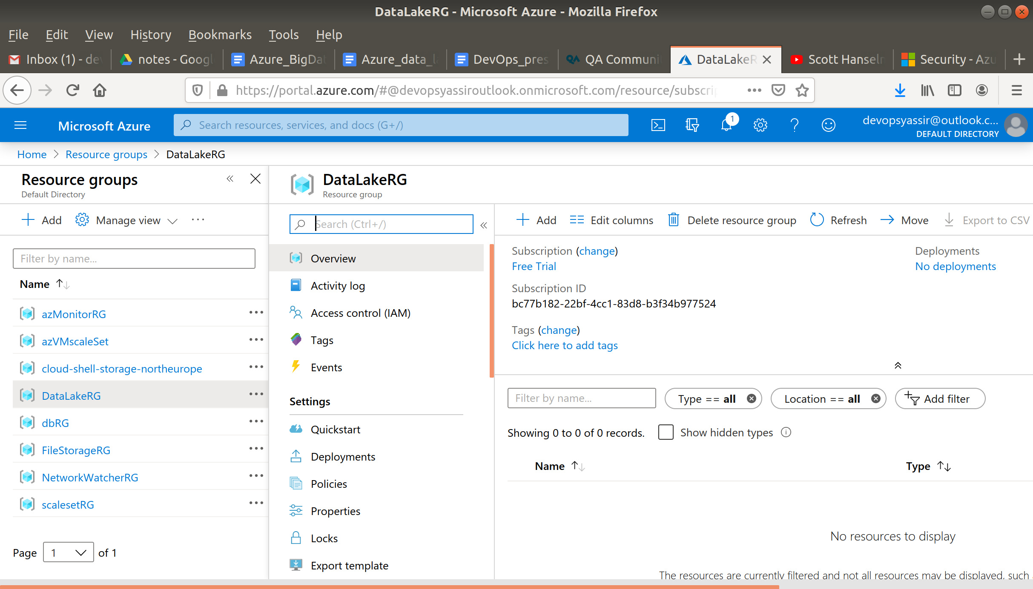

### **Data Lake Analytics**

Type Data Lake Analytics into the search bar and select it.

Click on +Add and enter the following:

* Resource Group - The one we just created
* Name - Any name you like but it must be unique
* Location - West Europe
* Azure Data Lake Storage Gen1 - Create a new one and name it something unique
* Pricing Package - Pay as you go

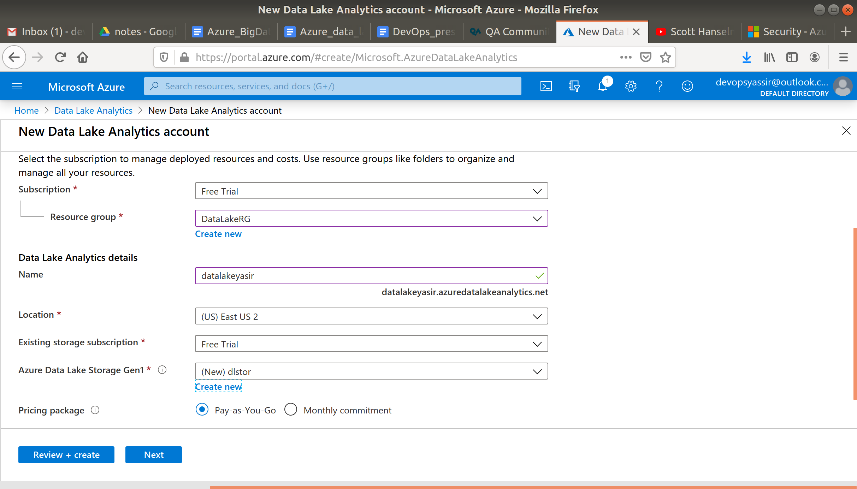

Click Review and Create and then Create.

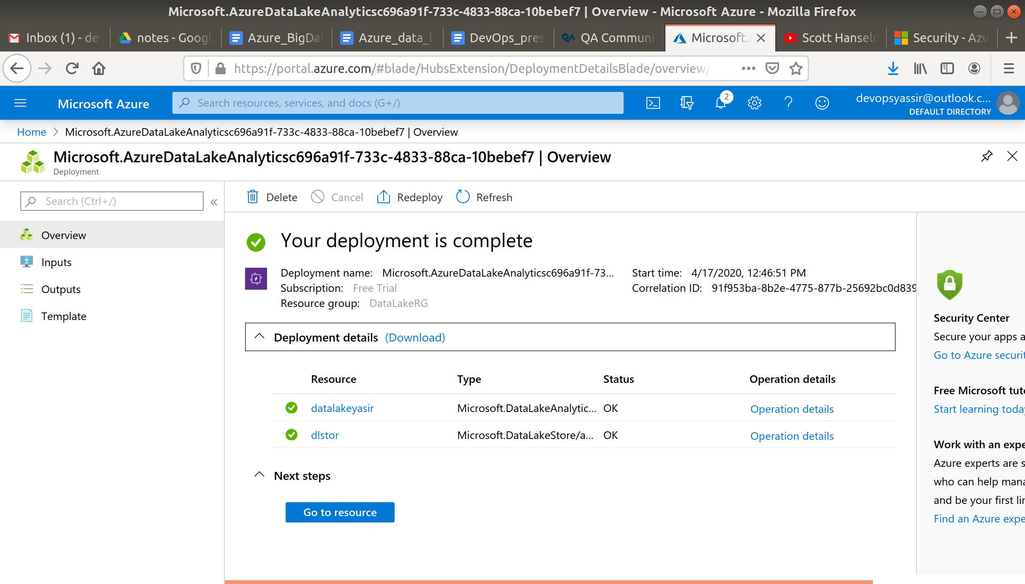

Navigate to your Data Lake Analytics account and click +New Job.

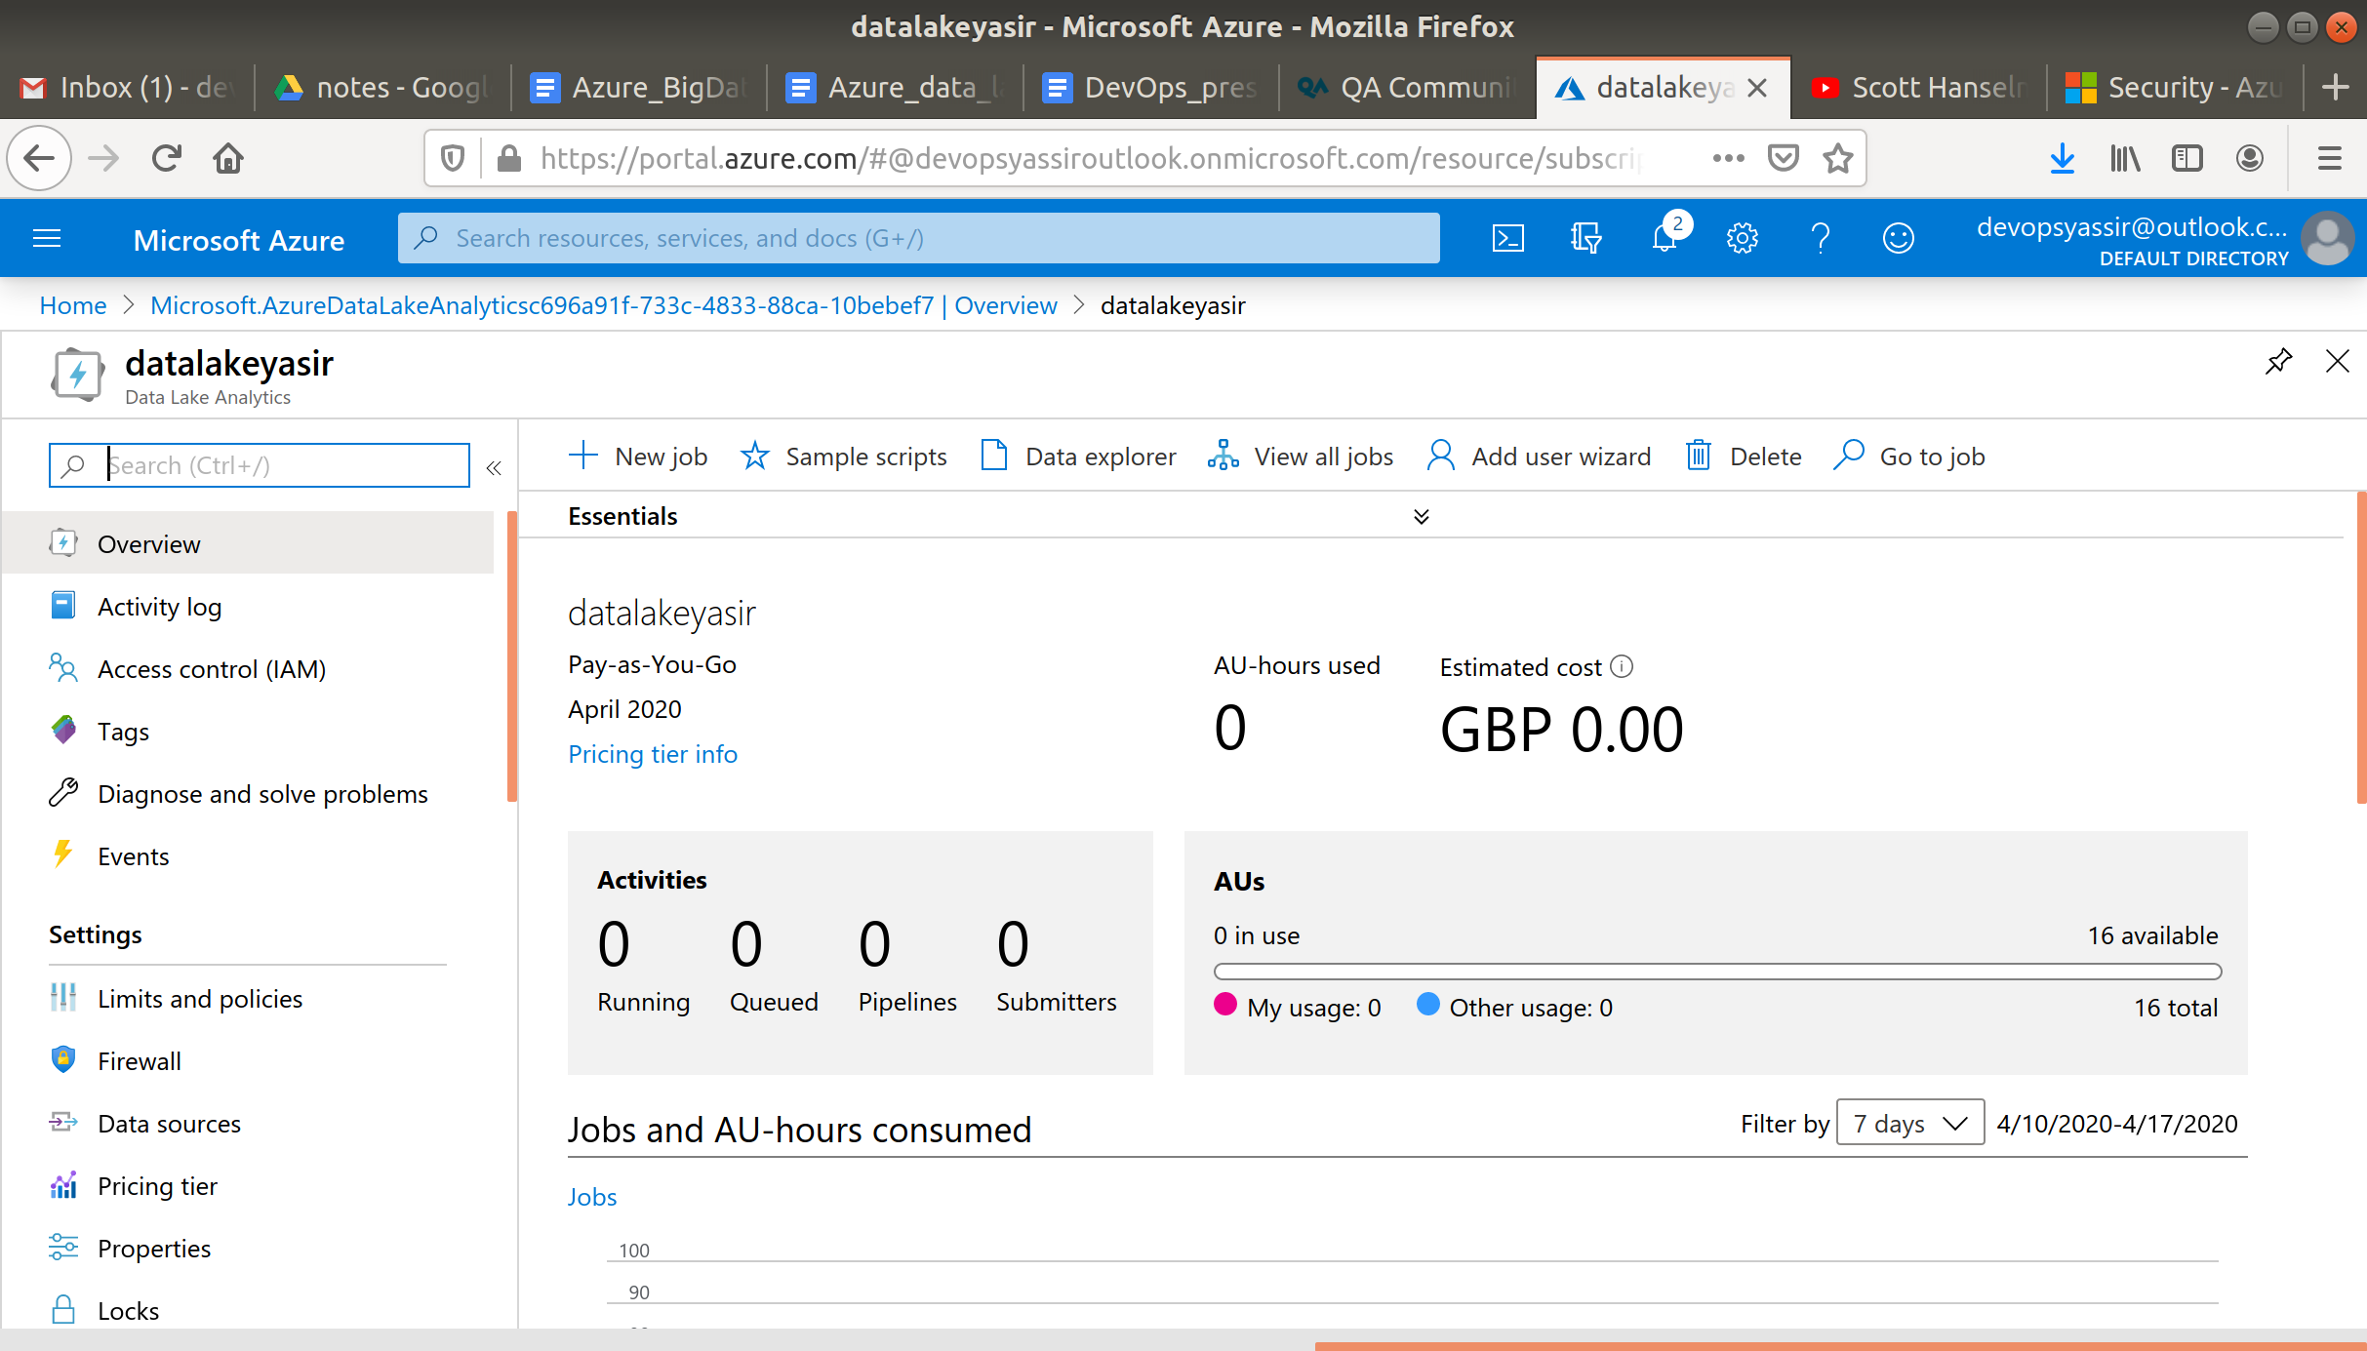

Now enter the following script.

@a =

SELECT * FROM

(VALUES

("Ben", 5460.0),

("Luke", 4350.0)

) AS

D( trainer, amount );

OUTPUT @a

TO "/data.csv"

USING Outputters.Csv();

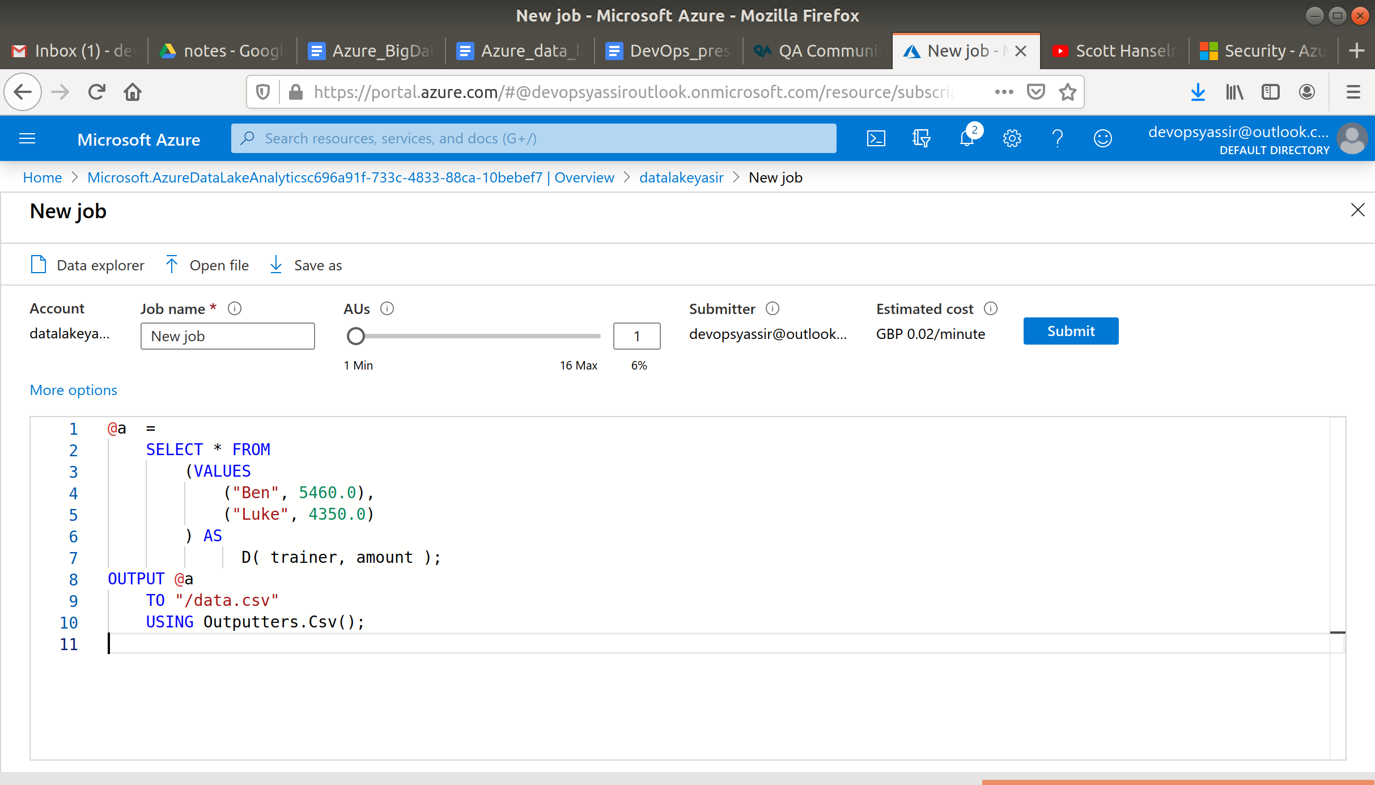

Then click Submit and wait for the job status to say succeeded.

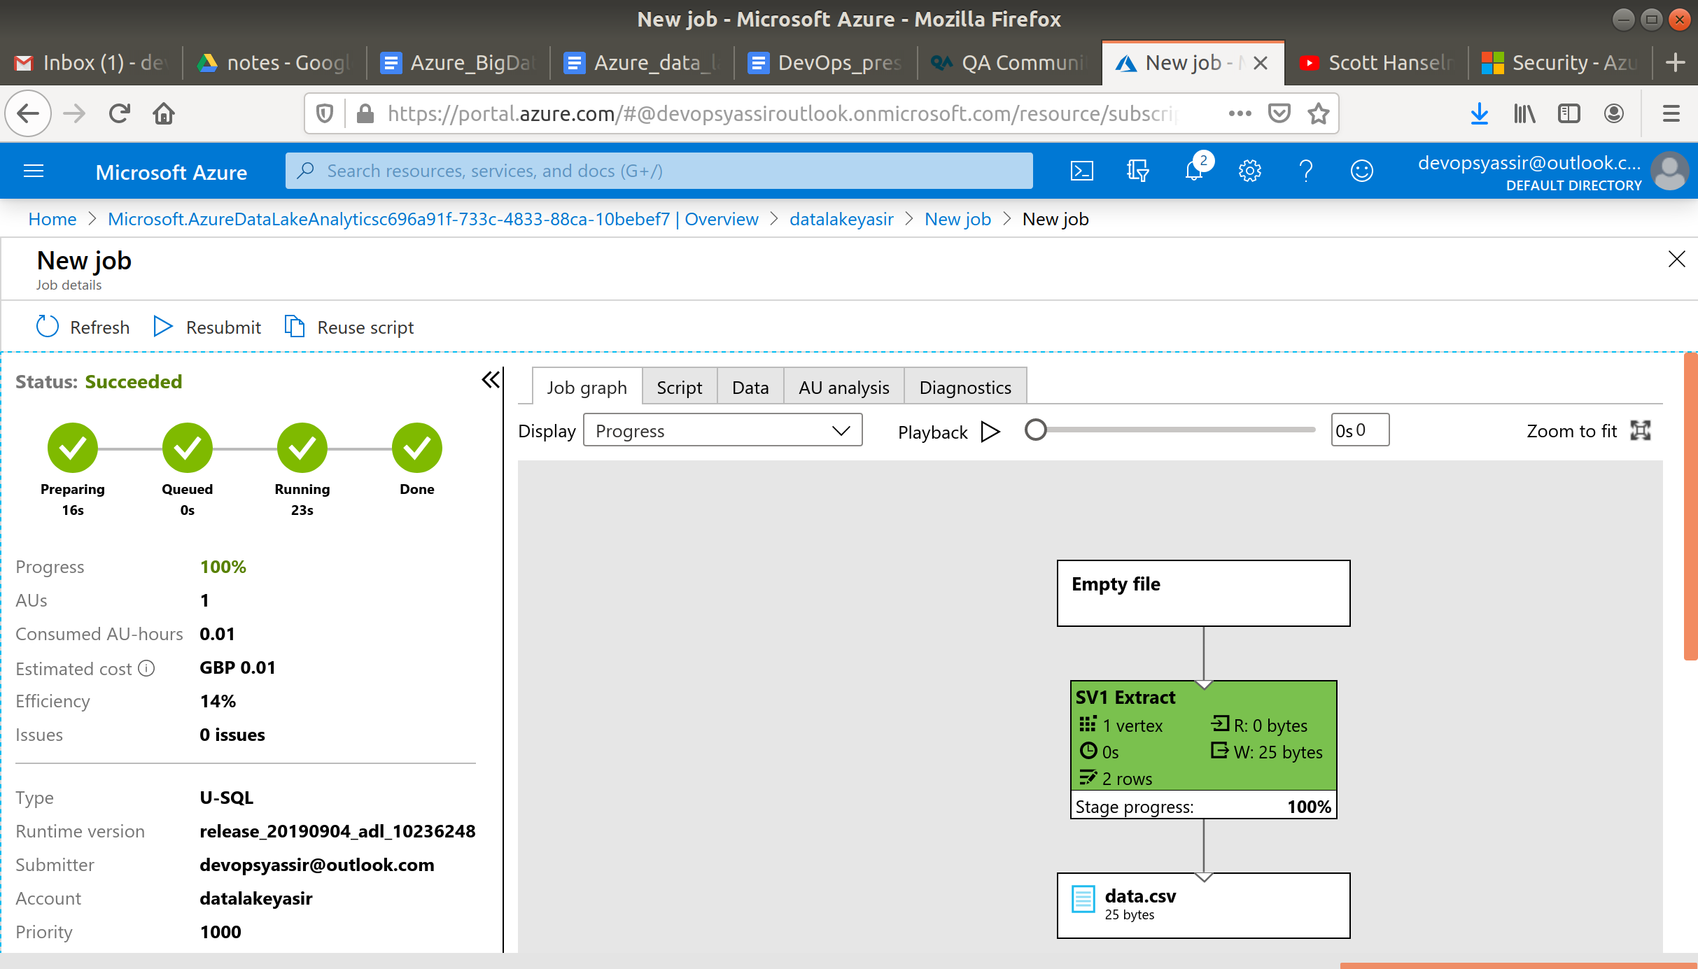

Then select the Data tab and Outputs and then the data.csv file to see the output data.

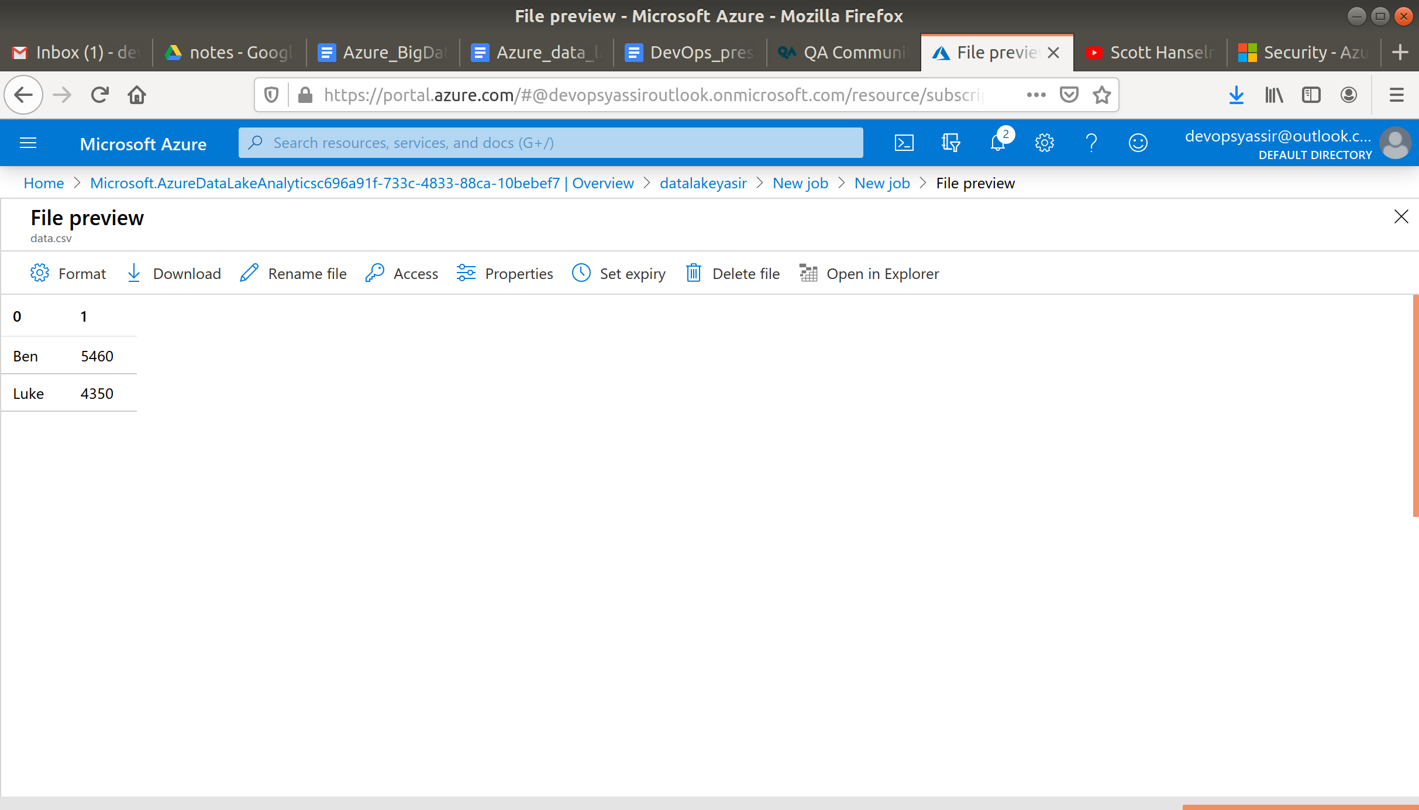

### **Clean Up**

To clean up, go back to the Resource Group page, click your resource group you used for this module, and then choose Delete.

Once you type the name of the resource group to confirm deletion, this will be deleted along with everything inside of it.