# Azure File Storage

## **Tutorial**

In this tutorial we will create a file shard and add a file to it.

### **New Resource Group**

The first thing is to create a new resource group, which we can do by clicking the burger bar in the top left corner and choosing Resource groups:

Then, we can click +Add:

Here, we can name the resource group and pick a location to have it in:

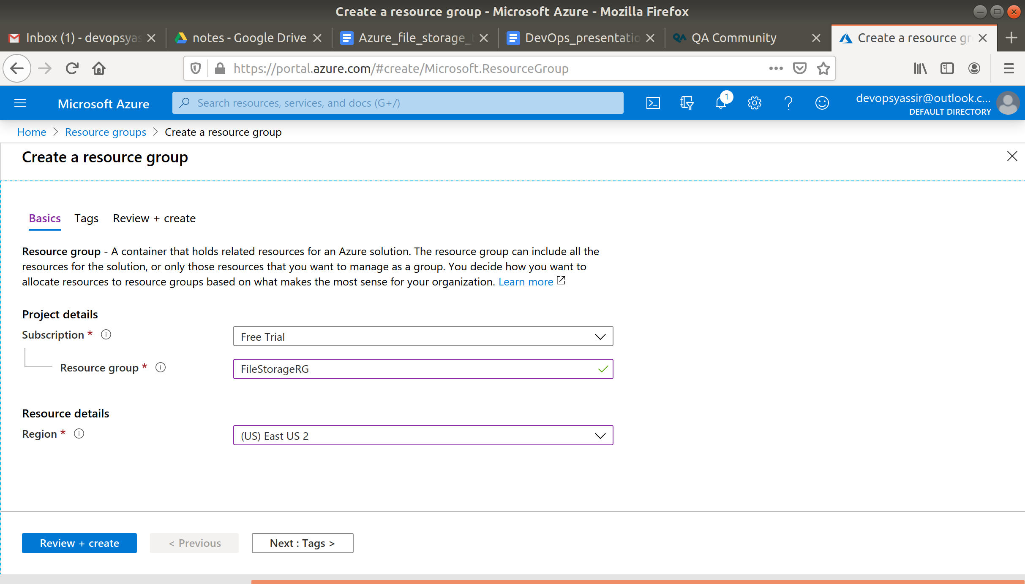

Lastly, we will click Review & Create and then Create to create the resource group:

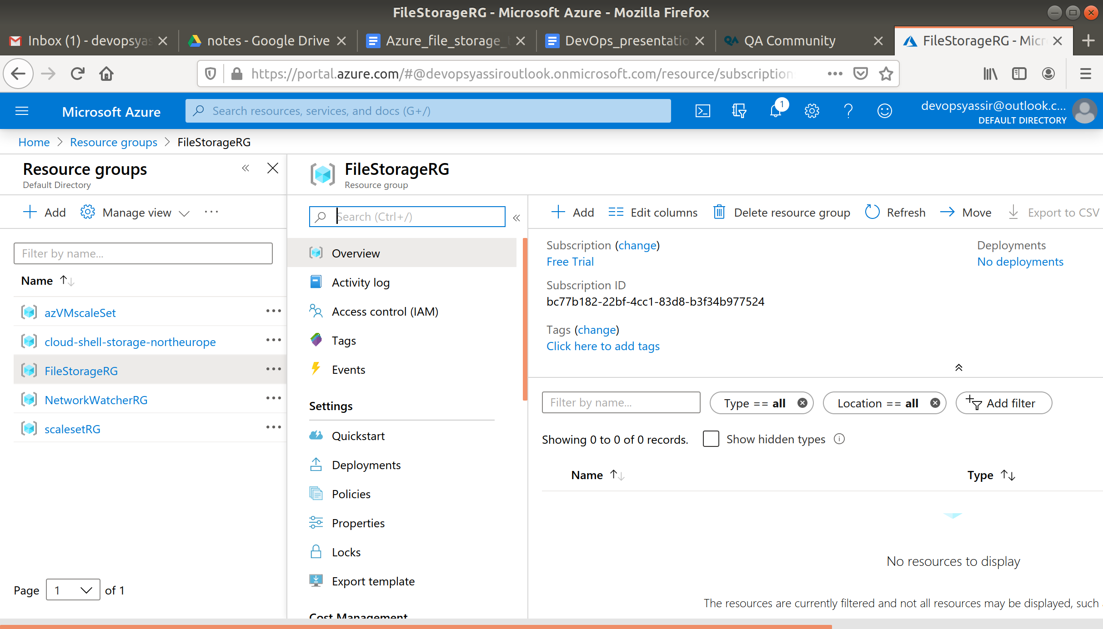

### **Storage Account**

Next we will create a storage account.

Type Storage Accounts in the search bar and click it when it appears.

Now click **+Add**.

In the field enter the following:

* Resource Group - The resource group we created
* Storage Account Name - Anything you like, must be **Unique**, can only contain lowercase letters and numbers
* Location - UK South

Leave the rest as default. And click **Review and Create**.

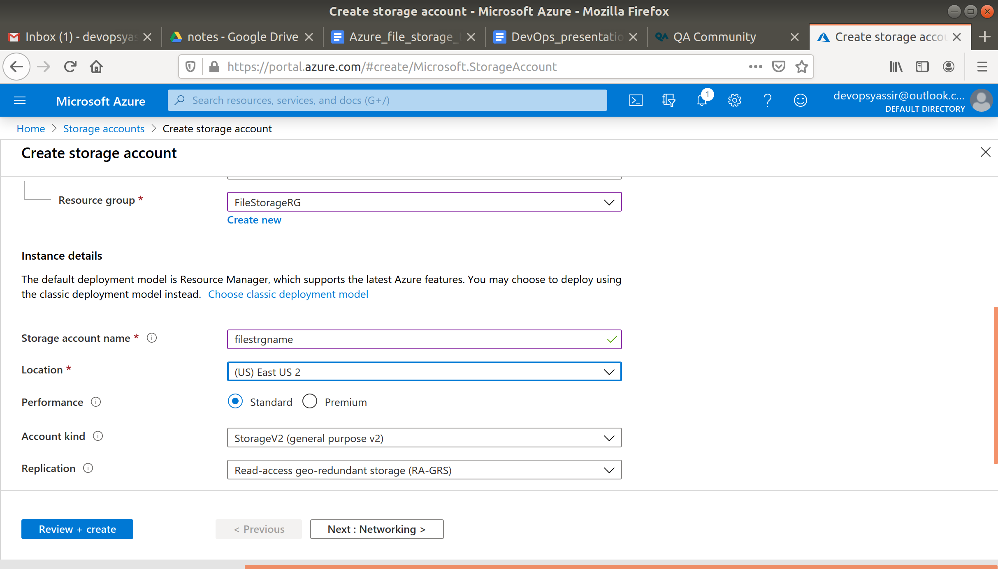

Then when the validations pass, click **Create**.

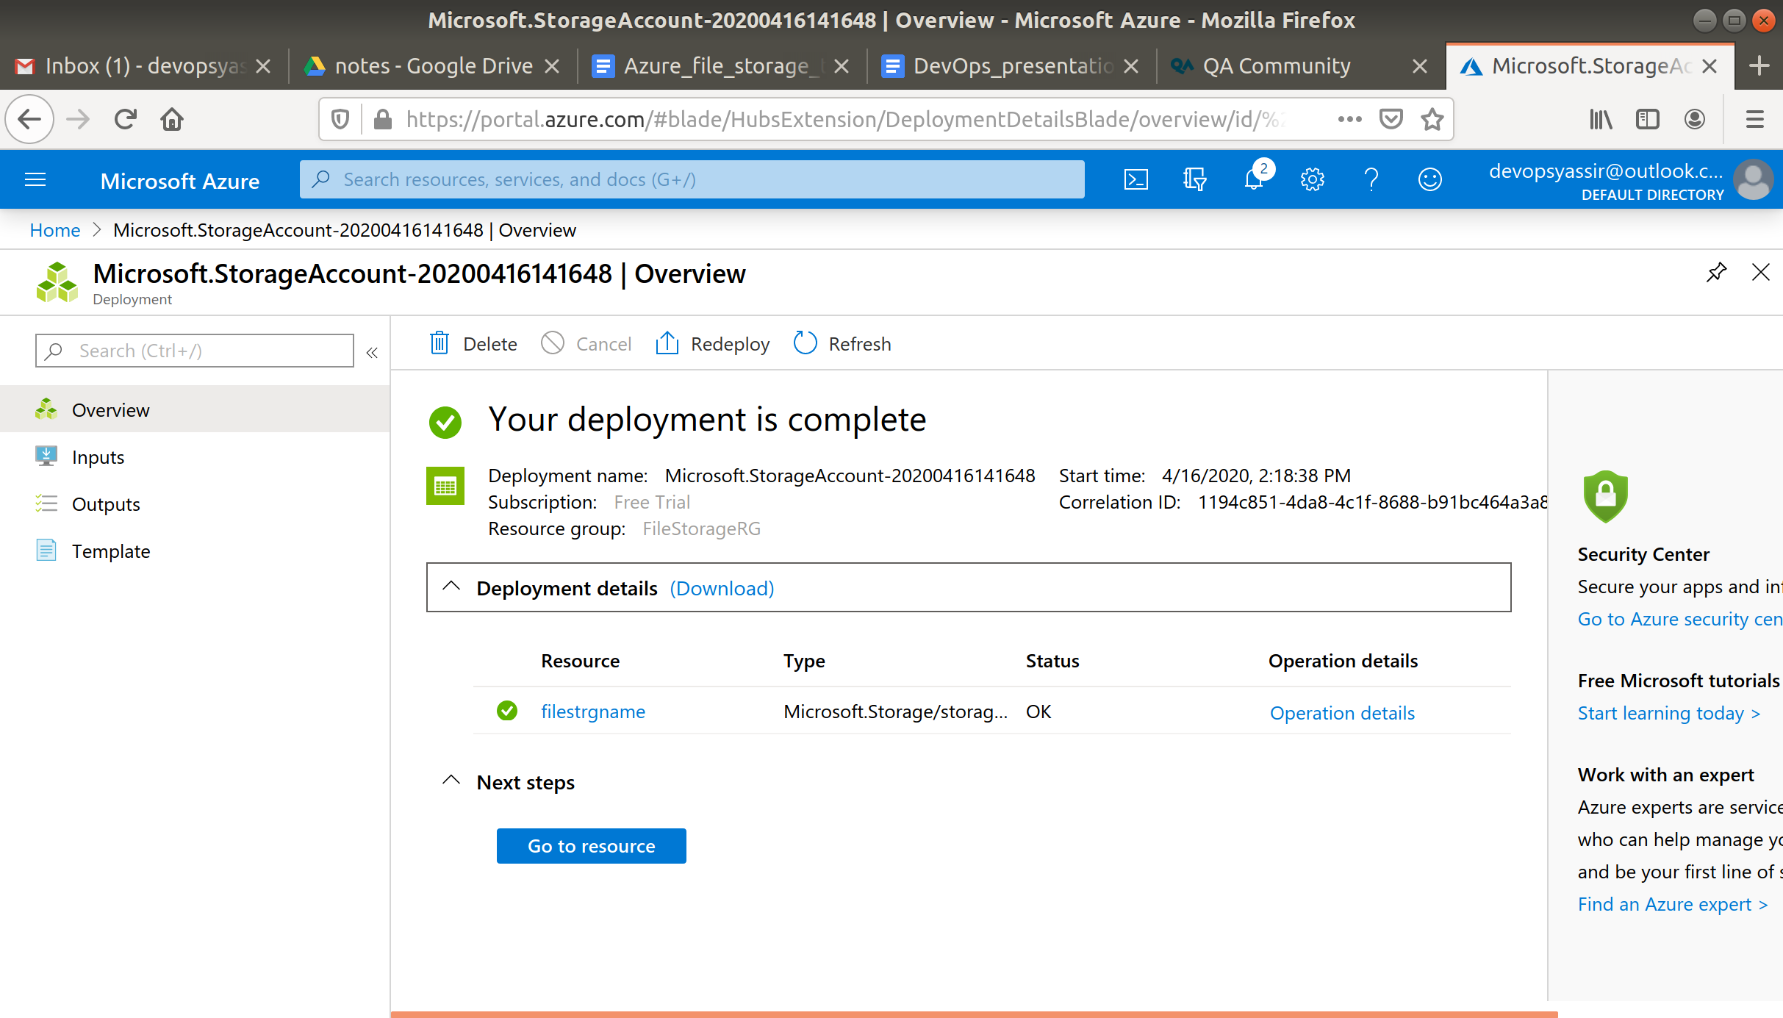

### **File Share**

Now in the left blade select File shares and then select + File Share.

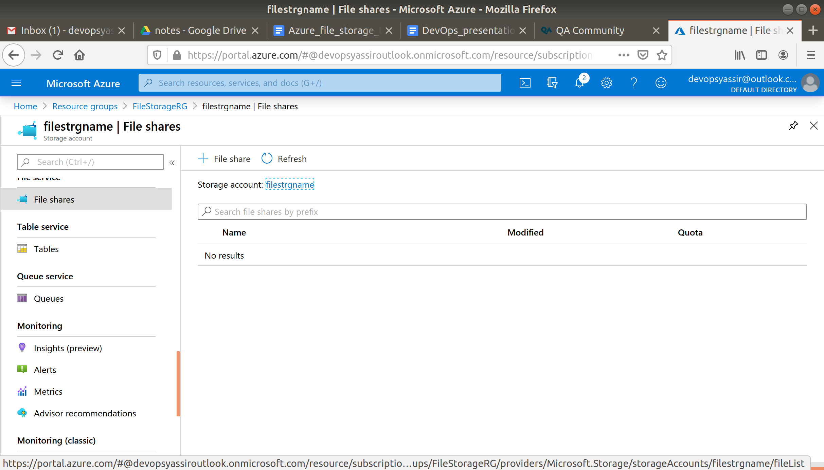

Type in a name and leave the Quota blank for now.

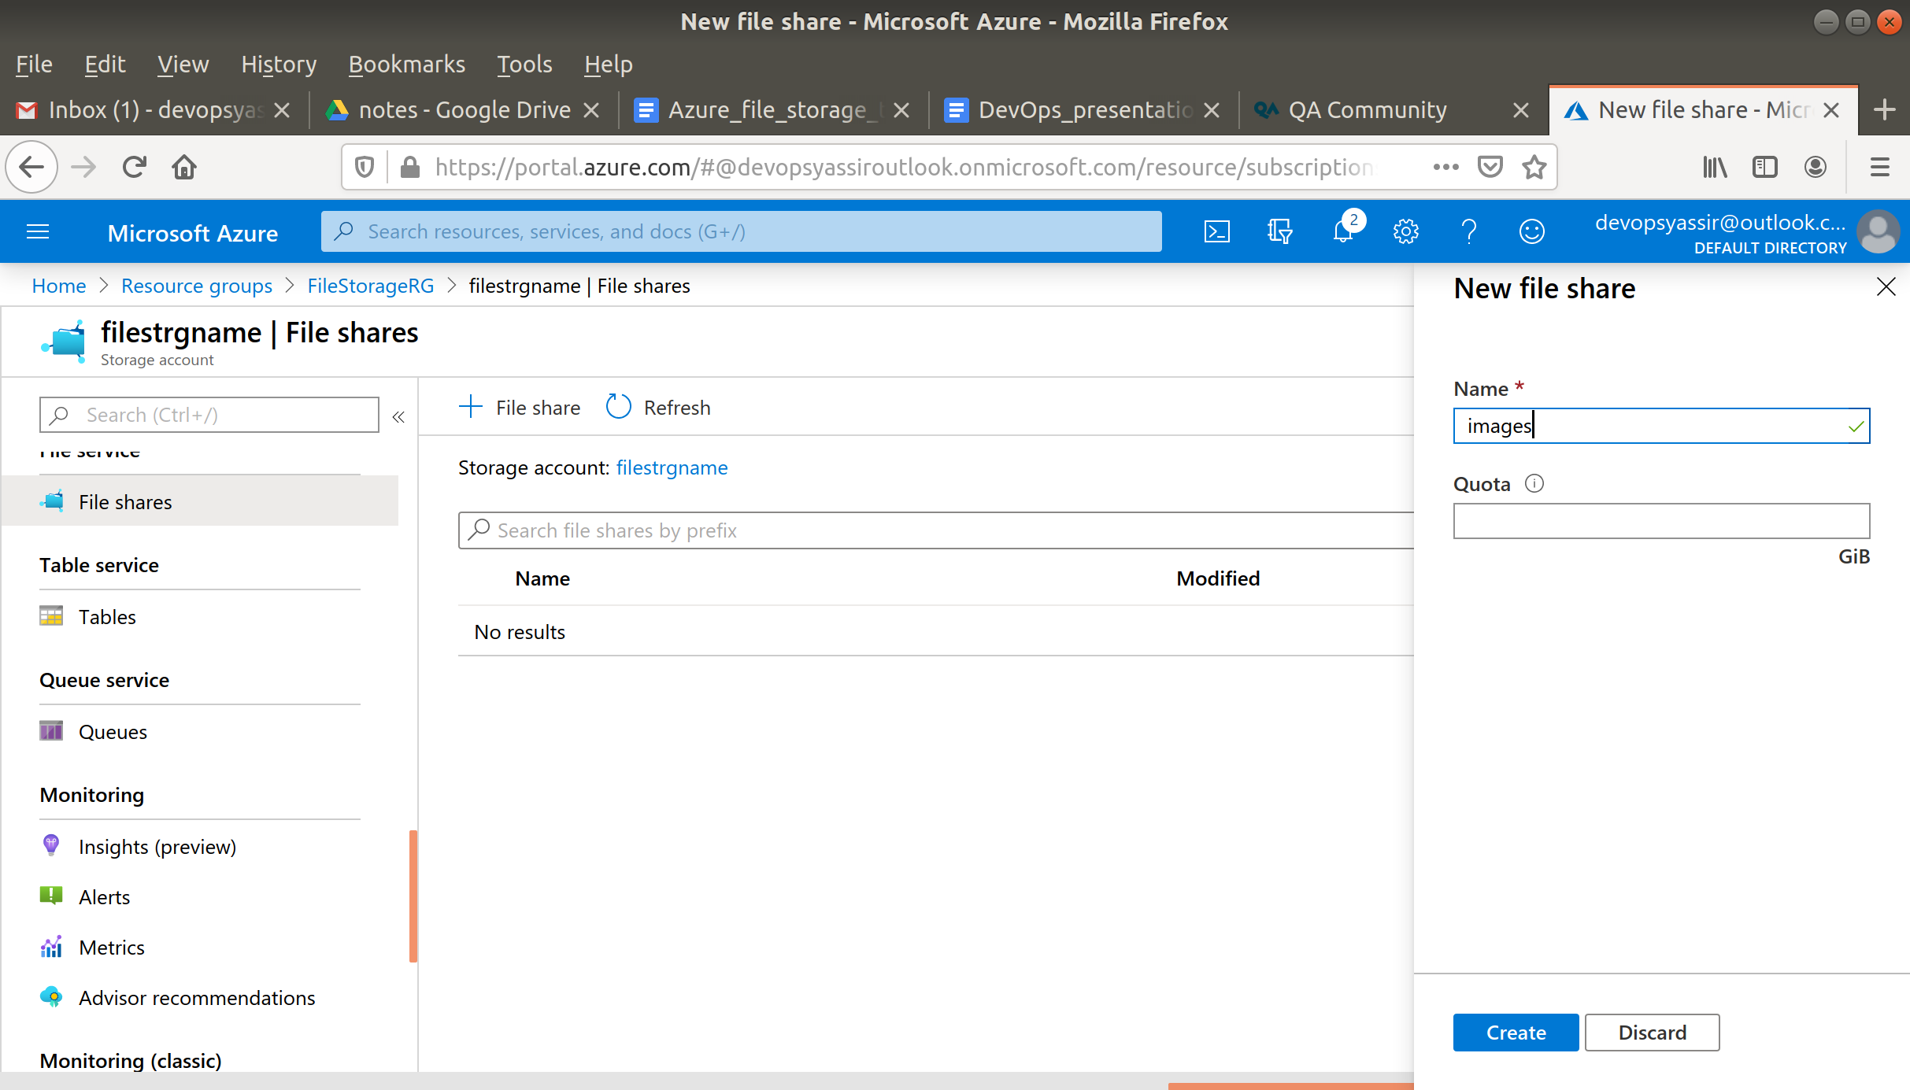

You should then see your file share appear.

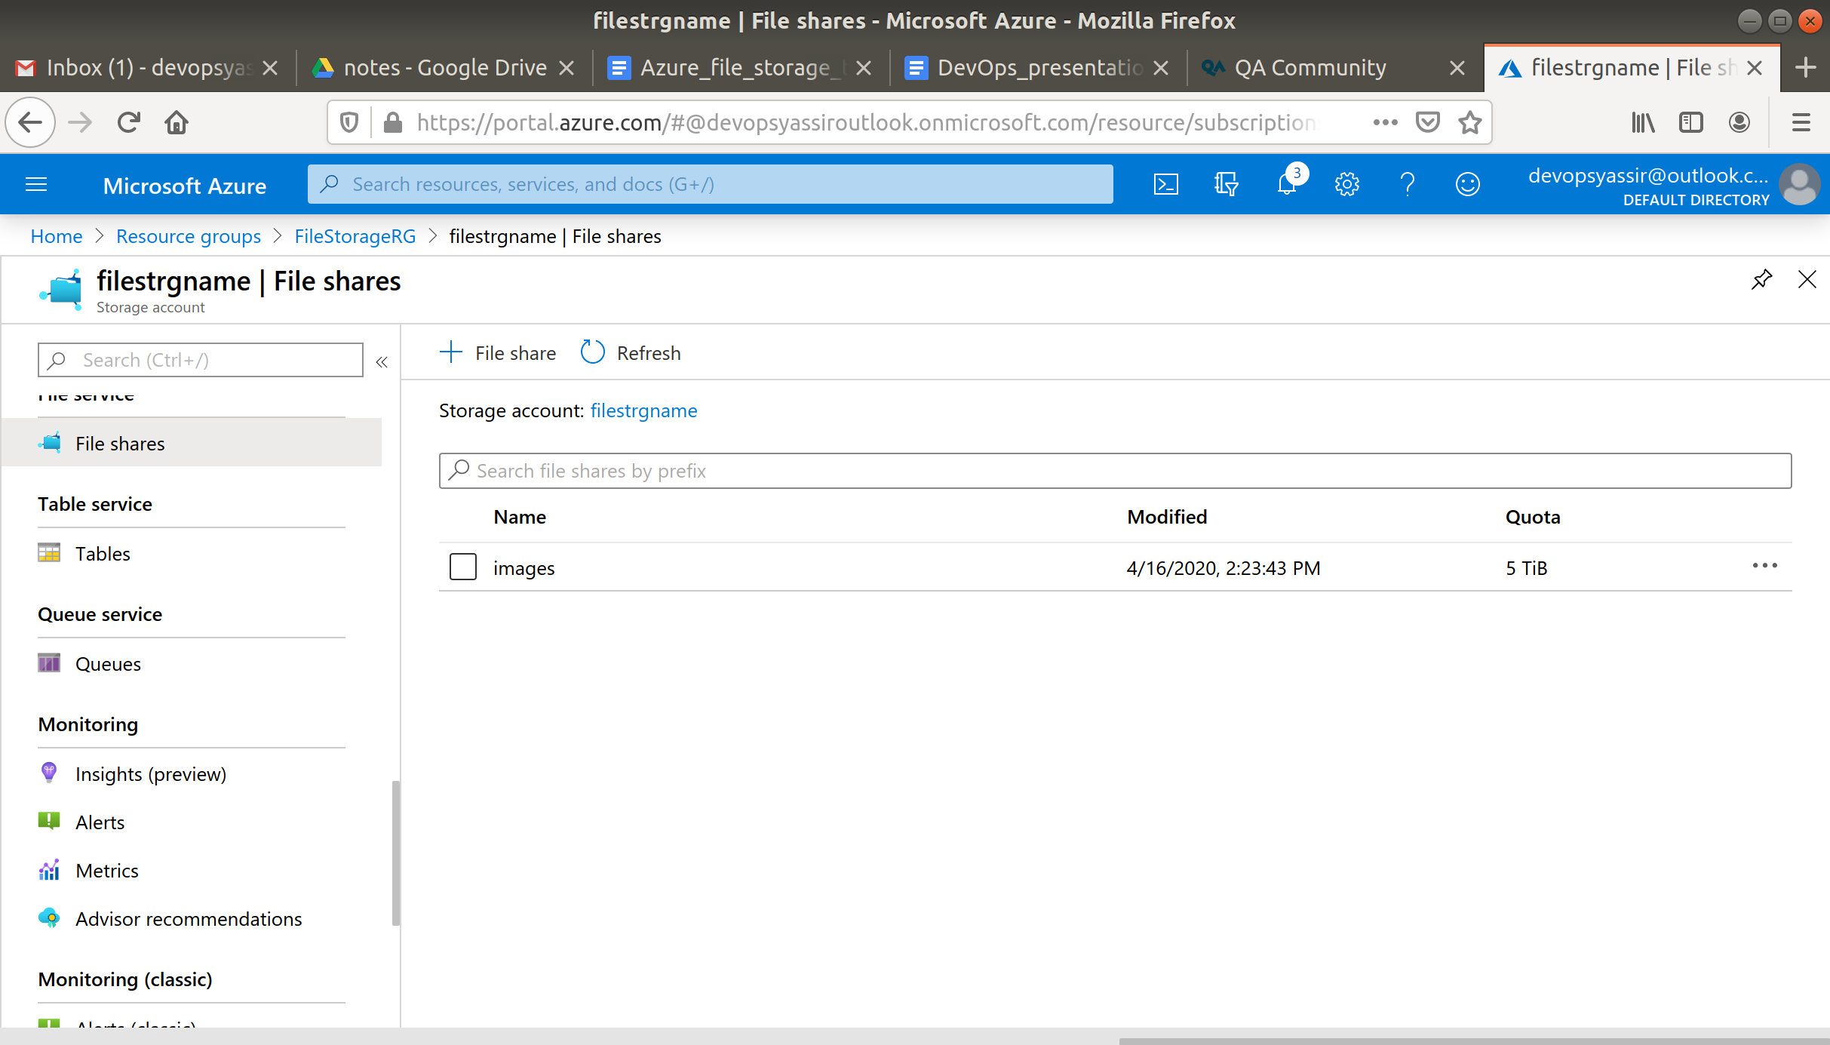

Click on your new file share and select Upload

In the right blade, select a file and select Upload to add to your file share.

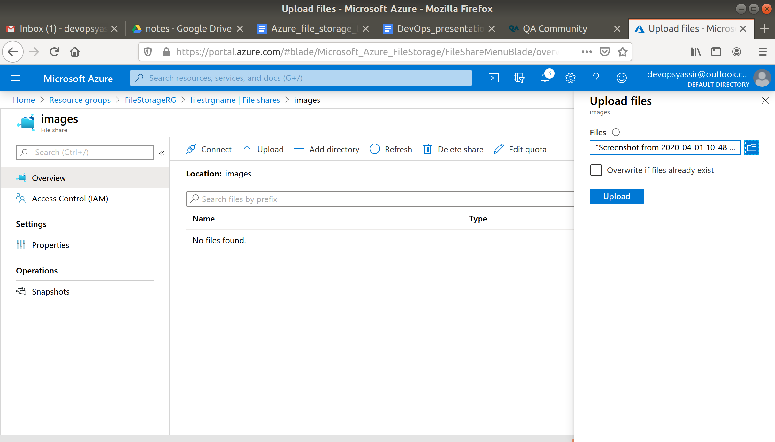

You should be able to see your new file, on the cloud.

