# Azure Resource Groups

## **Tutorial**

In this tutorial we will make use of ARM via tags.

### **New Resource Group**

The first thing is to create a new resource group, which we can do by clicking the burger bar in the top left corner and choosing Resource groups:

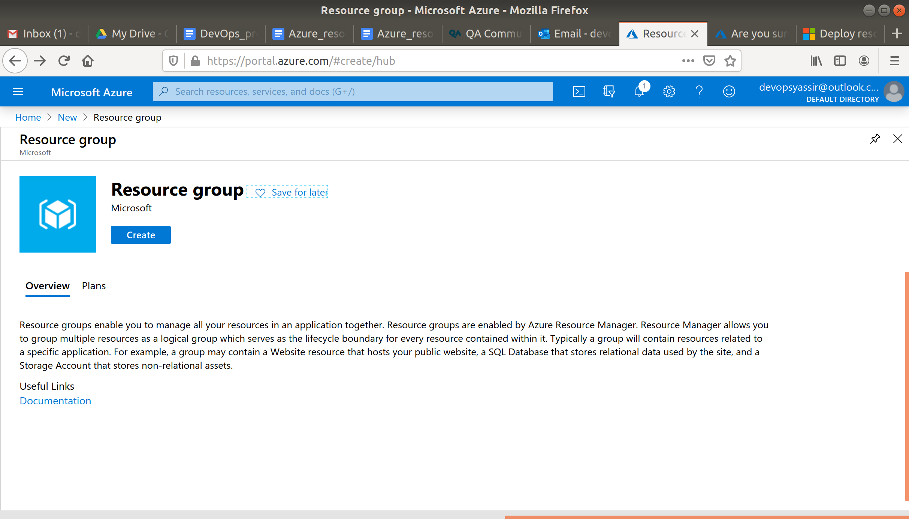

Then, we can click +Add:

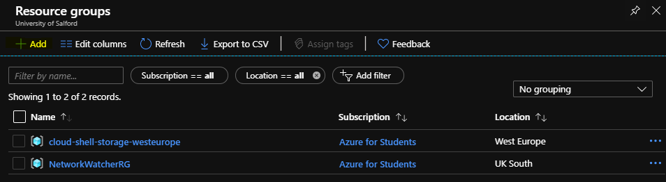

Here, we can name the resource group and pick a location to have it in:

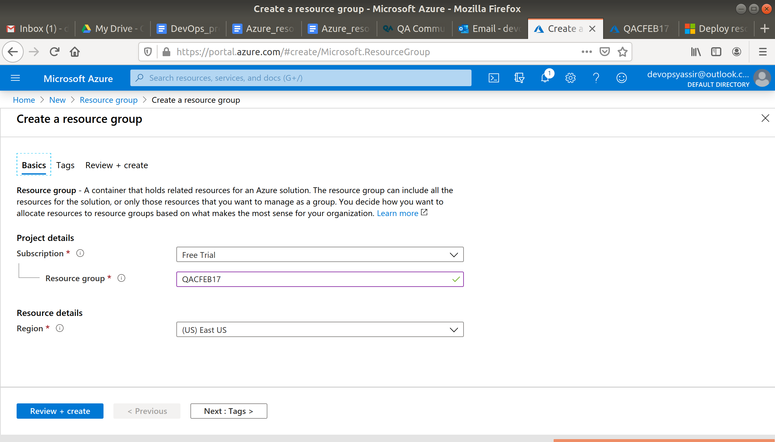

Lastly, we will click Review & Create and then Create to create the resource group:

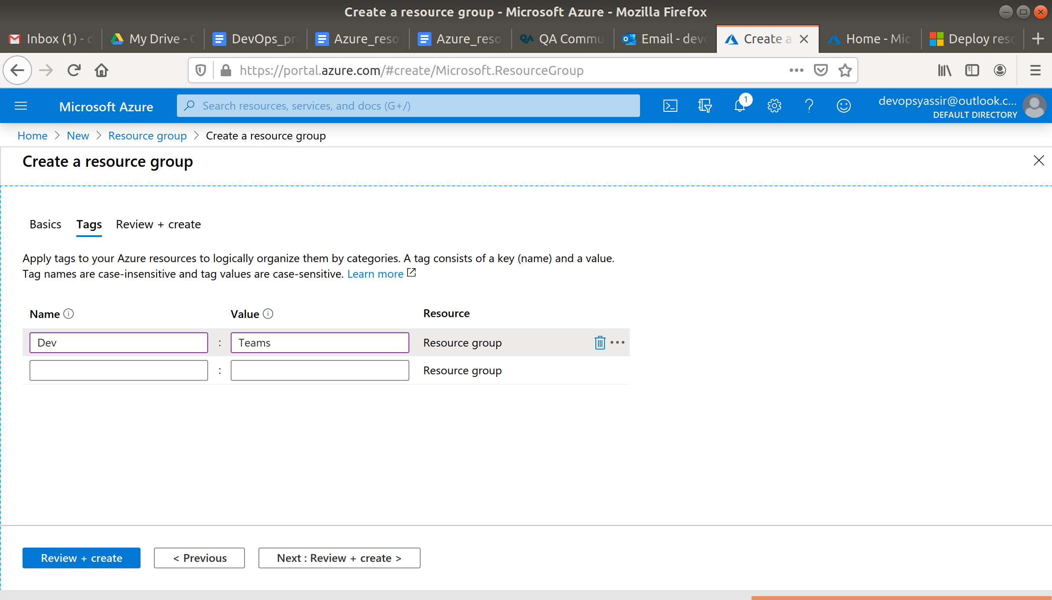

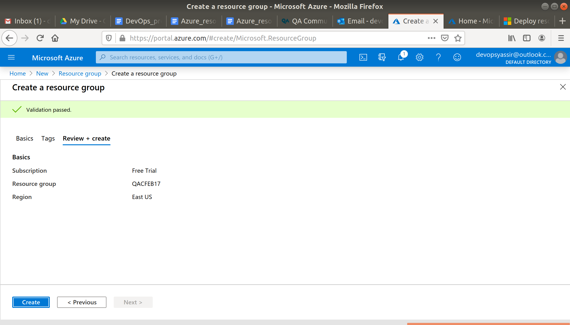

### **New Virtual Machine**

For this, we need to first go to the hamburger menu again, but this time click Virtual machines:

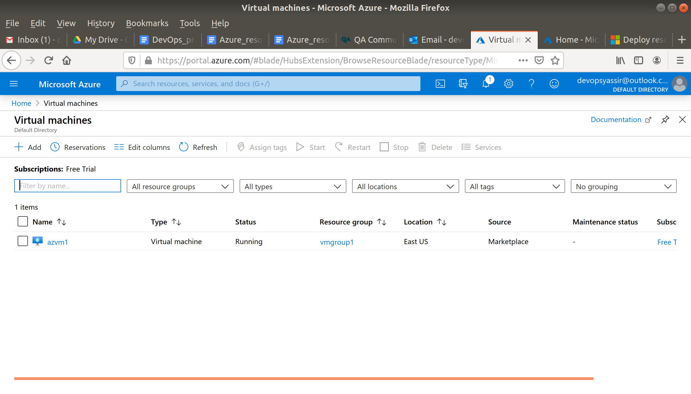

Then, we click + Add:

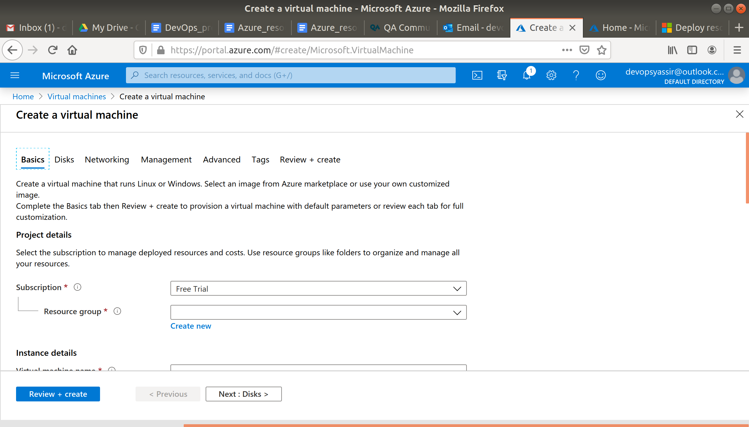

We will need to choose our new resource group from the drop down menu, give the machine a name and pick a region for it to be deployed into.

The image can be Ubuntu Server 18.04 LTS, and the Size can be Standard D2s v3:

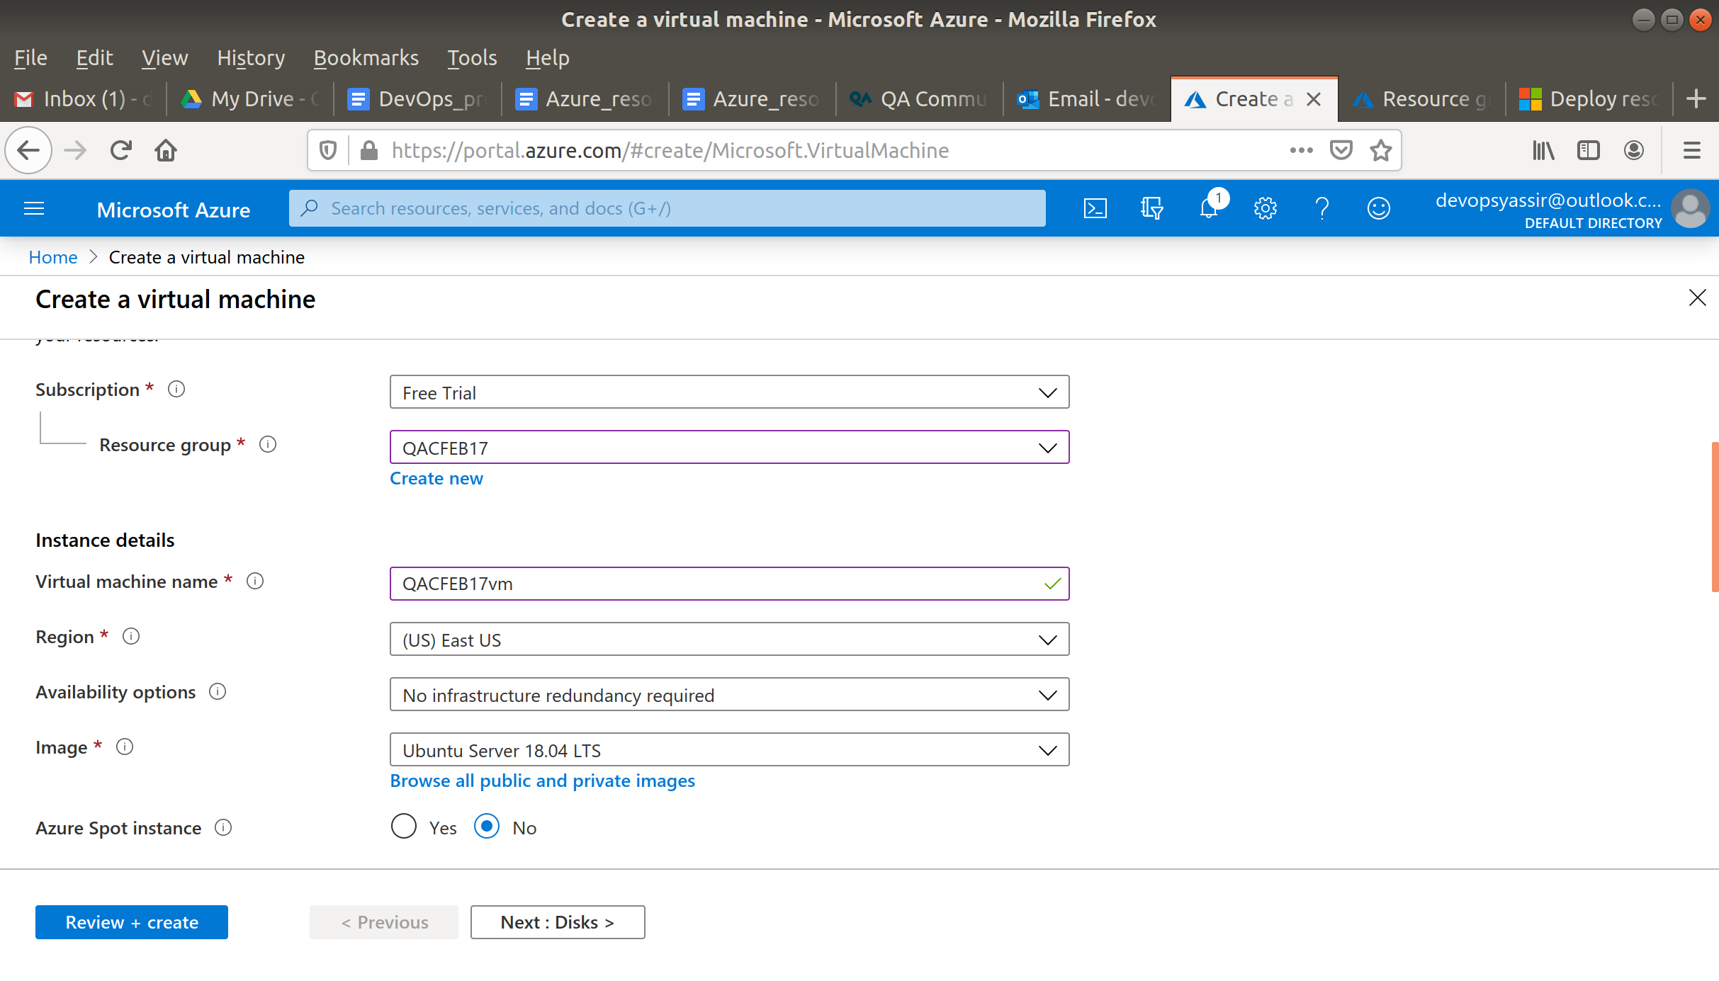

We need to choose password for authentication type, and create a username and password.

We also need to ensure that Port 22 is open, so we can SSH into the machine later (this should be checked by default):

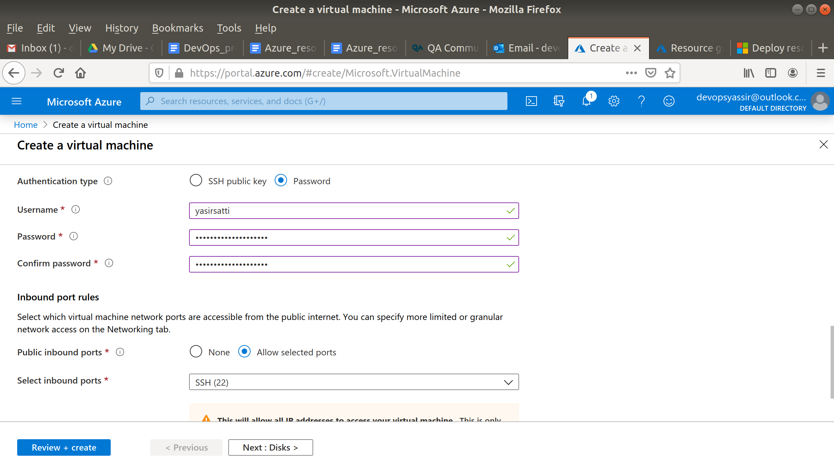

Now click the tags tab and add an Owner tag with the value Luke.



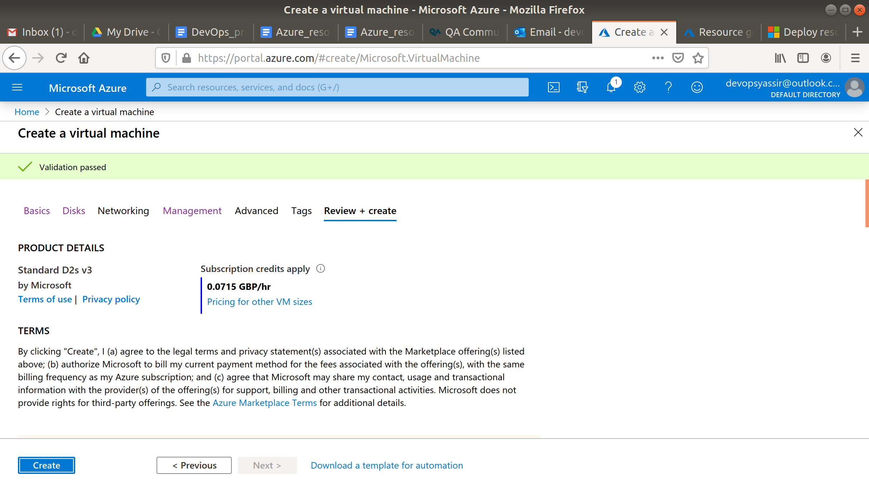

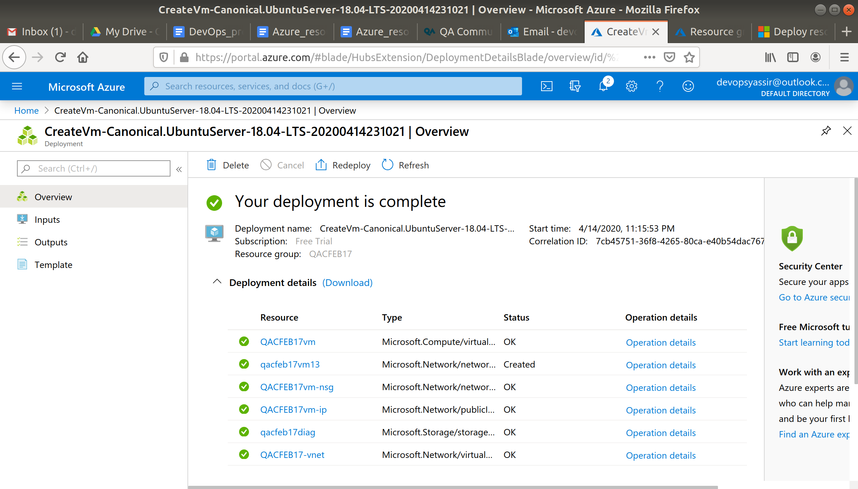

After clicking Create, our Linux VM is created!

### **Second Virtual Machine**

Now repeat the steps to make a virtual machine with a different name.

This time add the Owner tag with a value of Ben.

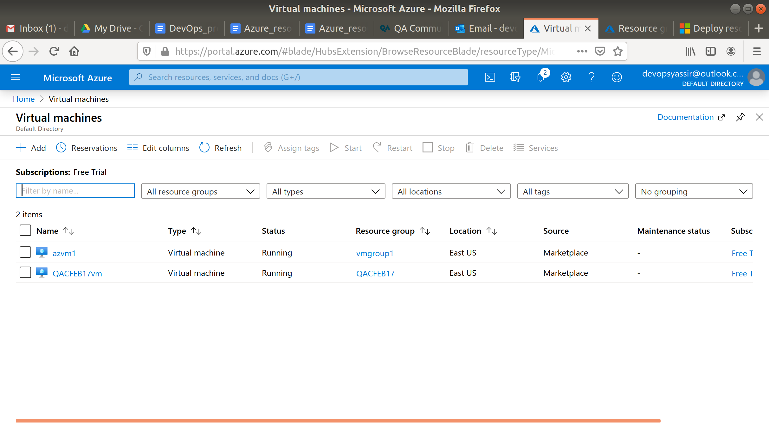

### **Filter**

Normally if we wanted to delete all our resources we would delete the resource group rather than individually delete each resource.

However, we can filter in our resources to show only the ones we are interested in.

Now go to your resources page and click Add Filter.

filter

In the box that appears, type in Owner.

You can then select either Ben or Luke.

If you select one only one vm should appear.

As well as this, we could have filtered resources by location or type.

There are many ways you can use the management tools offered by ARM, and this is just one example of how to organise resources effectively when working in a team.

## **Exercises**

In this task, you are going to leverage a publicly available ARM template to create the infrastructure needed for a web app:

Create a resource group, go to this

<https://azure.microsoft.com/en-gb/resources/templates/101-webapp-basic-windows/>

