# Azure Creating and Configuring Storage Accounts

# 

## **Tutorial**

In this tutorial, we will create a storage account and go through uploading some data to it from the Azure CLI:

1. First, we will create a resource group and put a storage account inside it:

**$ az group create -n storage -l uksouth**

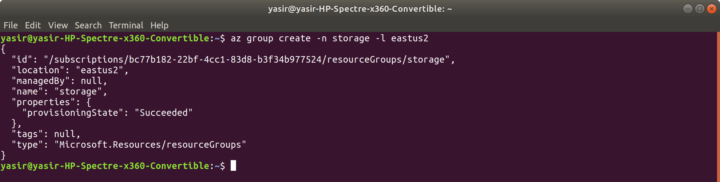

az storage account create -g storage -n <account-name>

<account-name> should be a unique name.

**$ az storage account create -g storage -n azSrtg**

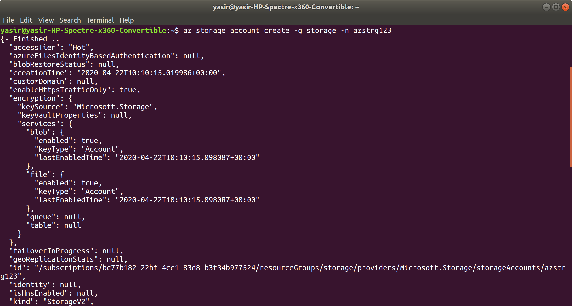

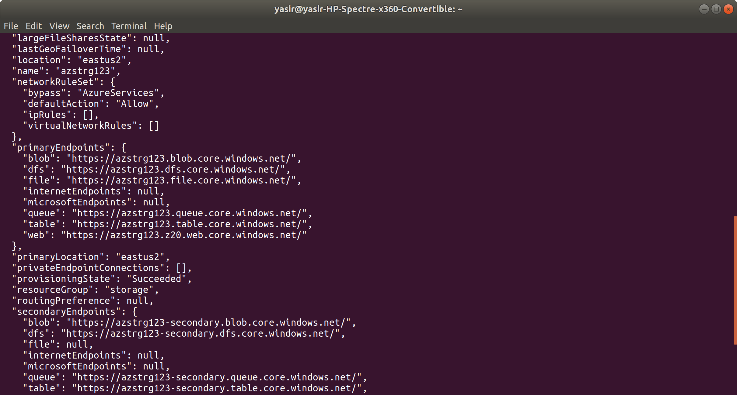

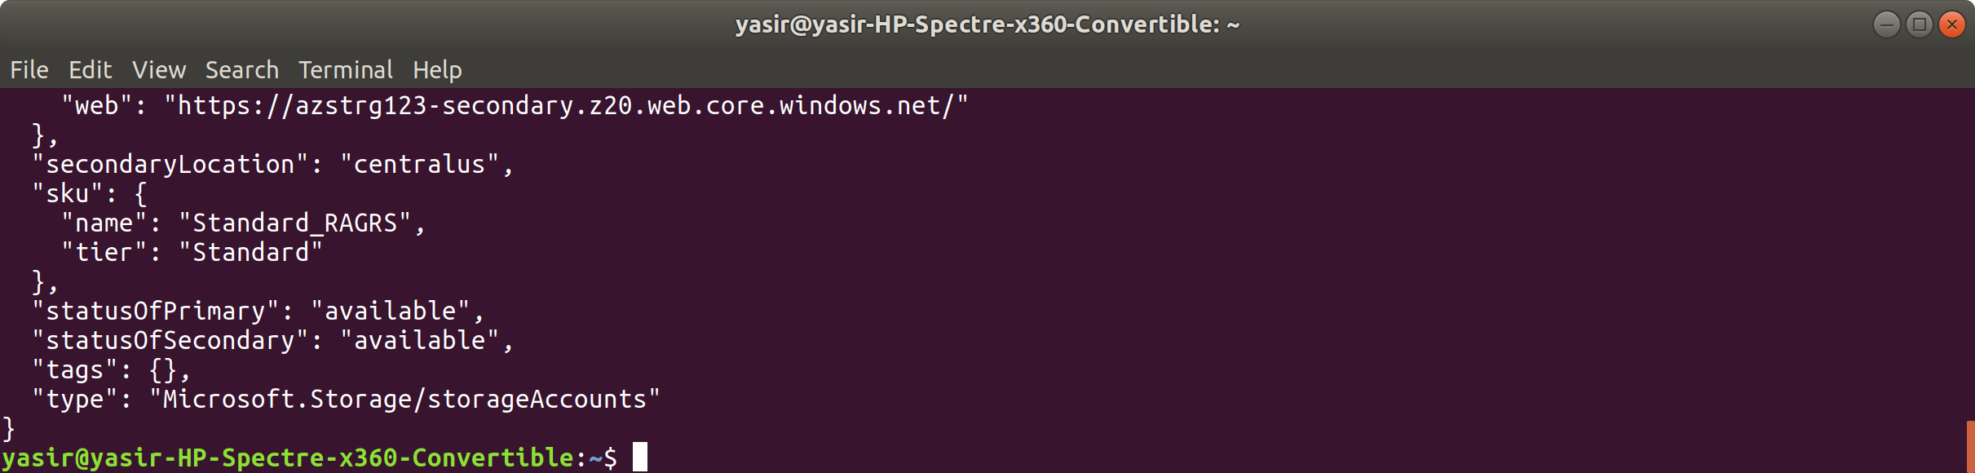

1. Next, we need to set **environment variables** for our storage account name and key. This is because the Azure CLI will need them to authenticate with our storage account:

az storage account keys list --account-name <account-name> -g storage -o table

**$ az storage account keys list --account-name azstrg123 -g storage -o table**

From the output, copy the key1 value and paste it below into <account-key>:

**$ export AZURE_STORAGE_KEY="<account-key>"**

And use your <account-name> for the following:

**export AZURE_STORAGE_ACCOUNT="<account-name>"**

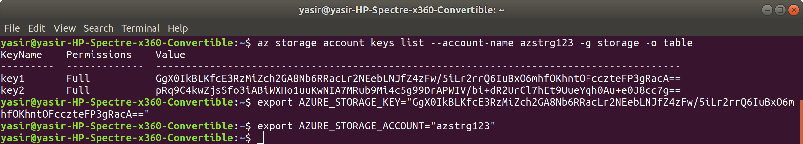

1. We are going to upload a **Blob object**, so for this we must first create a **container**:

**$ az storage container create --name tutorial-container**

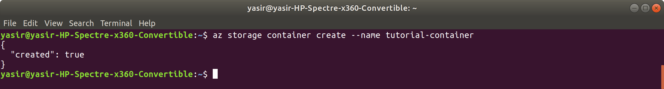

1. Now we need to **create the Blob object**:

**$ cd**

**$ touch hello.txt**

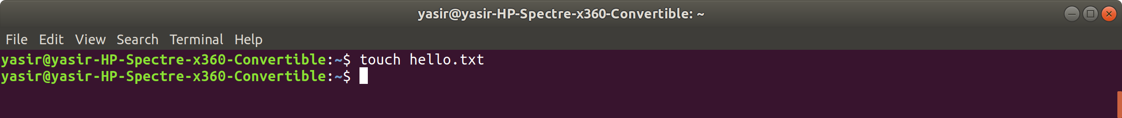

1. Next, **upload the Blob object** to the container:

**$ az storage blob upload --container-name tutorial-container --name hello --file hello.txt**

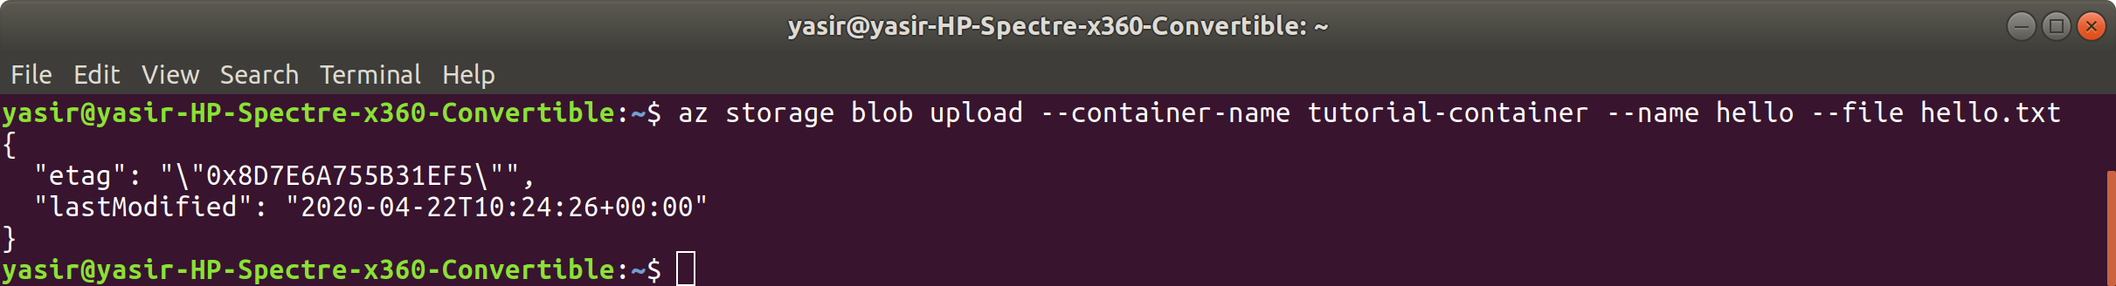

1. To **list the Blobs** in a container

**$ az storage blob list --container-name tutorial-container -o table**

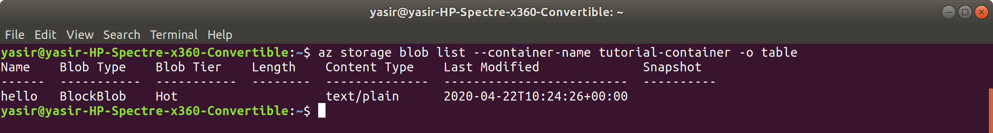

1. To **download** the Blob:

**$ az storage blob download --container-name tutorial-container -n hello -f ~/hello1.txt**

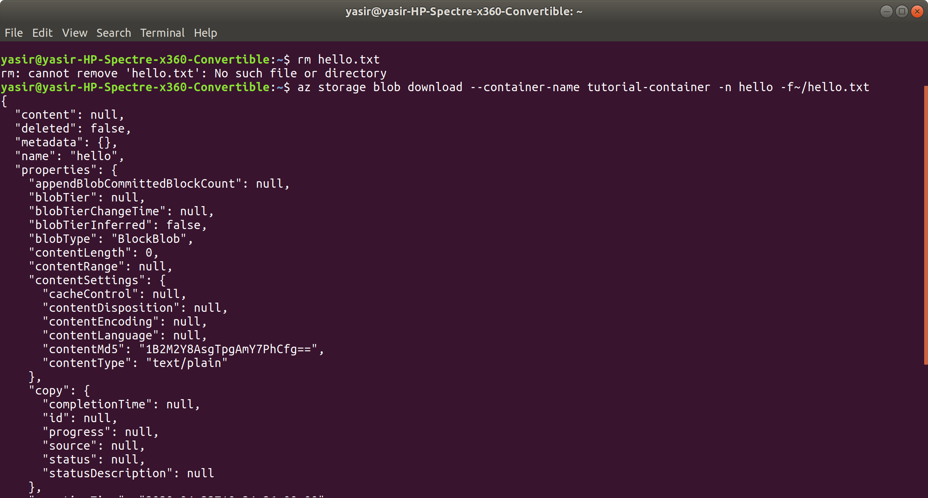

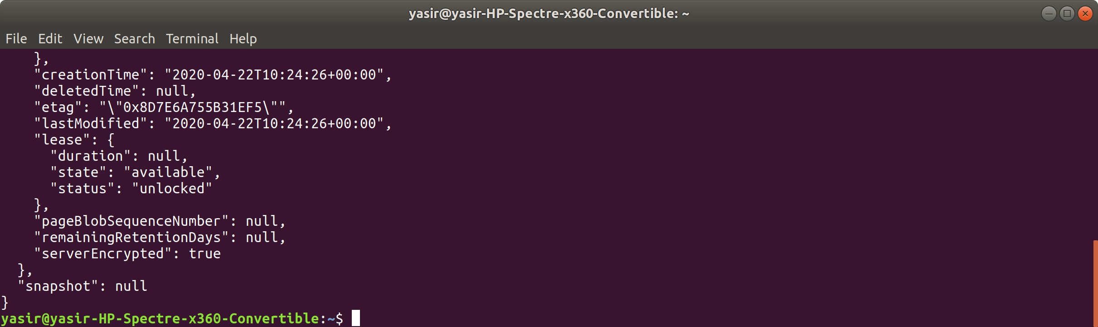

You can use the ls command to see if this has downloaded the file to your home folder.

1. To **delete** the Blob:

**$ az storage blob delete --container-name tutorial-container -n hello**



1. Finally, we can clean up:

**$ az group delete -n storage -y --no-wait**



**cd**

**rm hello.txt**

**rm hello1.txt**

