# Azure Importing and Exporting Data

# 

## **Exercises**

* Go through the process of creating an Export Job in the Azure Portal
* Make sure to delete the job, and all resources used, once you are done with the Exercise.

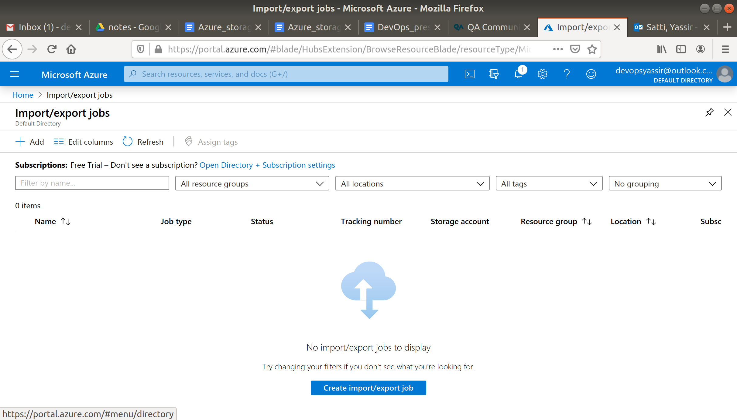

1 - Configure job type:

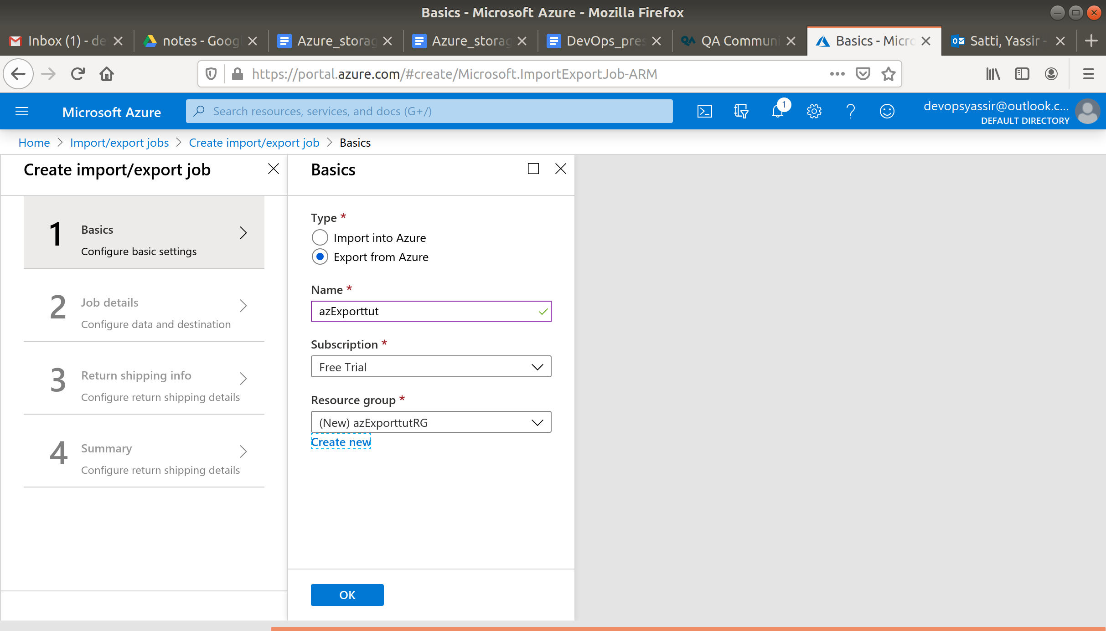

2 - select storage account to export from:

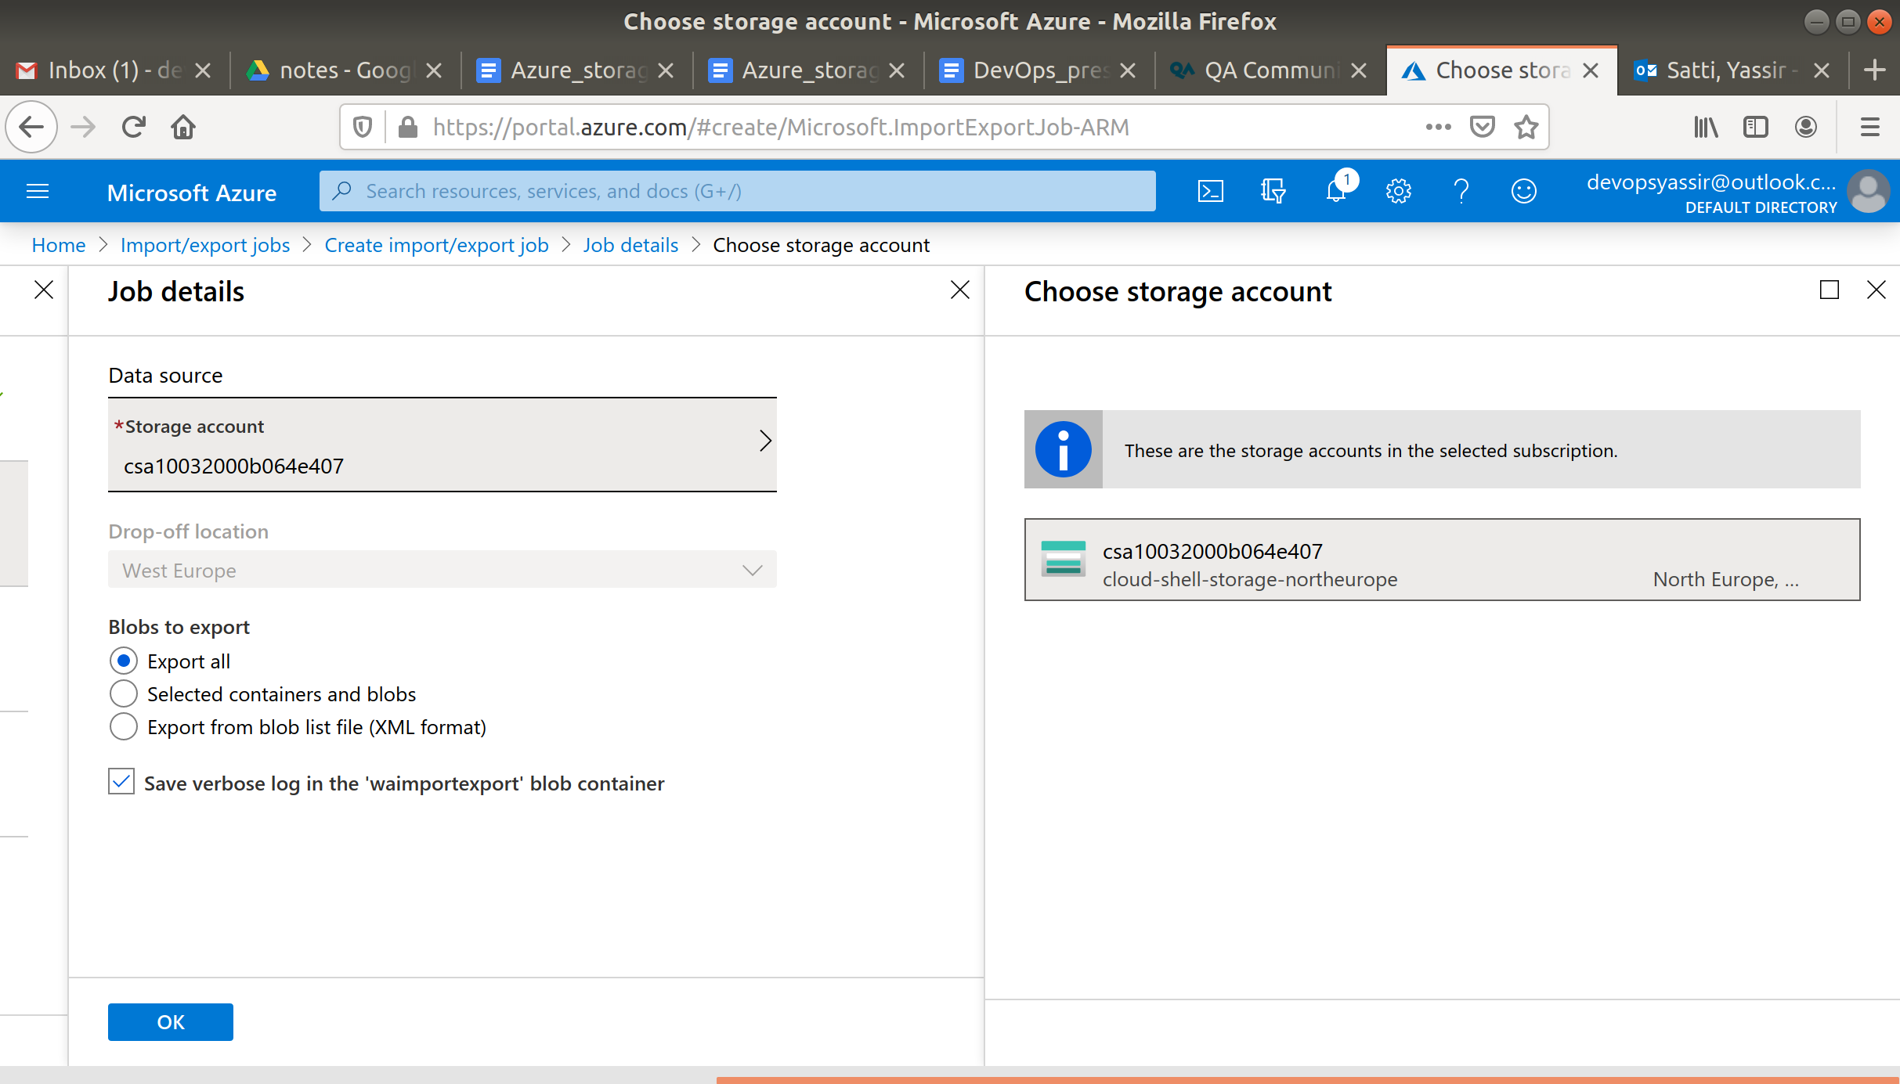

3 - provide return shipping details and address

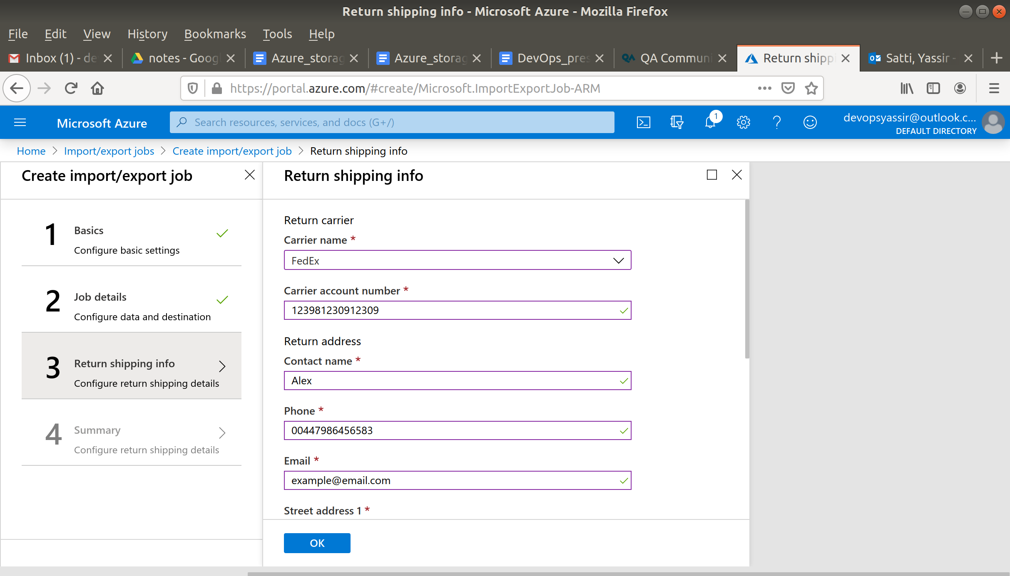

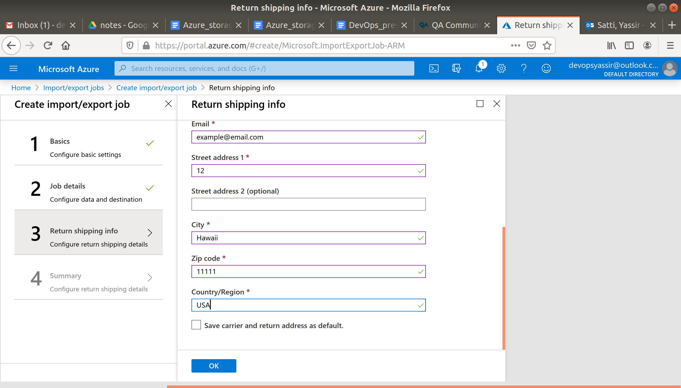

4 - Export job confirmation

