# Docker - compose installation tutorial

Docker Compose installation

**$ sudo apt update**

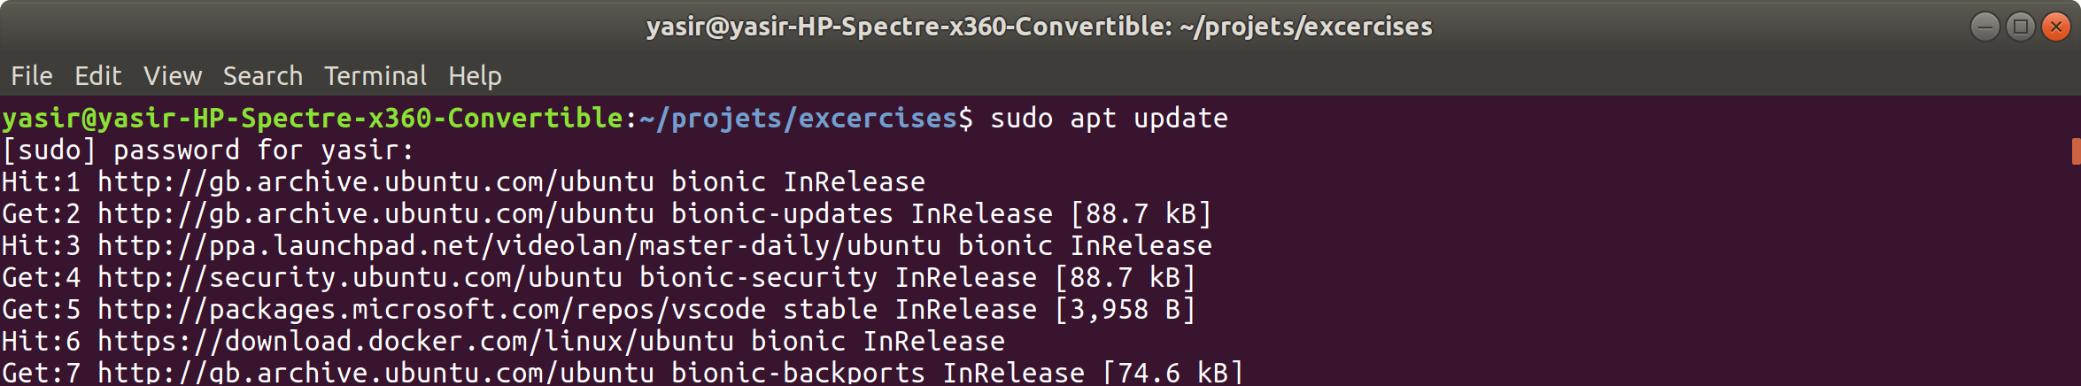

**$ sudo apt install -y curl jq**

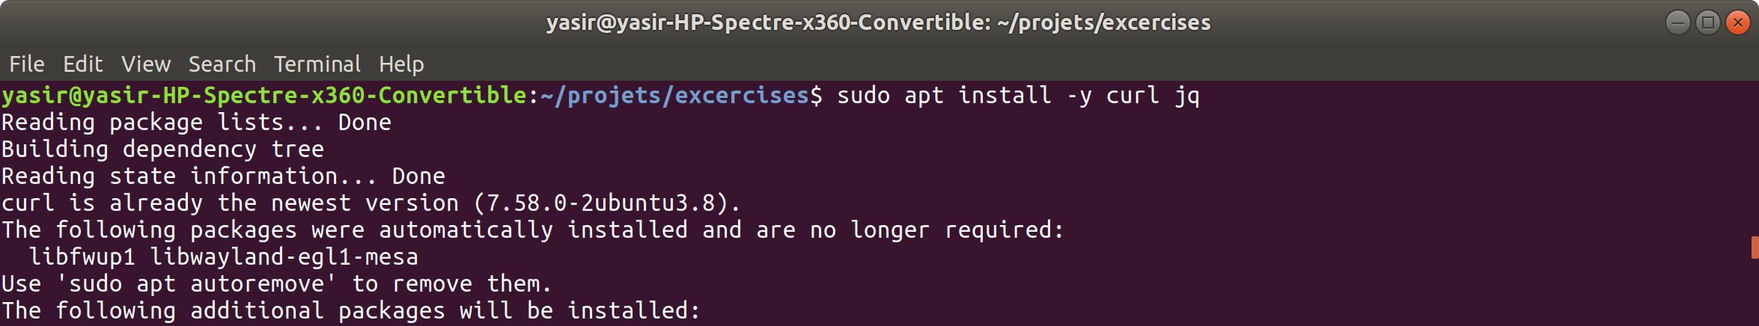

# set which version to download (latest)

**$ version=$(curl -s https://api.github.com/repos/docker/compose/releases/latest | jq -r '.tag_name')**

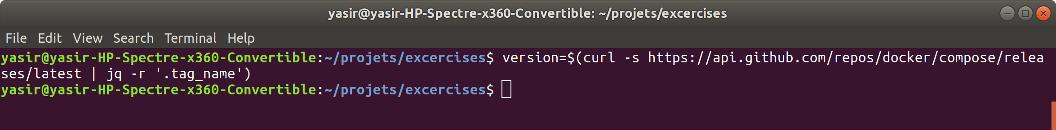

# download to /usr/local/bin/docker-compose

**$ sudo curl -L "https://github.com/docker/compose/releases/download/${version}/docker-compose-$(uname -s)-$(uname -m)" -o /usr/local/bin/docker-compose**

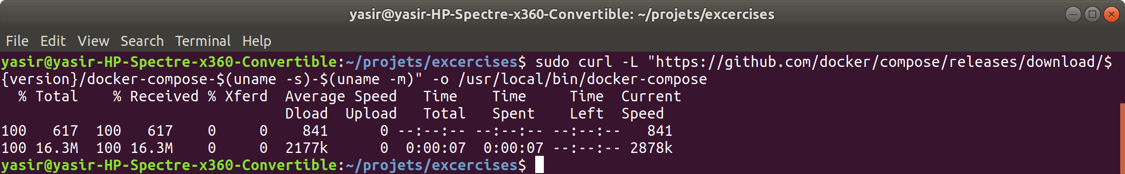

# make the file executable

**$ sudo chmod +x /usr/local/bin/docker-compose**



### **Verify the Installation**

You can check that compose is installed and which version it is by using the --version option:

**$ docker-compose --version**



### **Scaling an NGINX Container**

#### **Step 1: Docker Compose Configuration File**

**$ mkdir docker-compose-scaling-nginx-tutorial && cd $_**



Now create a file called docker-compose.yaml and enter the following:

version: "3.7"

services:

nginx:

image: nginx:alpine

ports:

- target: 80

protocol: tcp



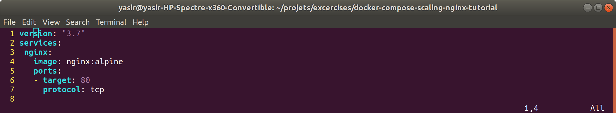

#### **Step 2: Run Your Configuration**

**$ docker-compose up -d**

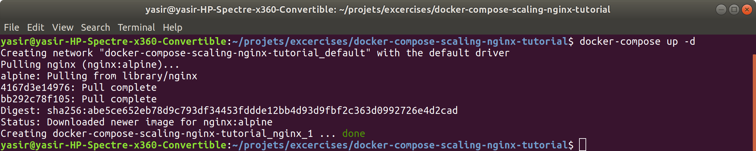

#### **Step 3: View the Running Containers Using Compose**

**$ docker-compose ps**

#### 

#### **Step 4: Access the Application**

**$ curl localhost:32768**

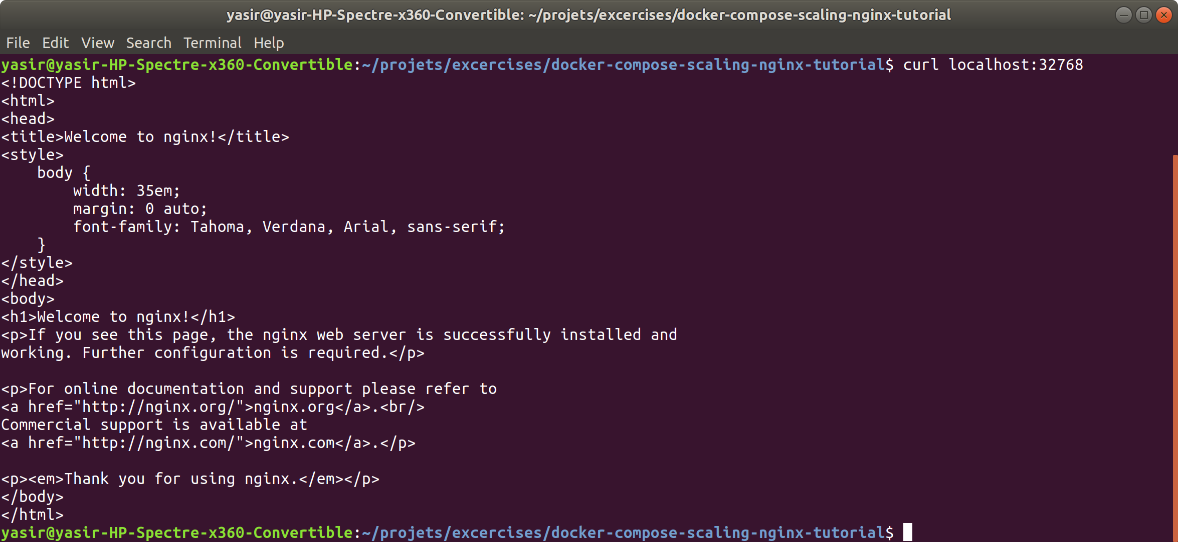

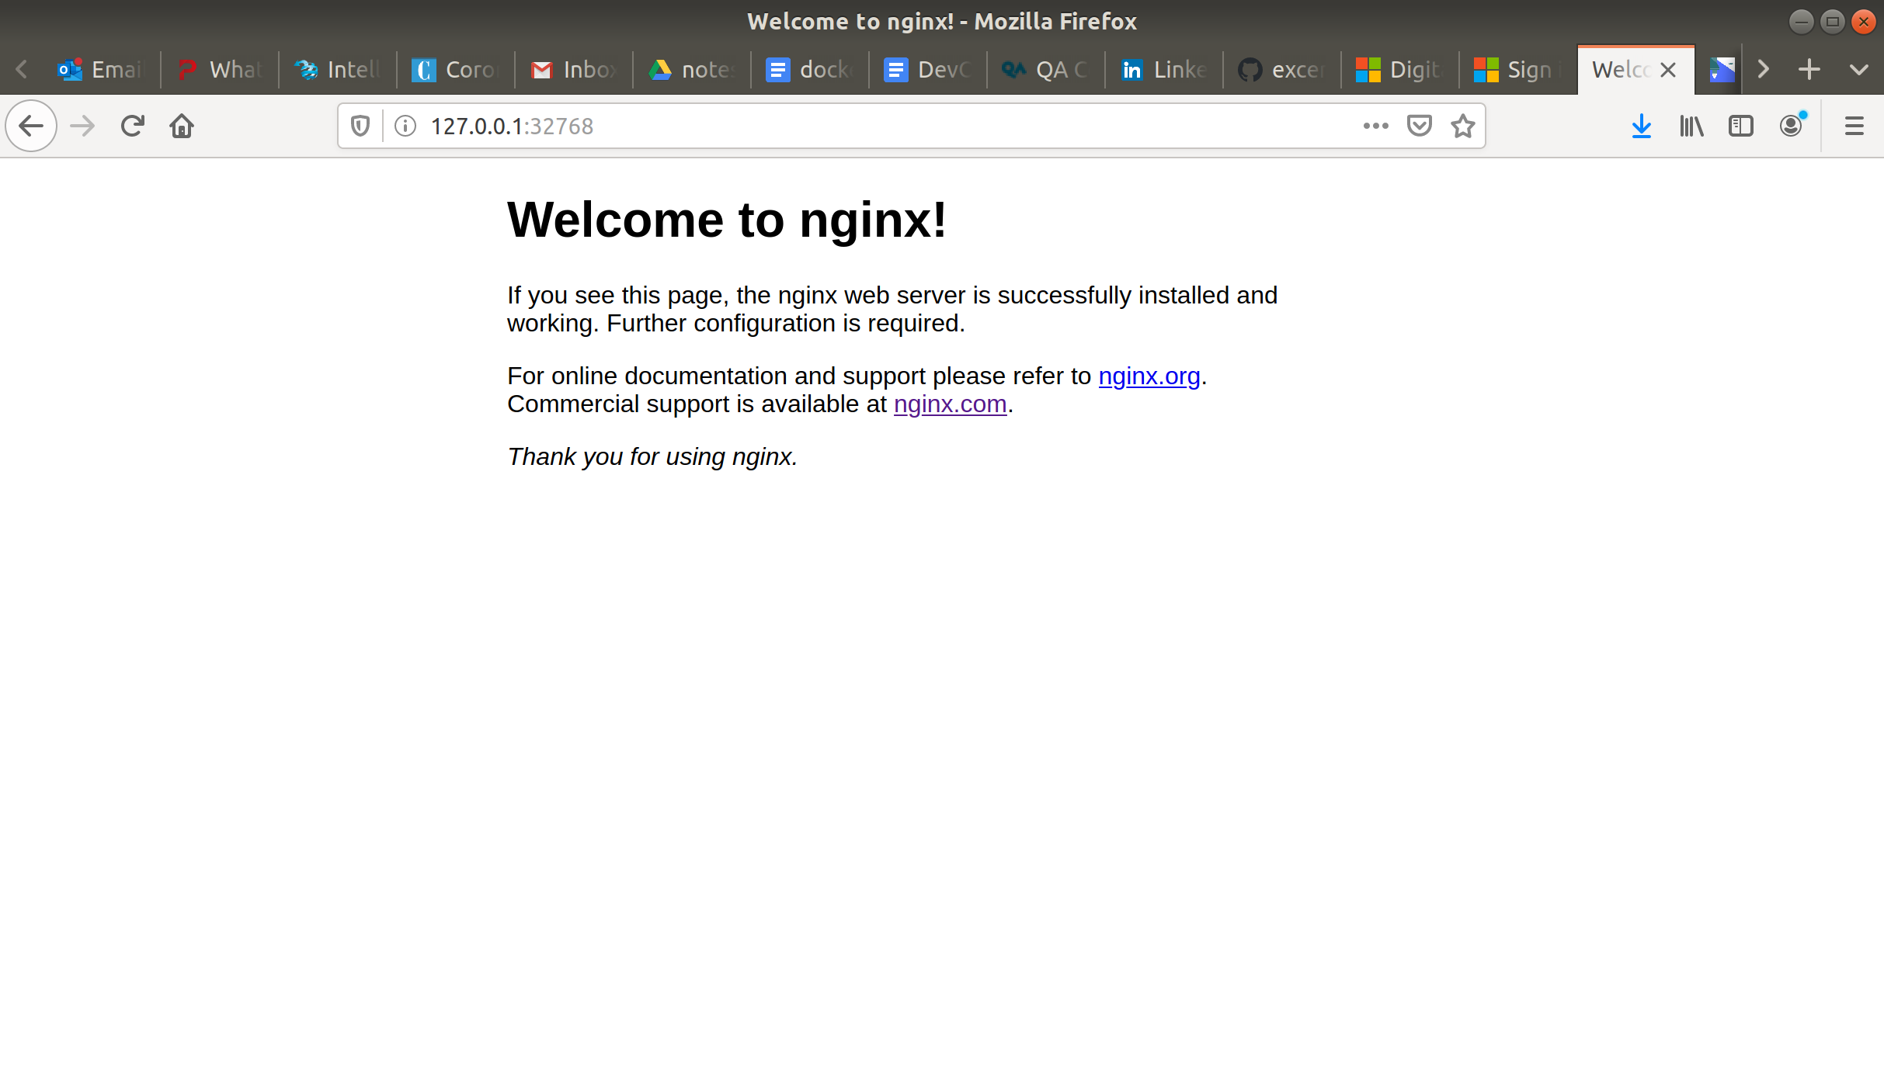

#### **Step 5: Scale Your Application**

**$ docker-compose up -d --scale nginx=3**

#### 

#### **Step 6: Clean Up**

**$ docker-compose down --rmi all**

