# Docker - bind mount exercise

Using another image, create a script and a bind mount that will save the script in the container. Run that script inside the container.

Using my individual project



run the container

**$ docker run -d -p 5000:5000 --name actdiary --mount type=bind,source=/home/$(whoami)/projets/excercises/docker/bind_mounts_script_exercise/home.html,target=/etc/actdiary/application/templates/home.html actdiary**

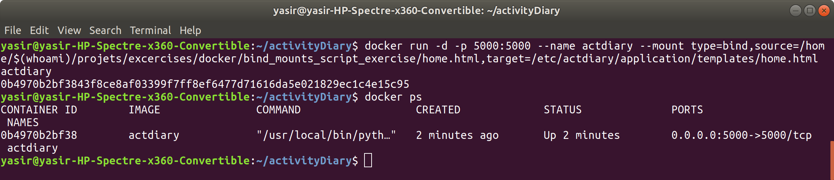

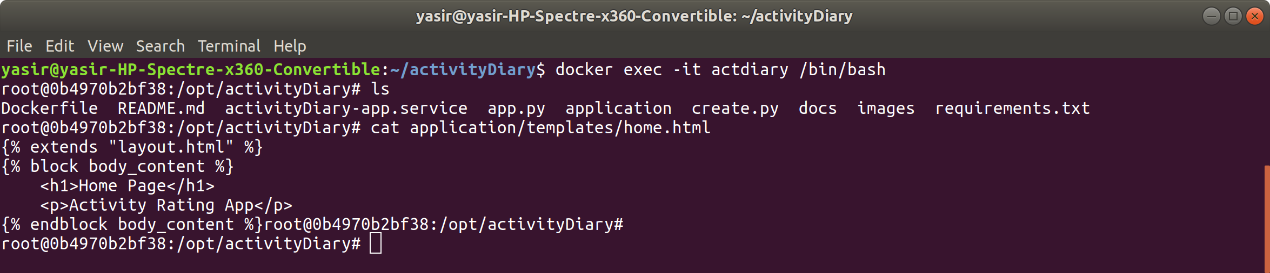

after inspecting Dockerfile discovered the working directory is /opt/activityDiary

so need to change the target when creating the container

stopped and removed the container

created the container again

did curl on localhost:5000

also web browser

