# Docker - bind-mount tutorial

This exercise will get you to create a custom configuration for NGINX on your host machine and then override the default configuration for NGINX running in a container by using a bind mount of the configuration file.

**Step 1: Creating a directory**

Create a new directory called bind_mounts_exercise, the command for this is:

**$ mkdir bind_mounts_exercise**

Change to the new directory by executing:

**$ cd bind_mounts_exercise**



**Step 2: Creating configuration file**

Create NGINX configuration file called nginx.conf, the command for this is:

**$ touch nginx.conf**

Place the following in the configuration file, to keep the formatting try using **SHIFT+INSERT**:

events {}

http {

server {

listen 80;

location / {

return 200 "NGINX";

}

}

}

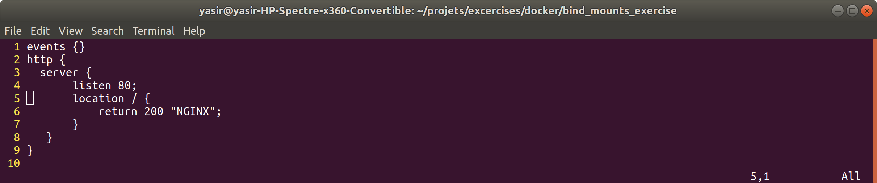

**Step 3: Run the NGINX container**

Run the NGINX container, mapping port 80 and override the existing NGINX configuration file with the one you created.

The command for this is:

**$ docker run -d -p 80:80 --name nginx --mount type=bind,source=$(pwd)/nginx.conf,target=/etc/nginx/nginx.conf nginx**

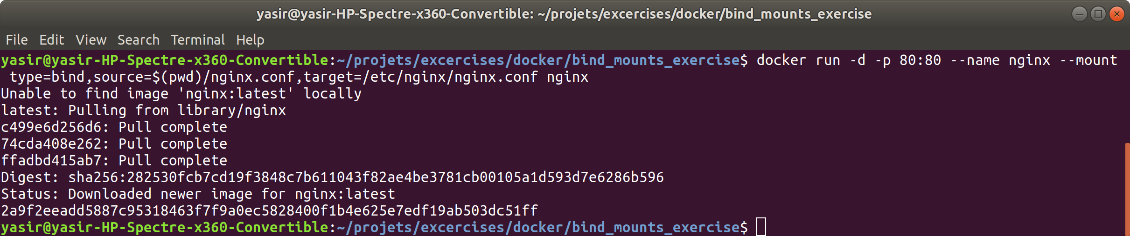

**Step 4: Checking it works**

There are two ways how you can check whether it works:

1. Execute the following command:

**$ curl localhost:80**

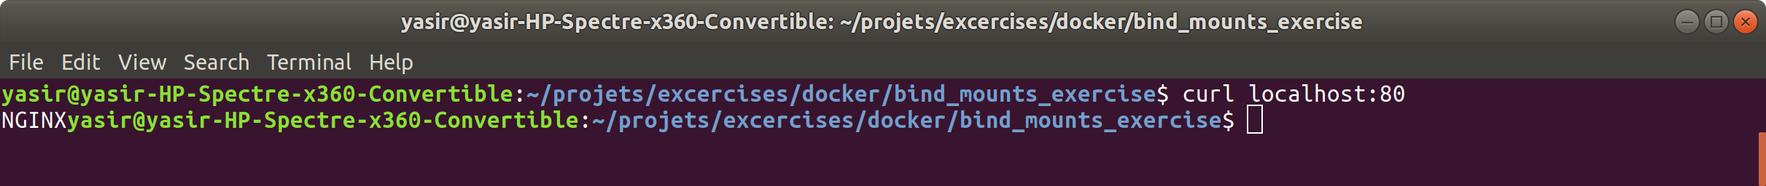

You should see the highlighted text printed on the terminal:

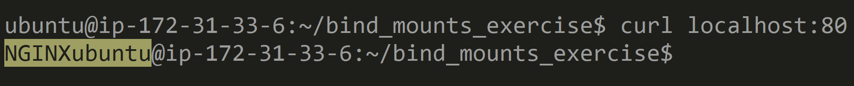

1. Second way is by navigating your browser to localhost:80 and you should see the following:



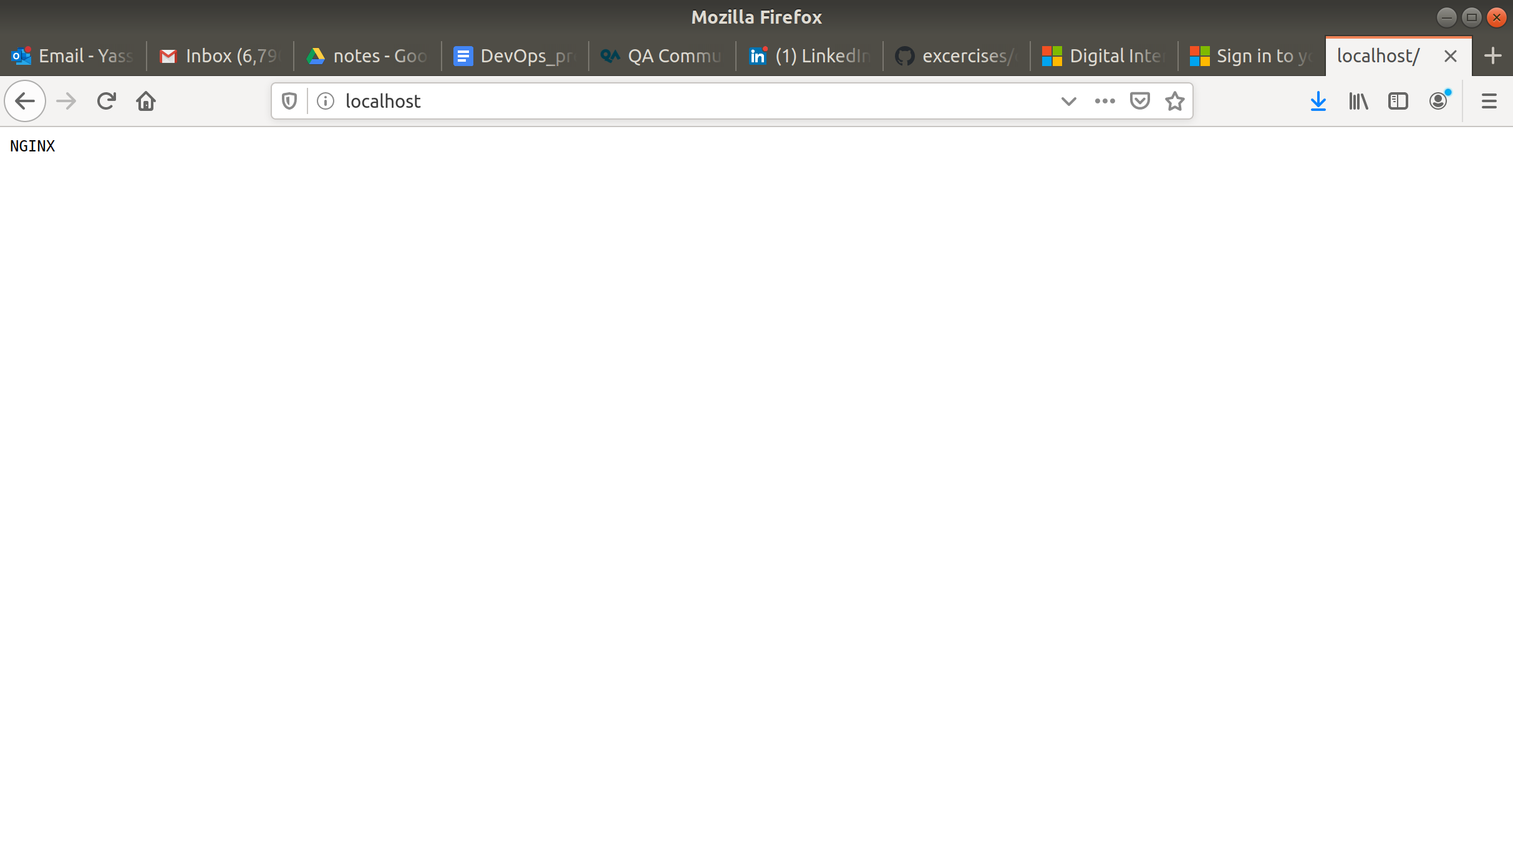

**Step 5: Stop container**

Stop the container by executing:

**$ docker stop nginx**

**Step 6: Step Remove container**

Remove container by executing:

**$ docker rm nginx**

**Step 7: Remove NGINX image**

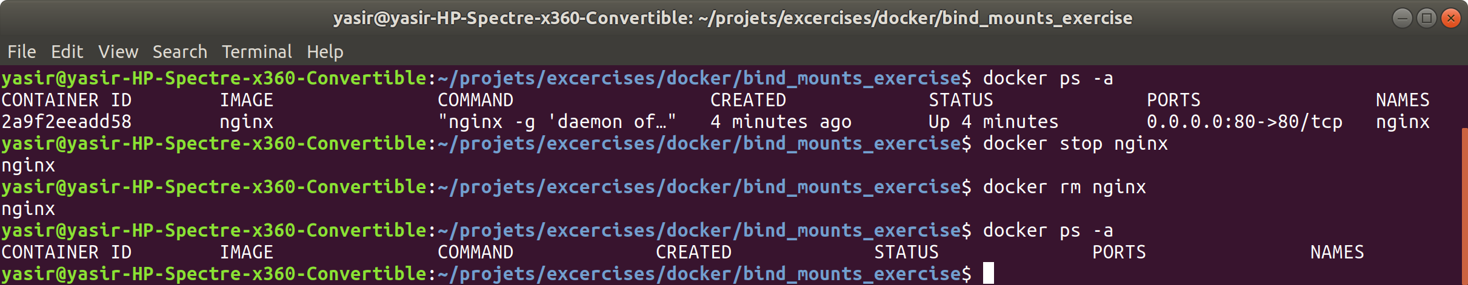

Remove NGINX image by executing:

**$ docker rmi nginx**

I use it alot for tutorials, so i will keep it

## 