# Docker - Compose Configuration Exercise

Make use all the different configurations in this module to write a docker compose yaml file that will spin up these 3 services and allow them to work with each other. [Trio Task](https://gitlab.com/qacdevops/trio-task)

<https://hub.docker.com/_/mysql>

<https://stavshamir.github.io/python/dockerizing-a-flask-mysql-app-with-docker-compose/>

<https://phoenixnap.com/kb/mysql-docker-container>

<https://medium.com/better-programming/customize-your-mysql-database-in-docker-723ffd59d8fb>

<https://github.com/lindycoder/prepopulated-mysql-container-example/blob/master/Dockerfile>

Create directories and files

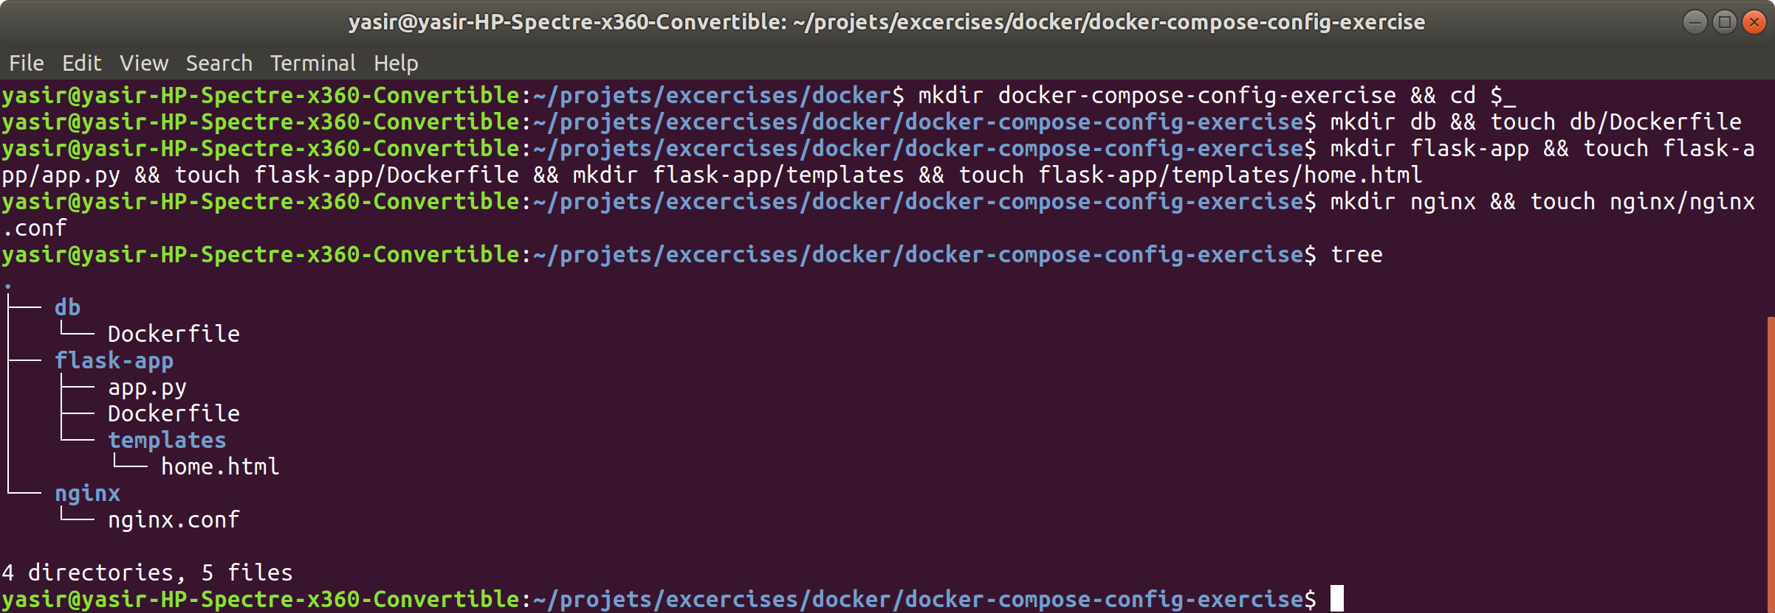

Configure the Nginx service



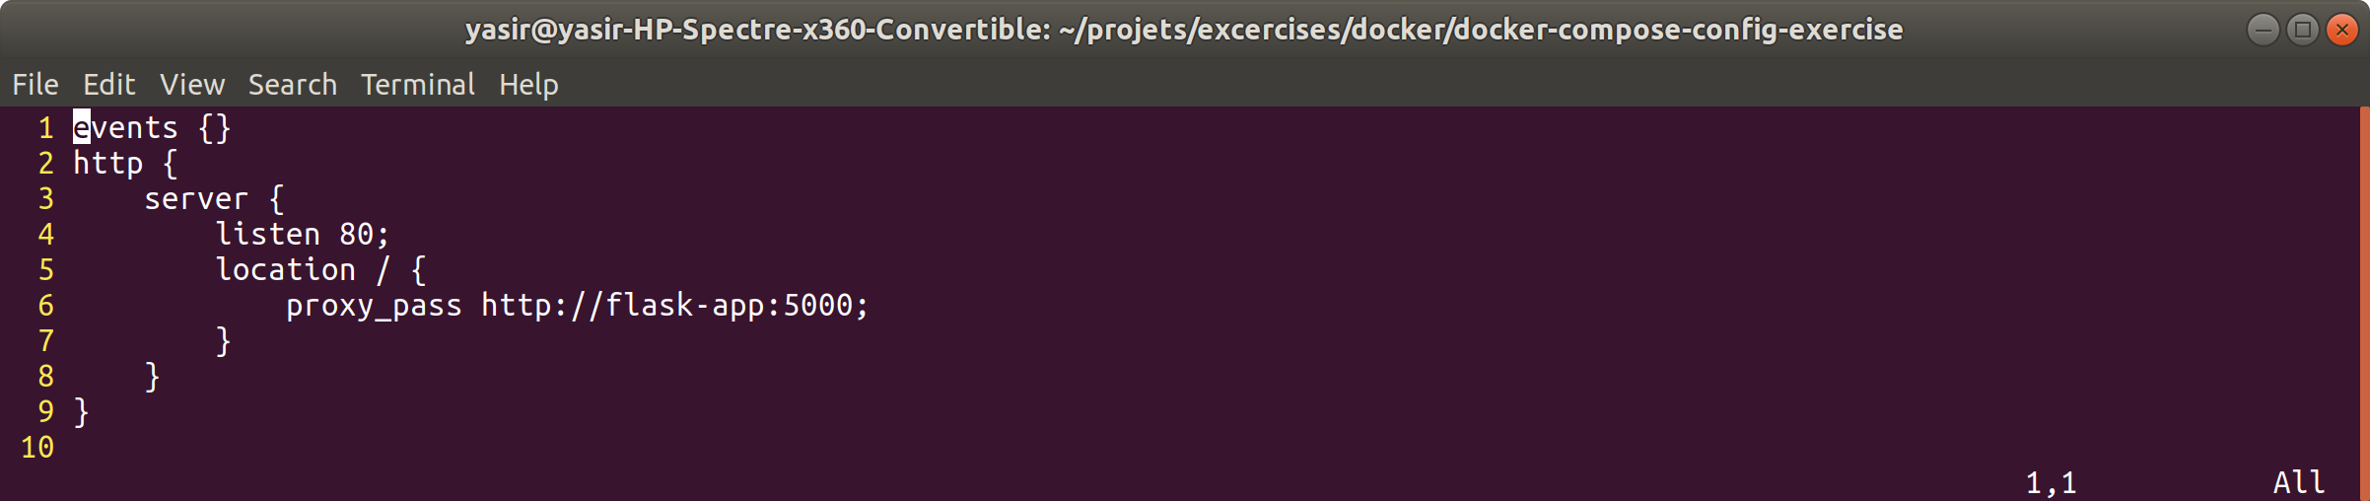

Configure the app



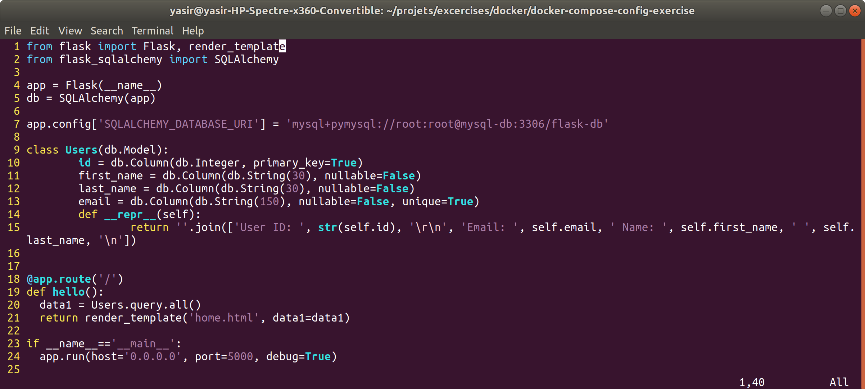

create home.html file

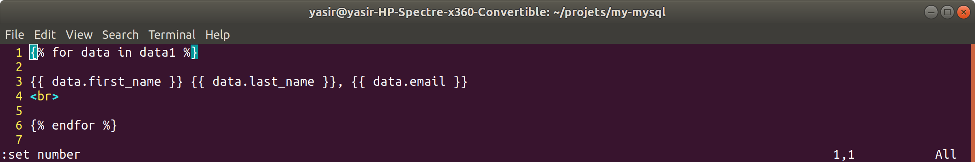

Setup app Dockerfile

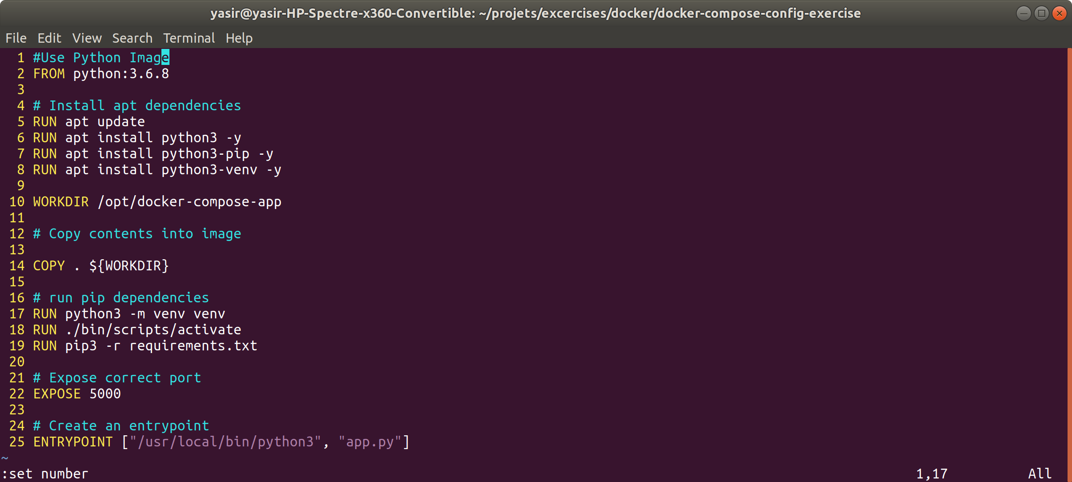

Setup db Dockerfile

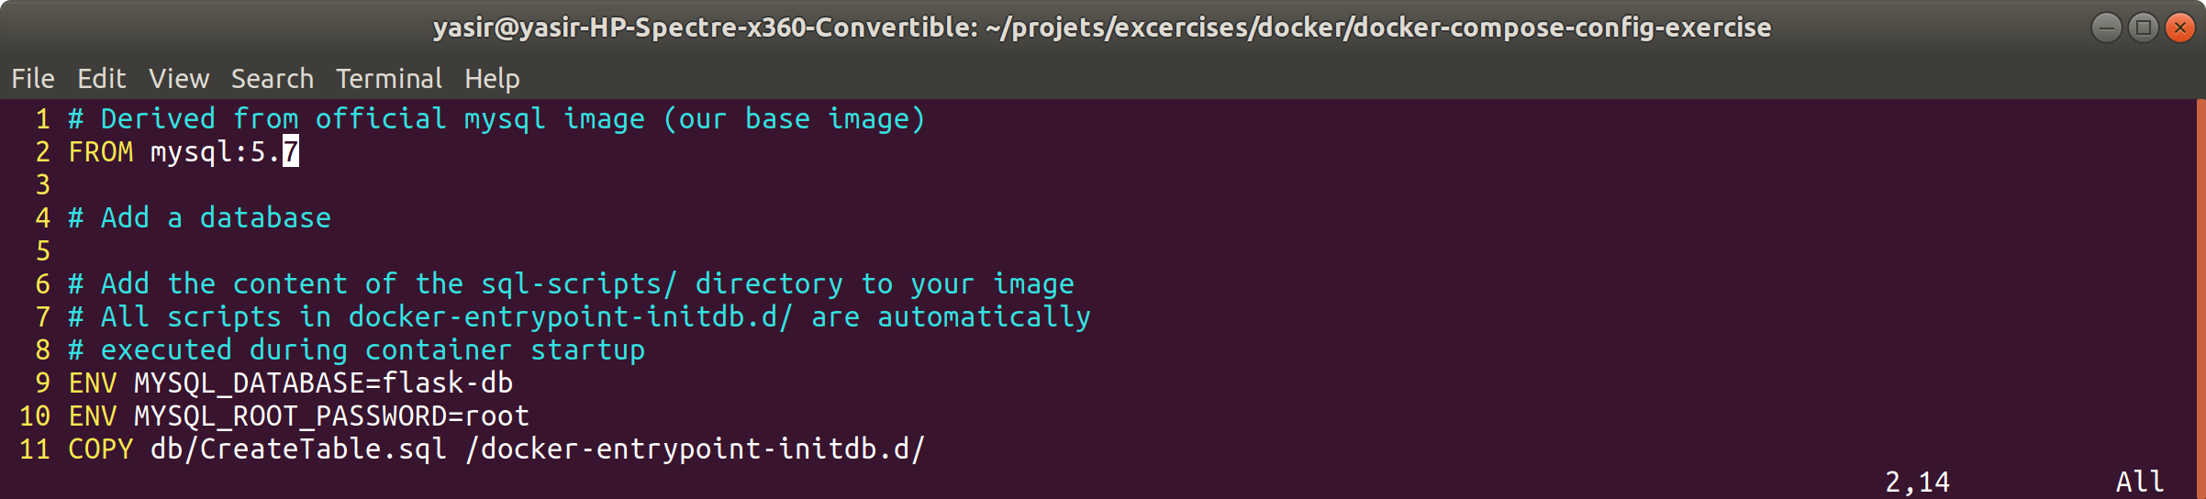

Create table file

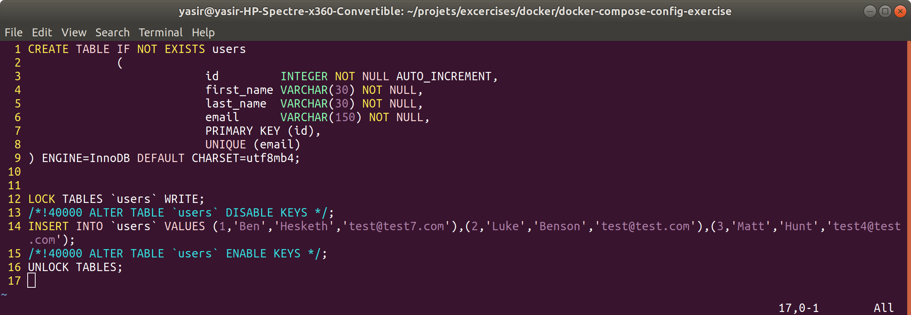

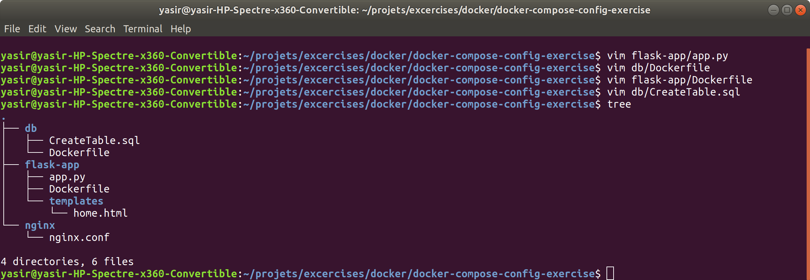

Configure docker-compose.yaml

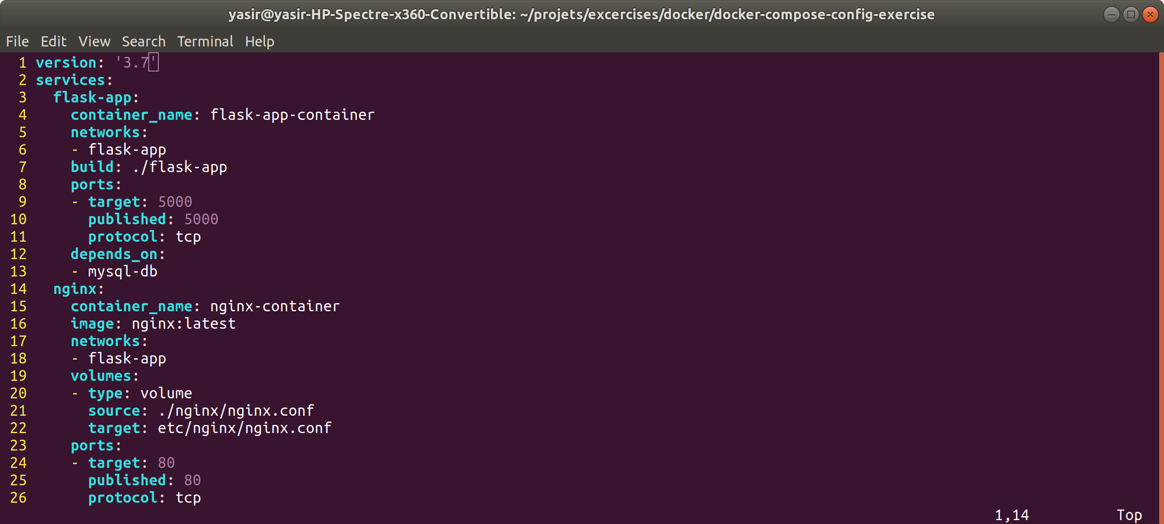

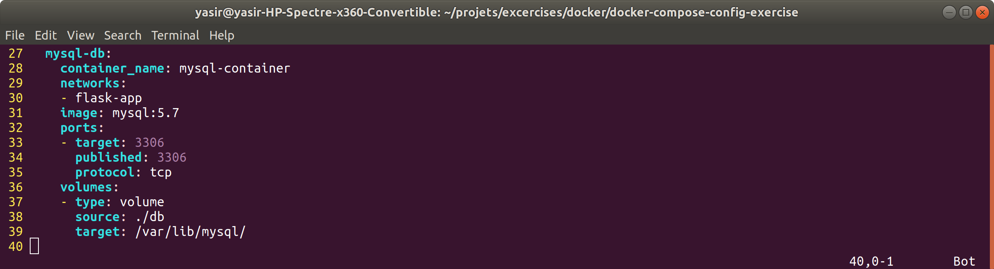

**$ docker-compose up -d**

