# Docker - Stretch goal

Get your app running in a docker container.

**app tested and running**

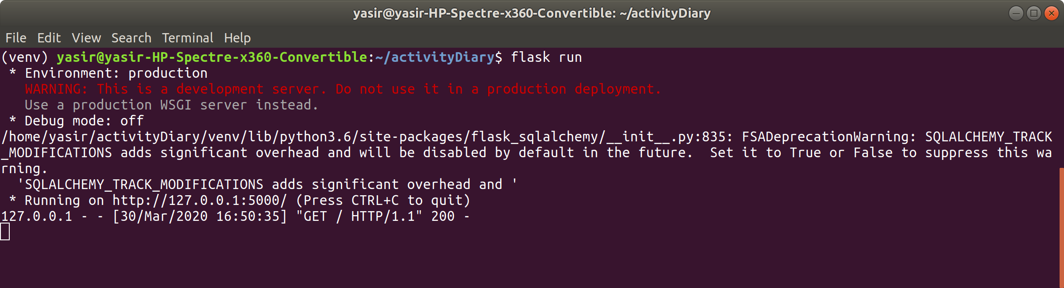

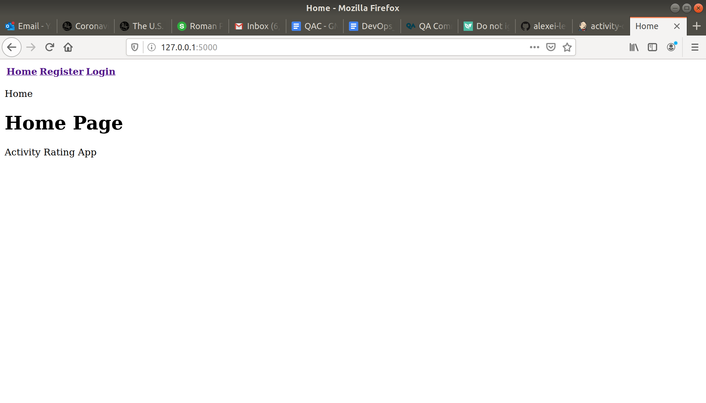

**create Dockerfile**

version 1.0 (failed!)

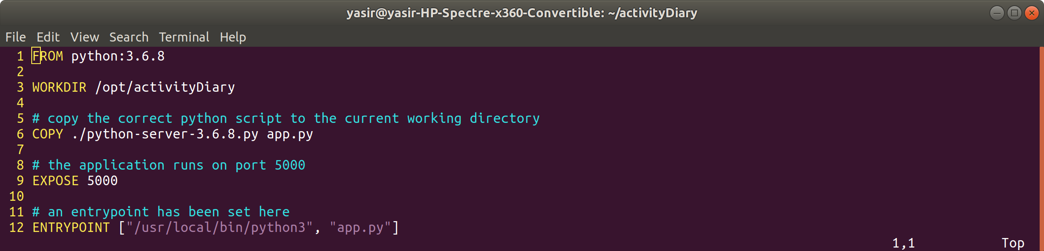

version 1.1 (failed!)

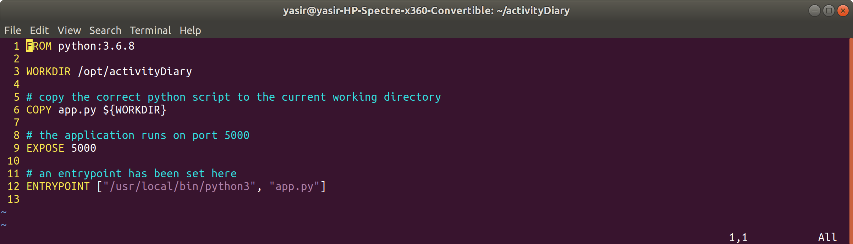

version 1.2 (success!!)

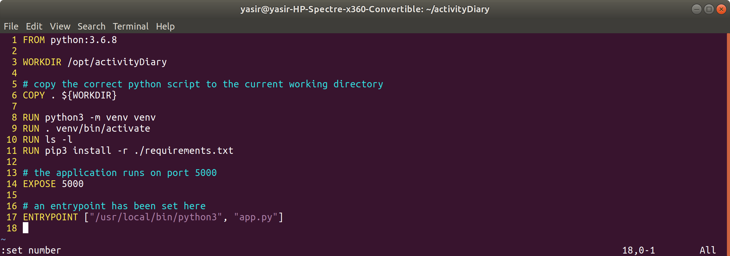

**create .dockerignore file**

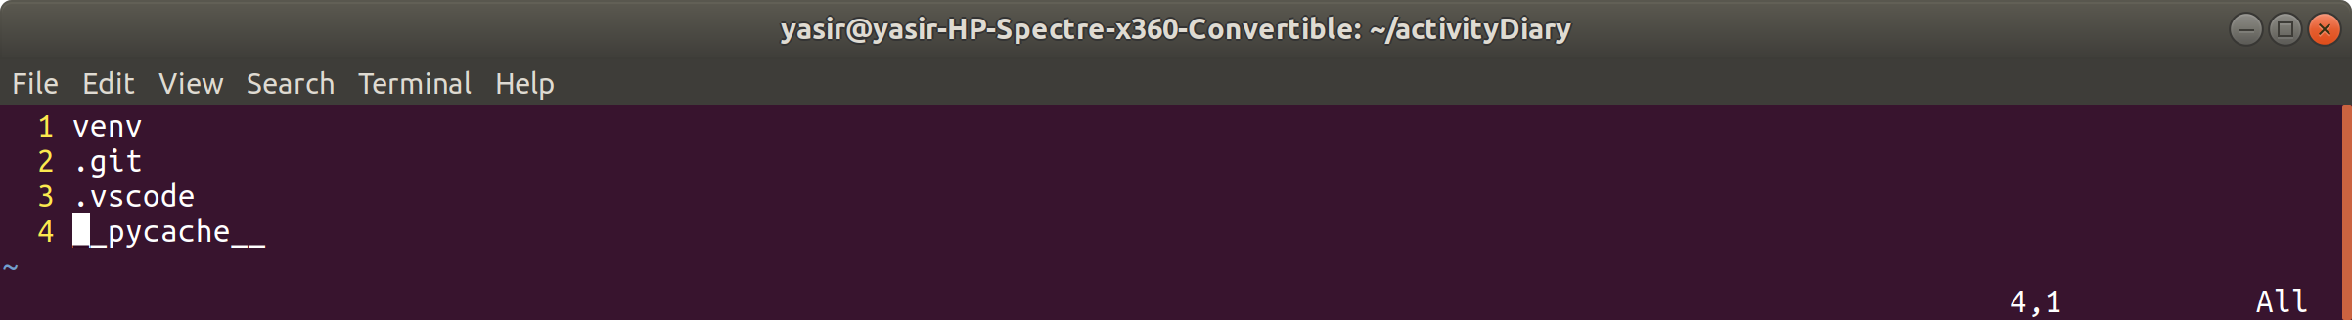

**build image file**

first attempt (with error)

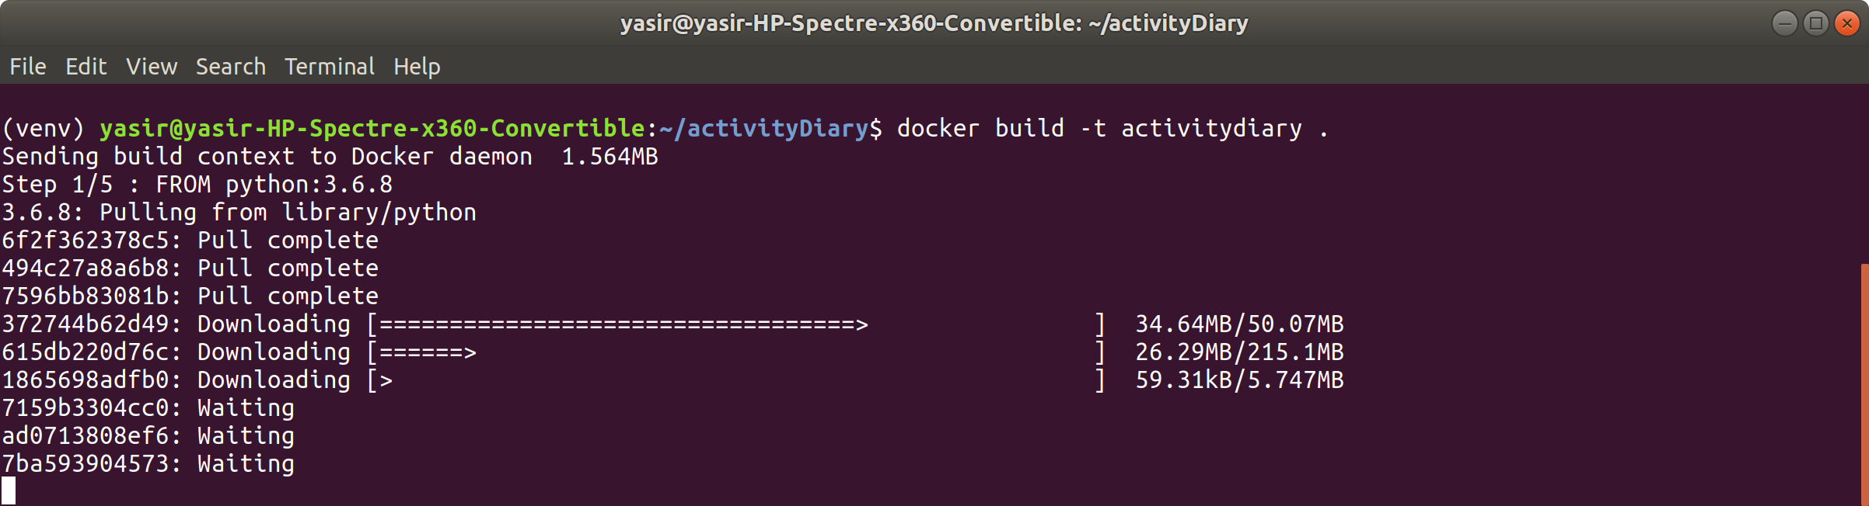

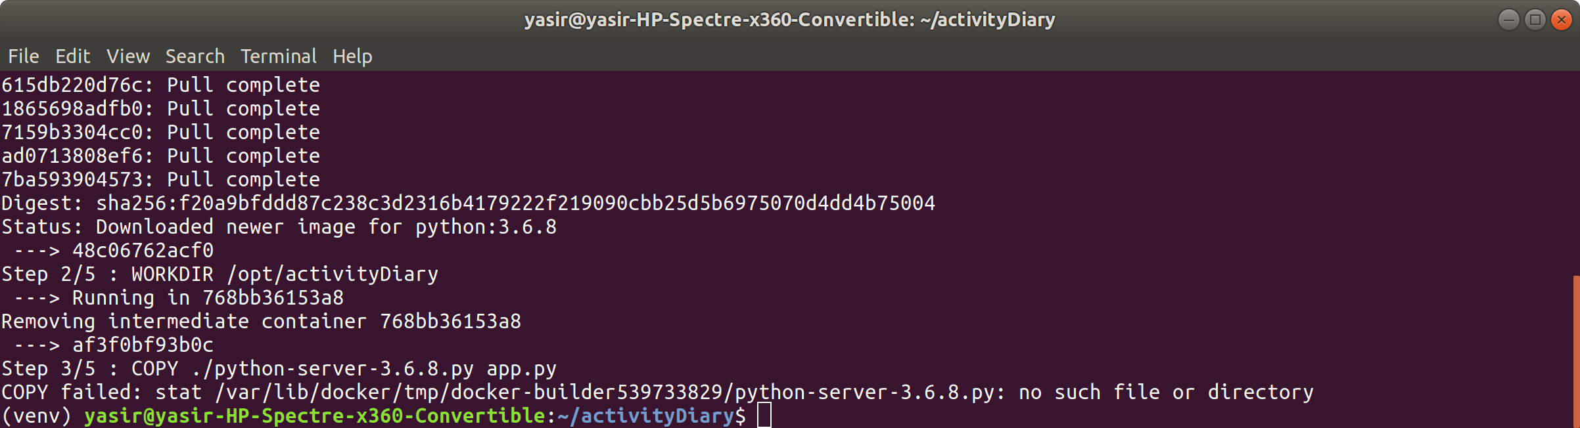

second attempt (issue as missing things from Dockerfile)

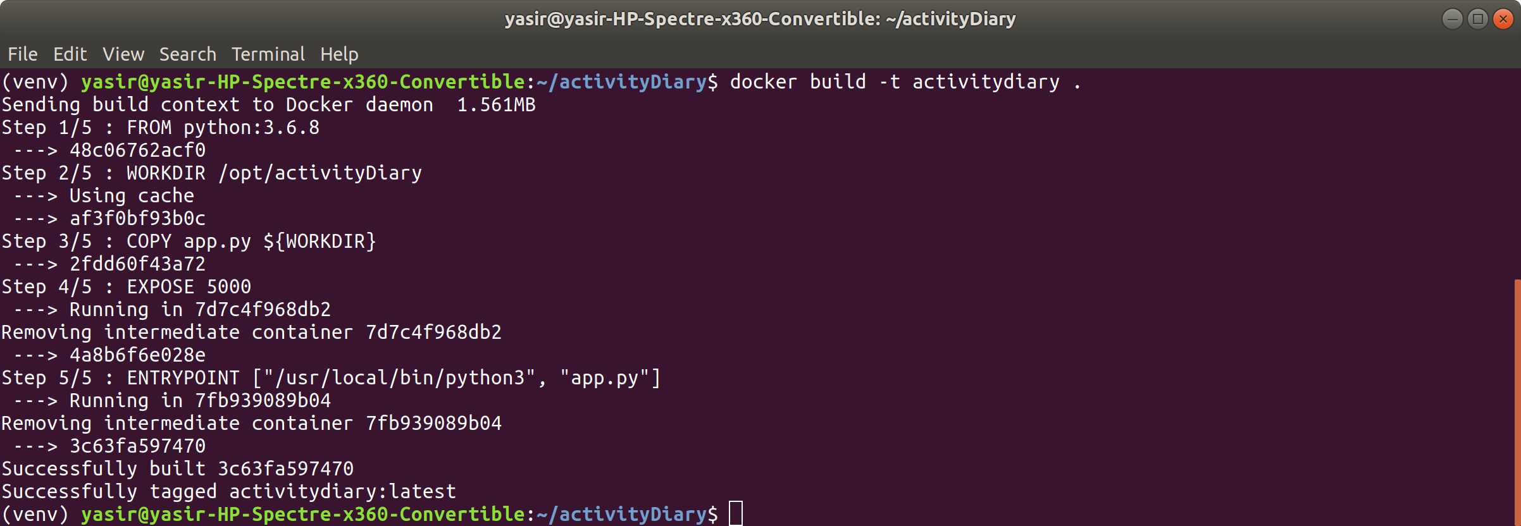

third attempt (success!!)

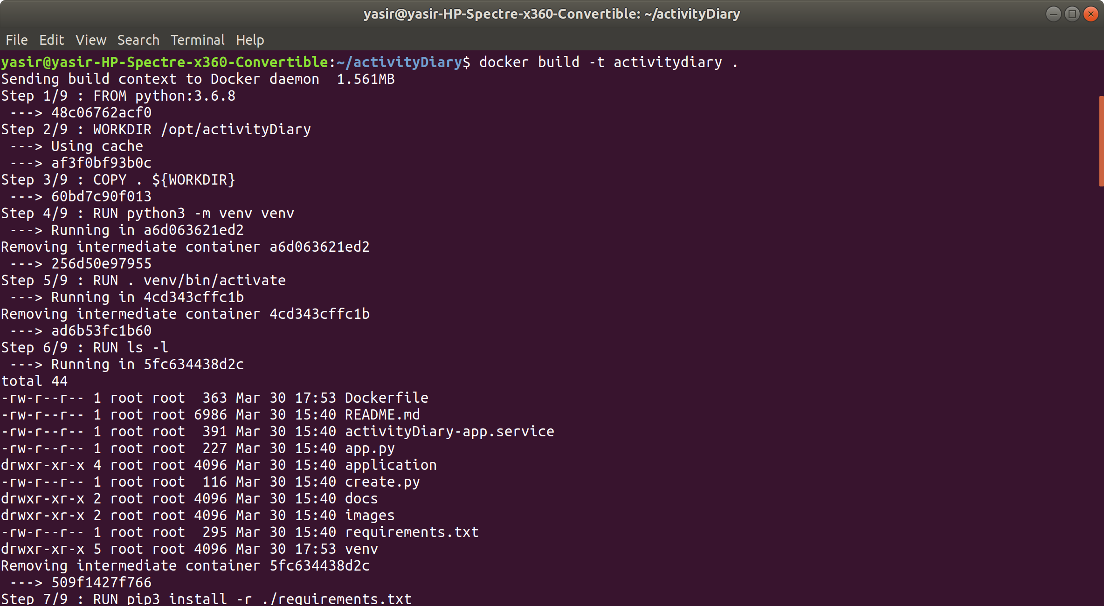

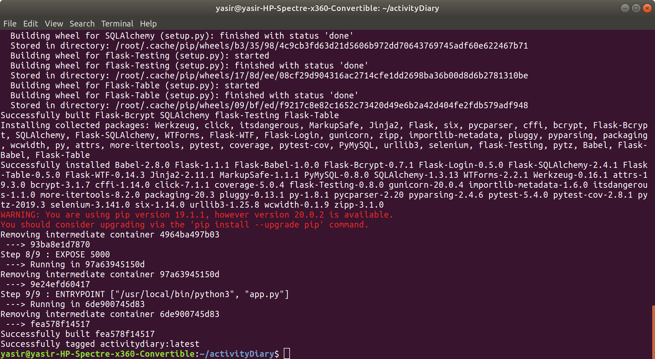

**run the image**

first attempt failed!

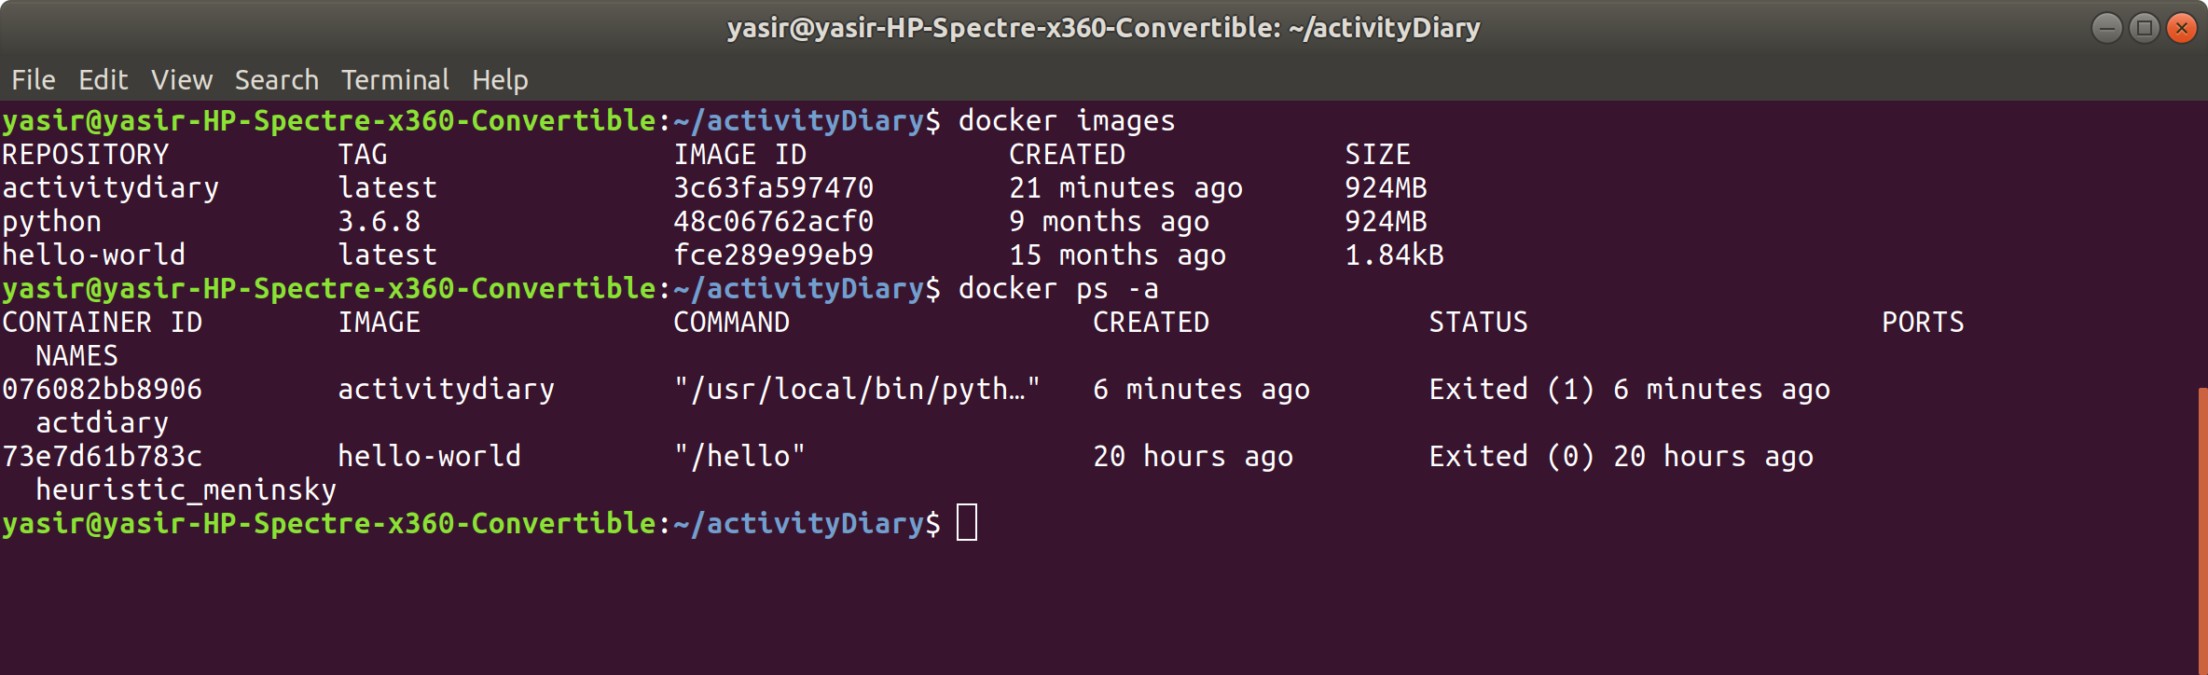

second attempt success after correcting the Dockerfile

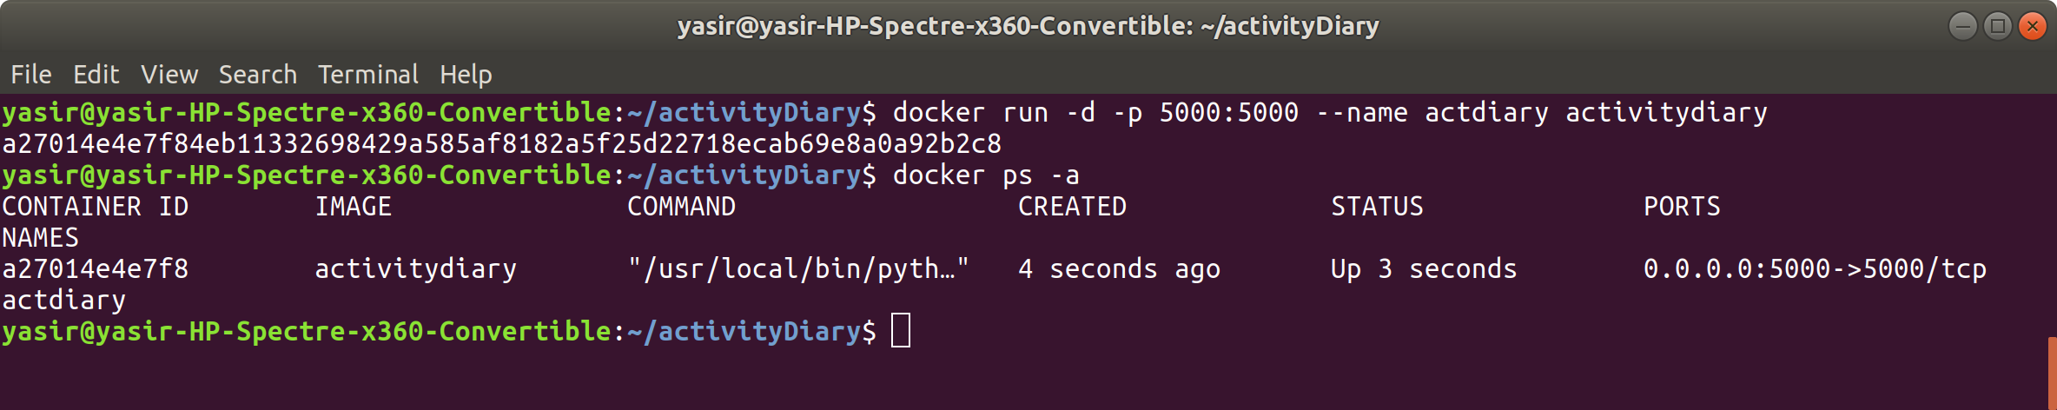

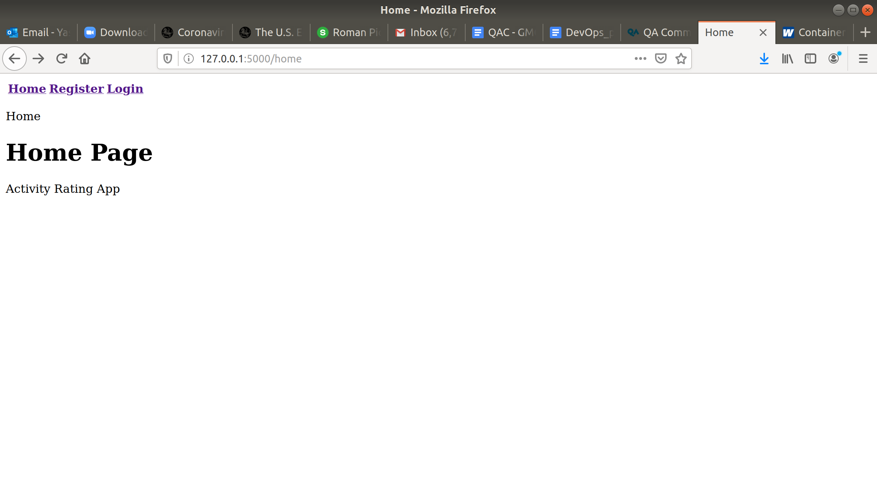

**stop and remove container**

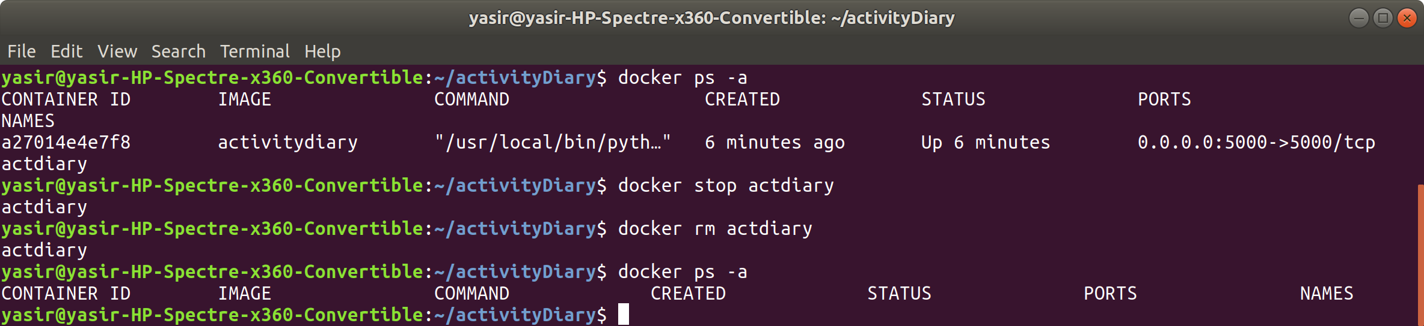

**remove image**

