# Docker - Volumes Jenkins exercise

Stop and remove all containers, delete the volume that was created.

Try to persist all the jobs and configurations for Jenkins, so that when the container has been stopped and removed, Jenkins can pick up where it left off when you create the container again.

The default Jenkins home folder in the Jenkins Docker image is **/var/jenkins_home**, so this is the folder that you will want to look at persisting.

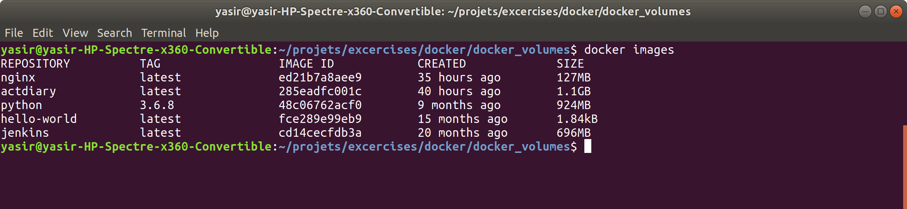

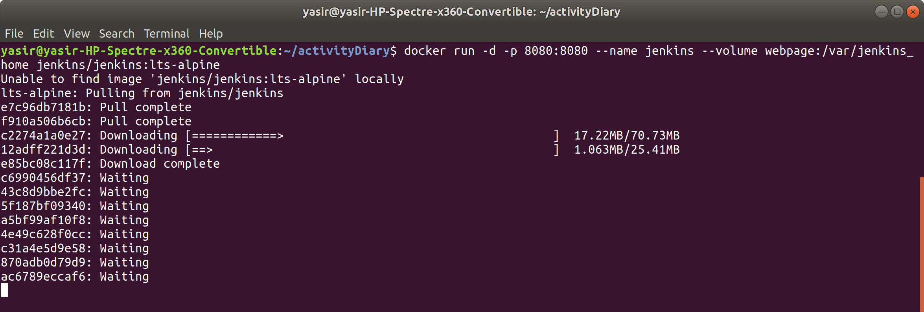

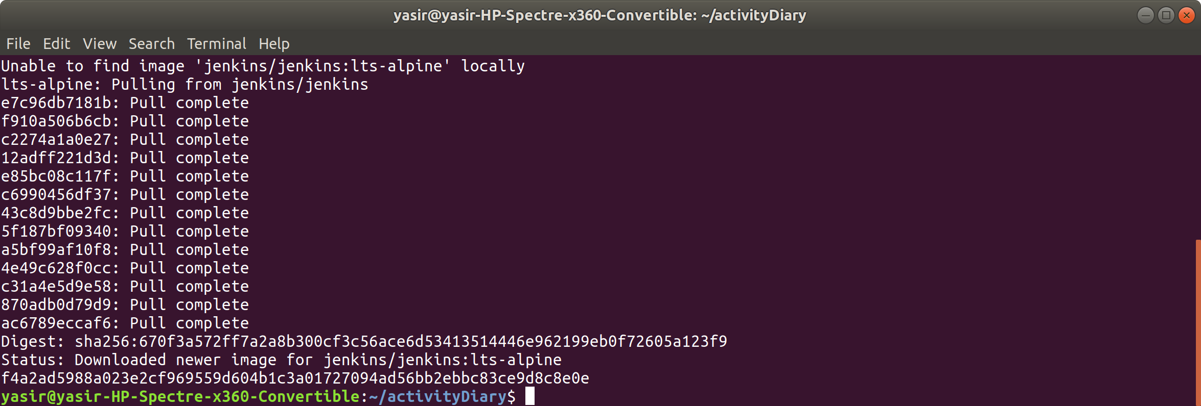

get Jenkins initial Admin password

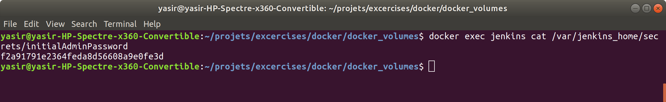

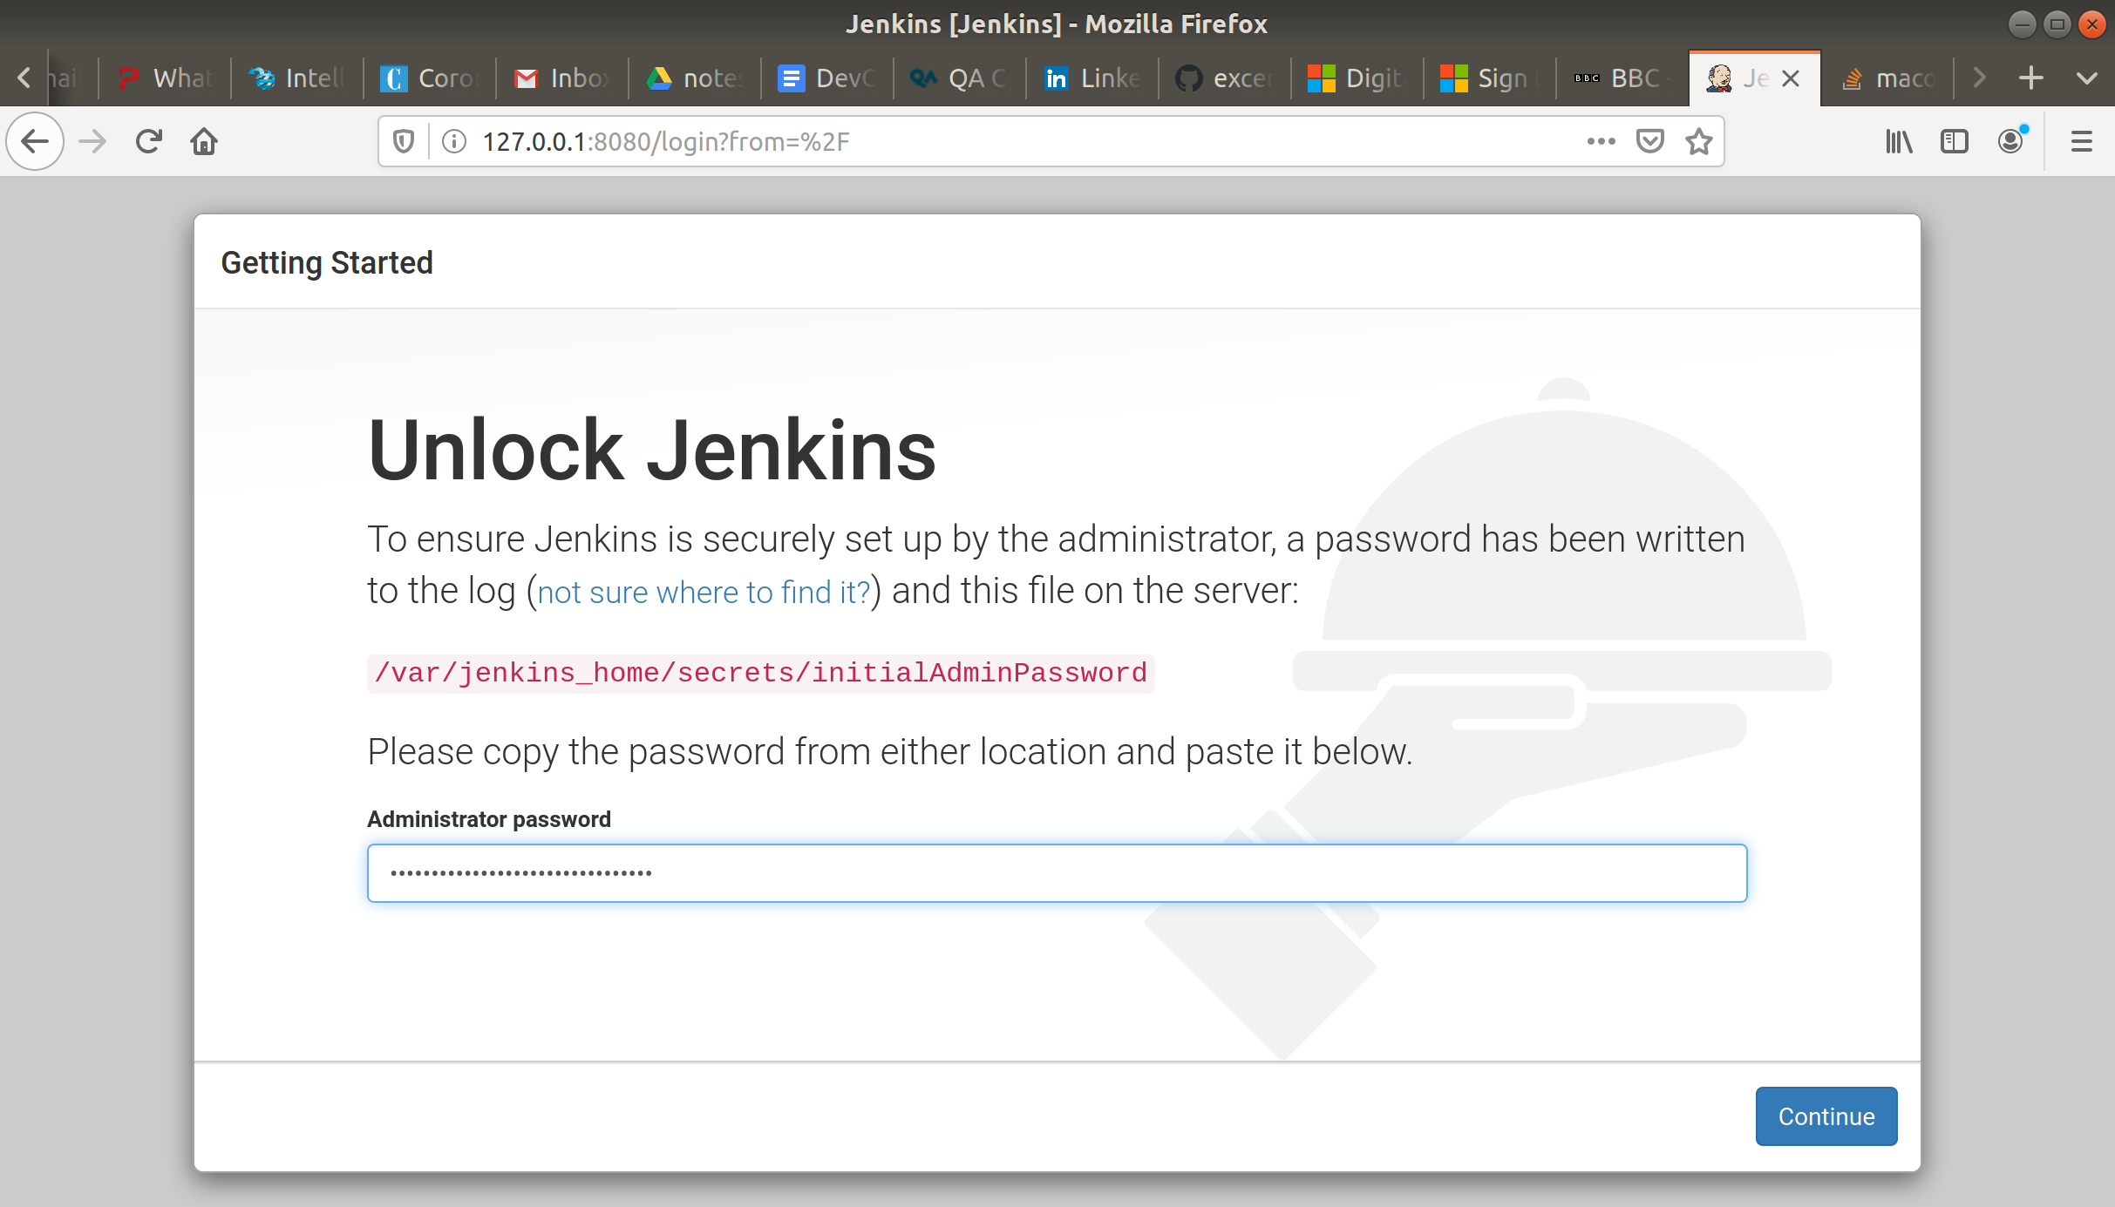

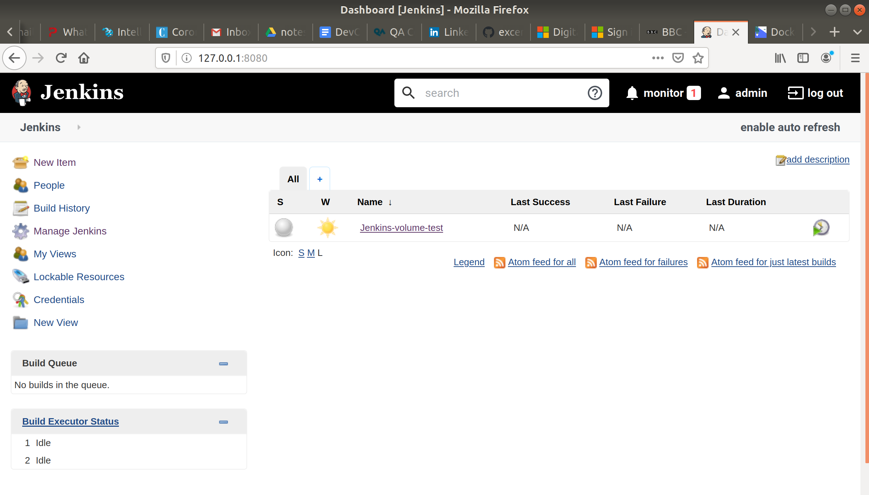

logged out from Jenkins

stopped and removed the container

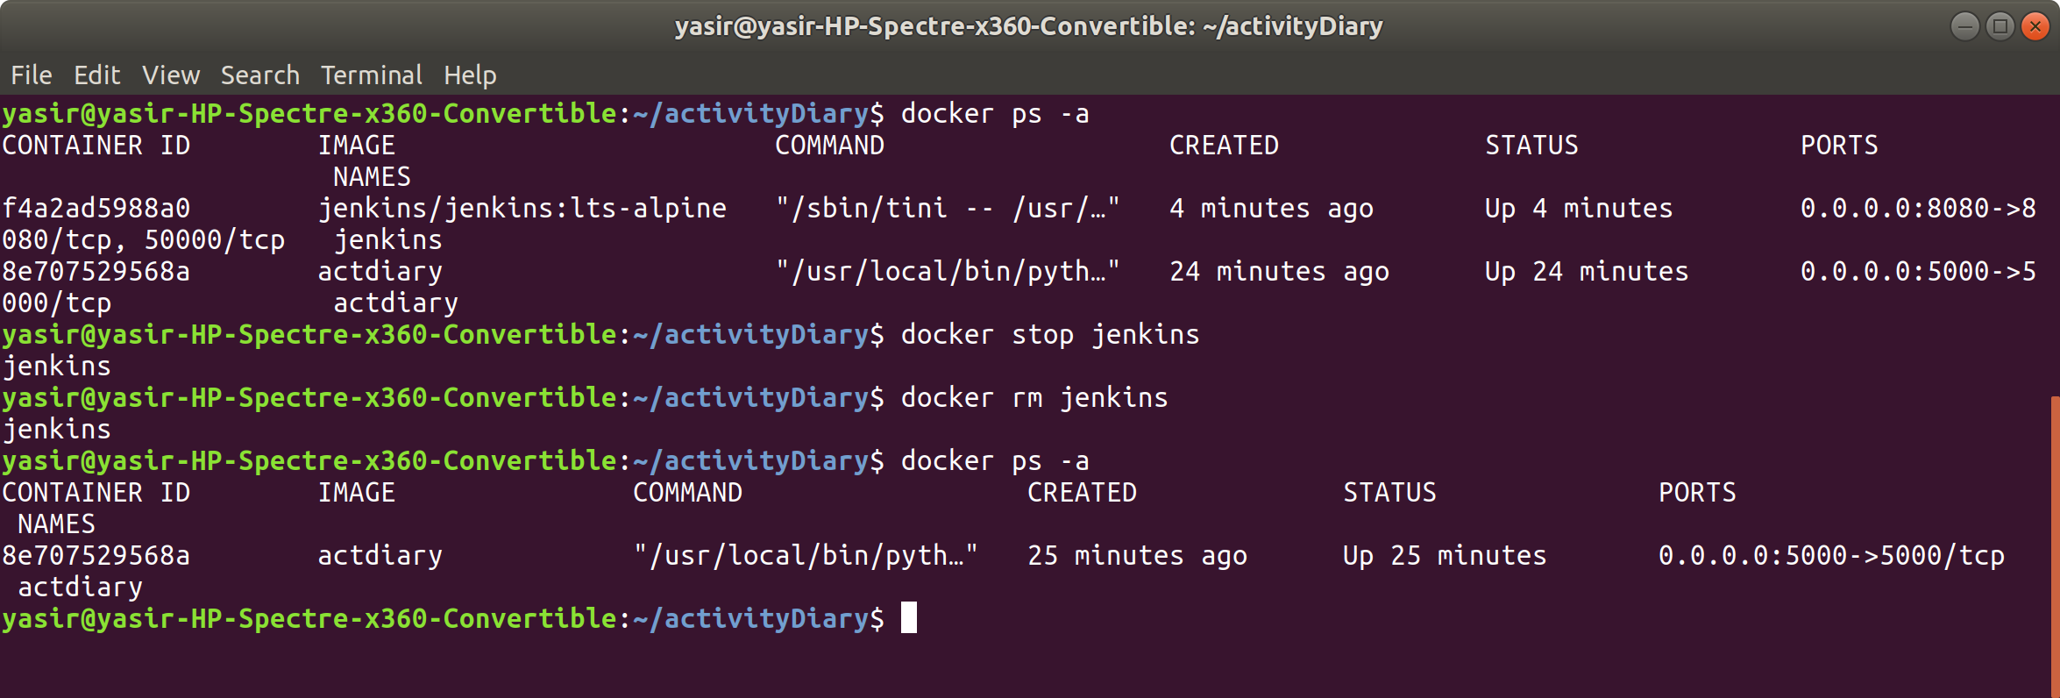

create a new container

got new Admin password

run curl

**$ curl localhost:8080**

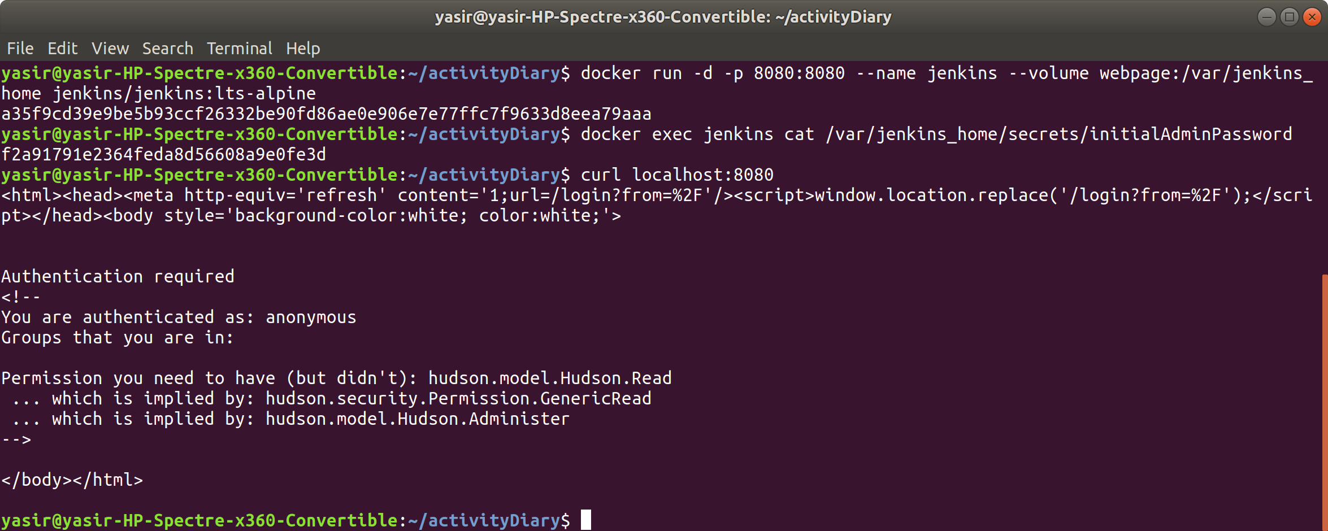

on web took me straight to authentication as if the container never removed

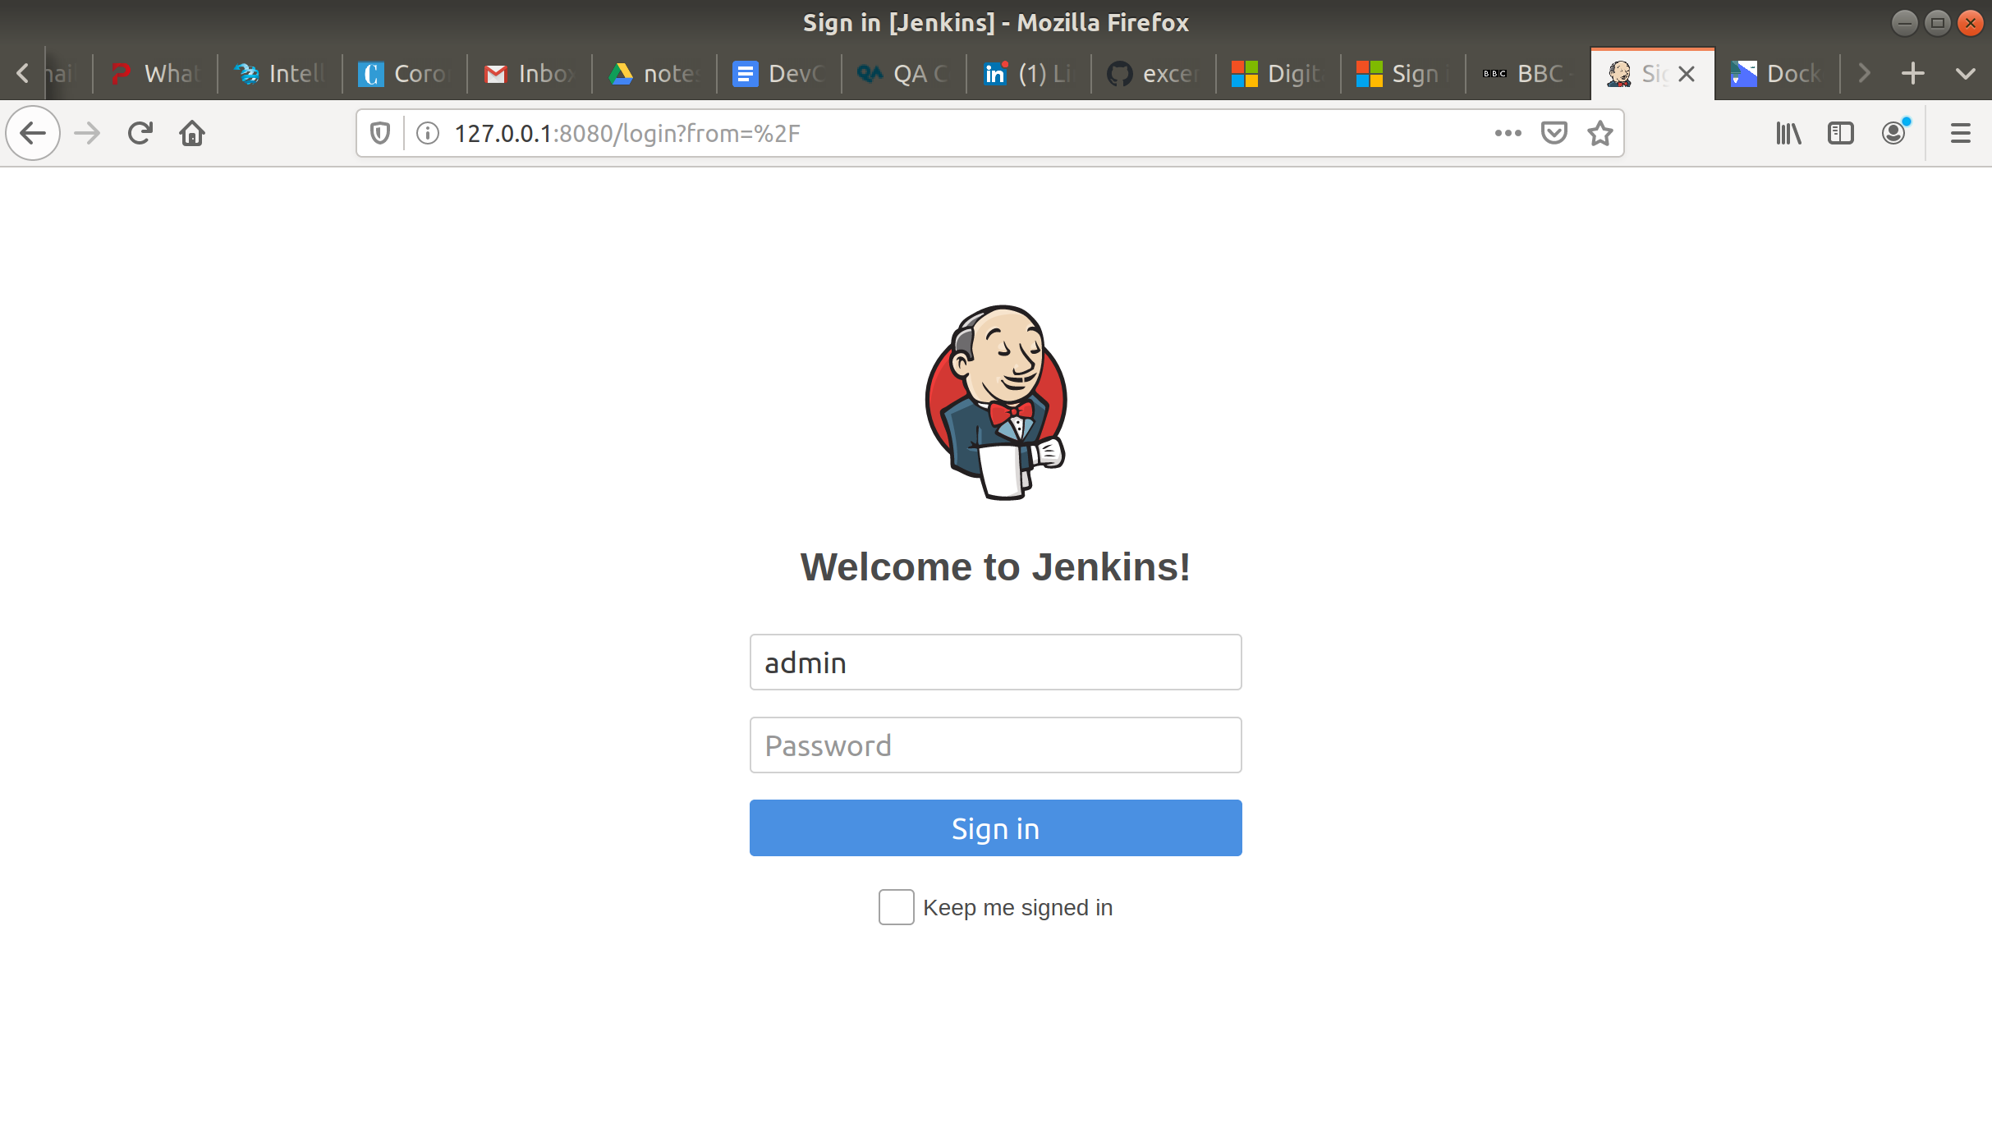

Got my project back!

