# Python HTTP request tutorial

This tutorial will guide through:

* Creating basic Flask application which has several routes to test with the requests library
* Making requests to the various routes on the example Flask application

### **Prerequisites**

* **Fresh Debian/Ubuntu VM**This will help avoid conflicts with any other work that you have been doing.

**Python 3 & Virtual Environment**Neccessary for configuring the Python applications we are building, use this command on a terminal to make sure that they are installed:  
  
 sudo apt update

**$ sudo apt install -y python3 python3-venv**

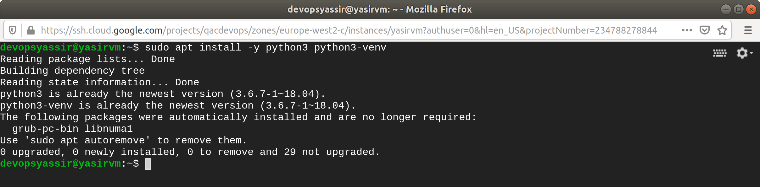

**Git**Git will be needed to download the example API application:  
  
 sudo apt update

**$ sudo apt install -y git**

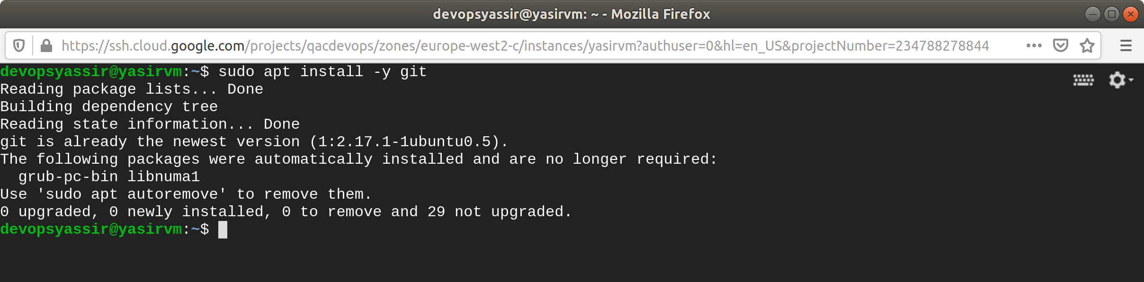

The requests library can be installed using Pip:

**$ pip install requests**

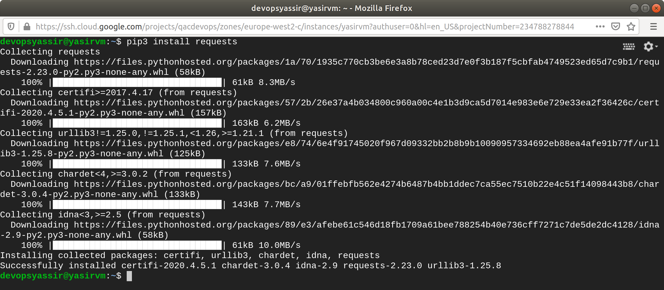

**Example Flask API**To test the requests module an example API Flask Application has been provided.  
It is a very simple application which returns text and JSON responses, feel free to look at the code for this [here](https://gitlab.com/qacdevops/python-flask-example-api).  
Install this API on the VM using these commands:  
  
 **$ mkdir -p ~/projects/gitlab.com/qacdevops && cd $_**

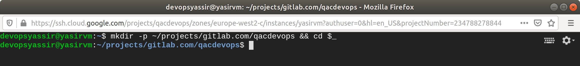

**$ git clone https://gitlab.com/qacdevops/python-flask-example-api**

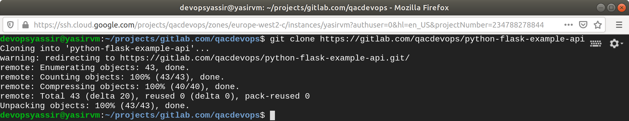

**$ cd python-flask-example-api**

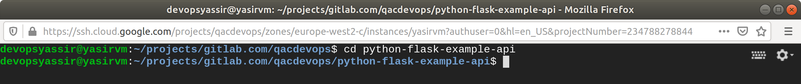

**$ sudo ./hack/deploy.sh**

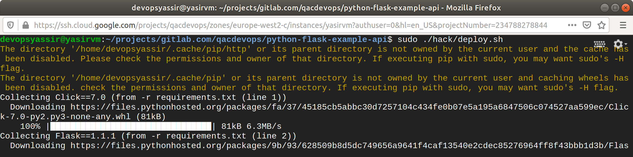

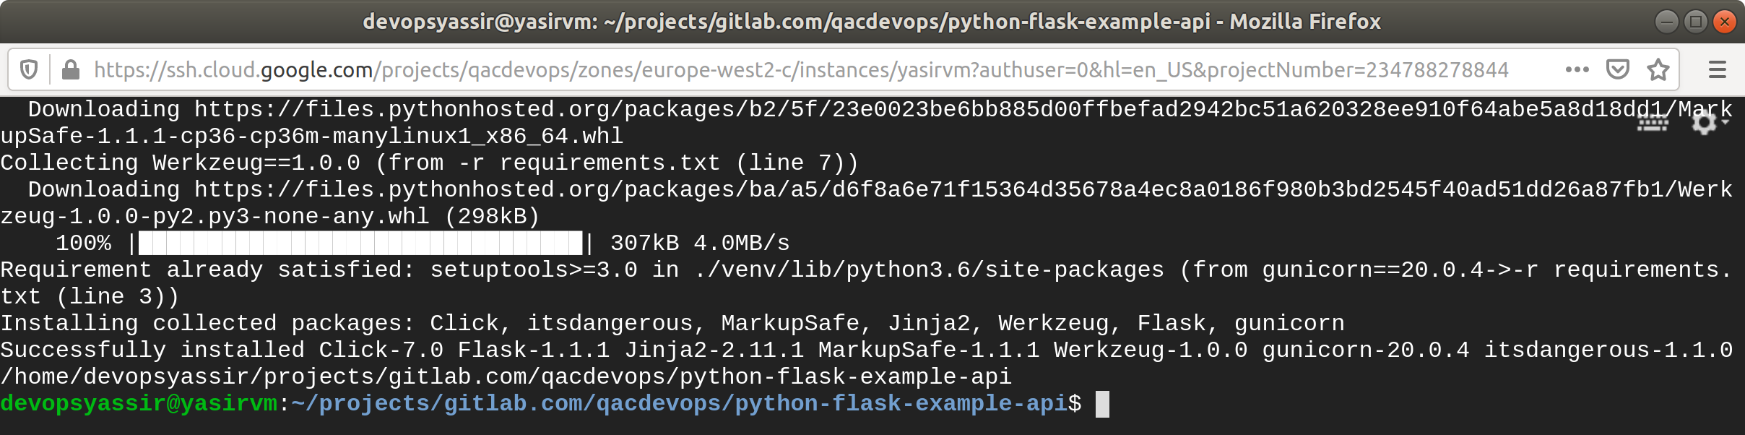

The API setup is running on port 5000 and has the following routes configured:

|  |  |  |
| --- | --- | --- |
| **Route** | **Description** | **Content Type** |
| /get/text | Return a simple text message: *"Hello from Flask"* | text/plain |
| /post/text | Return the data from request back as a part of a string: *"Data you sent: [DATA_YOU_SENT]"* | text/plain |
| /get/json | Return a JSON object containing a data property with a message: {"data": "Hello from Flask"} | application/json |
| /post/json | Return the data from request back as a data property inside of a JSON: {"data": "[DATA_THAT_WAS_SENT]"} | application/json |

### **Setup a Project for Making Requests**

We'll need a project setup now for using the requests library:

**$ mkdir -p ~/projects/http-requests-tutorial/ && cd $_**

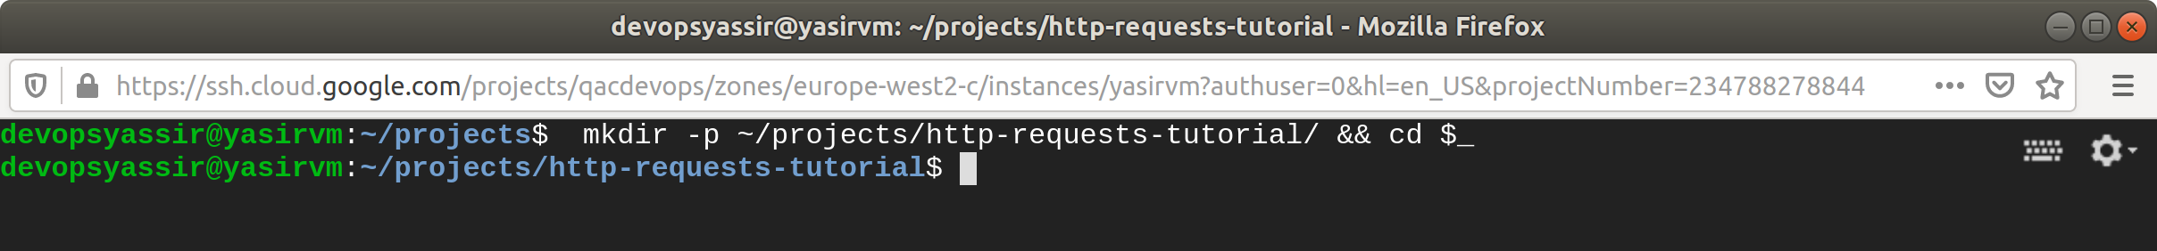

**$ python3 -m venv venv**

**$ source ./venv/bin/activate**

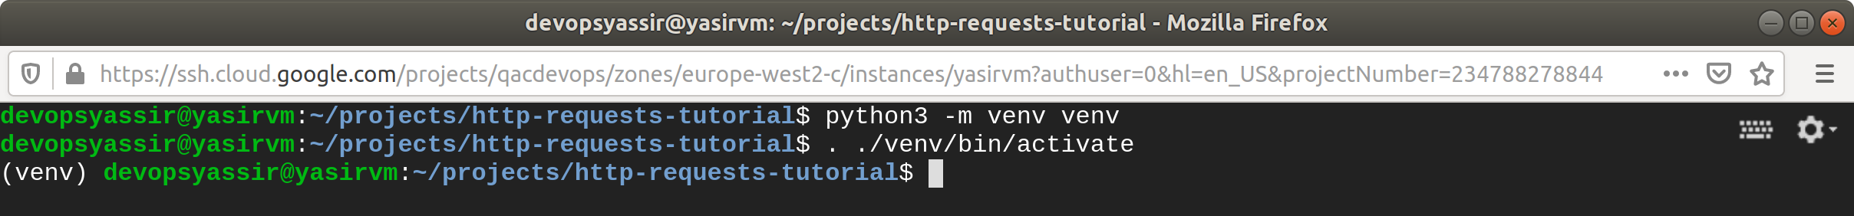

**$ pip install requests**

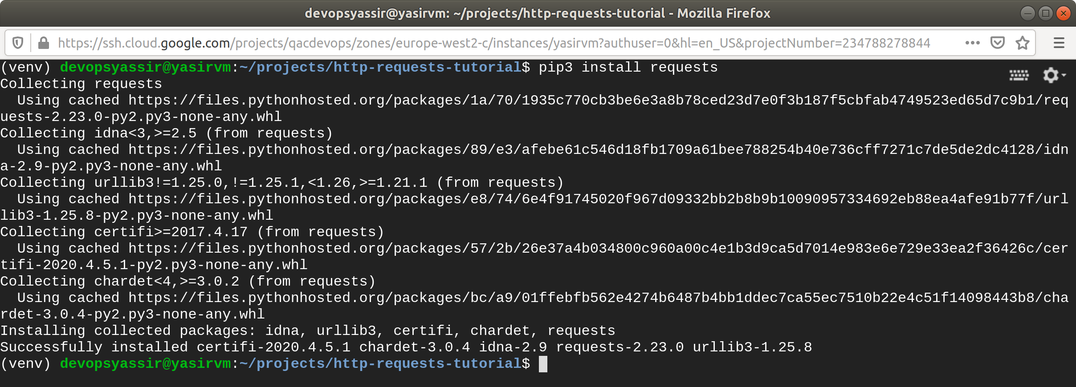

You now a virtual environment with requests installed, create an __init__.py file in this folder and enter the following:

import requests

api = 'http://localhost:5000'

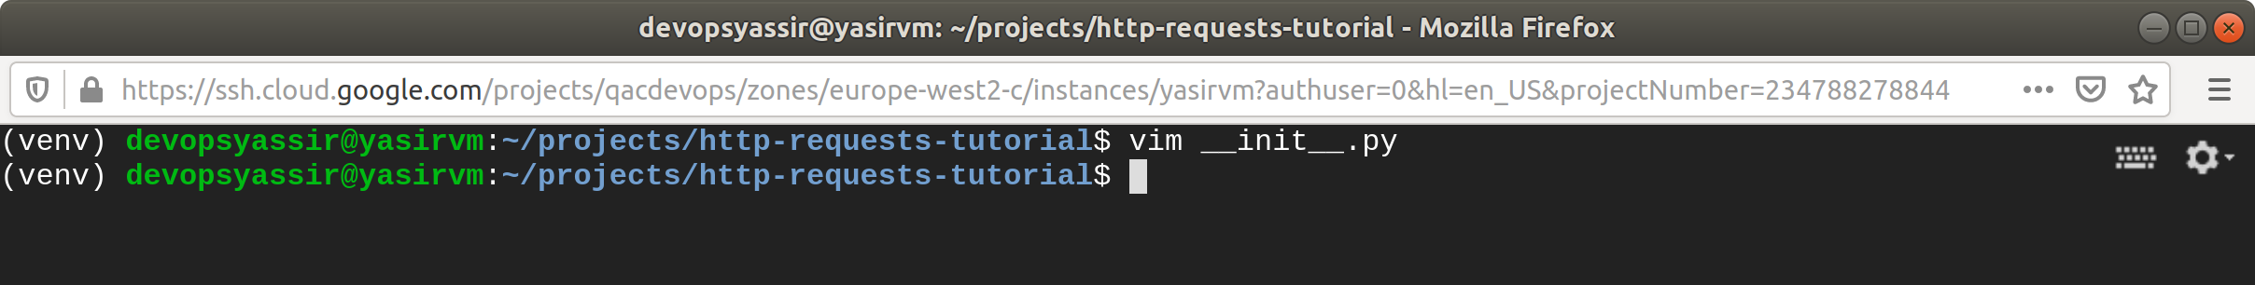

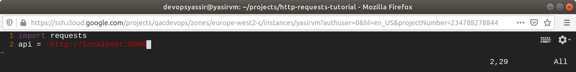

Here we have imported the requests module for making requests and made an api variable so that we aren't going to be repeating ourselves as much on all the requests.

### **Basic HTTP GET Request**

There's a route: /get/text we can create requests for to get a text response, add this to the __init__.py:

print('HTTP GET Request (text):')

response = requests.get(api + '/get/text')

print('Response: ', response.text)

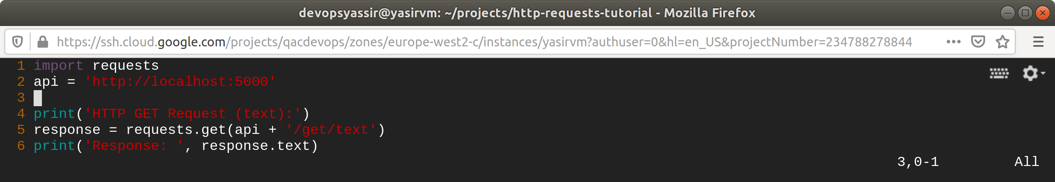

When you run python __init__.py there should be an output like this:

HTTP GET Request (text):

Response: Hello from Flask



### **Basic HTTP POST Request**

Some text can be sent to /post/text, the response will change depending on the data that you send to it:

print('HTTP POST Request (text):')

response = requests.post(api + '/post/text', 'My Data')

print('Response: ', response.text)

You should see an output like this:

HTTP POST Request (text):

Response: Data you sent: My Data

### **JSON HTTP GET Request**

A simple GET request to /get/json can be made to get a JSON response:

print('HTTP GET Request (json):')

response = requests.get(api + '/get/json')

print('Whole Response: ' + str(response.json()))

print('"data" Property of the Response: ' + str(response.json()["data"]))

You should see an output like this:

HTTP GET Request (json):

Whole Response: {'data': 'Hello from Flask'}

"data" Property of the Response: Hello from Flask

### **JSON HTTP POST Request**

A POST request to /post/json will return a JSON object containing the JSON object that you have sent:

print('HTTP POST Request (json):')

response = requests.post(api + '/post/json', json={"message": "mydata"})

print('Whole Response: ' + str(response.text))

print('"data" Property of the Response: ' + str(response.json()["data"]))

You should see an output like this:

HTTP POST Request (json):

Whole Response: {"data":{"message":"mydata"}}

"data" Property of the Response: {'message': 'mydata'}

