# Terraform - Introduction HashiCorp Configuration language

# 

# 

## **Tutorial**

Azure

**$ mkdir example && cd $_**

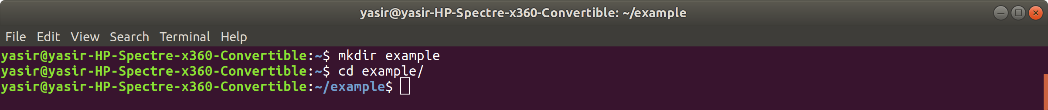

create main.tf file

**$ vim main.tf**

type in:

provider "azurerm" {

version = "=2.0.0"

features {}

}

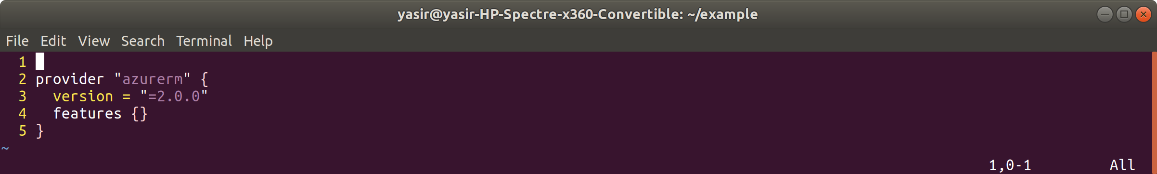

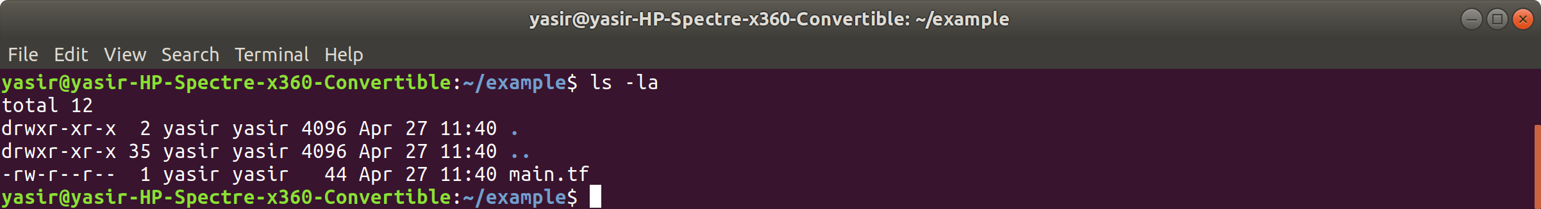

Initialize Terraform by typing:

**$ terraform init**

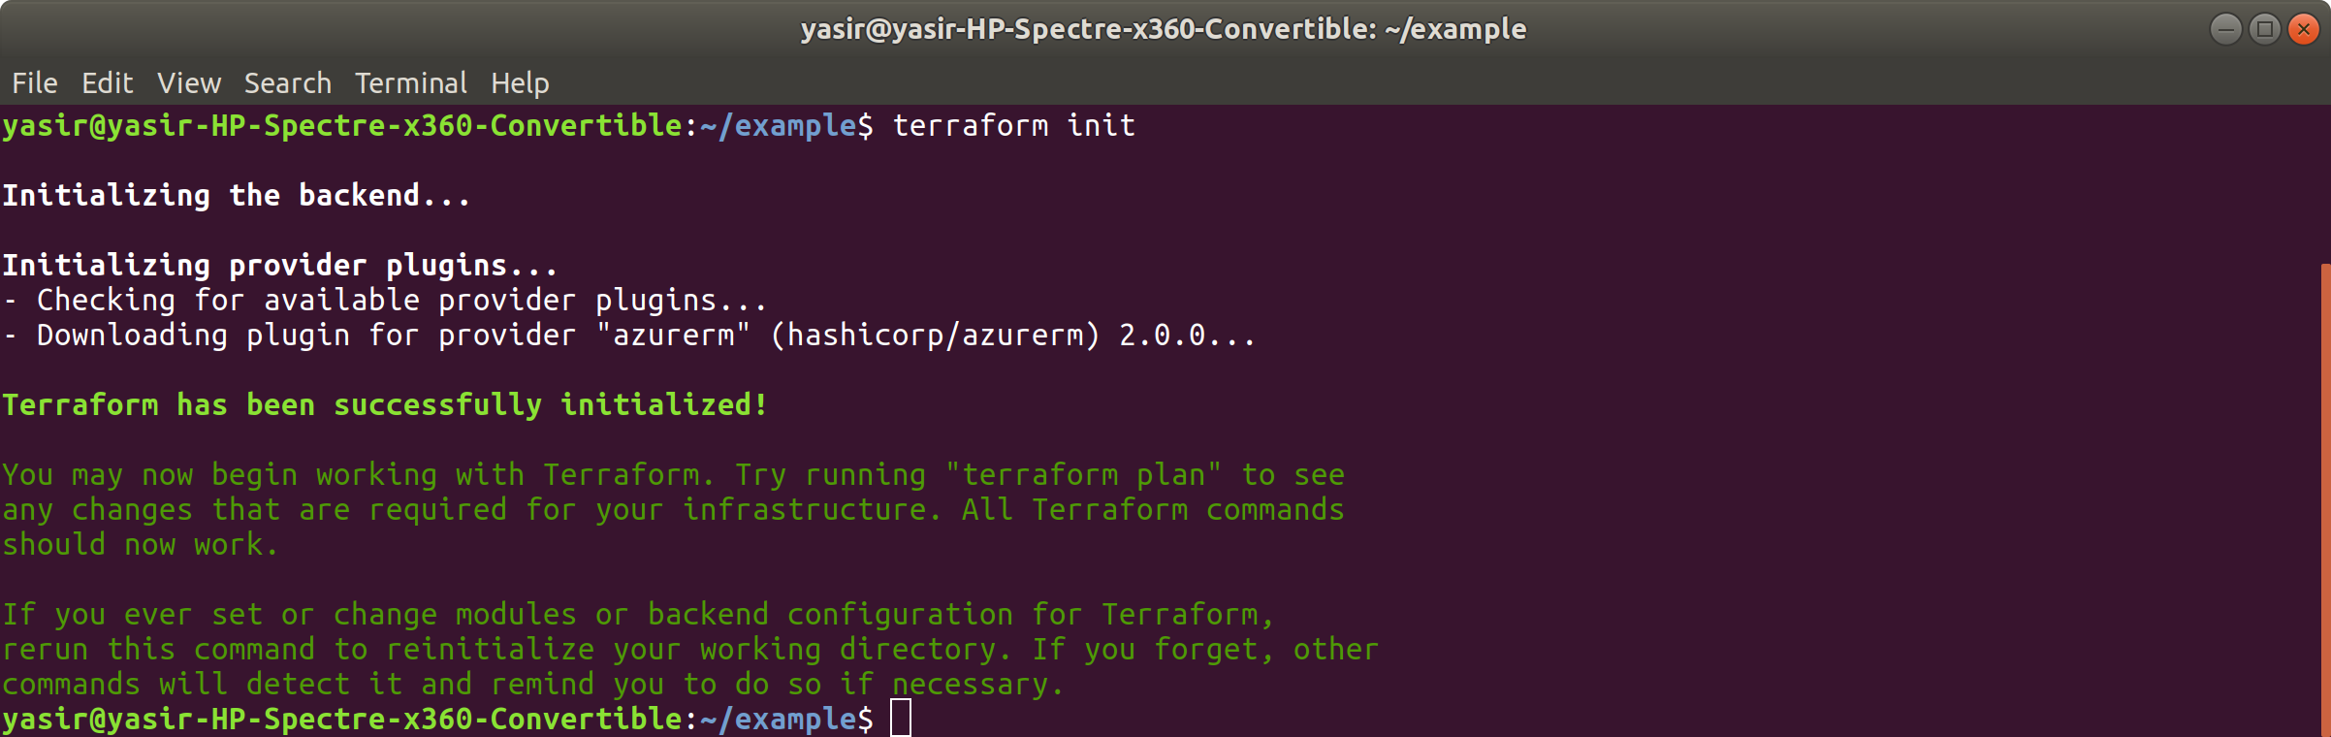

**$ ls -la**

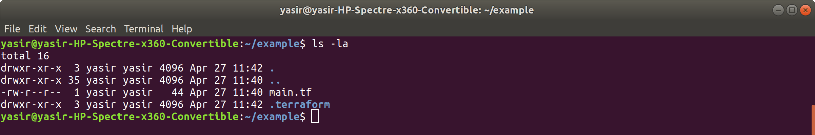

**$ ls -la .terraform/**

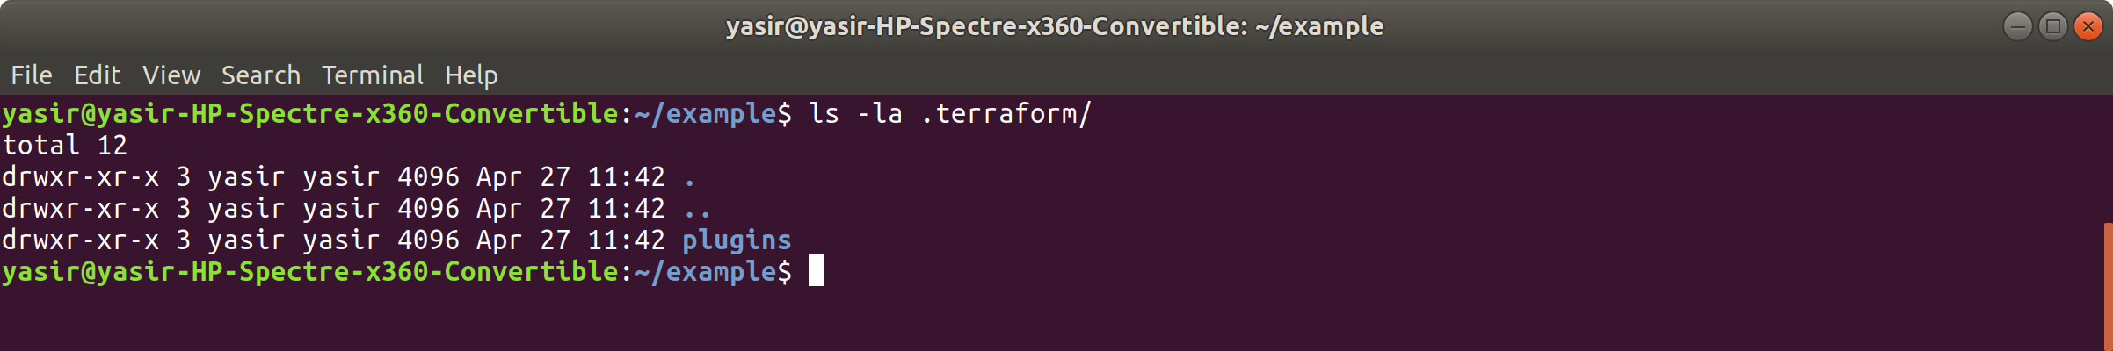

Create resource group

$ vim main.tf

add the following:

# Create a resource group

resource "azurerm_resource_group" "example" {

name = "exampleRG"

location = "East US 2"

}

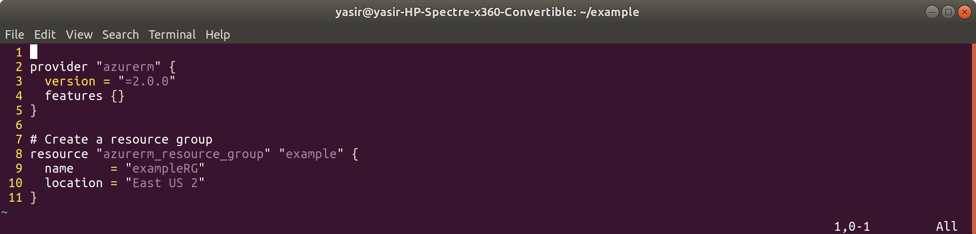

Now apply by typing:

**$ terraform apply**

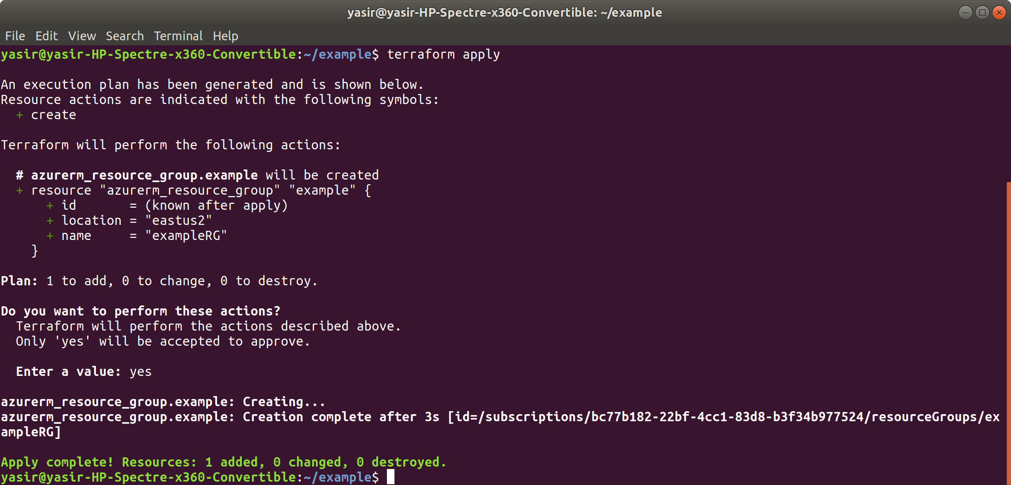

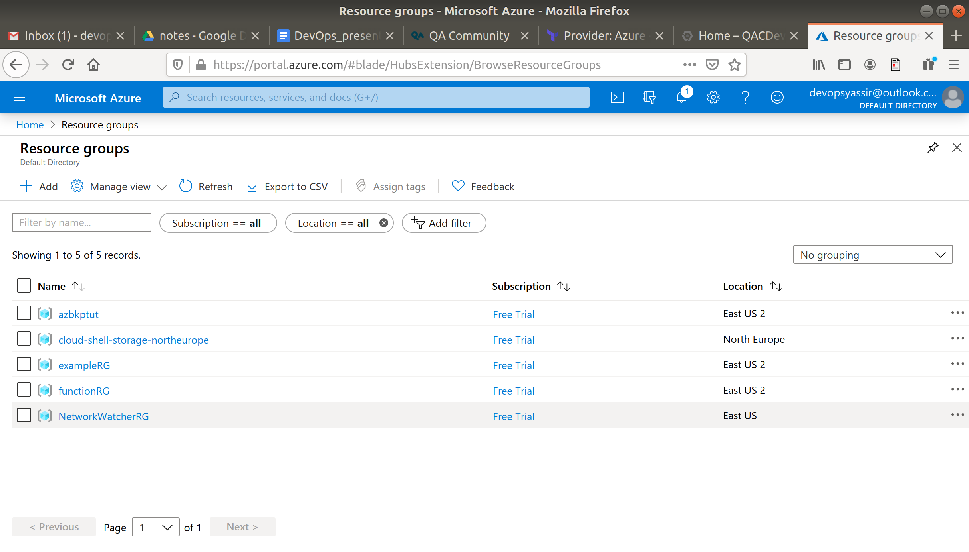

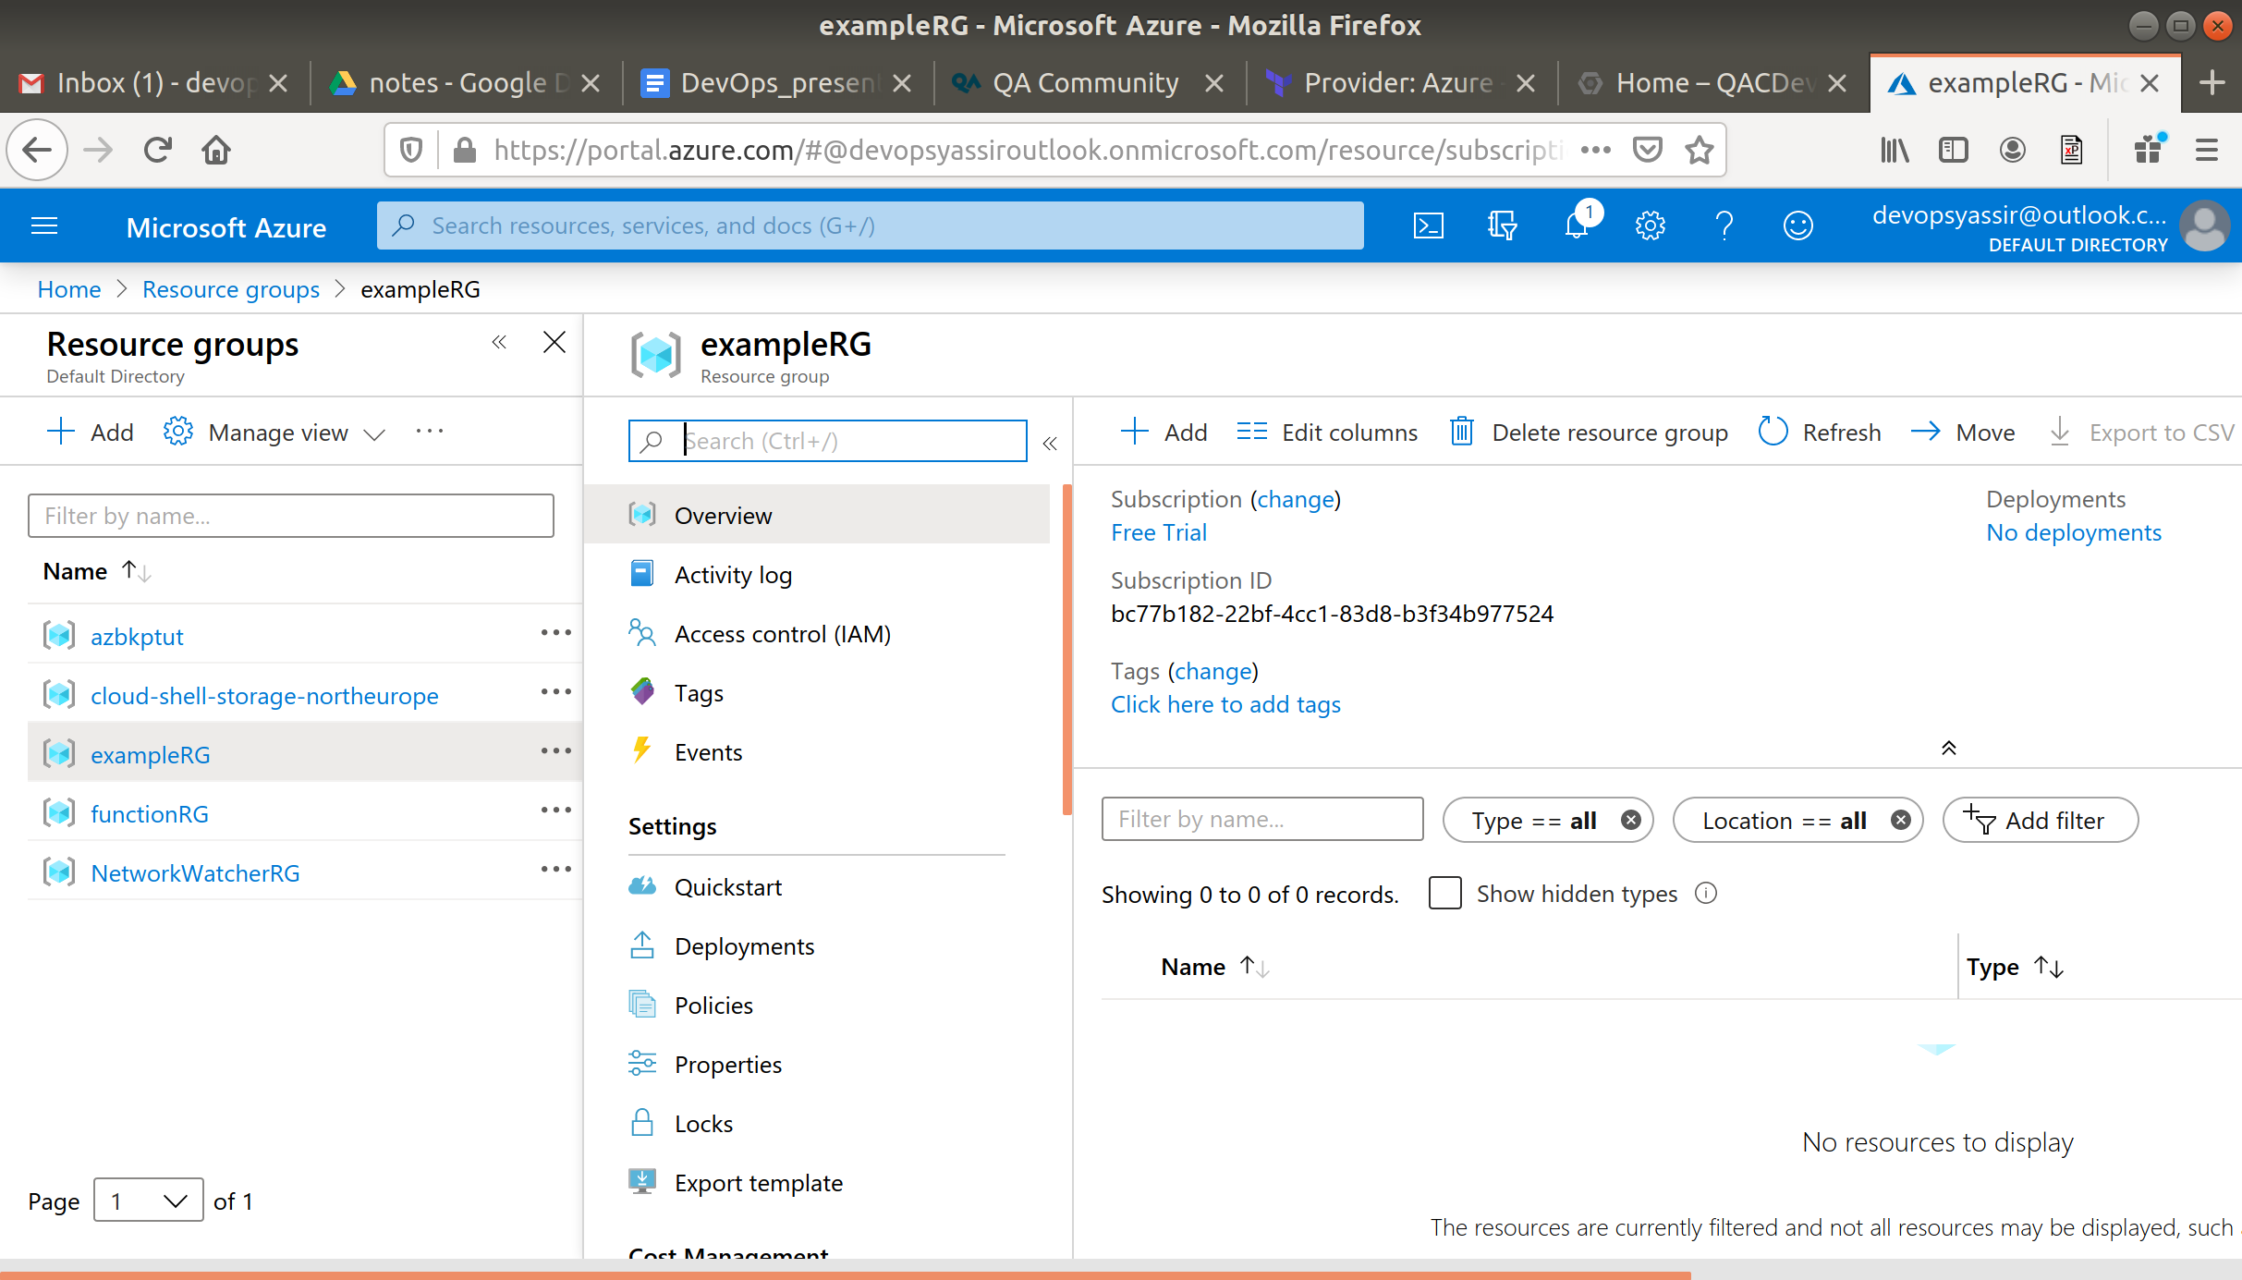

Clean up

Now to remove the resource group type:

**$ terraform destroy**

