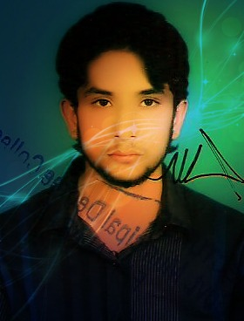
Sohaib Ahmed

Takbeer block 298, Bahria Town,
Lahore, Pakistan. Zip Code - 54000
Mobile: +923024342957
Email: Sohaib_ahmed536@yahoo.com

CAREER OBJECTIVE

To get elevated in the field assigned, by exploring my skill and working hard as true to my conscience for the upliftment of the Organization as well as my personal growth

ACADEMIC QUALIFICATION
Degree/ Course | Institution | University / Board | Year of Passing | CGPA/Division
M.I.T | The University of Lahore | Lahore | 2015 | 3.1/4.0
B.com | University of the Punjab | Lahore | 2012 | 2nd
H.S.C. | Superior College | Faisalabad | 2010 | 2nd
S.S.C. | City Cadet School | Faisalabad | 2008 | 1st

SOFTWARE PROFICIENCY

- Languages : C++, PHP, HTML, CSS , Java script
- Packages : MS Office
- Operating systems : Windows XP,7,8
- Tools : Microsoft Visual Studio, Adobe Dreamweaver, Adobe Fireworks, Turbo, Dev++.

AREA OF INTEREST

- Oops Concept
- Online Database Systems
- Software Engineering
- Computer Networks
- Website designing & Development

CERTIFICATION

- Completed 4 Months Website Designing & Development Course
- Completed 3 Months Diploma in Basic Computer Hardware

PROJECT WORK

Title: “News Extractor”

Description: News Extractor is an online web based application. Its purpose is to help user to find appropriate news according to his area of interest. Best ranked news will be shown which will be based on user’s reviews. Application will help in saving time and ease for the user to find news at one click over the internet.
Collaboration filtering will help user to find the desired news according to his area of interest. Giving user the news that he likes, which is never done before.
.

TRAINING DETAILS

Name of the Industry | Duration | Areas of Exposure
Opoole Technologies  IT Empires | 1 Day  3 Days | Search Engine Optimization  Word press

ACHIEVMENTS
.
- Presented a CMS and PHP based Web Project in annual exhibition conducted by University of the Lahore.
- Attended Workshop on “Graphics and Multimedia”.
- Project Representative during Final year Project.
- Actively Participated in Technical Quizzes.
- Completed New Zealand based trademe.com site ad posting
- Worked on blogging, word press

LEADERSHIP SKILLS

- Executive student committee member.
- Organized various functions and social welfare activities.
- University rewarded Proctor Title
STRENGTHS

- Self Motivated.
- Quick Learner and Team player.
- Flexible and hard worker, Leadership.
- Can handle things smoothly under pressure.

HOBBIES

- Learning new things.
- Gardening.
- Playing Cricket.

PERSONAL PROFILE

Father’s Name : Attique Qureshi
Date of Birth : 21.04.1993
Gender : Male
Marital status : Single
Languages Known : English, Urdu, Punjabi Nationality : Pakistani

DECLARATION

I am keen to continue my career and prepared to work hard in order to achieve my organization objectives and I hereby declare that the information furnished above is true to the best of my knowledge.

Date / / (Sohaib Ahmed)

