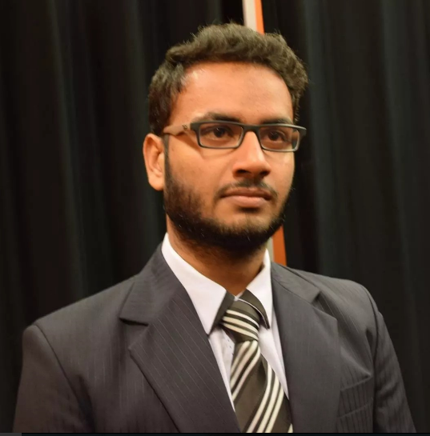  Born 1993 | Adnan Shaukat  House # E-325, street 8, block B, Nishat Colony, Lahore Cantt, Pakistan.  Cell#: 0092-334-4193661  Email: adnanshaukat.uol@gmail.com
Personal Profile | I am studying BSCS from UOL (The University of Lahore) with 3.05/4 CGPA. To pursue my Career in the field of Information and Technology with a sense of responsibility, loyalty, integrity and leadership coupled with excellent communication & interpersonal skills to maximize the profit and good will and excel by hard work and dedication.
Qualification  Courses  Trainings &  Workshop’s  IT & Language Skills  Personal Information  Reference | The University of Lahore 2012-2016  Bachelors in Computer Science (7th Semester Continue)  Garrison Degree College for Men, Lahore 2012  BISE  Intermediate in Science (Pre-Engineering)  Lahore Cantt Public High School. 2010  BISE  Matriculation in Science  - Netcom Institute of Computer Education  MS office certification  - IEEE UOL Student Branch  Web Development  - C++  - PHP, Javascript, HTML5, CSS  - Java  - MySQL  - Marital Status: Single  - CNIC No: 35201-5439825-1  - Age: 21 Years  - Nationality : Pakistani  Will be furnished upon request.

