MUHAMMAD BALAWAL BUTT

CURRICULUM VITAE

OBJECTIVE:
To be a part of progressive organization where I can contribute best for the benefit of the organization, get opportunities for professional as well as personal grooming & enhance my accountancy & managerial skills.

QUALIFICATION:

- Matriculation (2011)
L.D.A High School
- F.Sc Pre Engineering (2013)
Government Science College
- BS.CS (5th Semester) (Continue)
Minhaj University, Lahore

EXPIERNCE:

- Currently working in Law Firm SELCON as Admin of I.T
- 6 Month experience in Clemance International Software House as Internee (Web Development in Php) 20th November 2014- 20th April December 2015
COMPUTER SKILLS:

- Wrote programs in C++,Java,PHP,C#
- Windows(VISTA, Windows 7,8.XP)
- Internet Browsing
- MS Office
- Fast Typer

LANGUAGES:

- English
- Urdu
- Punjabi

EXTRA CURRICULAR ACTIVITIES AND INTERESTS:

- News Paper Reading
- Cricket
- Body Building

REFERENCES:

- References will be furnished when desired.

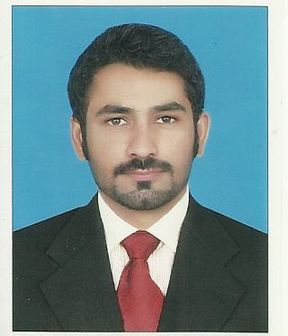

PERMANENT ADDRESS:

House #61 Street# 02 Satluj
Block Allama Iqbal Town
Lahore.

Contact No:

0301-4380009

Nationality

Pakistani.

Email ID:
Cute.bilawal@gmail.com

CNIC #:

35202-6481726-5
S/o:

Muhammad Mushfiq Butt

DATE OF BIRTH:

18/11/1994
Marital Status:
Single
Religion:

Islam

Sex:

Male

