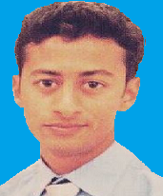

**Syed Waqar Hussain**

Eid Gah Mohallah Pakpattan District Pakpattan

+92-3214554828

Waqarshah440@gmail.com

28 June 1994

|  |
| --- |
|  |

**CAREER OBJECTIVE**

The Primary objective is to enhance my technical, managerial and interpersonal skills. I can meet the challenges that your company will entrust me.

**EDUCATION**

**University of Engineering and Technology Lahore**

Jan 2012- December 2015

BS Computer Sciences

CGPA 3.0

**PROJECTS**

* Market Billing Management system
* Cybercafé Management System
* Account Tracker (Mobile App)

**FYP**

Online University Management System

**ADDITIONAL SKILLS**

**Softwares**:

* Microsoft Office(Word, Power Point, Excel)
* Dream Viewer
* Visual Studio
* Eclipse
* SQL server

**Computer Languages**:

* C
* C++
* C#
* HTML
* CSS
* ASP.NET
* PHP
* VB
* JAVA

**EXTRA CURRICULAR**

* Readings