HALAH — Cross-Alignment Review
Yasir_CA2_Report ↔ HALAH Implementation v1.2 (Narrative)
Six-agent A-to-Z consistency check. Every passage in red is text to insert, in the author's own style; every generated figure and table carries the exact place where it belongs.

Verdict of the A-to-Z check
The two documents describe the same system and are mutually consistent in substance: every mechanism the implementation chapter demonstrates — the structured consent object, EIP-712 guardian verification, the all-guardians threshold, the five-verdict decision matrix, on-chain activation and revocation, and the audited, independently verified ledger — is anticipated by the research report. Two gaps prevent them from reading as one work. First, the report's formal core (Eqs. (7), (36), (51), the three-predicate decision rule, and Algorithms 3–4) still describes the four-component consent object and generic thresholds, while the implementation demonstrates the six-component object and the N-of-N ceremony; the red report edits in Part B close this gap. Second, the implementation chapter never cites the report's numbered artefacts, so a reader cannot trace a screenshot back to the equation or algorithm it realises; the red insertions in Part C and the generated Table A and Figure A close that gap in the other direction.

Part A — Five systemic corrections (apply everywhere in the report)
R1 — Six-element consent tuple.
Every C = (I, A, P, E) — Eqs. (7), (36), (51) — becomes:
C = (I, A, P, T, L, E)
R2 — Five-verdict decision rule.
Every ALLOW = VI ∧ VA ∧ VP becomes:
ALLOW = V_I ∧ V_A ∧ V_P ∧ V_T ∧ V_L
R3 — V_L is jurisdiction matching.
Define wherever V_L appears:
V_L(C, R) = 1 ⟺ Jur(R) = Jur(C) ∨ Jur(C) = ∅
R4 — N-of-N threshold.
The implemented threshold is derived, not configurable:
N = |G| (evaluated with |G| = 2)
R5 — Delivered work in the past tense.
Passages that promise what v1.2 already demonstrates switch from "will be implemented" to "has been implemented", citing contract 0x0EC3617581DEC63A7f2bb162DC14d088916ADc73, blocks 11,771,243 / 11,771,307 / 11,771,581 and the ALL CHECKS PASSED verification.

Part B — Red edits to the CA2 report (alignment-critical selection)
The 26 edits below are the subset of the full 73-edit review that directly affects consistency with the implementation chapter (equations, algorithms, status tables and progress sections). The complete pack remains available in HALAH_CA2_Report_Required_Edits_RED.docx.
Report edit 1 [TABLE] Page 8, Table 1, RO5 row

Current: Next | RO5: Temporal and Lifecycle Trust
Why: Temporal/lifecycle trust is now implemented (VT enforcement, on-chain notBefore/expiry, end-to-end revocation, six-state lifecycle).
Replace with / insert (in RED):
Stage: Current. Objective: Extend the authorisation model with validity periods, expiration, revocation, and controlled consent-state transitions. Implemented in the current prototype: temporal windows are enforced locally and mirrored on-chain, and revocation is executed as a verifiable Sepolia transaction.

Report edit 2 [TABLE] Page 8, Table 1, RO6 row

Current: Next | RO6: Formal Security Assurance and Empirical Validation
Why: The empirical half of RO6 is substantially delivered (23 automated tests, live jurisdiction denial on Sepolia, independent chain verification); only formal analysis remains future.
Replace with / insert (in RED):
Stage: Current (empirical) / Next (formal). Objective: Empirically evaluate the HALAH implementation using representative, negative, and adversarial scenarios (delivered through automated testing and live on-chain evaluation), and subsequently define and formally analyse the security properties of the framework.

Report edit 3 [TEXT] Page 7, §1.3 (before Table 1)

Current: The distinction between the current contribution and the subsequent research is summarised in Table 1.
Why: Current-versus-subsequent framing is outdated.
Replace with / insert (in RED):
Table 1 summarises the research dimensions, indicating those realised in the implemented HALAH prototype and the formal-assurance work that remains for subsequent research.

Report edit 4 [EQUATION] Page 21 (end of Ch.2), Eq (6)

Current: Decision(C,R) = ALLOW ⟺ VI(u) ∧ VA(C) ∧ VP(C,R) … The subsequent research will extend this model towards temporal and lifecycle trust…
Why: The implemented rule is five-predicate; the ‘will extend’ framing is stale.
Replace with / insert (in RED):
Decision(C, R, t) = ALLOW ⟺ VI ∧ VA ∧ VP ∧ VT ∧ VL. This is the rule enforced by the implemented Consent Engine: every access request is evaluated over the complete tuple, and the temporal and jurisdictional predicates are already operational rather than deferred to subsequent research.

Report edit 5 [EQUATION] Page 24, §3.3.1, Eq (7)

Current: C = (I, A, P, E)
Why: The tuple omits T (temporal window) and L (jurisdiction); the implemented and demonstrated tuple has six components. Apply the same correction wherever the four-component form recurs (Eq 36 p.43, Eq 51 p.51).
Replace with / insert (in RED):
C = (I, A, P, T, L, E), where I represents the participating identities, A the authority and multi-party authorisation evidence, P the purpose and data-scope constraints, T the temporal validity window, L the jurisdictional constraint, and E the enforcement state recording whether the consent remains active or has been revoked.

Report edit 6 [TEXT] Pages 30–31, §4.5 RO5

Current: This objective constitutes a principal component of the next stage research programme. It will investigate how temporal and lifecycle conditions can be incorporated…
Why: RO5 is substantially realised.
Replace with / insert (in RED):
This objective has been substantially realised in the current implementation. The prototype enforces the temporal validity window at every access decision (VT), records notBefore and expiry on-chain within the consent token, implements end-to-end revocation including an on-chain revoke transaction, and manages the consent through an explicit lifecycle state machine. The remaining work concerns hardening these controls rather than introducing them.

Report edit 7 [TEXT] Page 31, §4.6 RO6

Current: Although preliminary implementation and scenario-based testing may support the current stage findings, the complete formal analysis and comprehensive empirical validation will be conducted as part of next stage works.
Why: Understates delivered evidence.
Replace with / insert (in RED):
The empirical component has been partially delivered: 23 automated tests exercise per-dimension denial, signature rejection and proof tampering; a live out-of-jurisdiction request was refused on the deployed Sepolia contract; and an independent tool re-verified every recorded transaction against the chain. The complete formal analysis — proofs or model checking of the stated properties — remains next stage work.

Report edit 8 [TABLE] Page 33, Table 4, RO5/RO6 rows

Current: RO5 “Extend the authorisation model with temporal validity, expiration, revocation…” (listed under CA3)
Why: RO5 is implemented; RO6 must distinguish done empirical work from future formal work.
Replace with / insert (in RED):
RO5 scope: Temporal validity, expiration, revocation and controlled state transitions, enforced in the current prototype and anchored on-chain. RO6 scope: Formal analysis of the security properties (CA3), building on the empirical negative and adversarial testing already performed with the HALAH prototype.

Report edit 9 [EQUATION] Pages 34, 42, 45 — Eqs (29), (35), (42), (43)

Current: Decision(C,R) = ALLOW ⟺ V_I(u) ∧ V_A(C) ∧ V_P(C,R) — presented as the current-stage decision, with V_T/V_L deferred.
Why: The implemented engine enforces all five checks and the Doctor view displays the five-check matrix.
Replace with / insert (in RED):
Make ALLOW = VI ∧ VA ∧ VP ∧ VT ∧ VL the decision rule throughout the chapter; delete each three-predicate variant or relabel it explicitly as an early design iteration superseded by the implementation.

Report edit 10 [EQUATION] Page 43, Eq (36)

Current: C = (I, A, P, E)
Why: Four-component tuple again.
Replace with / insert (in RED):
C = (I, A, P, T, L, E), with T (temporal window) and L (jurisdiction) defined as implemented.

Report edit 11 [FIGURE / DIAGRAM] Page 36, Figures 3–4 (layered MVC)

Current: Controller = {Request Validation, DID/VC Verification, Authority Verification, Multi-Party Threshold Evaluation, Policy & Scope Evaluation, Authorisation Decision, Audit Event Generation}; Model = seven local state boxes.
Why: No blockchain, ZK, revocation or verifier appears anywhere in the diagrams.
Replace with / insert (in RED):
FIGURE EDIT — (a) Controller layer: add “ZK Proof Service (Groth16 generation + verification)” feeding the Authorisation Decision, and “On-chain Anchor Service (asynchronous mint/revoke)”; (b) Model layer: add “ConsentSBTv3 (Sepolia)” beside a box relabelled “SQLite Audit Ledger”; (c) add a Revocation arrow from the Patient interface through the Controller to both the ledger and the contract; (d) add an external box “verify_poc (independent verifier)” reading both the ledger and Sepolia.

Report edit 12 [FIGURE / DIAGRAM] Page 41, Figure 6 (end-to-end workflow)

Current: Flow ends “Authorization Decision → ALLOW/DENY → Record Audit Evidence”.
Why: Missing anchoring, VT/VL checks, ZK step, revocation and verification.
Replace with / insert (in RED):
FIGURE EDIT — after “Threshold Satisfied? Yes” insert “Mint SBT in local ledger” → “Background job anchors mint on Sepolia (async)”; insert V_T and V_L checks before the Authorisation Decision; add “Generate & verify Groth16 proof” on the ALLOW branch; after “Record Audit Evidence” append “Patient revokes → on-chain revoke tx → Auditor review + independent verify_poc”. Rename “Threshold Satisfied?” to “All |G| guardians signed? (N-of-N)”.

Report edit 13 [EQUATION] Pages 40/42/43, Eqs (33), (37)

Current: |A_v| ≥ N (generic threshold N)
Why: Implies configurable k-of-n.
Replace with / insert (in RED):
(Append after Eq 37) In the implemented prototype N = |G|: every listed guardian must sign (2-of-2 in the evaluation); configurable k-of-n thresholds are future work.

Report edit 14 [TABLE] Page 50, Table 6, RO5/RO6 rows

Current: RO5/RO6 phrased as expected contributions.
Why: RO5 is implemented; RO6 empirical work done, formal not.
Replace with / insert (in RED):
TABLE EDIT — RO5 contribution: “Implemented: VT enforcement, lifecycle state machine, end-to-end revocation including on-chain”. RO6 mechanism: “Empirical validation (automated tests, live negative test, independent chain verification); formal proofs remain future work”.

Report edit 15 [EQUATION] Page 51, Eq (51)

Current: C = (I, A, P, E)
Why: Six-component tuple implemented; this chapter contradicts the Implementation chapter.
Replace with / insert (in RED):
C = (I, A, P, T, L, E), where T represents the temporal validity window of the consent and L represents the jurisdiction in which the consent may be exercised.

Report edit 16 [TEXT] Page 61, §6.3 around Eq (54)

Current: The threshold mechanism establishes collective authorisation without requiring every possible participant to approve.
Why: False for the implementation: N-of-N.
Replace with / insert (in RED):
In the current implementation the threshold is fixed to the full guardian set, N = |G|, so every designated guardian must approve before activation; the demonstrated configuration is therefore 2-of-2. A configurable k-of-n threshold is a direct generalisation left to future work.

Report edit 17 [ALGORITHM] Page 66, Algorithm 3, Require line

Current: Require: Consent object C, participant approval a, threshold N
Why: N is not an input.
Replace with / insert (in RED):
Require: Consent object C, participant approval a — and insert after line 1: “N ← |G|”.

Report edit 18 [ALGORITHM] Page 66, Algorithm 3, lines 2–3

Current: Verify identity and authority of participant submitting a
Why: The actual verification is off-chain EIP-712 recovery.
Replace with / insert (in RED):
2: signer ← RecoverEIP712(domain, {id_C, g, APPROVE}, sig_a) ▷ off-chain recovery. 3: if signer ≠ Addr(g), or the signature binds a different consent, guardian, or chain, then return DENY.

Report edit 19 [ALGORITHM] Page 66, Algorithm 3, line 15

Current: Record valid approval a
Why: Evidence kept is unspecified.
Replace with / insert (in RED):
15: record signature_data[g] ← (signer, sig_a).

Report edit 20 [ALGORITHM] Page 66, Algorithm 3, lines 18–19

Current: Activate authorisation / Generate activation or token evidence
Why: Understates the concrete on-chain mechanism.
Replace with / insert (in RED):
19: state ← PENDING_TOKEN. 20: submit mintConsentV3(addr_p, addr_r, keccak(P_u), t_s, t_e, L, burnAuth) via the owner account (background job; reconciled on next lookup). 21: on confirmation: state ← ACTIVE; record the token identifier.

Report edit 21 [ALGORITHM] Page 66, Algorithm 3, terminal line (minor)

Current: return ALLOW
Why: Collides with the access-decision ALLOW.
Replace with / insert (in RED):
return ACTIVATED — avoiding conflation of consent activation with the access decision.

Report edit 22 [EQUATION] Page 67, Eq (59)

Current: Decision(C,R) = ALLOW ⟺ V_I(u) ∧ V_A(C) ∧ V_P(C,R)
Why: The implemented decision is the five-way conjunction, logged per request.
Replace with / insert (in RED):
Decision(C, R, t) = ALLOW ⟺ V_I ∧ V_A ∧ V_P ∧ V_T ∧ V_L, evaluated at every access request; the decision matrix is recorded in the audit ledger with each GRANTED or DENIED result.

Report edit 23 [EQUATION] Pages 76–77, Eqs (64)–(65) and §6.4.2

Current: V_L(C) = ValidState(C) ∧ ValidTransition(C)
Why: V_L is jurisdiction in the implementation; lifecycle is inside V_A; jurisdiction is otherwise absent from 6.4–6.6.
Replace with / insert (in RED):
V_L(C, R) = 1 ⟺ Jur(R) = Jur(C) ∨ Jur(C) = ∅, where the jurisdiction is a two-letter ISO code stored on-chain; lifecycle state and revocation are evaluated within V_A. This check produced the demonstrated denial for jurisdiction SA against a consent issued for AU.

Report edit 24 [ALGORITHM] Page 72, Algorithm 4, lines 21–26

Current: if S_R ⊄ S_C then … end if → 26: Generate or verify access evidence
Why: Missing temporal, jurisdiction and non-empty-scope checks.
Replace with / insert (in RED):
Line 21: “if S_R = ∅ or S_R ⊄ S_C then …”. Insert 25a: “if t < t_s or t > t_e then Record denied decision; return DENY”. Insert 25b: “if Jur(R) ≠ Jur(C) then Record denied decision; return DENY”.

Report edit 25 [ALGORITHM] Page 72 Algorithm 4 line 26; Page 75 Step 8

Current: Generate or verify access evidence
Why: The evidence is a concrete Groth16 proof, never named.
Replace with / insert (in RED):
26: Generate and verify a Groth16 proof that Poseidon(secret, expiry) equals the public commitment and that t ≤ t_e; record proof_mode = groth16. Because the prover and verifier currently run on the same server, the proof demonstrates toolchain integration rather than an additional privacy guarantee.

Report edit 26 [TEXT] Page 88, §7.2–7.3 (RO2, RO3)

Current: threshold-based multi-party authorisation … required approval threshold N; RO2 identity verification
Why: Overstates generality; mechanism unstated.
Replace with / insert (in RED):
(Append to §7.3) In the current prototype the threshold is fixed at N-of-N: every listed guardian must approve, each through an EIP-712 typed-data signature verified by cryptographic recovery, with the two-guardian case evaluated end-to-end. Configurable k-of-n thresholds remain future work. (Append to §7.2) In the prototype, VI performs identifier- and credential-format validation; cryptographic DID resolution against a registry and requester authentication are acknowledged limitations reserved for the next stage.

Part C — Red insertions into the Implementation chapter
The implementation chapter is factually accurate; the insertions below add the missing citations of the report's numbered artefacts so each demonstrated step is traceable to the equation, algorithm or figure it realises. Each insertion is written to continue the surrounding paragraph.
Insertion 1 — Section 1 (HALAH System and Workflow) — insert after the workflow sequence Create Consent → … → Independent Audit
This operational sequence realises the trust-oriented authorisation model developed in the research report. The consent object of Eq. (51), the identity and authority verification of Algorithm 2, the threshold-based multi-party authorisation of Algorithm 3, and the trust-predicate evaluation of Figure 5 are each exercised in this workflow by a real transaction on the Ethereum Sepolia test network, so the conceptual model and the running system can be verified against one another.
Insertion 2 — Section 2 (Patient — consent creation) — insert after the paragraph listing the form fields
The form fields therefore instantiate the consent object of the research report. The demonstrated representation extends the four-component object C = (I, A, P, E) of Eq. (51) to C = (I, A, P, T, L, E), in which the temporal validity window T = [t_s, t_e] and the jurisdiction L are stored on-chain by the deployed ConsentSBTv3 contract and evaluated at every access decision.
Insertion 3 — Section 3 (Guardian — EIP-712 approval) — insert after the paragraph describing signature verification
Each approval is evaluated by the procedure formalised in Algorithm 3 of the research report. In the implemented configuration the authorisation threshold is derived from the designated guardian set as N = |G|, so that every listed guardian must produce a valid EIP-712 signature before activation; the demonstrated 2-of-2 ceremony is consequently an N-of-N instantiation of the threshold condition |A_v| ≥ N of Eq. (54).
Insertion 4 — Section 4 (Doctor — decision matrix) — insert after the paragraph reporting the five PASS verdicts
The five columns of the decision matrix are the operational form of the decision rule Decision(C, R) = ALLOW ⟺ V_I(u) ∧ V_A(C) ∧ V_P(C, R) ∧ V_T(C, t) ∧ V_L(C), which extends the three-predicate rule of Eq. (59) in the research report with the temporal and jurisdictional verdicts of Figure 5. The jurisdiction predicate is satisfied if and only if the requester's declared jurisdiction equals the jurisdiction recorded in the consent, which the SA-jurisdiction denial demonstrates empirically.
Insertion 5 — Section 5 (Patient — revocation) — insert after the paragraph describing the on-chain revocation, together with Figure A below
The demonstrated revocation completes the consent lifecycle anticipated by the research report: the consent progresses through the controlled states PENDING_SIGNATURE, PENDING_TOKEN, NOT_STARTED, ACTIVE and REVOKED, and the activating and revoking transitions are themselves verifiable Sepolia transactions (blocks 11,771,243 and 11,771,307). Trust is therefore not treated as permanently established at the moment a consent is created, which is precisely the lifecycle-trust principle stated in the report.
Insertion 6 — Section 6 (Auditor — lifecycle and ledger) — insert after the paragraph on the aggregate indicators
This audit reconstruction, together with the independent verification of every recorded transaction against the public chain, constitutes the empirical component of the security-assurance objective of the research report: representative valid, invalid and adversarial scenarios have been executed against the running prototype, and the recorded evidence is consistent with the public chain. The formal component — proofs and model checking of the stated properties — remains next-stage work.
Insertion 7 — End of the chapter — insert as a closing subsection 'Traceability to the Research Framework', together with Table A below
Table A summarises how each formal artefact of the research report is realised in the implemented subsystem and which publicly verifiable evidence supports it. Every row can be checked independently: the report defines the artefact, the implementation exercises it, and the Sepolia network or the exported audit ledger preserves the evidence.

Part D — Generated additions (place as indicated)

Figure A — Consent lifecycle state machine
Place in the revocation section of the implementation chapter (with Insertion 5), and equally in §6.4 of the report as the implemented form of the lifecycle mechanism.
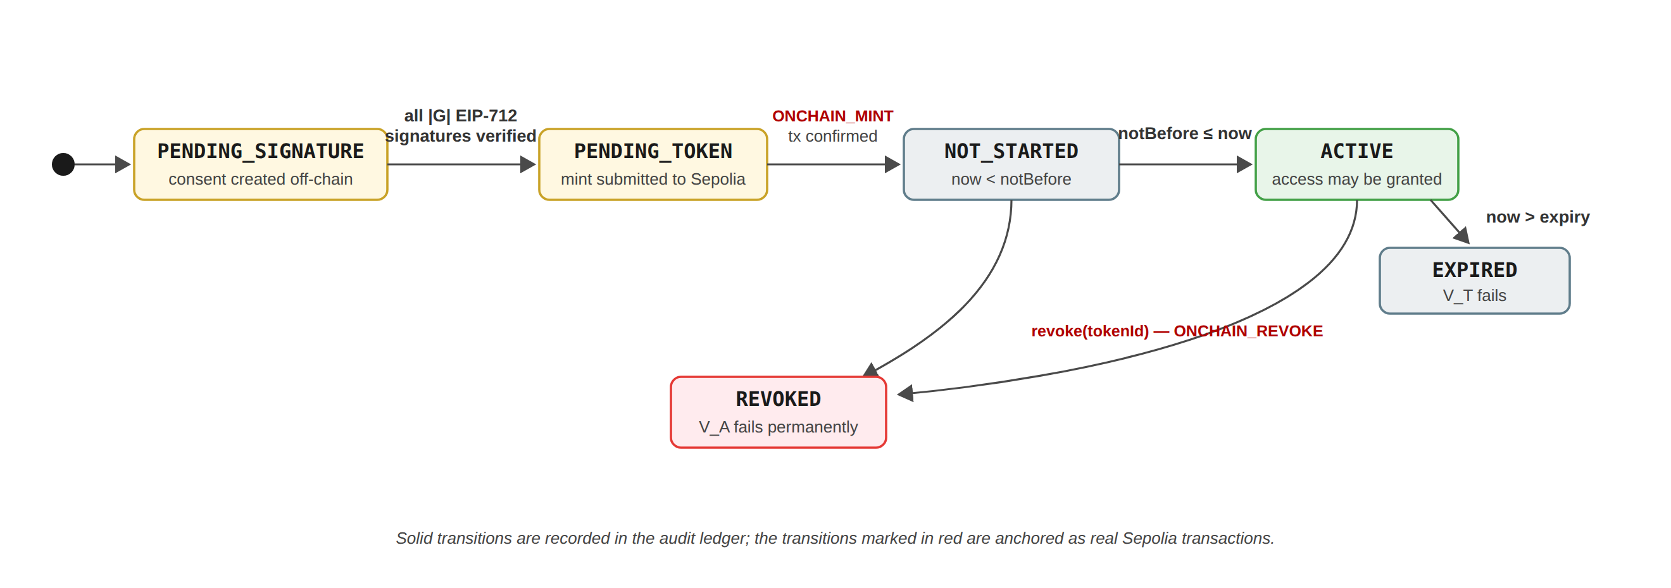
Figure A: The implemented consent lifecycle: every consent progresses through controlled states, and the activating and revoking transitions are anchored as verifiable Sepolia transactions.

Figure B — Trust predicate evaluation flow
Place beside the decision-matrix discussion of the implementation chapter (with Insertion 4); it is the report's Figure 5 redrawn with the two implemented verdicts included.
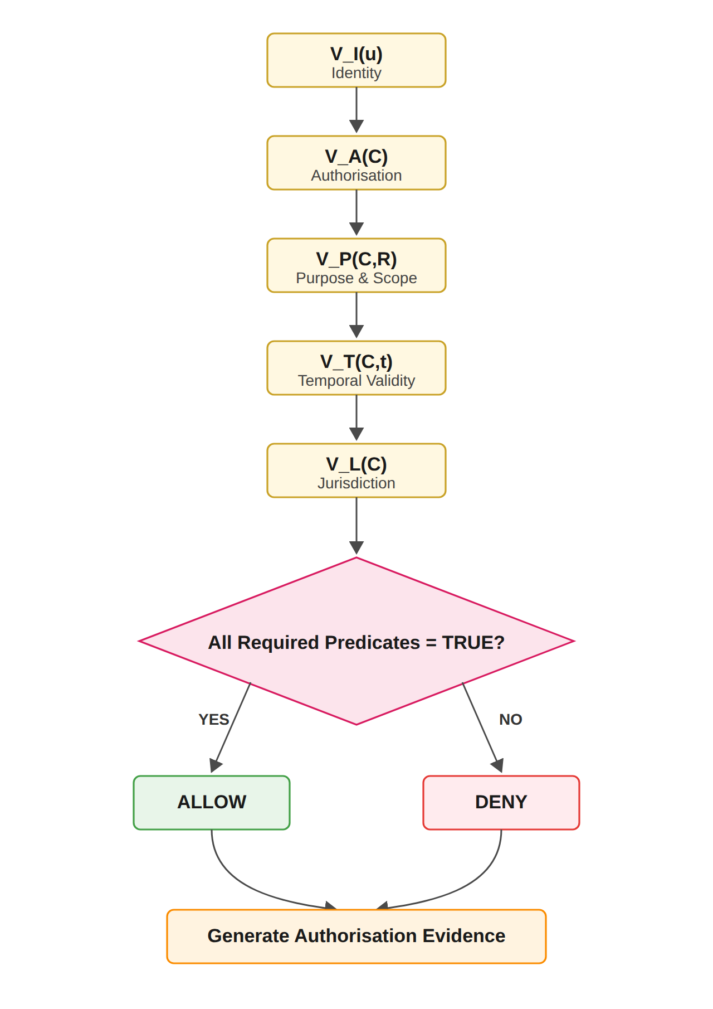
Figure B: Trust Predicate Evaluation and Authorisation Decision Flow, as enforced by the implemented Consent Engine.

Table A — Traceability from the research framework to the on-chain evidence
Place at the end of the implementation chapter as the closing subsection introduced by Insertion 7.
Research artefact | Defined in | Realised by (implementation) | Publicly verifiable evidence
RO1 / RQ1 — Consent object, Eq. (51), Algorithm 1 | §6.1 of the report | Patient subsystem: consent creation form; state PENDING_SIGNATURE | Consents f050c29a and 04da25f5 in the exported audit ledger
RO2 / RQ2 — DID and VC verification, Algorithm 2 | §6.2 of the report | Guardian subsystem: EIP-712 typed-data signatures, off-chain signer recovery per guardian DID | Verified signer 0x3Af549b0… recorded per SIGN_CONSENT event
RO3 / RQ3 — Threshold authorisation, Eq. (54), Algorithm 3 | §6.3 of the report | 2-of-2 ceremony with N = |G|; SBT minted on threshold | Mint tx 0x8be1b99e…daf13d, block 11,771,243, token #1
Decision rule and trust predicates, Eq. (59), Figure 5 | §5.2 and §6.6 of the report | Doctor subsystem: five-verdict decision matrix, ALLOW / DENY with failed-check listing | GRANTED and DENIED DATA_ACCESS events in the ledger; SA-jurisdiction denial
Lifecycle trust (RO5 direction) | §6.4 of the report (next stage) | Six-state lifecycle with on-chain revocation (Figure A) | Revoke tx 0x017efb9d…dceaa, block 11,771,307
Empirical assurance (RO6, empirical half) | §6.6 of the report | Auditor subsystem and the independent verifier re-checking every tx receipt | 60-event ledger; RESULT: ALL CHECKS PASSED; reproduction token #2, block 11,771,581
Table A: Traceability from the formal artefacts of the research report to the implemented mechanisms and their on-chain evidence.

Closing note
With Parts A–B applied to the report and Parts C–D applied to the implementation chapter, the two documents read as a single, mutually citing body of work: the report states the model in its implemented six-component, five-verdict, N-of-N form, and the implementation chapter names, for every demonstrated step, the equation, algorithm or figure it realises, closing the loop with evidence that any third party can verify on the public chain.

