RED-LINE REVISION (28 Sep 2026): red strikethrough = delete; red text = add or replace; black text = unchanged original. All 39 equations are kept unchanged. Aligns this chapter with HALAH v1.1 (commit 0a960ca) and with the revised CA2 report.
HALAH System and Workflow
The HALAH implementation provides a role-based patient consent management environment that operationalises the proposed multi-party healthcare data-sharing framework. The subsystem is organised around four principal actors and functions: patient consent creation, guardian cryptographic approval, authorised doctor data access, and independent audit of the consent lifecycle. Rather than treating consent as a single approval event, the implementation represents consent as a lifecycle in which a consent request is created, independently authorised by designated parties, cryptographically activated, continuously checked for validity, and subsequently used to control access to specific electronic medical record (EMR) modules.
The overall workflow implemented by the implementation is therefore consistent with the proposed authorisation model as
$$\text{Create Consent}→\text{Guardian Approval}→\text{Multi-signature Validation}→\text{Consent Activation}→\text{Doctor Access}→\text{Audit}$$
This sequence provides an end-to-end demonstration of how the conceptual consent model is translated into an operational healthcare data-sharing process.

1. HALAH System
The main HALAH subsystem presents the system as a Patient Consent Management Platform for History Access by Authorised Healthcare Providers. The subsystem provides a role-oriented environment in which different participants interact with the same consent lifecycle according to their respective authorisation responsibilities.
The implementation does not expose the underlying blockchain and cryptographic mechanisms as isolated technical components. Instead, these mechanisms are incorporated into the user workflow. Consequently, the subsystem presents the system from the perspective of the healthcare participants while the underlying implementation performs identity verification, consent-state checking, multi-party approval, cryptographic validation, and audit recording.
This design corresponds to the overall HALAH architecture, in which decentralised identifiers (DIDs) provide identity pointers, the consent object defines the authorisation conditions, cryptographic signatures provide evidence of approval, and the blockchain-based ledger provides lifecycle traceability.
The subsystem therefore serves as the entry point for demonstrating the complete authorisation process rather than functioning merely as a conventional patient-record application.

2. Create Smart Consent Contract: Patient Subsystem
The first functional subsystem is the Create Smart Consent Contract module. This module represents the patient-side initiation of a consent transaction and corresponds directly to the construction of the proposed consent object.
The subsystem requires the patient to specify the Patient DID, Authorised Doctor DID, Data Access Scope, Designated Guardian DIDs, and the temporal validity of the consent. These fields collectively operationalise the proposed consent representation:
$$C=\left(I , A , P , T , L , E\right)$$
where the identity of the patient is represented through a DID, the authorised actor is explicitly specified, the permitted data scope is constrained to selected EMR modules, and the temporal fields define when the authorisation becomes valid and when it expires.
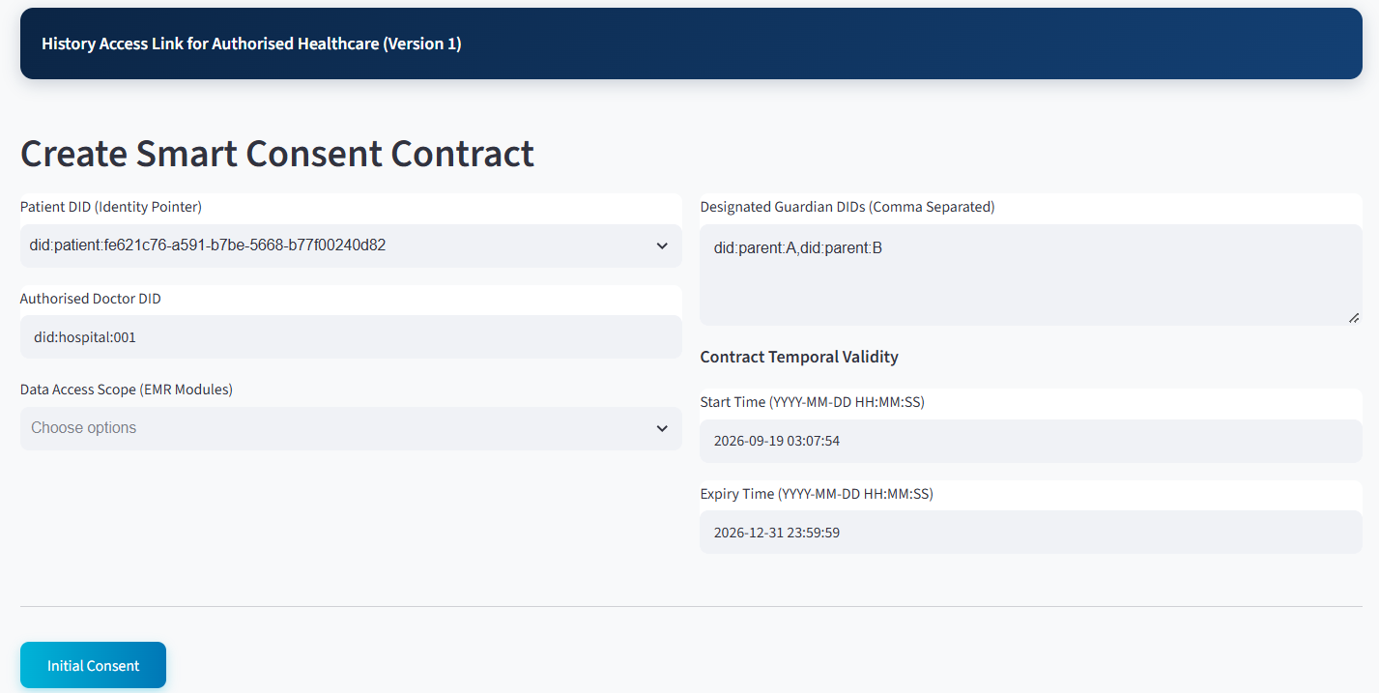
As shown in the figure above, the Patient DID provides the identity pointer for the data subject, while the Authorised Doctor DID limits the intended healthcare recipient. This is important because the implementation does not implement consent as a general permission to access a patient's medical information. Instead, the authorisation is bound to a specific identity and therefore supports subject-specific and actor-specific access control.
The Data Access Scope is particularly important to the proposed framework. Instead of granting access to the complete EMR, the patient can select particular modules, such as medication or procedure information. This implements the principle of purpose- and scope-limited consent and corresponds to the $P$component of the consent object.
The Designated Guardian DIDs establish the additional parties required to participate in the authorisation process. Their presence in the consent-creation subsystem demonstrates that multi-party consent is incorporated at the point at which the consent contract is constructed rather than being added after authorisation.
Finally, the Start Time and Expiry Time implement temporal constraints on the consent. Consequently, authorisation is not represented as a permanent permission. Instead, the consent has a defined lifecycle and can subsequently be evaluated by the Consent Engine according to its temporal validity.
From a system perspective, this module therefore corresponds primarily to Consent Object Construction and Patient Initiation.

3. Guardian Cryptographic Approval
The second part is the Guardian Cryptographic Approval. As shown in the figure below, operationalises the multi-party authorisation component of the proposed framework.
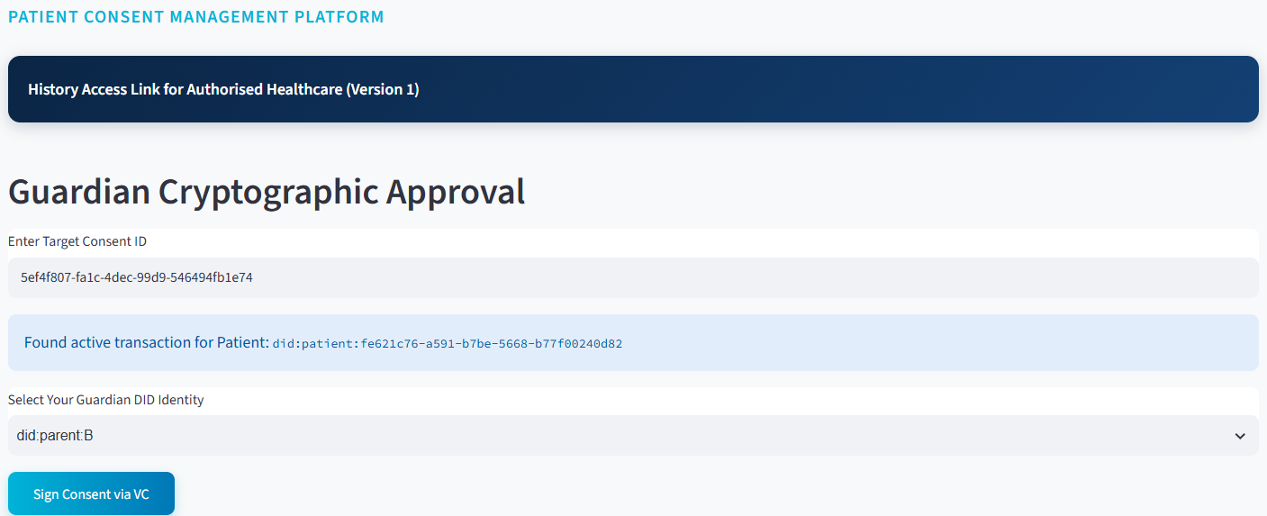
The guardian first enters the target Consent ID, after which the system retrieves the corresponding active transaction and displays the associated patient DID. The guardian then selects and verifies their own Guardian DID identity. In v1.1, the approval is an EIP-712 typed-data signature that is accepted only if the signer recovered from it matches the guardian's DID-bound address, and a second approval by the same guardian is refused. Full W3C Verifiable Credential verification is Stage 2 (CA3) work.
The subsystem subsequently reports:
Identity verified. Multi-sig added: (2/2)
Update: In v1.1 this message reads 'EIP-712 signature verified (signer 0x…). Multi-sig: 2/2'. Retake the screenshot and update this quotation.
This is an important implementation-level demonstration because the consent is not activated merely because the patient created it. Instead, the system requires the predefined guardian approval condition to be satisfied.
The implementation therefore implements the logical authorisation rule:
$$Decision=V_{I}∧V_{A}∧V_{P}$$
where identity verification, authorisation verification, and permission/scope verification must all be satisfied before access can be granted.
For the demonstrated two-party guardian configuration, the approval process can also be represented as:
$$\sum_{g∈G}{S}ign\left(g , C\right)≥2$$
where $G$represents the designated guardians and two valid signatures are required for activation. Once the required signatures have been obtained, the subsystem displays SBT MINTED SUCCESS[SBT MINTED – LOCAL LEDGER], followed by the Sepolia anchoring result (v1.1), together with the Soulbound Token identifier and the status as Consent Fully Activated. This provides a visible representation of the transition from a pending consent transaction to an activated consent state. The SBT therefore functions in the implementation as a persistent cryptographic representation of the completed consent authorisation rather than as a transferable asset.
The guardian subsystem consequently corresponds to Multi-Party Approval, Cryptographic Verification and Consent Activation in the proposed architecture.

4. Secure Patient Data Access for Doctor
The third module is the Secure Patient Data Access module and represents the healthcare-provider side of the authorisation process.
The doctor enters an authorised Consent ID, after which the system retrieves and displays the associated consent information. The subsystem shows the patient DID, Consent ID, purpose, and current consent state:
$$State=ACTIVE$$
This is important because the doctor does not directly access patient data based solely on possession of a Consent ID. The system first evaluates whether the underlying authorisation remains valid.
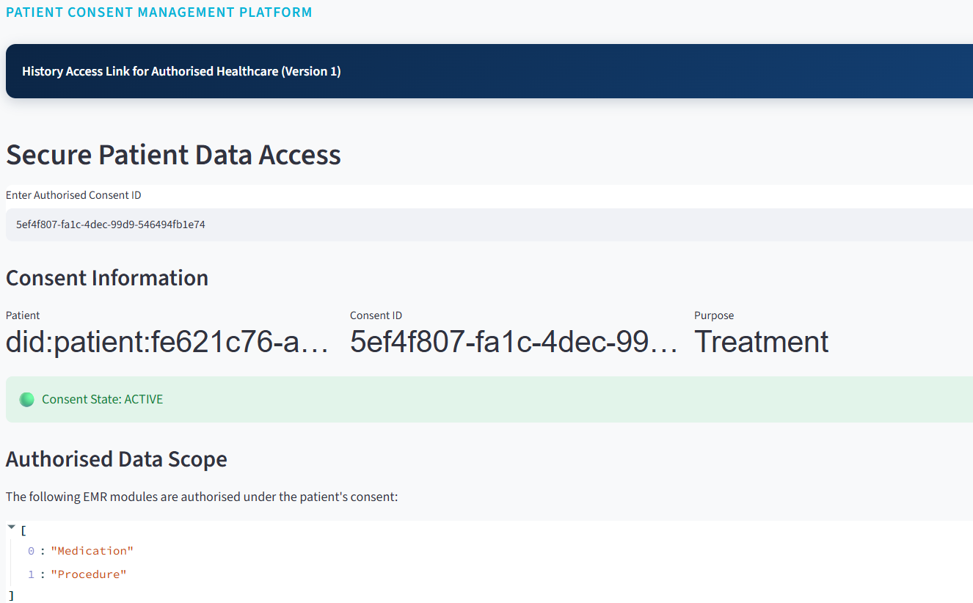
The subsystem then presents the Authorised Data Scope, showing that only the EMR modules specified in the original consent are available. In the demonstrated transaction, the authorised modules are:
$$Scope=\left\{\text{Medication} , \text{Procedure}\right\}$$
The doctor must subsequently select the modules to request. The system displays the requested modules and performs cryptographic verification before granting access. In v1.1 this is an integrity proof labelled as a ZK placeholder; a Groth16 zero-knowledge proof of consent validity is used only when the circuit in zk/ has been built.
The message shows Cryptographic Verification Successful — Access Granted.
Add: The v1.1 Doctor page also displays the decision matrix VI, VA, VP, VT and VL computed by evaluate_allow(). Data release itself is gated by authorize(), which requires an ACTIVE consent, a valid proof and a requested scope contained in the consented scope; routing release through the full matrix is planned for Stage 2.
demonstrates the transition from consent verification to data-access authorisation.
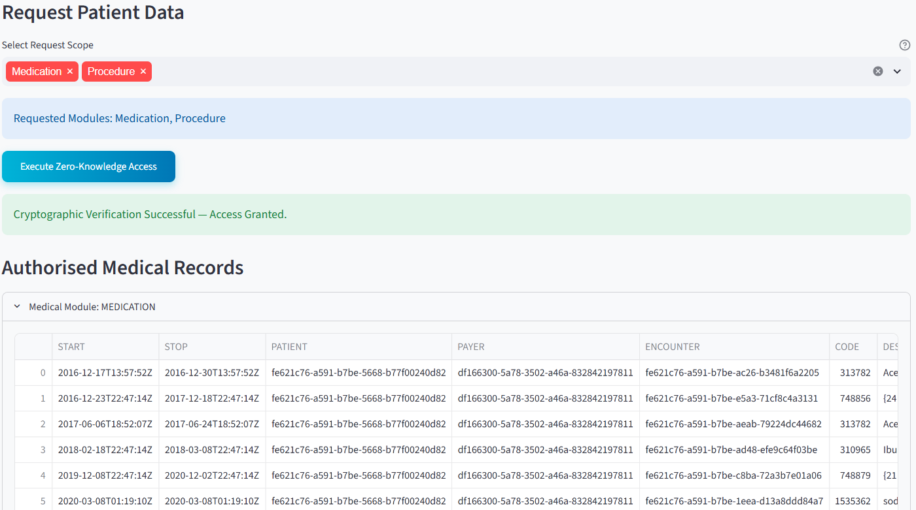
This distinction is central to the HALAH design. Consent and data access are not treated as identical events. Instead, it goes the flow as below
$$Consent→Verification→AccessDecision$$
The doctor is therefore authorised only when the requested resources are consistent with the consent object and the consent remains active. A request outside the consented scope is refused with ACCESS DENIED, and the denial is written to the audit log.
The final Authorised Medical Records section presents the actual data modules available to the doctor. Because the subsystem separates MEDICATION and PROCEDURE modules, it provides a direct visual demonstration of fine-grained EMR access control.
Thus, the doctor subsystem corresponds to Consent-State Validation, Scope Enforcement and Authorised Data Access.

5. Blockchain Audit & Consent Lifecycle for Auditor
The fourth major module is the Blockchain Audit & Consent Lifecycle module. This subsystem provides an independent view of the complete consent process and corresponds to the auditability and accountability component of the HALAH framework.
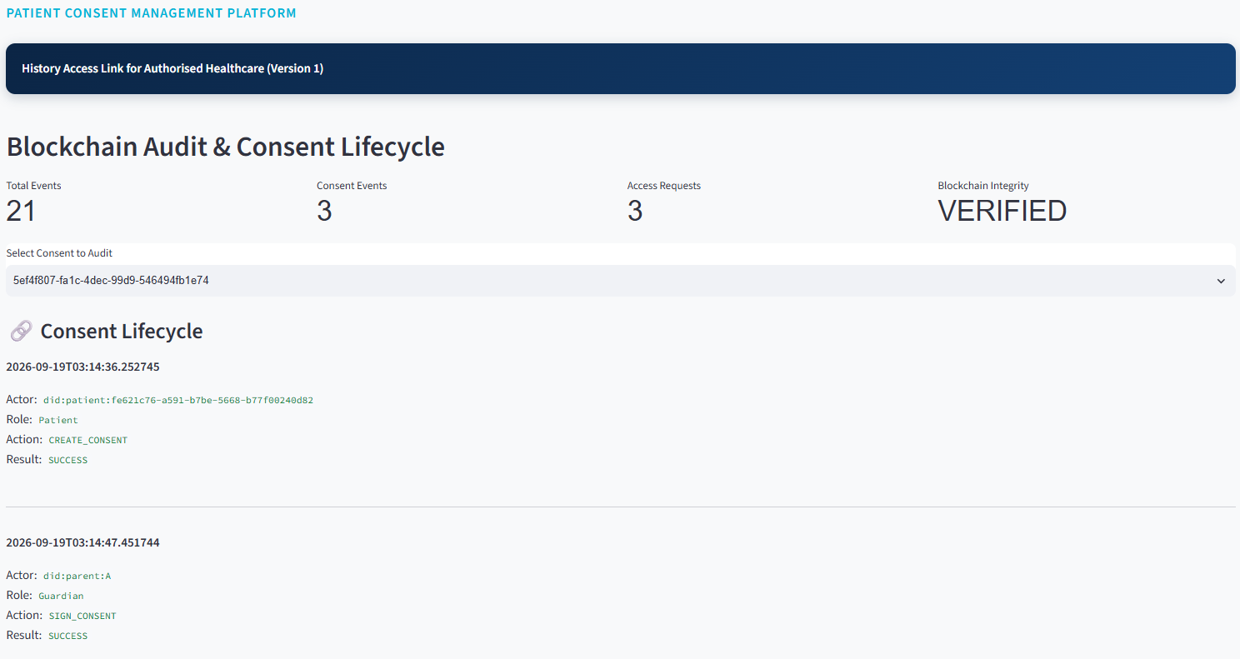
As shown in the figure above, the system first provides aggregate indicators including:
$$\text{Total Events}=21 \\ \text{Consent Events}=3 \\ \text{Access Requests}=3$$
and:
$$\text{Blockchain Integrity}=\text{VERIFIED}$$
These indicators give the auditor an immediate overview of the recorded system activity and the integrity status of the underlying ledgerwhether each event is anchored on Sepolia (with a real transaction hash) or recorded off-chain only.
More importantly, the Consent Lifecycle section reconstructs the sequence of events associated with a particular consent. The displayed records include: $CREATE_CONSENT$
performed by the patient, followed by: $SIGN_CONSENT$
performed by the guardians, followed by: $MINT_SBT$
performed by the smart contract.
The subsequent system events: $STATE_CHECK$
demonstrate that the Consent Engine continuously evaluates the state of the authorisation. Finally, the doctor generates: $DATA_ACCESS$
with the result: $GRANTED$
This produces an explicit chain of evidence as
$$Patient→Guardian_{A}→Guardian_{B}→SmartContract→ConsentEngine→Doctor$$
The audit subsystem therefore allows an auditor to reconstruct not only who accessed the data, but also why that access was permitted, because the access event can be associated with the preceding consent creation, guardian approvals, consent activation, and state checks.
This corresponds to the proposed requirement for traceability, accountability and non-repudiable consent evidence.

6. Detailed Audit Records
The Detailed Audit Records component provides a lower-level view of the events represented in the lifecycle subsystem.
Where the lifecycle view is primarily designed to communicate the chronological sequence of the authorisation process, the detailed audit view provides the underlying event-level evidence. Each event can be associated with attributes such as actor, role, action, result, timestamp and consent context.
This separation is useful because different stakeholders require different levels of information. A clinician may only need to know that a consent is active and valid, whereas an auditor may need to establish precisely when an approval occurred, which identity performed it, and what authorisation decision followed.
The subsystem therefore implements the distinction between operational access information and forensic/audit information.
Add figure: Add a screenshot of the Detailed Audit Records table from v1.1 (key columns first, including tx_hash) as evidence for this section.

CA 3 Discussion ← stray heading; delete (or move to a separate Discussion section at the end).
7. Complete Blockchain Audit Ledger (off-chain SQLite ledger with Sepolia-anchored events)
The Complete Blockchain Audit Ledger provides the most comprehensive representation of the recorded consent history. Only events that carry a real transaction hash are on-chain; all other events are stored off-chain in SQLite, and the ledger never shows a synthetic hash for them (commit 0b30b44).
This component demonstrates that the audit mechanism is not limited to successful data-access events. Instead, the system records the broader lifecycle of the consent, including creation, signatures, state validation, smart-contract actions and data-access decisions.
Consequently, the ledger provides the evidentiary foundation for evaluating several properties of the proposed framework:
$$\text{Accountability}+\text{Traceability}+\text{Integrity}+\text{Non-repudiation}$$
The complete ledger also provides a mechanism for independently examining whether the observed access event is consistent with the original consent conditions.
For example, the demonstrated sequence shows that the doctor receives a GRANTED result only after the consent has reached the ACTIVE state. This provides an implementation-level demonstration that access decisions are linked to the consent lifecycle rather than being independent application events.

8. Correspondence Between Subsystems and the HALAH Framework
The four subsystems collectively implement the principal stages of the proposed framework:
HALAH Framework Component | Implementation Subsystem | Main Function
Consent Object Construction | Create Smart Consent Contract | Defines patient, authorised doctor, data scope, guardians and temporal validity
Identity & Authorisation | Guardian Cryptographic Approval | Verifies guardian identities and records required signatures (EIP-712 signatures; W3C VC in Stage 2)
Multi-party Consent | Guardian Cryptographic Approval | Implements the 2-of-2 approval condition (N = |G|; configurable k-of-n in Stage 2)
Consent Activation | Guardian Cryptographic Approval | Generates the SBT and changes consent to fully activated
Consent-State Management | Secure Patient Data Access | Checks whether the consent is ACTIVE
Scope Enforcement | Secure Patient Data Access | Restricts access to authorised EMR modules
Cryptographic Access Control | Secure Patient Data Access | Verifies the access request before granting data
Healthcare Data Access | Secure Patient Data Access | Provides authorised Medication and Procedure records
Lifecycle Traceability | Blockchain Audit & Consent Lifecycle | Reconstructs the chronological consent process
Accountability | Detailed Audit Records | Provides event-level evidence
Ledger Integrity | Complete Blockchain Audit Ledger (SQLite + Sepolia anchors) | Provides the complete recorded transaction history
This mapping demonstrates that the implementation is not merely a collection of independent user-subsystem modules. Rather, the modules correspond to successive stages of the proposed authorisation protocol.

9. Overall System Demonstration
Taken together, the subsystems demonstrate an end-to-end implementation of the proposed HALAH authorisation workflow. The patient first establishes the consent conditions through the Smart Consent Contract subsystem. The designated guardians then independently authenticate and provide the required cryptographic approvals. Once the multi-signature condition is satisfied, the consent is activated and represented by an SBT. The authorised doctor subsequently submits an access request, which is evaluated against the patient's identity, consent state and authorised data scope. Only when these conditions are satisfied does the system provide access to the specified EMR modules. Finally, the complete sequence is recorded and exposed through the auditor subsystem.
where $C$denotes consent creation, $MS$multi-signature approval, $SBT$consent activation, $StateCheck$lifecycle validation, $AccessDecision$authorisation enforcement, $EMR$authorised medical-record access, and $Audit$immutable lifecycle recordingtamper-evident lifecycle recording (hash-anchored on Sepolia).
From a research-implementation perspective, the most significant feature of the presented subsystems is therefore the continuity between consent specification, multi-party authorisation, access enforcement and audit evidence. The user subsystems provide a visible representation of this continuity, allowing the proposed HALAH model to be demonstrated as an operational authorisation workflow rather than only as a conceptual framework.
Limitations. The demonstration uses synthetic Synthea records, guardian keys derived from the DID for demonstration, a syntactic DID check instead of W3C Verifiable Credentials, an N-of-N guardian threshold, and the Ethereum Sepolia testnet. These limitations are addressed in Stage 2 (CA3), together with the adversarial evaluation defined in Algorithm 6 of the CA2 report.

