|  |  |
| --- | --- |
|  | **ArchiMateCG** is a solution aiming at assessing the value of using ArchiMate I**nteractive Compound Graphs** for the various stakeholders involved in [architecting the enterprise for its digitalisation and who adopted the ArchiMate® 3.1 language as the standardized architecture description language.](https://pubs.opengroup.org/architecture/archimate3-doc/)  ArchiMateCG aims at serving actors dealing with End to End Digital Processes, Model Based System Engineering, Product Lifecycle Management industrial approach (as defined by [CIMDATA](https://www.cimdata.com/en/resources/about-plm)) and Interoperability of Enterprise Application.  For this, ArchiMateCG supports creation of advanced interactive compound graphs visualization and algorithms in order to analyze architecture descriptions and blueprints produced using the ArchiMate language.  ArchiMateCG is not intended to replace legacy ArchiMate modeling platforms and enterprise repositories, but to complement and extend them with previously described features.  Consequently ArchiMateCG comes with various import and export [functionalities, and complementary sets of scripts for Archi and Enterprise](https://sparxsystems.com/enterprise_architect_user_guide/15.2/model_domains/archimate.html)  [Architect.](https://sparxsystems.com/enterprise_architect_user_guide/15.2/model_domains/archimate.html)  ArchiMateCG is realized by combined usage of standardized Web technologies such as HTML, SVG and JavaScript, in order to run on and require only a Web Navigator.  Finally ArchiMateCG is a research incubator, aiming at demonstrating and assessing research results on Continuous Operational Interoperability for digital collaboration within and between enterprises applying Model Based approaches. [It will in particular address the combined usage of Linked Data, Semantic](https://www.w3.org/standards/semanticweb/)  [Web,](https://www.w3.org/standards/semanticweb/) [Standardized Application Protocols](https://en.wikipedia.org/wiki/ISO_10303) [and](https://www.w3.org/standards/semanticweb/) [Graph based technologies.](https://www.linkedin.com/pulse/emerging-landscape-distributed-knowledge-ontology-semantic-figay/) |
| A prototype and  demonstrator under  development |

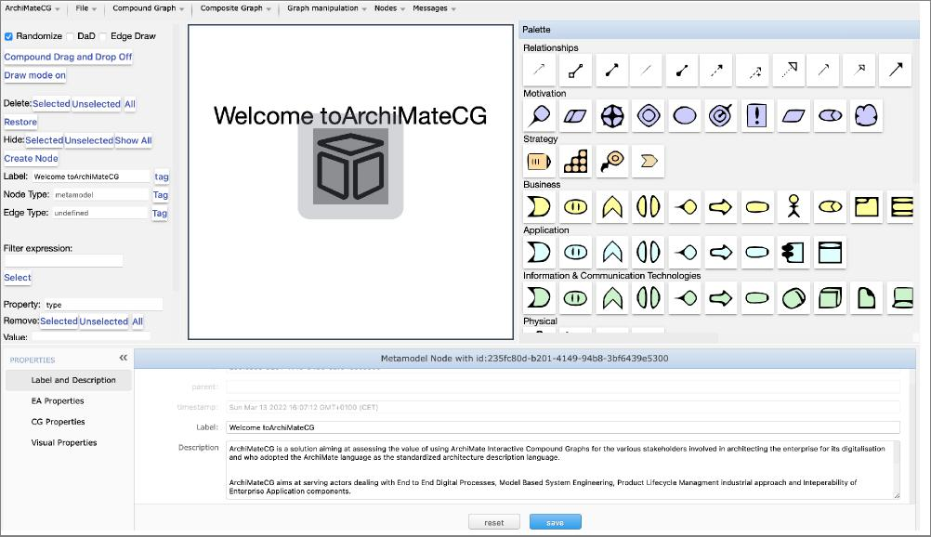

|  |  |  |  |  |  |  |  |  |  |
| --- | --- | --- | --- | --- | --- | --- | --- | --- | --- |
| **Import models from Archi and other ArchiMate  models repositories in order to take advantage of the  functionalities provided by ArchiMateCG**  This can be made relying on:   * specific JSON data models * the XML Open Exchange Format defined by the Open Group * and in the future many other syntaxes | | | |  | | | | | |
|  |  |  | | | |
|  |  |  | | | |
|  |  |  | | | |
|  |  | |  |  |  |
|  | | | | **Collapse or Extend the graph nodes taking advantage of automated layouts adapted to compound graphs.**  This can be done on:   * the whole graph * a given compound element * a selection of elements | | | | | |
|  | |  | |
|  |  |  |  |
|  | | | |
|  | | | |
| Collapse or Extend the Graph Edges taking advantage of automated layouts adapted to compound graphs.  This can be done on:   * the whole graph * a given selection of edges * the edges existing between a selections of nodes | | | |  | | | | | |

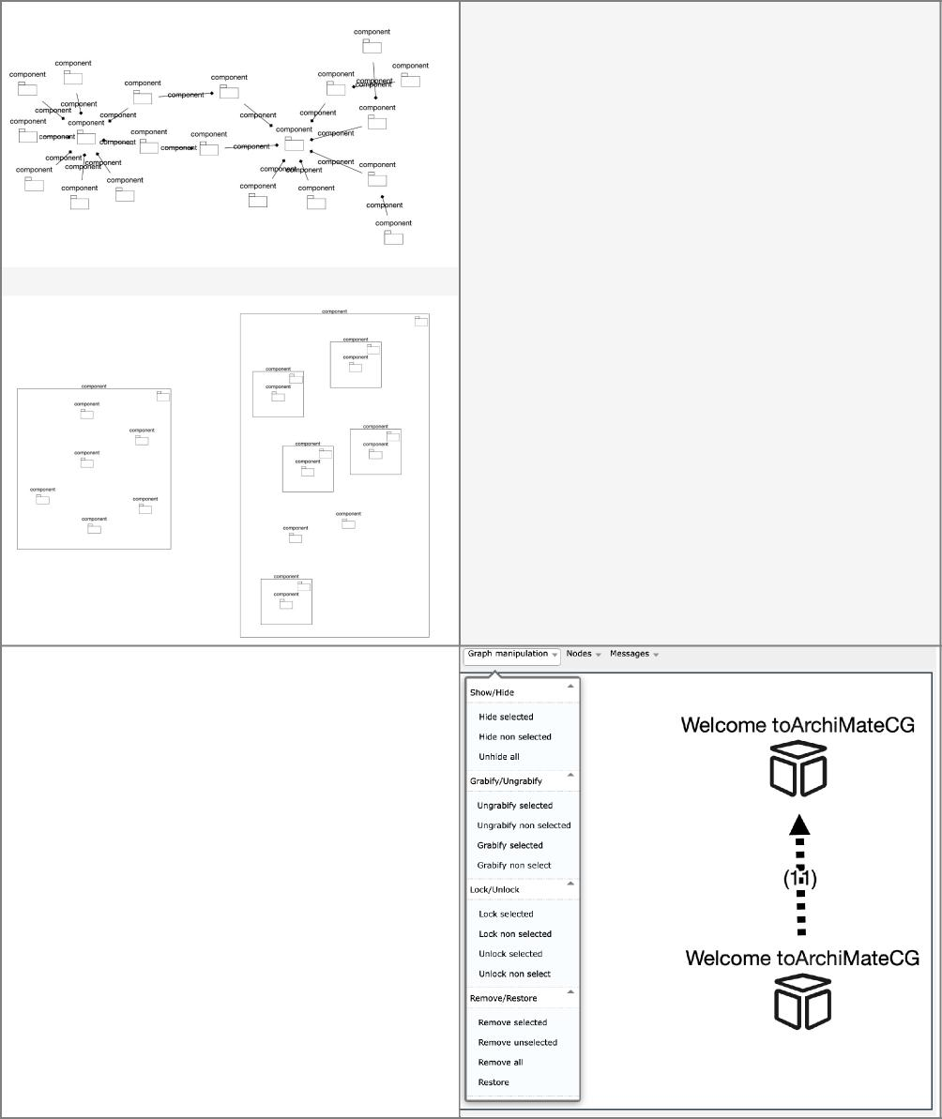

**Let's change the presentation of a composite mode!.**

This can be done by:

* Transforming a graph of model elements with composition relationships on compound nodes
* Transforming compound nodes reflecting a composition in a graph

The composition relationships are preserved, even in not displayed on the graph.

You can also shows graph content as dynamic interactive matrixes, displaying various graph characteristics or calculate weights.

**Let's manipu!ate the graphs in order to show what you expect**

This can be done by:

* Hiding a selection of nodes
* Removing a selection of nodes
* Preventing the users or the software to move a selection of nodes

The reverse operations can be made.

Selections can be made manually, through a filter expression on data (properties of nodes and edges) based on shortest path or neighborhood.

|  |  |  |  |  |  |  |  |  |  |  |  |  |  |  |  |  |
| --- | --- | --- | --- | --- | --- | --- | --- | --- | --- | --- | --- | --- | --- | --- | --- | --- |
|  | | | | | | |  | |  |  | |  | | |  |  |
|  | |  | **Let's Create complementary models elements, as nodes, compound nodes and edges** | | | | | |  |
|  | |  |  | |  | | |  |  |
|  | | This can be done by relying on :   * an enrichment of the ArchiMate language suited for * specializations of ArchiMate  Architects' needs * ergonomic combined usage of a palette and of action buttons | | | | | |  |  |
|  | |  |  | |  | | |  |  |
|  | | The goal is to reach the same level of ergonomy than mindmap solutions. | | |  | | |  |  |
|  | |  |  | |  | | |  |  |
|  |  |  |  |  |  | |  | | | | | | | | | |
|  |  | **Let's visualize, modify and create properties of the model elements and relationships** | |  |  | |
|  |  |  |  |  |  | |
|  | This can be done with :   * the property pane displaying what concerns double clicked graph elements * the node creation menu | | | |  | |
|  |  |  |  |  |  | |
|  | The goal is to access both data model and visual properties of the nodes, in order to control both the content and how it is rendered. | |  |  |  | |
|  |  |  |  |  |  | |
|  | | | | | | |  | |  | |  |  |  |  | | |
|  | |  | | **Let's color the graph elements according two their values for a given property** | | |  | | |
|  | |  | |  |  |  |  | | |
|  | | This can be done by :   * selecting the property * automatically generating the colors legend and coloring the graph | | |  |  |  | | |
|  | |  | |  |  |  |  | | |
|  | | The goal is to perform some visual mining in order to support the analysis of an architecture. | | | |  |  | | |
|  | |  | |  |  |  |  | | |

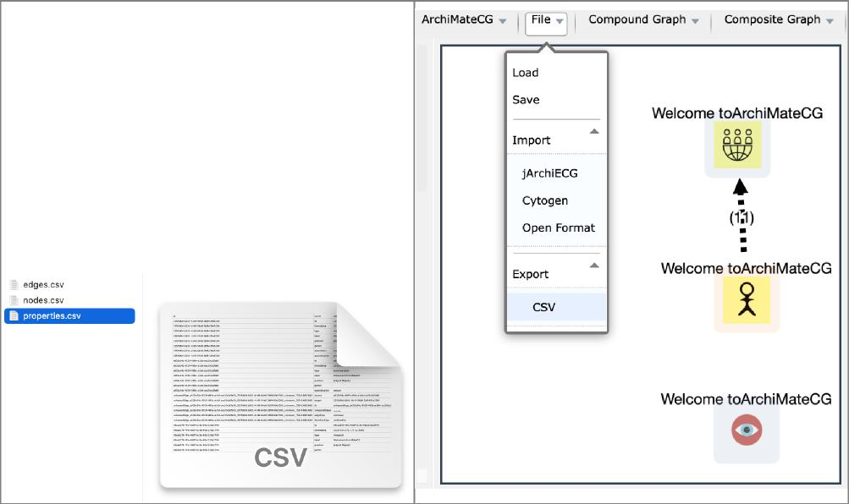

**Let's export as CSV/OWL files the model contained in a selected part of the graph**

CSV export provides :

* a list of model elements (nodes.csv)
* a list of relationships (edges.csv)
* a list of properties (properties.csv)

The goal is to be able to complete an architecture analysis

relying on worksheets.

OWL export produces a JSON LD file which can be imported on Protégé or various graph/knowledge data base, such as RDFox, Stardog, OpenLink Virtuoso, etc.

|  |  |
| --- | --- |
|  | **Let's visualize the graph as matrixes**  With complex graph with many relations, you have to face the "hairball" effect. Adjacency matrixes provides alternative way for visualizing a graph. But many other kinds of matrixes can be derived for analysing an architecture:   * matrixes of distance between nodes * matrixes with relations between nodes * Matrixes with shortest paths between nodes ...   Proposing only a simple adjacency matrix with the current version, it is intended to extend the proposed interactive matrixes with those bringing value for the architecture analysis in future versions, including matrixes suited for compound graphs with lines and columns which can be collapsed and extended. |

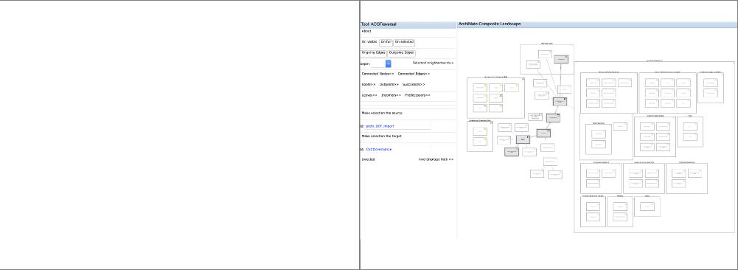

**Let's visually traverse the graph**

The model being a graph, it is possible from a node, an edge or a group of them to select:

* connected edges and nodes or neighborhood with a given depth
* Shortest path from a source node to a target node
* Roots and Leaves ...   
  if it exists

Future versions will extend graph traversal to compound graph traversal, which is more suited for Composite Graph analysis

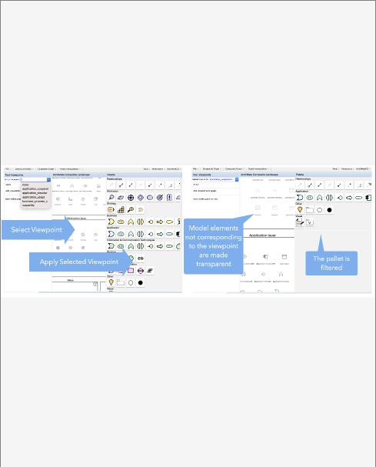

**Let's develop exports script on your preferred tools (Archi, Enterprise Architect, etc.) in order to feed the ArchiMate Compound Graph viewer and analyzers.**

ArchiMateCG comes with a set of jArchi scripts allowing to make some preprocessing before to export data to ArchiMateCG :

* what is contained in a view or a set of views
* the content of a model
* a subset of a model

The goal is to be able to aggregate data coming from various model repositories relying on various products and languages, in order to aggregate them and perform required analysis on you desktop.

**Let's automate algorithms defined   
for relevant architecture analysis**

Relying on the set of available features for graph analytics and for advanced visualization, it is possible to create and includes modules launching parameterized treatments on subsets of your model, eventually filtered by relevant viewpoints, which are suited for such or such Architectural analysis, and to display it in the appropriate presentations for communication or results publishing, being in a document or in models repositories.

**Let's filter models according to Architectural viewpoints**

Based on [ISO 42010](https://www.iso.org/standard/50508.html) (Systems and software engineering — Architecture description), ArchiMate proposes a set of predefined viewpoints, which are suited for guiding production of views suited for different kind of stakeholders, having given concerns and purposes. ArchiMateCG allows to filter the palette according to these viewpoints.

Combined with the ability to export a visible graph as an ArchiMate view based on the Open Exchange Format and to preserve identifiers during import and export, it makes it possible to quickly push compound diagrams resulting from you analysis in you usual ArchiMate modeling tools supporting import of Open Format.

It is also plan to create you own viewpoints, or to use those [which will be defined by the NATO Architecture Framework V4 when available.](https://www.nato.int/cps/en/natohq/topics_157575.htm)



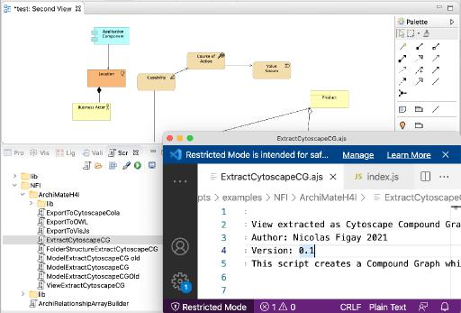

**Let's register some animation on top of model for story telling applied to your model**

It is possible to automate and registed a set of interactions with you graph model as an animation, which you can make available in ArchiMateCG and run on you model.

It can be used for communication purpose, or as a way to publish some results as dynamic animation, and not static (office documents) or impossible to change (videos) documents.