STUDENT INDUSTRIAL WORK EXPERIENCE SCHEME
(SIWES) TECHNICAL REPORT

DESIGN AND DEVELOPMENT OF LIBRIS:
A VOICE-ASSISTED, BOOK-GROUNDED DIGITAL READER

PREPARED BY
[STUDENT NAME]
MATRICULATION NUMBER: [MATRICULATION NUMBER]

DEPARTMENT OF COMPUTER SCIENCE
[NAME OF INSTITUTION]

SUBMITTED IN PARTIAL FULFILMENT OF THE REQUIREMENTS FOR THE AWARD OF B.Sc. COMPUTER SCIENCE

SEPTEMBER 2026

TITLE PAGE
DESIGN AND DEVELOPMENT OF LIBRIS: A VOICE-ASSISTED, BOOK-GROUNDED DIGITAL READER
A technical report submitted by [STUDENT NAME], Matriculation Number [MATRICULATION NUMBER], to the Department of Computer Science, [NAME OF INSTITUTION].
The report documents practical software-development activities carried out during the Student Industrial Work Experience Scheme and is submitted in partial fulfilment of the requirements for the award of B.Sc. Computer Science.

CERTIFICATION
This is to certify that this technical report titled “Design and Development of LIBRIS: A Voice-Assisted, Book-Grounded Digital Reader” was prepared by [STUDENT NAME], Matriculation Number [MATRICULATION NUMBER], in partial fulfilment of the requirements for the Student Industrial Work Experience Scheme (SIWES) of the Department of Computer Science, [NAME OF INSTITUTION].
______________________________
Industrial Supervisor / Date
______________________________
Departmental SIWES Coordinator / Date
______________________________
Head of Department / Date

DEDICATION
This report is dedicated to God, to my family for their support, and to every learner who benefits when technology makes reading more accessible, continuous, and engaging.

ACKNOWLEDGEMENTS
I am grateful to God for the strength and opportunity to complete the Student Industrial Work Experience Scheme. I sincerely appreciate [NAME OF INSTITUTION], the Industrial Training Fund, and my department for providing an environment in which theoretical computer-science knowledge can be applied to a practical task.
I acknowledge the guidance of my industrial supervisor, [SUPERVISOR NAME], and the support received from colleagues and fellow students during the design, implementation, testing, and documentation of LIBRIS. I also appreciate my family and friends for their encouragement throughout the attachment period.

ABSTRACT
This report presents the design and development of LIBRIS, a Python-based digital reading companion created during the Student Industrial Work Experience Scheme. LIBRIS enables a user to import TXT, PDF, and EPUB books, read them within a desktop reader, listen to book content through text-to-speech, issue spoken commands, continue from saved progress, and ask questions that are answered from the selected book rather than from the internet. The project addresses common reading difficulties such as losing one’s position, navigating long digital documents, and accessing written content when visual reading is inconvenient.
The system was developed with Python, Tkinter, pyttsx3, SpeechRecognition, sounddevice, pypdf, EbookLib, and BeautifulSoup. The user interface was designed with a black base, light-purple emphasis, and red action states. Testing was performed on TXT, PDF, and EPUB files. The result is an educational prototype that demonstrates practical software engineering, user-interface design, file processing, local data management, and voice interaction. Future versions can improve semantic retrieval, accessibility settings, synchronized audio controls, user accounts, and cross-device progress synchronization.

TABLE OF CONTENTS
Title Page
Certification
Dedication
Acknowledgements
Abstract
List of Tables
List of Figures
Chapter One: Introduction
Chapter Two: Organisation and SIWES Experience
Chapter Three: Activities and Technologies Used
Chapter Four: Design and Implementation of LIBRIS
Chapter Five: Problems Encountered
Chapter Six: Recommendations
Chapter Seven: Summary
References
Appendices

LIST OF TABLES
Table 3.1: Software tools used for LIBRIS
Table 4.1: Functional requirements of LIBRIS
Table 4.2: Non-functional requirements of LIBRIS
Table 4.3: Test cases and outcomes
LIST OF FIGURES
Figure 4.1: ReadEra-inspired library-navigation reference
Figure 4.2: LIBRIS reader and spoken-text tracking concept

CHAPTER ONE
1.1 Background to SIWES
The Student Industrial Work Experience Scheme (SIWES) is a skills-acquisition programme established to complement classroom learning with supervised practical experience. Computer Science is a field in which knowledge changes rapidly, so students need opportunities to transform programming concepts, data structures, algorithms, databases, and software-engineering principles into working solutions. SIWES creates that bridge by exposing students to professional routines, work ethics, documentation, troubleshooting, collaboration, and the limits of real hardware and software environments.
The experience documented in this report focused on the planning and construction of LIBRIS, a digital reading companion. The project was selected because reading remains central to academic life, yet many students find it difficult to maintain concentration, remember where they stopped, manage many electronic books, or obtain help while studying. A voice-assisted reader is a suitable practical task because it combines programming, user-interface design, data handling, accessibility, and artificial-intelligence concepts in one manageable system.
This chapter introduces SIWES, explains the purpose and objectives of the scheme, and states the problem that motivated LIBRIS. Later chapters describe the organisation context, tools, system requirements, development activities, challenges, recommendations, and the final outcome of the work.

CHAPTER ONE
1.2 Purpose and Objectives of SIWES
The primary purpose of SIWES is to expose students to real work situations related to their courses of study. It allows the student to understand how tasks are planned, assigned, implemented, tested, reviewed, and documented outside the classroom. In Computer Science, a practical placement helps students understand that a useful program is not only one that runs; it must also be understandable, maintainable, reliable, secure, and convenient for its intended users.
SIWES also develops transferable skills. These include communicating technical ideas clearly, managing time, using version control and project folders responsibly, reading library documentation, handling errors calmly, and receiving feedback from supervisors or users. The scheme therefore provides both technical competence and professional maturity. The LIBRIS project offered an opportunity to practise these skills by moving from an initial folder structure to a functioning desktop prototype.
For this report, the placement organisation should be entered as [ORGANISATION NAME]. The organisation description in Chapter Two is written as an editable template so that the student can replace it with accurate facts about the actual host establishment, department, supervisor, period of attachment, and assigned duties before printing.

CHAPTER ONE
1.3 Problem Statement, Aim, and Scope
The main problem addressed by LIBRIS is that ordinary file storage does not provide a supportive reading experience. A student may own several PDFs or EPUBs but still have to remember a file location, search manually for the previous page, and read without assistance. When a reader wishes to listen rather than look at a screen, a simple text reader is inadequate. In addition, a general chatbot may answer from outside knowledge rather than the chosen study material, which can be misleading during revision.
LIBRIS was therefore designed around five objectives: to maintain a local library of books; to provide a visible reader for imported documents; to read text aloud while highlighting the current section; to preserve reading progress; and to answer questions from the selected book’s extracted text. A further objective was to create an inviting interface whose colour scheme and navigation encourage repeated use. The final design uses black surfaces, light-purple emphasis, and red controls for important stop or pause actions.
The scope of the first version is deliberately limited to desktop use and the TXT, PDF, and EPUB formats. It is not a replacement for a commercial e-reader, cloud storage service, or academic search engine. Instead, it is a practical prototype demonstrating how locally stored material can support voice-assisted study without using web search for book answers.

CHAPTER TWO
2.1 Description of the Organisation
[ORGANISATION NAME] is the host establishment where the SIWES attachment was undertaken. Before final submission, this section should be edited to state the organisation’s location, ownership, business area, services, relevant computer facilities, staff structure, and the department or unit to which the student was attached. Accurate facts are important because this technical report is also a record of the student’s industrial exposure.
For a software-development attachment, a suitable organisation description may explain that the organisation uses information systems to support communication, records, training, operations, customer service, or digital-product development. The student’s placement can then be positioned within an information-technology, software, data, or support unit. During the attachment, attention was given to observing how user requirements are converted into program features and how applications are tested before being presented to users.
The work environment encouraged a practical development cycle: identify a need, define requirements, select suitable tools, create a small implementation, test with real files, note problems, improve the design, and document the result. This cycle guided the development of LIBRIS and reinforced the importance of structured problem solving in Computer Science.

CHAPTER TWO
2.2 Nature of Work Performed
The expected responsibilities during the attachment included learning the local development environment, reviewing Python libraries, designing an application structure, testing different file formats, documenting observed issues, and improving the usability of the application. These activities required independent research as well as deliberate experimentation. A major lesson was that installing a package is not enough: its behaviour must be tested with the kind of file or device that a real user will use.
The LIBRIS project was organised into separate modules. The library module registers and selects books. The reader module extracts text and saves reading progress. The audio module provides text-to-speech and microphone transcription. The AI module identifies passages relevant to a user’s question. The user-interface module displays the collection, reader controls, progress, and question area. This separation made the project easier to debug and improved maintainability.
Supervision and feedback influenced the decision to make the reader visible when a book is imported. The earlier interface could import a file and read it aloud, but it did not present the text in a form that allowed the reader to follow along. The revised reader window now highlights the section being spoken and provides Previous, Next, Read Aloud, and Pause buttons.

CHAPTER THREE
3.1 Development Tools and Technologies
Python was selected as the implementation language because it is readable, widely documented, and suitable for beginners while still supporting desktop interfaces, audio processing, document extraction, and artificial-intelligence experiments. Tkinter was selected for the graphical user interface because it is included with standard Python on Windows and allows a desktop prototype to be built without introducing a complex web framework.
The system uses pyttsx3 to access Windows text-to-speech voices locally. SpeechRecognition, sounddevice, and soundfile capture a short microphone command and convert it into text. The command transcription may use an online recognition service, but the book-answering feature does not use the internet: it searches only the extracted text of the currently selected book. The pypdf library extracts PDF text, while EbookLib and BeautifulSoup process EPUB content.
The table below summarises the major tools and their roles. Each tool was selected because it solves a clear part of the application requirement and because it can be explained, tested, and maintained by a Computer Science student.

Tool | Role in LIBRIS
Python | Core programming language
Tkinter | Desktop interface and reader window
pyttsx3 | Offline Windows text-to-speech output
SpeechRecognition + sounddevice | Voice-command capture and transcription
pypdf | PDF text extraction
EbookLib + BeautifulSoup | EPUB extraction
JSON | Library metadata and reading-progress storage

CHAPTER THREE
3.2 Development Activities
The development process began with a simple terminal program and a proposed folder structure. Early tests revealed that some modules were incomplete and that the requirements file did not guarantee every feature would work. The work therefore included correcting syntax, grouping imports, implementing book management, and testing an end-to-end flow with a temporary sample book before relying on the user’s actual collection.
A second activity involved dependency management. The EPUB reader initially failed because BeautifulSoup and EbookLib were missing from the virtual environment. PDF extraction also produced warnings for some font encodings. Installing the declared requirements and adding fonttools improved the environment. This experience demonstrated an important industrial lesson: a reproducible project must specify its packages and verify the behaviour of each supported file type.
The final activity was interface redesign. The visual reference supplied by the user showed a library-first reading application with a strong navigation pattern, book list, progress indication, and an accessible reader. LIBRIS did not copy the reference application; rather, it adopted the useful interaction ideas of a clear collection panel, an obvious reading state, and simple actions while applying its own light-purple, red, and black visual identity.

CHAPTER FOUR
4.1 System Architecture and Book Management
LIBRIS uses a modular architecture. The book manager stores title, author, file path, file format, and date added in a local JSON file. The reader module loads text from a selected format, divides lengthy material into reader-friendly sections, and saves the current section number and percentage completed. The audio module speaks text and records a short voice command. The interface module coordinates these services and presents the result to the user.
This architecture follows separation of concerns. A change to the book parser does not require rewriting the microphone component. A change to button colours does not change progress calculations. The approach is appropriate for a student project because it keeps each file focused on one responsibility and makes faults easier to locate. It also supports future extension, such as replacing the keyword retrieval method with a vector database without replacing the reader interface.
Book data remains local by default. Importing a book copies it into the managed library and registers it in library.json. An Inbox folder also exists for users who prefer to place files directly in the project before pressing Import from Inbox. The imported original is moved to an imported subfolder so that it is not added repeatedly.

CHAPTER FOUR
4.2 Interface and Reader Design
The revised interface follows a library-and-reader pattern. The left panel lists books and import actions. The main panel presents the selected title, book format, current progress, reader controls, voice command control, and the book-discussion area. The black background reduces glare, light purple provides a calm visual emphasis, and red is reserved for pause or stop actions. The colour choices create contrast without making the reading area visually busy.
When a user imports a book using the file chooser, LIBRIS immediately registers it, selects it, and opens a separate reader window. The reader window displays the book text in a larger serif typeface. When Read Aloud is selected, the paragraph currently spoken by the text-to-speech engine receives a highlighted background. The reader can select Previous or Next to revisit sections, and the progress record is updated so that a future reading session resumes at the selected location.
The figures below are colour reference images supplied for the project. They informed the decision to keep navigation direct, show reading status prominently, and organise a collection in an immediately recognisable panel. LIBRIS uses an original desktop implementation and its own purple, red, and black palette.

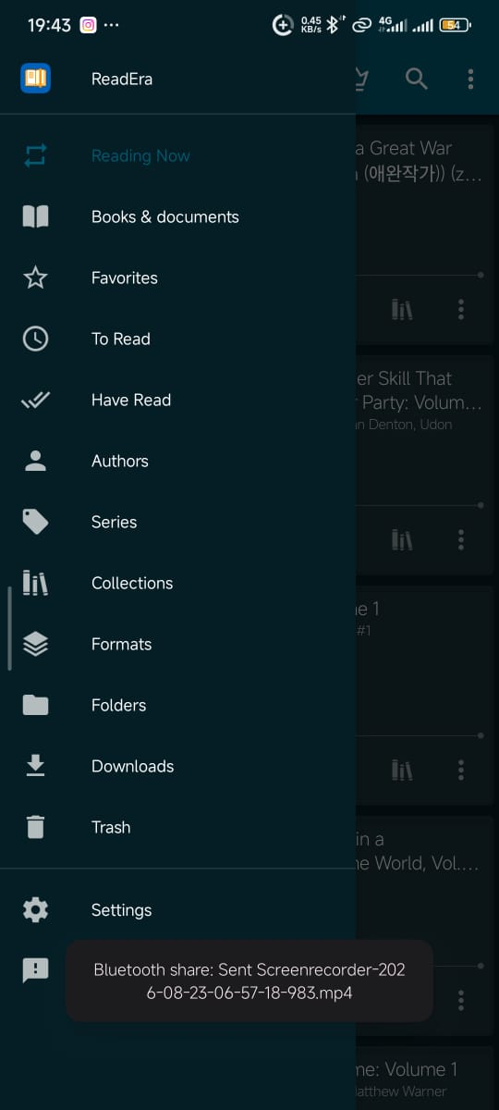
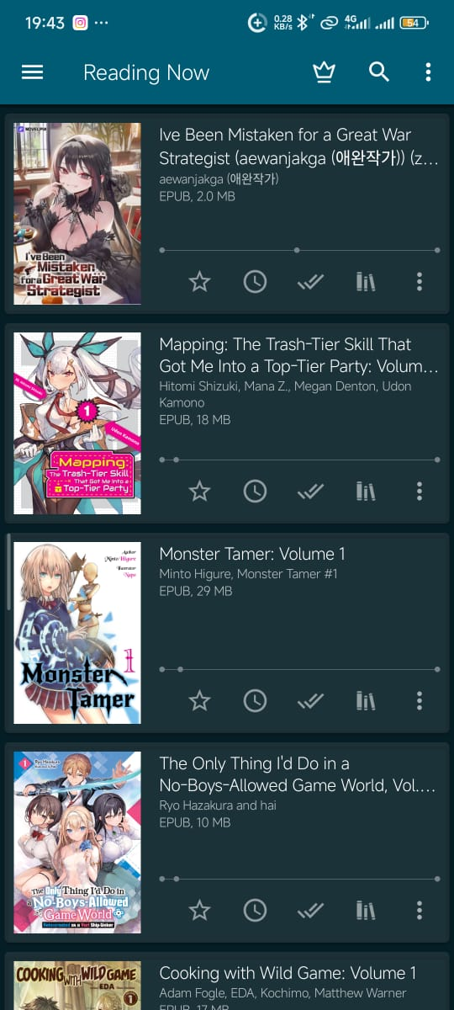
Figure 4.1: Library-navigation and reading-list design references.

CHAPTER FOUR
4.3 Voice Interaction and Text-to-Speech
Text-to-speech is handled by pyttsx3, which connects to voices available in Windows. The speaker module cleans the supplied text, creates an engine, sets a reading rate, speaks the current section, and reports errors instead of failing silently. During reading, progress is saved after each spoken section. This design provides a practical pause point even where an operating-system speech engine cannot be stopped in the middle of a sentence.
Voice input is handled by a separate microphone module. The module checks that an input device supports the required sample rate, records a short command, converts the recording to WAV data, and sends it for transcription. Recognised commands include read, continue, resume, pause, stop, progress, back, and previous. A command that is not a reader control is treated as a question about the selected book. The interface reports failures such as a missing microphone, permission issue, unavailable recognition service, or unrecognised speech.
An important privacy distinction is maintained: voice transcription may need network access when using Google recognition, but book-question retrieval is local. LIBRIS does not search the internet to answer a question about a selected book. It extracts relevant passages from that book and states when it cannot find sufficient evidence.

CHAPTER FOUR
4.4 Book-Grounded Question Answering
The discussion component applies a simple retrieval-augmented approach suitable for a first-year prototype. The selected book is split into overlapping passages. Significant terms are extracted from the user’s question and compared with terms in each passage. The best matching passage is returned with an approximate source location. When no relevant passage is found, the program explains that the requested answer could not be located in the selected book.
This method is intentionally conservative. It does not claim to understand every literary question and it does not generate information that is absent from the document. The method is less natural than a large language model, but it is easy to inspect and demonstrates the central requirement: the selected book is the context. Future work can use embeddings and a local vector database to improve semantic matching while keeping the same safety rule.
Functional requirements include importing books, opening a reader, preserving progress, reading aloud, accepting a voice command, supporting back and next navigation, summarising book text, and answering book-grounded questions. Non-functional requirements include local-first storage, readable feedback, compatibility with Windows, modular organisation, dependency documentation, and error reporting.

Requirement | Implementation
Book import | File picker and Inbox folder support TXT, PDF, and EPUB
Visible reader | Reader window opens after import and displays extracted text
Read aloud | pyttsx3 speaks the active reader section
Progress | JSON record stores current section and percentage
Voice control | Microphone command routes to reader actions or book Q&A
Book-only answers | Keyword retrieval searches only the selected extracted book text

CHAPTER FOUR
4.5 Testing and Evaluation
Testing was conducted with three book types already present in the LIBRIS collection: a TXT demonstration book, an EPUB novel, and a PDF programming text. The application was compiled, the user interface was constructed, and each source was extracted into reader sections. The TXT file generated five sections, the EPUB generated 1,215 sections, and the PDF generated 599 sections. These results confirmed that long files can be divided into manageable units for highlighting and progress tracking.
Further tests verified that books copied from the Inbox were registered in the local metadata file, a selected book could be restored after restart, progress could be saved and reloaded, and a question about a selected book returned text from that book. Text-to-speech was tested through the installed Windows speech engine. The microphone stack was checked for a default input device and required packages. Actual recognition quality depends on microphone hardware, Windows permission, background noise, and network availability.
The tests show that LIBRIS meets its prototype objectives. However, user acceptance should continue after deployment because real readers may prefer a different speech rate, larger type, dark/light reader modes, bookmarks, and chapter-aware navigation.

Test | Expected outcome | Result
Import TXT | Book is registered and reader opens | Pass
Import EPUB | Text is extracted into sections | Pass after dependency installation
Import PDF | Text is extracted into sections | Pass after dependency installation
Read aloud | Current section is spoken and progress changes | Pass
Back/Next | Reader returns to adjacent section | Pass
Book Q&A | Evidence comes from selected book | Pass
Voice stack | Microphone device and packages initialise | Pass; recognition depends on user environment

CHAPTER FIVE
5.1 Problems Encountered and Solutions
Several challenges were encountered during development. The first was incomplete early code and a terminal-only interface, which made it difficult for a reader to see the book while it was being spoken. This was resolved by creating a Tkinter desktop interface and a separate reader window that highlights the active section. A second challenge was dependency availability. EPUB extraction failed until EbookLib and BeautifulSoup were installed, while PDF extraction produced font warnings until fonttools was added.
Audio features also required careful troubleshooting. Text-to-speech can appear not to work when Windows selects a different audio output or when a program suppresses its error message. The speaker module was changed to report exceptions clearly. Voice command recognition depends on a microphone device, application permissions, background noise, and an available transcription service. The microphone module therefore performs device checks and reports a specific problem rather than ending silently.
A final challenge was balancing ambition with scope. An advanced conversational model, online accounts, perfect PDF page layout, and real-time word highlighting would require more infrastructure. The prototype instead prioritised reliable importing, readable navigation, paragraph-level tracking, and a clear demonstration of book-grounded assistance.

CHAPTER SIX
6.1 Recommendations and Suggestions
The Industrial Training Fund, institutions, and host organisations should continue to support practical assignments that require students to build and document a complete small system. Such work develops stronger skills than isolated programming exercises because it includes requirements gathering, dependency management, error handling, testing, interface design, and reporting. Students should be encouraged to begin with an achievable prototype and improve it in stages rather than attempting every advanced feature at once.
For future versions of LIBRIS, the following improvements are recommended: use a local speech-recognition model to reduce network dependence; add bookmarks and named reading lists; provide a slider for speech rate and voice selection; show chapters and true PDF page references; add a theme selector; use semantic embeddings for stronger question retrieval; and create automated tests for file import, progress recovery, and reader navigation. User research should also be carried out with students who have different reading habits and accessibility needs.
Before submission, the student should replace all bracketed placeholders in this report, verify dates with the department, include accurate organisation details, and obtain the appropriate signatures. The final print copy should follow the required binding and colour-printing instructions.

CHAPTER SEVEN
7.1 Summary
This report has described the practical development of LIBRIS, a voice-assisted and book-grounded digital reader. The project combined desktop-interface programming, local file management, text extraction, text-to-speech, microphone commands, reading-progress tracking, and simple retrieval-based question answering. The final application supports TXT, PDF, and EPUB material, displays an imported book in a reader window, highlights the section being spoken, and gives the reader controls to move backward, move forward, pause, resume, and continue later.
The project demonstrates that a useful educational application can be developed incrementally with accessible Python tools. The most important design decision was to make the reader experience visible and controllable rather than treating speech as a hidden background action. The final black, light-purple, and red interface gives LIBRIS a clear identity while preserving contrast and readability. The SIWES experience strengthened practical problem-solving ability and showed the value of testing with real files and devices.

REFERENCES
Beautiful Soup. (2026). Beautiful Soup documentation. https://www.crummy.com/software/BeautifulSoup/
EbookLib. (2026). EbookLib documentation. https://docs.sourcefabric.org/projects/ebooklib/
Industrial Training Fund. (n.d.). Student Industrial Work Experience Scheme (SIWES). https://www.itf.gov.ng/
Python Software Foundation. (2026). Python documentation. https://docs.python.org/3/
pyttsx3. (2026). pyttsx3 documentation. https://pyttsx3.readthedocs.io/
pypdf. (2026). pypdf documentation. https://pypdf.readthedocs.io/
SpeechRecognition. (2026). SpeechRecognition documentation. https://pypi.org/project/SpeechRecognition/

APPENDIX A: LIBRIS USER GUIDE
1. Start the application by running python main.py from the LIBRIS project folder.
2. Click Import book and choose a TXT, PDF, or EPUB file, or place a supported file inside books/inbox and click Import from Inbox.
3. The book opens in the reader. Select Read aloud to hear it and follow the highlighted section.
4. Use Previous and Next to move through the book. Progress is saved automatically.
5. Use the question field to discuss the selected book, or choose Voice command and say read, pause, resume, back, progress, or a question about the selected book.

APPENDIX B: PROJECT FILE STRUCTURE
main.py — launches the desktop application.
ui/app.py — contains the light-purple, red, and black library and reader interface.
library/book_manager.py — imports books and manages local library metadata.
library/book_reader.py — extracts text and records reading progress.
audio/speaker.py — performs text-to-speech output.
audio/microphone.py — captures and transcribes voice commands.
ai/brain.py — retrieves relevant passages from the selected book.
books/inbox — folder for manually placed books awaiting import.
data/library.json and data/progress — local storage for library and reading state.

