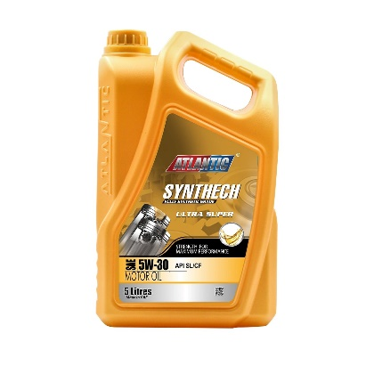

ATLANTIC SYNTHECH ULTRA SUPER

MOTOR OIL SAE 5W-30 API SL

(Fully Synthetic Engine Oils-Full SAPs)

**DESCRIPTION**

ATLANTIC SYNTHECH ULTRA SUPER MOTOR OIL SAE 5W-30 API SL is premium performance, multi-grade motor oils formulated from selected synthetic base fluids and race-proven additive technology optimized to provide complete engine protection plus ultimate performance under all operating conditions for passenger cars with gas and diesel engines with extended drain intervals beyond 229.3 oils.

**APPLICATIONS**

ATLANTIC SYNTHECH ULTRA SUPER MOTOR OIL SAE 5W-30 API SL is top-tier motor oils designed for naturally aspirated Gasoline engines, LPG and Diesel engines in passenger cars, light truck gasoline and diesel engines, gasoline and diesel powered RV and SUVs(Sport Utility Vehicles), Common Rail Direct Injection engine in passenger cars, Passenger cars with high speed, four-stroke, turbocharged and EGR, DPF, Four-stroke gasoline engines in motorcycles and portable power equipment where the manufacturer recommends conventional passenger car motor oils.

**PROPERTIES**

ATLANTIC SYNTHECH ULTRA SUPER MOTOR OIL SAE 5W-30 API SL is high performance engine oils formulated for highly tuned four cylinder and latest technology engines that operate at higher temperatures with exceptional characteristics ensuring that all engine components from the valve train to the bearings are fully lubricated to provide the strength for maximum engine performance. Specifically developed to provide the highest fuel economy and lowest CO2 emissions & boosted with fluid Titanium technology, its film strength is doubled preventing oil film breakdown and reducing friction.

**PERFORMANCE FEATURES AND BENEFITS**

* Longer intervals between oil changes
* Easier starts in very cold weather
* Excellent engine cleanliness and protection
* Excellent engine protection, particularly against wear of the distribution system
* Extends engine life
* Lower impact emissions
* Delivers unsurpassed levels of protection across a variety of driving conditions and temperatures

|  |
| --- |
| **RECOMMENDATIONS / SPECIFICATIONS**  International Standards : API SL, SL/CF, ACEA: A3/B3, A3/B4, A5/B5  OEM Approvals : MB Approval 229.5  Meets or exceeds: MB-229.3, MB-226.5, Opel GM-LL-B-025, Opel GM-LL-A-025, BMW Longlife-01, Renault RN0700 /RN0710, VW/Audi 502.00/505.00  Meets quality requirements of most gasoline engine manufacturers in the USA, Europe, Japan and Korea |
| **TYPICAL TECHNICAL PROPERTIES**   |  |  | | --- | --- | | Viscosity Grade, SAE J300 | 5W-30 | | PRODUCTS CODE: | PCMO-24108 | | Density at 15⁰C, g/ml, ASTM D4052 | 0.855 | | Cold Cranking Viscosity(CCS), mPa s, ASTM D5293 | 6200 @-30⁰C | | Kinematic Viscosity at 40⁰C, mm²/s, ASTM D445 | 68.9 | | Kinematic Viscosity at 100⁰C, mm²/s, ASTM D445 | 12.0 | | Viscosity Index, ASTM D2270 | 172 | | Flash Point(COC), °C, ASTM D92 | 228 | | Pour Point, °C, ASTM D97 | -45 | | Total Base Number (TBN), mg KOH/g, ASTM D2896 | 10.3 | | Sulphated Ash, %wt, ASTM D874 | 1.2 | |

Note: These characteristics are typical of current production. While future production will conform to Atlantic’s specification, variations in these characteristics may occur.

ATL/PDS/AL/01.1-0125436 HT/02*, 04.07.24, Page 1/1 * supersedes all previous versions

**Packing :** 700 ml ,800 ml , 1L , 2L, 3L, 4L, 5L, 6.5L, 7L, 8L,16L,18L, 20L, 25L, 200L, 205L, 208L, 210L