Homework 5
Advance Embedded System Design
Spring 2019

Yasir Aslam Shah

Include in your report:
1) A link to your project’s git repo.
2) A scope shot of the LED pin switching at the required frequency.
3) Screenshots of UART terminal on HOST machine showing log output of both tasks
4) (BONUS) If attempting, Screenshot of UART terminal showing alert.

Submit the report to Canvas and your complete CCS Workspace/Project and code to your git repo.

Github Link:
https://github.com/yasiraslamshah/Advance-Embedded-System-Developement

Screenshot of UART Terminal on HOST Machine showing Output
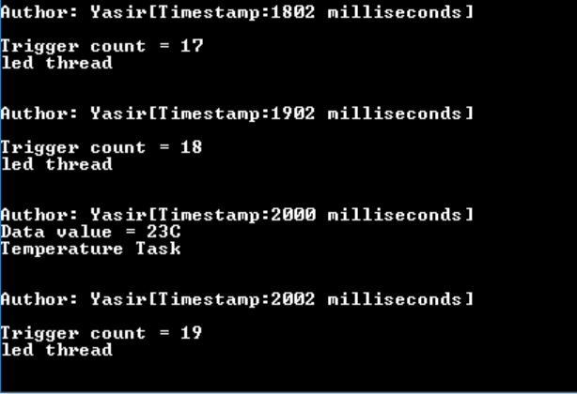

4) (BONUS) If attempting, Screenshot of UART terminal showing alert.:

